GAUTENG DEPARTMENT OF EDUCATION
SENIOR CERTIFICATE EXAMINATION

TECHNIKA (MECHANICAL) HG

TIME: 3 hours

MARKS: 300

REQUIREMENTS:

- A calculator and drawing instruments.

INSTRUCTIONS:

- Answer ALL the questions.

- An information sheet (pages 9 to 12) appears at the back of this question paper. Please detach it for ease of reference.

QUESTION 1  1.1 Name the factors that have an influence on the structural changes during welding.  1.2 Study the diagram below and name the instruments numbered 1.2.1 – 1.2.5 that are used when testing for accuracy. Write down only the numbers (1.2.1 – 1.2.5) below each other and the correct answer next to each number. | (5)  (5)
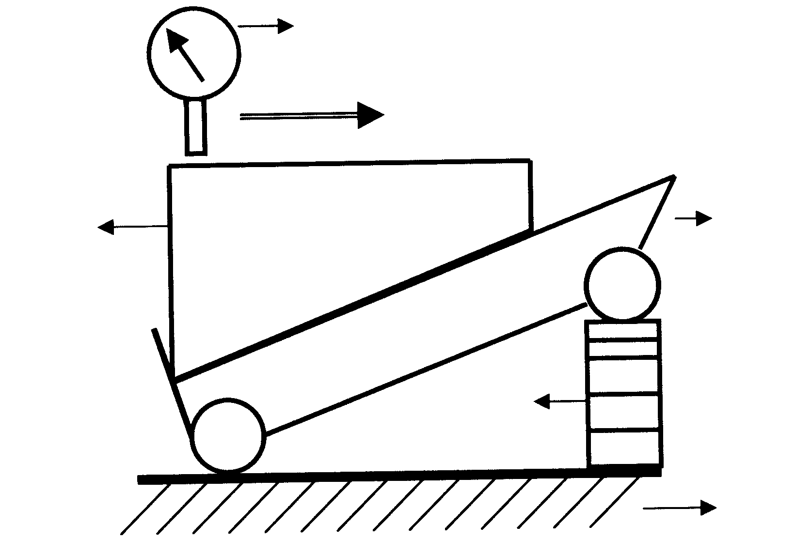
1.2.1
1.2.2
1.2.3

1.2.4

1.2.5

1.3 Draw neat sketches of THREE basic surface-finish symbols and state the meaning of each. | (9)

1.4 Prove that one revolution is equal to 2$π$radians. | (3)

1.5 Why is annealing important during heat treatment? | (4)

1.6 A spiral spring is 90mm long when not stretched out. A force of 5N is needed to stretch the spring by 10mm. Calculate the work done to stretch the spring from 100mm to 130mm, assuming the limit of elasticity is not exceeded. | (5)

1.7 Most metals crystallize to one of three space lattice types. Write down the name and atomic number of each type. | (6)

1.8 Briefly explain what happens to the structure of steel at the following halting points of the iron carbon equilibrium diagram:  - AC₁  - AC₂  - AC₃ | (5)  (2)  (3)

1.9 Draw a fully labelled, typical pressure volume diagram for a four-stroke spark ignition engine to illustrate the pressure-volume relationship during one complete cycle. | (10)

1.10 Name THREE uses of etyn. | (3)  [60]

QUESTION 2

2.1 Name FIVE important safety features which should be taken into consideration when designing a factory building. | (5)

2.2 Describe Young’s modules of elasticity E. | (4)

2.3 A mild-steel bush, 100mm in length, with an inner diameter of 30mm and an outer diameter of 40mm, is used in a press to press out bearings. The press exerts a force of 500N on the bush.  - Name the type of stress in the bush material.  - Calculate the safe working stress, when the ultimate stress for mild steel is given as 500MPa. A safety factor of 4 was used when the bush was designed.  - Calculate the stress in the bush material. Give your answer in megamagnitude.  - Calculate how much the bush will shorten under the given load. Take Young’s modulus of elasticity as 90 x 10³MPa. | (1)  (3)  (6)  (5)

2.4 A mass of 50kg is accelerated up an incline making an angle of 15º with the horizontal, from 4 m/s to 18m/s during a period of 20s. The coefficient of friction is 0,25. Calculate the  - acceleration.  - distance travelled.  - work done against the gravitational component parallel to the planet.  - frictional force.  - work done against the frictional force.  - work done converted to kinetic energy.  - power delivered by the total force. | (3)  (3)  (3)  (3)  (3)  (4)  (5)  [48]

QUESTION 3

3.1 Ninety-nine (99) teeth must be milled on a spur gear. The dividing head ratio is 40:1.  - Calculate the indexing required. (Choose 100 divisions.)  - Calculate the change wheels required.  - Determine the direction of rotation of the index plate.  - Draw a simple sketch to indicate the position and arrangement of the change wheels. | (3)  (5)  (2)  (4)

3.2 State THREE destructive and THREE non-destructive tests that can be carried out on a weld. | (6)

3.3 Study the diagram below and name the following components numbered  3.3.1 – 3.3.4 of the epicyclic gear train. Write down only the numbers  (3.3.1 – 3.3.4) one below the other and the correct answer next to each number. | (8)
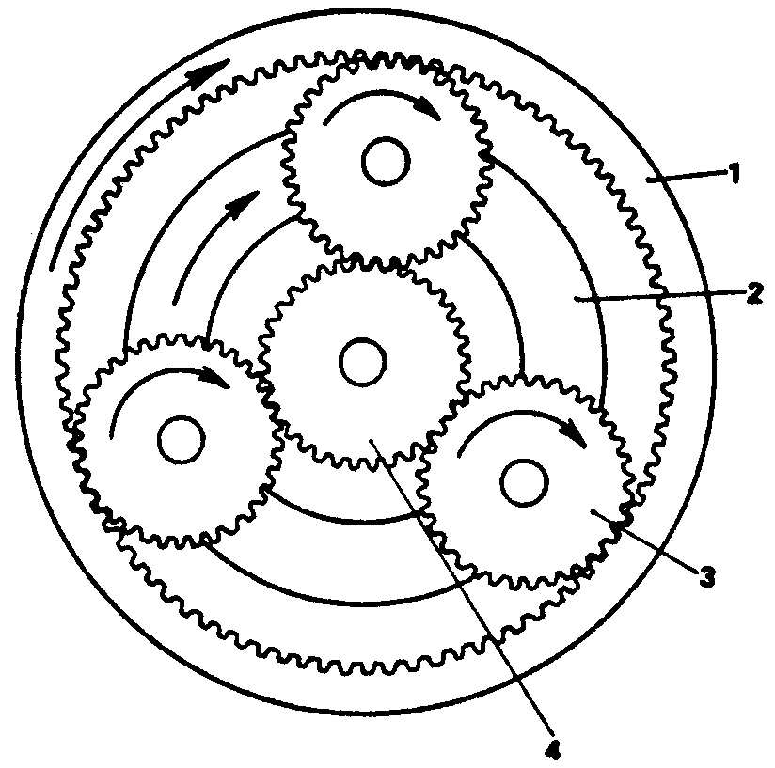
3.3.1

3.3.2

3.3.3

3.3.4

3.4 The engine of a motor vehicle has a mass of 540kg and it is lifted from ground level to a height of 1,2m with a crane.  Calculate the  - gain in potential energy.  - force required to lift the engine without acceleration.  - work done to lift the engine to a height of 1,2m. | (4)  (4)  (4)

3.5 Define Hooke’s law. | (4)

3.6 Draw the symbol that is used to represent a rectifier diode in an electric circuit. Indicate the direction in which the current flows through the diode. | (4)  [48]

QUESTION 4

4.1 Briefly describe how the change gears of a lathe can be used to cut a multi-start thread. | (8)

- The following data applies to a four-stroke engine:  Mean effective pressure 1 200kPa  Stroke length 70mm  Cylinder diameter 70mm  Revolutions per minute 3120  Indicated power 33,62kW  Calculate the  4.2.1 number of cylinders of the engine.  4.2.2 work done during one power stroke. | (7)  (3)

4.3 The use of alcohol and drugs has detrimental effects on society and the work environment. Name FOUR of these effects. | (4)

- The power transmitted by a drive belt from a drive pulley with a diameter of  300mm rotating at 2 500 revolutions per minute, is 8kW. The ratio of the tractive force in the tight side to that in the slack side is 2,5:1.  Calculate the  4.4.1 tractive force in the tight side of the belt.  4.4.2 belt speed in metres per second. | (10)  (3)

4.5 The two-wire method of screw-thread measurement is used to test the angle of M50 x 5 I.S.O. screw-thread. The measurement across the two sets of wires shows a difference of 7,03mm. The diameters of the two sets of wires are  1,01P and 0,505P respectively.  Calculate the  - size of the screw-thread angle.  - error, if any, in the screw angle. | (8)  (2)

4.6 Name THREE ways in which you can make your employees aware of the growing AIDS crisis in our country. | (3)  [48]

QUESTION 5

5.1 Briefly describe the chemical combustion process of petrol in the presence of sufficient oxygen. Name the products of this combustion. | (6)

5.2 The flywheel of a motor vehicle increases its speed uniformly from 76 revolutions per minute to 118 revolutions per minute in 8 seconds. The flywheel has a diameter of 560mm. The mass of the flywheel is 60kg and the radius of inertia 175mm.  Calculate the  - angular acceleration of the wheels in radians per second.  - linear velocity of a point on the circumference of a wheel in m.s when the wheel rotates at 118 revolutions per minute.  - kinetic energy if it rotates at 76 r/min. | (4)  (3)  (5)

5.3 Use the table of primary selection of fits in the information sheet on page 12, and state the following:  - The limits for a 15H7 – p6 hole shaft combination  - The type of fit  - The allowance for this fit | (4)  (1)  (3)

5.4 Define Boyle’s Law. | (3)

5.5 A casting with a mass of 60kg is placed on a surface inclined at 20º to the horizontal. The coefficient of friction is 0,4. Determine the smallest force (F) required to push the casting up the slope if the force is inclined at 30º to the surface. | (10)

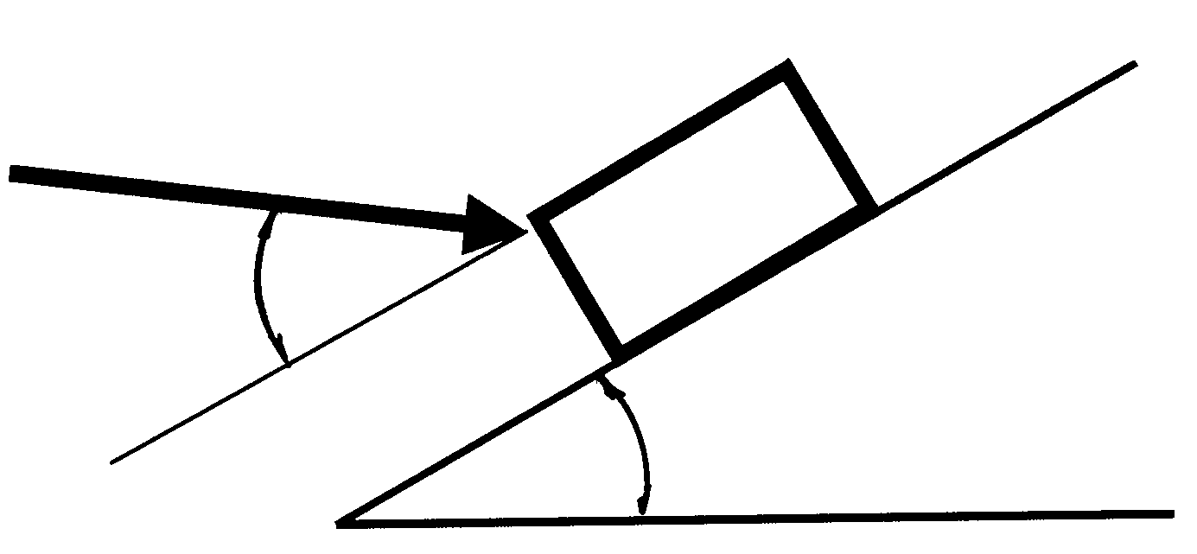
F

60kg

30º

20º

5.6 The engine of a motor vehicle develops a torque of 650 Newton metres at  3 000 revolutions per minute. Calculate the brake power of the engine. | (5)

5.7 Define the concept brake power with reference to internal combustion engines. | (4)  [48]

QUESTION 6

6.1 Calculate the magnitude and direction of the reaction at the pivot point O of the lever in the diagram below. The lever is in equilibrium. | (18)
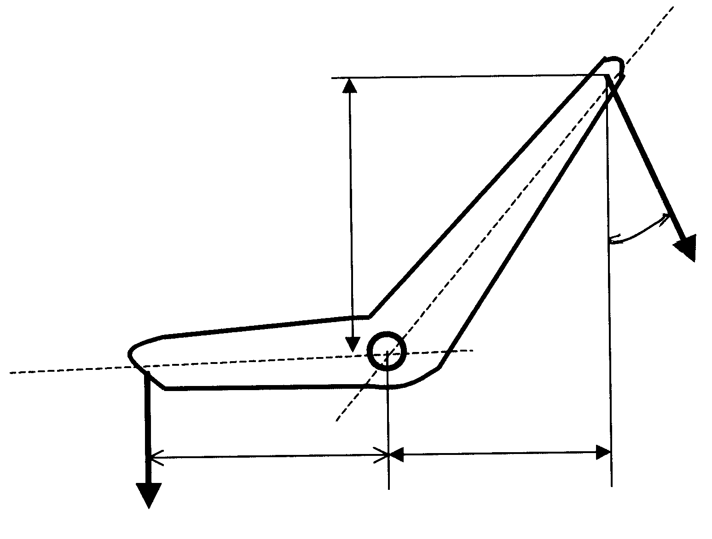
300mm
30º

F

O

200mm 170mm

35kN

6.2 Calculate the resultant velocity of the boat as shown in the diagram below. | (15)
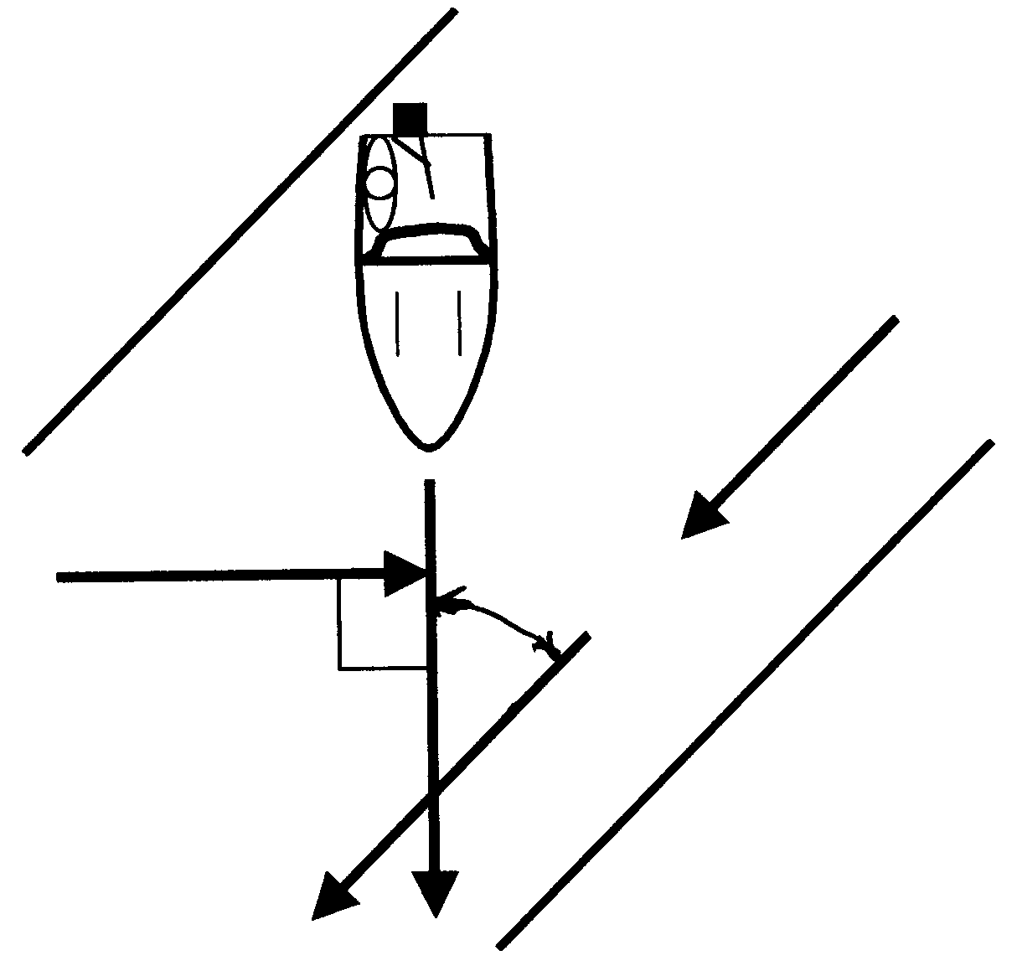
Wind

20km/h

Boat 40km/h

river

8km/h

40º

6.3 The schematic diagram below shows the layout of a simple hydraulic system. Name each of the numbered components. Write down only the numbers  6.3.1 – 6.3.10 one below the other and the correct answer next to each number. | (10)

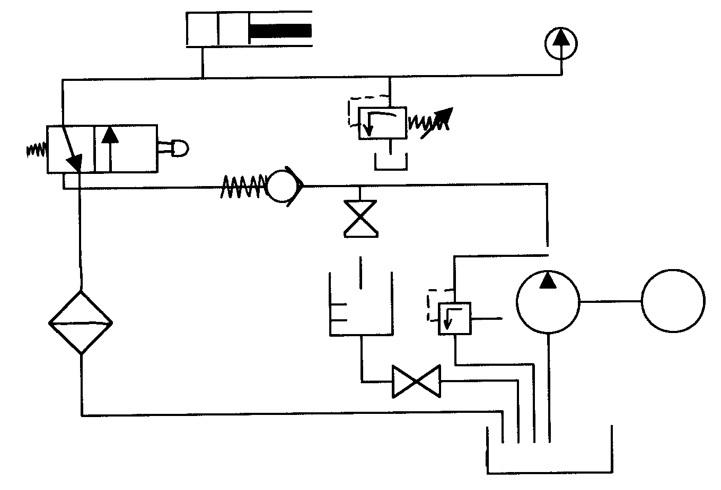
6.3.1 6.3.2
6.3.7 6.3.8 6.3.9

6.3.3
6.3.5
6.3.4

6.3.6

M

6.3.10

6.4 The driver pulley diameter of a motor is 200mm and it rotates at 1 500 r/min. Calculate the diameter of a pulley driven at a belt speed of 500 r/min. | (5)  [48]

TOTAL: | 300

INFORMATION SHEET / INLIGTINGSBLAD

