GAUTENG DEPARTMENT OF EDUCATION

SENIOR CERTIFICATE EXAMINATION

TECHNIKA (MECHANICAL) SG

TIME: 3 hours

MARKS: 200

REQUIREMENTS:
Calculator and drawing instruments.

INSTRUCTIONS:
- Question 1 is COMPULSORY.

- Answer Question 1 and any FOUR other questions.

- Answer Questions 1.1 to 1.5 on the answer sheet on the inside cover of your answer book.

- Information pages are provided (pages 9-12).
QUESTION 1
COMPULSORY

Choose the correct answer out of each of the following and draw a cross (X) over the appropriate letter next to the respective question number (1.1 to 1.5) on the answer sheet, on the inside cover of your answer book.

  - Which of the following is a vector quantity?
 | A. | Energy | B. | Momentum
 | C. | Mass | D. | Time
 | E. | Distance

1.2 The displacement divided by the time interval is called:
 | A. | Speed | B. | Average speed
 | C. | Average velocity | D. | Instant velocity
 | E. | Acceleration

1.3 The power or tempo of work done by a machine, if 60 000 J of work is done per minute, is
 | A. | 1 000 W. | B. | 36 000 000 W.
 | C. | 60 000 W. | D. | 6 W.
 | E. | 6 000 W.

1.4 Two forces of 3 N and 5 N respectively act on the same point. The magnitude of their resultant is 2 N when the work lines of the forces are at an angle of
 | A. | Oº. | B. | 45º.
 | C. | 90º. | D. | 180º.
 | E. | 360º.

- According to Boyle’s Law for a mass of gas at constant temperature,  - the pressure is constant.  - the volume increases.  - the pressure is directly proportional to the volume.  - the pressure is inversely proportional to the volume.  - the volume is inversely proportional to the pressure | 5x2=(10)

Answer the following questions in full:  - State THREE advantages and THREE disadvantages of V-belts over flat belts.  - When the blade of a hacksaw is tightened, the blade is under stress. State the type of stress.  - Distinguish between speed and velocity.  - Define the term resultant.  - Draw the symbol which is used to represent each of the following components in an electric circuit:  - A transistor  - A rectifier diode | (6)  (1)  (2)  (4)  (3)  (3)

- Define a radian.  - Define torque.  - State THREE facilities necessary to ensure the proper hygiene of factory personnel. | (4)  (4)  (3)  [40]

QUESTION 2  - Ninety nine (99) teeth must be milled onto a spur gear. The dividing head  ratio is 40:1.  - Calculate the indexing required. (Choose 100 divisions).  - Calculate the change wheels required.  - Determine the direction of rotation of the index plate. | (3)  (5)  (1)

- State FOUR aspects with regard to safe working conditions for employees,  which are important when designing a factory building.  - Why is good industrial housekeeping important in a factory?  - What is an employee’s responsibility with regard to industrial diseases?  - The abuse of alcohol and drugs is a social evil of our time. State FIVE detrimental consequences of such abuse for an individual’s work situation  and/or family.  - Briefly describe how a two start 5 mm pitch square thread is cut on a lathe  using the compound slide method of thread cutting.  - State THREE reasons why surface roughness occurs when parts are machined.  - The surface of a machine component has to be finished by lapping to a finish between 0,05 and 0,10 m. Sketch the symbol that will show this finish on a drawing. | (4)  (4)  (4)  (4)  (9)  (3)  (3)  [40]

QUESTION 3  Figure 1  - 3.1.1 Sketch a complete iron carbon equilibrium diagram for types of steel. Indicate the temperature between 0ºC and 1000ºC, and the carbon content between 0% and 1,4%.  - Determine, with the aid of the above-mentioned diagram, the structure of steel with a carbon content of 0,4% at a temperature of 800ºC.  - Name THREE space lattice types with reference to metals and state the atomic number of each.  - Provide TWO examples of each of the following types of tests:  - Machinable tests  - Destructive tests  - Non-destructive tests  - State FOUR factors which influence the change in the structure of steel during the arc-welding process. | (13)  (2)  (12)  (3)  (3)  (3)  (4)  [40]
QUESTION 4  50N  45º  75º  45º  30N  100N  - Determine graphically the magnitude of the resultant force of the system of concurrent forces shown in the figure.  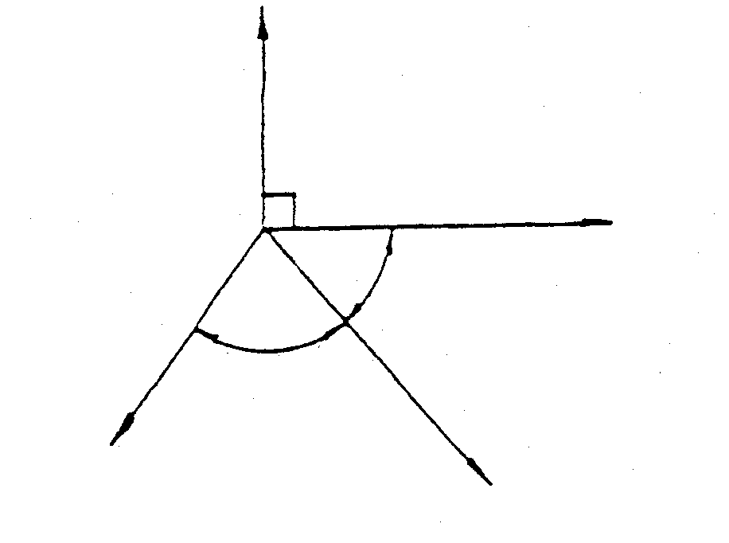 | (8)
Figure 1

- A casting with a mass of 5 000 kg rests on a horizontal surface. The coefficient of friction between the surfaces is 0,35. Calculate the force (F) required to pull the casting if the force is inclined at 20º to the horizontal.  F  20 ° ° °  5000 KG  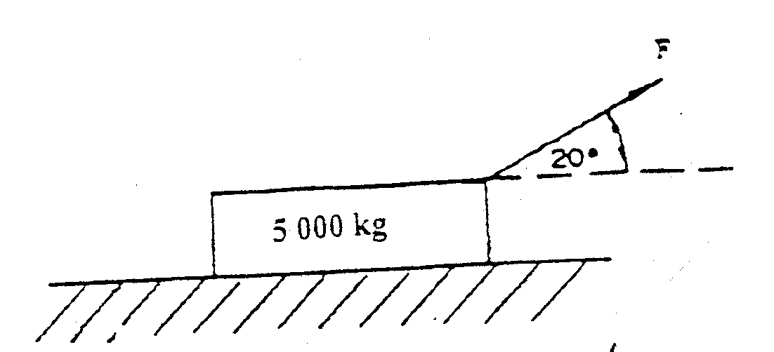  Figure 2  Figure 2  4.3 Draw a neat, labelled sketch of a typical stress-strain graph that is obtained when mild steel is subjected to a destructive tensile test. | (12)  (7)

- Calculate the included angle of a M50 V screw thread with a pitch of 6 mm. The distance over the large and the small measuring wires shows a total difference of 3,56 mm.  Given: Maximum diameter of measuring wires = 0,76 P  Minimum diameter of measuring wires = 0,54 P | (6)

- Use the table of primary selection of fits, and state the following:  - The limits of size for a 34 H7 – n6 hole shaft combination  4.5.2 The type of fit | (6)  (1)  [40]

QUESTION 5  - The ultimate stress for a particular type of steel used to manufacture bolts is  500 MPa. Calculate the  - load in newton to fracture a M6-bolt at the root diameter of the thread if the root diameter of the thread is 4,55 mm.  - safe working stress for the bolt where a safety factor of 7 is used.  - An engine with a mass of 540 kg is lifted from ground level to a height of 1,2 metres with the aid of a crane. Calculate  - the force required to lift the engine with no acceleration.  - the work done to lift the engine to a height of 1,2 metres. | (6)  (3)  (4)  (4)

- Draw a neat sectional sketch of a single plate helical spring dry clutch. Clearly indicate the following components:  Figure 3  - Flywheel  - Pressure plate  - Pressure springs (helical springs)  - Clutch plate  - Clutch release levers (clutch release fingers)  - Input shaft  - Output shaft  - Thrust bearing  - Pilot bearing  - What type of universal joint is used in a motor vehicle with front wheel drive? Explain why. | (20)  (3)  [40]
QUESTION 6  - An electric motor turns with a speed of 1 000 rpm. It drives a pulley wheel with a diameter of 1 200 mm that fits onto the machine spindle by means of a drive belt at a speed of 200 rpm.  What is the size of the pulley wheel that is mounted on the machine spindle?  Please note: This kind of drive is known as a simple drive.  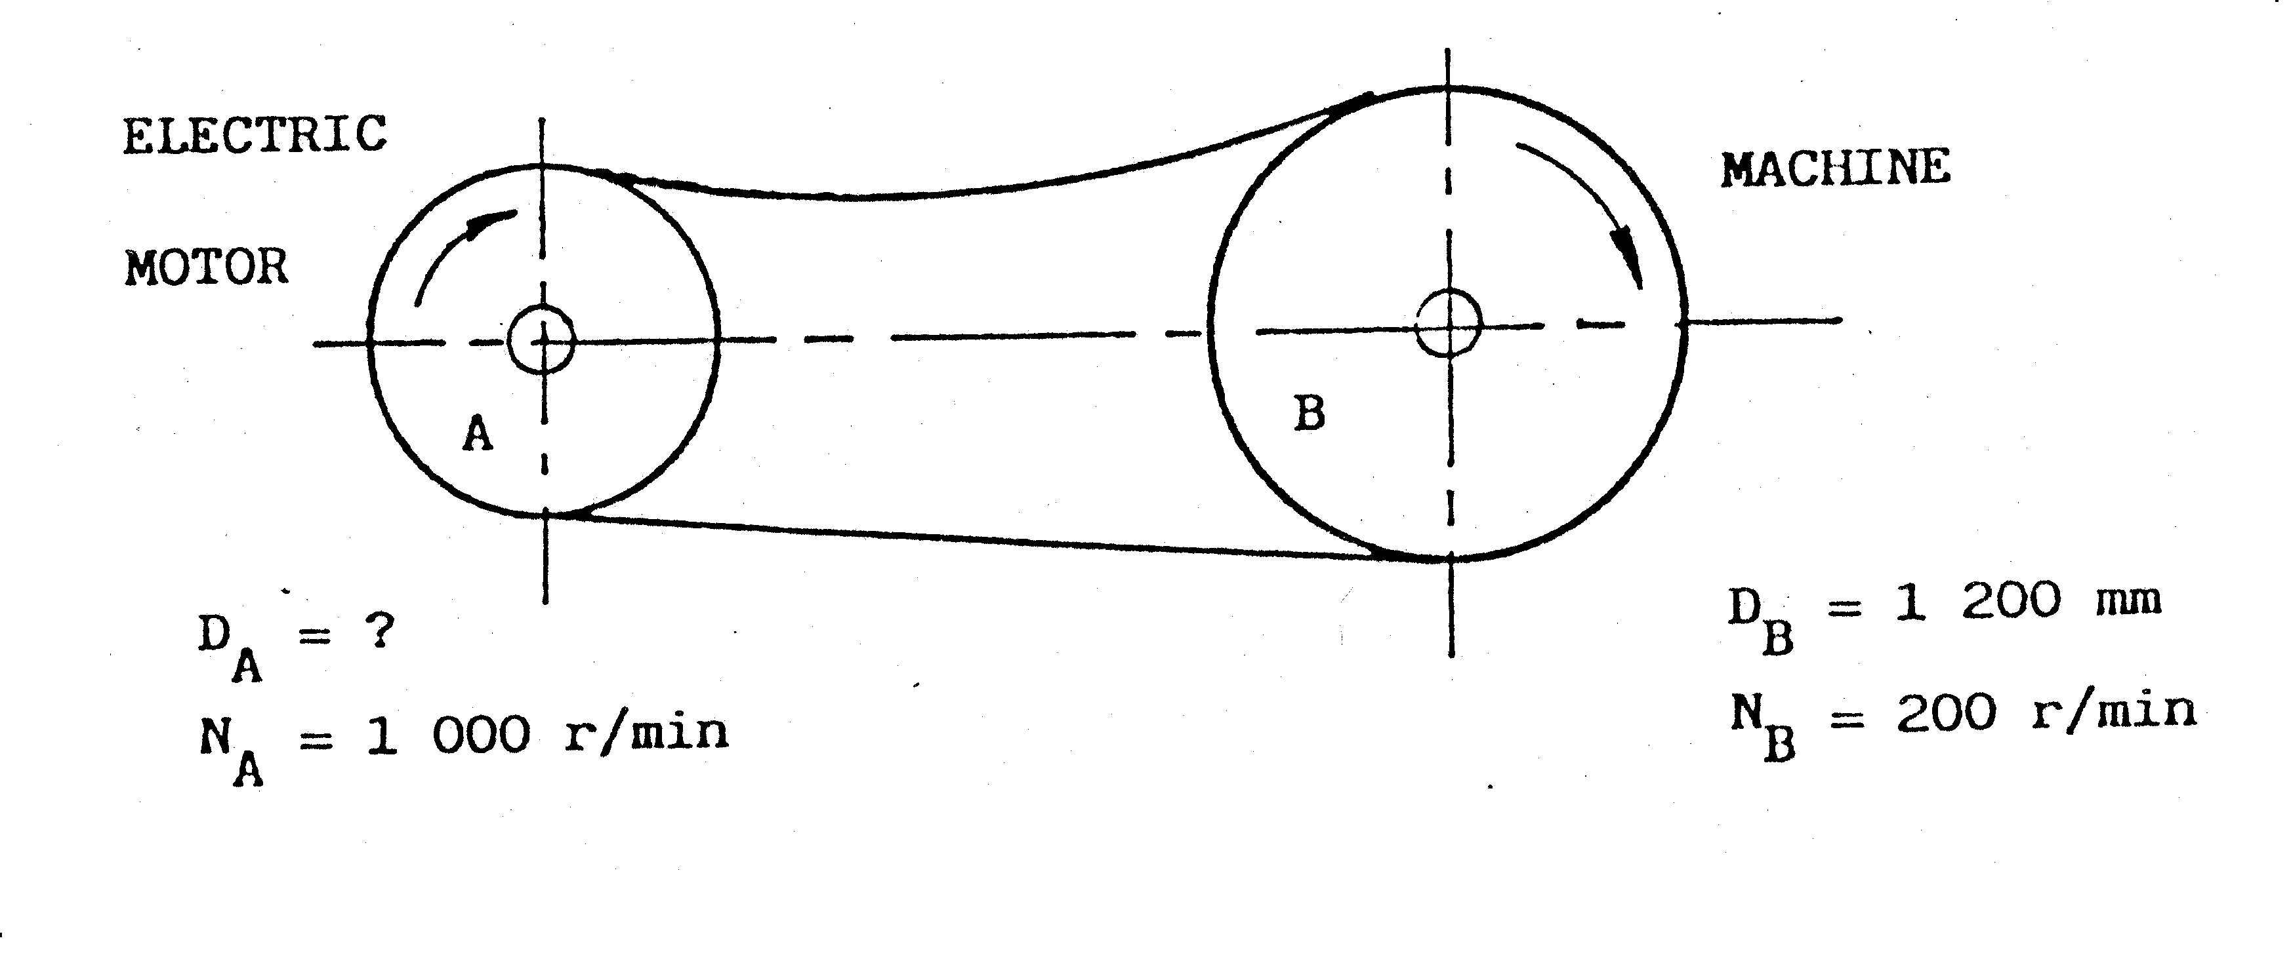Figure 3  - A drive gear with 50 teeth meshes into an idler with 70 teeth which rotates  at 210 rpm. The idler in turn, meshes into a driven gear that turns at 100 rpm. Calculate:  - the rotation frequency of the drive gear.  - the number of teeth of the driven gear.  - the speed ratio of the gear train. | (6)  (4)  (7)  (8)

- A crane, with a drum diameter of 550 mm and a rotation frequency of 50 r/min, lifts a load of 5 kN with the aid of a rope. Calculate the  - torque required.  - speed of the rope in m.s ^{–1.}  - work done per minute.  - power required to lift the load.  - efficiency of the crane if it is powered by a 15 kW electric motor. | (3)  (3)  (3)  (4)  (2)  [40]
QUESTION 7  - The following is the data for a four cyclinder four stroke internal combustion engine:  Mean effective pressure on piston = 1 200 kPa  Stroke = 70 mm  Bore (cylinder diameter) = 70 mm  Revolutions per second = 52  Effective brake arm length = 900 mm  Reading on scale = 9,4 kg  Calculate the  7.1.1 indicated power in kW.  7.1.2 brake power in kW.  7.1.3 mechanical efficiency as a percentage.  - Name EIGHT components which are used in a hydraulic system. | (9)  (7)  (4)  (8)

- Calculate the width, thickness and length of a parallel key used to secure a pulley on a 100 mm diameter shaft.  - State TWO characteristics and TWO uses, of each of the following carbon compounds:  - Alkane  - Alkene  TOTAL: | (4)  (4)  (4)  [40]  200

