GAUTENG DEPARTMENT OF EDUCATION

SENIOR CERTIFICATE EXAMINATION

TECHNIKA (MECHANICAL) SG

TIME: 3 hours

MARKS: 200

REQUIREMENTS

- Calculator
- Drawing instruments

INSTRUCTIONS:

- Answer FIVE questions: Question 1 (COMPULSORY) and FOUR other questions.
- Information pages are provided (pages 8-11).

QUESTION 1
COMPULSORY

Write only the letter of your choice (A – E) alongside the question numbers 1.1 – 1.3.

1.1 Which one of the following is a vector quantity?
 | A. | Energy | B. | Momentum
 | C. | Mass | D. | Time
 | E. | Distance
(2)

1.2 The displacement divided by the time interval is called
 | A. | speed. | B. | average speed.
 | C. | average velocity. | D. | instant velocity.
 | E. | acceleration.
(2)

1.3 Two forces of 3 N and 5 N respectively act on the same point. The magnitude of their resultant is 2 N when the work lines of the forces are at an angle of
 | A. | Oº. | B. | 90º.
 | C. | 180º. | D. | 360º.
 | E. | 45º.
(2)
Answer the following questions in full.  - Distinguish between speed and velocity.  - Define the following:  - Energy  - The characteristics of an ideal gas  - State THREE destructive tests that can be carried out on steel.  - A weight lifter with a mass of 100 kg lifts a set of weights of 120 kg above his head.  Calculate the force with which the set of weights is pulled to the earth.  - Which of the following instruments may be classified as indicators?  - The fuel gauge of a motor vehicle  - A thermometer  - An oscilloscope  - A dial test indicator  - A comparator  - Define the Law of Moments.  - Define the term resultant.  - Define a radian.  - Define torque.  QUESTION 2  - State EIGHT main causes of a fire.  - What is the main aim of the Factory Act?  - Mention SIX occupational diseases and state the cause of each.  - Two tractors are used jointly to pull down a tree. Tractor A exerts a tractive force of 75 kN directly north. Tractor B exerts a tractive force of 50 kN directly east.  Determine graphically  - the position, in degrees, from the north, where the tree will fall.  - the power output required to achieve the same result, if only one tractor is used.  2.5 Mention TWO elements, or factors, which influence surface finish on machined components. | (2)  (2)  (4)  (3)  (4)  (3)  (4)  (4)  (4)  (4)  [40]  (8)  (2)  (12)  (2)  (2)  (2)
- A round steel cable, comprising 50 strands, has to be designed to be able to withstand a load of 60 kN. Calculate the diameter of each of the strands if the load in the cable may not exceed 100 MPa.  45 N  30 N  100 N  45º  75º  50N  - Name TWO elements of a screw-thread.  QUESTION 3  - One hundred and twenty seven (127) teeth have to be milled onto a gear.  - Calculate the indexing required. (Choose 125 divisions.)  - Calculate the change wheels required.  - Determine the direction of rotation of the index plate.  - Draw a simple sketch which clearly indicates the position and arrangements of the change wheels.  - Sketch a complete iron carbon equilibrium diagram for types of steel.  Indicate the temperature between 0ºC and 1 000⁰C and the carbon content between 0% and 1,4%.  - Describe the following grain structures of steel:  - Sementite  - Austenite  - Use the table of primary selection of fits on the information sheet on page 8 and state the following:  - The limits for a 28H7 –p6 hole shaft combination  - The type of fit  - The allowance of this fit  QUESTION 4  4.1 Describe in detail the colour penetrating test as carried out on welding joints.  - Determine graphically the magnitude of the resultant force of the system of concurrent forces shown in Figure 1 below.  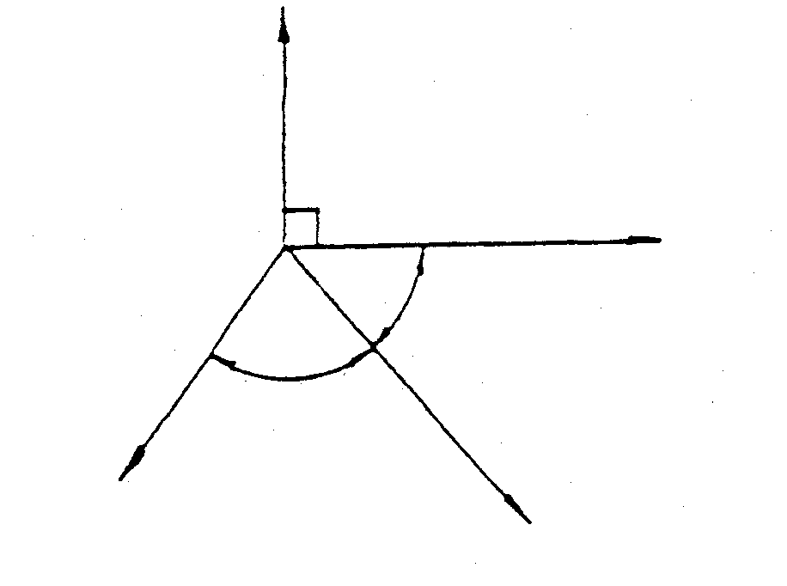  Figure 1 | (10)  (2)  [40]  (2)  (8)  (1)  (2)  (10)  (5)  (5)  (4)  (1)  (2)  [40]  (11)  (8)
4.3 An object with a mass of 5 000 kg rests on a horizontal plane in Figure 2. The coefficient of friction between the surfaces is 0,35. Determine the force (F) required to pull the object if the force is inclined at an angle of 20⁰ to the horizontal plane.  F  20º  5 000 kg  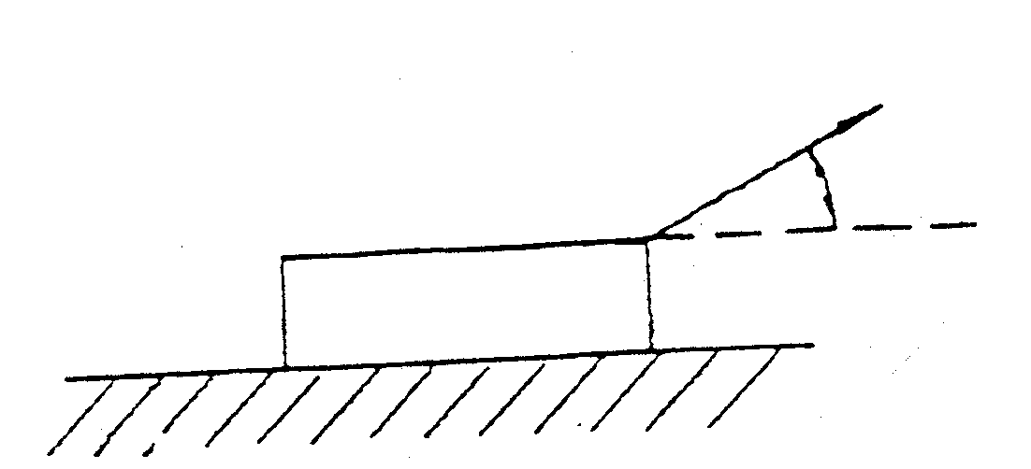  Figure 2  - Calculate the included angle of M50 V screw thread with a pitch of 6 mm.  The distance over the large and the small measuring wires shows a total difference of 3,56 mm.  Given:  Maximum diameter of measuring wires = 0,76 P  Minimum diameter of measuring wires = 0,54 P  QUESTION 5  - Draw a neat sectional sketch of a single plate helical spring dry clutch. Indicate the name of the following components:  - Flywheel  - Pressure plate  - Pressure springs (helical springs)  - Clutch plate  - Clutch release levers (clutch release fingers)  - Input shaft  - Output shaft  - Thrust bearing  - Pilot bearing  - List THREE types of keys in common use.  - Calculate the width, length and thickness of an ordinary parellel key that is used to secure a component to a 50 mm diameter shaft.  - Draw the symbol that is used to represent a transistor in an electrical circuit. Label all the components.  - State TWO different methods of activating a transistor as a switch. | (12)  (9)  [40]  (20)  (3)  (9)  (6)  (2)  [40]

QUESTION 6  10 kg  13º  - State THREE methods which are used to cut multi-start screw threads on a lathe.  - Describe briefly the purpose of each of the following components of a hydraulic system:  6.2.1 The pressure release valve  6.2.2 The pressure gauge  - Describe briefly how the compound slide of a lathe can be used to cut a three-start thread.  - Name FOUR ways in which you will make the employees of a business aware of the increasing AIDS crisis in the country.  6.5 A pulley, with a diameter of 500 mm, is driven by means of a drive belt and rotates at 500 rpm. The tractive force in the tight side is 300 N, and the tractive force in the slack side is 150 N.  - Calculate the effective tractive force.  - Calculate the belt speed in metres per second.  - Calculate the power transmitted.  - A casting with a mass of 10 kg (Figure 3) rests on an inclined plane at 13 degrees to the horizontal. The coefficient of friction between the surfaces is 0,5.  - Determine the force, parallel to the inclined plane, which must be applied to move the casting up the inclination.  - Determine the force, parallel to the inclined plane, which must be applied to move the casting down the inclination.  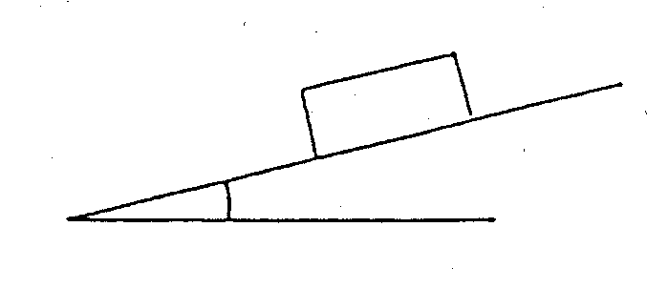  Figure 3  QUESTION 7  - The following is the data for a four cyclinder four stroke internal combustion engine:  Mean effective pressure on piston = 1 200 kPa  Stroke = 70 mm  Bore (cylinder diameter) = 70 mm  Revolutions per second = 52  Effective brake arm length = 900 mm  Reading on scale = 9,4 kg | (3)  (2)  (2)  (8)  (4)  (4)  (4)  (3)  (5)  (5)  [40]
Calculate the  - indicated power in kW.  - brake power in kW.  - mechanical efficiency as a percentage.  - State TWO characteristics and TWO uses, of each of the following carbon compounds:  - Alkane  - Alkene  - Draw a typical pressure-volume diagram for a four stroke compression ignition engine to illustrate the pressure-volume relationship for a complete cycle. Label all components on the diagram.  - What type of universal joint is used in a motor vehicle with front wheel drive? Explain why.  TOTAL: | (9)  (7)  (4)  (4)  (4)  (9)  (3)  [40]  200

