GAUTENG DEPARTMENT OF EDUCATION
SENIOR CERTIFICATE EXAMINATION

TECHNICA (MECHANICAL) HG

TIME: 3 hours

MARKS: 300

REQUIREMENTS:

- Calculator
- Drawing instruments

INSTRUCTIONS:

- Question 1 is COMPULSORY.
- Answer Questions 1.1 – 1.5 on the answersheet on the inside cover of your answerbook.
- Answer Question 1 and any FIVE other questions.
- Information pages are provided (pages11-14).

QUESTION 1
COMPULSORY

Choose the correct answer out of each of the following and draw a cross (X) over the appropriate letter next to the relevant question number (1.1 to 1.5) on the answer sheet on the inside cover of the answer book.

  - The following metals are part of the cubic space-lattice arrangement. Which one does not fit?

- Aluminium
- Copper
- Lead
- Magnesium
- Platinum

  - In the equation S = ut + ½at² the term ½at² has the same unit as:

- Time
- Displacement
- Velocity
- Acceleration
- Speed

  - The sketch below shows three forces X, Y and Z at a common point O in equilibrium. If the angle between forces X and Y is decreased slightly, keeping the magnitude of X and Y constant, then the magnitude of Z will
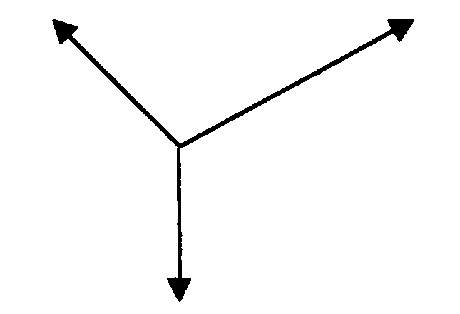

X

Y

O

Z

- increase.
- decrease.
- remain constant.
- double
- None of the above.

  - State the correct name of the following hydrocarbon compound in the alkane series: C₈H₁₈

- Heptane
- Heksane
- Octane
- Propane
- Butane

- According to Boyle’s law for a mass of gas at constant temperature, one of the following is TRUE:  - Pressure remains constant  - Volume increases  - Pressure is directly proportional to the volume  - Pressure is equal to the volume  - Pressure is inversely proportional to the volume | 5x2=(10)

1.6 Describe the concept thermodynamics. | (2)

1.7 The figure below indicates the pressure-volume diagram for a four-stroke compression-ignition engine to illustrate the pressure-volume relationship for one complete cycle. Name the following numbered parts.

1.7.1  1.7.2  1.7.3  1.7.4  1.7.5  1.7.6  1.7.7  0 2 4 6 8  3000  1000  100  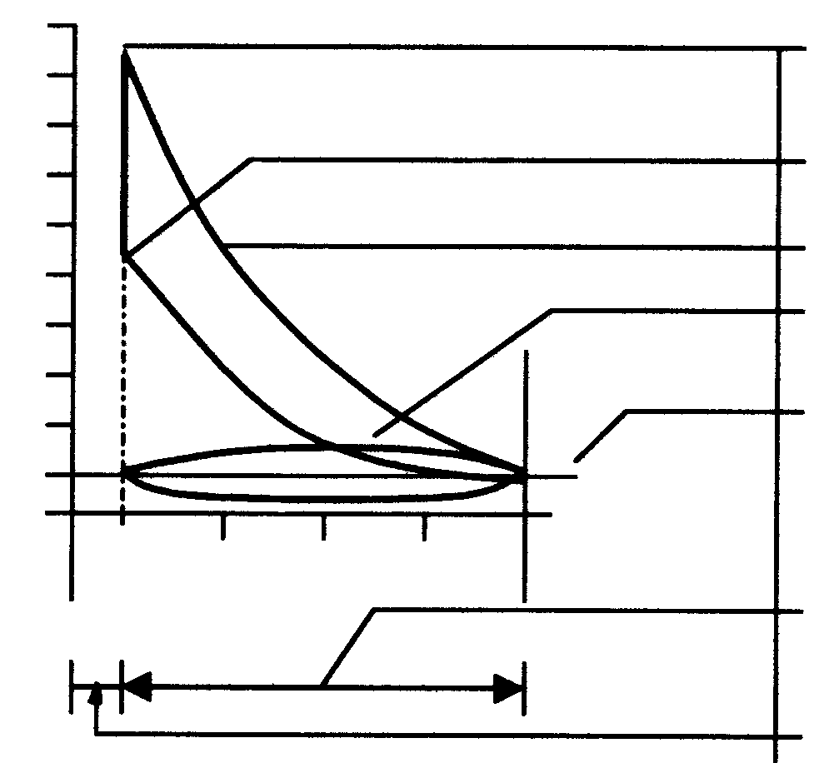 | (7)

1.8 A load of 1900 N is lifted by the drum of a lifting device. The diameter of the drum is 0,2 m. Calculate the power if the drum rotates at 14 r/min. | (5)

1.9 Define velocity. | (2)

1.10 Name TWO types of universal joints in general use. | (2)

- Most metals crystallise to one of three space lattice types. State the following:  1.11.1 The atomic number of each.  1.11.2 TWO materials from each category | (3)  (6)

- Define the following concepts:  1.12.1 The mean effective pressure on the piston of an internal combustion engine  1.12.2 Indicated power | (4)  (4)

- The following data pertains to a four cylinder four stroke internal combustion engine:  Cylinder diameter 80 mm  Stroke 100 mm  Mean effective pressure on piston 860 kPa  Revolutions per minute 3600 r/min  Effective brake arm length 900 mm  Reading on scale 9 kg  Calculate the following:  1.13.1 The indicated power in kW  - The work done during ONE power stroke when the piston moves from  T.D.C. to B.D.C.  - The brake power in kW. | (7)  (3)  (4)  [60]

QUESTION 2

- What is an employee’s responsibility as far as industrial hygiene is concerned?  Name FOUR aspects.  - Draw neat sketches of THREE basic surface-finish symbols and state the meaning of each.  - State the THREE basic crystal structures of steel.  - Draw a graph of a typical stress-strain condition which is obtained when low carbon steel (mild steel) is subjected to a destructive tensile test. Label all the components of the graph. | (4)  (9)  (3)  (8)

- A vehicle, with a mass of 800 kg, accelerates uniformly from rest to 60 km/h during 5 s up an incline of 1:20. The frictional resistance is 250 N. Calculate:  - The work done against the frictional force when the velocity has reached  60 km/h  - The work done against the gravitational component parallel to the plane  - The total force exerted by the vehicle | (8)  (3)  (5)

2.6 Briefly describe how metal crystallises when it cools. | (8)  [48]

QUESTION 3

- Two V-belts are used on a pulley which rotates at 1440 r/min. The tractive force in the tight side is 150 N and the ratio of the tractive force in the tight side to the slack side is 6:1. Calculate  3.1.1 the power transmitted in kilowatt if the driving pulley has a diameter of  0,2 metre.  3.1.2 the belt speed in metres per second. | (10)  (3)

- Seventy-three (73) teeth must be milled on a spur gear. The dividing head ratio is 40:1.  3.2.1 Calculate the indexing required. (Choose 70 divisions.)  - Calculate the change wheels required.  - Determine the direction of rotation of the index plate. | (2)  (5)  (1)

3.3 Define power. | (3)

3.4 What is the difference between the angle of rest and the angle of friction? | (4)

3.5 State THREE possible reasons for belt slippage in a belt transmission system. | (3)

3.6 Describe the concept organic chemistry. | (2)

3.7 State THREE properties of an ideal gas. | (3)

3.8 Sketch a complete iron-carbon equilibrium diagram for steel types. Indicate the temperature between 0º and 1000º C, and the carbon content between 0% and 1,4%. | (12)

3.9 Render the carbon-content percentage, the properties and the temperatures at which the grain structure of Austenite is formed. | (3)  [48]

QUESTION 4

4.1 Briefly describe the chemical combustion process of petrol in the presence of sufficient oxygen. Indicate the products of this combustion. | (6)

- Describe how the following gear ratios are obtained by means of a single epicyclic gear train:  4.2.1 Reduction gear ratio  - Overdrive ratio  - Direct drive (1:1 ratio) | (4)  (4)  (2)

4.3 The diagram in the figure below shows four forces acting at a point. Calculate the magnitude and direction of the equilibrium force.
88 N
35 N  120º  120 N  65 N  30º  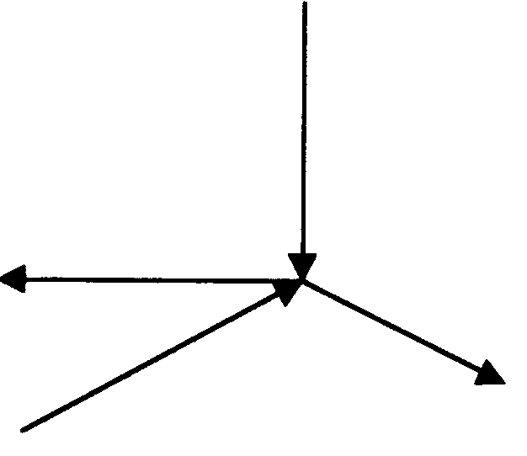 | (17)

4.4 Briefly describe the method of using the index driving plate of a lathe to cut a three start thread. | (6)

- Use the table of primary selection of fits as given in the information pamphlet and state the following:  4.5.1 The limits of size for a 19HO9–d 10 hole shaft combination  4.5.2 The type of fit | (8)  (1)  [48]

QUESTION 5

5.1 Define the law of moments. | (4)

5.2 Calculate the magnitude of the reaction at the pivot point A of the lever below. The lever is in equilibrium.

260 N  400 mm  45º  “A”  30º  F  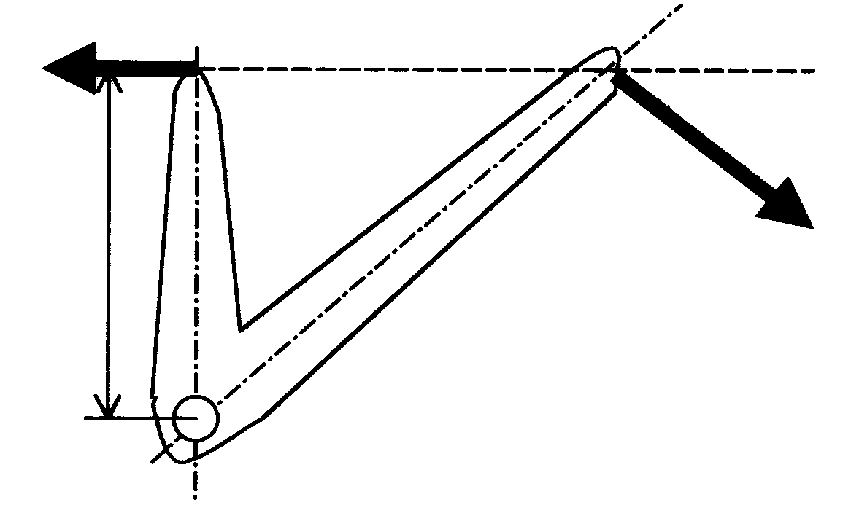 | (15)

- Define the following concepts:  5.3.1 Potential energy  5.3.2 Kinetic energy | (3)  (3)

- A body with a mass of 6 kg is projected vertically upwards at a velocity of 8 m/s. Calculate the  5.4.1 maximum height that it will reach.  - kinetic energy when it is 2 m above the ground.  - velocity when it is 2 m above the ground. | (5)  (7)  (4)

5.5 Describe briefly the origin of petroleum (crude-oil). | (4)

5.6 Which FOUR important conditions must be complied with to represent a force graphically? | (4)

QUESTION 6

6.1 Define a radian.

- The mass of a flywheel is 60 kg and the radius of inertia is 200 mm. The flywheel is accelerated from 300 r.p.m. to 1000 r.p.m. in 10 seconds.  Calculate:  6.2.1 The angular acceleration in radians per second²  - The accelerating torque  - The moment of inertia  - The increase in kinetic energy | (7)  (3)  (4)  (6)

6.3 Describe Hooke’s Law. | (4)

6.4 A stress of 20 MPa is caused in a round brass rod by a load of 40 kN. The original length of the rod is 2 metres and Young’s modulus of elasticity for brass is 90 GPa. Calculate:  - The diameter of the rod in mm  - The strain  - The change in length in mm | (7)  (3)  (4)

6.5 Name THREE occupational diseases and state the cause of each. | (6)  [48]

QUESTION 7

7.1 A body with a mass of 60 kg is placed on an inclined plane making an angle of 20º with the horizontal. The coefficient of friction is 0,4. Calculate the magnitude of the smallest force P that is needed to push the object up the incline.

P  30º  60 kg  20º  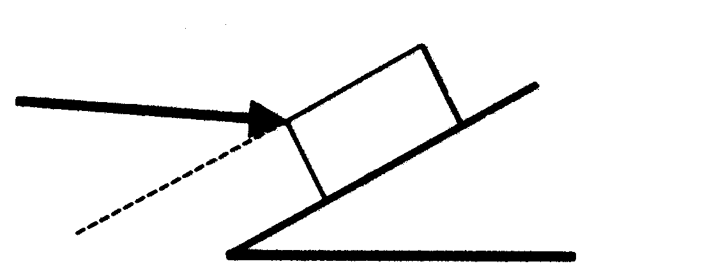 | (10)

7.2 What is kinetic frictional force? | (2)

7.3 Name the TWO groups into which organic compounds are divided. | (2)

- A spiral spring is 80 mm long. A force of 9 N is needed to stretch the spring by  10 mm. Calculate the work done when the spring is stretched from 90 mm to  120 mm. The limit of elasticity of the spring is not exceeded. | (5)

- The following components were used in the design of a hydraulic system for a car hoist:  - Electric motor  - Hydraulic gear pump  - Ventilated reservoir  - Non-adjustable pressure relief valve  - Adjustable pressure relief valve  - Shut-off valves  - Check valve (one way)  - Two-way control valve (spring loaded)  - Measuring vessel  - Single acting power cyclinder  - Pressure gauge  - Filter  Use I.S.O 1219 symbols and design a flow diagram for the hoist. | (15)

- Calculate the included angle of a M50 V screw thread with a pitch of 6 mm. The distance over the large and small measuring wires shows a total difference of  9 mm.  Given:  Maximum diameter of measuring wires 1,01P  Minimum diameter of measuring wires 0,5P | (8)

7.7 Why is control important in terms of workstream planning? | (6)  [48]

TOTAL: | 300

