GAUTENG DEPARTMENT OF EDUCATION
SENIOR CERTIFICATE EXAMINATION

TECHNIKA (MECHANICAL) HG

TIME: 3 hours

MARKS: 300

REQUIREMENTS:

- Calculator
- Drawing instruments

INSTRUCTIONS:

- Question 1 is COMPULSORY.
- Answer Question 1 and any FIVE other questions.
- Answer Question 1 on the answer sheet on the inside cover of your answer book.
- Information pages are provided (pages 11-14)

QUESTION 1
COMPULSORY

Choose the correct answer out of each of the following and draw a cross (X) over the appropriate letter next to the respective question number (1.1 to 1.10) on the answer sheet. The answer sheet is on the inside cover of your answer book.

  - The following metals are part of the cubic space-lattice arrangement.
Which one does not fit?

- Chrome
- Iron
- Tungsten
- Copper
- Vanadium

  - An object is suspended from a spring balance in a lift. The balance reading is
100 N when the lift is at rest. If the balance reads 110 N, the lift will move

- downwards at a constant speed.
- downwards at a constant acceleration.
- downwards and will increase speed.
- upwards and will decrease speed.
- upwards at a constant acceleration.

  - What is the correct name of the following hydrocarbon compound in the alkane series: C₇H₁₆?

- Pentane
- Octane
- Hexane
- Butane
- Heptane

  - The power unit in a hydraulic system consists of:

- Hydraulic gearpump, shut off valve, and pressure gauge
- Reservoir, electric motor, hydraulic gearpump
- Pressure relief valve, filter, hydraulic gearpump
- Hydraulic gearpump, power cyclinder, one way valve
- Shut off valve, hydraulic gearpump, electric motor

  - The term dragging refers to:

- The clutch’s inability to engage smoothly.
- A clutch’s ability to disengage fully.
- The inability of a clutch to engage fully.
- The inability of the clutch to engage gradually.
- The inability of a clutch to exert pressure.

  - 180 r/min converted to m/s, if the wheel radius is 80 cm, is equal to:

- 904,778 m/s
- 7,53 m/s
- 15,07 m/s
- 45,84 m/s
- 2,4 m/s

  - The table of primary selection of fits is used to calculate the limits for a
35H11-c11-hole shaft combination. What will the allowance be for this type of fit?

- 0,16
- 0,28
- 0,22
- 0,72
- 0,44

  - If the beam in Figure 1 is in equilibrium, how far must the 6 N force be from the pivot point A?
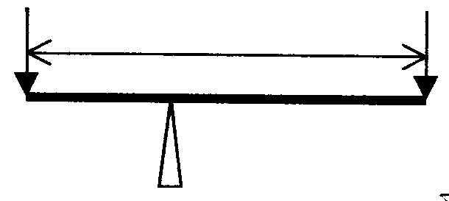
6 N
15 N
A

Figure 1
4,2 m

- 1,8 m
- 3,0 m
- 3,6 m
- 3,8 m
- 2,4 m

  - The structure which is formed by the breakdown of a solid Austenite solution is called:

- Ferrite
- Cementite
- Pearlite
- Austenite
- Austenite and Ferrite

- If a girl on a bicycle doubles her speed, her kinetic energy will  - be halved.  - remain constant.  - double.  - increase four fold.  - None of the above. | 10x2(20)

1.11 Describe the concept ergonomics. | (4)

1.12 Define Newton’s law of inertia. | (3)

1.13 A pull bar must carry a load of 150 kN. Calculate the width of the pull bar if a rivet hole of 22,21 mm diameter is drilled on the centre line. The thickness of the pull bar is 12,8 mm and the working stress is 78,3 MPa. | (8)

1.14 Name TWO advantages of belt drives compared to gear drives. | (2)

1.15 Draw a typical pressure-volume diagram for a four-stroke compression-ignition engine, to illustrate the pressure-volume relationship for a complete cycle. | (8)

1.16 Define isotermal compression of gases. | (4)

1.17 State THREE properties of an ideal gas. | (3)

1.18 What is the purpose of a key in a transmission system? | (2)

1.19 Briefly describe the combustion process of petrol in the presence of sufficient oxygen. State the products of combustion. | (6)  [60]

QUESTION 2

2.1 Why are the services of a social worker very important? | (2)

2.2 Name FOUR ways in which you will make the employees of a business aware of the increasing Aids crisis in the country. | (4)

2.3 In the diagram in Figure 2 a schematic drawing shows the outlay of a simple hydraulic system. Name each of the numbered components.

M  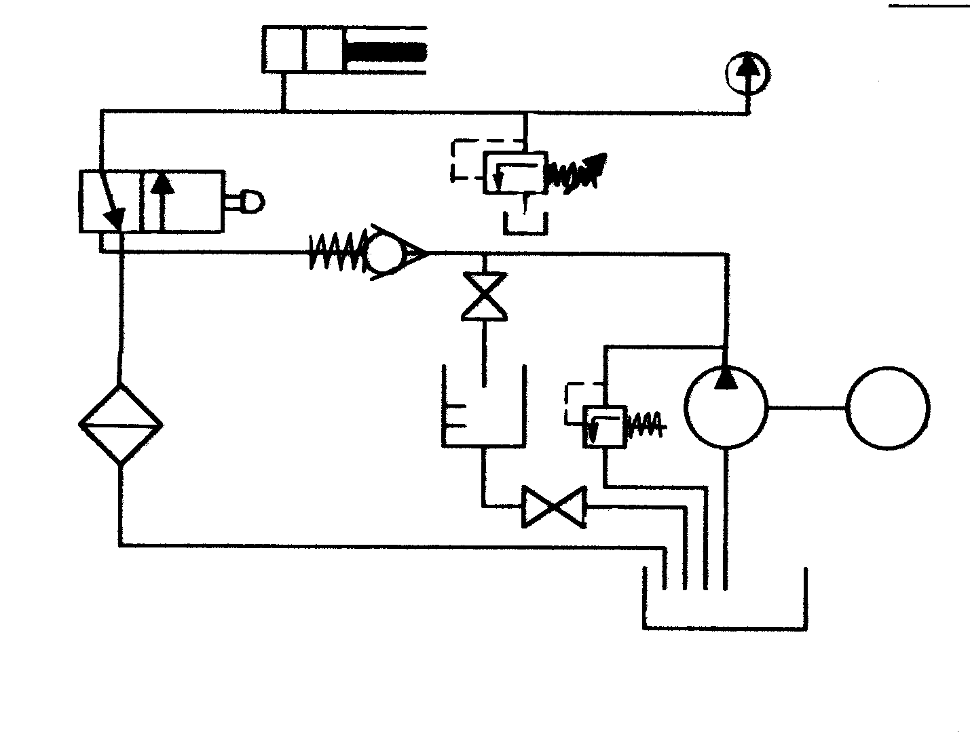  2.3.2  Figure 2  2.3.9  2.3.10  2.3.7  2.3.8  2.3.6  2.3.5  2.3.4  2.3.3  2.3.1 | (10)

- In Figure 3 a lightweight string is passed over a frictionless pulley and is attached to two masses, one of 6 kg and one of 7 kg. Calculate the  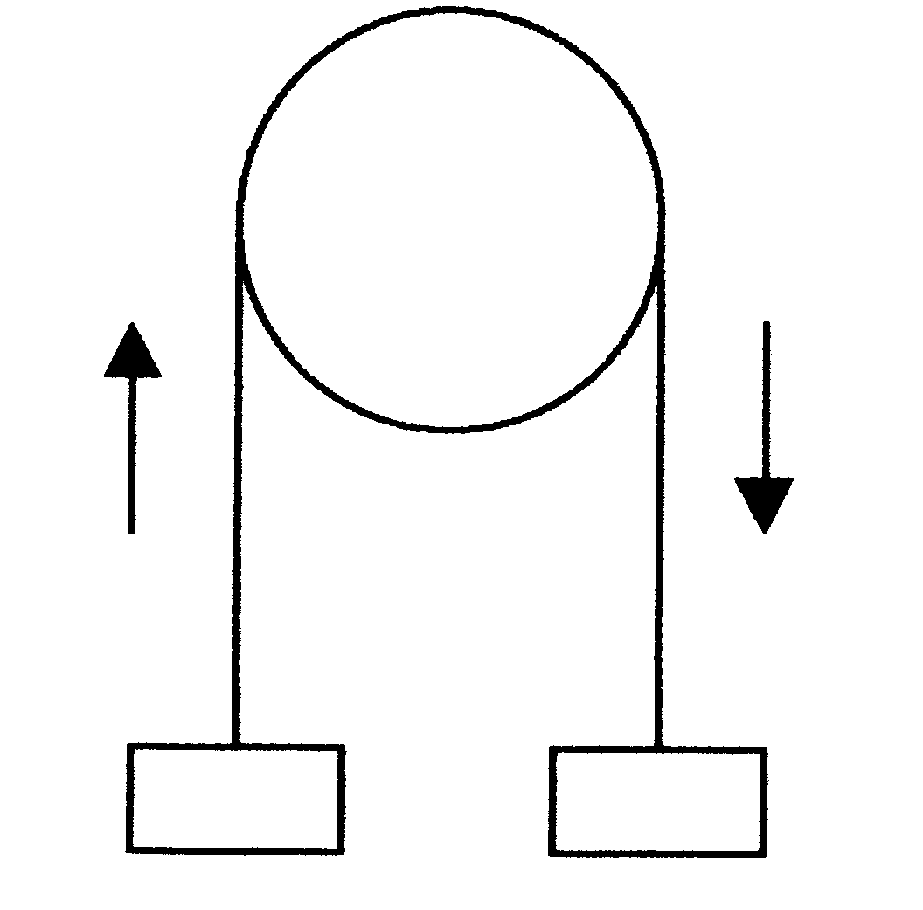  +  a  a  6 kg  7 kg  Figure 3  2.4.1 acceleration of the masses.  - force in the string. | (8)

2.5 Describe the operation of a helical-spring single-plate dry clutch during disengagement of the input shaft from the output shaft. | (8)

2.6 Define the following concepts:  - The mean effective pressure on the piston of an internal combustion engine  - Indicated power. | (4)  (4)

2.7 Name FOUR occupational diseases, and state the cause of each. | (8)  [48]

QUESTION 3

3.1 Describe fully the colour penetrating test as it is carried out on welded joints. | (10)

3.2 Describe the concept thermodynamics as a ramification of physics. | (2)

3.3 State FOUR reasons why a high-quality finish on components is of utmost importance. | (4)

- Briefly describe the following occurrences according to the kinetic molecular theory of gases:  3.4.1 The increase in pressure when the temperature increases  3.4.2 The compressibility of gases. | (5)  (4)

- State the carbon-content percentage, the properties and the temperatures at which the grain structures of the following are formed:  3.5.1 Pearlite  - Ferrite  - Austenite | (3)  (3)  (3)

3.6 What is the difference between the angle of rest and the angle of friction? | (4)

3.7 The layout of a V-belt transmission for a lathe is shown in Figure 4. The 200 mm and 400 mm diameter pulleys are keyed to the same shaft. Determine the speed of the lathe spindle in r/min if the motor spindle rotates at a speed of 2000 r/min.
Da = 200 mm
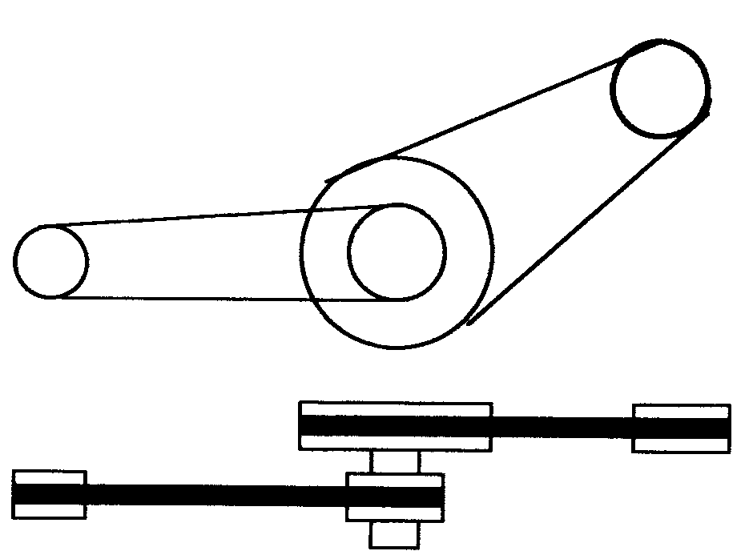  Dd = 50 mm  LATHE SPINDLE  COUNTER SHAFT  MOTOR SPINDLE  Dc=200 mm  Db =400 mm  Na = 2000 r/min  B  +  +  A  +  D  D  C  Figure 4  C | (10)  [48]

QUESTION 4

- Sixty seven (67) teeth must be milled onto a spur gear. The dividing head ratio is 40:1.  4.1.1 Calculate the indexing required. (Choose 70 divisions.)  - Calculate the change wheels required.  - Determine the direction of rotation of the index plate.  - Draw a neat sketch to indicate the position and arrangement of the gear train required. | (2)  (5)  (2)  (4)

4.2 The diagram in Figure 5 shows four forces acting at a point. Calculate the magnitude and direction of the equilibrium force.

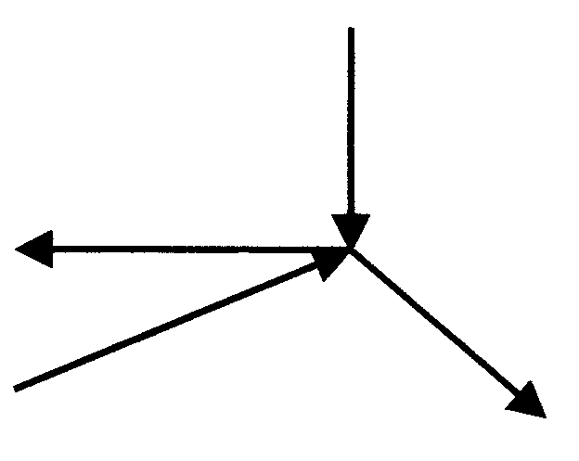  90 N  90º  30º  120º  70 N  50 N  100 N  Figure 5 | (15)

4.3 Draw a schematic representation of a Prony brake which is used to determine the brake power of an engine. Label all components. | (8)

4.4 Name TWO types of universal joints in general use. | (2)

- Briefly describe what happens to the structure of steel at the following halting points of the carbon iron equilibrium diagram:  4.5.1 AC₁  - AC₂  - AC₃ | (5)  (2)  (3)  [48]

QUESTION 5

- A rope is used to hoist a lift with a mass of 400 kg vertically for a distance of 80 m. The mass of the rope is 2 kg/m. Calculate:  5.1.1 The average tensile force in the rope  - The work done  - The power required if it takes three minutes to hoist the lift | (4)  (3)  (2)

5.2 The two-wire method of screw-thread measurement is used to test the angle of an M50 x 5, I.S.O screw thread. The measurement across the two sets of wires shows a difference of 7,03 mm. The diameter of the two sets of wires are 1,01P and 0,505 P respectively. Calculate the size of the screw-thread angle. | (7)

5.3 Define Boyle’s Law. | (5)

5.4 5.4.1 Calculate the width, the thickness and the length of a parallel key suitable for a 48 mm diameter shaft.  5.4.2 Draw the key and clearly indicate all measurements. | (6)  (4)

5.5 Calculate the magnitude and direction of the reaction at pivot O of the lever in Figure 6. The lever is in equilibrium.
5 kN
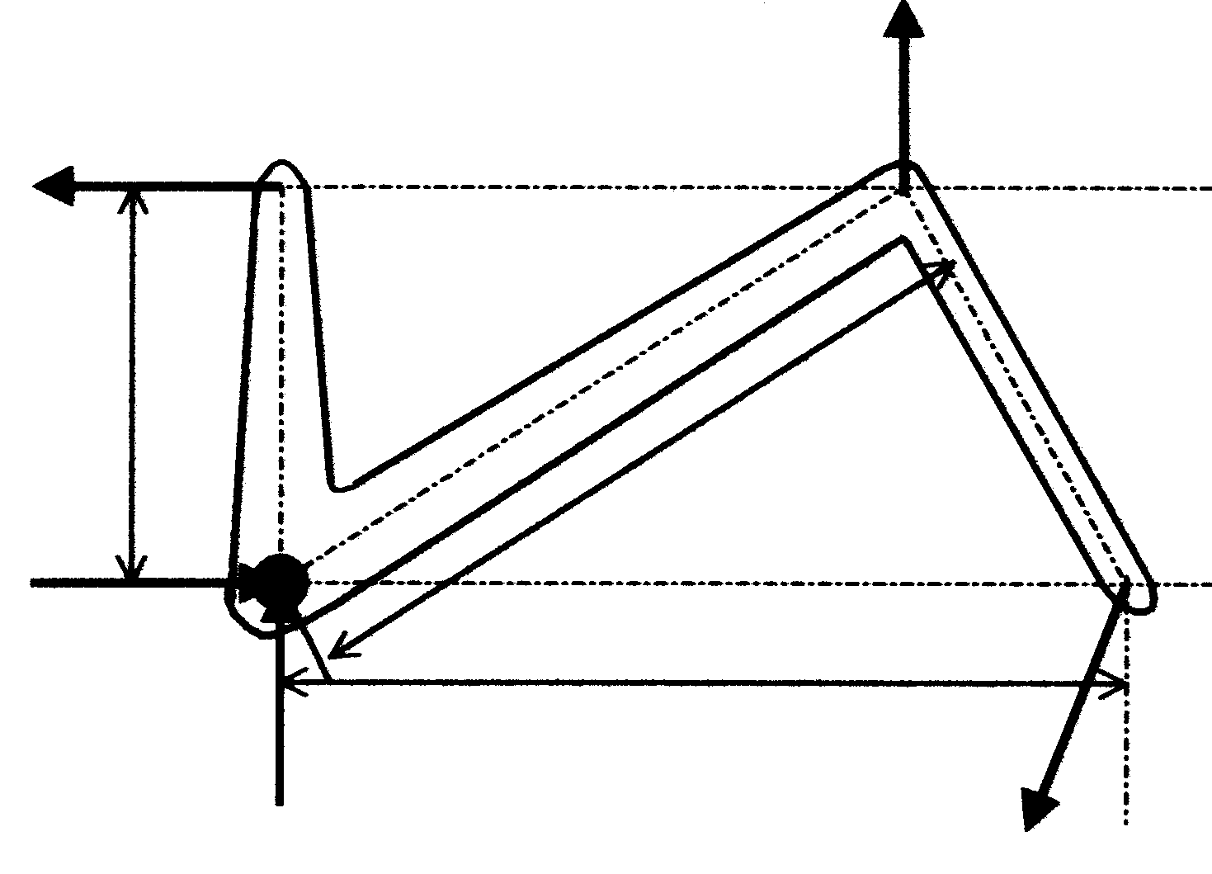  60º  b  a  60º  X  50 kN  P  Y  “o”  200 mm  Figure 6 | (18)

5.6 What is the trade name for etyn? | (1)  [48]

QUESTION 6

- Sketch an iron carbon equilibrium diagram for types of steel. Indicate the temperature between 200ºC and 1000ºC and the carbon content between 0% and 1,4%. Label all components of the diagram. | (12)

6.2 Define adiabatic compression of a gas. | (5)

6.3 What THREE conditions are important before work can be done? | (3)

- A mild steel bush, 80 mm in length with an inner diameter of 30 mm and an outer diameter of 40 mm, is used in a hydraulic press to press out bearings. The press exerts a force of 500 N upon the bush.  6.4.1 State the type of stress in the bush material.  - Calculate the safe working stress when the ultimate stress for mild steel is given as 500 MPa. A safety factor of 4 was used when the bush was designed.  - Calculate the stress in the bush material. State your answer in mega magnitude.  - Calculate how much the bush will shorten as a result of the load.  Given E = 90 x 10³ MPa. | (1)  (3)  (6)  (5)

6.5 A hammer is used to drive a nail into a wooden block. It strikes the nail with a velocity of 7 m/s and drives the nail 20 mm into the block. Calculate the resistance of the block if the mass of the hammer is 2 kg. | (5)

6.6 Define a radian. | (4)

6.7 Explain how gear reduction is obtained by means of a single epicyclic gear train. | (4)  [48]

QUESTION 7

7.1 A body with a mass of 60 kg is placed on an inclined plane making an angle of 20º with the horizontal. The coefficient of friction is 0,4. A force P, at an angle of 30º to
the plane, is required to pull the body down the plain. Calculate the

- component of P parallel to the plane.  - gravitational component parallel to the plane.  - gravitational component perpendicular to the plane.  - magnitude of P. | (2)  (2)  (2)  (8)

7.2 The following data is provided for a six cylinder four stroke internal combustion engine:

Cylinder diameter 90 mm
Stroke 110 mm
Mean effective pressure on piston 928 kPa
Revolutions per minute 3500 rpm
Effective brake arm length 1200 mm
Reading on scale 16 kg

Calculate the following:

- The indicated power in kW  - The work done during one power stroke if the piston moves from the TDC to the BDC  - The brake power in kW  - The mechanical efficiency of the engine | (7)  (3)  (4)  (3)

7.3 State THREE basic crystal structures of steel. | (3)

7.4 Draw a graph of the typical stress-strain condition which is obtained when mild steel is subjected to a destructive tensile test. Label all the components of the graph. | (10)

7.5 Define power. | (2)

7.6 Which FOUR important conditions must be complied with to represent a force graphically? | (4)  [48]

TOTAL: | 300

