GAUTENG DEPARTMENT OF EDUCATION

SENIOR CERTIFICATE EXAMINATION

TECHNIKA (ELECTRONICS) SG

TIME: 3 hours

MARKS: 200

INSTRUCTIONS:

- Answer ALL the questions.

- Sketches and diagrams must be large, neat and labelled.

- All calculations must be shown.

- Answers must be clearly numbered.

- An approved pocket calculator may be used.

QUESTION 1  ELECTRIC CURRENT THEORY  - The following three components are connected in series: R = 20Ω, L = 0, 1H and C = 15μF. The supply voltage is 100V/100Hz.  Calculate the following:  - The voltage drop across each component  - The total current through the circuit  - The phase angle (Draw a labelled phasor diagram.)  - Determine the minimum and maximum values of a variable capacitor connected in parallel with a 10μH coil that resonates between a frequency of 500kHz and 1Mhz.  1.3 A 0,1mH coil and a resistor of 8Ω are connected across an alternating voltage with a frequency of 10kHz. Calculate the Q-factor of the circuit. | (18)  (3)  (8)  (7)  (6)  [42]

QUESTION 2  SEMICONDUCTOR DEVICES  - Identify the following components in Figure 1.  - T1  - D1  - R1  - R2  - L1  2.1.6 C1 | (6)

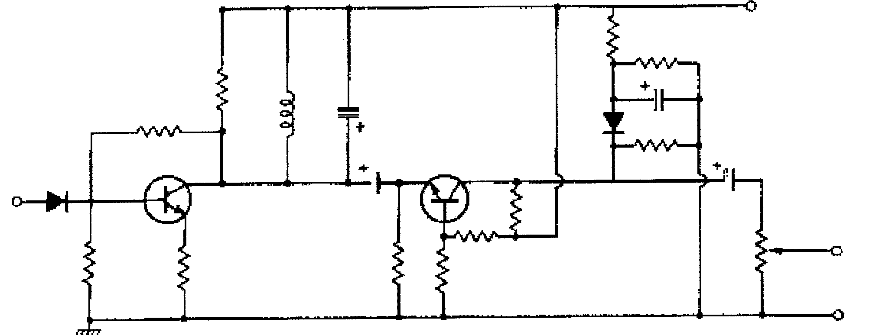
470Ω
R2
L1
10µF
100K
1N4001
D1
24K
T2
91Ω
1K
4K7
10K
5K5
T1
10µF
8µF
75K
C1
7K2
125V
R1
Output
Input
250m H
1N4002
30K

Figure 1

- Name FOUR requirements necessary for an SCR to function correctly.  - Once conducting, an SCR continues to operate from a 12V/DC supply regardless of the voltage on the gate. The SCR must switch on a light. Draw a labelled circuit diagram of such a device, and show how one can switch off the SCR.  - Write down the standard colour code you would use to determine the value and tolerance of any resistor. | (8)  (8)  (12)  [34]

QUESTION 3  AMPLIFIERS  - Draw a labelled circuit diagram of a symmetrical push-pull pair-class AB amplifier.  - Make use of an NPN transistor, capacitors and resistors and explain with the aid of a circuit diagram how an inverting amplifier amplifies an input signal. Draw the input and output signals.  - Make use of a graph and calculations to determine the load line of a common emitter amplifier using a 1 kΩ and 5kΩ load resistor respectively. The supply voltage is a 100V/DC. (The circuit has no emitter resistor.)  - Draw a labelled circuit diagram of an operational summing amplifier.  - What would the summing amplifier most commonly be used for? | (10)  (8)  (15)  (8)  (1)  [42]

QUESTION 4  SWITCHING AND CONTROL CIRCUITS  - Draw a labelled circuit diagram of  - a series voltage regulator.  - a shunt voltage regulator.  - Make use of transistors and draw a labelled circuit diagram of an astable multivibrator. | (12)  (10)

4.3 What is the circuit diagram in Figure 2 called? | (1)

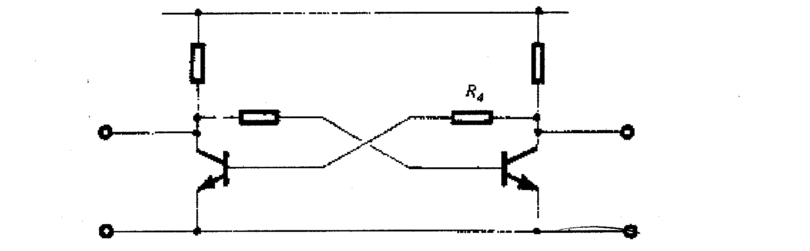
+v_{CC}
R₄
R₂
output B
output A
R₁
Y₃
R₂
T₂
Figure 2

4.4 Suppose T1 in Figure 2 is on after the circuit has been switched on, explain how T1 reacted first. | (4)  [27]

QUESTION 5  OSCILLATORS  5.1 Draw a labelled circuit diagram of a Hartley oscillator. | (12)  [12]

QUESTION 6  COMPUTER PRINCIPLES  - Sketch the following gates and complete a truth table for each.  - NAND  - NOR  - OR | (12)  [12]

QUESTION 7  INFORMATION TRANSFER  7.1 With the aid of a labelled block diagram explain the construction of a fibre optic telephone communication system. | (10)  [10]

QUESTION 8  MEASURING INSTRUMENTS  - Determine the RMS voltage and the frequency of the wave shown in Figure 3 when the Volt/div switch is set on 1 Volt/div and the sec/div switch is set on 5ms/div. | (10)
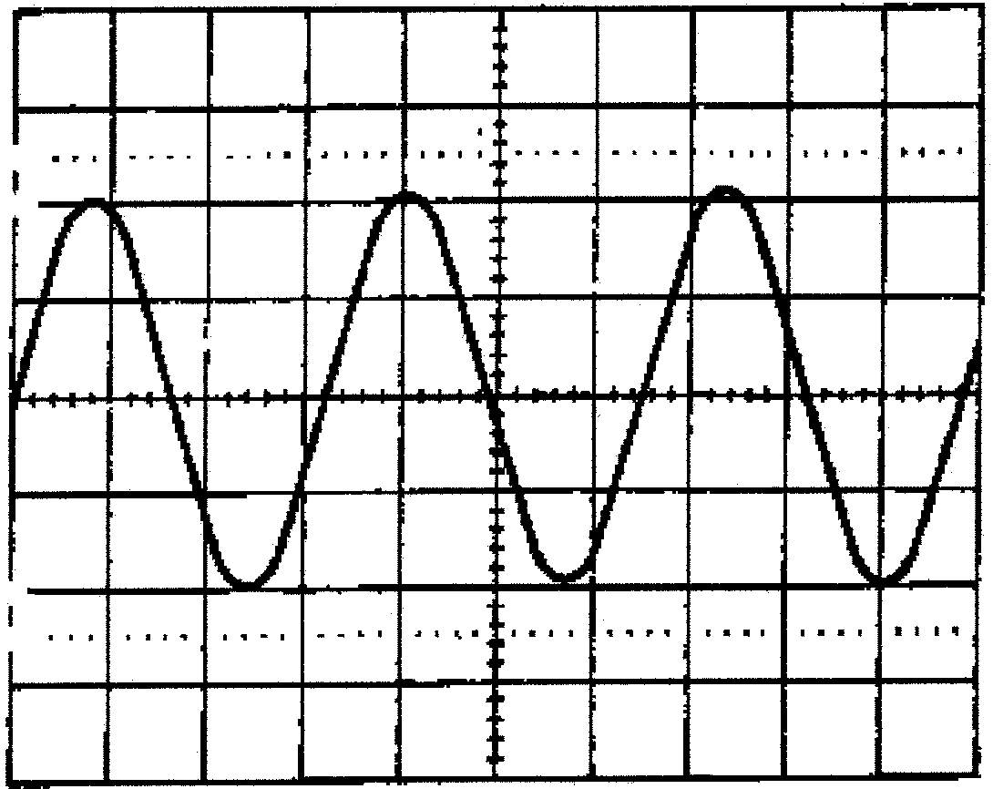
100
90
10
0%
Figure 3 | [10]

QUESTION 9  SAFETY PRECAUTIONS  - Name FOUR unsafe acts in a workshop.  - Explain how you would perform mouth to mouth resuscitation in order to save the life of a person who has been exposed to an electrical shock in the workshop and has stopped breathing.  - Say whether the following statements are TRUE or FALSE.  - By using the same tools as an HIV positive person, one can easily contract this virus.  - One never has to check electrical cords of electrical hand equipment.  TOTAL: | (4)  (5)  (1)  (1)  [11]  200

