GAUTENG DEPARTMENT OF EDUCATION
SENIOR CERTIFICATE EXAMINATION

TECHNIKA (ELECTRONICS) HG

TIME: 3 hours

MARKS: 300

INSTRUCTIONS:

- Answer ALL the questions.
- Sketches and diagrams must be large, neat and labelled.
- All calculations must be shown.
- Answers must be clearly numbered.
- A formula sheet (pages 10 – 13) is provided at the end of the paper.

QUESTION 1

ELECTRIC CURRENT THEORY

1.1 A parallel circuit consists of a coil with an inductance of 9 µH, a capacitor with a capacitance of 100 pF and a resistor with a resistance of 2 kΩ. The circuit is supplied from a 100 Volt/5 MHz supply.

Calculate:

- The current in each branch  - The total current in the circuit  - The phase angle and sketch a fully labelled phasor diagram representing the currents.  - The impedance of the circuit | (15)  (3)  (9)  (3)

1.2 Briefly explain the term impedance matching and name ONE application thereof. | (4)

1.3 Calculate the turns ratio required for an impedance matching transformer to satisfy the requirements of a loudspeaker with an 8Ω voice coil. The transistor needs a 500Ω load for maximum power transfer. | (4)  [38]

QUESTION 2

SEMICONDUCTOR DEVICES

2.1 Identify the following electronic components with reference to the electronic circuit diagram in Figure 2.1. Example: R225 is a 3K3Ω resistor.

- T113  - R235  - D107  - L122  - C188 | (2)  (3)  (1)  (2)  (2)

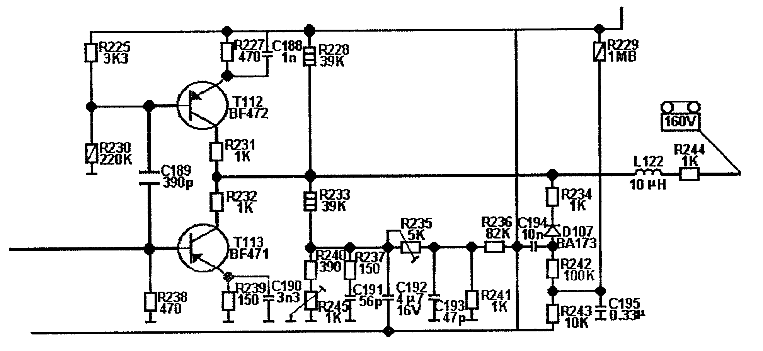

Blue

Figure 2.1

2.2 The field effect transistor (FET) Has been used since 1952 as a semiconductor device. Explain, by means of neatly labelled sketches and brief descriptions, the basic construction and functional operation of a field effect transistor (FET). | (12)

2.3 Name FOUR precautions that must be taken into account when handling CMOS devices. | (4)

2.4 To identify the pins of integrated circuits (IC), they are each numbered from number one upwards. Sketch the integrated circuit of Figure 2.2 in your answer book and number the pins.

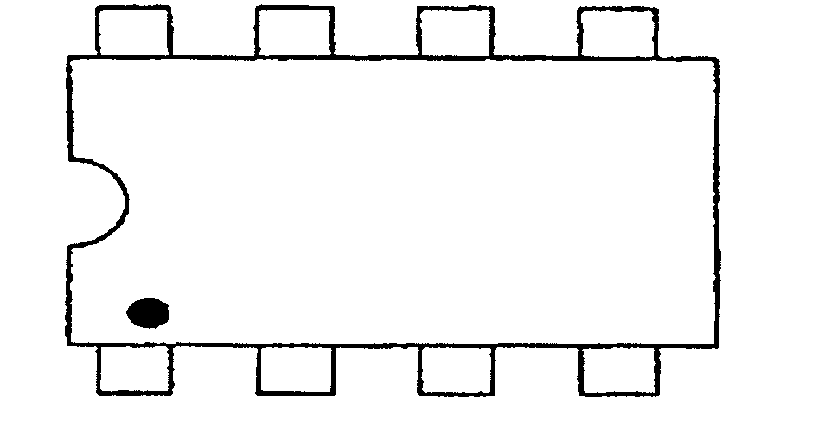

Figure 2.2  The dual in line package | (2)  [28]

QUESTION 3

AMPLIFIERS

3.1 Determine by means of calculations and a neatly labelled graph the load line of the circuit shown in Figure 3.1. | (9)

Calculate:

- The base current (Ib)  - The collector current (Ic) if the gain (ß) of the transistor is given as 120 | (4)  (4)

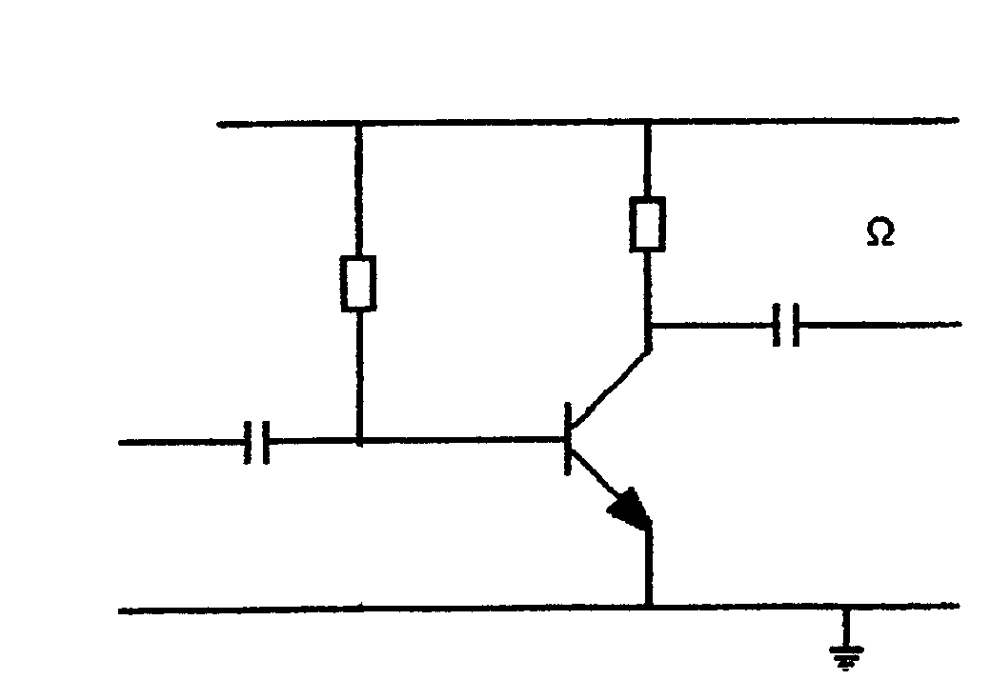
V_{cc}=12 Volt
R_{c}=800 Ω
120 KΩ
R_{b}1
C₂
C₁

Figure 3.1

3.2 A 741 operational amplifier is connected in the inventing mode. It amplifies a signal of 1mV to 100mV. The input impedance is 1kΩ.

- Draw a neatly labelled diagram of the circuit.  - Determine the value of the feedback resistor by means of calculations. | (10)  (7)  [34]

QUESTION 4

SWITCHING AND CONTROL CIRCUITS

4.1 Draw a neatly labelled circuit diagram of a fixed voltage series regulator with the following values:

Input voltage = 20 Volt  Output voltage = 10 Volt  Power of the zener diode = 400 mWatt | (8)

4.1.1 Calculate the value of the resistor (Rs) in series with the zener diode. | (13)

4.2 Figure 4.1 illustrates the electronic circuit of a brushless fan commonly found in computers. The motors within these fans generally consist of an outer revolving armature containing permanent magnets surrounding a static inner coil assembly. The coils are switched sequentially to produce the rotation by an internal electronic circuit as shown in Figure 4.1. Explain the working principle of this circuit. | (12)

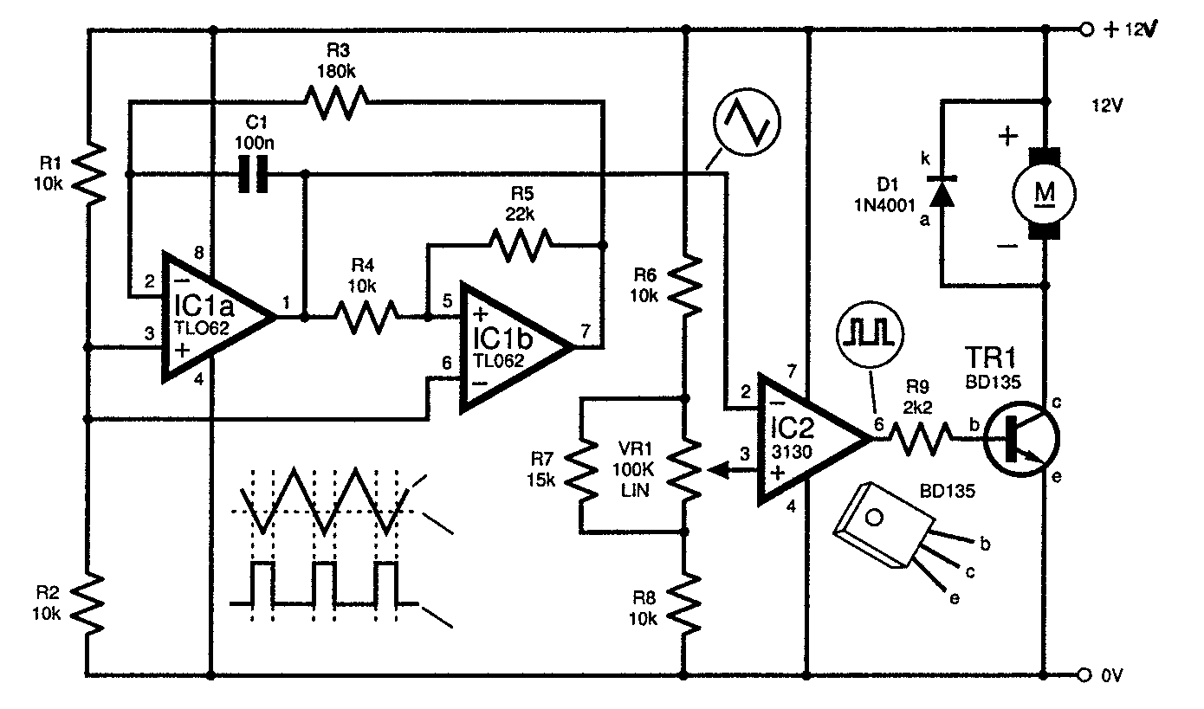

Figure 4.1
Speed controlled circuit diagram for a brushless fan

4.3 Clippers and clampers are diode wave shaping circuits transmitting parts of waveforms and suppressing others to a predetermined value. Find the output voltage wave shape for the inputs shown in Figure 4.2. (Only sketch the output voltage wave shape in your answer book.)
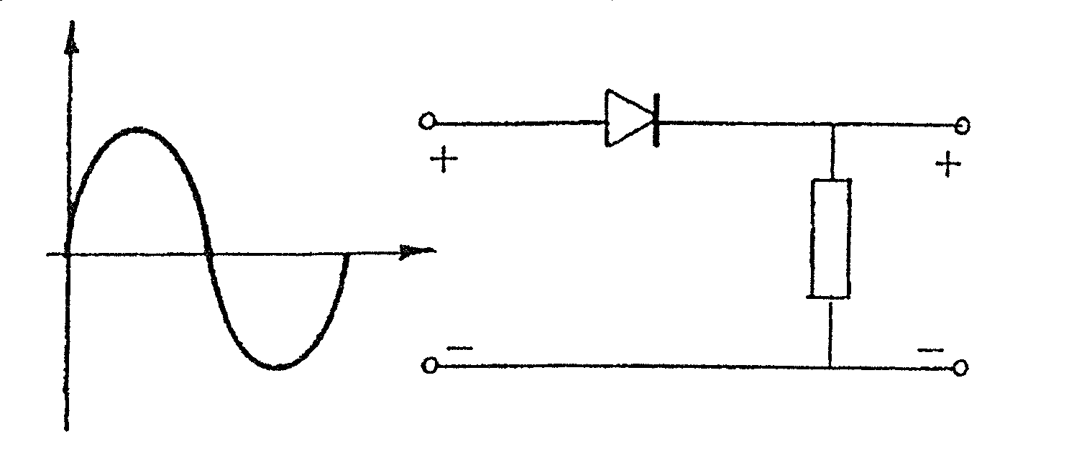
D
R
V_{in}
V_{out}
O
(a)  V | (2)

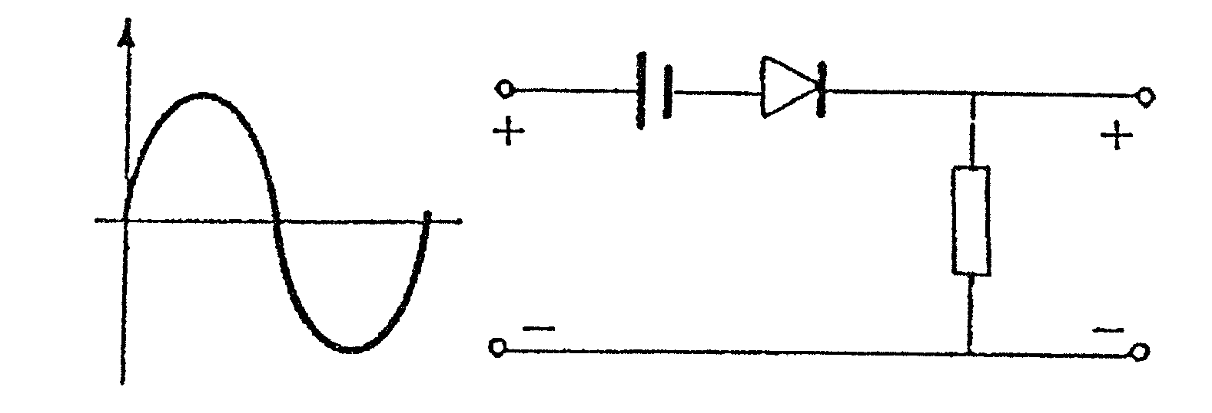  (b)  D  V  O  6 V  R  V_{out}  V_{in} | (2)

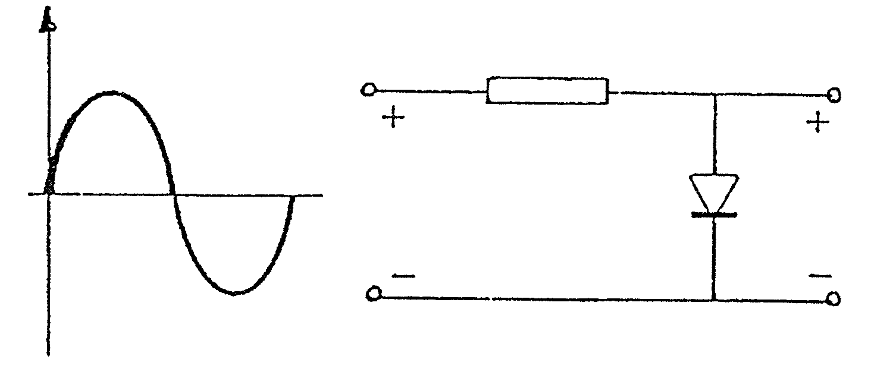  (c)  V_{out}  V_{in}  R  D  V  O | (2)

Figure 4.2
Wave shaping circuits

4.4 Explain the working principle of ANY electronic experiment or model that you have built/designed this year. Take note that your explanation should include a neatly labelled circuit diagram or block diagram with a brief description. All wave forms, where applicable, should be included. | (11)  [50]

QUESTION 5

OSCILLATORS

5.1 Explain what an electronic oscillator circuit is. | (3)

5.2 Explain with the aid of a neatly labelled characteristic curve and a brief description of the characteristic curve, the operating principle of a unijunction transistor (UJT). | (15)  [18]

QUESTION 6

COMPUTER PRINCIPLES

6.1 Design a NOR gate network for the following Boolean expression (A, B, C and D are direct gate inputs.):

F =($\overset{−}{A}$ + B)(C +$\overset{−}{D}$) | (7)

6.2 Simplify the following Boolean expression:

F = [A$\overset{−}{B}$ (C+ BD) + $\overset{−}{A}$$\overset{−}{B}$] C | (7)

6.3 A hospital requests you to design an electronic circuit to monitor the condition of a patient in the I.C.U. An alarm must sound when the following conditions occur:

- The blood pressure of a person is not normal or
- The temperature and blood pressure are not normal or
- The temperature and pulse are not normal

6.3.1 Design the logic circuit to satisfy the request. | (15)

6.4 Refer to Figure 6.1 and draw a truth table that will indicate when LED 1 and LED 2 are switched on. Note that the symbol for the logic gates is the American equivalent for a NOR gate. | (9)

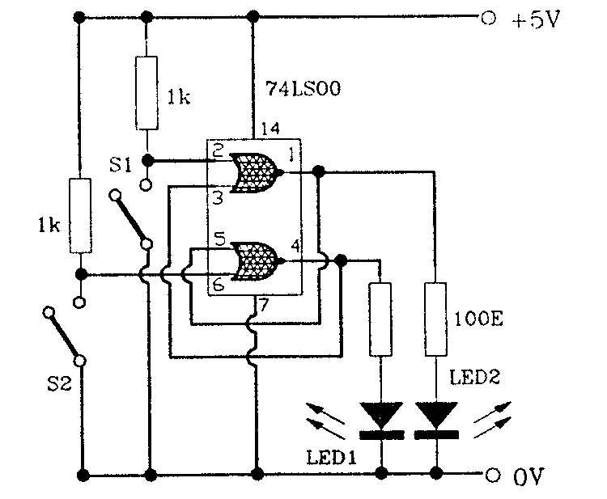

Figure 6.1
Electronic circuit

6.4.1 Name the circuit diagram of Figure 6.1. | (1)

6.5 Illustrate by means of a neatly labelled block diagram of a full adder circuit how the following two binary numbers are added:

1001  + 0011  ____ | (16)  [55]

QUESTION 7

INFORMATION TRANSFER

7.1 Fibre optic cables are manufactured in different sizes and construction. Describe the basic construction of a fibre optic cable by means of a neatly labelled sketch. | (7)

7.2 Explain the importance of interfacing (joining) between fibre and cable ends. | (6)

7.3 Discuss the advantages of using fibre optic cables. | (5)

7.4 Explain by means of a neatly labelled block diagram the working principle of a typical fibre optic communication system. | (13)

7.5 Explain what a modem is and how it is used with reference to computers. | (5)  [36]

QUESTION 8

MEASURING INSTRUMENTS

8.1 Explain the working principle of a digital multi-meter by means of a neatly, labelled block diagram. | (6)

8.2 List FIVE advantages a digital multi-meter has compared to an analogue meter. | (5)

8.3 Determine the reading of the multi-meter for the switch illustrated in Figure 8.1. | (2)

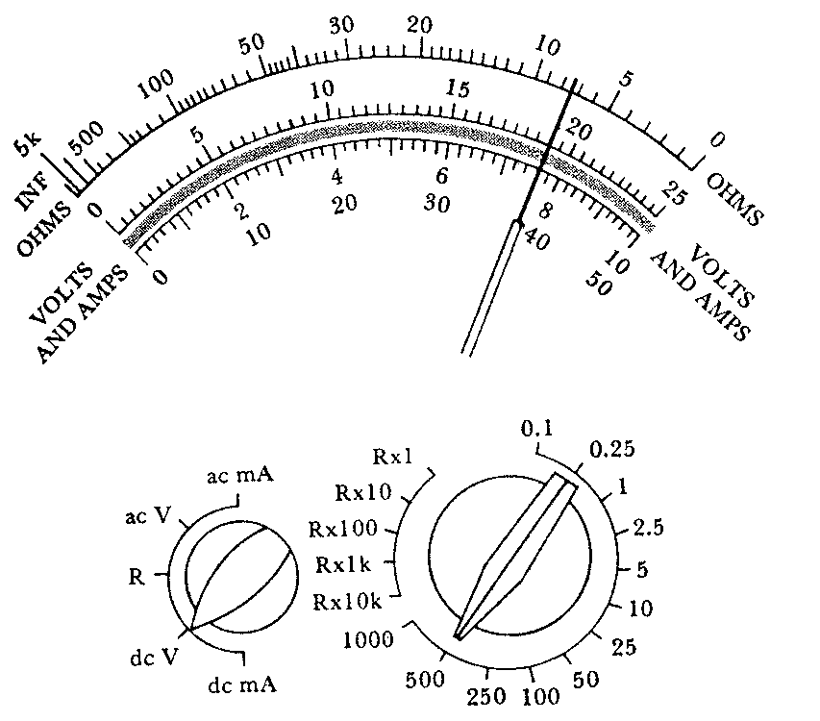

Figure 8.1
Multi-meter reading

8.4 A sinusoidal waveform is observed on the screen of an oscilloscope as having a peak amplitude of 3 cm (divisions). If the CRO vertical sensitivity setting is set at 10 V/cm (divisions) and a “time ten” (10) probe is used, calculate the RMS value of the voltage waveform. | (6)

8.5 Explain the purpose of the X and Y deflection plates of an oscilloscope. | (6)  [25]

QUESTION 9

SAFETY PRECAUTIONS

9.1 Name FIVE safety checks that should be done before using portable electrical equipment from a socket outlet. | (5)

9.2 Name FIVE precautions that should be taken into account when handling a multimeter. | (5)

9.3 Explain why foam fire extinguishers should not be used on electrical fires. | (2)

9.4 Explain how Aids can be spread from one person to another and explain how you would protect yourself against the possible infection of HIV. | (4)  [16]

TOTAL: | 300

