GAUTENG DEPARTMENT OF EDUCATION

SENIOR CERTIFICATE EXAMINATION

TECHNIKA (ELECTRONICS) HG

TIME: 3 hours

MARKS: 300

INSTRUCTIONS:

- Answer ALL the questions.
- Sketches and diagrams must be large, neat and labelled.
- All calculations must be shown.
- Answers must be clearly numbered.
- An approved pocket calculator may be used.
- A Formulae Sheet is attached (pages 10 – 12).

QUESTION 1  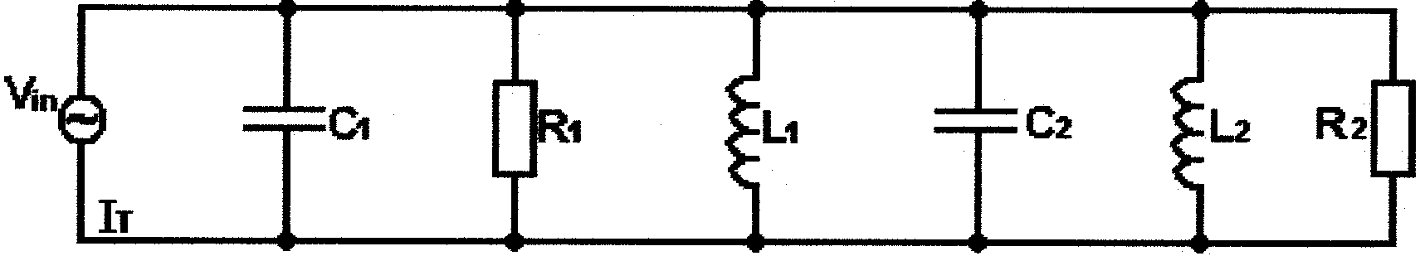  250V  ELECTRIC CURRENT THEORY  - The impedance has a significant effect on the performance of an electronic circuit. In the rejecter filter circuit of Figure 1.1, assume:  X_{C1} = 200 k Ω, R₁ = 15 k Ω, X_{L1} = 50 k Ω,  X_{C2} = 150 k Ω, R₂ = 27 k Ω, X_{L2} = 33 k Ω,  Figure 1.1 Multi-element parallel RLC- circuit  1.1.1 Determine the total impedance and phase angle of the circuit in  Figure 1.1. Sketch a fully labelled phasor diagram representing the currents. | (38)

1.2 Explain the term impedance matching. | (3)

1.3 A transistor using transformer coupling, drives a 8Ω loudspeaker. If the transformer has a primary of 100 turns and a secondary of 10 turns, calculate the actual impedance as “seen” by the transistor. | (4)  [45]

QUESTION 2  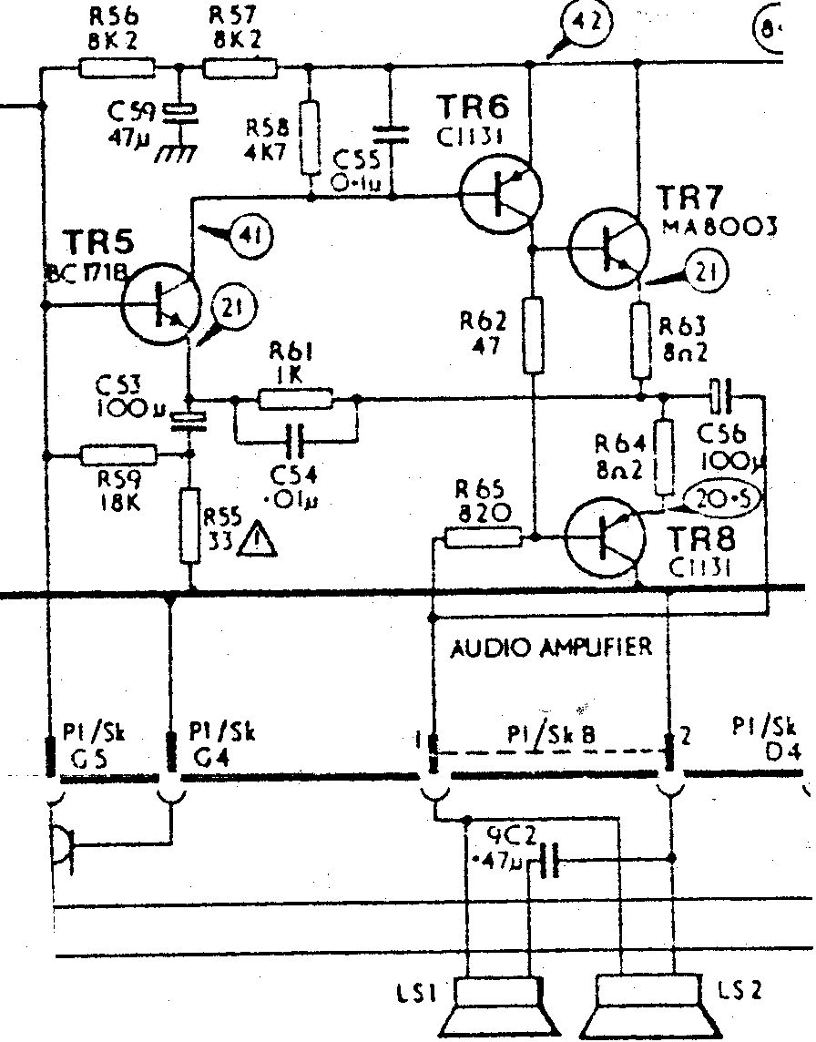  SEMICONDUCTOR SERVICES  - Identify the following electronic components with reference to the circuit diagram in Figure 2.1. (For example: R56 is a 8,2 kilo-ohm resistor)  - TR6  - TR7  - C59  - R58  - LS1  Figure 2.1 Electronic circuit diagram | (2)  (2)  (3)  (2)  (1)

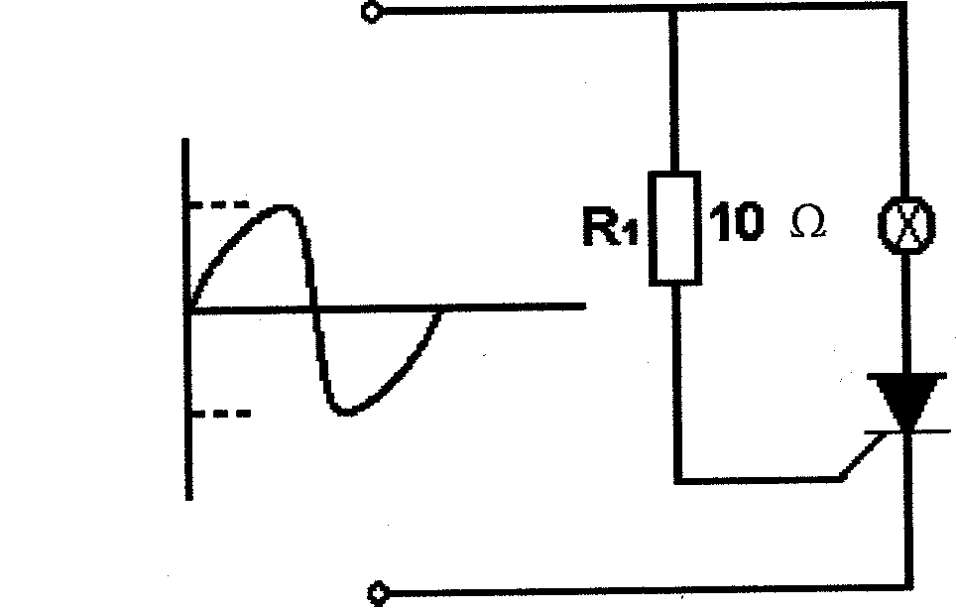  - Refer to the circuit diagram in Figure 2.2 and sketch the waveforms that can be observed across the load (lamp) and the SCR.  12 volt  12 volt  INPUT  Figure 2.2 Circuit controlling the brightness of a lamp | (6)

- Figure 2.3 illustrates a unijunction transistor (UJT) connected as a relaxation oscillator. Explain the working principle of this circuit.  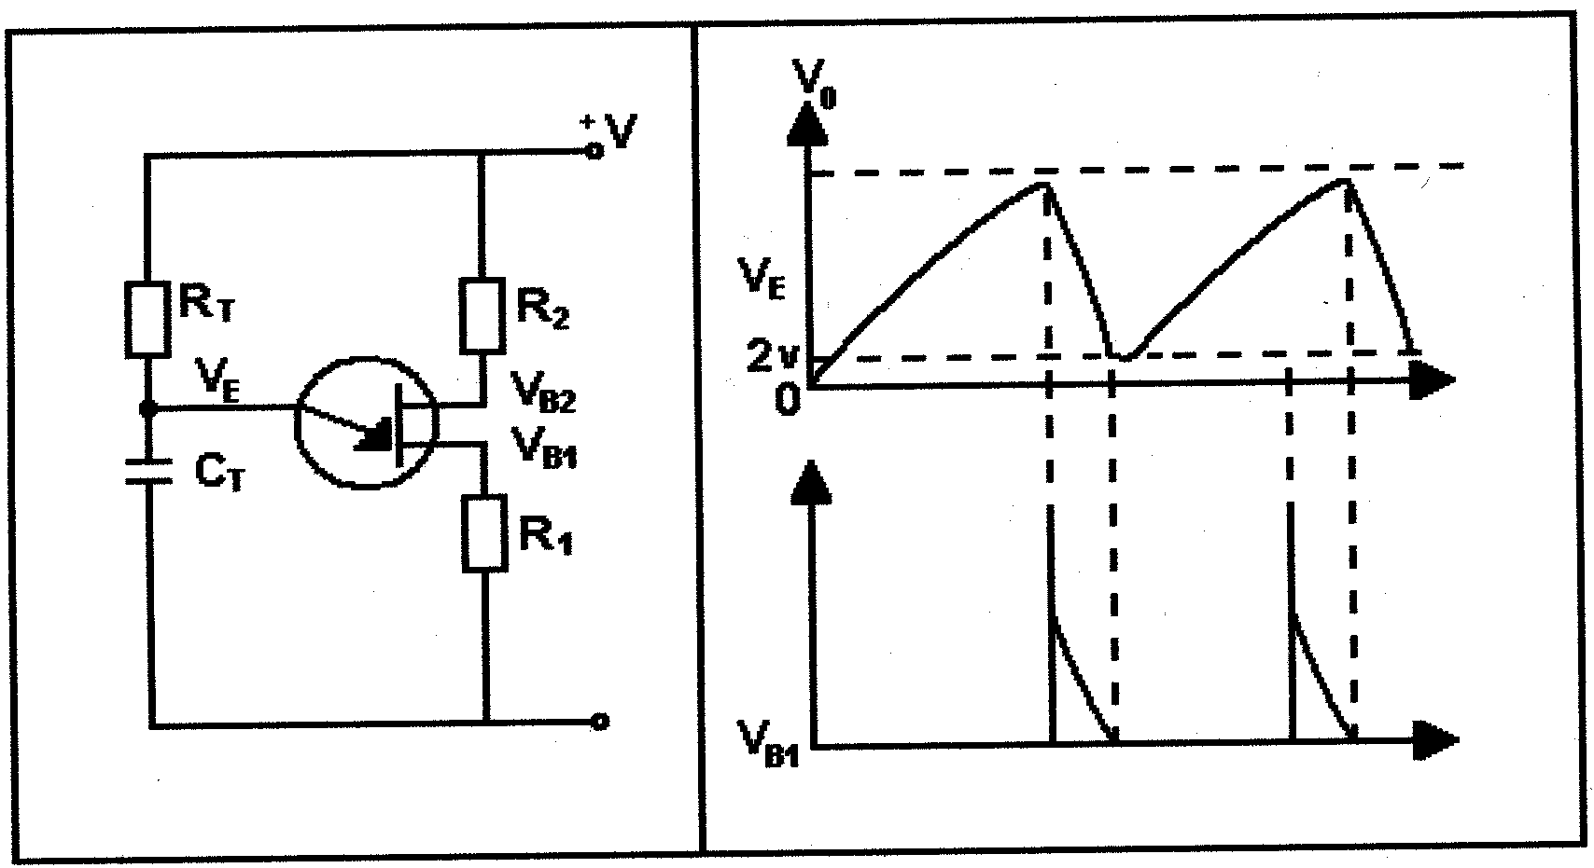  Figure 2.3 Relaxation oscillator | (13)

- To identify the pins of integrated circuits (IC) they are numbered from “1” onwards. Sketch the integrated circuit in Figure 2.4 in your answer book and number the pins.  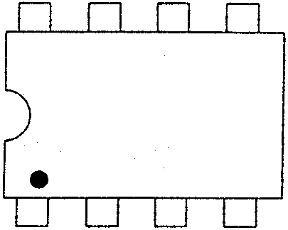  Figure 2.4 The DUAL in line package | (2)

2.5 Name THREE handling procedures which should be followed for the safe handling of CMOS integrated circuits. | (3)  [34]

QUESTION 3  AMPLIFIERS  3.1 The operating capabilities of a transistor are best described by a load line. Determine by means of calculation and a neatly labelled graph, the load line for a common emitter amplifier by making use of the following data:  Applied voltage : 20 volt  Load resistor : 2K5 Ω | (12)

Explain with the aid of a neatly labelled diagram and brief description the working principle of a class A amplifier.  - Name FOUR advantages of negative feedback.  - To amplify the signal from a microphone to a power level adequate to drive a loudspeaker, requires several stages of amplification. Explain with the aid of a neatly labelled diagram the basic principle of operation of EITHER the  complementary-symmetry amplifier OR the transformer coupled amplifier.  - The input power to a device is 10 000 watts at a voltage of 1000 volts. The output power is 500 watts. Calculate the power gain in decibels. | (8)  (4)  (20)  (3)  [47]

QUESTION 4  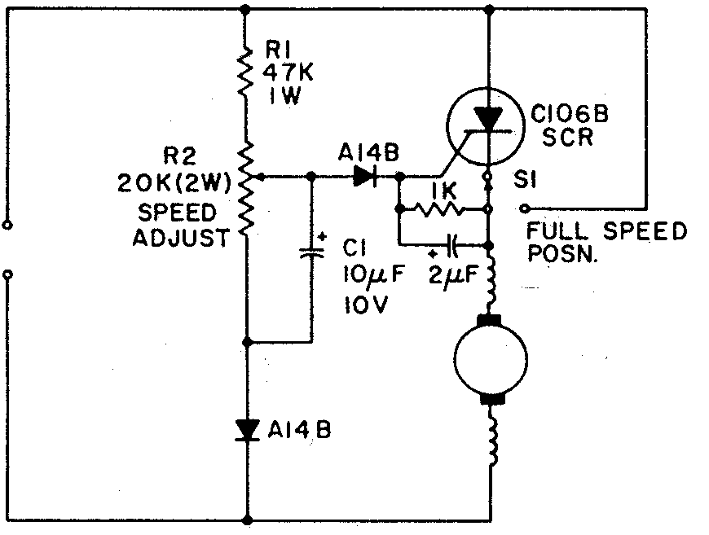  SWITCHING AND CONTROL CIRCUITS  - Regarding power supplies, illustrate by means of neatly labelled diagrams the difference between transistor series and shunt regulation.  - Figure 4.1 illustrates a motor speed control circuit. Explain the working principle of this circuit.  Figure 4.1 Speed control circuit | (12)  (10)

Figure 4.2 illustrates an electronic wave shaping circuit. Name this circuit and sketch the input and output waveforms of this electronic circuit. Name ONE application of this circuit.  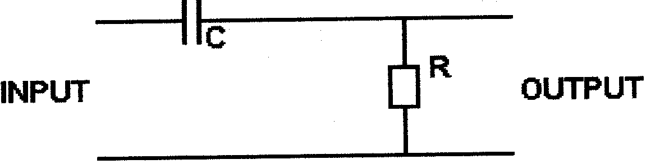  Figure 4.2 Wave shaping circuit | (6)

4.4 Briefly explain the difference between a clipping and a clamping circuit. | (8)

4.5 Clipping and clamping circuits are diode wave shaping circuits used to provide for example a clear image in television receivers. Sketch the output wave shapes for the inputs to the circuits in Figure 4.3. (Assume D is an ideal diode.)  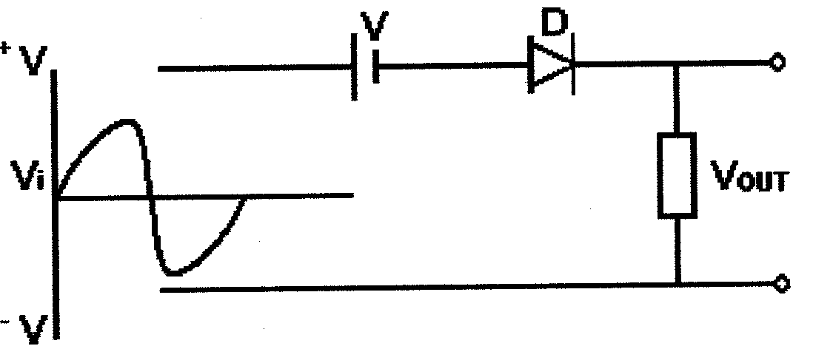  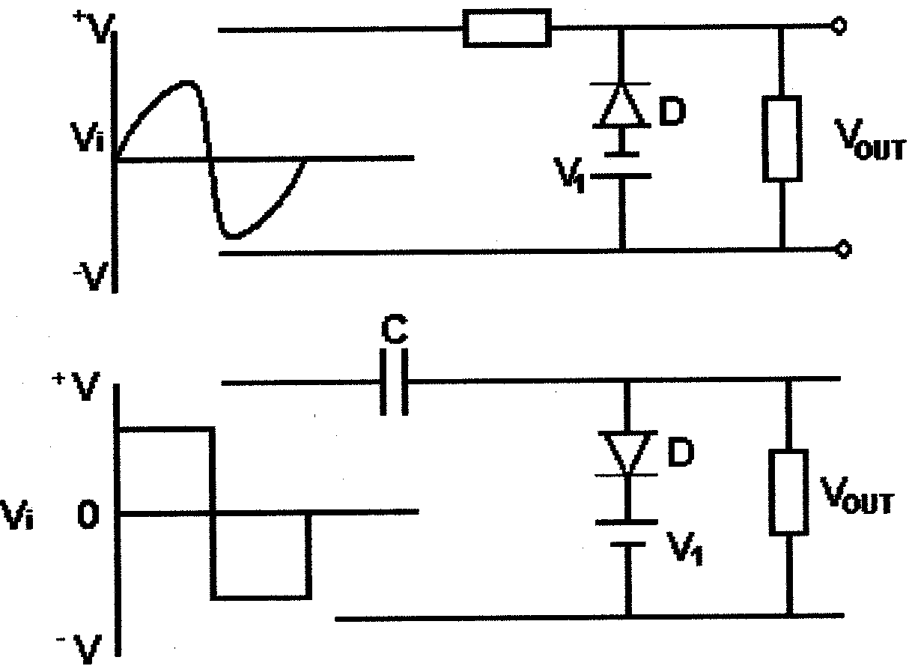  A  B.  C. | (3)  (3)  (3)  [45]

Figure 4.3 Wave shaping circuits

QUESTION 5
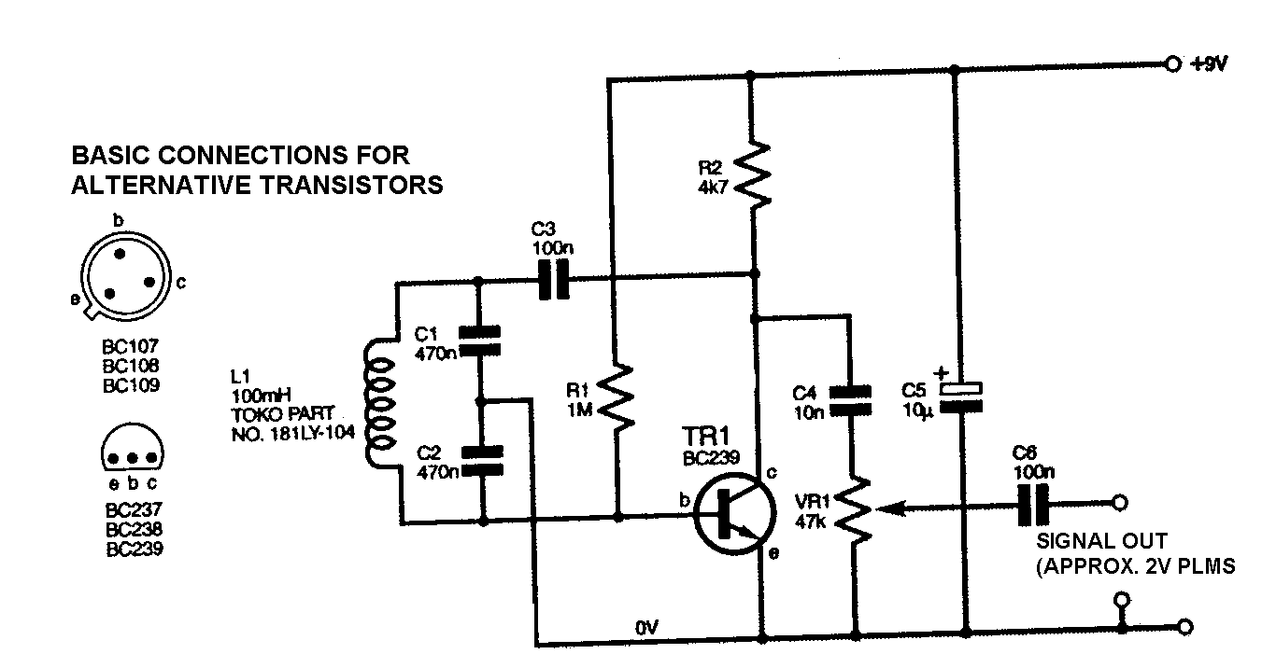

OSCILLATORS

  - Figure 5.1 illustrates the circuit diagram of a Colpitts oscillator for modulating an r.f. signal generator.

Figure 5.1 Colpitts oscillator

- Explain the operating principle of the circuit.  - Calculate the oscillating frequency of this circuit. | (8)  (6)

5.2 Drift becomes an increasing problem in all LC oscillators as the frequency of operation rises through the high frequency spectrum. Name the FOUR main causes of drift. | (4)  [18]

QUESTION 6  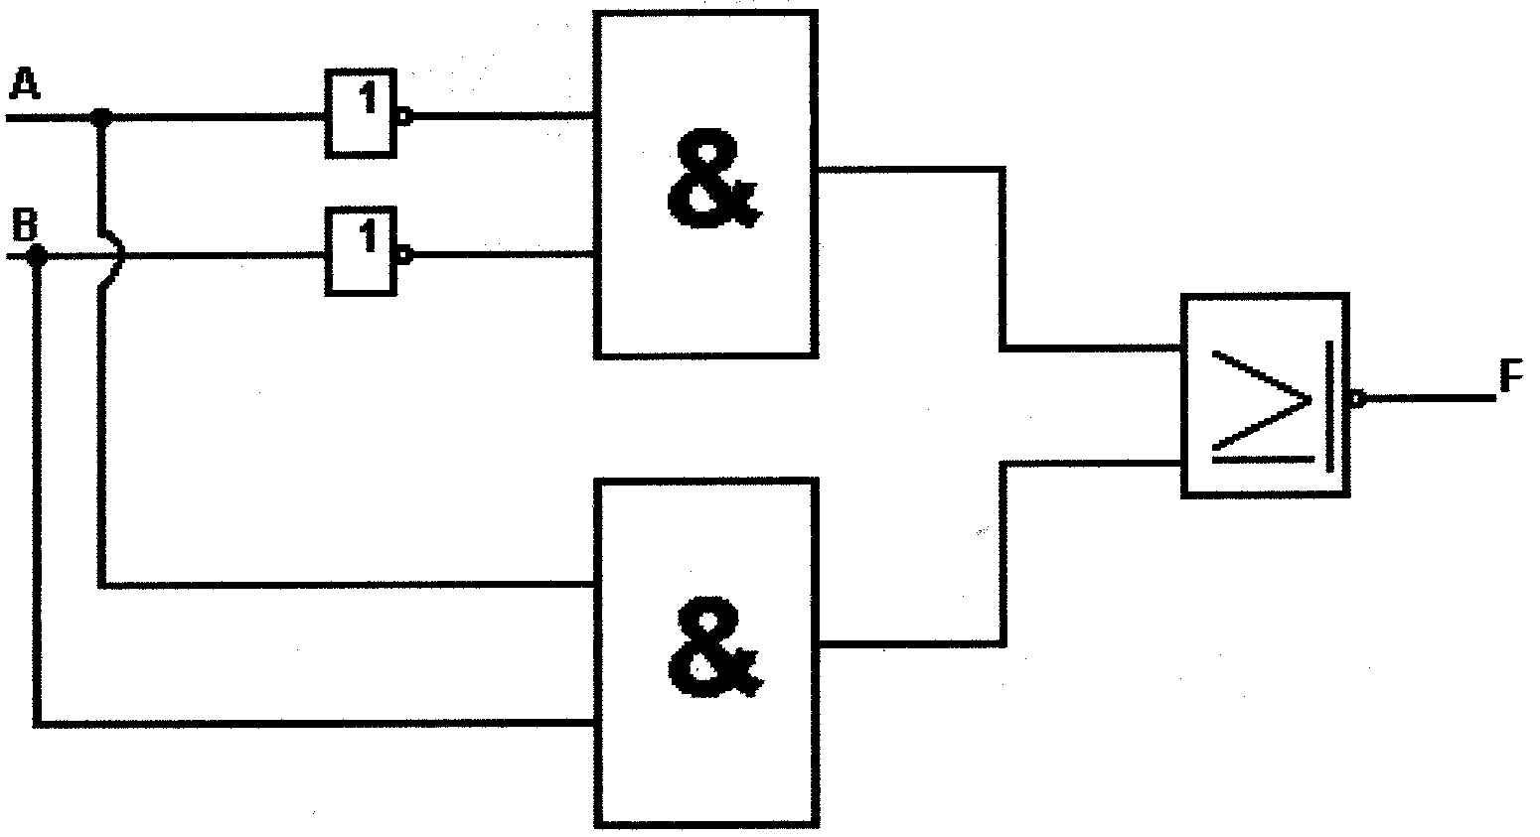  COMPUTER PRINCIPLES  - Analyse the logic circuit of Figure 6.1 and determine F in terms of A and B. Use Boolean algebra and de Morgen’s theories to demonstrate how this circuit can be simplified and replaced by a single exclusive OR gate. Test your result with the aid of a truth table.  Figure 6.1 Logic circuit | (7)

Prove by means of Boolean algebra that:  (A + B)(A + C) = A + BC  - Consider the following logic statements:  - Julius never drinks coffee.  - Norma only drinks coffee if Tsepho and Julius are present.  - Pierre drinks coffee under all conditions – even by himself.  - Tsepho only drinks coffee if Julius is not present.  If: A represents Julius’s presence in the coffee bar,  B represents Tsepho’s presence in the coffee bar,  C represents Pierre’s presence in the coffee bar,  D represents Norma’s presence in the coffee bar,  determine the Boolean function defining the state of: NO coffee drinking. | (6)  (10)

Explain by means of a neatly labelled circuit diagram and truth table the functional operation of a full-adder.  - Provide a brief description of the working principle of a read only memory (ROM).  - Name FOUR applications of digital electronics. | (16)  (5)  (4)

The RAM of a certain computer is referred to as having a capacity of 64 Mbytes. What does it mean? | (3)  [51]

QUESTION 7  INFORMATION TRANSFER  7.1 Explain the working principle of a FM receiver system with the aid of a neatly labelled block diagram and a brief explanation. | [15]

QUESTION 8  MEASURING INSTRUMENTS  List FIVE advantages a digital multi-meter has compared to an analogue meter.  - A measuring instrument is a device used for determining the value of an unknown electrical quantity or variable. Refer to Figure 8.1. List the value of each needle reading for the ranges and functions indicated, in your answer book. | (5)

 | Needle Position | Range |  | Function
 | A  B  C  D  E |  | 1000 V  0.03 V  300 V  R x 100  100 V | dc  dc  ac  Ω  ac
 |  |  |  |  |  | (10)

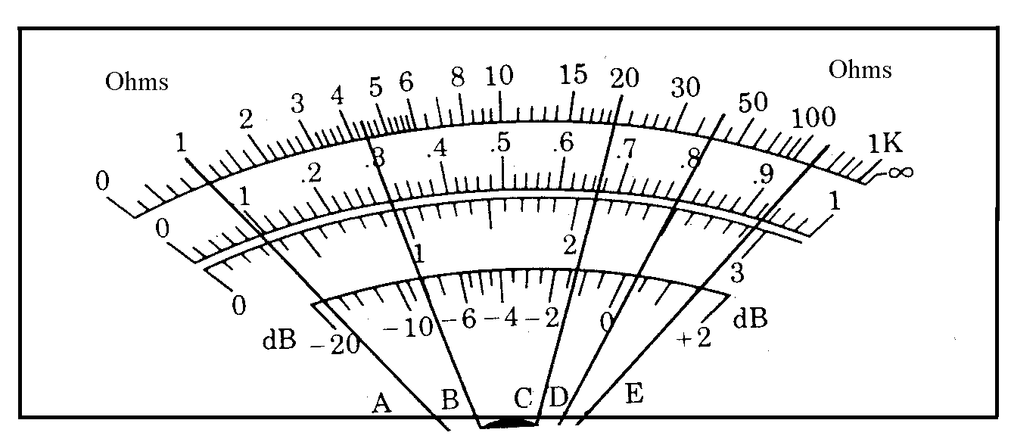

Figure 8.1

Name the adjustment controls on an oscilloscope.  - Explain the function of the time-base generator in an oscilloscope. | (2)  (3)

Determine the rms voltage and frequency of the waves shown in Figure 8.2 if the Volt / DIV switch is set on 2 volt / division and the sec / DIV switch is set on 5 ms / division.  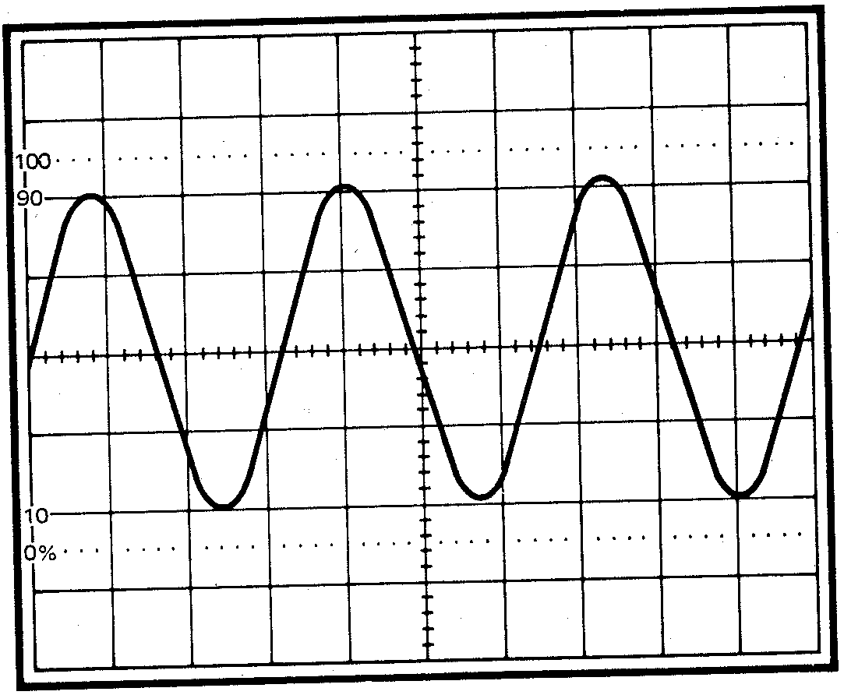  Figure 8.2 Wave form | (10)  [30]

QUESTION 9  SAFETY PRECAUTIONS  - Explain how Aids can be spread from one person to another.  - Explain what safety precautions you will follow in your workshop to prevent Aids from spreading to workers.  - Name THREE places where you should place a fire extinguisher in your workshop.  - Name FOUR precautions that should be taken into account when using a multi-meter.  - Name TWO workshop rules applied in the workshop where you have worked this year.  TOTAL: | (3)  (3)  (3)  (4)  (2)  [15]  300

