GAUTENG DEPARTMENT OF EDUCATION

SENIOR CERTIFICATE EXAMINATION

TECHNIKA (ELECTRONICS) HG

TIME: 3 hours

MARKS: 300

INSTRUCTIONS:

- Answer ALL the questions.
- Sketches and diagrams must be large, neat and labelled.
- All calculations must be shown.
- Answers must be clearly numbered.
- An approved pocket calculator may be used.
- Please find a Formula Sheet attached (pages 12 – 14).

QUESTION 1  ELECTRIC CURRENT THEORY  - A coil with an inductance of 12 mH and an internal resistance of 16 Ω is connected in parallel with a 4,7 μfarad capacitor. The circuit is supplied from a 12 volt / 620 Hz supply. Determine:  - The current in each branch  - The power factor of the inductive leg.  - The reactive component of the current in the inductive leg  - The active component of the current in the inductive leg  - The total current in the circuit. Sketch a fully labelled phasor diagram representing the currents. | (15)  (3)  (3)  (3)  (8)

1.2 Briefly explain the term impedance matching. Name an application thereof. | (3)

1.3 Calculate the turns ratio required for an impedance matching transformer to satisfy the requirements of a loudspeaker with an 8 Ω, voice coil. The transistor needs a 500 Ω load for maximum power transfer. | (4)

1.4 A transistor using transformer coupling, drives a load of 10 Ω. The transformer has a primary of 100 turns and a secondary of 10 turns. Calculate the actual impedance as “seen” by the transistor. | (4)  [43]

QUESTION 2  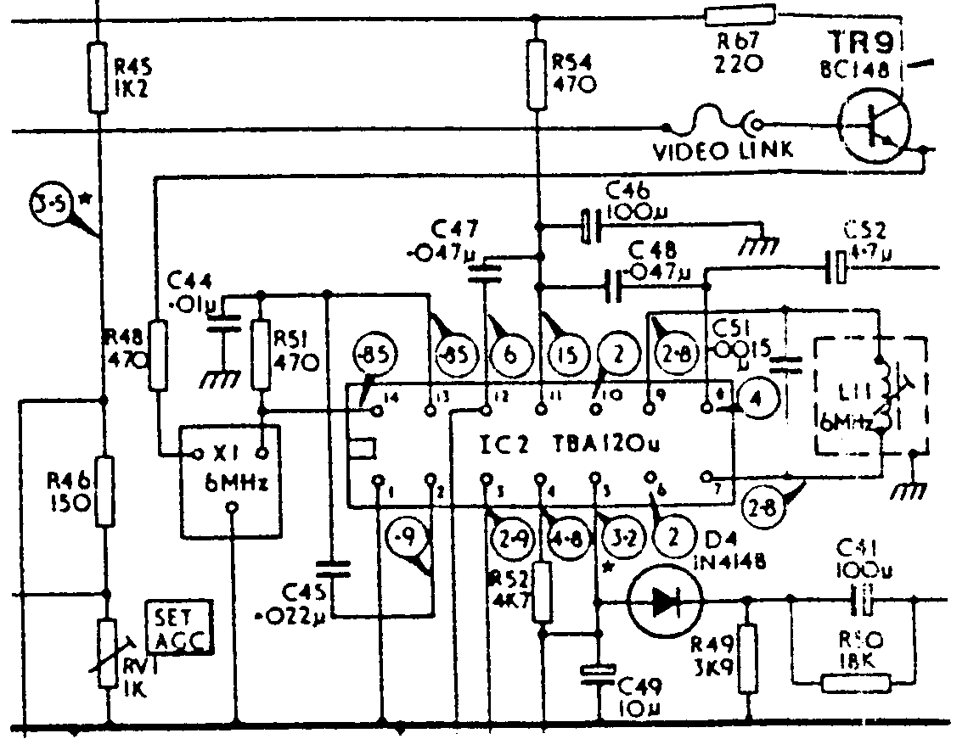  SEMICONDUCTOR DEVICES  - Identify the following electronic components with reference to the electronic circuit in Figure 2.1. (For example: R54 is a 470 Ω resistor.):  - TR9  - C46  - IC2  - RV1  Figure 2.1 Electronic Circuit | (2)  (3)  (2)  (3)

- Explain by means of a neatly labelled sketch and brief description the basic construction and functional operation of a triac in an A.C. circuit. All waveforms must be shown. | (15)

  - Study Figure 2.2 and answer the following questions:
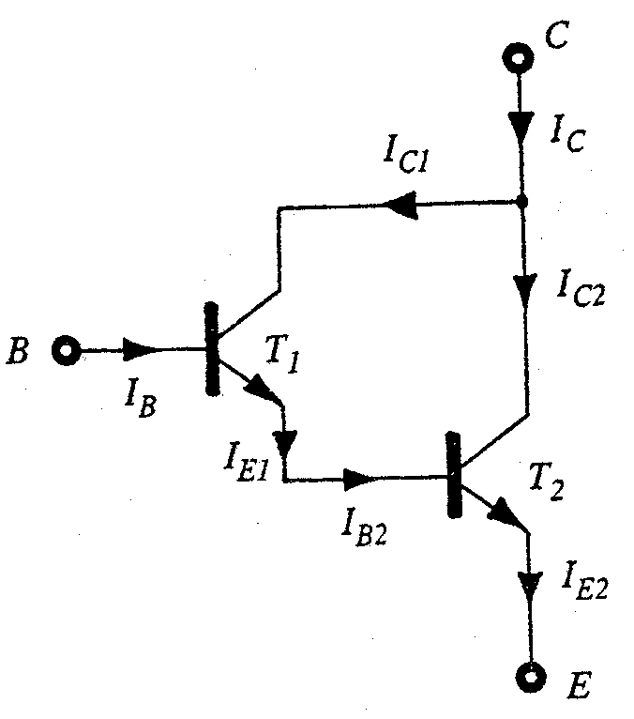

Figure 2.2

- Identify the circuit in Figure 2.2.  - Explain the working principle of the circuit in Figure 2.2.  - Name THREE important advantages of using the circuit in Figure 2.2. | (1)  (6)  (3)

2.4 Name THREE precautions that must be taken into account when handling CMOS devices. | (3)  [38]

QUESTION 3  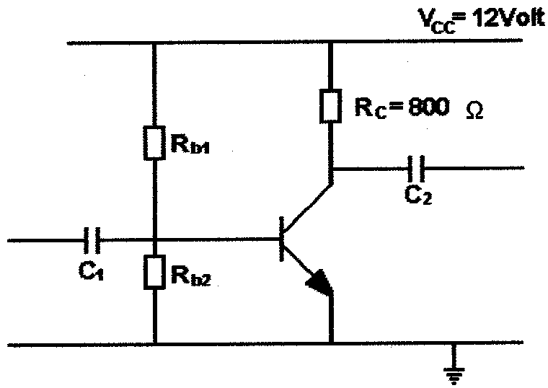  AMPLIFIERS  3.1 Determine by means of calculations and a neatly labelled graph the load line of the circuit shown in Figure 3.1.  Figure 3.1 | (9)

Figure 3.2 indicates a circuit employing negative feedback. Explain the working principle of the circuit.  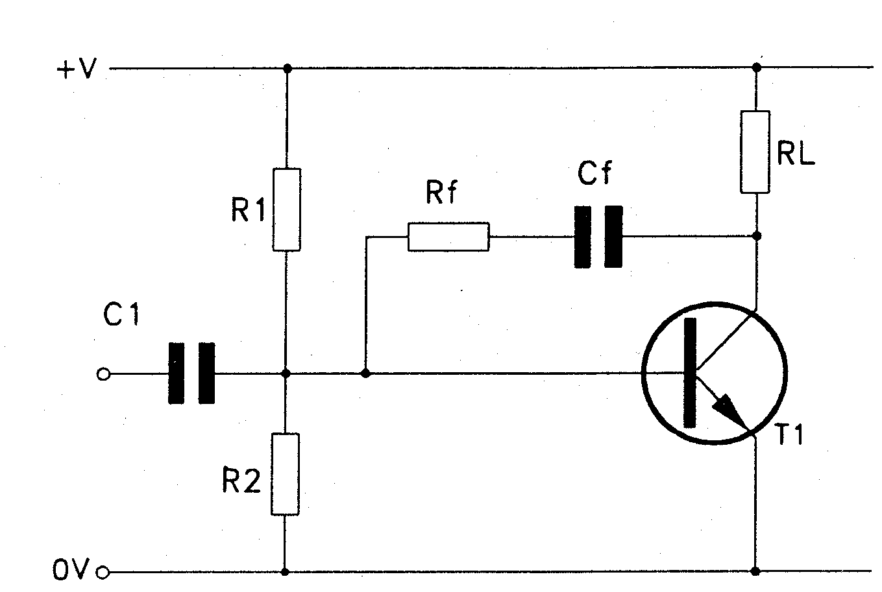  Figure 3.2 Amplifier with negative feedback | (8)

Name FOUR advantages of negative feedback.  - To drive a loudspeaker requires an appreciable output of power, therefore transistors are connected in stages to amplify the signal. Explain with the aid of a neatly labelled diagram and a brief discussion the principle of operation of EITHER a push-pull amplifier OR a resistor-capacitor (RC) amplifier.  - An audio amplifier’s currents are measured as 3,6 mAmp input current and 15,3 mAmp output current. Calculate the amplifier current gain in decibels. | (4)  (20)  (4)  [45]

QUESTION 4  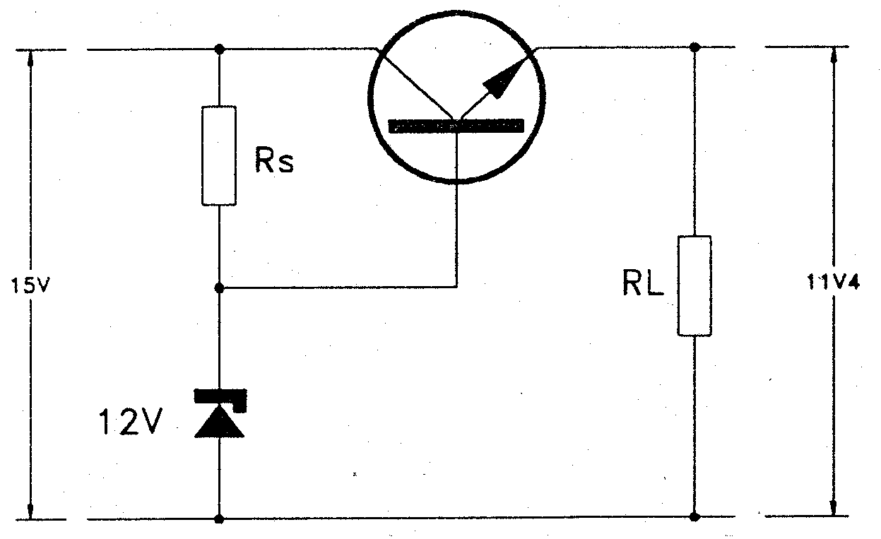  SWITCH AND CONTROL CIRCUITS  - Figure 4.1 indicates a fixed voltage series regulator. Explain the working principle of this circuit.  Figure 4.1 Fixed voltage series regulator | (10)

Figure 4.2 indicates a phase control circuit. The waveforms shown are:  V_{s} = The AC supply  I_{g} = The gate trigger pulse  Explain the working principle of this circuit and sketch the waveform across the load. | (7)

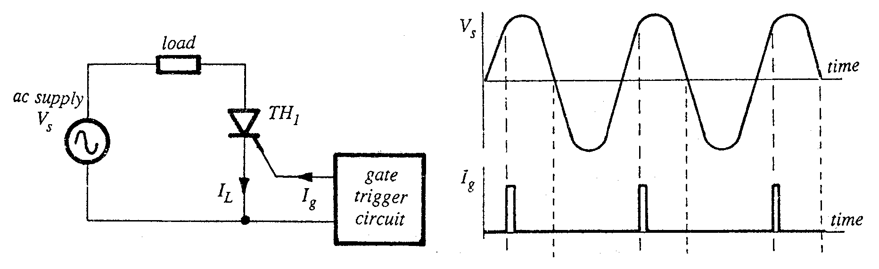

Figure 4.2 Phase control circuits

Figure 4.3 indicates two wave shaping circuits. Name the two circuits and sketch the output waveform for each in your answerbook.  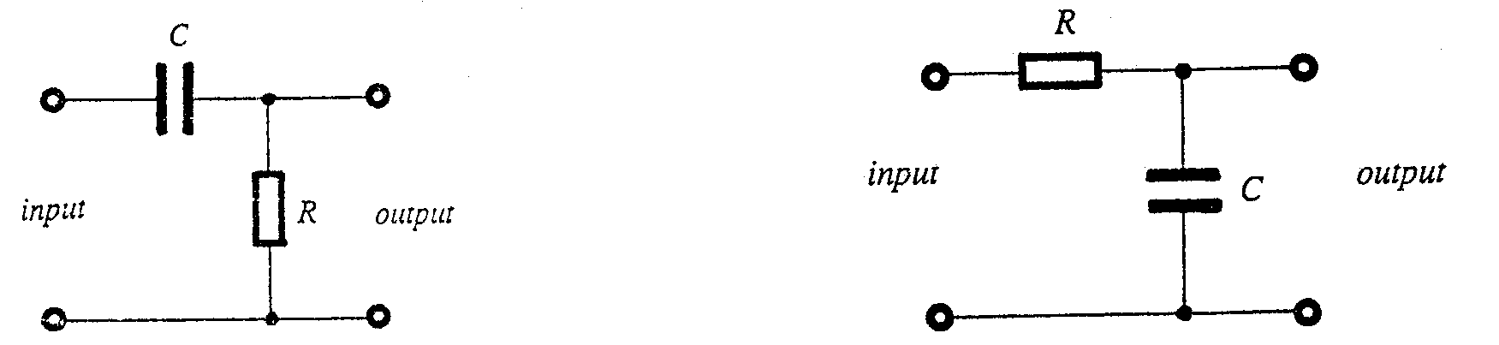  (a) (b)  Figure 4.3 Wave shaping circuits | (6)

Clippers and clampers are diode wave shaping circuits transmitting parts of waveforms and suppressing others to a predetermined value. Find the output voltage wave shape for the inputs shown in Figure 4.4 (Only sketch the output voltage wave shape in your answer book.)  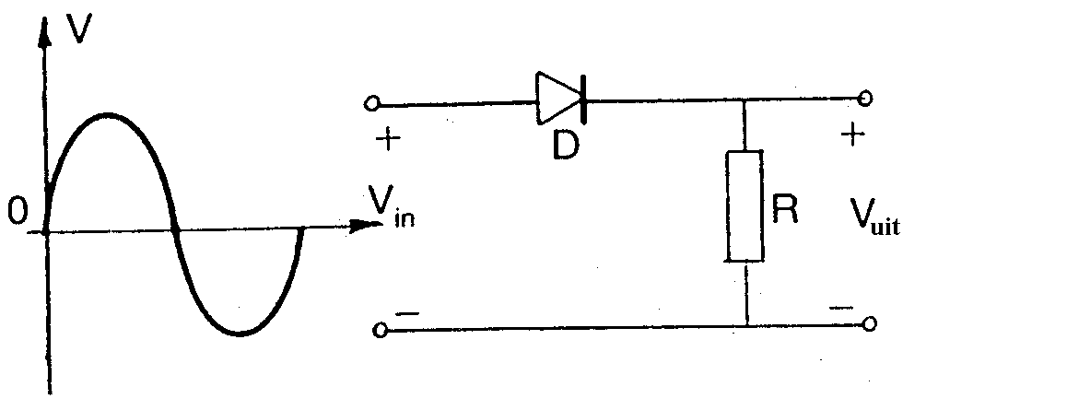  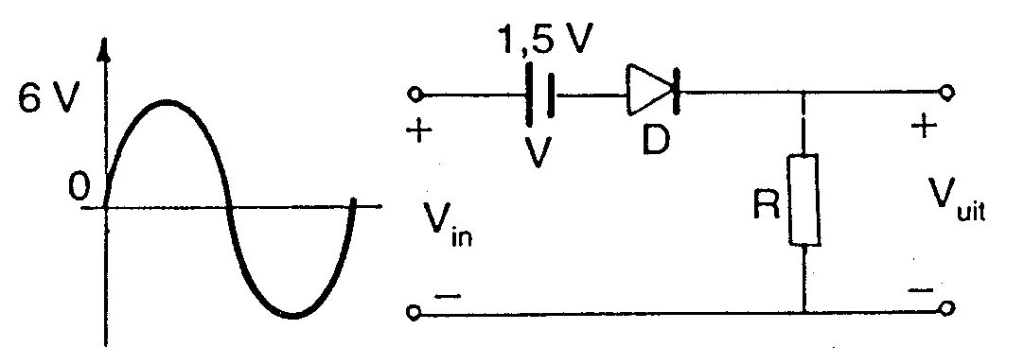  out  out  out  (a)  (b) | (2)  (2)

( c)  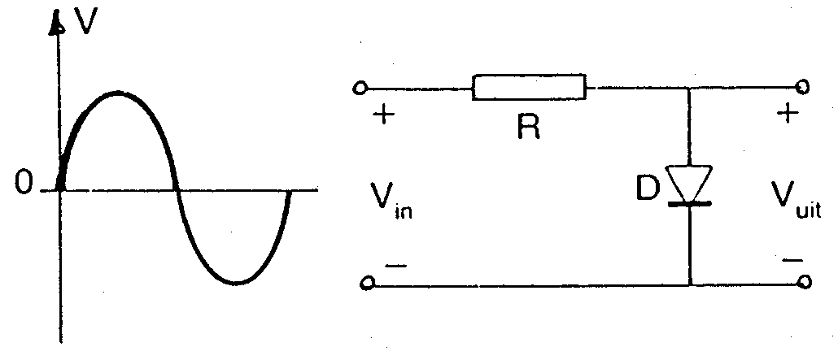 | (2)

(d)  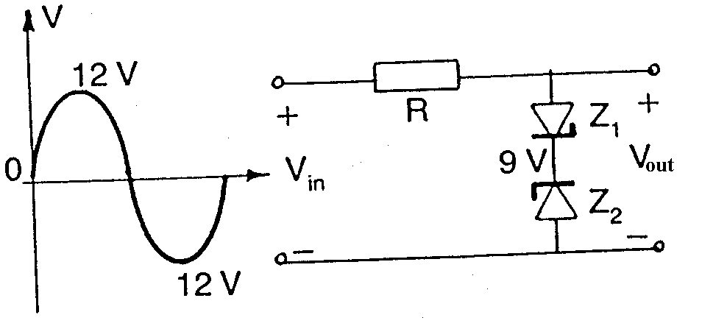  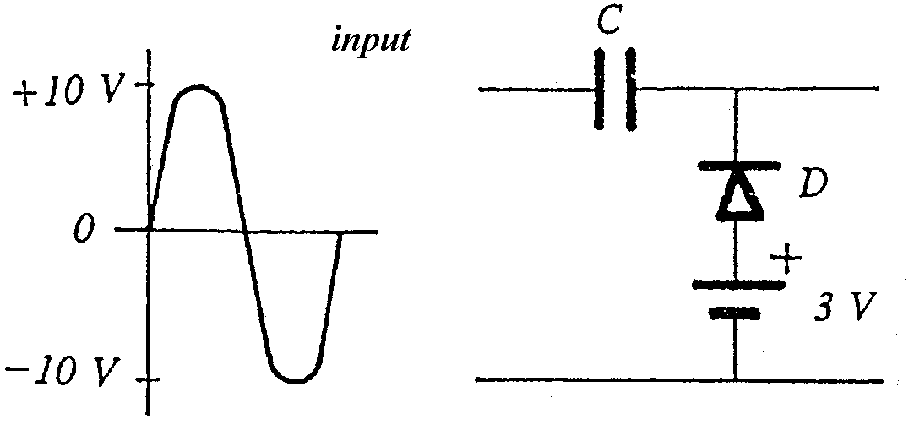  (e)  Figure 4.4 Wave Shaping Circuits | (2)  (3)

You have studied the operating principle of three types of multivibrators. That is the astable, bistable and monostable multivibrator. Illustrate by means of a neatly labelled diagram, the working principle of any ONE of the above mentioned multivibrators. All relevant waveforms should be shown.  - Name ONE application of multivibrator circuits. | (10)  (1)  [45]

QUESTION 5  OSCILLATORS  Explain with the aid of a neatly labelled circuit diagram and brief description the operation of a crystal controlled Hartley oscillator.  5.2 Calculate the oscillating frequency of the circuit in Question 5.1 if the values of L₁ and L₂ are both 100 mH and C is 47 pF. The mutual coupling coefficient (M) according to the manufacturer is 0,1. | (14)  (6)  [20]

QUESTION 6  COMPUTER PRINCIPLES  - Design a NOR gate network for the following Boolean expression (A,B,C and D are direct gate inputs.):  F = ($\bar{A}$+ B)(C + $\bar{D}$)  - Simplify the following Boolean expression:  F = [A$\overline{B}$ (C + BD) + $\bar{A}$$\bar{B}$] C  - A motor-vehicle has only two doors. Design an alarm circuit for the vehicle by making use of amongst others two AND gates and one exclusive OR gate. The following conditions must be adhered to:  Whenever any of the two doors are not closed properly and the motor vehicle is switched on, the alarm should be activated.  Hint: the two switches of the doors are grounded when the doors open and the ignition system becomes “high” when the motor vehicle is switched on.  Sketch a neat, labelled diagram of the alarm system.  - Prove by means of Boolean-algebra that:  A + $\bar{A}$B = A + B  6.5 Explain the working principle of a clocked RS flip flop (latch) by means of a neatly labelled logic circuit and truth table. | (7)  (7)  (13)  (7)  (15)  [49]

QUESTION 7  INFORMATION INSTRUMENTS  7.1 Sketch a neatly labelled block diagram of an FM-radio receiver. Explain the function of each block. | [15]

QUESTION 8  MEASURING INSTRUMENTS  Explain the working principle of a digital multi-meter by means of a neat, labelled block diagram. | (6)

  - A measuring instrument is a device used to determine the value of an unknown electrical quantity or variable. Fill in the readings indicated on the meter dial of an analogue meter as indicated in Figure 8.1 in your answer book. Carefully note the range selector switch setting.

 | Needle position | Selector switch setting |  | Function | Value
 | A  B  C  D  E |  | 1 V  R x 1M  0,03 V  100 V  R x 100 | dc  Ω  dc  ac  Ω | ______  ______  ______  ______  ______
 |  |  |  |  |  |  | (10)

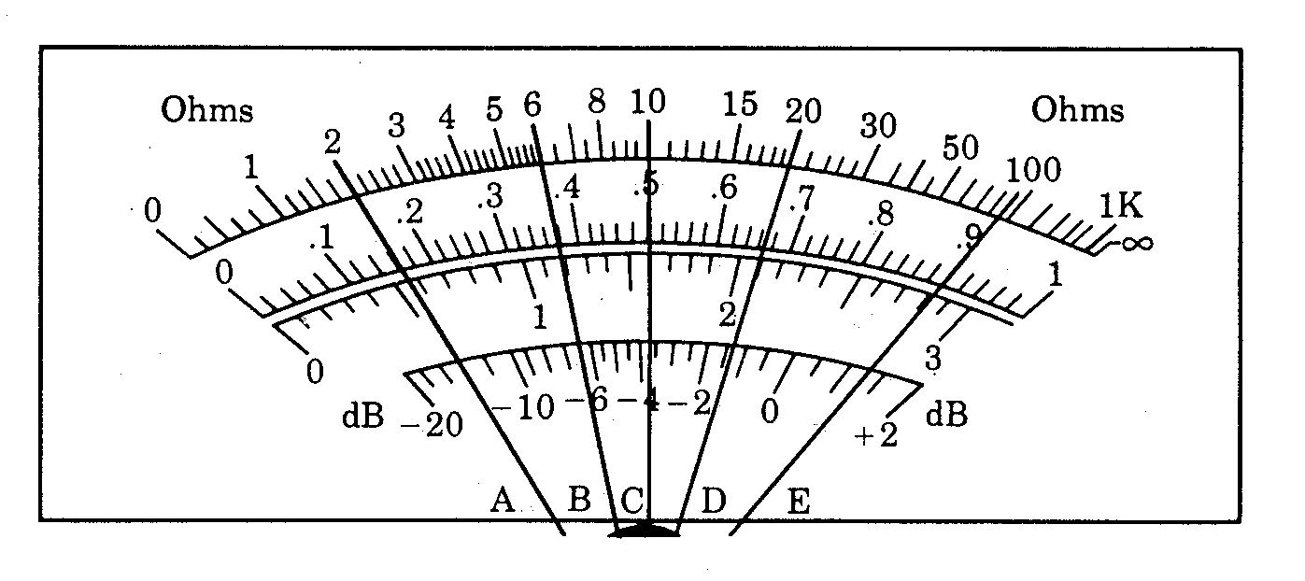

Figure 8.1 Meter readings

Explain the working principle of a cathode ray oscilloscope by means of a neat, labelled block diagram.  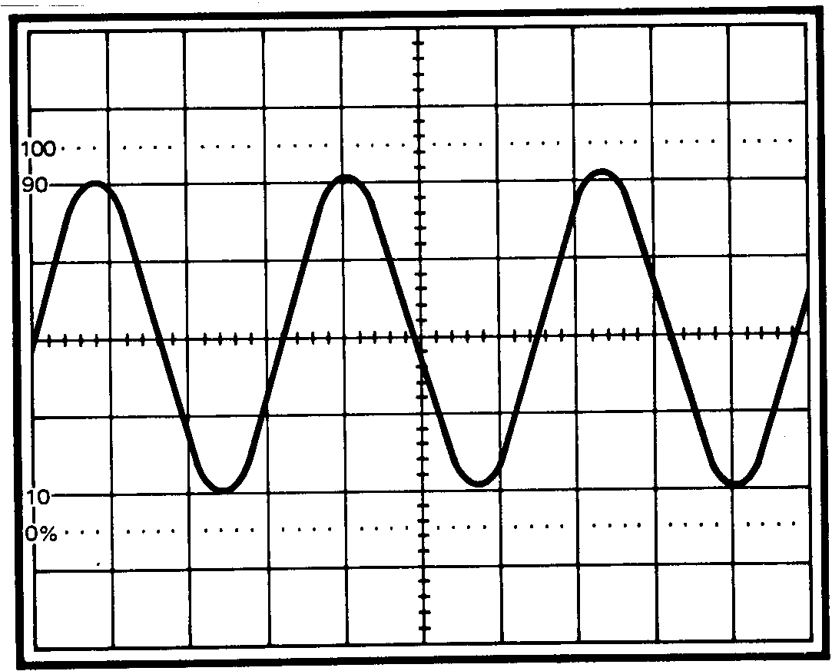  - Determine the peak to peak voltage of the waveform shown in Figure 8.2 if the volt / DIV switch is set 10 mV / DIV.  Figure 8.2 Waveform measured by oscilloscope | (12)  (3)  [31]

QUESTION 9  SAFETY PRECAUTIONS  - Explain how Aids can be spread from one person to another.  - Name FIVE safety checks that should be made before using portable electrical equipment.  9.3 Name FIVE safety precautions that should be taken into account when handling a multi-meter.  - Name ONE emergency number which may be dialled in case of an emergency.  TOTAL: | (3)  (5)  (5)  (1)  [14]  300

