GAUTENG DEPARTMENT OF EDUCATION
SENIOR CERTIFICATE EXAMINATION

TECHNIKA (ELECTRICAL) SG

TIME: 3 hours

MARKS: 200

REQUIREMENTS:

- Approved calculator and drawing instruments

INSTRUCTIONS:

- Answer ALL questions.

- Sketches and diagrams should be clear and neat.

- Formulae and calculations must be clear.

- Formulae and calculations must be shown where indicated.

- A list of formulae, which may be used where applicable, is given on the last page of this examination paper.

QUESTION 1

- Briefly explain the meaning of the following terms:  - Inductive reactance  - Capacitive reactance  - Impedance | (3)  (3)  (3)

- A resistance of 75 Ω and a capacitor of 50 μF are connected in parallel over a power supply of 220 V 50 Hz. Calculate the following:  1.2.1 Current through the resistance  - Current through the capacitor  - Supply current | (3)  (6)  (3)

1.3 A coil with an inductance of 0,65 H and a resistance of 32 Ω is connected in series with a capacitor of 56 μF. The circuit is connected to a 150 V 50 Hz supply. Calculate the following:  - Inductive reactance  - Capacitive reactance  - Impedance  - Power of the circuit at 50 Hz  - Draw a neatly labelled phasor diagram of the circuit at 50 Hz. | (3)  (3)  (3)  (6)  (4)  [40]

QUESTION 2
SINGLE AND THREE-PHASE SYSTEMS

- Name the THREE colours, in the correct sequence, used to identify the three phases in a three-phase system.  - Name THREE advantages that a three-phase system has over a single-phase system.  - Explain, using a neatly labelled diagram, the relevance of line and phase voltages and currents in a star-coupled three-phase system. | (3)  (3)  (4)  [10]

QUESTION 3
TRANSFORMERS

- A three-phase 6600/400 volt star-delta transformer has a rating of 250 kVA. The transformer has 100 windings on the secondary side. Calculate the following:  3.1.1 The number of primary windings  - The maximum secondary phase current  - The maximum output power if the load has a power factor of 0,8 lagging. | (3)  (3)  (3)

3.2 Show, by means of a neatly labelled drawing, how a single-phase wattmeter can be connected to a high voltage, high current circuit using instrument transformers.  3.3 Briefly explain why it is not possible for a transformer to function when direct current is applied to it. | (8)  (3)  [20]

QUESTION 4
ALTERNATING CURRENT MOTORS

- Explain the purpose of the rotor bars and short circuit rings in the rotor of the induction-type alternating current motor.  - Explain the following terms with reference to induction-type motors:  4.2.1 Synchronous speed  4.2.2 Rotor slip | (5)  (2)  (2)

- What is the function of the copper ring on the pole of the shaded-pole motor?  - Explain why star/delta starters are used to start large three-phase motors under full load. | (3)  (4)

- Draw a neatly labelled diagram of the following:  4.5.1 Capacitor-start motor  4.5.2 Squirrel-cage motor-three phase and coupled in delta | (6)  (4)

- Briefly explain how a rotating magnetic field is obtained in the capacitor-start motor. | (4)  [30]

QUESTION 5
SEMICONDUCTORS

- With the aid of a neatly labelled diagram, explain the principle of operation of a bipolar NPN transistor.  - Draw the IEC symbols for the following components:  5.2.1 Silicon Controlled Rectifier  - DIAC | (8)  (1)  (1)  [10]

QUESTION 6
AMPLIFIERS

- Explain, using the relevant waveforms, the difference between class A, class B and class C amplification.  - Name THREE advantages of negative feedback in relation to amplifiers.  - Explain the principle of operation of the push-pull amplifier illustrated in  Figure 6.3. | (6)  (3)  (7)

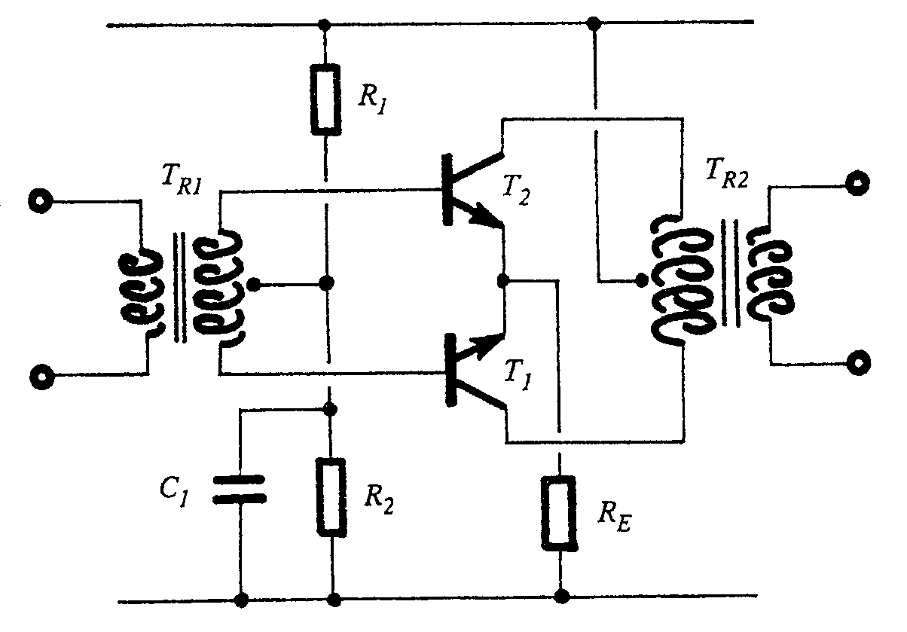

Figure 6.3
Push-Pull Amplifier

- Draw a neatly labelled diagram of the representative frequency curve of a transformer-coupled amplifier. | (4)  [20]

QUESTION 7
SWITCHING AND CONTROL CIRCUITS

- Explain the functional principle of operation of the zener diode in relation to an increase in voltage over the diode and a decrease of voltage over the diode.  - Explain the following terms in relation to Silicon-Controlled Rectifiers:  7.2.1 Holding current  - Forward conducting voltage  - Trigger pulse  - Peak inverse voltage | (8)  (3)  (3)  (3)  (3)  [20]

QUESTION 8
OPERATIONAL AMPLIFIERS

- Name FOUR qualities of an ideal operational amplifier.  - Draw the output waveform of an operational amplifier differentiator circuit if a triangular waveform is applied to the input of the circuit.  - Name FOUR items that should be included in the modern first aid kit. | (4)  (2)  (4)  [10]

QUESTION 9
OSCILLATORS

9.1 Identify the circuit in Figure 9.1
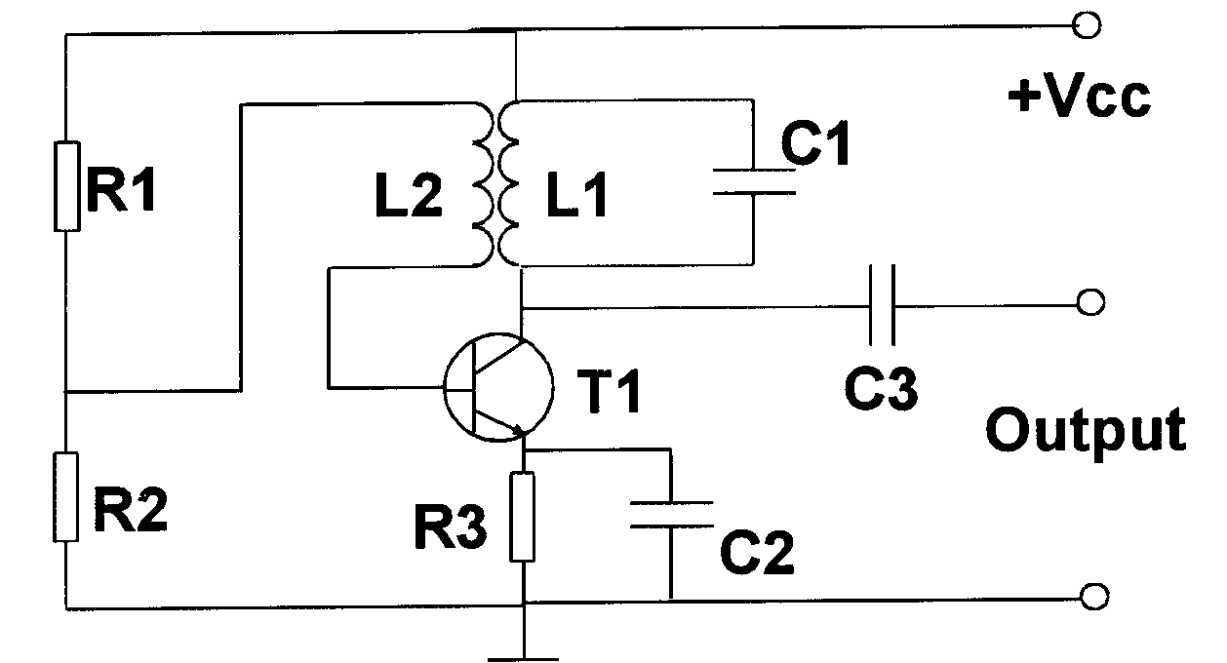
(1)

Figure 9.1

- Briefly explain the piezo-electrical principle. Make use of neatly labelled diagrams where necessary.  - What is the purpose of the crystal in the feedback circuit of the crystal-controlled Hartley oscillator? | (6)  (3)  [10]

QUESTION 10
COMPUTER PRINCIPLES

10.1 Convert the following product-of-the-sum expression to a sum-of-the-product expression. | (3)

(A + B) (B + C) (A + C)

- Name ONE associative Boolean Algebraic rule  10.3 Draw a neatly labelled logic circuit diagram of the following Boolean expression: | (1)  (5)

[(A.B)+(A.C)]+D = X

10.4 Name TWO precautionary measures to be taken when handling C-MOS logic devices. | (2)

10.5 Set up a truth table for the RTL-gate in Figure 10.5. Draw a neatly labelled logic circuit diagram for this gate. | (5)

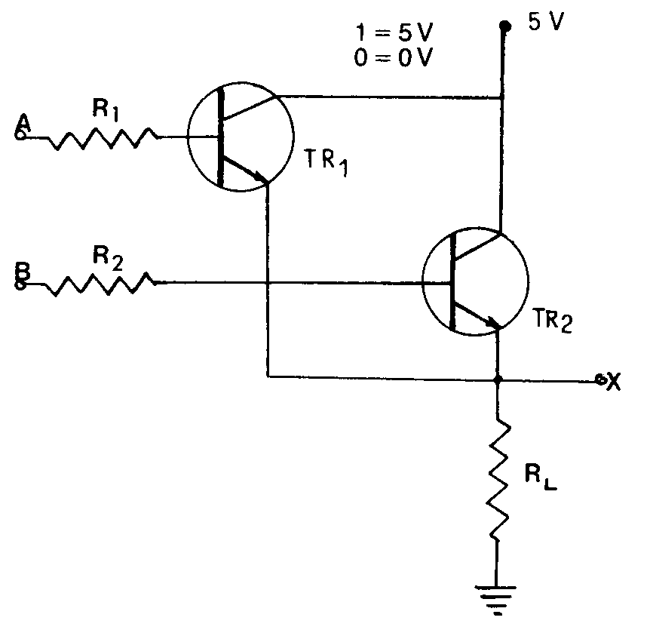

Figure 10.5
RTL-Gate

10.6 Name THREE possible causes of fire in the workshop. | (3)

- Name the type of fire extinguisher that should be used in an electrical workshop. | (1)  [20]

QUESTION 11
MEASURING INSTRUMENTS

- Name THREE uses of the multimeter.  - Name THREE precautionary measures to be taken when working with an oscilloscope.  - Is it possible to contract the HI-virus when working under normal conditions in the same workshop as an HIV-positive person? Motivate your answer.  - What does the term creeping refer to in relation to single-phase energy meters?  TOTAL: | (3)  (3)  (2)  (2)  [10]  200

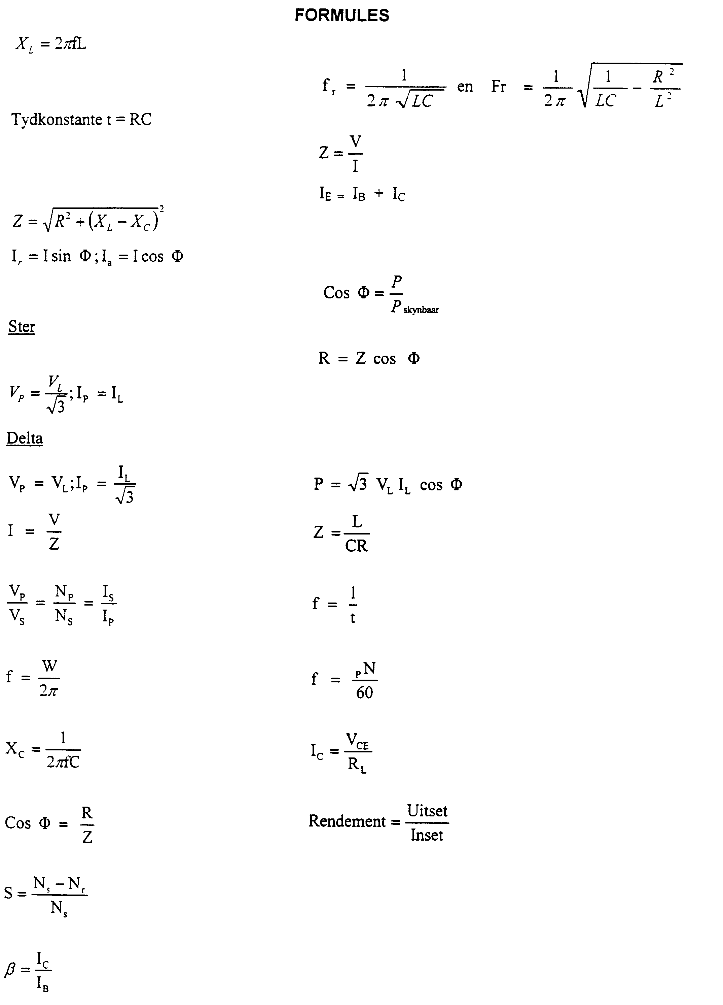
FORMULAE
Time Constant t = RC
and
Star
apparent

