GAUTENG DEPARTMENT OF EDUCATION

SENIOR CERTIFICATE EXAMINATION

TECHNIKA (ELECTRICAL) HG

TIME: 3 hours

MARKS: 300

REQUIREMENTS

- Drawing instruments and an approved calculator

INSTRUCTIONS:

- Answer ALL the questions.
- Sketches and diagrams must be clear and writing must be legible.
- Formulae and calculations must, where applicable, be indicated.
- A list of formulae, which may be used when applicable, is provided on the last page of the question paper.

QUESTION 1
MULTIPLE-CHOICE QUESTIONS

For each of Questions 1.1 – 1.10 five possible answers are given. Indicate the correct answer by making a cross (X) over the appropriate letter on the answer sheet on the inside cover of your answer book.

- A NAND function can also be performed by  - a bubble OR-gate.  - an AND-gate with an invertor in the output.  - an exclusive OR-gate.  - A and B.  - A and C. | (2)

- With three-phase transformers the equation N₁ = E₁ applies to  N₂ E₂  - both line and phase voltages.  - line voltages.  - phase voltages.  - line currents.  - phase currents. | (2)

- For an NPN transistor to switch on,  - the base-emitter junction must be forward biased and the base-collector junction must be reverse biased.  - the current through the base-emitter junction must be ten times higher than that through the base-collector junction.  - a regulated voltage supply must be used.  - the base current must be controlled by the collector current.  - the minority carriers must flow across the forward biased junction. | (2)

1.4 When a triangular wave is applied as the input to a differentiator, the output will  A. be a mirror image of the input.  B. be a sawtooth wave.  C. look exactly like the input.  D. be a square wave.  E. be a sine wave.  1.5 Which one of the following statements is TRUE?  A Digital meters are always more accurate than analog meters as they need not be calibrated.  B. The oscilloscope is ideal for the accurate measurement of voltage, current and resistance.  C. The frequency of a wave can be read directly from the oscilloscope.  D. A kilowatt-hour meter measures the consumption of energy.  E. A power factor meter gives an indication of the energy consumption of an appliance. | (2)  (2)

- The Boolean equation (X.Y.Z) + (X.Y) is equivalent to:  A. Z  B. Z  C. 1  D. X + Y  E. An exclusive NOR-gate  - The cosine of the angle between the alternating current and voltage in a circuit is known as the  - active component of the power.  - reactive component of the power.  - power factor.  - reactance.  - admittance. | (2)  (2)

- Which of the following statements about the three-phase alternating current systems is not correct?  - For machines with equal size and frame, three-phase machines deliver a higher power than single-phase machines.  - They are more versatile, as both line and phase voltage are available.  - Three-phase motors normally deliver a higher torque than their single-phase counterparts.  - The efficiency of three-phase machines is normally equal to that of single-phase machines.  - It is relatively easy to use three-phase alternators in parallel. | (2)

1.9 The percentage slip of a two-pole motor that rotates at 2 880 r/min when connected to a 380 V, 50 Hz supply is:  A. 7%  B 0,04%  C. 4%  D. 0,07%  E. None of the above.  1.10 When a three-phase induction motor is connected in star to the supply  A. only the starting current will be lower than when connected in delta.  B. both the starting and running currents will be lower than when connected in delta.  C. only the starting current will be higher than when connected in delta.  D. both the starting and running currents will be higher than when connected in delta.  E. the starting current will be equal to that of a delta-connected system.  2x10 = | (2)  (2)  [20]

QUESTION 2  OCCUPATIONAL SAFETY  2.1 Name THREE preventative measures which have to be taken to reduce industrial accidents.  2.2 Name TWO ways in which Aids can be spread. | (3)  (2)  [5]

QUESTION 3  ELECTRICAL CURRENT THEORY  - A resistor of 120 ohm, a coil with a reactance of 160 ohm and a capacitor with a reactance of 220 ohm are connected in parallel with a 100V supply.  - Calculate the current in each branch.  - Calculate the total current.  - Calculate the phase angle.  - Draw the phasor diagram. | (20)

- A series RCL circuit consists of a resistor of 10 ohm, an inductor of 100mH and a capasitor of 100 μF. This combination is connected across a 250V, 50Hz supply. Calculate:  - The resonant frequency  - The current flow at resonance  - The Q-factor of the circuit  - Explain what is meant by resonant frequency by referring to series circuits.  - The inductance of an LC parallel resonant circuit is 200 mH and the inductor’s resistance is 10 ohms. A supply current of 100 mA is drawn from a 20 Volts supply. Calculate:  - The value of the capacitor in the circuit  - The circulating current between the inductor and the capacitor  - The resonant frequency  - A lighting unit’s specifications are given as 750 Watts, 100 Volts. A capacitor is connected in series with the unit across a 230 Volts 60 Hz supply. Calculate the capacitance of the capacitor. | (10)  (1)  (6)  (3)  (3)  (13)  [56]

QUESTION 4  SINGLE- AND THREE-PHASE ALTERNATING CURRENT SYSTEMS  - Name the advantages of a three-phase alternating current system over a single- phase system.  - A 7.5 kW inductive single-phase system draws 40A from a 250 Volts 50 Hz supply.  - Calculate the kVA rating of the circuit.  - Calculate the power factor.  - Show by means of a current phasor diagram to any convenient scale how the power factor of the circuit could be improved to 0.9.  - Determine by measurement the current through the capacitor.  - Calculate the capacitance of the capacitor. | (3)  (3)  (3)  (3)  (2)  (6)

- Calculate the frequency of a four-pole alternator driven at 1 800 revolutions per minute.  - Explain what is meant by apparent power.  4.5 Why is electricity that is transmitted at high voltages, for example 800 kilo-volts, sent by means of transmission lines? | (3)  (1)  (1)  [25]

QUESTION 5  TRANSFORMERS  - Three single-phase transformers, each with a turn ratio of 2:1, are connected in delta-star to supply energy to a three-phase motor with a power factor of 0.9 and an efficiency of 80%. The input power and primary line voltage are 48 kVA and 1.1 kV, respectively.  Calculate:  - The primary phase voltage  - The secondary phase voltage  - The primary line current  - The primary phase current  - The secondary phase current  - The output power of the motor | (3)  (3)  (3)  (3)  (3)  (5)

- Which TWO methods are generally used to cool off transformers?  5.3 Describe with the aid of a labelled diagram the structure of a single-phase, auto-transformer. Name TWO advantages of an autotransformer in comparison to an ordinary transformer.  5.4 An autotransformer has 1 000 windings and is used to reduce 250V to 25V.  5.4.1 State ONE disadvantage of the autotransformer.  5.4.2 Calculate the position of the tap on the winding where the 25V is obtained. | (2)  (6)  (2)  (4)  [34]

QUESTION 6  ALTERNATING CURRENT MOTORS  - State the most important reasons for the use of a no-volt coil and an overload mechanism in electric motor starters.  - Sketch a diagrammatic representation of a capacitor-run motor and answer the following questions:  - How does the above motor differ from a capacitor-start motor?  - To what value does the phase angle between the currents in the run and start windings tend?  - What is the result of a large phase angle between the currents in the start and run windings?  - How can the direction of rotation of the capacitor-run motor be changed? | (2)  (6)  (2)  (2)  (2)  (2)  [16]

QUESTION 7  SEMI-CONDUCTORS  - Name TWO important forward biased conditions for an SCR to function adequately.  - Describe the term holding current as applicable to silicon-controlled rectifiers.  - Sketch a circuit diagram of an N-channel field effect transistor coupled as an amplifier.  - What is the difference between a triac- and a silicon-controlled rectifier? | (2)  (1)  (5)  (4)  [12]

QUESTION 8  AMPLIFIERS  - State ONE advantage of negative feedback as applicable to amplifiers.  8.2 8.2.1 Sketch neatly labelled frequency response curves to compare an  RC-coupled amplifier with a mutually coupled amplifier.  8.2.2 Which ONE of these amplifiers is more suited to low frequency applications? | (1)  (10)  (2)

8.3 Calculate the turns of a coupling transformer suited to rendering maximum transfer of energy between an amplifier with an output impedance of 350 ohms and a loudspeaker with an impedance of 4 ohms. | (3)
8.4
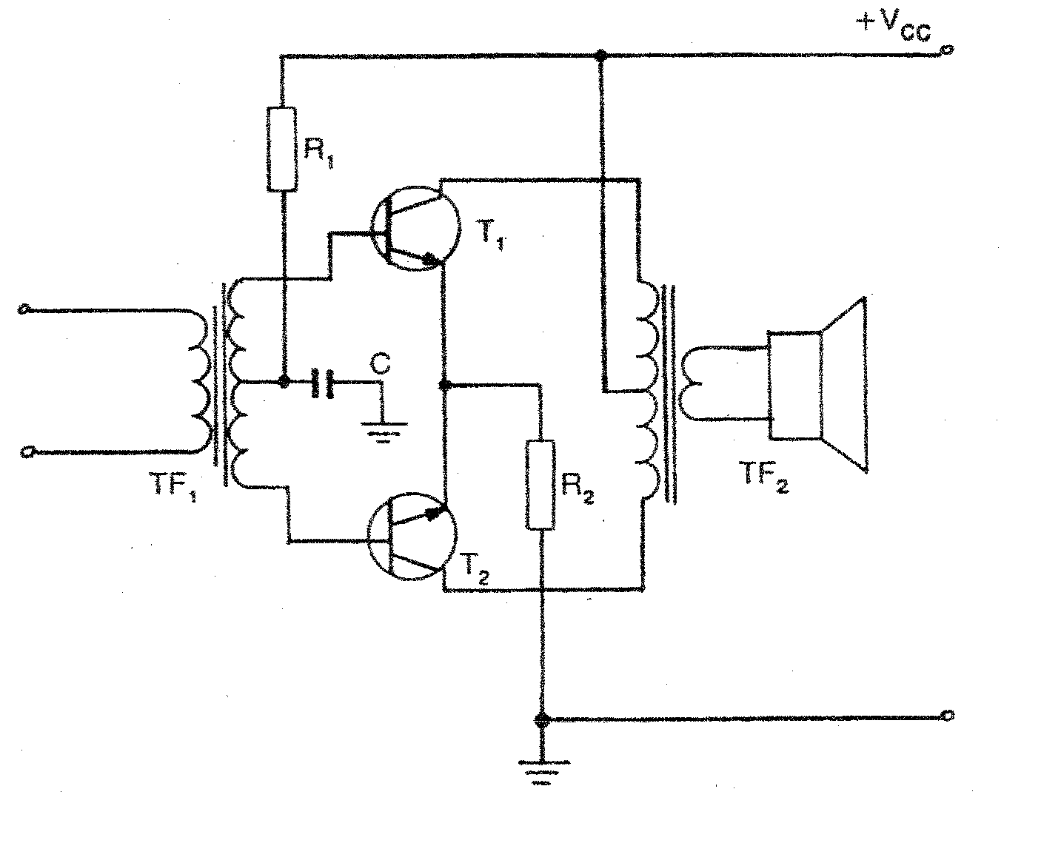

- Identify the circuit illustrated above.  - Explain the purpose and operation of TF₁ in the circuit.  - State TWO functions of TF₂.  - What class of amplification is used by each of the transistors? | (2)  (8)  (2)  (2)  [30]

QUESTION 9  SWITCHING AND CONTROL CIRCUITS  - Define the concept regulated power supply.  - A practical power supply can be designed to convert 220 V supply voltage into a desired dc voltage. Design a simple 12 volt dc regulated power supply circuit to maintain an essentially constant output voltage under changing load conditions. Your circuit should include a step down transformer, a diode rectifier circuit, a filter circuit and a shunt regulator. All the relevant waveforms should be indicated. (Please note that this should not be a block diagram.) | (3)  (18)

9.3 Describe by means of a circuit diagram how a transistor can be used as a switch. Name the requirements to switch on a transistor. | (6)

9.4

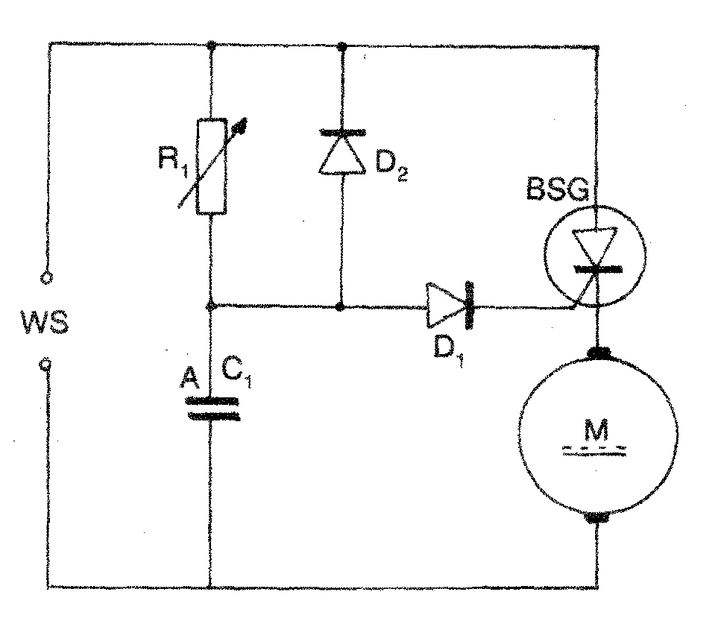
AC
SCR

- Identify the circuit illustrated above.  - Explain the relation between the adjustment of R1 and the power in the load.  - What type of load is used in the circuit?  - Why would there be an absence of current in the load during the negative half cycle of the supply voltage? | (2)  (6)  (1)  (3)  [39]

QUESTION 10  OSCILLATORS  - What is the function of the crystal in the crystal-controlled Hartley oscillator circuit?  10.2 | (2)

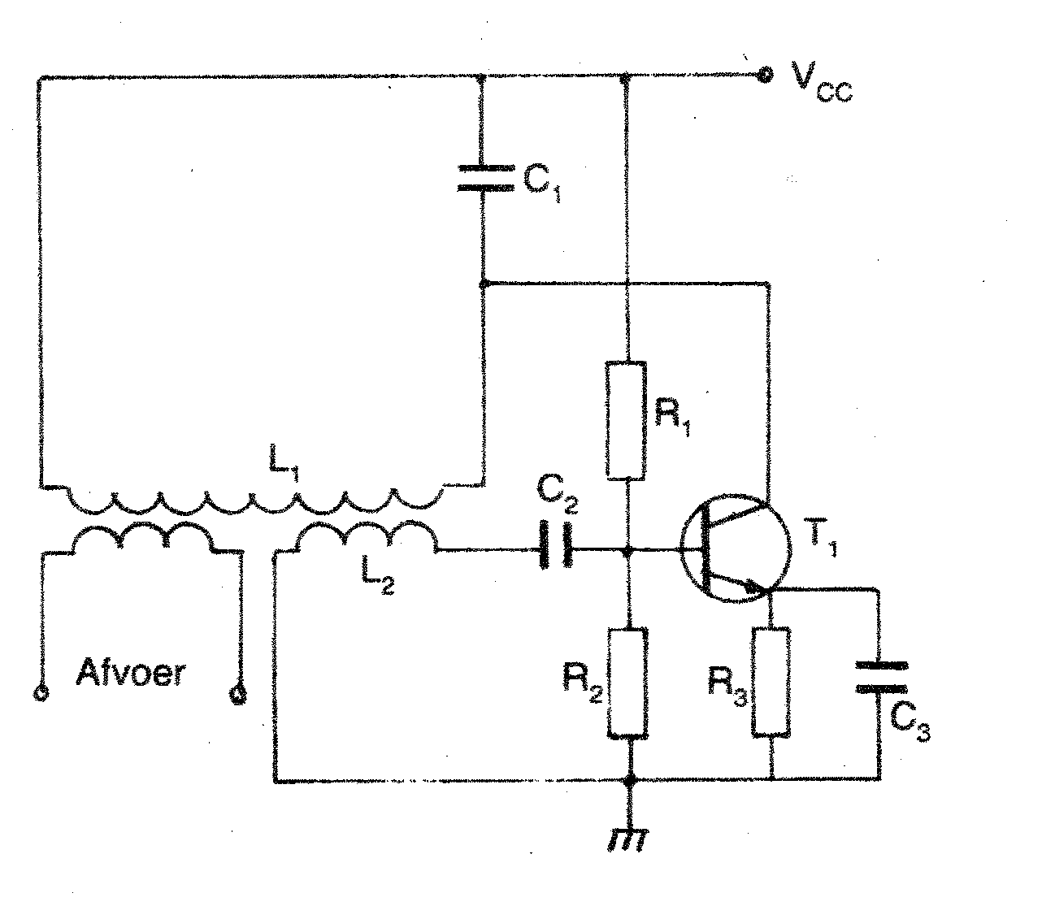
output

- Identify the circuit illustrated above.  - Identify the components which determine the frequency of the output signal.  - Which component is responsible for the amplification in the circuit?  - Describe the principle of operation of the circuit step-by-step. | (1)  (2)  (1)  (6)  [12]

QUESTION 11  APPLICATION OF OPERATIONAL AMPLIFIERS  - Show with the aid of a diagram how an operational amplifier can be connected to operate as an astable multivibrator.  11.2 Name TWO characteristics of the operational amplifier as an astable multivibrator. | (6)  (2)  [8]

QUESTION 12  COMPUTER PRINCIPLES  - Differentiate between combination and sequential circuits.  - Simplify the following Boolean equation:  X = A + (ABC + ABC) + (BC + B)  12.3 Design a logic circuit for increased reliability on a spacecraft where triple sensing systems are used. No action is taken unless at least two of the three systems call for action. (HINT: Draw a truth table, simplify your logic circuit by means of Boolean algebra.) | (2)  (6)  (17)  [25]

QUESTION 13  MEASURING INSTRUMENTS  - Sketch a neatly labelled block diagram of a digital inductance meter.  13.2 | (7)

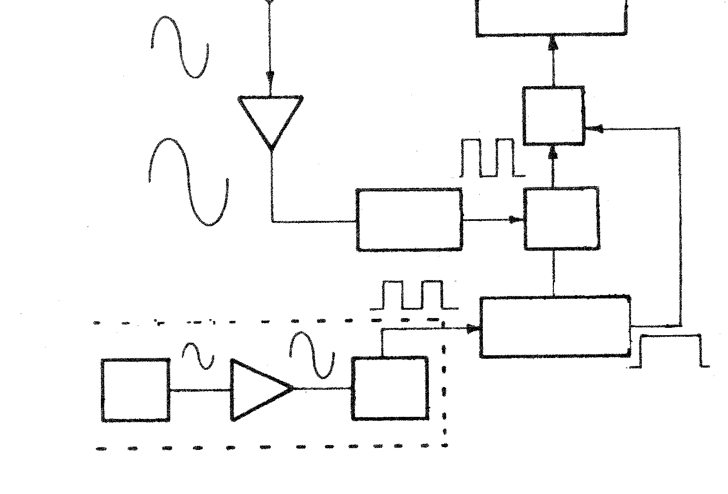
input
display unit
amplifier
counter
wave transformer
gate control
clock pulse control circuit
crystal oscillator
clock pulse generator
Schmitt
trigger

- Identify the block diagram in Question 13.2.  - What is the function of the Schmitt trigger?  - What is the function of the crystal oscillator?  13.3 Draw a labelled circuit diagram to show how one wattmeter can be connected to measure the power in a balanced, star-connected load. Give the appropriate formula.  TOTAL: | (1)  (2)  (2)  (6)  [18]  300

