GAUTENG DEPARTMENT OF EDUCATION

SENIOR CERTIFICATE EXAMINATION

TECHNIKA (ELECTRICAL) SG

TIME: 3 hours

MARKS: 200

REQUIREMENTS:

- Drawing instruments and an approved calculator.

INSTRUCTIONS:

- Answer ALL questions.
- Sketches and diagrams must be clear.
- Formulae and calculations must be clear.
- Formulae and calculations must be shown, where applicable.
- A list of formulae that may be used, where applicable, is given on the last page of this paper.

QUESTION 1  ELECTRICAL CURRENT THEORY  - A parallel circuit consisting of a resistor to the value of 12 Ω and a pure inductor with a value of 1,5 H as well as a capacitor to the value of 80 µF are coupled to an alternating supply of 240 V 55 Hz.  Calculate the following:  1.1.1 The current flow through each of the components of the circuit as well as the total current flow through the parallel circuit  - The impedance of the circuit  - The Q-factor of the circuit  1.2 Explain briefly the term electric oscillation. | (18)  (3)  (3)  (2)

1.3 Explain briefly the term reactive power.  - Draw a fully labelled current triangle for a RC circuit.  - Why is the improvement of power factor used in practice?  - State the reason why it is not always advantageous to improve the power factor of an installation to the maximum?  - What would the power in a purely inductive circuit with a pure inductance of 100 H be if it is coupled to an alternating current source of  200 volt 50 Hz?  - State your understanding of the term power factor. | (2)  (4)  (1)  (1)  (1)  (2)  [37]

QUESTION 2  ONE AND THREE PHASE ALTERNATING SYSTEMS  - Name TWO advantages of three phase alternating current systems above single phase alternating current systems.  2.2 Using simple sketches, explain briefly how three phase electricity is generated. | (2)  (8)  [10]

QUESTION 3  TRANSFORMERS  - Draw a neat diagram to explain how THREE single phase transformers would be coupled to obtain a star-delta transformer configuration.  - A three phase delta-star transformer has the primary windings connected to a 6,6 kV three phase supply. The secondary winding is coupled so that the secondary line voltage is 380 volt. The power of the transformer is 250 kVA. The power factor of the transformer is 0,85 lagging. The number of windings on the secondary winding of the transformer is 50.  Calculate the following:  3.2.1 The number of turns on the primary winding  - The value of the secondary line current  3.3 Indicate, using a simple circuit diagram, how a voltmeter should be connected to a 10kV alternating supply. | (7)  (6)  (3)  (4)  [20]

QUESTION 4  ALTERNATING CURRENT MOTORS  - Explain the basic principle of operation of the induction type three phase motor.  - Explain the functional operation of the capacitor run motor, by means of a neat labelled sketch and brief explanation.  - Name THREE methods that can be used to start three phase star-delta-  motors.  - Under which circumstances will the slip-ring motor be used?  - Name TWO advantages of the squirrel cage motor.  - Give TWO uses of the shaded pole motor. | (8)  (10)  (3)  (2)  (2)  (2)  [27]

QUESTION 5  SEMI CONDUCTORS  - Explain, using a fully labelled diagram and brief explanation the principle of operation of a bipolar transistor.  - Draw a neatly labelled sketch showing the basic composition of a SCR (Silicon Controlled Rectifier). | (8)  (2)  [10]

QUESTION 6  AMPLIFIERS  - Draw a neatly labelled circuit diagram of a push-pull amplifier.  - A common emittor amplifier has a load resistance to the value of 4 kΩ. The circuit is then coupled to a 10 V supply. Determine the value of the amplifier’s loadline, by means of calculations and a neatly labelled graph.  - Define the term feedback and explain the difference between negative and positive feedback. | (10)  (6)  (4)  [20]

QUESTION 7  SWITCHING AND CONTROL CIRCUITS  - Draw a neatly labelled circuit diagram of a lamp dimming circuit using a silicon controlled rectifier. Further explain the principle of operation of this circuit.  - Explain the principle of operation of the zenerdiode.  - Identify the underlying circuit (Figure 7.1). Explain how increasing the resistance of the potensiometer (R2) will influence the operation of the circuit.  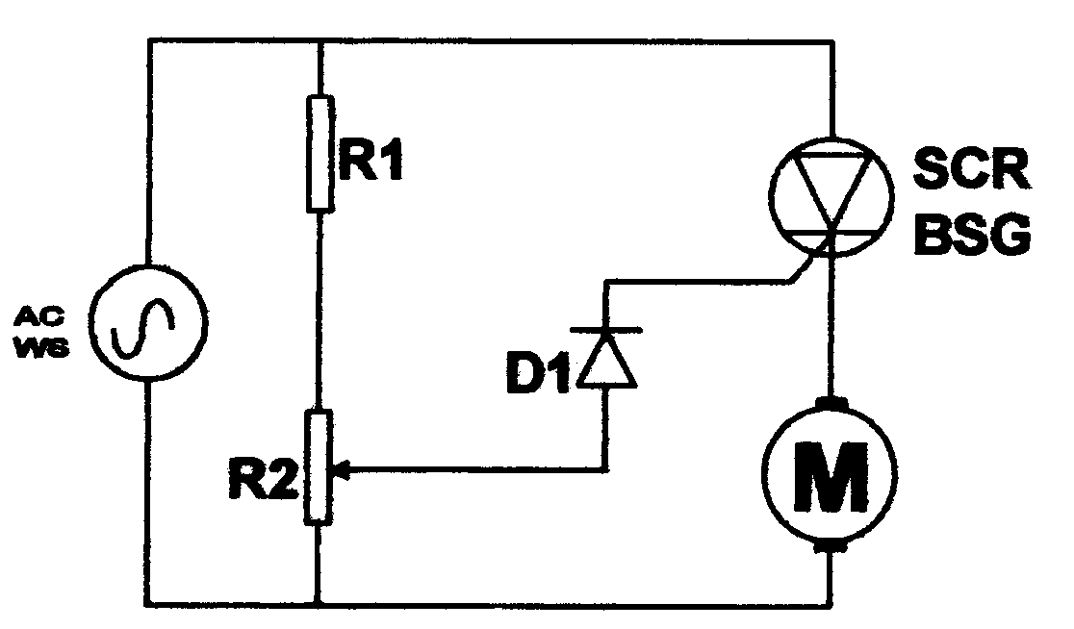  Figure 7.1 | (10)  (4)  (6)  [20]

QUESTION 8  APPLICATION OF OPERATIONAL AMPLIFIERS  8.1 Explain, using an integrating circuit with an operational amplifier, how a triangular wave output is obtained from a square wave supply. | (10)  [10]

QUESTION 9  OSCILLATORS  9.1 Explain the basic principle of operation of the tuned collector oscillator using a neatly labelled circuit diagram. Explain briefly the principle of operation as well. | (10)  [10]

QUESTION 10  COMPUTER PRINCIPLES  10.1 Explain, using a logic circuit diagram and truth table the principle of operation of a half adder.  - Determine the Boolean expression of the logic circuit below (Figure 10.1) using Boolean Algebra and de Morgan’s rules.  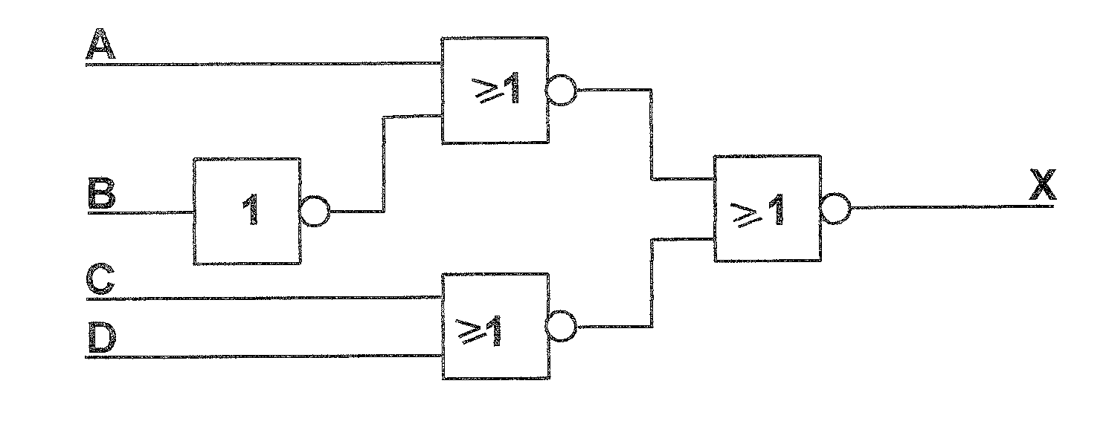  Figure 10.1 | (12)  (8)  [20]

QUESTION 11  Display Unit  Counter  Gate Control  Comparator  Reference Voltage  Convertor  Amplifier  Oscillator  Constant Power supply  MEASURING INSTRUMENTS  - Explain the basic operation of the oscilloscope using a simple block diagram.  11.2 Look at the sketch below (Figure 11.1).  11.2.1 Identify the circuit below (Figure 11.1).  - Explain the function of the comparator circuit.  - Name an example of a circuit that can be used as a wave convertor circuit.  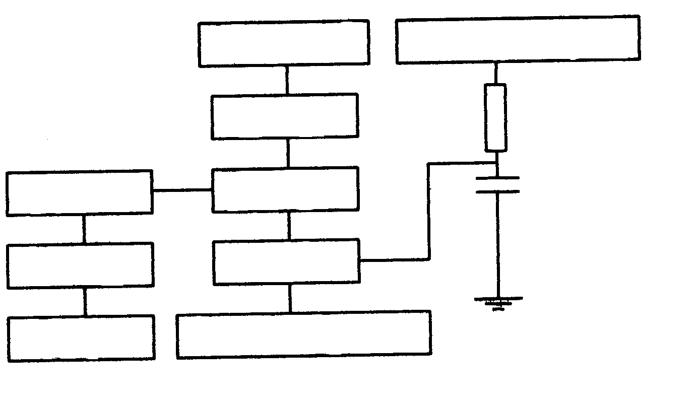  Figure 11.1 | (5)  (1)  (2)  (2)  [10]

QUESTION 12  SAFETY  - Name THREE causes of industrial accidents.  - Indicate TWO precautionary measures that have to be taken when administering first aid in order to prevent contracting the HIV virus.  - Explain what the abbreviation Aids stands for.  TOTAL: | (3)  (2)  (1)  [6]  200

