GAUTENG DEPARTMENT OF EDUCATION

SENIOR CERTIFICATE EXAMINATION

TECHNIKA (ELECTRICAL) HG

TIME: 3 hours

MARKS: 300

REQUIREMENTS:

- Drawing instruments and an approved calculator

INSTRUCTIONS:

- Answer ALL the questions.
- Sketches and diagrams must be clear and writing must be legible.
- Formulae and calculations must, where applicable, be indicated.
- A list of formulae which may be used where applicable, is provided on page 11 of the question paper. You may detach it for easy reference.

QUESTION 1  OCCUPATIONAL SAFETY  - Explain how you would apply artificial respiration to a person who has stopped breathing as a result of an electric shock. | (4)

1.2 Explain how Aids can be spread from one person to another. | (3)  [7]

QUESTION 2  ELECTRICAL CURRENT THEORY  - A coil with an insignificantly small resistance has an inductance of 75 mH and is connected in series with a 0,22 micro-Farad capacitor and a 20 Ohms resistor. The supply voltage is 110 Volts, 500 Hertz. Calculate accordingly:  2.1.1 The maximum current flow in the circuit  - The voltage over the reactive parts of the circuit when maximum current flow takes place  - The Q-factor of the circuit  - The phase angle when maximum current flow takes place in the circuit | (4)  (7)  (3)  (4)

2.2 A parallel resonance circuit consists of a capacitor of 100 micro-Farads and a coil of which the inductance is 25 mH and the resistance 5 Ohm. The supply voltage is 25 Volts.  - Draw a neat labelled diagram of the circuit.  - Calculate the dynamic impedance of the circuit.  - Calculate the value of the supply current.  - Calculate the value of the circulating current.  - At which frequency will the circuit resonate?  - Draw a neat labelled current phasor diagram (not according to scale, but in good relation to the circuit). | (4)  (3)  (3)  (3)  (3)  (3)

2.3 Explain the following terms:  - The ampère  - Frequency  - Phasor  - Electromagnetic induction | (4)  (2)  (2)  (4)

2.4 Describe the meaning of each of the following concepts:  - Q factor  - Active component of alternating current  - Efficiency | (2)  (2)  (3)  [56]

QUESTION 3  SINGLE- AND THREE-PHASE ALTERNATING CURRENT SYSTEMS  - Three identical coils are connected in star to a 400 volts, 50 hertz three-phase supply. The total power used by the coils is 1,5 kW at a power factor of 0,2.  Determine the resistance and the inductance of each coil. | (23)

- Prove that the total power used in a star connected three-phase system is:  P = $\sqrt{3}$.V_{L}.I_{L}.Cos ø watts. | (7)  [30]

QUESTION 4  TRANSFORMERS  - The winding of an auto-transformer consists of 1 000 turns, and is used to transform 250 volts to 25 volts.  4.1.1 State the disadvantage of this specific application in which the voltage is stepped down to 25 volts.  - Make a neat labelled diagrammatic representation of the transformer.  - Calculate the position of the tap on the winding where the 25 volts are obtained (number of secondary turns). | (3)  (4)  (4)

4.2 Three identical single phase transformers, each having a turn ratio of 50:1, are connected in star-delta across a 33 kV supply. The load connected to the transformers is a three-phase star connected motor with a power factor of 0,8 and an efficiency of 90%.  - Draw a neat labelled circuit diagram of the transformers, the motor and all the inter-connections.  - Calculate the voltage across each motor winding.  - Calculate the current through each motor winding if the output power of the motor is 20 kW. | (8)  (11)  (9)  [39]

QUESTION 5  ALTERNATING CURRENT MOTORS  - Explain the term synchronous speed of an electric motor. | (2)

5.2 A four-pole three-phase induction motor is connected to a 380V/50Hz supply. Calculate the synchronous speed. | (4)

5.3 Sketch a neat labelled diagram to show the internal wiring of a capacitor start motor. | (7)

5.4 What is the most important difference between a starting capacitor for an electric motor and a regular electrolytic capacitor? | (2)

5.5 How can the direction of rotation of a single-phase capacitor run motor be altered? | (2)

- A four-pole three-phase induction motor is connected to a 380 V, 50 Hz-supply.  Calculate:  5.6.1 The synchronous speed  5.6.2 The rotor speed if the slip is 4% | (3)  (3)

- A single-phase alternating current motor is connected to a 500V, 50 Hz supply. The motor develops 20 kW at a lagging power factor of 0,8. If the efficiency of the motor is 84%, calculate:  5.7.1 The input kVA  5.7.2 The active component of the current | (4)  (3)  [30]

QUESTION 6  SEMI-CONDUCTORS  - Briefly explain the difference between a silicon controlled rectifier and a conventional diode.  6.2 Explain by means of neatly labelled sketches and brief descriptions the basic construction and functional operation of a silicon controlled rectifier (SCR). | (3)  (12)  [15]

QUESTION 7
AMPLIFIERS

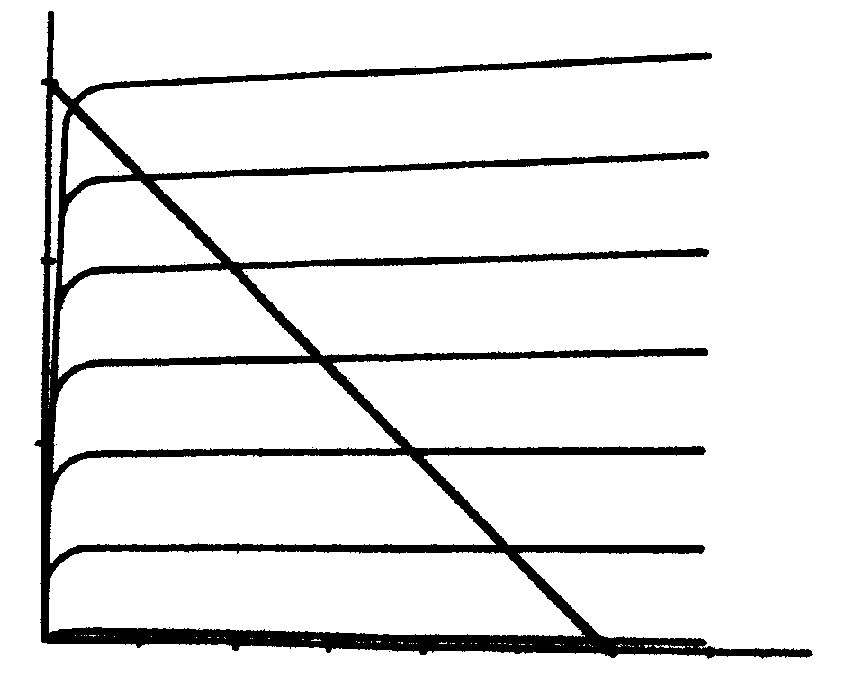
I_{C} (mA)
15

10

5

0 2 4 6 8 10 12 14 V_{CE}
I_{B} = 120 μA

I_{B} = 100 μA

I_{B} = 80 μA

I_{B} = 60 μA

I_{B} = 40 μA

I_{B} = 20 μA

I_{B} = 0

(Volts)

Figure 7.1: Loadline

7.1 Figure 7.1 illustrates the loadline of a certain amplifier. If we assume the amplifier employs class A amplification, determine  7.1.1 the supply voltage for this circuit.  7.1.2 the value of Rc.  7.1.3 the value of I_{B} at the quiescent point. | (2)  (3)  (2)

7.2 Answer the questions that follow with reference to Figure 7.2.

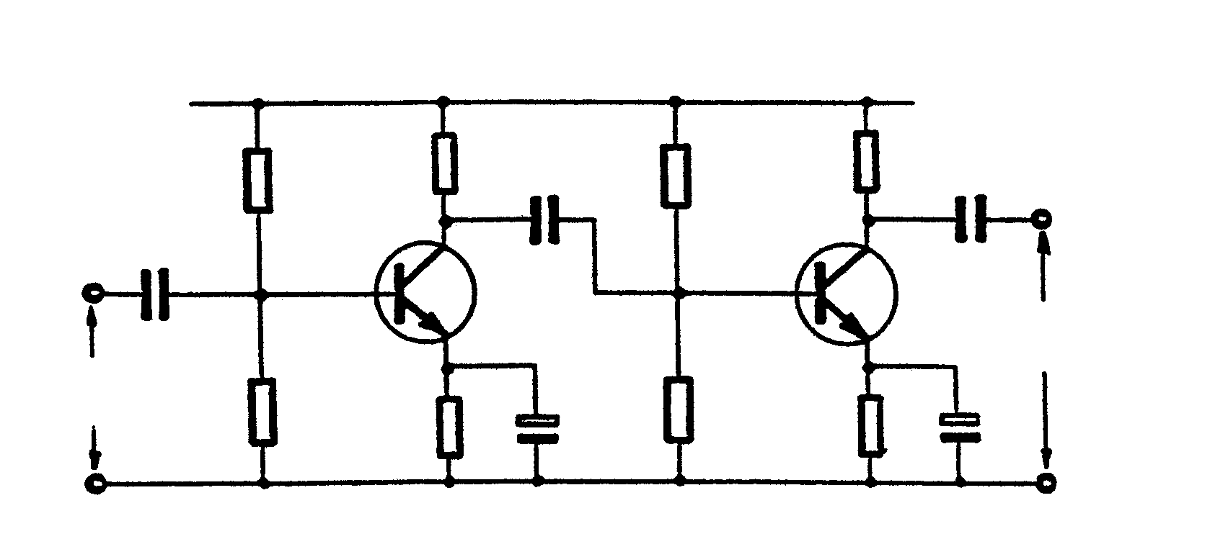
+V_{CC}
R_{B1}
C_{E1}
R_{B4}
R_{B2}
R_{C1}
R_{B3}
R_{C2}
C₂
C_{E2}
C₃
C₁
Q₁
Q₂
+
+
Input
Output

Figure 7.2

- Identify the circuit.  - What is the purpose of each of the following?  - R_{B1} and R_{B2}. Indicate why this is necessary.  - C_{E1}  - C₁ and C₂ | (2)  (4)  (2)  (2)

7.3 Calculate the gain in dB’š if a 2W input signal results in a 6W output signal. | (3)

7.4 Describe the term positive feedback. | (2)

7.5 Answer the questions that follow with reference to Figure 7.3.

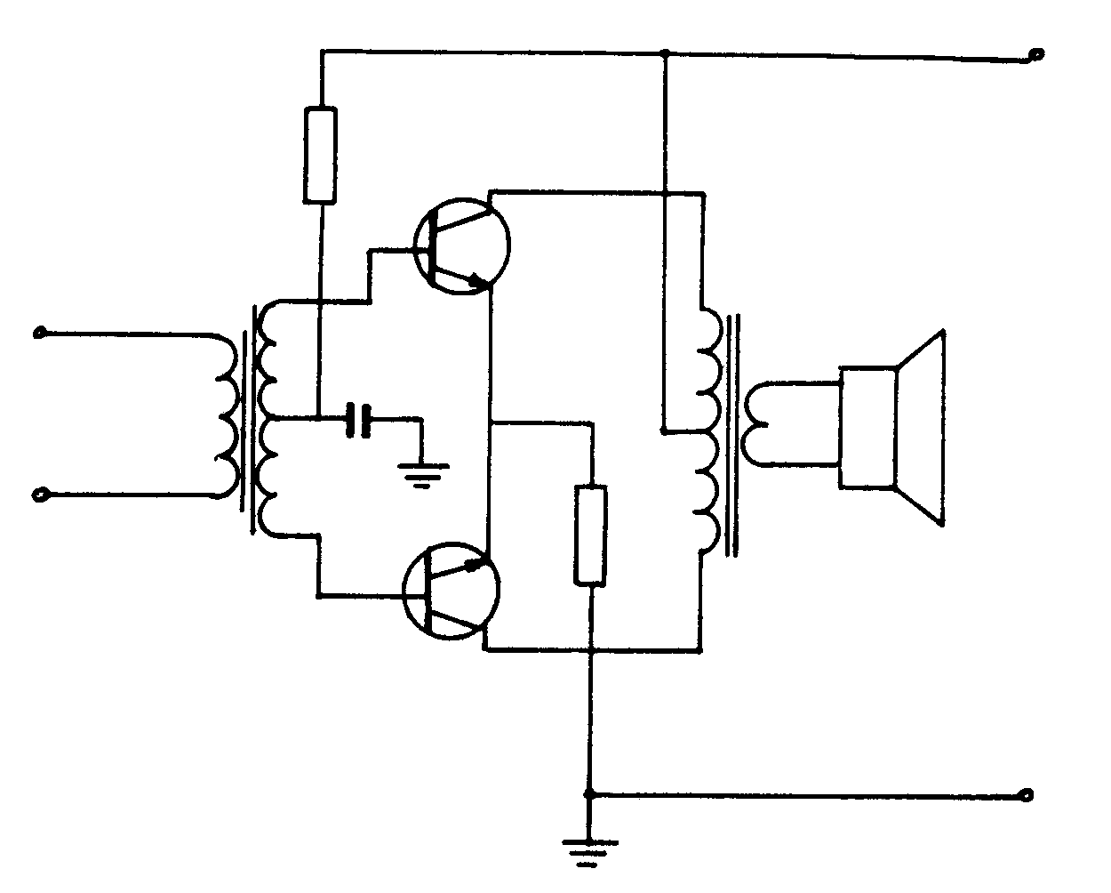
+V_{CC}
R₁
T₁
TF₂
T₂
TF₁
R₂
out
in

C

Figure 7.3

- Identify the circuit in Figure 7.3.  - Where is this type of amplifier generally used?  - What is the function of TF?  - What is the function of R₂?  - State TWO functions of TF₂. | (2)  (2)  (2)  (2)  (2)  [32]

QUESTION 8
SWITCHING AND CONTROL CIRCUITS

8.1 Briefly explain the term regulated power supply. | (3)

8.2 Answer the questions that follow with reference to Figure 8.1.

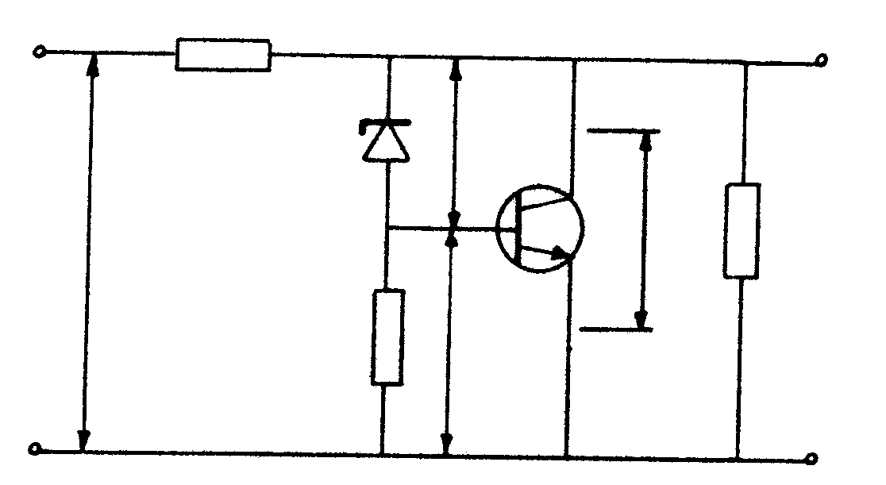
Vr₁
R₁
R₂
R_{L}
T₁
V_{z}
V_{in}
V_{BE}
D_{z}
V_{out}
V_{CE}

Figure 8.1

- Identify the circuit in Figure 8.1  - Fully describe how the circuit will compensate for a reduction in the value of R_{L}. | (2)  (10)

8.3 Draw a neat labelled circuit diagram of a 180º (full wave) phase control circuit to control the power of an electric motor. Explain what influence the capacitor value has on the working of the circuit. | (10)  [25]

QUESTION 9
OSCILLATORS

9.1 Answer the questions that follow with reference to Figure 9.1.

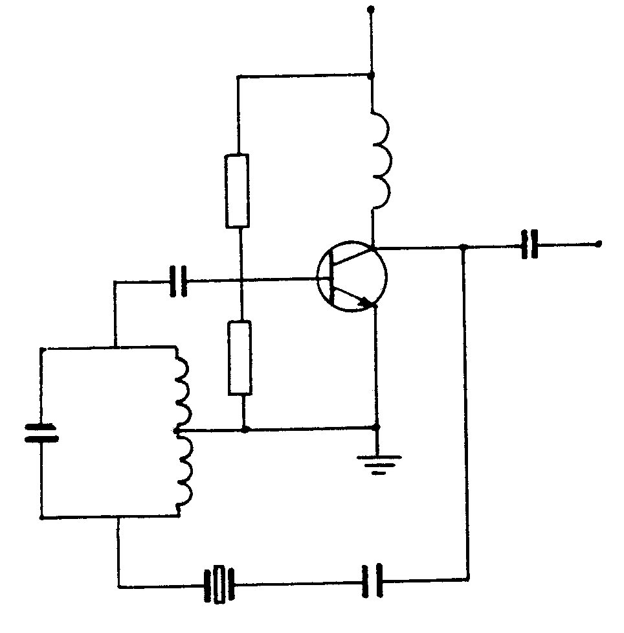
V_{CC}
L₂
C₁
L₁¹
R₂
T
C₂
R₁
Y₁
L₁²
C₃
C₄

Figure 9.1

- Identify the circuit in Figure 9.1.  - Explain the function of L₂.  - Explain how Y₁ maintains a constant output frequency if the frequency of the tank circuit tends to increase. | (2)  (2)  (5)

9.2 Name TWO differences between a bistable and an astable multivibrator. | (2)

9.3 Explain the following terms with reference to oscillators:  - Positive feedback  - Tank circuit  - Piezo electric effect | (2)  (2)  (2)  [17]

QUESTION 10
APPLICATION OF OPERATIONAL AMPLIFIERS

  - Answer the questions that follow with reference to Figure 10.1.
+ V_{CC}
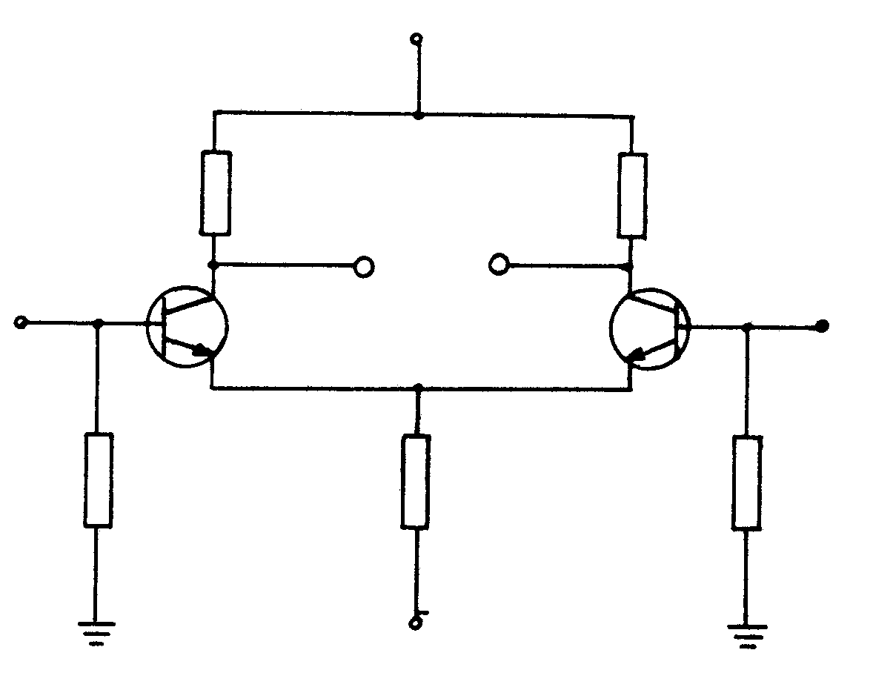
R₂
T₂
V₂
R₃
A
B
R_{E}
R₁
T₁
V₁
V_{EE}
R₄

Figure 10.1

10.1.1 Identify the circuit in Figure 10.1.  - What is the function of R_{E}?  - How will an increase in current through T₁ influence the current throughT₂?  - In what mode will this circuit be when the output signals have the same  amplitude and phase relationship?  - Why does the circuit have a high degree of thermal stability? | (1)  (2)  (2)  (1)  (5)

10.2 Name TWO characteristics of an operational amplifier. | (2)  [13]

QUESTION 11
COMPUTER PRINCIPLES

11.1 Give the Boolean expression of a half adder. | (2)

11.2 Draw the logic diagram of an RS flip-flop and give the truth table thereof. | (10)

- An artisan uses THREE electric machines to manufacture furniture. The overload switch in the workshop cuts out on 121 Ampéres. Machine A uses 50A,  machine B uses 70A and machine C uses 60 A. If the artisan uses more than 120A the power will be interrupted.  11.3.1 Draw a truth table for the combinations of the machines that would not  interrupt the power supply.  - Write down the Boolean expression for the functions in Question 11.3.1 and  simplify the Boolean expression.  - Draw a logical circuit for the simplified Boolean function. | (8)  (7)  (4)  [31]

QUESTION 12
MEASURING INSTRUMENTS

12.1 Answer the questions that follow with reference to Figure 12.1.

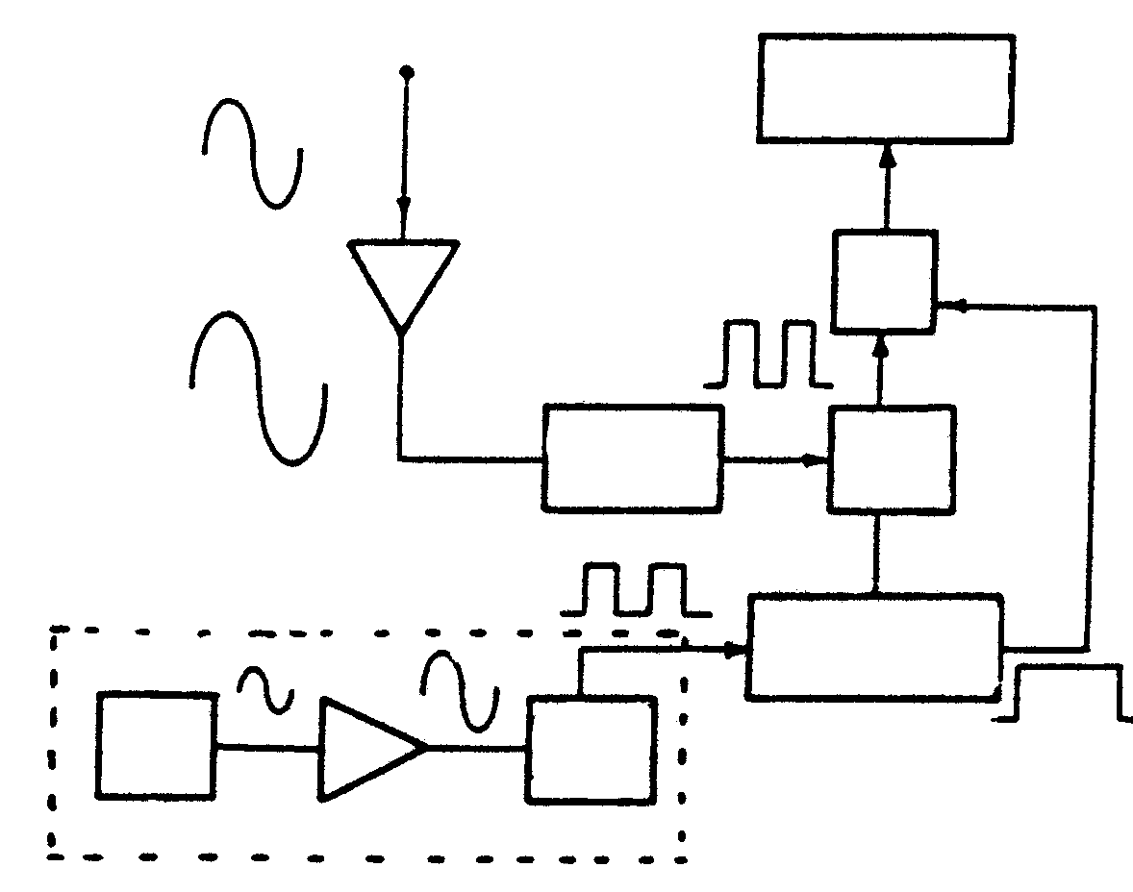
display unit
count
gate
control
clocked pulse
control circuit
Schmitt
trigger
amplifier
clocked pulse generator
Schmitt
trigger
crystal osc
input

Figure 12.1

- Identify the block diagram in Figure 12.1.  12.1.2 What is the function of the Schmitt trigger?  12.1.3 What is the function of the crystal oscillator? | (1)  (2)  (2)  [5]
TOTAL: | 300

FORMULES / FORMULAE

X_{L} = 2$π$fL I_{E} = I_{B} + I_{C}

Tydkonstante / Time constant t = RC f_{r} = $\frac{1}{\text{2π}\sqrt{\text{LC}}}$ en/and $\sqrt{\frac{1}{\text{LC}} − \frac{R^{2}}{L^{2}}}$

Z = $\sqrt{R^{2_{+}}+{\left(X_{L}−X_{c}\right)}^{2}}$ Cos $Φ$ = $\frac{P}{P}$ ^{skynbaar / apparent LC - L2}

V_{R} = I . R
V_{L} = I . X_{L}
I_{r} = I sin $Φ$ : I_{a} = I cos $Φ$ V_{C} = I . X_{C}

Ster / Star

V_{P} = $\frac{V_{L}}{\sqrt{3}}$ : I_{P} = I_{L} Z = $\frac{V}{I}$ P $\sqrt{3}$ I_{L} V_{L} cos $Φ$

Delta

V_{P} = V_{L} : I_{P} = $\frac{I_{L}}{\sqrt{3}}$ Z = $\frac{L}{\text{CR}}$
I = $\frac{V}{Z}$ f = $\frac{1}{T}$ $\frac{V_{P}}{V_{S}}$ = $\frac{N_{p}}{N_{S}}$ = $\frac{I_{S}}{I_{P}}$

ƒ = $\frac{W}{\text{2π}}$ I_{c} = $\frac{V_{\text{ce}}}{R_{L}}$

X_{c} = $\frac{1}{2π\text{CF}}$ Rendement / Efficiency = $\frac{\text{Uitset/Output}}{\text{Inset/Input}}$

Cos $Φ$ = $\frac{R}{Z}$ I_{c} = V $\sqrt{\frac{C}{L}}$

S =$\frac{\text{Ns}−\text{Nr}}{\text{Ns}}$ A_{F} = A_{v} / $\left(1±{\text{BA}}_{v}\right)$

$β=\frac{I_{c}}{I_{B}}$ N = 10Log $P2P1$

Q = $\frac{X_{L}}{R}$ $\frac{Np}{Ns}$ = $\sqrt{\frac{Z_{p}}{Z_{s}}}$
N = $\frac{F}{p}$ Nr = Ns - S

