GAUTENG DEPARTMENT OF EDUCATION

SENIOR CERTIFICATE EXAMINATION

TECHNIKA (ELECTRICAL) HG

TIME: 3 hours

MARKS: 300

REQUIREMENTS:

- Drawing instruments and an approved calculator.

INSTRUCTIONS:

- Answer ALL the questions.
- Sketches and diagrams must be clear and writing must be legible.
- Formulae and calculations must, where applicable, be indicated.
- A list of formulae, which may be used when applicable, is provided on the last page of the question paper.

QUESTION 1  OCCUPATIONAL SAFETY  - Briefly describe the safety precautions which must be complied with before a portable electric appliance is taken into use.  1.2 State TWO important causes of industrial accidents. | (5)  (2)

1.3 In case of an accident taking place in the workshop, i.e. someone has cut himself/herself and there is bleeding, what precaution would you take to ensure that you would not be infected with the HIV virus? | (1)  [8]

QUESTION 2  ELECTRICAL CURRENT THEORY  - A resistance of 10 ohms, an inductance of 200 milli-henrys and a capacitor of 100 micro-farads are connected in series across a  250V 50 Hz supply.  Calculate:  2.1.1 The circuit impedance  - The circuit power factor  - The reactive component of the current  2.2 A coil with a resistance of 10 ohms and an inductance of 50 milli-henrys is connected in parallel with a capacitor of 200 micro-farads across a supply voltage represented by the equation.  V = 100 sin (628+ $\frac{\text{85}xΠ}{\text{180}°}$ ) volt.  Calculate:  - The supply frequency  - The resonate frequency of the circuit  - The dynamic impedance of the circuit  - The value of the circulating current | (9)  (3)  (7)  (3)  (3)  (3)  (3)

2.3 In a certain balanced, star connected three-phase circuit with an inductive load, the line to line voltmeter reading is 380 V, the ammeter reading 10 A and the wattmeter reading 3 kW.  Determine:  - The phase voltage  - The phase current  - The power factor of the load  - The phase impedance  - The phase resistance | (3)  (2)  (3)  (3)  (3)  [45]

QUESTION 3  SINGLE- AND THREE-PHASE ALTERNATING CURRENT SYSTEMS  - State THREE characteristics of a balanced, star connected system.  - A resistance load draws 15A when connected to a 125 V supply. An inductor is connected in series with this load to a 240 V, 50 Hz supply. The current through the load remains the same. Ignore the resistance of the load and  3.2.1 calculate the inductance of the coil in mH.  - calculate the phase difference between the current and the applied voltage and state whether it is leading or lagging.  - calculate the voltage across each component.  - draw a neat labelled voltage phasor diagram of the circuit in good proportion.  - draw a neat labelled impedance triangle of the circuit to any applicable scale. | (3)  (14)  (5)  (6)  (6)  (4)  [38]

QUESTION 4  TRANSFORMERS  - Three single phase transformers are connected in delta to a 3 kV supply. The secondaries of the transformers are connected in star and supply 415 V line voltage to a balanced load. The power in the load is 150 kW at a power factor of 0,8 lagging. The primary is wound at 4 V per turn. Assume 100% efficiency.  4.1.1 Draw a neat labelled diagram to show the connection of the transformers.  - Calculate the number of primary windings.  - Calculate the number of secondary windings.  - Calculate all the current values in the circuit.  4.2 Describe fully why the secondary windings of a current transformer may never be left open-circuited.  4.3 State TWO disadvantages and TWO advantages of an autotransformer. | (5)  (5)  (5)  (13)  (6)  (4)  [38]

QUESTION 5  ALTERNATING CURRENT MOTORS  - Describe how the direction of rotation of a capacitor run induction motor can be changed.  - Briefly describe TWO methods that are used in starters to limit the starting current of three phase squirrel cage motors.  - A four pole squirrel cage induction motor is connected to a 380 V alternating current supply with a periodic time of 0.02 seconds. The motor slip is calculated to be 0,04.  Calculate:  5.3.1 The supply frequency  - The rotor speed  5.4 Sketch a neat labelled diagram to show the internal wiring of a capacitor start motor.  5.5 Give the phase order of a three phase system. | (2)  (6)  (3)  (6)  (7)  (3)  [27]

QUESTION 6
SEMI-CONDUCTORS

6.1 With reference to Figure 6.1 answer the questions that follow.

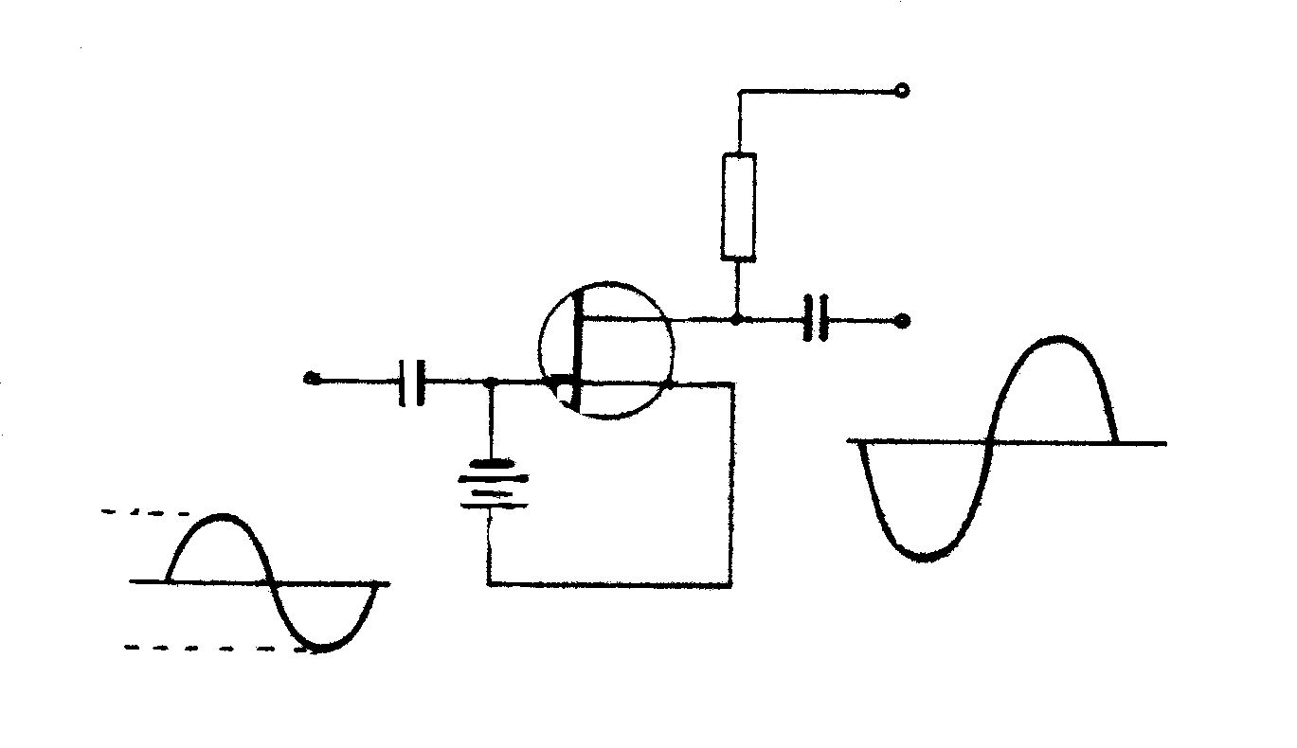
+50 V
V_{G} = –3 V
C₁
C₂
R₁
T₁
–2V
–3V
–4V

Figure 6.1

- Identify the above circuit.  - Identify T₁.  - Briefly describe the function of R₁.  - What is the phase relation between the input and the output signals?  - Draw the simbol of T₁ in your answer book and identify each terminal.  - Discuss TWO advantages of the above circuit as compared to a functionally equivalent bipolar transistor circuit. | (2)  (2)  (2)  (1)  (3)  (4)  [14]

QUESTION 7  AMPLIFIERS  - Calculate the turns ratio of a transformer which matches an 8 ohms speaker to an amplifier with an output impedance of 400 ohms so as to obtain maximum power transfer.  - The input power of an amplifier is 20 W. Calculate the gain, in decibels, if it supplies 50 W to a load.  - Sketch a typical frequency characteristic curve of a mutually coupled amplifier.  - Draw a diagram of a Darlington amplifier with NPN transistors.  - A simple common emitter amplifier is connected to a load resistor of  4k-ohms. The voltage supply to the circuit is 10V.  7.5.1 Calculate the co-ordinates of the loadline.  7.5.2 Draw the load line according to an appropriate scale. | (4)  (3)  (4)  (7)  (6)  (5)  [29]

QUESTION 8  SWITCHING AND CONTROL CIRCUITS  - Fully describe why it is sometimes necessary to connect a regulator to the output of a dc voltage source so as to form a regulated voltage supply.  - Describe, with the aid of a circuit diagram and a brief discussion, how full wave lamp dimming can be obtained in an ac circuit.  - Sketch a circuit diagram of a circuit capable of limiting a sinus oidal voltage with a maximum value of 10V, to 5V in both directions. All input and output waveforms must be shown. | (5)  (12)  (8)  [25]

QUESTION 9  OSCILLATORS  Draw a neat labelled diagram of a crystal controlled Harley oscillator and name the most important reason for including the crystal in the circuit. | (12)  [12]

QUESTION 10  APPLICATION OF OPERATIONAL AMPLIFIERS  Draw a diagram of a bi-stable multivibrator which uses an operational amplifier. | (5)  [5]

QUESTION 11  –  COMPUTER PRINCIPLES  Sketch a logic combination circuit for the following Boolean equation:  X = (A + B) (Ā + B)  - Explain the meaning of the following terms briefly:  11.2.1 Combination circuit  - Clock pulse  - Full adder  11.3 Draw a schematic diagram of a clocked RS latch consisting of nand gates. Use a truth table to show the output of the latch for all possible input combinations. Assume in each case that the clock pulse = 1.  11.4 An electronics engineer is approached to design a circuit consisting of three switches, A, B and C, which will allow the current to flow under the following conditions:  * Switches A and C open and B closed  * Switches B and C open and A closed  * Switches A and C closed and B open  * All three switches closed  - Draw up a truth table for the circuit.  - Derive a logical expression for the circuit.  - Simplify the Boolean expression and sketch a logic circuit of the expression. | (4)  (2)  (2)  (2)  (12)  (8)  (4)  (10)  [44]

QUESTION 12  MEASURING INSTRUMENTS  - Draw a neat labelled, block diagrammatic representation of an induction meter.  12.2 The block diagram below represents a digital capacitance meter. | (9)  (6)

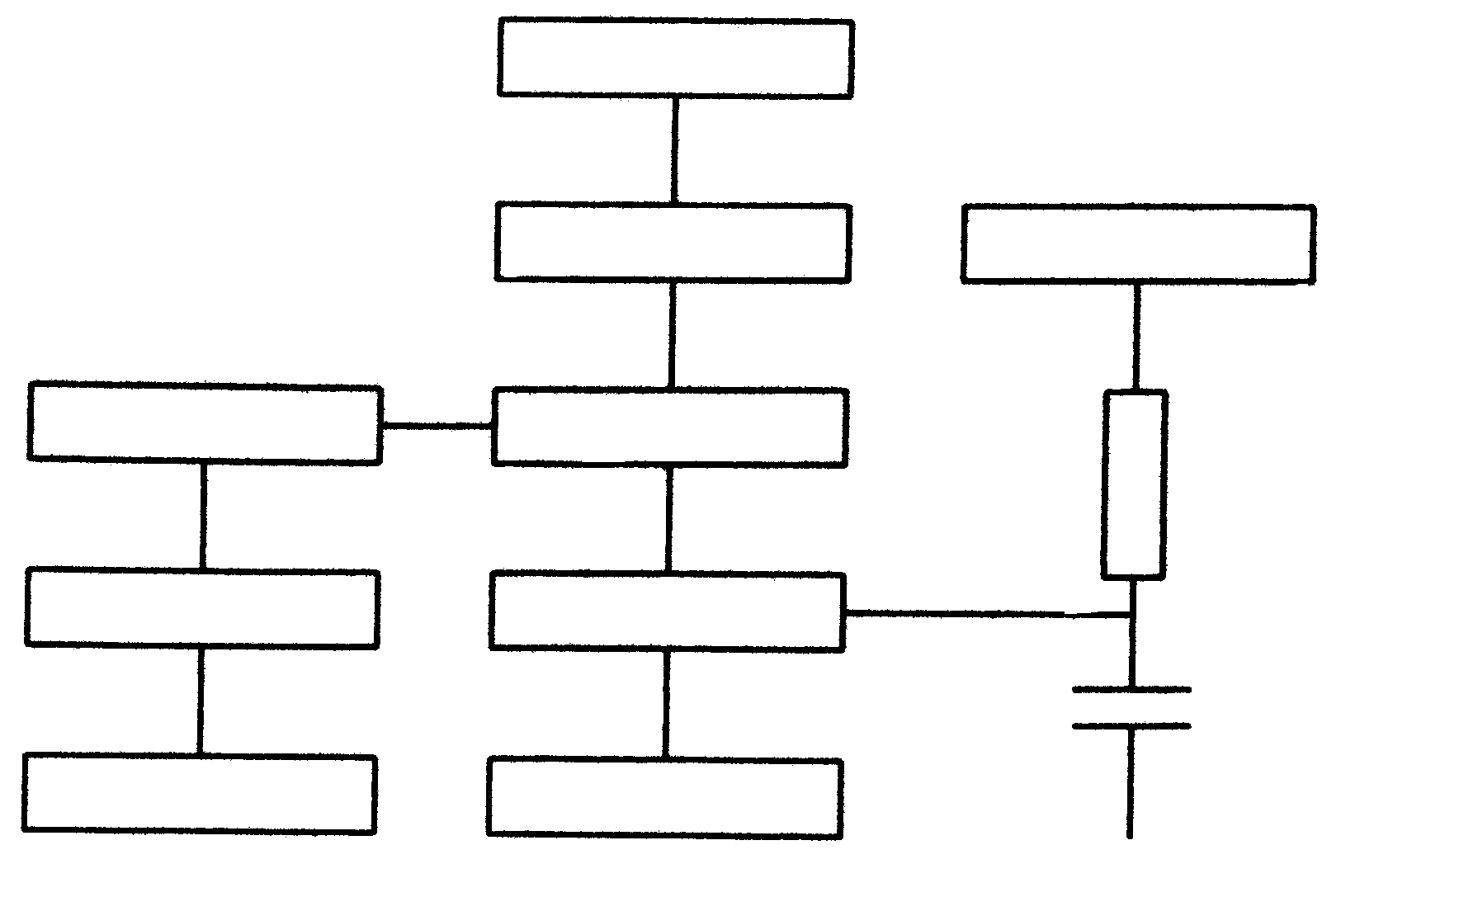
A
B
C
R
E
D
F

GATE CONTROL
COMPARATOR
OSCILLATOR
CONVERTER
EARTH

Identify the components A – F. | [15]

TOTAL: | 300

FORMULES / FORMULAE

x₆ = 2$π$fL I_{E} = I₈ + I_{c}

Tydkonstante / Time constant t = RC f_{r} = $\frac{1}{\text{2π}\sqrt{\text{LC}}}$

Z = $\sqrt{R^{2}÷{\left(X_{L}−X_{c}\right)}^{2}}$ Cos $Φ$ = $\frac{P}{P}$ skynbaar / apparent

V_{R} = IxR
V_{L} = IxX_{L}
I_{r} = I sin $Φ$ : I_{a} = I cos $Φ$ R = X cos $Φ$ V_{C} = IxX_{C}

Ster / Star
_{P} = $\frac{V_{L}}{\sqrt{3}}$ : I_{P} = I_{L} Z = $\frac{V}{I}$ P $\sqrt{3}$ I_{L} E_{L} cos $Φ$

Delta
V_{P} = V_{L} : I_{P} = $\frac{I_{L}}{\sqrt{3}}$ Z = $\frac{L}{\text{CR}}$
I = $\frac{V}{Z}$ f = $\frac{1}{{}_{L}}$ $\frac{\text{Vp}}{\text{Vs}}$ = $\frac{\text{Np}}{\text{Ns}}$ = $\frac{\text{Is}}{\text{Ip}}$

ƒ = $\frac{W}{\text{2π}}$ I_{c} = $\frac{V_{\text{ce}}}{R_{L}}$

X_{c} = $\frac{1}{\text{2πfC}}$ Rendement / Efficiency = $\frac{\text{Uitset/Output}}{\text{Inset/Input}}$

Cos $Φ$ = $\frac{R}{Z}$ I_{c} = V $α$$\sqrt{\frac{C}{L}}$

S =$\frac{\text{Ns}−\text{Nr}}{\text{Ns}}$ A_{F} = A_{v} / $\left(1÷{\text{BA}}_{v}\right)$

$β=\frac{I_{c}}{I_{B}}$ N = 10Log $\text{P2}\text{P1}$

Q = $\frac{X_{L}}{R}$ $\frac{\text{Np}}{\text{Ns}}$ = $\sqrt{\frac{\text{ZP}}{\text{ZS}}}$

Ns = $\frac{f}{p}$ Nr = Ns - S)

