GAUTENG DEPARTMENT OF EDUCATION
SENIOR CERTIFICATE EXAMINATION

TECHNIKA (CIVIL) SG

TIME: 3 hours

MARKS: 300

REQUIREMENTS:

- Answer book
- A3-size drawing paper
- Drawing instruments
- Pocket calculator
- Answer sheet SG 712-2/1(1)

INSTRUCTIONS:

- This question paper consists of TWO Sections, A and B.

- Candidates must answer Section A (COMPULSORY) and any TWO questions from Section B.

- All calculations and written answers must be done in your answer book.

- Number the questions as they appear in the examination question paper.

- Clearly indicate on the drawing paper, the number of the question you are answering.

- Drawings and sketches must be fully dimensioned and neatly finished with titles and labels to conform with the SABS Recommended Practice of Building Drawings.

- Do proper planning and use both sides of the drawing paper.

- Write your examination number on all loose pages, drawing paper and your answer book.

- For the purpose of this examination, the size of a brick should be taken as
220 mm x 110 mm x 75 mm.

- Measurements not shown or given must be taken as standardized measurements.

SECTION A

This section is compulsory for all candidates.

QUESTION 1

- Give the standard abbreviations for the following components on a sewer plan:  - Shower  - Bidet  - Vent pipe  - Water closet  - Bath  - Inspection eye | (1)  (1)  (1)  (1)  (1)  (1)

- Give the standard colour codes used to indicate the following pipes on a sewer plan:  - Vents to waste pipes  - Existing drains  - Waste pipes  - New drains | (1)  (1)  (1)  (1)

- Name any FIVE different types of bricks.  - Name any THREE tests which can be carried out on a sewer system.  - Name any SEVEN facts that can be obtained from site plans.  - Interpret the following annotated code on a plan to ensure that the correct bars will be used for reinforcement: 9R 1201 – 300  - List any FIVE requirements for concrete reinforcement.  - Name any TEN safety precautions which must be taken to ensure the safety of workers and the public while building is in progress.  - List any FIVE reasons why a sewer plan must accompany new house plans submitted for municipal approval.  - Name any FIVE requirements for cavity walls. | (5)  (3)  (7)  (5)  (10)  (10)  (5)  (5)  [60]

QUESTION 2  Figure 1 shows a diagram of a simply supported framework.  - Draw a complete space diagram using a scale of 1:100.  - Draw the vector diagram according to a scale of 10 mm = 1 kN.  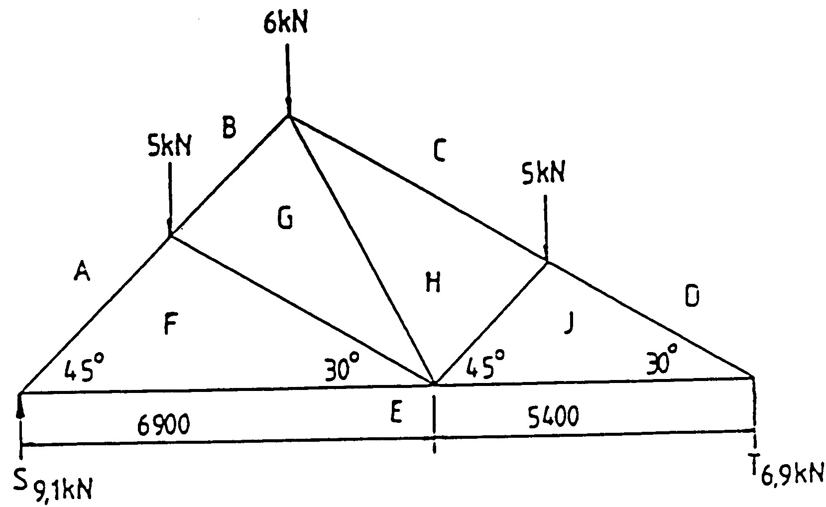  Figure 1 | (19)  (14)

Draw the table below in your answer book and answer Question 2.3 within the table.

2.3 Determine graphically the nature and magnitude of the force in each member of the framework.

 | MEMBER | MAGNITUDE | NATURE
 | JE
 | AF
 | HJ
 | BG
 | GH
 | CH
 | DJ
 | FE
 | GF |  |  | (27)
 |  |  |  |  | [60]

QUESTION 3

Use Answer Sheet SG 712-2/1(1) to answer this question.

Figure 2 below shows the ground plan of a dwelling to be erected. Calculate the number of bricks required for the:

  - 330 mm substructure

  - 220 mm superstructure

  - 110 mm beam filling

  - Total number of bricks for the complete building

  - Amount of concrete needed for the floor

Only the number of bricks for the doors and windows must be deducted.

Use the following specifications for the calculation:

- Use 50 bricks per square metre for a half-brick wall
- The height of the substucture is 450 mm
- The height of the superstructure is 2 900 mm
- The beam filling is three layers of bricks high
- The floor thickness is 75 mm and penetrates the outer wall by 110 mm
- All window openings are 2 000 mm x 1 500 mm
- Door openings are 2 000 mm x 1 000 mm
- A six percent brick wastage should also be included in the calculations
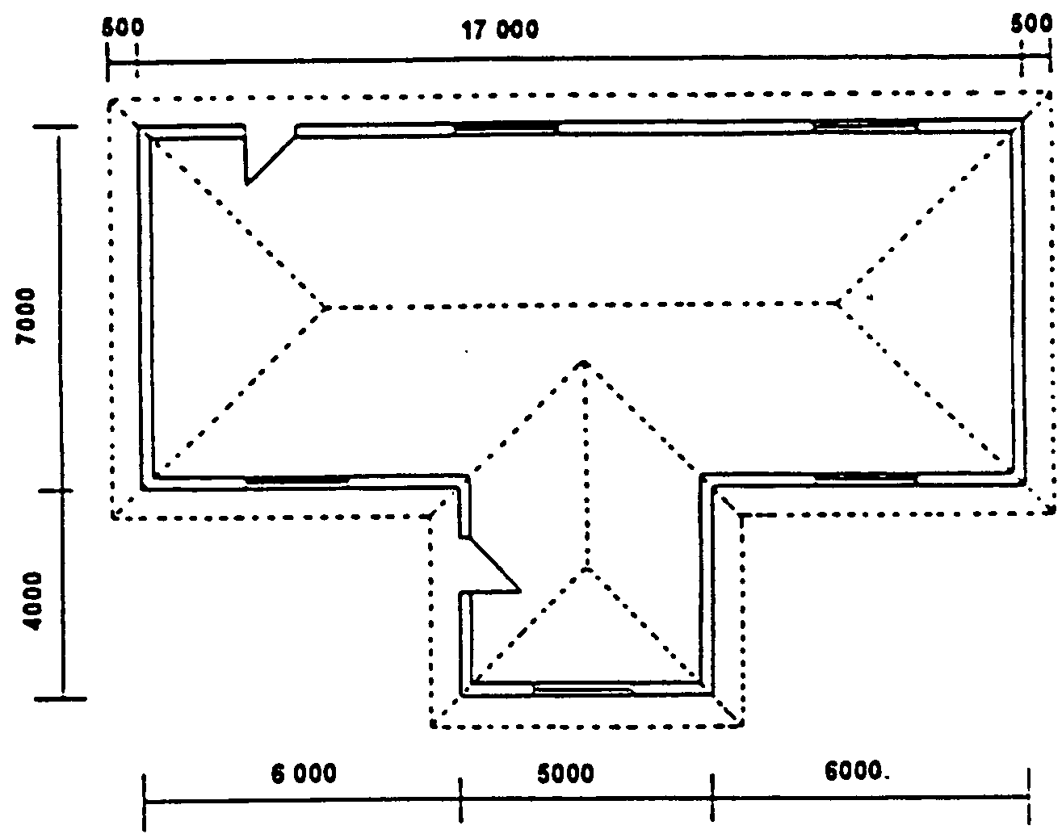
Figure 2 | [60]

TOTAL FOR SECTION A: | [180]

SECTION B

Answer any TWO questions from this section.

QUESTION 4

- Draw to a scale of 1:10 a vertical section through a floor and beam, and part of the floor on both sides to show the shuttering, reinforcement as well as the top and bottom ends of the prop in position.  The size of the concrete beam is 300 mm x 350 mm, and the floor thickness is 150 mm. The total height of the floor and beam is 500 mm. | (40)

  - Show by means of a sketch the construction of a one-brick wall foundation wall. The following must be clearly indicated on the sketch:

- Concrete foundation strip
- Foundation wall
- Core filling
- Hard core
- Ground level
- Blinding
- Screed
- Damp proof
- Concrete floor
- Floor blocks
- Quarter round
- Skirting
- Part of the one-brick wall
- Plaster finish on the inside wall
(20)
[60]

QUESTION 5

Figure 3 shows the ground plan of a house. The dwelling has a corrugated iron hipped roof. The slope is 30 degrees with a 500 mm open eaves overhang. The roof is finished off with a 200 mm asbestos fascia board, 100 mm x 100 mm square gutters with 75 mm downpipes. The superstructure is 2 700 mm high and the substructure is 300 mm high. The outer door is framed, ledged and braced. The window sills on the outside are finished off with 30 mm cement clay tiles.

Use the given window schedule for the window sizes.

Draw to a scale of 1:100 the North and West elevation of this dwelling.

Also show, by means of a scale sketch, how the height of the roof is determined.
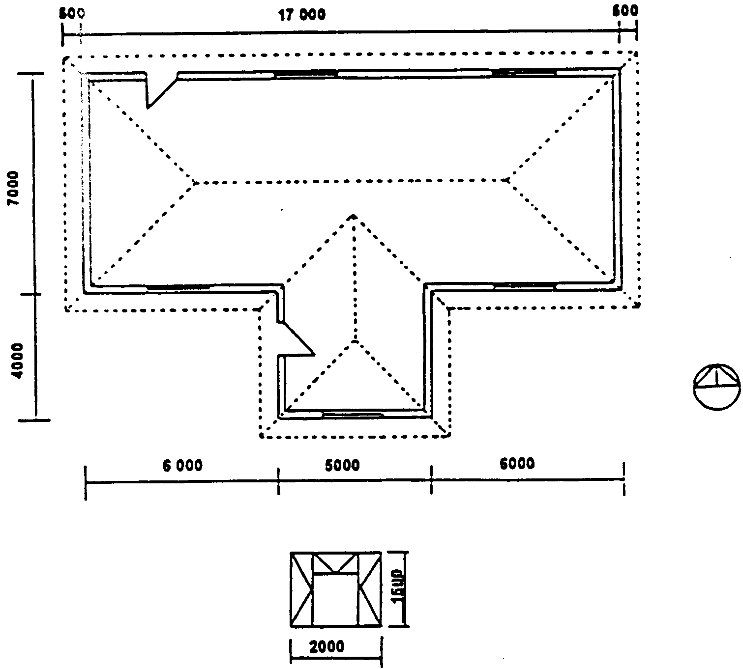
Window schedule
50017 000500
6 000
500
6 000
4 000
4 000
1 500
2 000
Figure 3

[60]

QUESTION 6  - Figure 4 shows a part of a steel framework construction. Draw to a scale of 1:5 a gusset plate for this roof construction. | (40)

Main beam : 89 mm x 89 mm x 6 mm
Struts : 63 mm x 63 mm x 6 mm
Bolt diameter (D) : 18 mm
Border seam : 1.5 D
Bolt pitch for the main beam : 4D
Bolt pitch for the struts : 3D
Standard back mark for the 89 mm angle: 55 mm
Standard back mark for the 63 mm struts: 35 mm

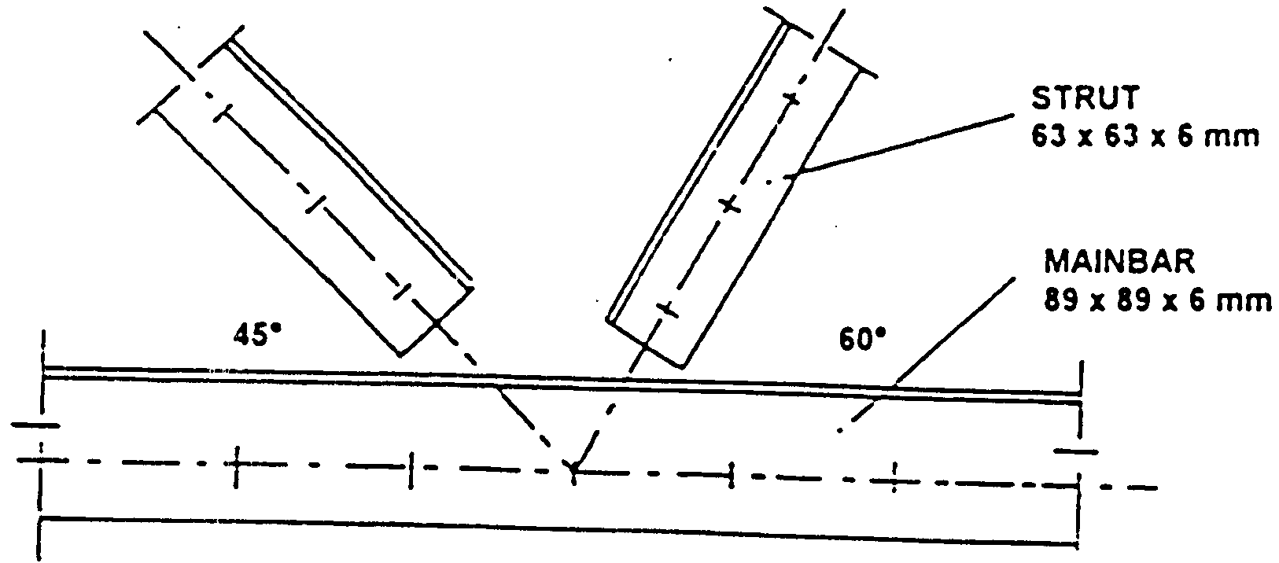

Figure 4

  - Raking shores must support the wall of a building. Using a scale of 1:10, draw an isometric view to illustrate the top and bottom ends of the shoring.

Use the following dimensions for the drawing:

Wall plate : 228 mm x 75 mm
Cleat : 200 mm x 100 mm x 100 mm
Needle : 300 mm x 100 mm x 100 mm
Raking shore : 228 mm x 228 mm
Wall hook : 8 mm diameter
(20)
[60]

QUESTION 7

Figure 5 shows a line diagram of a simply supported beam.

  - Calculate the reactions at the supports LR and RR.

  - Calculate all the bending moments in the beam.

  - Calculate all the shear forces in this beam.

  - Draw the space, shear force and bending moment diagrams of the beam.

Use the following scales for the drawings:

Space diagram : 1:100
Shear force diagram : 1 kN = 2 mm
Bending moment diagram : 1 kNm = 2 mm

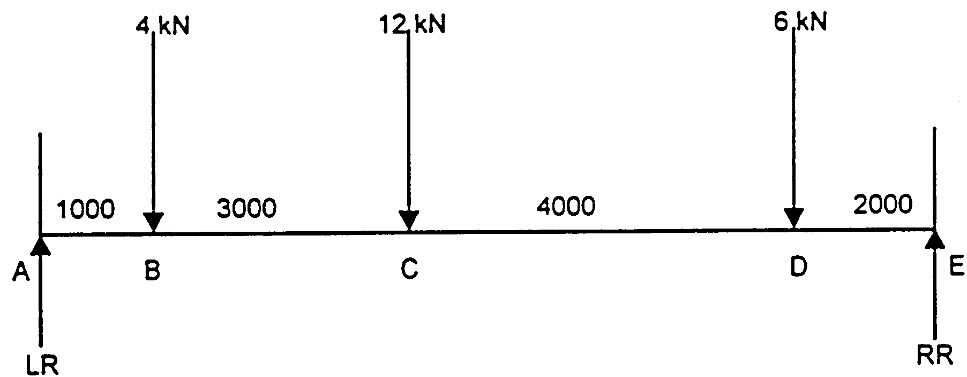  Figure 5 | [60]

TOTAL FOR SECTION B:  TOTAL: | [120]  300

