GAUTENG DEPARTMENT OF EDUCATION
SENIOR CERTIFICATE EXAMINATION

TECHNIKA (CIVIL) HG

TIME: 3 hours

MARKS: 300

REQUIREMENTS:

- Answer book
- A3-size drawing paper
- Drawing instruments
- Pocket calculator
- Answer Sheet HG 712-1/1(1)

INSTRUCTIONS:

- This question paper consists of TWO Sections, A and B.

- Section A is COMPULSORY.

- Answer Section A and any THREE questions from Section B.

- All calculations and written answers must be done in your answer book.

- Answer Sheet HG 712-1/1(1) (pages 9 – 12) is at the back of this question paper. Please detach this answer sheet and place it inside your answer book after completing it.

- Number your questions as they appear in the examination question paper.

- Clearly indicate on the drawing paper, the number of the question you are answering.

- Use both sides of the drawing paper.

- Drawings and sketches must be fully dimensioned and neatly finished with titles and labels to conform to the SABS Recommended Practice of Building Drawings.

- Write your examination number on all loose pages, drawing paper and your answer book.

- For the purpose of this examination, the size of a brick should be taken as 220 mm x 110 mm x 75 mm.

SECTION A

COMPULSORY

QUESTION 1

Figure 1 shows a beam simply supported at P and Q with point loads and uniformly distributed loads.

1.1 Calculate the reactions at points P and Q. | (10)

1.2 Calculate the bending and shear forces at all the points. | (41)

1.3 Draw the bending and shear forces diagrams. | (9)

Use the following scales:

Space diagram: 1:100
Shear force diagram: 2 mm = 1 kN.m
Bending forces diagram: 4 mm = 1 kN

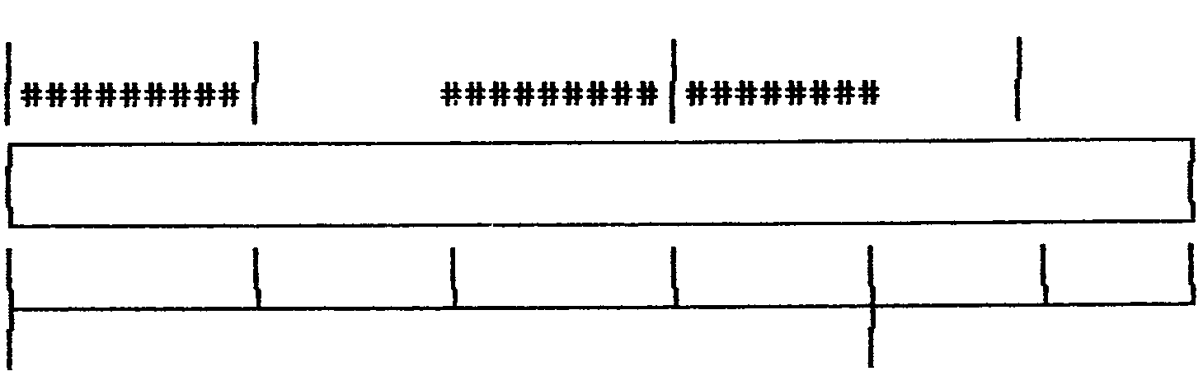
P
Q
2 000 mm
2 000 mm
2 000 mm
2 000 mm
2 000 mm
1 000 mm
AXBCDEFG
3 kN.m7 kN4 kN2 kN.m6 kN

Figure 1 | [60]

QUESTION 2

2.1 Name FIVE items to be shown on a sewer plan. | (6)

2.2 Name THREE different functions of a dumpy level. | (6)

2.3 Describe how you would measure the slumping in a slump test. | (8)

2.4 Name TEN safety precautions which must be taken to ensure the safety of workers and the public while building is in progress. | (10)

2.5 Name FIVE requirements of the building regulations when a drain is to be laid underneath a building. | (10)

2.6 Draw a flow diagram of an organization structure at a normal building project. | (10)

2.7 Describe FIVE important aspects which must be taken into consideration, for maximum efficiency, when installing a solar water heating system. | (10)  [60]

TOTAL FOR SECTION A: | [120]

SECTION B

QUESTION 3

Figure 3 shows a space diagram of a simply supported frame.

3.1 Calculate the reactions at P and Q.

3.2 Determine graphically the nature and the magnitude of the forces in each member.

Use the following scales:

- Space diagram: 1:100
- Force diagram : 10 mm = 1 kN

Copy the table below on your drawing paper and answer Question 3.2 in the table.

 | MEMBER | NATURE | FORCE
 | AH
 | BJ
 | CL
 | DN
 | EP
 | FO
 | FP
 | GH
 | HJ
 | JK
 | KL
 | LM
 | MN
 | NO
 | OP
 | GK
 | GM
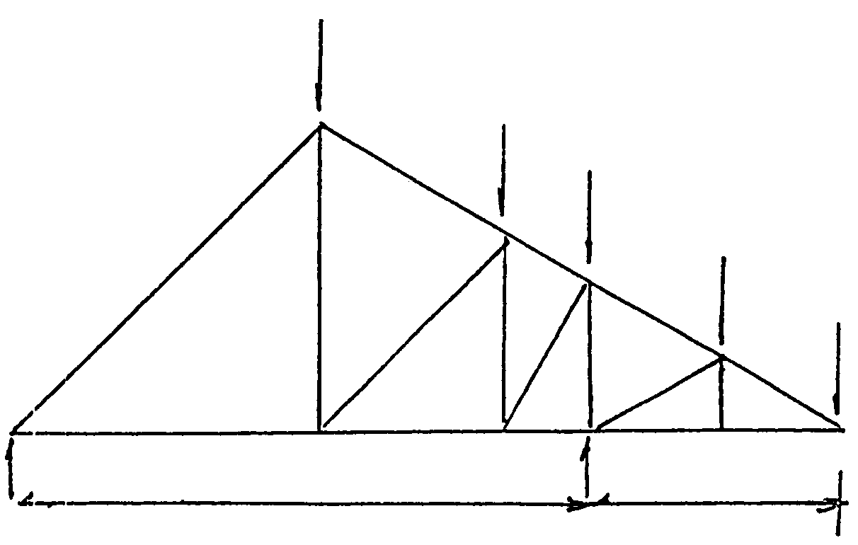
7 000 G
F 3000
45°
45°
60°
30°
30°
H
J
L
N
M
E
D
C
B
A
5 kN
4 kN
3 kN
3 kN
2 kN
P
Q
P
O
K

Figure 3 | [60]

QUESTION 4

Figure 4 shows a ground plan of a dwelling. Determine the number of bricks required for the:

4.1 substructure 330 mm and 220 mm in width.

4.2 superstructure 220 mm and 110 mm in width.

4.3 beam filling 110 mm.

4.4 total number of bricks for the complete building.

Use the following specifications for calculation purposes:

- Use 50 bricks per square metre for a half-brick wall.
- The height of the substructure is 375 mm.
- The height of the superstructure is 2 800 mm.
- The height of the beam filling is 225 mm.
- Door openings are 1 900 x 900 mm.
- Window sizes are 2 500 mm x 1 800 mm.
- A 5% wastage of bricks should also be included in the calculations.

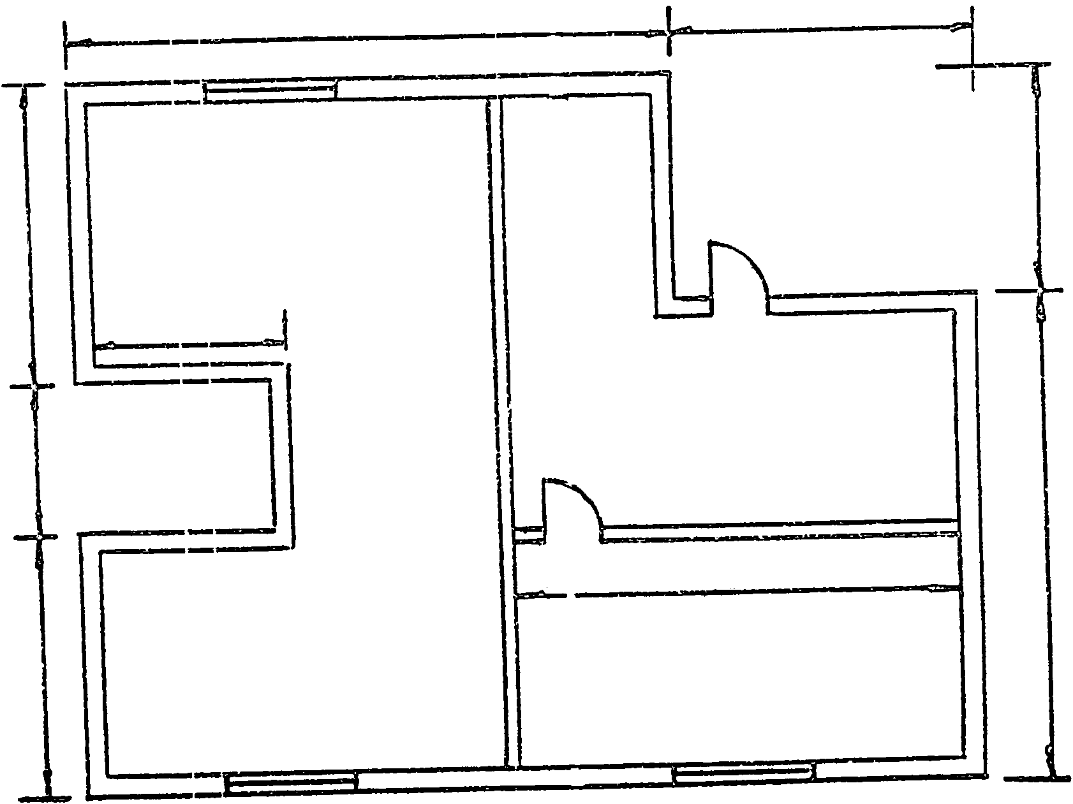
2 500
6 000
8 000
4 000
4 000
2 000
3 500
3 000
6 500

Figure 4 | [60]

QUESTION 5

The plan of a dwelling is shown in Figure 5. The dwelling has a hipped roof covered with corrugated iron and open eaves with an overhang of 500 mm and a pitch of 30°. The roof has square gutters of 100 mm x 100 mm and a fascia board of 200 mm. The superstructure is 2 800 mm high and the substructure consists of 6 layers of bricks of which 4 layers are above ground level. The dwelling has a framed Z-batten door, all steel windows must be placed in the correct positions by using the sizes given in the window schedule.

5.1 Draw, according to a scale of 1:100, a South elevation. | (40)

5.2 Draw, according to a scale of 1:100, a West elevation. | (20)
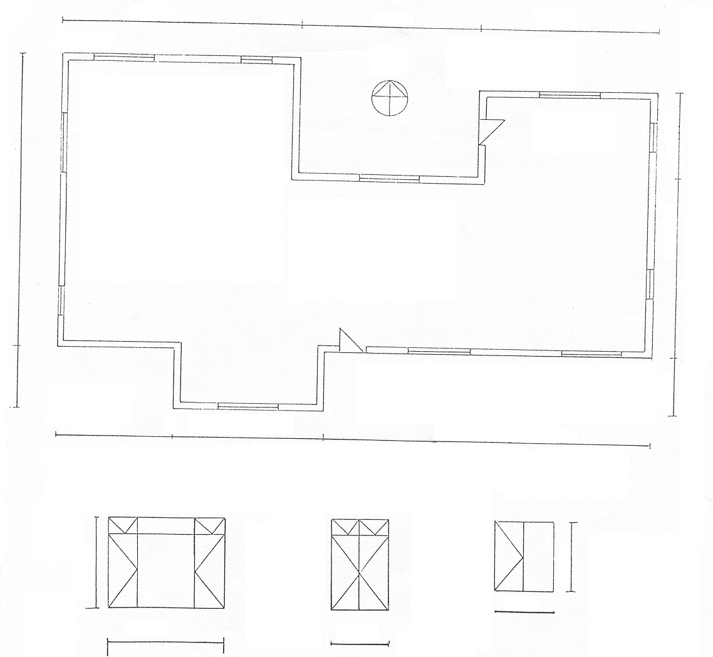
2 000
10 000
3 000
6 000
2 000
11 000
6 000
6 000
4 000
5 000
8 000
2 000
1 022
1 022
1 245
1 540
Figure 5
N
WINDOW SCHEDULE
[60]

QUESTION 6

6.1 A hot-water system consists of an electric geyser, a water cylinder and a solar heating system. The hot-water system is connected in such a way that the electric geyser may be used separately from, or together with the water cylinder and the solar-heating system. The cold-water supply is controlled by a pressure-reducing valve. Draw a neat line diagram to illustrate the placing and interconnection of the various parts. Also indicate the flow of the water when both the water storage cylinder and the electric geyser are used simultaneously. | (30)

6.2 Figure 6 shows a junction of steel roof trusses. Draw according to a scale of 1:5, a detailed drawing of the connection suitable for a gusset plate by using the following dimensions:

- The diameter of the bolts D is 18 mm.  - The border seam is 1.5 D.  - The bolt pitch for the main beam is 5 D.  - The bolt pitch for the struts is 3 D.  - The main tie is 89 mm x 89 mm x 6 mm and the standard back mark is 55 mm.  - The struts are 63 mm x 63 mm x 6 mm and the standard back mark is 35 mm. | (30)

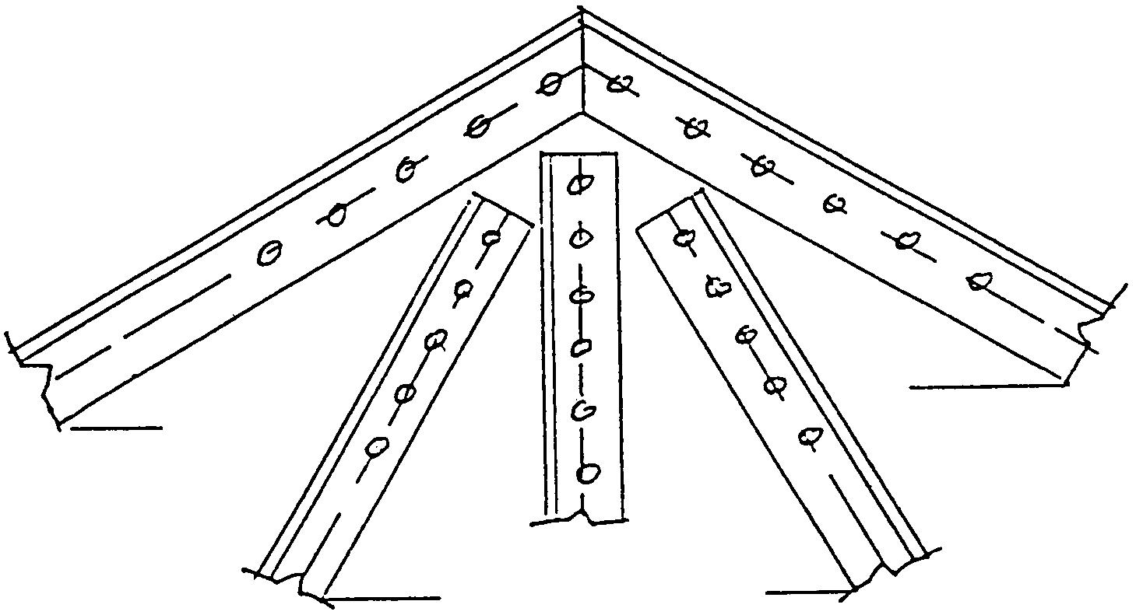
60°
60°
30°
30°

Figure 6 | [60]

QUESTION 7

7.1 Give TWO characteristics of material which can be used to reinforce concrete. | (4)

7.2 Give THREE important reasons why steel reinforcing is used in concrete constructions. | (6)

7.3 A reinforced concrete beam with a width of 450 mm, a depth of 300 mm and a span of 5 000 mm is supported by two concrete columns of 350 mm x 350 mm, as well as a round column, with a diameter of 300 mm, in the center of the beam.

Use the following specifications:

Concrete beam:

Main bars 2/20 mm diameter
Anchors bars 2/16 mm diameter
Shear reinforcement 2/20 mm diameter
Stirrups 8 mm as required for the beam

Round column:

Main bars 8/20 mm diameter
Helical stirrup 1/6 mm diameter

7.3.1 To a scale of 1:20, draw a longitudinal section through the beam to show all the necessary steel reinforcement in position. | (30)

7.3.2 Draw, to a scale of 1:15, a vertical section through the concrete beam, 300 mm from the left-hand column to show the steel reinforcement and one stirrup with accurate concrete cover. | (10)

7.3.3 Draw, to a scale of 1:5, a horizontal section through the central concrete column. Clearly show all steel reinforcement with accurate concrete cover. | (10)  [60]

TOTAL FOR SECTION B: | [180]

TOTAL: | 300

