GAUTENG DEPARTMENT OF EDUCATION

SENIOR CERTIFICATE EXAMINATION

TECHNIKA (CIVIL) SG

TIME: 3 hours

MARKS: 300

REQUIREMENTS:

- A3 Size drawing paper

- Drawing instruments

- Pocket calculator

INSTRUCTIONS:

- Answer any five questions.

- All calculations and written answers must be done in your Answer Book.

- Number the questions exactly as they appear in the examination paper.

- Show clearly the number of the question you are answering on the drawing paper.

- Use both sides of the drawing paper.

- Drawings and sketches must be fully dimensioned and neatly finished with titles and labels to conform with the SABS Recommended Practice of Building Drawings.

- Write your examination number on all loose sheets, the drawing paper and your Answer Book.

- For the purpose of this examination, the size of a brick should be taken as
220 mm x 110 mm x 75 mm.

QUESTION 1  - List any TEN safety precautions which must be taken while building is in progress to ensure the safety of workers and the public.  - List any FIVE parts of clothing issued to workers to protect and safeguard them against particular hazards and unsafe conditions.  - Name any FOUR requirements for sewerage pipes.  - Name THREE materials which can be used for damp proofing.  - List any FIVE factors which should be taken into consideration when new houses are designed.  1.6 List any FIVE different types of bricks.  1.7 List FIVE requirements of concrete reinforcement.  1.8 Name any EIGHT members of a building team.  QUESTION 2  - State any FIVE essential characteristics to which column shuttering must comply.  - List any FIVE reasons why a sewer plan must be submitted and accompany new house plans for municipal approval.  - Name any FIVE important points to consider when purchasing a new stand.  - Name TEN safety precautions applicable to scaffolding.  - List any FIVE characteristics of good glass.  - List FOUR important reasons why steel reinforcement must be used in concrete constructions.  - Name any TWO main causes of fires.  - Can an aids infected person infect another person who sustains an injury? | (20)  (10)  (4)  (3)  (5)  (5)  (5)  (8)  [60]  (10)  (5)  (5)  (20)  (10)  (4)  (4)  (2)  [60]

QUESTION 3  Strut 63 x 63 x 6 mm  Mainbar 89 x 89 x 6 mm  60º  45º  - Show by means of a sketch the construction of a one brick foundation wall.  The following must be indicated clearly on the sketch:  - concrete foundation strip  - foundation wall  - core filling  - hard core  - ground level  - blinding  - screed  - damp proof  - concrete floor  - floor blocks  - quarter round  - skirting  - part of the one brick outside wall  - plaster finish on the inside wall  - Figure 1 below shows the junction of the beams of a roof truss. Use the measurements below and draw to a scale of 1:5 a detailed drawing of the gusset plate:  - The diameter of the bolts D is 20.  - The border seam is 1.5 D.  - The bolt pitch for the main beam is 4 D.  - The pitch for the struts is 3 D.  - The standard back mark for the 89 mm angle is 55 mm.  - The standard back mark for the 63 mm struts is 35 mm.  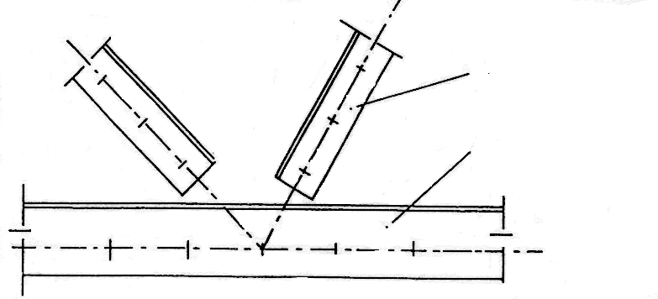  Figure 1 | (30)  (30)  [60]

QUESTION 4  5 500  Figure 2  WINDOW SCHEDULE  12 000  Figure 2 shows the ground plan of a house. The dwelling has a corrugated iron hipped roof; a 30-degree pitch and a 500 mm open eaves overhang. The 100 m x 100 mm square gutters with 75 mm down pipes are fixed to a 200 mm fascia board.  The superstructure is 2 800 mm high and the substructure is 300 mm high. The outside doors are Z-framed, ledged and braced doors.  Make use of the window schedule (Figure 3) for the window placing. The window sills are finished off with cement clay tiles.  Draw to a scale of 1:100, the north and west elevation of this dwelling. Also show the drawing to determine the height of the roof.  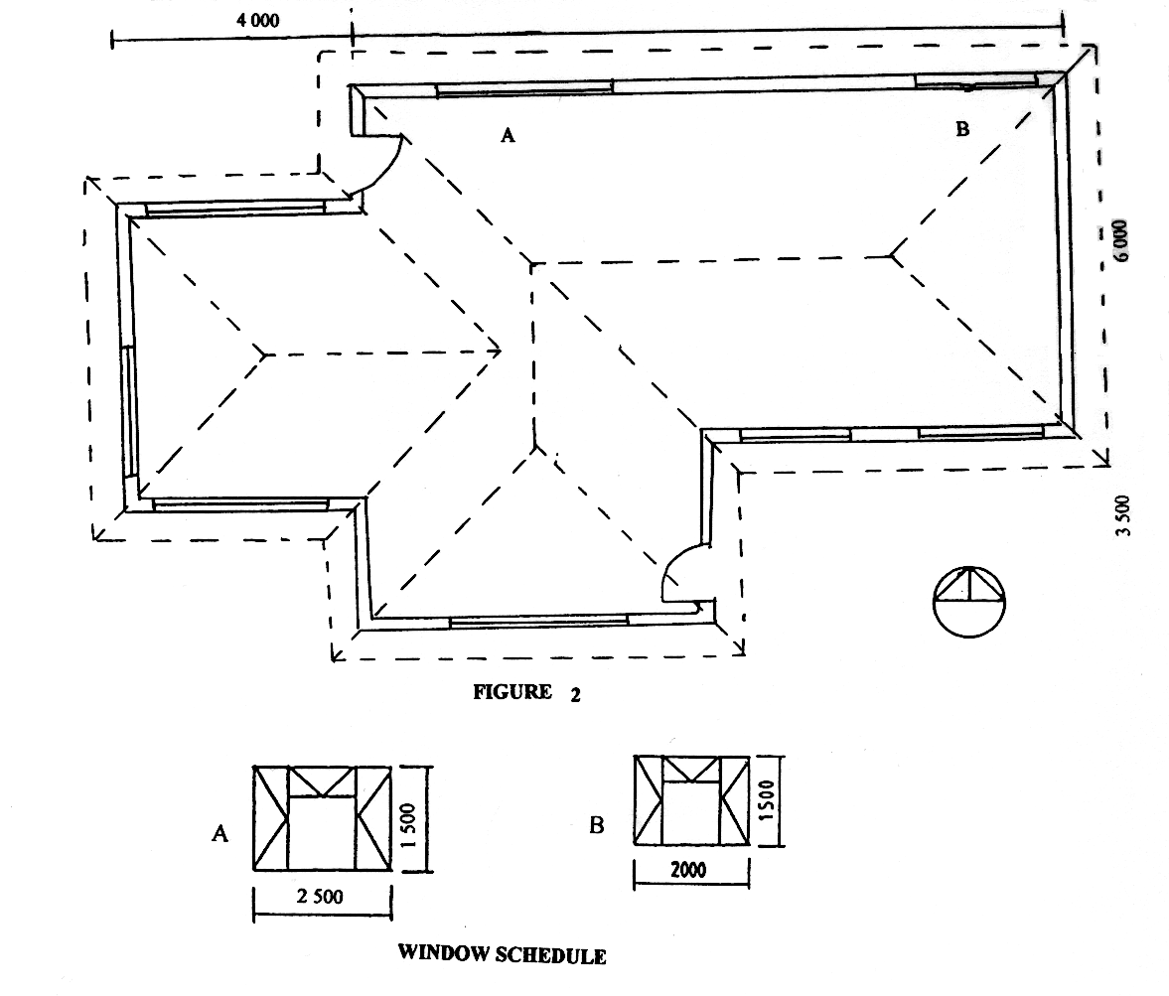  Figure 3 | [60]

QUESTION 5  Figure 4 shows the ground plan of a building to be erected. Determine the amount of bricks required for  - the substructure 330 mm.  - the superstructure 220 mm.  - the beam filling 110 mm.  - the total amount of bricks for the entire building.  Only the bricks for the doors and windows must be deducted.  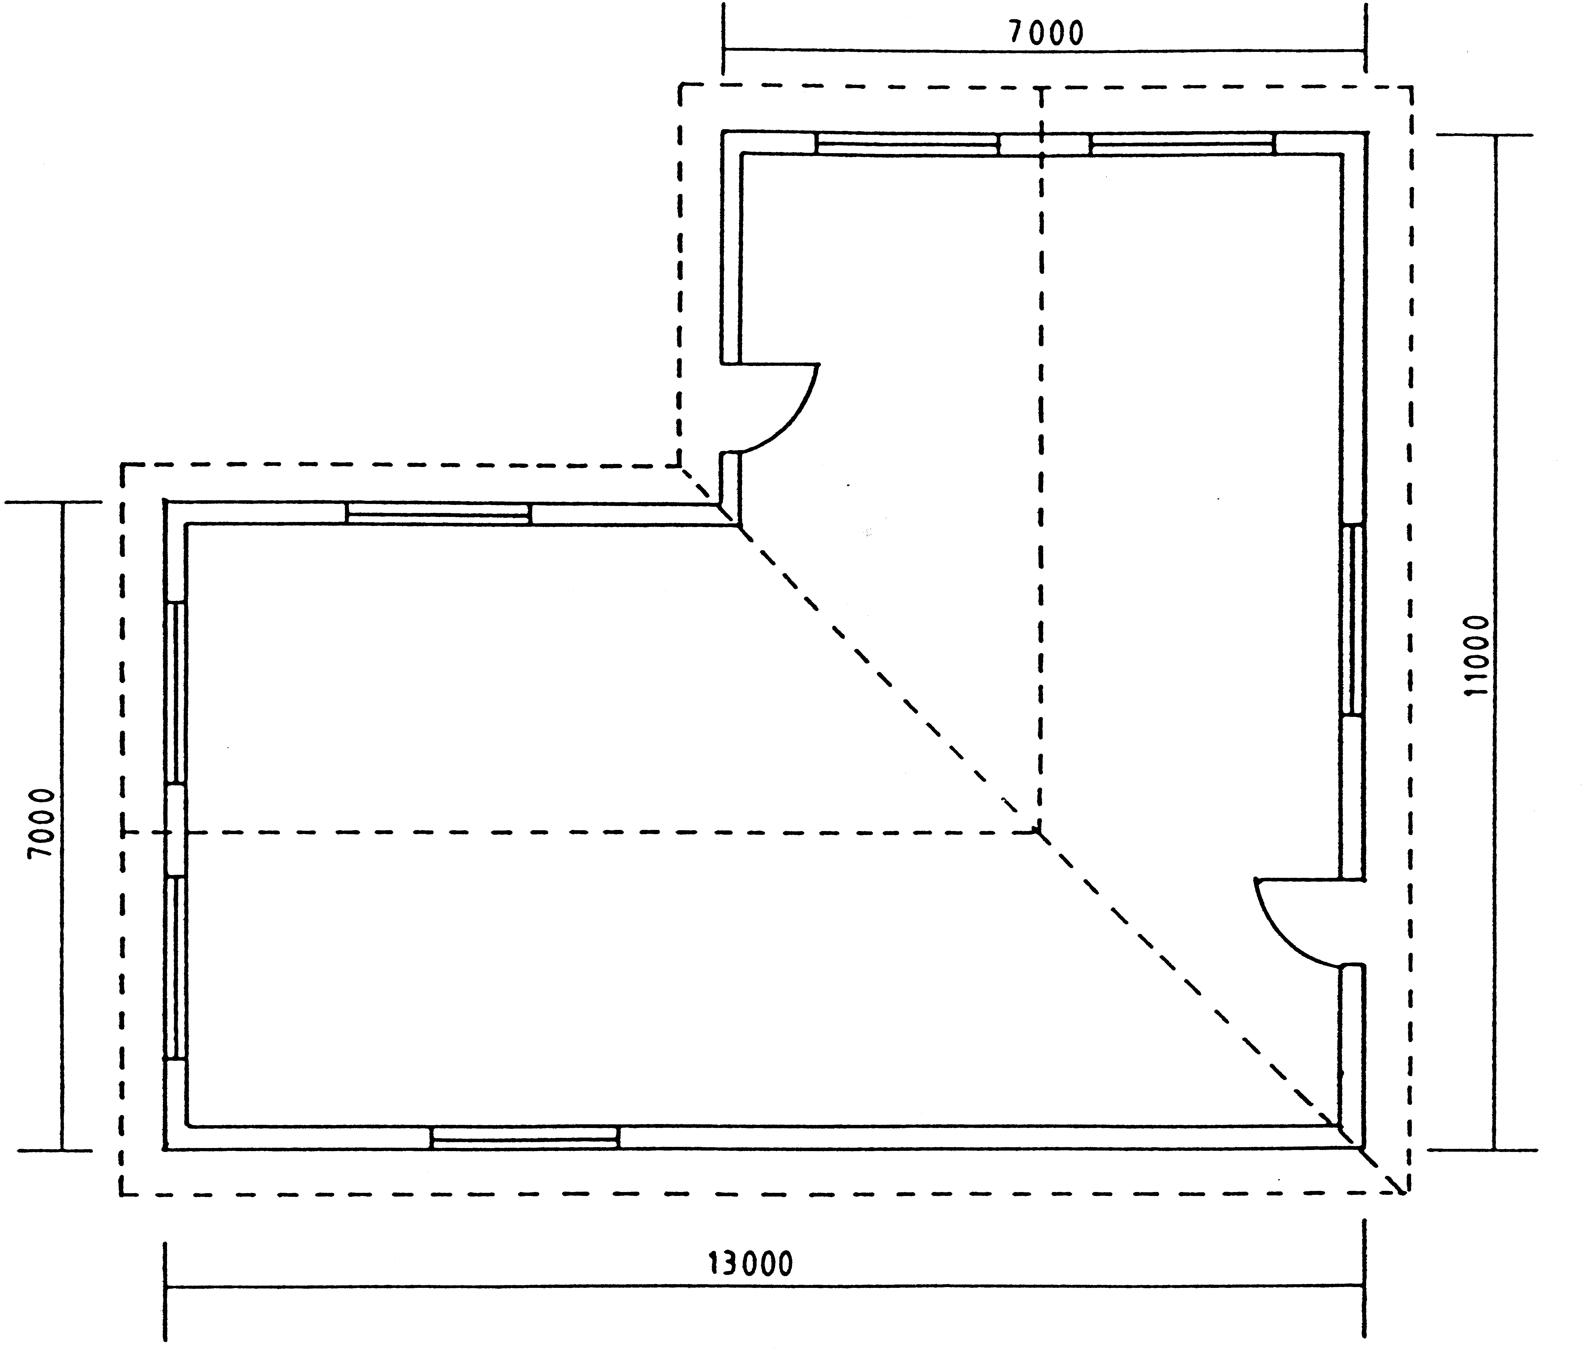  Figure 4  Use the following specifications for the calculations:  - Use 50 bricks per square metre for a half brick wall.  - The substructure is 375 mm high.  - The superstructure is 2 800 mm high.  - The beam filling is 3 layers of bricks high.  - The door openings are 2 000 mm x 1 000 mm.  - All windows are 2 500 mm x 1 500 mm.  - A six-percent wastage of bricks must also be included in the calculation.  Tabulate your answer according to the standard columns. | [60]

QUESTION 6

Figure 5

Figure 5 shows a space diagram of a simply supported and loaded framework.

  - Calculate the reactions at points P and Q.
  - Use a scale of 1:100 and draw the space diagram.
  - Draw the forces diagram to a scale of 2 mm = 1 kN.
  - Determine graphically the magnitude and nature of the forces in each member of the framework.

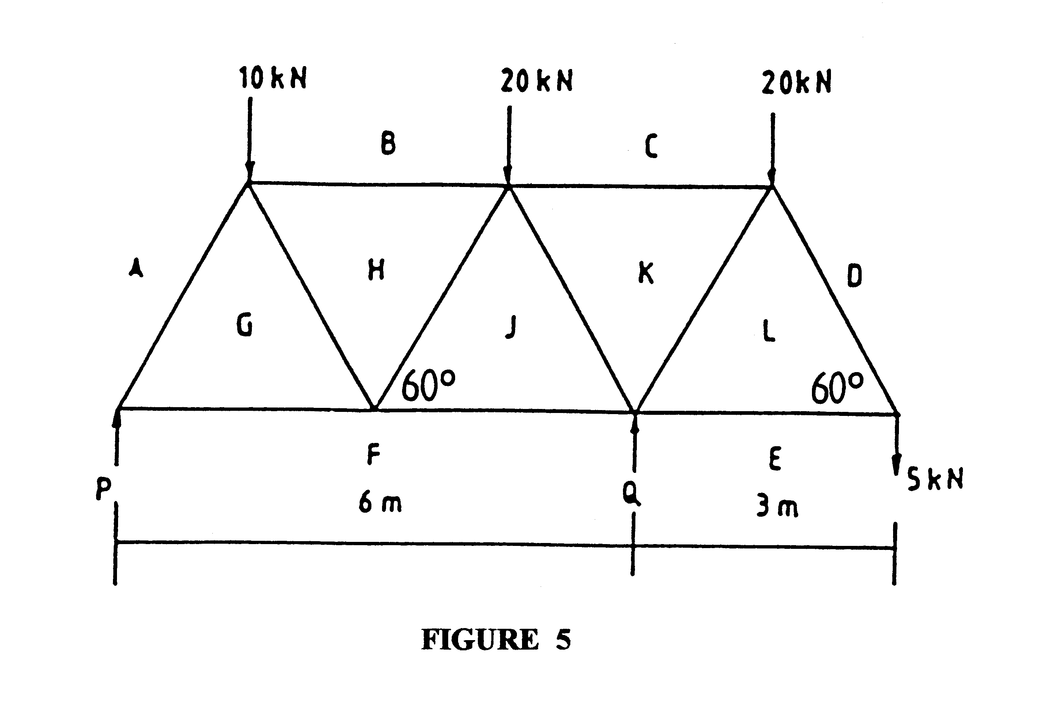
Draw the table below in your answer book and use it to answer Question 6.4.

MEMBER | NATURE | MAGNITUDE
AG
BH
CK
DL
EL
FG
FJ
GH
HJ
JK
KL
[60]

QUESTION 7  Figure 6  Figure 6 shows a simply loaded beam supported at the ends.  - Calculate the reactions at the supports.  - Calculate the bending moment at points A, B, C, D and E.  - Calculate the shear force at points A, B,C, D and E.  - Draw the space diagram as well as the bending moment and shear force diagrams.  Use the following scales for the diagrams:  Space diagram : 1:100  Bending moment diagram : 1 kNm = 2 mm  Shear force diagram : 1 kN = 5 mm  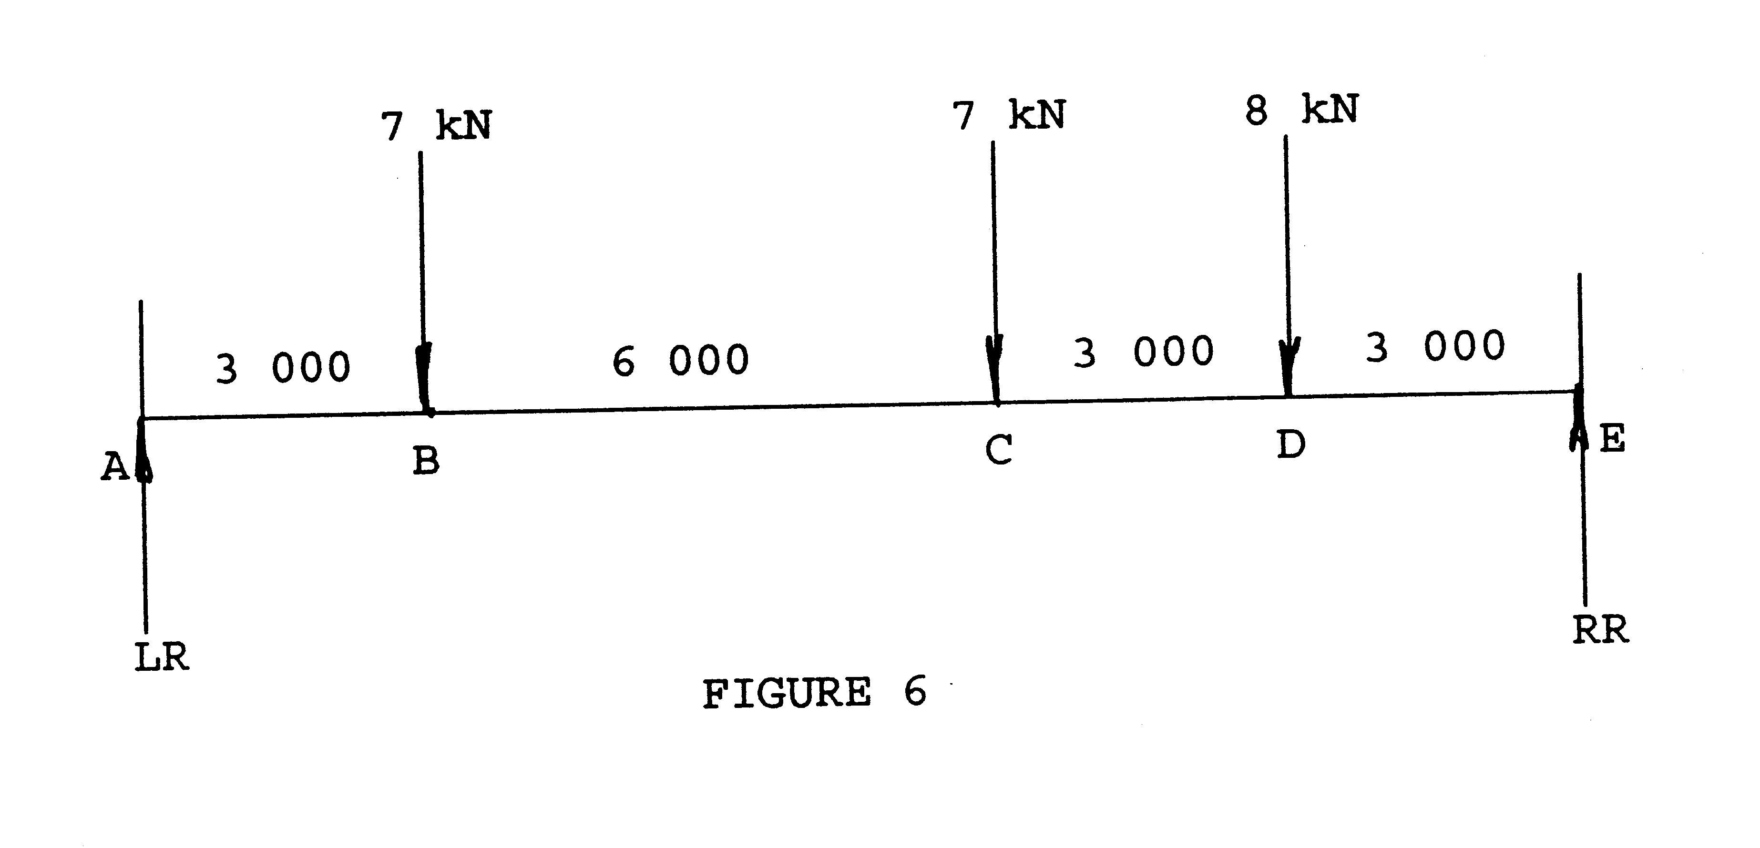  TOTAL : | [60]  300

