GAUTENG DEPARTMENT OF EDUCATION

SENIOR CERTIFICATE EXAMINATION

TECHNIKA (CIVIL) SG

TIME: 3 hours

MARKS: 300

REQUIREMENTS

Answer book
A3 size drawing paper
Drawing instruments
Pocket calculator

INSTRUCTIONS

- Answer any FIVE questions.

- All calculations and written answers must be done in your answer book.

- Number the questions as they appear in the examination question paper.

- Show clearly on the drawing paper, the number of the question you are answering

- Use both sides of the drawing paper.

- Drawings and sketches must be fully dimensioned and neatly finished with titles and labels to conform with the SABS Recommended Practice of Building Drawings.

- Write your examination number on all loose sheets, the drawing paper and your answer book.

- For the purpose of this examination, the size of a brick should be taken as
220 mm x 110 mm x 75 mm.

QUESTION 1  - Name any FIVE materials suitable for roof covering.  - List any FIVE characteristics of damp proofing.  - Name FIVE different kinds of bricks.  - List any FIVE important points to consider when buying a new stand.  - Name any FIVE properties that steel, used for reinforcement in concrete, must comply with.  - List any FIVE characteristics of glass. | (10)  (10)  (10)  (10)  (10)  (10)  [60]

QUESTION 2  - Name any TEN safety precautions which must be taken while building is in progress to ensure the safety of workers and the public.  - List FOUR important reasons why steel reinforcement must be used in a concrete construction. |  | (20)  (4)
 | - Sketch FOUR different reinforcement bars.  - Name TWO methods to fix a water closet in a bathroom. |  | (4)  (2)
 | - Name any FOUR requirements, according to regulations, where a cleaning eye must be installed.  - What will the consequences be if the gradient of a sewerage system is  - too big?  - too small?  - Name any TWO density tests that can be carried out on a sewerage system.  - List TEN safety precautions which are applicable to scaffolds. |  | (4)  (2)  (2)  (2)  (20)  [60]

QUESTION 3  Draw, to a scale of 1:10, a vertical section through the length of a straight flight of a concrete staircase and show the formwork, supports and reinforcement necessary for the erection of the stairs. The flight of stairs consists of SIX steps, including a landing of 900 mm which is 100 mm thick. An unplastered external wall supports the landing, which is one brick thick. The steps have a rise of 150 mm and a tread of 280 mm. | [60]

QUESTION 4

Figure 1 below shows the ground plan of a dwelling. It has a hipped roof covered with corrugated iron. The slope is 30 degrees with an overhang of 500 mm. The roof is finished off with a 200 mm asbestos fascia board and 100 mm x 100 mm square gutter with a 75 mm diameter downpipe.

The superstructure is 2 700 mm high and the substructure 300 mm high. The outer door is framed, ledged and braced. The windowsills are finished off with 300 mm quarry tiles.

Make use of the window schedule in Figure 2 for the placing of the windows.

Draw, to a scale of 1:100, the south and east elevation of the dwelling.

Also show the drawing to determine the height of the roof.

1500  7000  4000  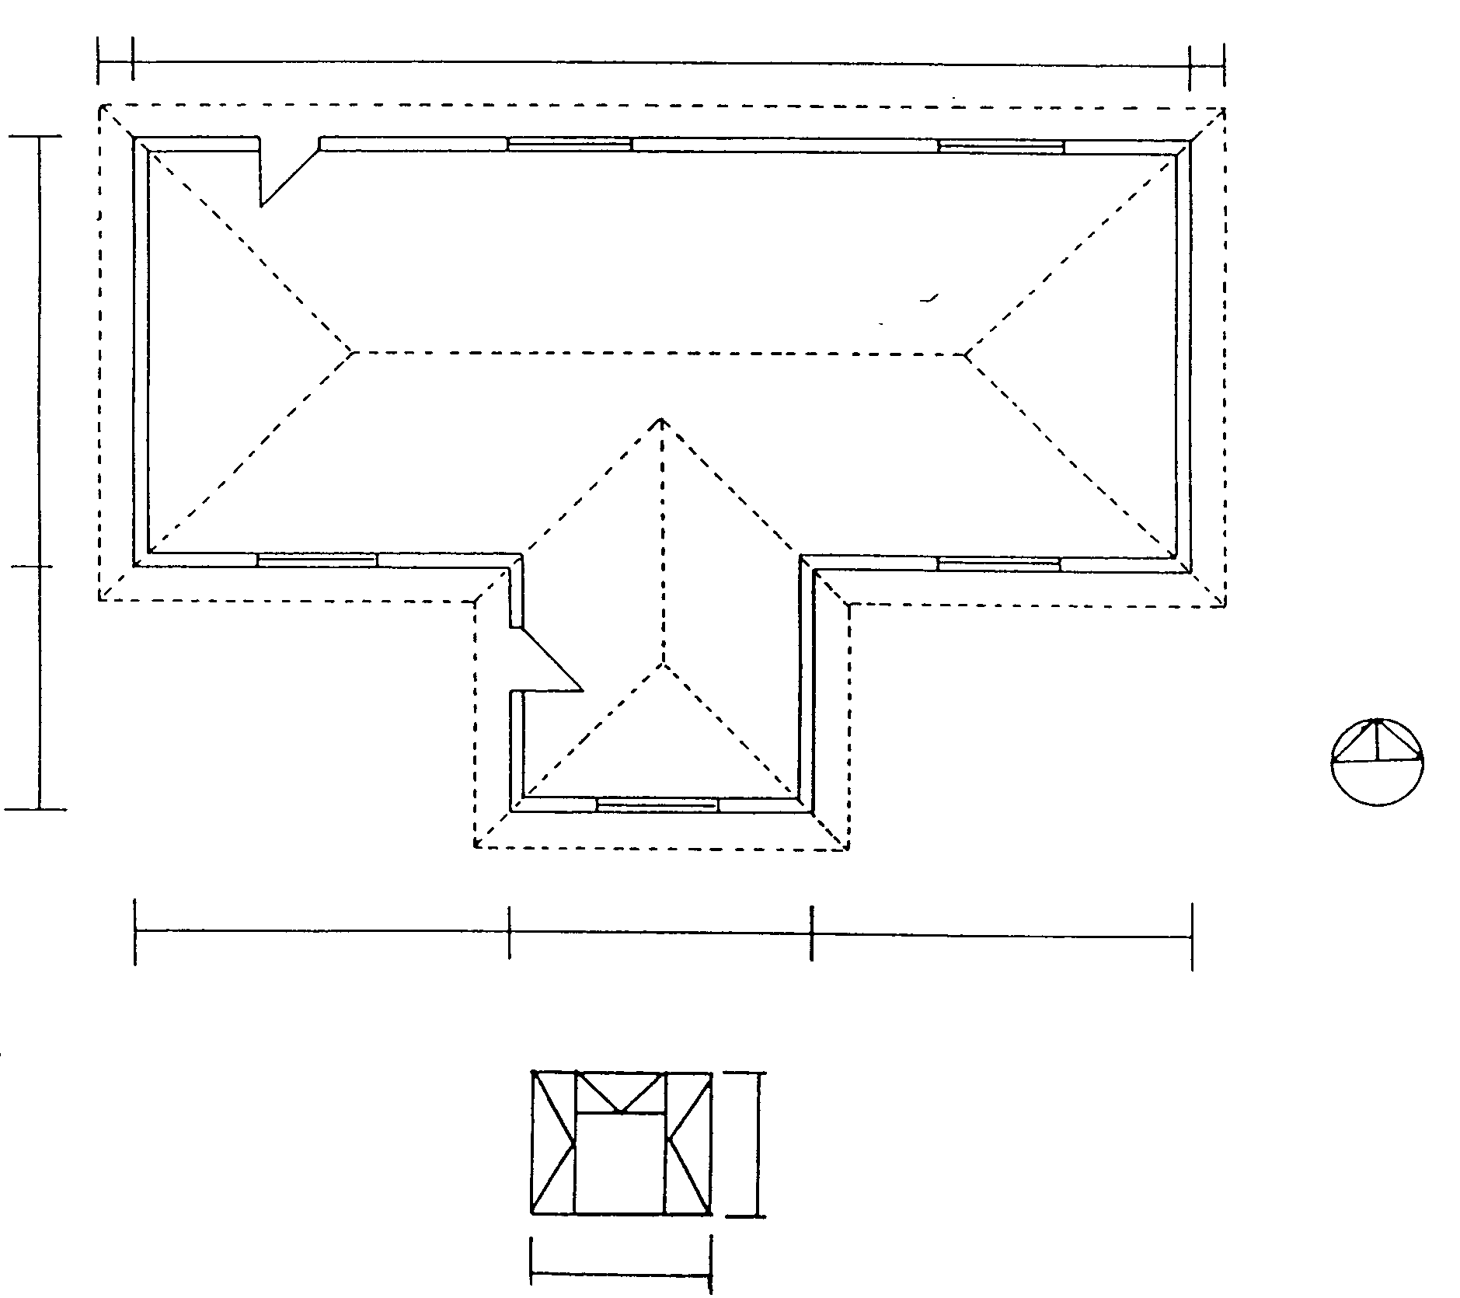  500  500  17 000  6 000  5000  6000  FIGURE 1  2000  WINDOW SCHEDULE FIGURE 2 | [60]

QUESTION 5

Figure 3 below shows the ground plan of a dwelling to be erected.
Calculate the number of bricks required for

  - the 330 mm substructure;
  - the 220 mm superstructure;
  - the 110 mm beam filling;
  - the total number of bricks for the complete building.

Only the number of bricks for the doors and windows must be deducted.
14 000
4 000
1220
2780
8 000
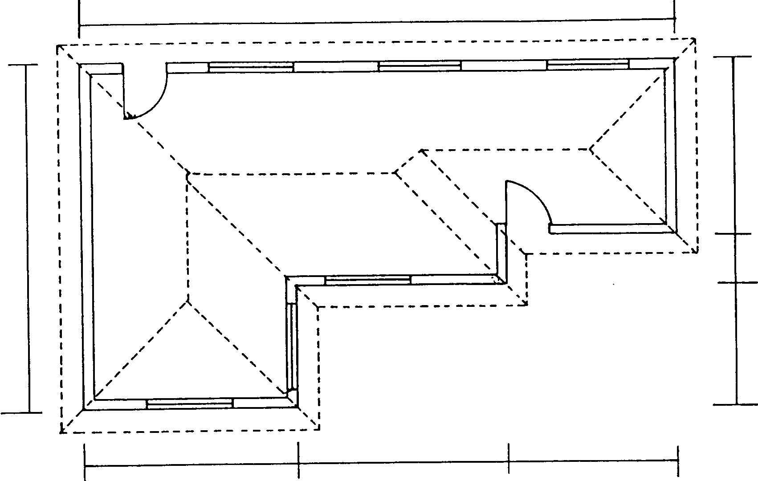
5 000
5 000
5 000

Figure 3

Use the following specifications for the calculations:

Use 50 bricks per square metre for a half brick wall.  - The substructure is 375 mm high.  - The superstructure is 2 800 mm high.  - The beam filling is 3 layers of bricks high.  - The door openings are 2 000 mm x 1 000 mm.  - All windows are 2 500 mm x 1 500 mm.  - A five- percent wastage of bricks must also be calculated.  Tabulate your answer according to the standard columns. | [60]

QUESTION 6

Figure 4 below shows a diagram of a simply supported framework with three vertical loads applied.

  - Draw the space diagram to a scale of 1:50.
  - Draw the vector diagram to a scale of 1:10.
  - Determine graphically the magnitude and nature of the forces in each member of the framework.

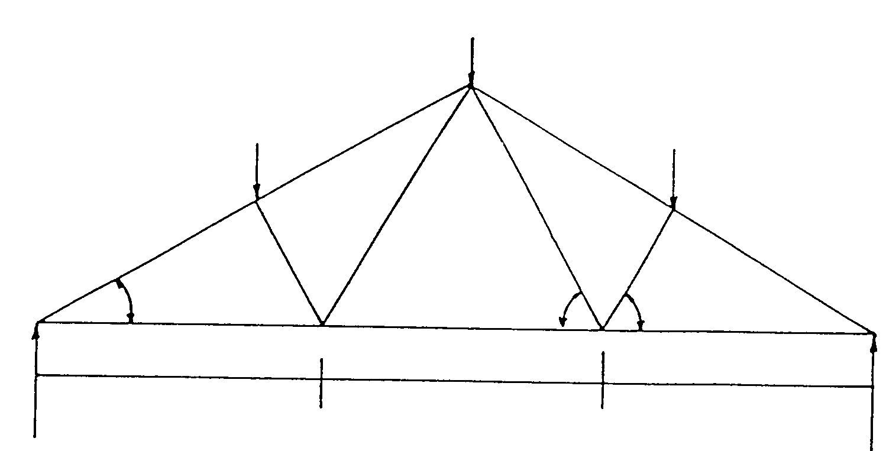
8 kN
6 kN
4 kN
C
D
B
A
F
G
H
E
J
K
2m
2m
2m
LR=9,5
RR=8,5
60°
60°
30°
Figure 4

Draw the table below in your answer book and answer Question 6.3 within the table.

MEMBER | NATURE | MAGNITUDE

AF

DK

BG

CJ

FG

JK

GH

JH

FE

HE

KE
 |  |  | [60]

QUESTION 7

Figure 5 shows a line diagram of a simply supported beam with three point loads.

  - Calculate the reactions at the supports LR and RR.
  - Calculate the bending moments at points A, B, C, D and E.
  - Calculate the shear force at points A, B, C, D and E.
  - Draw the space, shear force and bending moment diagrams.

Use the following scales:

Space diagram : 1:100

Bending moment diagram : 1 kNm = 2 mm

Shear force diagram : 1 kN = 2 mm

LR
RR
Figure 5
4 kN 12 kN 6 kN

1000 3000 4000 2000

A B C D E

TOTAL: | [60]  300

