GAUTENG DEPARTMENT OF EDUCATION

SENIOR CERTIFICATE EXAMINATION

TECHNIKA (CIVIL) HG

TIME: 3 hours

MARKS: 300

REQUIREMENTS

Answer book
A3-size drawing paper
Drawing instruments
Pocket calculator

INSTRUCTIONS

- Answer any FIVE questions.

- All calculations and written answers must be done in your Answer book.

- Number the questions as they appear in the examination question paper.

- Show clearly on the drawing paper, the number of the question you are answering.

- Use both sides of the drawing paper.

- Drawings and sketches must be fully dimensioned and neatly finished with titles and labels to conform with the SABS Recommended Practice of Building Drawings.

- Write your examination number on all loose sheets, the drawing paper and your Answer book.

- For the purpose of this examination, the size of a brick should be taken as
200 mm x 110 mm x 75 mm.

QUESTION 1  - Name FIVE reasons for the necessity of building regulations.  - List FOUR important reasons why steel reinforcement must be used in a concrete construction.  - Name any TWO density tests that can be carried out on a sewerage system.  - State FOUR properties that steel, used for reinforcement in concrete, must comply with.  - List any FIVE materials suitable for roof covering.  - Name the FOUR ingredients of concrete.  - Name the purpose of each of the following parts of a solar heating system:  - Pressure-reducing valve  - Relief valve  - Primary flow pipe  - State any FOUR important characteristics needed when a gusset plate must be drawn in an angle iron framework  - What is understood by the term topographical surveying?  - Define the term surveying.  - Why do some solar collectors have a double glass cover? | (10)  (4)  (2)  (4)  (10)  (4)  (2)  (2)  (2)  (4)  (2)  (2)  (2)
- List FOUR ways in which injuries on a building site can be eliminated.  - Can an Aids infected person infect another person who sustains an injury? | (8)  (2)  [60]

QUESTION 2

  - Show by means of a sketch the construction of a one brick foundation wall.
The following must clearly be indicated on the sketch:

- concrete foundation strip
- foundation wall
- core filling
- hard core
- ground level
- blinding
- screed
- damp proof
- concrete floor
- floor blocks
- quarter round
- skirting
- part of the one brick outer wall
- plaster finish on the inside wall
(30)

Figure 1 below shows the connection of the beams of a steel truss construction. Use the following information to draw according to a scale of 1:5, a detailed drawing of a gusset plate.

- The diameter of the bolts D is 20 mm
- Main beams 75 mm x 75 mm x 6 mm
- The border seam is 1,5 D
- The struts 75 mm x 75 mm x 6 mm
- The bolt pitch 4 D
- The standard back mark for the 75 mm angle profile is 45 mm.
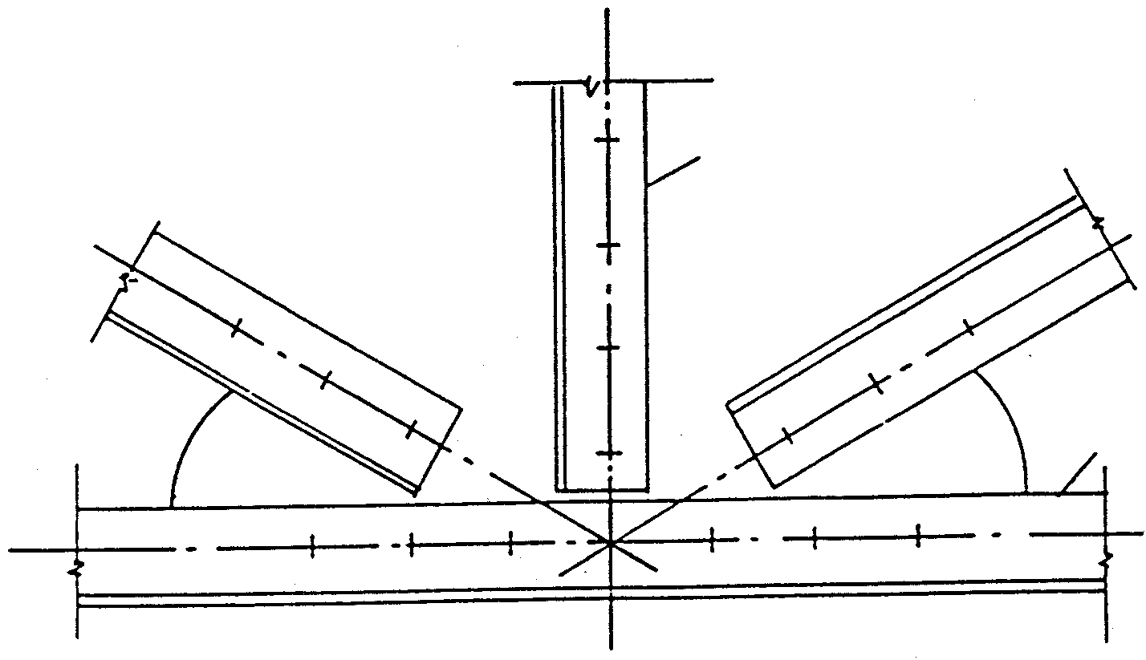
STRUTS 75 x 75 x 6 mm
75 x 75 x 6 mm
MAIN BAR
30°
30°
Figure 1
(30)
[60]

QUESTION 3  The first floor of a building comprises a concrete slab with a thickness of 150 mm supported by a 300 x 500 mm concrete beam. The total height of the floor and beam is 500 mm.  Draw to a scale of 1:10 a vertical section through the beam and slab and parts of the floor on both sides of the beam to show the formwork as well as the top and bottom parts of the prop in position. | [60]

QUESTION 4

Figure 2 below shows a ground plan of a building. It has a hipped roof covered with corrugated iron. The slope of the roof is 30 degrees with a 500 mm open eaves overhang. The roof is finished off with a 200 mm asbestos fascia board to which the 100 mm square gutter with 75 mm diameter downpipes is attached.

The superstructure is 2 700 mm high and the substructure 300 mm high. The outer door is framed, ledged and braced and the window sills are finished off with 30 mm quarry tiles.

Use the window schedule in Figure 3 for the window placing.

Draw, to a scale of 1:100 the south and east elevation of this dwelling.
Show the drawing to determine the height of the roof.
500
500
17 000
6 000
5000
6000

Figure 2
2000
1500  4000  7000  1500  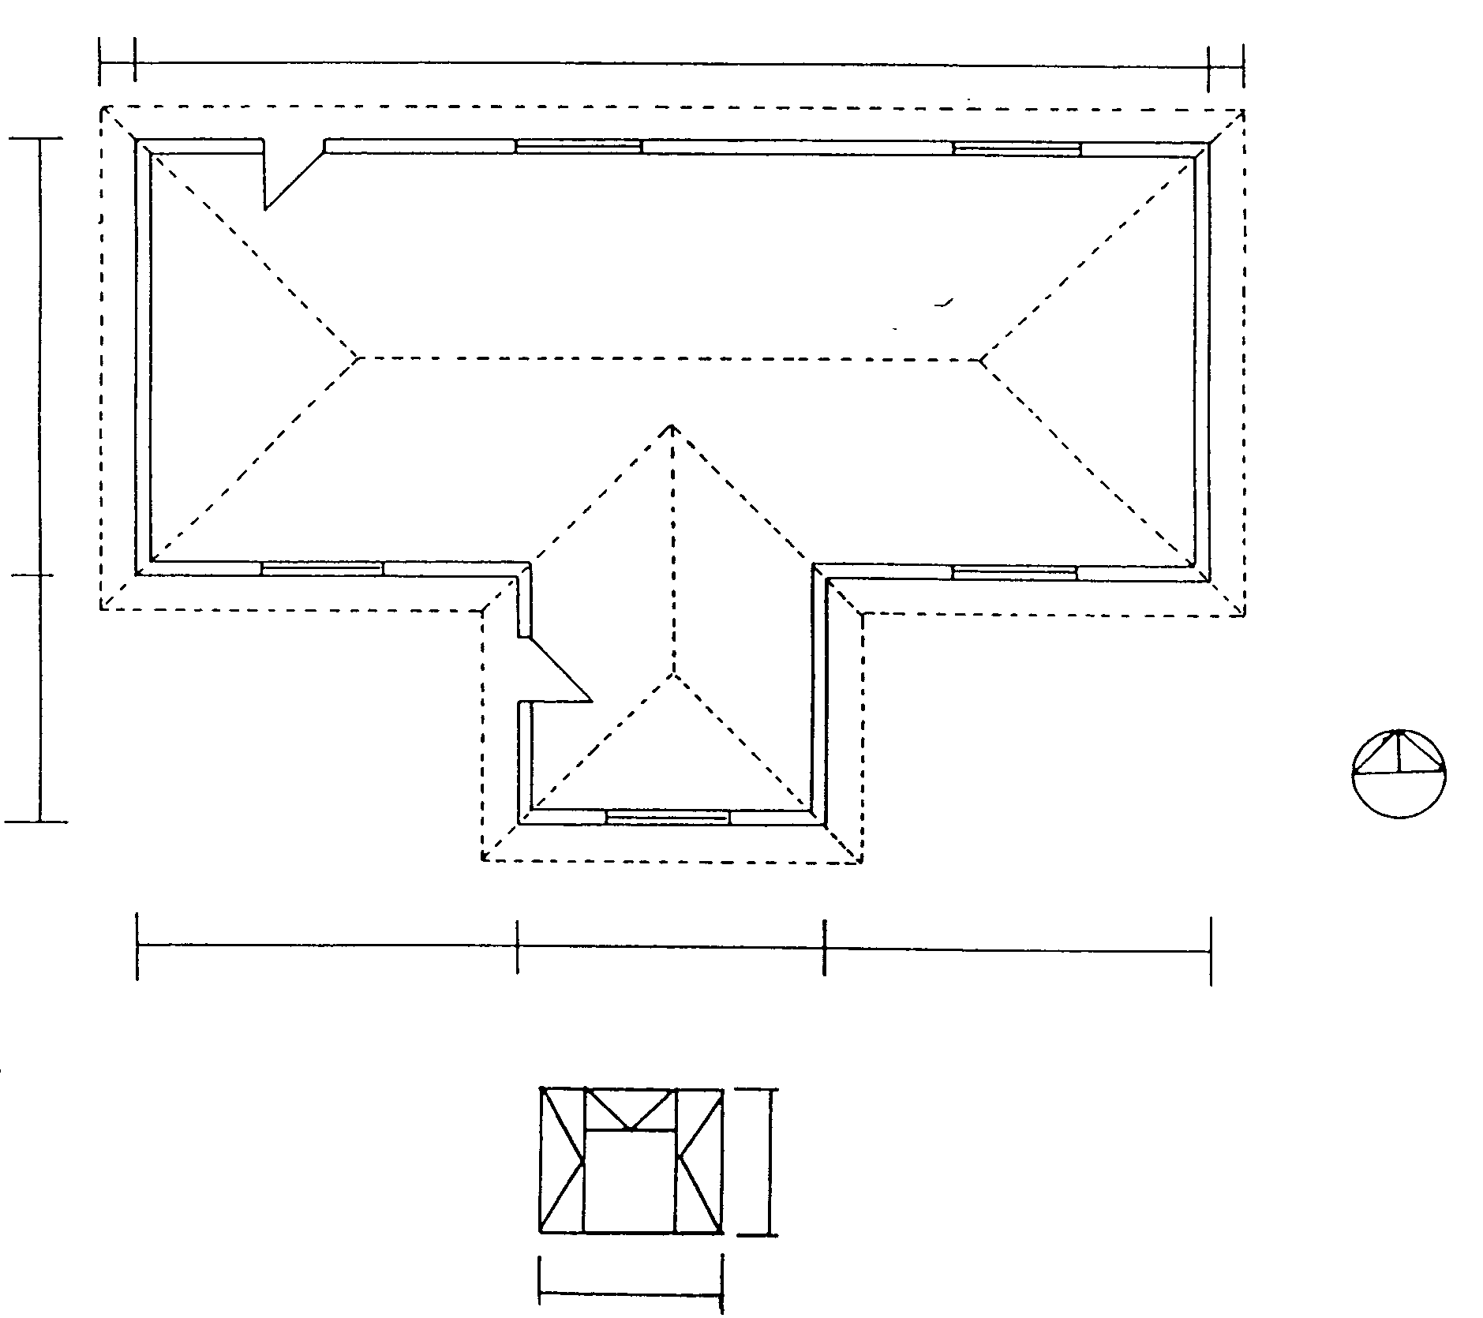  WINDOW SCHEDULE Figure 3 | [60]

QUESTION 5

Figure 4 below shows the ground plan of a dwelling to be erected.
Calculate the number of bricks required for

  - the 330 mm substructure;
  - the 220 mm superstructure;
  - the 110 mm beam filling;
  - the total number of bricks for the complete building.

Only the number of bricks for the doors and windows must be deducted.
14 000
5 000
4 000
5 000
Figure 4
4000
2780
4000
1220
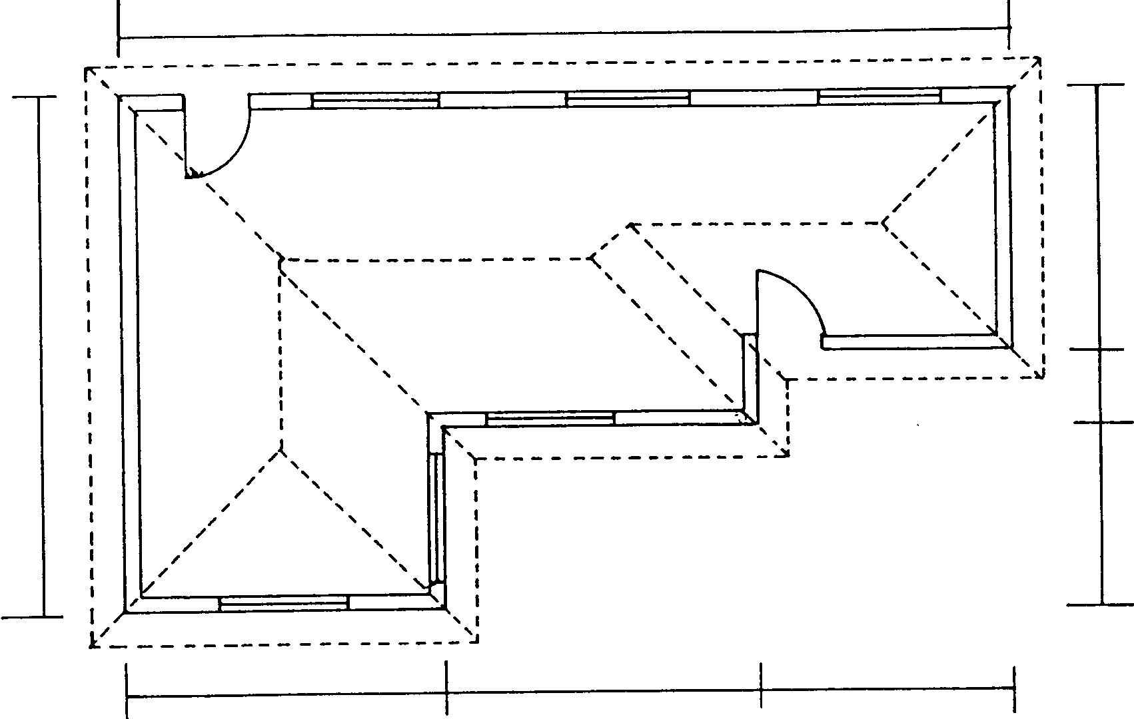

Use the following specifications for the calculations:

Use 50 bricks per square metre for a half brick wall.  - The substructure is 450 mm high.  - The superstructure is 3 000 mm high.  - The beam filling is 3 layers of bricks high.  - The door openings are 2 000 mm x 1 000 mm.  - All windows are 2 500 mm x 1 500 mm.  - A FIVE- percent wastage of bricks must also be calculated.  Tabulate your answer according to the standard columns. | [60]

QUESTION 6

Figure 5 below shows a diagram of a simply supported framework and supported at points P and Q.

  - Calculate the reactions at the supports P and Q.
  - Draw the space diagram according to a scale of 1:100.
  - Draw the vector diagram using a scale of 10 mm = 1 kN.
  - Determine graphically the nature and magnitude of the forces in each member of the framework.

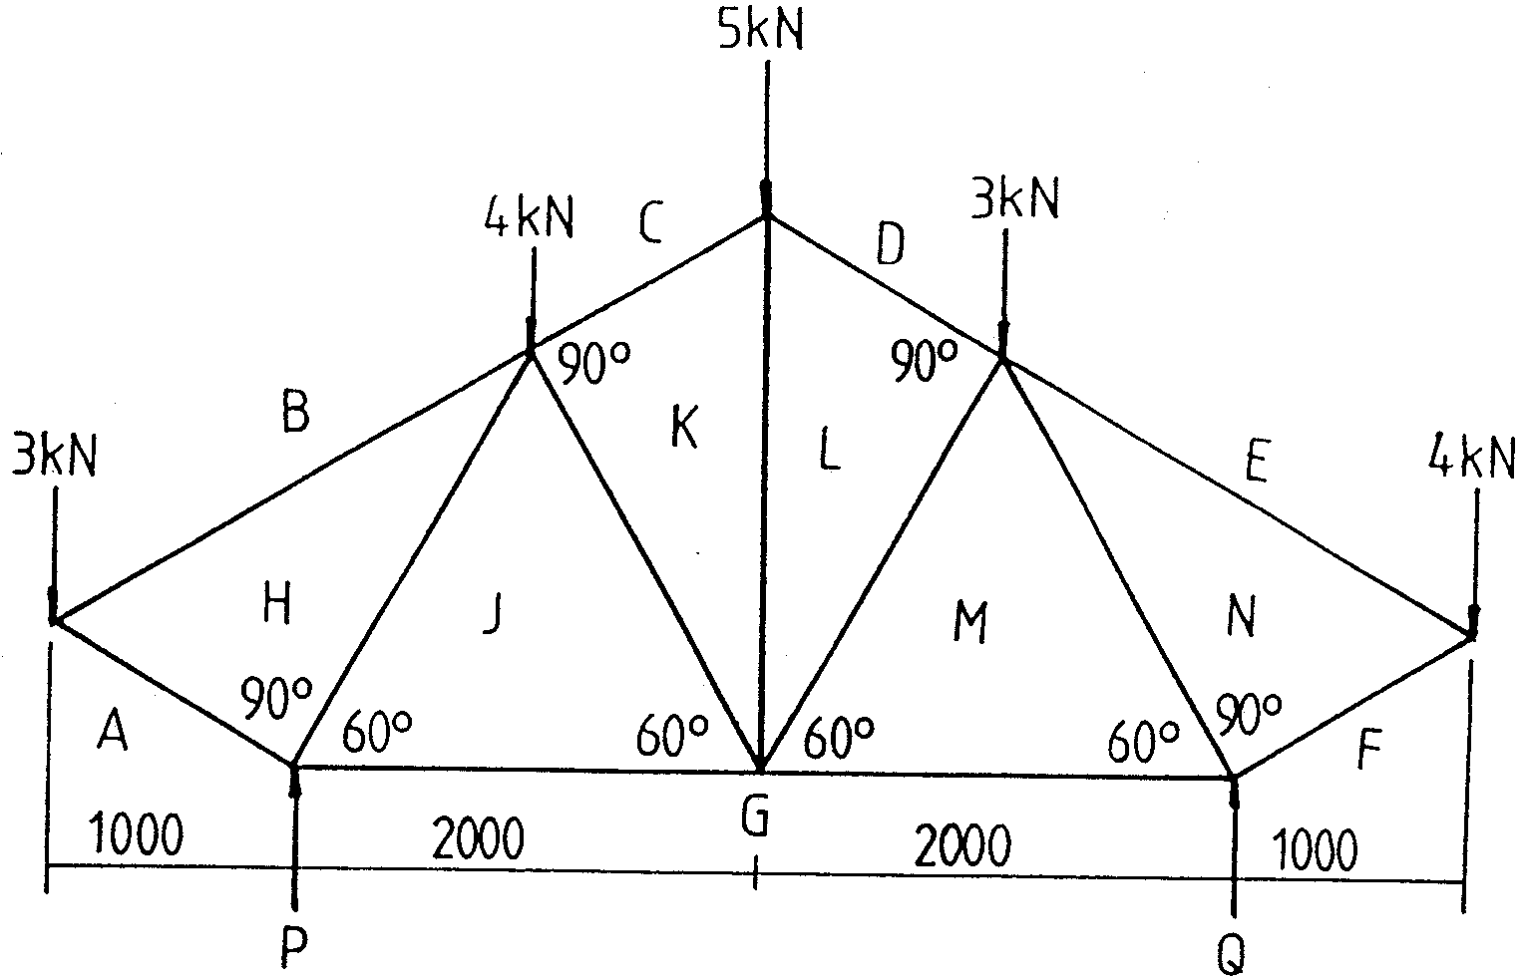
Figure 5

Draw the table below in your answer book and answer Question 6.4 within the table.

MEMBER | NATURE | MAGNITUDE

AH

BH

CK

DL

EN

FN

GM

GJ

HJ

JK

KL

LM

MN

QUESTION 7

Figure 6 below shows a loaded beam supported at points P and Q.

  - Calculate the reactions at the supports P and Q.
  - Calculate the bending moments at points A, B, C, D, E and F.
  - Calculate the shear forces at points A, B, C, D, E and F.
  - Draw the space, bending moment and shear force diagrams

Use the following scales for the diagrams:

Space diagram : 1:100

Bending moment diagram : 2 mm = 1 kN

Shear force diagram : 5 mm = 1 kNm

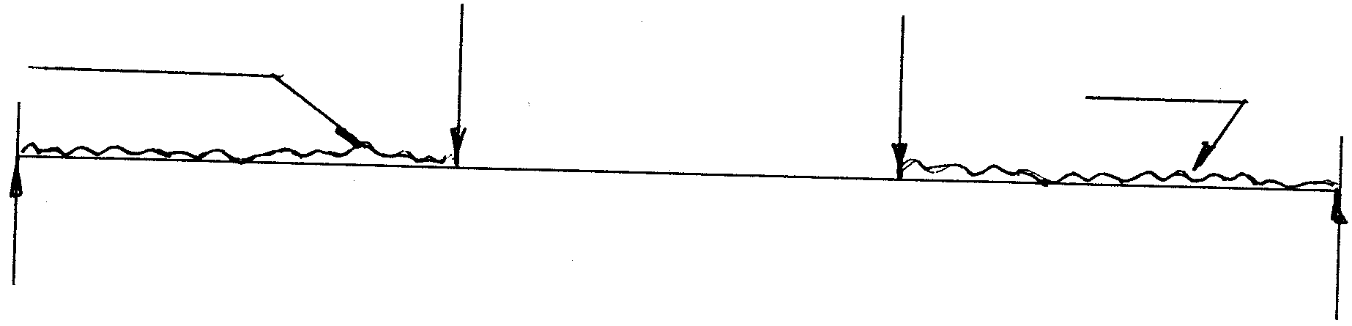  5 kN  4 kN  2 kN / m  3 000  2 kN / m  3 000  3 000  Q  P  Figure 6 | [60]
TOTAL: | 300

