GAUTENG DEPARTMENT OF EDUCATION
SENIOR CERTIFICATE EXAMINATION

TECHNIKA (CIVIL) HG

TIME : 3 hours

MARKS : 300

REQUIREMENTS:

- A3-size drawing paper

- Drawing instruments

- Pocket calculator

INSTRUCTIONS:

- Answer any FIVE questions.

- All calculations and written answers must be done in your Answer Book.

- Number the questions as they appear in the examination question paper.

- Show clearly on the drawing paper the number of the question you are answering.

- Use both sides of the drawing paper.

- Drawings and sketches must be fully dimensioned and neatly finished with titles and labels to conform with the SABS Recommended Practice of Building Drawings.

- Write your examination number on all loose sheets, the drawing paper and your Answer Book.

- For the purpose of this examination, the size of a brick should be taken as
220 mm x 110 mm x 75 mm.

QUESTION 1  - List any TEN safety precautions which must be taken while building is in progress to ensure the safety of workers and the public.  - Name any FIVE clothing items issued to workers to protect and safeguard them against particular hazards and unsafe conditions.  - Name any FIVE characteristics of good glass.  - State any TEN important duties of an architect beginning from the planning stage up to the completion of the project. | (10)  (10)  (10)  (10)

- Name any FIVE aspects which must be taken into consideration when installing a solar heating system to ensure maximum efficiency. | (10)
- Identify the following symbols which appear as standard abbreviations on a sewerage plan:  1.6.1 BT  - WC  - GT  - MSP  - FD  1.7 List any FIVE precautions with regard to a sewer when conditions are of such a nature that it is necessary to lay a sewer underneath a building. | (1)  (1)  (1)  (1)  (1)  (5)  [60]

QUESTION 2  - Draw a neat sketch to show the construction of a window sill for a metal frame window in the outer wall of a dwelling.  The following detail must be shown clearly on your sketch:  - One brick wall  - Plaster finish on the inside of the wall  - Damp proof course  - Window sill tiles on the inside  - Clay tiles on the outside  - Face bricks  - Metal window frame | (20)

2.2 The first floor of a building consists of a 150 mm thick concrete slab, which is supported by a 300 mm x 500 mm concrete beam. The total height of the beam and floor is 500 mm.  Use a scale of 1:10 to draw a vertical section through the beam and part of the floor on both sides of the beam. Show the formwork and reinforcement, as well as the top and bottom parts of a prop in position. | (40)  [60]

QUESTION 3  - Raking shores must support the wall of a building.  Using a scale of 1:10, draw an isometric view to illustrate the top and bottom end of the shoring. Also show the way the wall, shore, wall plate, cleat and needle fit together, to a scale of 1:5. | (40)

- A solar hot water system consists of a solar collector and a horizontal electric geyser that must be installed in a dwelling with a 30-degree pitched roof.  A pressure-reducing valve controls the cold water supply to the system.  By making use of a neat line diagram show the arrangement of all the components of this system.  Also indicate, by means of arrows, the direction of water flow when the system is in use.  Show clearly on the sketch the interconnection between the geyser and the hot water cylinder. | (20)  [60]

QUESTION 4
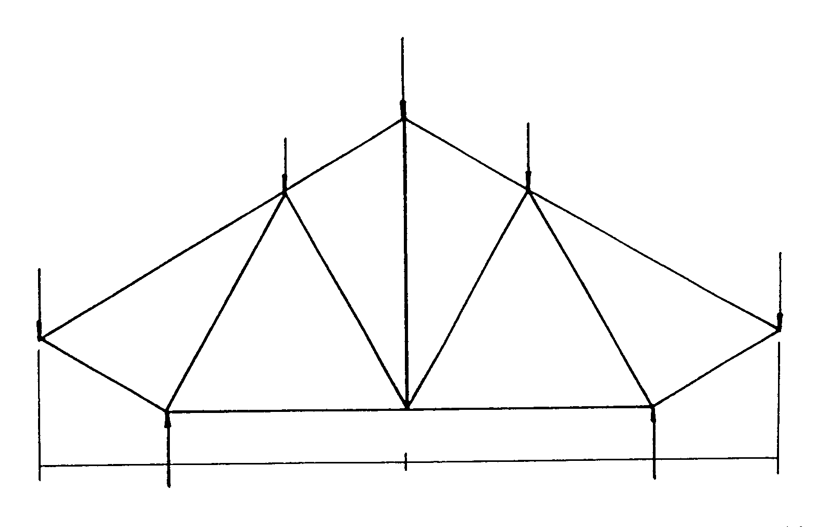

Figure 1 below shows a space diagram of a loaded framework which is supported at points P and Q.

Q
P
2000 G 2000

A

1000

J

60° 60°

M

60° 60°

N

90°
90° 90°

K L
4 kN
E
3 kN
D
5 kN
4 kN
B
3 kN

H

90°
C

F

1000
Figure 1

4.1 Calculate the reactions at the supports P and Q.
4.2 Draw the space diagram according to a scale of 1:100.
4.3 Draw the vector diagram using a scale of 10 mm = 1 kN.
4.4 Determine graphically the nature and magnitude of the forces in each member of the framework.

Draw the table below in your answer book and answer Question 4.4 within the table.

MEMBER | NATURE | MAGNITUDE
AH
BH
CK
DL
EN
FN
GM
GJ
HJ
JK
KL
LM
MN |  |  | [60]

QUESTION 5

Figure 2 shows the ground plan of a dwelling to be erected.
Calculate the number of bricks for:

5.1 The substructure
5.2 The superstructure
5.3 The beam filling
5.4 The total number of bricks required for the complete building.

Only the number of bricks for the windows and doors must be deducted.
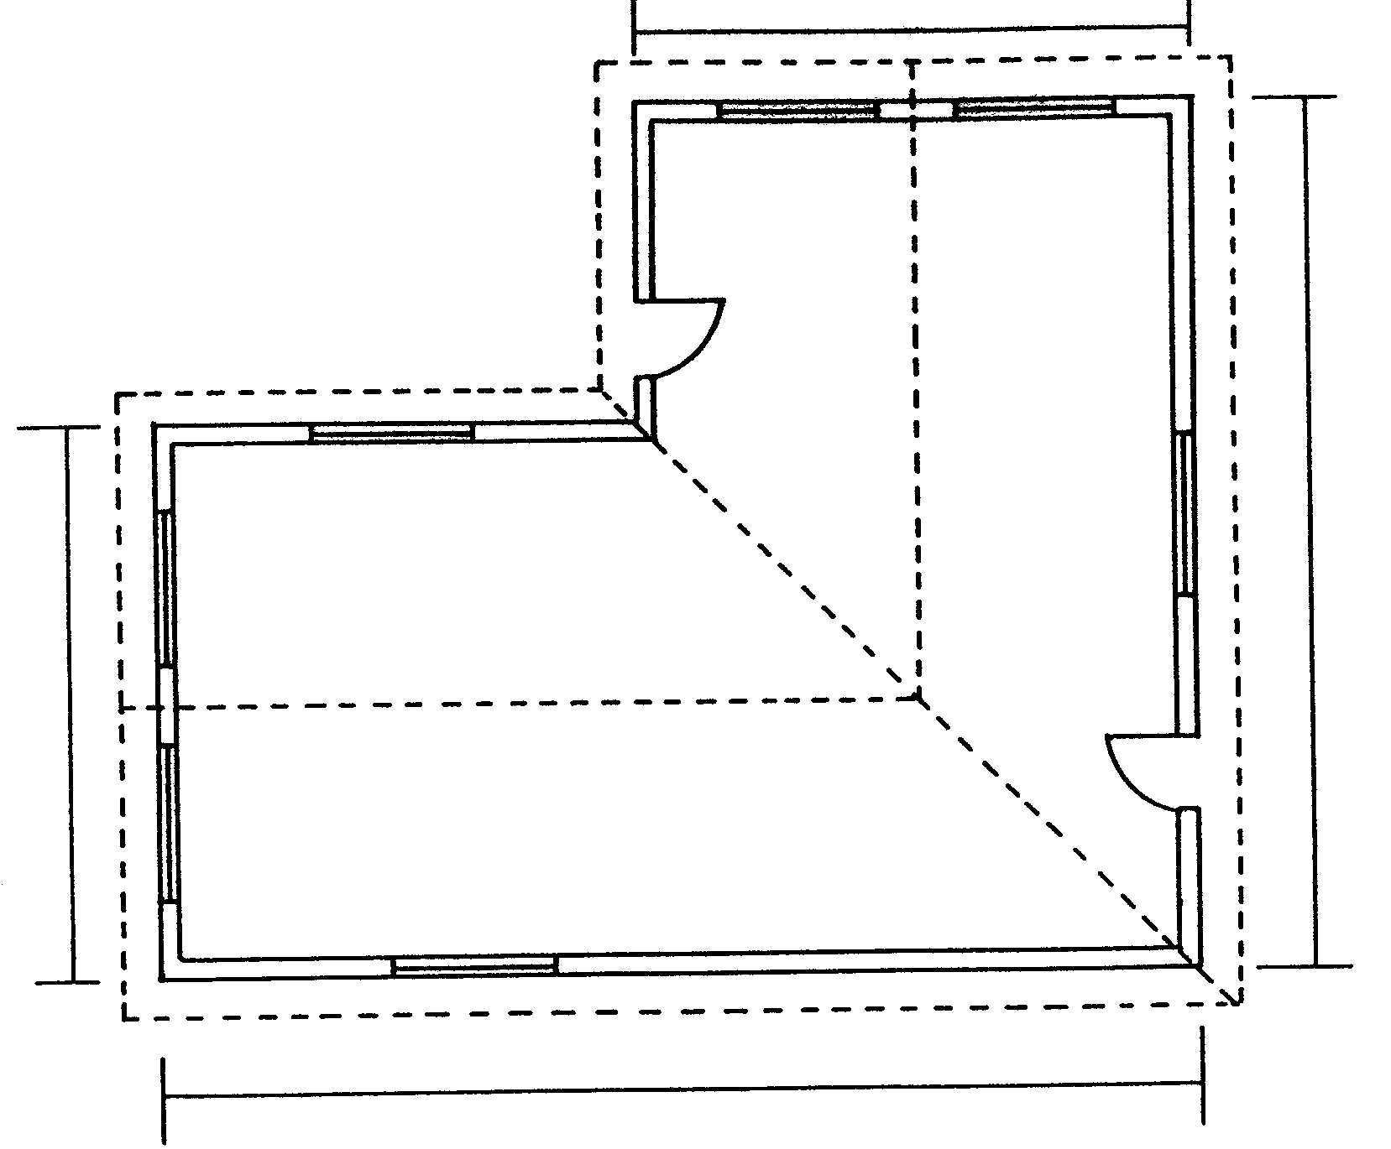
7000
11000
7000
13000

Figure 2
Use the following information for the calculations:  - Use 50 bricks per square metre for a half brick wall.  - Height of the substructure is 450 mm.  - Height of the superstructure is 2 900 mm.  - Door openings 2 000 mm x 1 000 mm.  - Window openings 2 000 mm x 1 500 mm.  - Allow SIX percent for wastage.  Tabulate your answer according to the standard columns. | [60]

QUESTION 6

Figure 3 shows a ground plan of a dwelling. The gable type roof has a 30-degree pitch covered with cement tiles, as well as a 500 mm open eaves overhang. The roof is finished off with 200 mm asbestos fascia boards to which the 100 mm square gutters with 75 mm down pipes are fixed.

The superstructure is 2 900 mm high and the substructure 300 mm high. The middle lock rail outer door is a three-panel door with two panels at the bottom and one at the top. The window sills on the outside are finished off with 30 mm quarry tiles.

Make use of the window schedule (Figure 4) for the placing of the windows.

Draw, to a scale of 1:100, the east and north elevations of this dwelling.

Also show the drawing to determine the height of the roof.
8 000
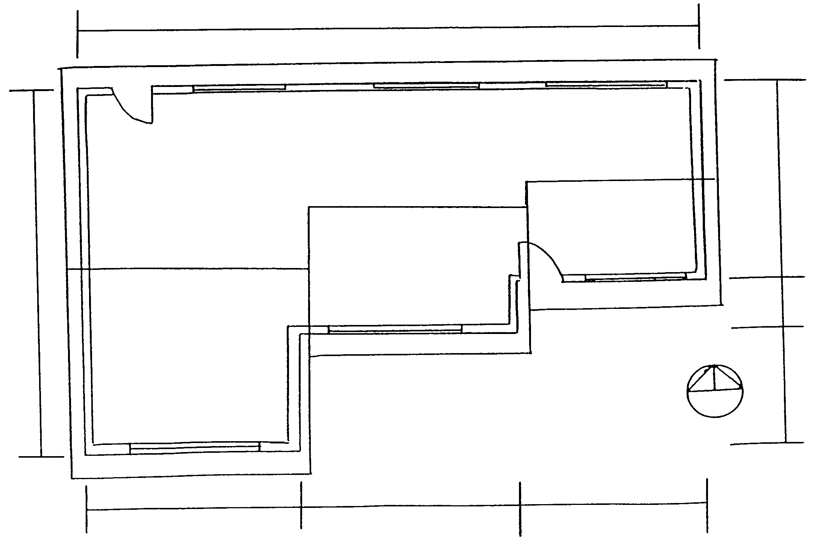
14 000
B A A
5 000 5 000 4 000
2780 1220 4 000

Figure 3

1500  1500  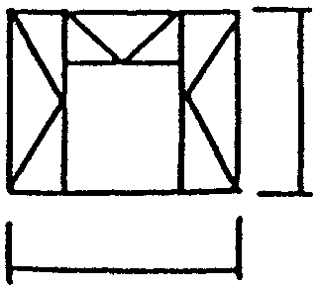  A  2000  B  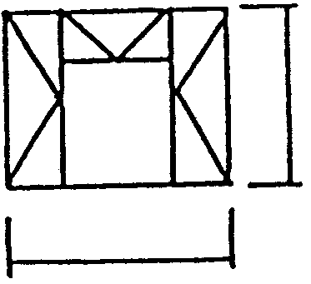  2500  WINDOW SCHEDULE  Figure 4 | [60]

QUESTION 7

Figure 5 shows a simply loaded beam supported at the ends.

7.1 Calculate the reactions at the supports.
7.2 Calculate the bending moment at points A, B, C, D and E.
7.3 Calculate the shear force at points A, B, C, D and E.
7.4 Draw the space diagram as well as the bending moment and shear force diagrams.

Use the following scales for the diagrams:

Space diagram : 1:100
Bending moment diagram : 1 kNm = 2 mm
Shear force diagram : 1 kN = 5 mm
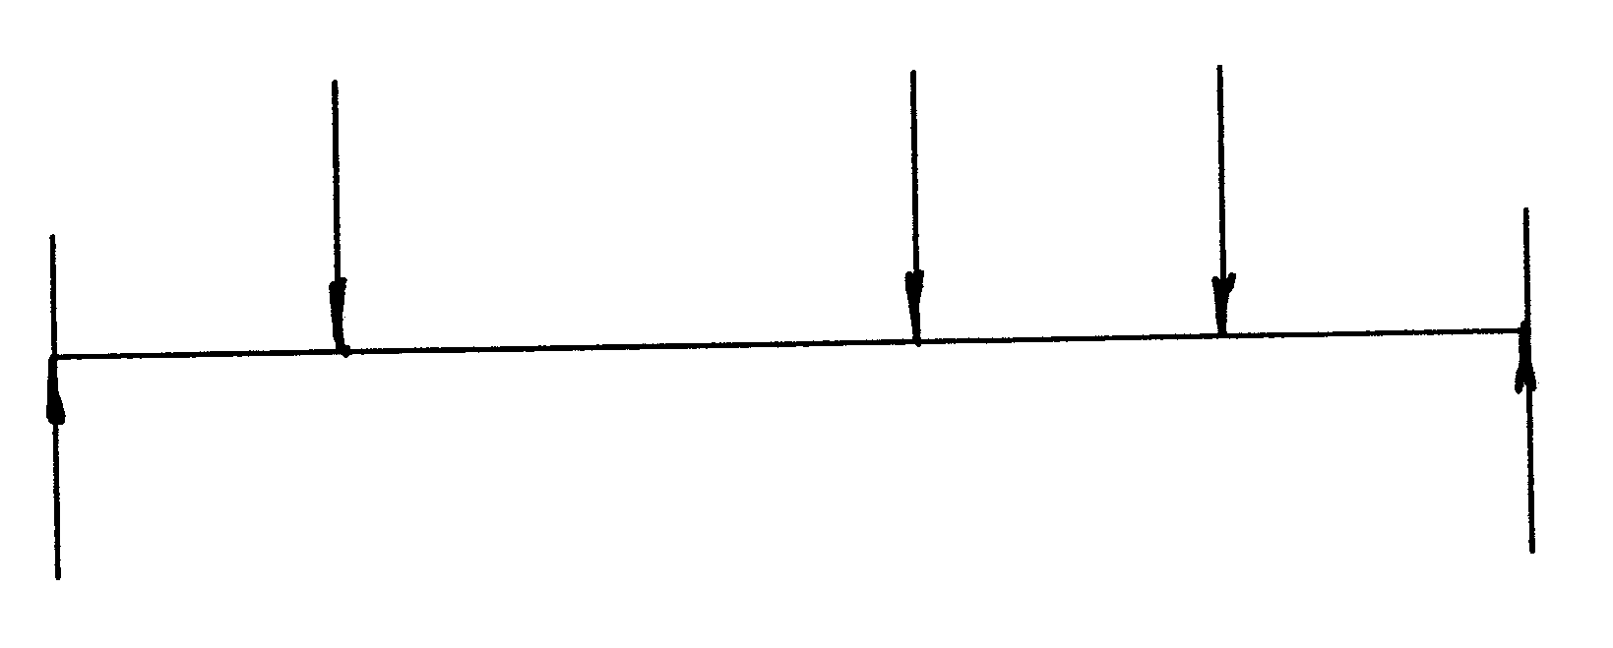
7 kN 7 kN 8 kN
3 000 6 000 3 000 3 000  A B C D E  RR  LR  Figure 5 | [60]

TOTAL: | 300

