GAUTENG DEPARTEMENT OF EDUCATION
SENIOR CERTIFICATE EXAMINATION

SISWATI LULWIMI LWEKUCALA
LIZINGA LELIPHASI
(Liphepha Lesitsatfu)

SIKHATSI: 2 ema-awa

EMAMAKI: 80

CAPHELA:

- Labahlolwako batawulahlekelwa ngemamaki nangabe umsebenti wabo ubhalwe ngebudlabha, nalapho batawube bente emaphutsa ekupeleni nasekuhlukaniseni emagama netigaba tendzaba kahle, kanye nasekusebentiseni timphawu tekukhuluma ngendlela lengakemukeleki.
- Bhala ngesandla lesifundzekako.

SIGABA A

UMBUTO 1

Bhala indzaba kugcwale emakhasi LAMABILI kungengci kulamatsatfu ngesihloko SINYE kuleti letilandzelako.

1.1 Bhala indzaba lekhuluma ngebubi nebuhle bekusebentisa makhalekhikhini (cell phone).

1.2 Labantfwana labakulesitfombe batintsandzane ngenca yekushona kwebatali babo babulawa sifo sengculazi. Bhala indzaba nganasi sifo lekutsiwa yingculazi (AIDS), yinike sihloko lendzaba yakho bese uyasho kutsi singancotjwa njani lesifo.

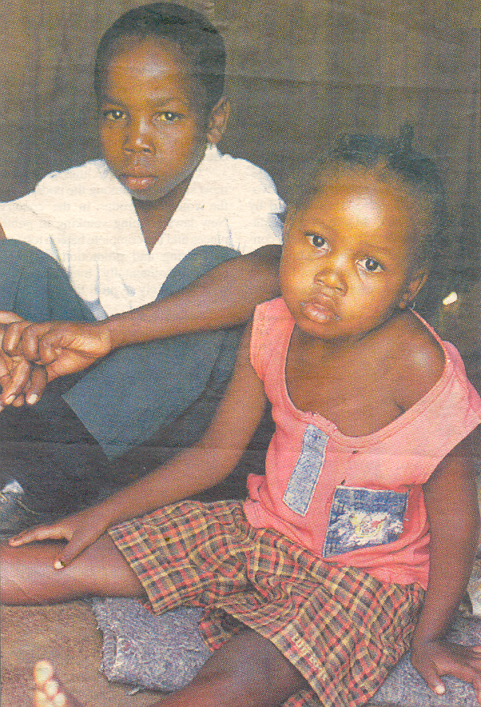

1.3 Imfundvo sikhali sanamuhla. Ngabe uyavumelana nalombono? Bhala indzaba unike imibono yakho. Ungakhohlwa kuyinika sihloko losibona siyifanele.

1.4 Umonakalo lowentiwa timvula.

1.5 Ngekubona kwakho kufanele yini kutsi bantfwana besikolo bangenele tindzaba tekuphatfwa kwesikolo. Bhala indzaba unike imibono yakho.

1.6 Mhla ngigubha lusuku lwami lwekutalwa.

EMAMAKI ESIGABA A: 1x30 = | [30]

SIGABA B

UMBUTO 2

Khetsa YINYE kuletincwadzi letilandzelako ubhale ugcwalise likhasi LINYE kuphela.

2.1 Bhalela sihlobo sakho lesikutfolele umsebenti emva kwekuba sewuhleli iminyaka lemitsatfu usekhaya ungati kutsi utatondla ngani.

2.2 Ubone simemetelo semsebenti ephepheni i-Sunday Times, kufunwa labo labanelikhono lekusebenta ngekhomputha. Bhala uwucele lomsebenti, njengoba sekungumnyaka wakho wekugcina ekolishi lekufundzela ikhomputha.  1x15 = | [15]

NOMA

UMBUTO 3

Fundzisisa kahle letihloko letilandzelako bese ubhala ngaSINYE sato. Ugcwalise likhasi LINYE.

3.1 Uliphoyisa lemgwaco. Utse usatihambela ngemsebenti watitsela etikwengoti lapho kushayisene khona ibhasi nemoto. Bhala umbiko ngalengoti lotawutfula kulokuphetse emsebentini.

3.2 Bhala emaminithi emhlangano wenyunyana yebasebenti lapho emalunga esigungu senyunyana yebasebenti bekabambe khona umhlangano ngemcashi loshaye ngesihluku umsebenti wamlimata.

3.3 Ungumabhalane welicembu lebhola / lomculo. Bhala luhlelo lwemhlangano wekuphetsa umnyaka welicembu. | 1x15=[15]

UMBUTO 4

Khetsa sihloko SINYE kuletilandzelako ubhale ugcwalise likhasi LINYE kuphela.

4.1 Wena uyiMeya yelilokishi i-Thandokuhle. Bugebengu butinike elokishini lapho ungumholi khona. Bhala indzabambiko watise emaphoyisa ngekubulawa kwebantfwana babulawa ngetibhamu mihla yonkhe.

4.2 Liphephandzaba iSowetan likhiphe timemetelo temsebenti letimayelana nabothishela. Ubone kulitfuba lelihle kutsi usale sewuzama inhlanhla ngekutsi utfumele incwadzi lekhombisa lwati lolumayelana nawe, lwati lonalo, titifiketi lonato nalokunye. Yibhale le-CV ubatfumele laba bekunene.

4.3 Sebentisa buciko bakho ubhale sikhangisi lotabe utsengisa timphahla takho letincane kuwe. | 1x15=[15]

EMAMAKI ESIGABA B: | [30]

SIGABA C

UMBUTO 5

Phendvula ngaYINYE incwadzi kuphela

SEKUHLWILE – G. MALINDZISA

5.1 Fundza lenganekwane bese uphendvula imibuto.

“Hawu babe nkhosiyami ase unginikete naliya libhayi lamake!”
“Ngena utitsatsele”.
Abone Vilase kutsi akekho masita. Angene ngematubane endlini. Atitsatsele libhayi. Utsite nakatsi uyaphuma, lambamba lizimu, wasabatse uzama kuphunyula, nani, tambamba tandla letinemandla, tandla letinkhulu. Inhlanhla yakhe nje yekutsi alizange limbulale, kepha lamfaka esakeni, waba kudla kwendvuku nje kuphela.
Dvunsu! “Khala mdvumbadvumbane wami sive tindzaba!”
Acale kuhlabela Vilase:
“Utsi ngikhale ngitsini bo!
Utsi ngikhale ngitsini bo!
Ngisabatse mntfwanamake ngipheleketele, wala.
Ngisabatse gogo nginikete libhayi, wala
Ngakholisakala ngelibhayi lamake!”

5.1.1 Make waVilase naMsesi wabatfuma ekudzeni kutsi bayokwentani? | (1)

5.1.2 Ase uchaze kutsi boVilase naMsesi babonani uma bangena kulowo muti labebacabanga kutsi ngumuti wamalume wabo. | (3)

5.1.3 Kwabangelwa yini kutsi Msesi angakudli kudla labaphakelwa kona salukati? | (2)

5.1.4 Kutsiwa abuzange behle butfongo kuMsesi wevani ebusuku njengoba bekangakalali? Chaza. | (2)

5.1.5 Ashiwo ngubani lamavi? Kwentenjani?  “Khala mdvumbadvumbane wami sive tindzaba!” | (2)

5.1.6 Shano kutsi lemisho iliciniso nobe ayisilo liciniso. Lungisa leyo misho lengasilo liciniso.

(a) Kwaba ngumsebenti welizimu wekuhamba lishinga tjwala ngemdvumbadvumbane onkhe emalanga.

(b) Kulomdvumbadvumbane welizimu bekuhlabela Vilase.

(c) Lizimu balinika imbita levutako kutsi liyewukha emanti emfuleni.

(d) Labantfu basekhaya bawuvula umdvumbadvumbane, waphuma Msesi.

(e) Kulelisaka lalomdvumbadvumbane bafaka libulo letinyosi, tinyoka, bofecela kanye nalokunye nje lokulumanako. | 2x5=(10)  [20]

NOMA

5.2 Phendvula lemibuto lelandzelako:

5.2.1 Chaza kabanti ngetifundvo letitfolakala kuletinganekwane:

(a) Yeswela umsila ngekulayetela. | (5)

(b) Litje lakaNtunjambili. | (5)

(c) Umtfwanenkhosi Nesicoco | (5)  [15]

5.2.2 Bunganekwane sibutfola kuphi kuletinganekwane letilandzelako?

(a) Sikhumba senyamlelane | (2)

(b) Khala mdvumbadvumbane | (3)  [5]  [20]

NOMA

lapha nalapho – j.j. ncongwane

6.1 Fundza lendzatjana bese uphendvula imibuto lelandzelako:

“Nx Uyati beLumbi balapha basagcwele umoya welubandlululo. Banembalandlati kabi labeLumbi. Bangitjela kutsi ngingangeni ngekhatsi angivele efasitelweni. Uyati ngitibambe kanyenti sekutsi angimbhamule ngetimphama. Ngabe kudzala ngibuyile solo ngibanjelelwa ngibo, bangitjela kutsi ngeke bangitsengisele ngingakaveli ngale efasitelweni. Yati ngimile nje ngababuka.”

“Hawu! Kantsi banjani beLumbi bakulendzawo yakini dzadzewetfu?” kubuta lijaha lelingumshayeli.

“Eyi, ngifisa shengatsi singefika sibanyenti singene kulokwelikhefana labo, sibafundzise sifundvo. Uyati ngala ngetulu ayisekho lentfo le. Sesabageza bebebe, sabafaka emgceni. Sesingena nabo beLumbi etindzaweni lapho bebangasivumeli kutsi singene khona.”

“Bomnaketfu ngicela kutsi sambeni ngoba ngijakile nebakitsi,” kusho misi Mdlalose.
“Ewu ncesi dzadzewetfu, sentiwe ngunaba beLumbi labadzelelako,” kusho umshayeli ayisusa imoto ihamba.

Isuka nje imoto lilanga seliyawulandza balimi. Yangenela umgwaco yashikisha. Yashikisha njalo imoto ngemgwaco lobheka eMntsoli. Yatsi nayifika lapha aKhrosini kaMlambo kwabe sekuhwalele kucedzile. Phela, ngaleso sikhatsi beyingekho lemakethe yakaMlambo lelapha eKhrosini; kulomgwaco lobheke eNhlazatje.

6.1.1 Lamajaha atsi kunkhosatana Mdlalose ayewufunani eKulindeni? | (2)

6.1.2 Nkhosatana Mdlalose ubone kutsi ushiywa sikhatsi nje ngobe ajake kuya kuphi? | (2)

6.1.3 Lamajaha akhuluma naNkhosatana Mdlalose nje akuphi? | (2)

6.1.4 Bekungubani libito laNkhosatana Mdlalose? | (2)

6.1.5 Asuchaze kwekutsi lamajaha nakefika eKulindeni entani. | (2)

6.1.6 Ngabe Nkhosatana Mdlalose wagcina ayile lapho bekatsi ujakele khona? Chaza. | (2)

6.1.7 Sifundvo sini umbhali lafuna ummango usifundze emphilweni nasekutiphatseni kwaNkhosatana Mdlalose? Chaza ubhekise endzabeni. Chaza. | (2)

6.1.8 Ngabe bekufanele yini kutsi Nkhosatana Mdlalose awasole lamajaha? Nikela sizatfu.  6.1.9 Yini umbalandlati? Chaza | (3)  (3)  [20]

NOMA

6.2 Ngabe babhali bazama kusecwayisa ngani kuletindzatjana? Veta kutsi secwayiso ngasinye umbhali usetfula kanjani. Sekela ngetibonelo letisencwadzini.

6.2.1 Maye ngeluswane lwakhe : S.J. Ncongwane  6.2.2 Kusasa lokusako : B.S. Khanyile | (10)  (10)  [20]

EMAMAKI ESIGABA C: | [20]

EMAMAKI SEKAWONKHE: | 80

