GAUTENG DEPARTMENT OF EDUCATION
SENIOR CERTIFICATE EXAMINATION

SISWATI LULWIMI LWEKUCALA
LIZINGA LELIPHAKEME
(Liphepha Lekucala)

SIKHATSI: 2½ emahora

EMAMAKI: 100

CAPHELA:

- Phendvula yonkhe imibuto, ungakhetsi.
- Bhala tinombolo njengobe tibhalwe ephepheni lemibuto.
- Yonkhe imibuto ayiphendvulwe ngelulwimi lolwemukelekako.
- Bhala ngesandla lesicacile lesifundzekako.

SIGABA A

UMBUTO 1

Fundza leticeshana tetindzaba bese uphendvula imibuto lelandzelako:

Sicephu A:

Tidzakamiva tindzala. Imitsambo yengati kube inemlomo ngabe seyafakaza ngisho enkantolo yamhlabuhlangene isho kutsi vele tidzakamiva tingumcedzave lobhubhisa umoyitela. Bantfu baseMsilezi sifundvo basitfola kuloko lokwagila Sabhawa nga-1959. Wabonakala sewutsenge tidzakamiva eMsilezi bavele batsi “utawubona saSabhawa.”

Sabhawa bekasidlakela sendvodza, awushiyile umhlaba. Bekayinkhomo ledla yodvwa. Bekasebenta yedvwa angaphazanyiswa ngumuntfu. Eshibhini bekafike abite pikiliyeza, simehlane sinye ashayele enhloko. Ntsambama utakwehlisa ngemtfunti wetinkhukhu. Kusuka lapho utawudvumela lipiki achekete ematje lamakhulu nemadvwala.

Kunyamalala kwelipiki kwaba yinkhomba yekugula kwaSabhawa. Ngodvwane, umLumbi welipulasi wenta takhe taba tashabalala. Imihlatsi beseyicinile. Umlomo besewomile ubhayele njengentsaba yeKenya imbonywe sitfwatfwa. Emanti alandvula angafuni kwengca emphinjeni. Kwamenela. Washiya timali takhe lekutsiwa abetimbela etigangeni lasebenta kuto.

Nawucabanga kutsi nibangani netidzakamiva ushaya phasi ngoba labadzala batsi nihlangene etulu njengelihlinzafuku. Loku kufana nekutsi ikhohlisana ihlomile imphi. Tidzakamiva! Tikucedza timoyitela.

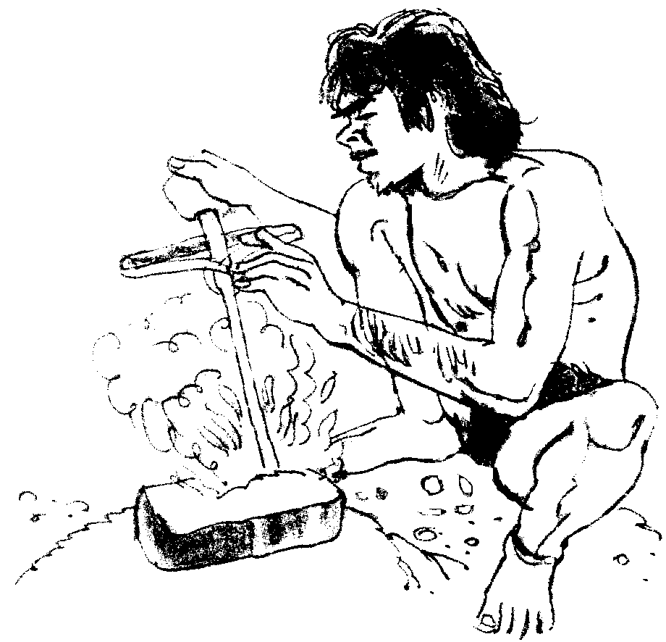

Sabhawa bekasidlakela sendvodza ahlala yedvwa.

1.1 Endzabeni lengenhla yini lekhomba kutsi imindeni leminyenti beyingatfoli lutfo nangabe lomdzala ashone nje ngekutuma? | (2)

1.2 Basuke bacondze kukutjelani bantfu baseMsilezi nabatsi kumuntfu utawubona saSabhawa? | (2)

1.3 Sitfombe lesingenhla ngabe siveta tiphi tigaba letibalulekile temphilo yaSabhawa? | (2)

1.4 Umlobi usebentise waphi emavi kuchaza loku?

1.4.1 Lihhovi letive tonkhe temhlaba.

1.4.2 Ulimala kancane, kancane ungacapheli kutsi tiyakubulala tidzakamiva.

1.4.3 Bekamudze kakhulu. 1x3 = | (3)

1.5 Kusigaba sesitsatfu endzabeni nyomula sifaniso. | (2)

1.6 Ucabanga kutsi lipiki linayiphi indzima lenkhulu kulendzaba? | (1)

1.7 Ngutiphi tidzakamiva lebetilimata bantfu ngeminyaka yabo-1959? Namhla-ke atisalimati muntfu yini? Chaza. | (2)

1.8 Ucabanga kutsi kungani Sabhawa kutsiwe uyinkhomo ledla yodvwa? | (1)

Sicephu B:
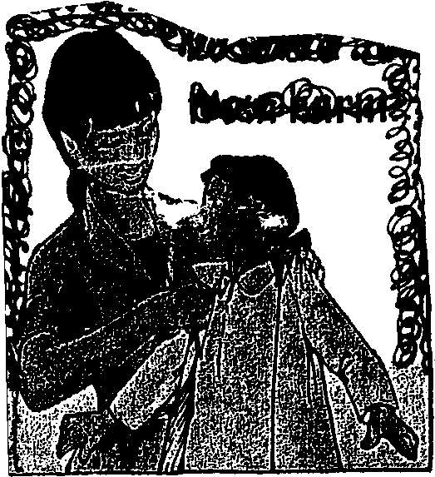
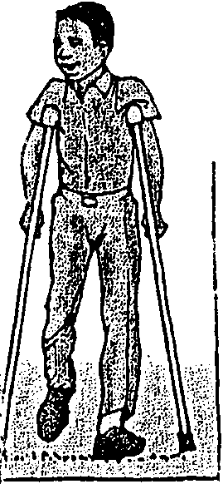
Umshado waSipho naDempi
Sipho, umphatse kahle Lomntwanebantfu

Sammy : Sengiso sikhatsi sakho lesi. Sukuma utfule inkhulumo yakho
kusadliwa. Batsatse Bhomba bakhala!

Bhomba : (1) (Atsintsa sikhwehlela) Ngiyabonga mphatsi tintsambo. Bomakhelwane, umndeni, bangani nani nonkhe lenikhona, nente lomshado watfunjana wami waba yimphumelelo. (Akhomba ngendvuku). Sipho, umphatse kahle lomntfwanebantfu. Nine bakhoti bakaMashego ngitsi Dempi seyintfombi yalapha kaNkuna. Ngiyabonga. (2) (Kukhale lihlombe).

Lebu : Njengasihlalo mine ngibonga wonkhe umuntfu lokhona lapha. Lelitfuba ngilinika mkhulu Sammy abeke naye lanako.

Sammy : Buhle bemsebenti wenu bungikhumbuta iminyaka yabo-1938. Buhlungu bekuphatfwa kabi kuhlukunyetwa lubandlululo, asinabulibala. Imphilo sayipenda ngetehlakalo letimnandzi. Bumnandzi sasitentela. LiJozi lonkhe silihamba ngetinyawo.

Bhomba : Imphelasontfo yayichichima imishado, imidanso, imicimbi yetinsuku letibalulekile emndenini noma emmangweni. Tatingekho tiphoci nabongoma uyayona.

Sammy : Sive sasibumbene, kungekho bosidlani. Kungekho tinkhundla temdlalo tatihlala tigcwele. Etikolweni kwakuphunywa ngemalengiso. Emandla entfutfuko asemculweni. Umlandvo nelikusasa letfu kulondvolotwe ngumculo.

Lebu : Umculo ngunina welutsandvo. Umculo namuhla bewungusawoti loyolisa kulobuhle belusuku lwaSipho naDempi. Nasenkonzweni yakusihlwa kutawuba khona (3) lokuya etfunjini. (Kusukume Khulekani naKhabo bemukele tipho tamakoti nemkhwenyane. Akungoma kushikisha lufudvu).
I-AFRIKA ITOLO

1.9 Ngabe lomshado ubaluleke ngani kuBhomba? | (1)

1.10 Lomshado labanye ubavusa lusinga. Njani? | (2)

1.11 Ngabe ushoni Sammy nakakhuluma ngetiphoco nabongoma uyayona? | (2)

1.12 Phawula tibe timbili letisenta sibuke umculo njengentfo lebaluleke kakhulu esiveni. | (2)

1.13 Shano kutsi emabintana ladvwetjelwe ngabe achaza kutsini njengoba asetjentiswe endzabeni. | (3)

1.14 Emagameni lowatiko ase ukhetse laphikisana nalawa:

1.14.1 lubandlululo  1.14.2 welutsandvo  1.14.3 watfunjana  1.14.4 letimnandzi 1x4 = | (4)

1.15 Kutsiwa ingcondvo lenhle ivela emtimbeni lophilile. Ngabe umculo wona unaliphi ligalelo emfundvweni njengoba umlobi Sammy ayibona? | (1)

EMAMAKI ESIGABA A: | [30]

SIGABA B

UMBUTO 2

Finyeta lendzaba. Emagama lowasebentisile angengci ku-20. | [10]

BakaMalope bebakhe eMbizana le eMashobodvo. Indzaba yekutsi indvuku lenhle igawulwa etiveni beyatiwa futsi iligugu. William Malope watsatsa Dinah intfombi yale kankuna eMamusini.

Ngelisiko loyi waMalope wacala ngekushaya taze taba sitfupha tinkhomo letihamba ngemasondvo. Letinye letisitfupha taba yimali. Lelichawe latakhela ludvumo kulo lonkhe laseMsilezi naseShakwaneng yeMapulane lebeyiphetfwe yindvuna Jubi Mashego. Phela William wacedza kulobola wagidza umtsimba ngelisiko leMakguntla. Ngalelisiko umtsimba ufika ngaLesine ntsambama kuchutjekwe umsebenti uphele ngeliSontfo emini.

Emva kwemtsimba kwalandzela umshado. Nawo umshado waba mkhulu kunayo yonkhe yangaleso sikhatsi sabo-1955. Emakholwa atseleka ngetinkhani bavela kuboPitoli, Mafikeng, Natal naseSwatini.

Tati titsi sitja lesihle asidleli. Sathane wajabula nga-1959 Dinah wahlaselwa yinyoka lebeyilwa naye yedvwa. Lenyoka beyibhace esihlahleni semdvubi nesempentjisi, endleleni lebekumele ahambe kuyo malanga onkhe. Emajaha nemadvodza bekayesaba lenyoka yetimanga. Budze beyimamitha layimfica. Umntfwana loneminyaka lemibili beyimesaba kabi. Kepha Dinah angavela nje kulendzawo lemamba ivuka indlobane. Lenyoka yagcina ibulawa nguGudimuntfu. Dinah besaphetfwe sifo senhlitiyo wawashiya emabele.

EMAMAKI ESIGABA B: | [10]

SIGABA C

UMBUTO 3

Fundza nasi sicashunwa bese uphendvula imibuto:

Inkhululeko yintfo lenkhulu sive lesihlala njalo siyikhumbula. Phela sive siyavota sentele kutsi livi le “Bantfu” livakale. Wenta liphutsa umuntfu lohlalako angavoti kantsi unelilungelo lekuvota. Umvoti ulungisela sive likusasa lelihle.

Emachegu lamphunga netalukati tiyavota. Emakhosikati nemadvodza ayavota. Kuvota emajaha netintfombi.
Bantfu labakhulu bayavota
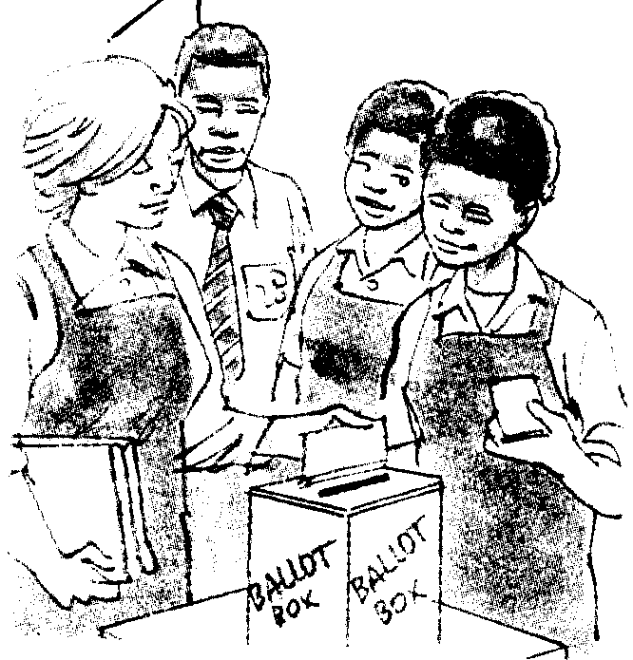

Laba labancane bantfu nabo bayavota.

Lilungelo letfu

Bavoti bonkhe kumele baphatse bomatisi. Bavotela etikhungweni noma etiteshini tekuvota letidvutane nalapho bahlala khona. Livoti lemuntfu liyimfihlo. Umngani nesinini sakho abakhonjwa kutsi uvotele bani. Kuvotwa emini kukhanya bha. Kuyavotwa kusihlwa sekumnyama bhuce nenja seyiluma umnikati. Emabhalothi ayabalwa kubikelwe sive kutsi bobani labahlabene. Unenhlanhla ummango nangabe wonkhe umuntfu lobhalisela kuvota abuye asukume ahambe ayovota.

- Kulomusho nyomula libito lelisebente kuveta mentiwangco:  3.1.1 Inkhululeko yintfo sive lesihlala siyikhumbula njalo. | (1)

3.2 Bhala inhloko yemusho lobhalwe ku-3.1.1 ngenhla. | (1)

3.3 Lapha esigabeni sekugcina nyomula libito lesigaba 2a naleli kusigaba 5 lelitsetfwe esiNgisini. | (2)

3.4 Emishweni lelandzelako sebentisa sabito selucobo sivete lokukhonjwe kubakaki:

- Emakhosikati nemadvodza ayavota (njengesabito).  - Emachegu lamphunga netalukati tiyavota (sigcizelele). 1x2 = | (2)

3.5 Esitfombeni lesingehla; ngabe sisebente njani sabito sekukhomba? | (2)

3.6 Sebentisa sento vota emshweni lemifisha lotibumbela yona sivete lokulokulandzelako:

- imphambosi yekwentela.  - imphambosi yekwentiwa  - imphambosi yekwentisa 1x3 = | (3)

3.7 Yakha sentakutsi lesisuselwa egameni luma bese usisebentisa emshweni. | (1)

3.8 Esigabeni sekugcina nyomula imisho lemibili lenesentakutsi usho nekutsi tisebente njani emshweni ngamunye. 2x2 = | (4)

3.9 Emshweni yesigaba sekugcina titfolele imisho lenaletindlela tesento letilandzelako uyibhale phasi.

- indlela lesabito  - indlela lecondzile  - indlela leyamile/lencikile 1x3 = | (3)

3.10 Sebentisa sibanjalo lesidvwetjelwe emshweni lotibumbele wona: | (1)

Livoti lemuntfu liyimfihlo.

UMBUTO 4

Fundza nati ticeshana bese uphendvula imibuto:

“Bangani lebesimatse nelulimi bashe kwemanti emhlabatsini. Emva kwekulahlekelwa ngumsebenti tintfo tijikile nalapha ekhaya.

Sinkhwa sesisimanga sekuphela kwenyanga. NaLaNgutjani sewungibita ngaVilavoco, ngoba sekusebenta yena. Umphakatsi ngeke uyivume lentfo le.
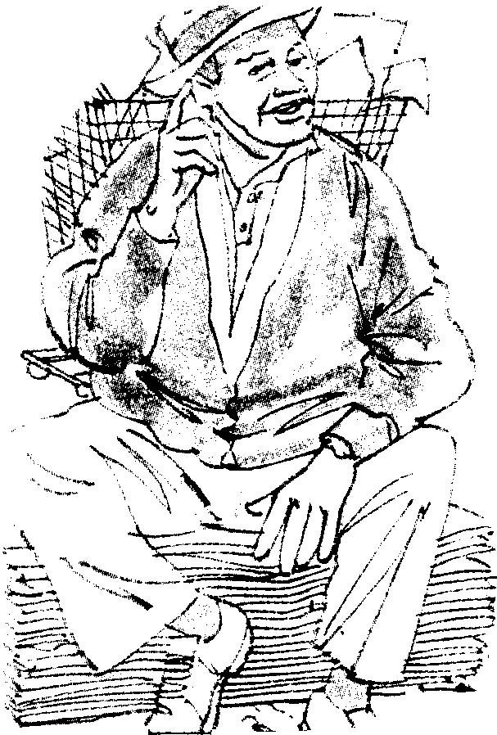
Sengibitwa ngaVilavoco ngoba angisebenti. Ngingumahlalela ngiphuyile.
A

Lapha ngiyolanyulelwa sitsembu Kulesidvwaladvwala semfati.

Nakuphuma sikolo indvodzana yami ivele itilahle phasi kwemganu idle ematsambo enhloko. Imbheke ngemehlo enzondo unina nakadvunga advwalele wonkhe umuntfu lapha ekhaya. Indlala sitsa senhlonipho”

Imbuka ngemehlo enzondo
B
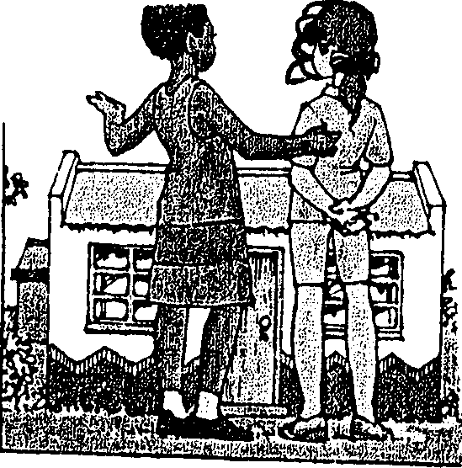

4.1 Letfula mcondvomuni ligama Vilavoco lelisesigabeni lesingenhla? Sekela. | (2)

4.2 Ngabe sijobelelo /–ana/ setfula mcondvomuni kulamagama?

- ingutjana  - indvodzana. 1x2 = | (2)

4.3 Sebentisa lesisho emshweni ubonise kutsi uyasati:

Simatse nelulimi. | (2)

4.4 Emishweni lengentasi enta lokufunwa tibiyelo.

4.4.1 Sinkhwa sesisimanga sekuphela kwenyanga. (landvula) | (1)

4.4.2 Imbuka ngemehlo enzondo unina nakadvunga advwalela wonkhe umuntfu. (phika) | (1)

4.5 Phendvula imibuto ngalamabintana lalandzelako ladvwetjelwe. Bhala lelinye lelimcondvophika walelidvwetjelwe.

4.5.1 Emva kwekulahlekelwa ngumsebenti tajika tintfo. | (1)

4.5.2 Kute umuntfu loneligunya lekudzelela. | (1)

4.6 Endzabeni lengenhla nyomula lelinye ligama lelinemcondvo lofana newaleli:

- siphuyile  - ngingumahlalela | (1)  (1)

4.7 Nika inchazelo lensha yeligama umphakatsi. | (1)

4.8 Bhala linye ligama esikhundleni salawa

- Bangani besimatse nelulimi.  - Idle ematsambo enhloko. | (1)  (1)

4.9 Nyomula ligama lelihlonishwa ngaleli:

emaphokoya | (1)

4.10 Chaza nankha emagama:

- sitsembu  - sidvwaladvwala | (1)  (1)

4.11 Veta tinchazelo letimbili teligama umsebenti ngekwakha imisho. | (2)

UMBUTO 5

5.1 Phindza ubhale lemisho ulungise lapho kuneliphutsa khona. Yibhale ngesiSwati lesihle. Dvwebela lapho ulungise khona.

5.1.1 Tihlwele (-jabula)(sicephwana) semdlalo wasesiteji. | (2)

5.1.2 Imbita (-va) ngumpheki. | (1)

5.1.3 Dragoni sitsa (-tfu) sonkhe. | (1)

5.1.4 Ingulube yesikhotsa ayihlekisani (-umuntfu). | (1)

5.1.5 Uvalekile (umlomana)(-aMjibha) nakahlulwa ligoli abukene nanozinti. | (2)

5.1.6 Sive (-Ngwane) siyatiwa (-hlonipho) futsi siyatitsandza. | (2)

5.1.7 Buhlalu (-mhlophe) bumele lutsandvo. | (1)  [10]

5.2 Phindza ubhale lesicashunwa bese ulungisa emaphutsa lakhona. Dvwebela konkhe lapho ulungise khona.

“Umntfwana usipho lesisinikwa ngumvelinchanti. Batali nemmango bona bamupha inhlonipha lutsandvo kanye naimfundvo lenhle,” kusho Sofi.  Tsine naMahashi siyibonile ikinga lesikolo kutsi umuntfu akanakekele bantfwana bakhe. “Habe nanimyekelelani umuntfwana agula? Niyeva na?” asho abadzindza ngemshiza Tapeti. | [10]

EMAMAKI ESIGABA C: | [60]

EMAMAKI SEKAWONKHE: | 100

