GAUTENG DEPARTMENT OF EDUCATION
SENIOR CERTIFICATE EXAMINATION

SISWATI LULWIMI LWESIBILI
LIZINGA LELILULA
(Lephepha Lesitsatfu)

SIKHATSI: 2 ema-awa

EMAMAKI: 80

CAPHELA:

- Bhala ngesandla lesifundzekako.

- Phendvula yonkhe imibuto ngesiSwati lesamukelekile.

- Landzela imigomo nemitsetfo yaleso naleso sigaba.

SIGABA A

UMBUTO 1

Khetsa sihloko sibe SINYE kuleti letilandzelako ubhale ngaso kugcwale emakhasi LAMABILI.

1.1 Bafati baseNingizimu Afrika bangenta lukhulu kondla sive saseNingizimu Afrika kanye nemhlaba wonkhe. Bukisisa letitfombe bese ususela kuso ekubhaleni indzaba.

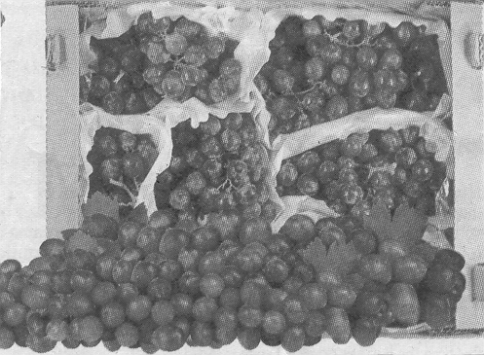
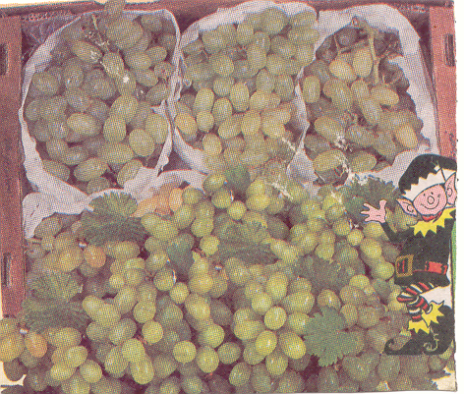

1.2 Bantfu sebaphelile kutsatselwa nati tintfo letilandzelako nabahluleka kubhadala noma kukhokhela tikweleti tato. Ngabe kufanele yini kuchutjekwe nekutsenga nati tintfo ngesikhweleti?

1.2.1
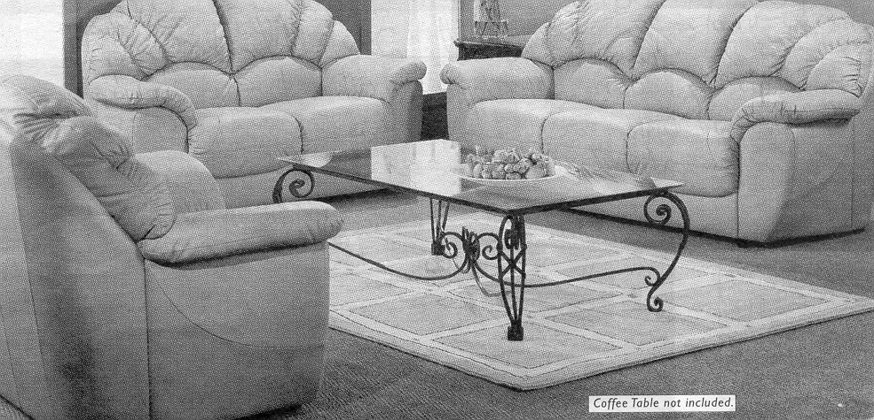

1.2.2
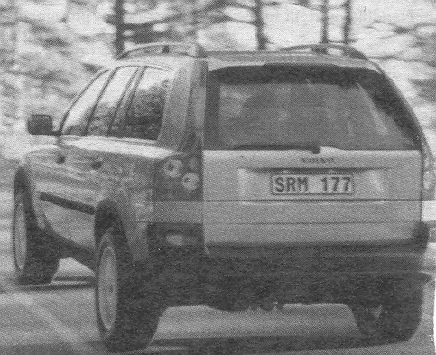

1.3 Tigebengu, babulali nebadlwenguli banemalungelo laphelele kunalabo labahlukunyetiwe. Ekucoceni kwakho ake ubuke nasi sitfombe lesingentasi kanye nalamaphuzu langaphasi kwesitfombe.

Utsini ngemalungelo alabahlukunyetiwe?

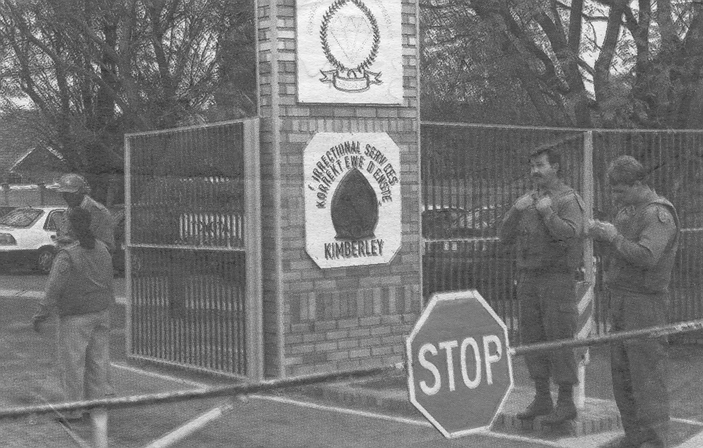

    - Ngabe tigebengu, babulali nebadlwenguli kufanele yini banikwe ibheyili (Bail)?
    - Ngabe kufanele yini bagcinwe imphilo yabo yonkhe emajele?
    - Ngubani lokufanele abondle lena emajele?
    - Ngabe sigwebo sentsambo nguyona mphendvulo lengehlisa bugebengu na?

1.4 Bhala indzaba ngemidlalo yalapha esikolweni senu. Indzaba yakho ayifake lokwenteka kuletitfombe letilandzelako.
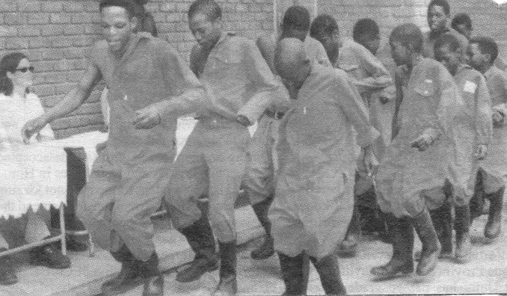
1.4.1

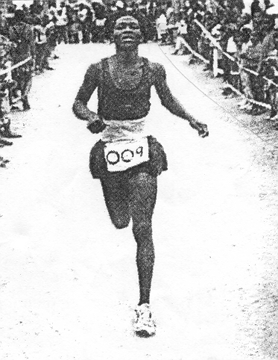
1.4.2

1.5 Kutiphatsa kwelusha endzaweni yakini.  EMAMAKI ESIGABA A: 1 x 40 = | [40]

SIGABA B
UMBUTO 2

Khetsa incwadzi ibe YINYE ubhale ngayo kugcwale likhasi LINYE

2.1 Utawube unemcimbi lofana nanankhu bewubanjwe nguDudu kulesitfombe. Bhalela umnganakho incwadi ummeme. Mtjele konkhe lenitakwenta.

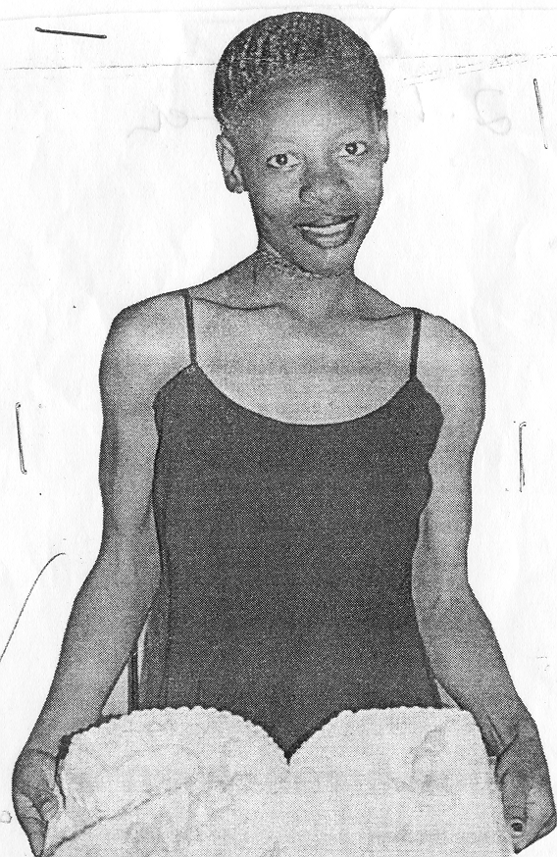

2.2 Bhalela sonhlalakahle wendzawo yakini incwadzi ukhonondze ngalelizinga lekwenyuka kwekusetjentiswa kwetidzakamiva kubantfwana besikolo. Ubeke phela netincomo letingawucedza lomkhuba lomubi kangaka.  2.3 Licembu lelidlala umdlalo wesiteji lifuna kudlalela umphakatsi wonkhe. Bhalela ikhansela yendzawo yakini incwadzi ucele imvumo yekusebentisa lihholo lemphakatsi.  EMAMAKI ESIGABA B: 1 x 20 = | [20]

SIGABA C
UMBUTO 3

Fundza kahle letihloko letilandzelako bese ubhala NGASINYE sato.

3.1 Kulesikolo lofundza kuso bafana labanyenti beta badzakiwe. Emalunga eSRC agcine akubona kufanele kwekutsi abite umhlangano webafundzi besikolo senu kutewubonisana ngalenkinga. Bhala emaminithi alowo mhlangano.

3.2 Ubone ephepheni (iSowetan) bakhangisa sikhundla semsebenti wekuba ngumabhalane. Nawe uyawufuna lomsebenti. Batse bafuna iC.V. Hlela kahle iC.V. yakho lotabatfumelela yona.

3.3 Bomakhelwane bakho bashonelwe ngumkhulu wabo. Bete kuwe bakucela kutsi ubabhalele umlandvo wemufi. Ngekulandza tihlokwane lebakunike tona wubhale-ke lowo mlandvo wemufi.  EMAMAKI ESIGABA C: 1 x 20 =  EMAMAKI ASAWONKHE: | [20]  80

