GAUTENG DEPARTMENT OF EDUCATION

SENIOR CERTIFICATE EXAMINATION

SETSWANA PUO YA BOBEDI SEEMOGODIMO
(Pampiri ya Ntlha)

NAKO: 2 diura

MADUO: 80
DITAELO:

- Araba dipotso tsotlhe.
- Dipotso tsotlhe di arajwe ka Setswana se se tlhapileng.
- Tlhaloganya potso pele o e araba.
- Dirisa dinomoro tse di maleba go ya ka dipotso.
- Tila tiro e e botlhaswa, mme o dirise mokwalo o o bonalang.

KAROLO YA A
TEKATLHALOGANYO

POTSO 1

Buisa temana e e latelang ka kelotlhoko, mme o arabe dipotso tse di fa tlase:

Naga ka bophara e aparetswe ke leroborobo la AIDS. Ke bolwetse jo bo tshwaetsanang. Batho bangwe ba akanya fa bolwetse jo bo tshwara fela batho ba ba ratanang ba bong jo bo tshwanang; bo go tshwara fa o lomilwe ke monang; bangwe bone ba ne ba akanya fa e le matlhajana a basweu go fokotsa setšhaba sa bantsho. Ga go a nna jalo gonne ga bo kgethe go ya ka mmala; bo tshwara baratani ba bong jo bo farologaneng; fa nkabe menang e rwala kokoana ya AIDS re ka be re tshwaeditswe rotlhe (mogare o o phela fela mo mothong).

Go tshwana le dintlha tsa gore dingaka tsa setso di phekola bolwetse jo; thobalano ya motho yo o tshwerweng ke bolwetse jo le ngwana yo o sa kgotlhelegang, le gore balwetse ba ba tshwanetse go isiwa kgolegelong ka maikaelelo a go fokotsa tshwaetsano. Ke naane, ga go a nna jalo.

Batho ba ba bonang mogare o, ke batho ba ba sa iphemeleng mo thobalanong; bakgweetsi ba dillori ba ba tsayang maeto a maleele; ditshwarwa kwa kgolegelong le bana ba ba belengwang ke batsadi ba ba lwalang. O ka se tshwarwe ke bolwetse jo ka katlano; go tlhakanela dijana le motho yo o lwalang, le fa e le go mo kgoma. Madi mangwe le mangwe a tshwanetse go tsewa jaaka a kgotlhelegile.

Molwetse ga a a tshwanela go kgethololwa, go tsewa jaaka botlhole jo bo bolayang. Re tshwanetse go mo rata le go mo ema nokeng. Go batho ba le bantsi ba ba bolailweng ke bolwetse jo, dimilione di le 25 mono Borwa ba Aforika (Sub-Sahara). Re tshwanetse go itlhokomela.

(Thulagantshololo – Gapsa Manual)

1.1 Kwala dintlha tse NNE tse di tsewang e le maaka (tumelo e e se nang nnete) tebang le bolwetse jwa AIDS. | 4x1=(4)

1.2 Ke go reng go twe go longwa ke monang go ka se go tsenyetse bolwetse jwa AIDS? | (1)

1.3 Kwala mefuta e MENE ya batho ba ba ka tsenwang ke bolwetse jo ga bonolo. | (4)

1.4 Tlhalosa o bo o naya mabaka a mane a goreng batho ba ba tshwerweng ke bolwetse jo ba sa tshwanela go kgethololwa? | (4)

- Ke batho ba ba kae ba ba bolailweng ke bolwetse jo mo Borwa jwa Aforika?  - Goreng go twe o tseye madi mangwe le mangwe jaaka a kgotlhelegile? Naya dintlha tse nne tse di supang maitemogelo a gago.  - A ke boamaruri gore dingaka tsa setso di kgona go alafa bolwetse jo? Naya ntlha e e sedifaditsweng ka botlalo.  - Ke dintlha / ditiragalo dife tse THARO le fa o ka di dira o ka se tsenwe ke bolwetse jo?  - Go ya ka kitso ya gago, goreng motho mongwe le mongwe a tshwanetse go tsaya teko ya AIDS? Kwala dintlha tse THARO.  - Goreng dintsho tebang le bolwetse jo di le kwa godimo mono Borwa jwa Aforika (Sub-Sahara)? Anaanela | (1)  (4)  (2)  (3)  (3)  (2)

- Go kaiwa eng ka bolwetse jo bo tshwaetsanang?  - Go tewang ka: go ema nokeng;  Go tlhakanela dijana  - Motho yo o tshwerweng ke bolwetse jo o mo lemoga ka diponagalo dife? Naya dintlha tse nne. | (1)  2x1=(2)  4x1=(4)

PALOGOTLHE YA KAROLO YA A: | [35]

KAROLO YA B
TSHOSOBANYO

POTSO 2

Araba potso 2.1 kgotsa 2.2

2.1 Buisa temana e e latelang mme morago o e sosobanye ka dintlha di le LESOME.

Go na le tumelo ya gore dikgogo di tlholegile kwa Java le Malaysia, mme
go tlogeng koo, batho ba di phatlhalatsa le lefatshe lotlhe. Dikgogo di ruelwa mae le nama. Maina a a latelang ke a dikgogo tse di itsegeng thata: White Leghorns, Brown Leghorns, Rhode Island Red, Light Sussex le Old English Game. Kgogo e simolola go beela fa e le bogolo ba dibeke tse somerobedi. Di beela ga ntsi mo mosong.

Fa e se na go beela, kgogo e simolola go elama. Fa e ka elama mae mme ya a baya mo 30°C, ditsuane di tshwanetse go thuthuga. Balemirui, gompieno ba dirisa dithuthusi go thuthusa mae a 100 000 ka nako e le
nngwe. Kgogo e kgona go phela dingwaga di le tlhano go ya go di le supa mme mo nakong e, e kgona go baya mae a a l 000.

Dikgogo di fepiwa ka mmopo, sonobolomo, korong, dinawa le bali kgotsa habore. Minerala wa khalisiamo o a tlhokega mo phepong ya dikgogo.

KGOTSA

2.2 Sekaseka ditshwantsho tse di latelang mme ka dintlha di le LESOME o sosobanye se se diragalang mo go tsone:

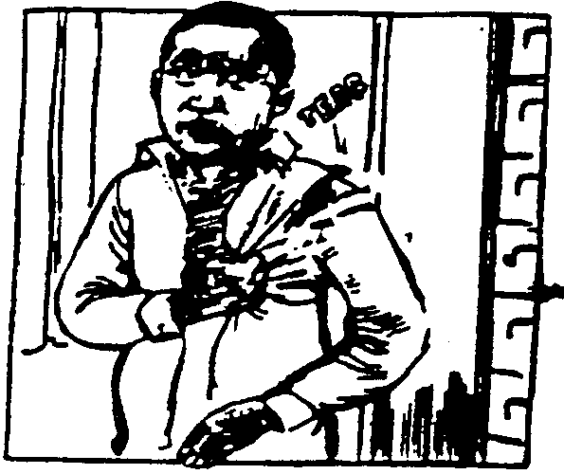  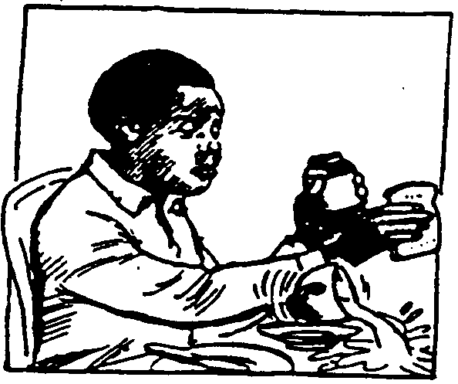  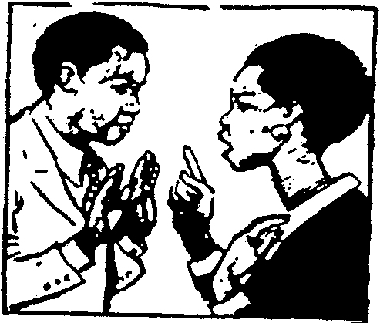  5.1 Pitso o kgeigelwa ke hempe mo mosong fa a ipaakanyetsa go ya tirong | - __________________________  __________________________  __________________________

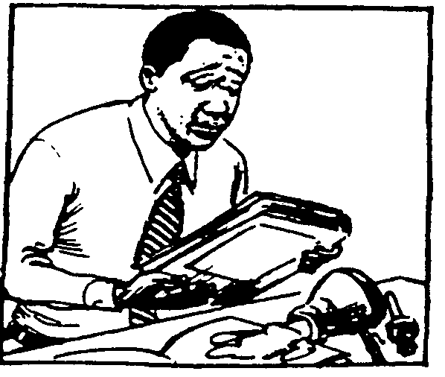  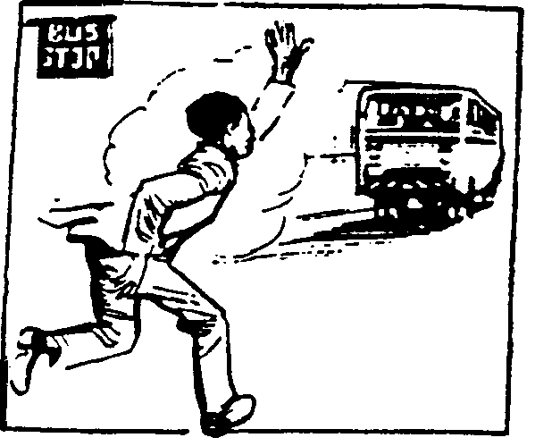  5.3 | 5.4
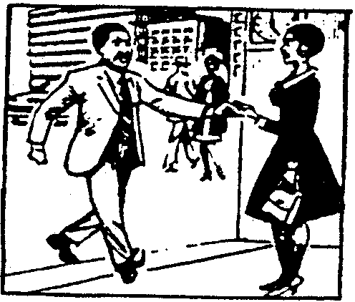  5.5 __________________________  __________________________ | 5.6 __________________________  __________________________

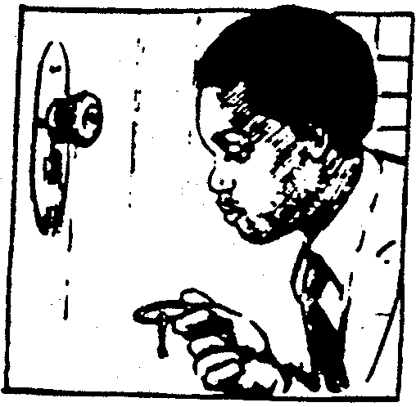  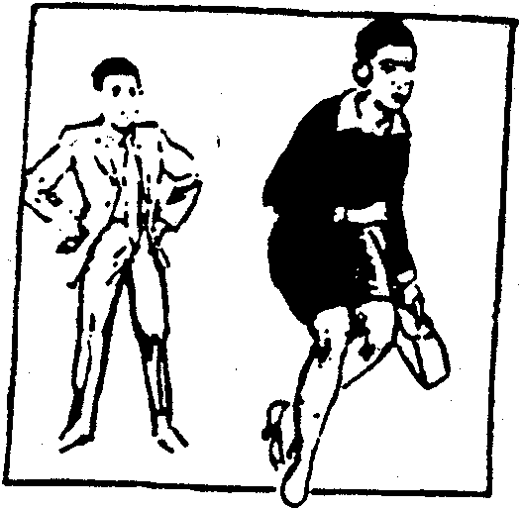  5.7 __________________________  __________________________ | 5.8 __________________________  __________________________
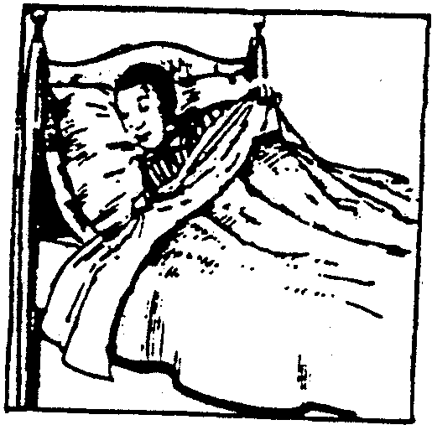  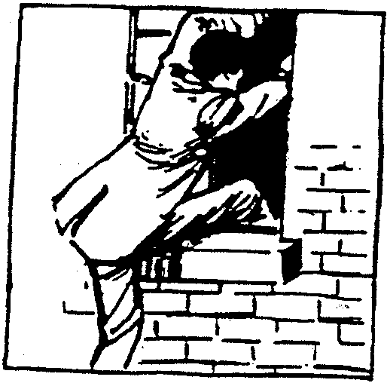  5.9 __________________________ | 5.10 __________________________

1x10=(10)

PALOGOTLHE YA KAROLO YA B: | [10]

KAROLO YA C
TIRISO YA PUO

POTSO 3

Buisa temana e latelang mme o arabe dipotso tse di ka fa tlase ga yona:

Go na le batho ba bantsi ba ba sa rutegang fela ba humile. Ba bangwe lehumo la bona
le a nyelela ka ba se na thuto go laola lehumo leo sentle. Motsalwapele kana a re metlhala ya khumo e mentsi, e batla baelatedi. Thuto ke motlhala o o botlhokwa o re ka o latelang.

Batsadi ba bantsi ba ratela bana ba bona thuto ya maemo. Le fa e le tlhwatlhwagodimo, ba a e lefelela le fa tota ba ikamoga. Ba bangwe ba rata bana ba bona le dilo dingwe tse di seng teng dikolong tsa bona. Ga go makatse fa dikhumbi le dibene di rwala dikete tsa baithuti di ba isa dikolong tse e neng e le tsa Makgoa (Basweu) fela le tsa Maindia. Matsapa di a tsaya kae? Thuto mogaetsho! Thuto ke boswa bo bo go kgomarelang gore o ye badimong ka bona.

- Mo polelong ya ntlha go tswa mo temeng e nopola letlhaodi le reletifi / leamanyi mme o dirise dikarolopuo tse mo dipolelong. | 2x2=(4)

- Itlhophele maina a tlhago a MABEDI go tswa mo temaneng mme o a dirise mo dipolelong.  - Nopola dithito tsa madiri tse PEDI tse di bontshang katoloso ya tirela, mme o bope dipolelo ka tsona.  - Dirisa lekaelagongwe la ‘matsalwapele’ mo polelong go bontsha fa o le tlhaloganya. | (2)  (2)  1x2=(2)

- Dirisa lefoko bana mo dipolelong jaaka:  - Sediri sa polelo  - Sedirwa sa polelo  - Thito ya lerui  - Kopulatifi  - Tlhalosi ya kopanelo | 5x1=(5)

3.6 Itseele marui a MABEDI go tswa mo temaneng, mme o bope dipolelo ka ona. | (2)

3.7 Dirisa leina le le LENGWE, go tswa mo temaneng, le e leng leadingwa mo polelong e e tlhabosang. | 1x1=(1)

3.8 Dirisa lelatodi la khumo, mo polelong | 1x1=(1)

- Go na le leemedi la maemo a bobedi mo ditemaneng tse,le itseele mme o le dirise mo polelong.  - Bopa dipolelo tse THARO ka matsamaelane a leinalegolo “batho” | (1)  3x1=(3)

- Kwalolola polelo e e latelang mo go pakaphethi: ‘Batsadi ba bantsi ba ratela bana ba bona thuto ya maemo’ | (1)

- Fetolela polelo e e leng mo go 3.11 mo go modirisopego pakajaanong tsweledi. | (2)

- Go kaiwa eng ka ‘o ye badimong’ | (1)

- Go na le maina a a bopilweng go tswa madiring mme a sa kaye batho mo temaneng e. Itseele a mabedi mme o bope dipolelo ka ona.  - Itseele lesupi la maemo a bobedi, mme o le dirise mo polelong e e tlhabosang, le le mo maemong a ntlha.  - Dirisa matlhalosi a mabedi go tswa mo temaneng mo dipolelong.  - Pharologanyo ke eng, magareng ga –ng yo o tlhagelelang mo go ‘ba ba sa rutegang’ le ‘dikolong’. Tlhalosa tiriso ya popi e.  - Kwala kganetso ya ‘Thuto ke motlhala o o botlhokwa o re ka o latelang’ | 2x1=(2)  (1)  (2)  (2)  (1)  [35]

PALOGOTLHE YA KAROLO YA C: | [35]

PALOGOTLHE: | 80

