GAUTENG DEPARTMENT OF EDUCATION
SENIOR CERTIFICATE EXAMINATION

SISWATI LULWIMI LWESIBILI
LIZINGA LELIPHAKEME
(Liphepha Lesitsatfu)

sikhatsi: 2 ema-awa

emamaki: 80

CAPHELA:

- Hlela umsebenti wakho ngendlela lokuhlelwe ngayo imibuto.
- Yonkhe imibuto ayiphendvulwe ngesiSwati lesamukelekile.
- Bhala ngesandla lesifundzekako.

SIGABA A

UMBUTO 1

Bhala indzaba kugcwale emakhasi lamabili ngesihloko sinye kuleti letilandzelako.

1.1 Imibono yami ngesifo ingculazi (AIDS).

1.2 Ngabe kubaluleke ngani kubalwa kwebantfu kuleli lakitsi eNingizimu Afrika?

1.3 Lisiko lingumgogodla wemphilo yayitolo, yalamuhla, nakusasa. Sekela lombono ngekubhekisa kulesitfombe lesilandzelako.

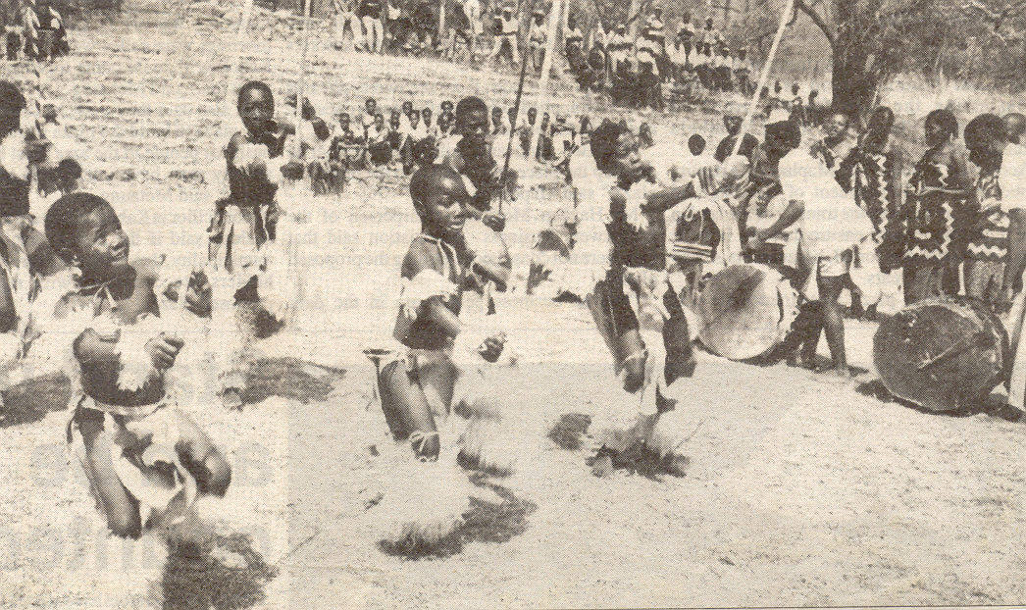

1.4 Kuhlukunyetwa kwebantfu nekungahlonishwa kwemalungelo abo. Leti tintfo letiyinselele esiveni.

1.5 Lusuku lwelukhetfo esigodzini sakitsi.

emamaki esigaba a: 1x40 = | [40]

SIGABA B

UMBUTO 2

fundzisisa kahle tihloko letilandzelako bese ubhala ngasinye sato. Bhala kugcwale likhasi linye.

2.1 Bhalela dzadzewenu incwadzi ucele kutsi akuchube etifundvweni takho njengobe batali bakho sebakushiyile emhlabeni.

2.2 Ubone simemetelo ephephandzabeni sekutsi kukhona sikhala samabhalane emahhovisi etenhlalakahle angakini. Bhala incwadzi ufune lomsebenti.

2.3 Ungulobhala wenhlangano yebasebenti iCOSATU. Bhalela baphatsi benkapani losebenta kuyo indzabambiko ukhonondze ngekwandza kwekubandlululana ngekwebuhlanga lapha emsebentini.

EMAMAKI ESIGABA B: 1x20 = | [20]
sigaba c

UMBUTO 3

Fundzisisa kahle letihloko letilandzelako bese ubhala NGASINYE sato.

3.1 Wena ungumhlali waseHillbrow kantsi unguSodolobha wakule ndzawo. Bantfu badutjulwa babulawe kabuhlungu masontfo onkhe. Bhala imemorandamu watise emaphoyisa ngekubulawa kwebantfu ngesihluku babulawa tigebengu.

3.2 Ungumholi wesigungu sebafundzi (SRC) balapho esikolweni lofundza kuso Benibambe umhlangano loshisa bhe ngathishelanhloko loshaye umfundzi wamlimata. Bhala emaminithi alowo mhlangano.

3.3 Wena usecenjini lemculo. Nilungisela kuculela umphakatsi wakini. Bhala sikhangiso lesingabhacekwa nome ngukuphi satisa mphakatsi ngalekhonsathi letabe yetfulwa licembu lenu.

EMAMAKI ESIGABA C: 1x20 = | [20]

EMAMAKI SEKAWONKHE: | 80

