GAUTENG DEPARTMENT OF EDUCATION

SENIOR CERTIFICATE EXAMINATION

SESOTHO LELEME LA BOBEDI BOEMO BO MAHARENG
(Pampiri ya Pele)

NAKO: dihora tse 2½

MATSHWAO: 90
DITAELO:

- Beha ditaba le ditema ka tatellano.

- Arola mantswe le matshwao a puo hantle.

KAROLO YA A

POTSO 1
DITEMA

Araba dipotso tse PEDI ho tse hlano tse butsitsweng.Bolelele ba karabo ka nngwe e be leqhephe le le LENG.

1.1 O hlopisitse ho bua ka lefu la phamokate kopanong ya batjha. Fana ka puo eo o tlang ho e tshetleha (beha).

1.2 Sebedisa sebopeho sena sa telegrama ho romela ngwaneno mohala o mo tsebisa ka tsa kgau eo o e hapileng.

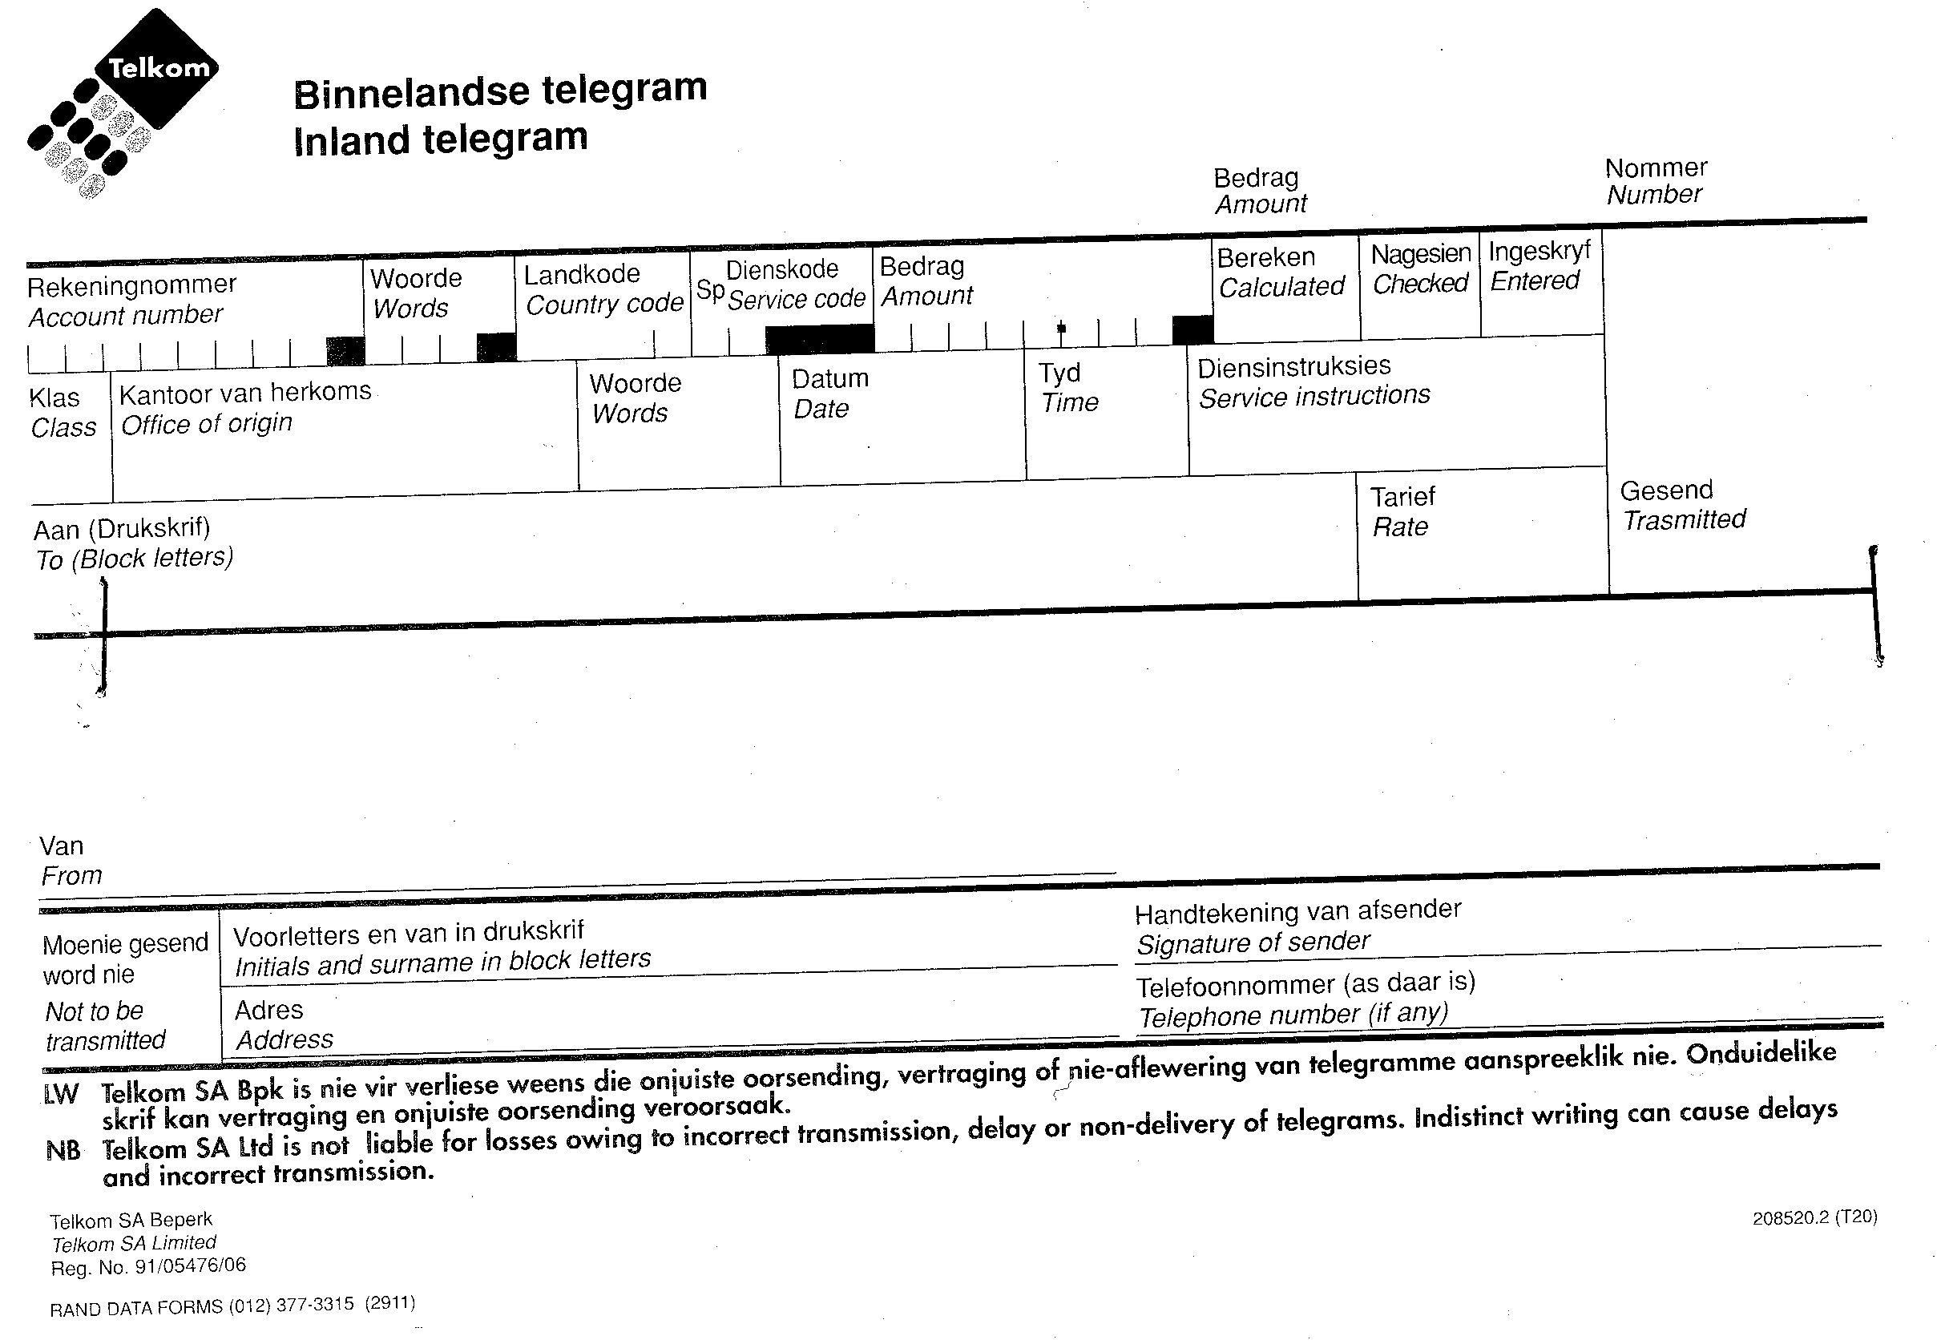

1.3 Ngolla rakgadi lengolo o mo tsebise ka mathata ao o seng o teane le ona haesale o bolellwa hore o na le kokwanahloko ya HIV.

1.4 Ngolla tayari ya hao, o e qoqele tsohle tse etsahetseng, ho tloha hoseng.  1.5 O ikgapetse monyetla wa ho ntshetsa thuto tsa hao pele ho e nngwe ya dinaha tse leboya ho Afrika. Ngola memo o memele motswalle moketjaneng wa teboho ya kgapo eo. | 20+20=[40]

KAROLO YA B

POTSO 2
THUTAPUO

Bala seratswana se latelang o nto araba dipotso tsa kerama tse hlahlamang.

Lefu lena la AIDS le se le bitswa ka mabitsobitso. Batho ba leka ka hohle ho bapisa bohale ba lona le ba mafu a kileng a be a hlorisa mehlape. Bang ba re ke phamokate, lefu la dikhooho, ha ba bang ba re ke bosollahlapi. Maoba mona ke utlwile e mong a re ke sesollahlapi yaba ke a makala. Le ha re ka le bitsa ka mabitsobitso, ho salang feela ke hore le a bolaya, le a phamolaka. Bophelo ba motho bo fela ka ho panya ha leihlo.

Re fumana hore batho ba bangata ba bolawa ke tsebo feela ya hore ba tshwaeditswe. Ba inehela ebe motho o se a bonela lefu la hae haufinyana. Ba bang, ka baka la ho ipata, ba hloleha ho fumana dikeletso tse ntle. Ba phela bophelo ka tsela eo ba neng ba ntse ba phela ka yona, motho a be a qetelle a se a swahlamane, a kenwe ke mahloko ao a neng a ka wa qoba. Batho ba tsebang ka bohloko bona ba teng. Ba sebedise!!!

Ho ka ba jwang ha o ka itlhahisa!!!

- Ho tswa ditabeng tse ka hodimo, qolla mantswe a tshwanang le ana ka moelelo:  - bohloko  - diruuwa  - phema | (3)

2.2 Kgetha mabitsobitso ho tswa lenaneng la mabitso a latelang:  2.2.1 Lefu  2.2.2 AIDS  2.2.3 Batho  2.2.4 Phamokate  2.2.5 Bosollahlapi  2.2.6 Kokwanahloko | (6)

2.3 Bolela hore dipolelo tse latelang ke nnete kapa mafosisa.  2.3.1 Lebitsohohle lena , kokwanahloko le bopilwe ka ditho tsena tsa puo kokwana le bohloko  2.3.2 Phamokate e bopilwe ka leetsi le leetsisa (leetsisamodumo)  2.3.3 Ka ho panya ha leihlo e bolela ha ketsahalo e etsahetse hang kapa ka pelepele. | (2)  (2)  (2)
Sebakeng sa mabitso, moleng o ntshofaditsweng, ngola maemedi.  2.5 Le a phamolaka ho sebedisetswe sekapuo se feng? | (8)  (2)

2.6 ‘Lefu lena la AIDS le a bolaya’, bolela hore mantswe a latelang a sebedisitswe jwalo ka ditho di fe tsa puo.  2.6.1 lena  2.6.2 la  2.6.3 le | (6)

2.7 ‘Lefu lena la Aids le a bolaya’ isa polelo ena ho  2.7.1 lekgathe letlang  2.7.2 tatolo  2.7.3 sekaokgoneho le ho sekaotlwaelo | (2)  (2)  (4)

2.8 Qolla lentswe le sebedisitsweng jwalo ka moetsi. | (1)

2.9 Bolela ho re dipolelwana tse latelang di sebedisitswe jwalo ka ditho difeng tsa puo.  2.9.1 leka ka hohle  2.9.2 bophelo ba motho  2.9.3 dikeletso tse ntle  2.9.4 batho ba tsebang  2.9.5 ba bolawa | (10)  [50]

MATSHWAO KAOFELA: | 90

