GAUTENG DEPARTMENT OF EDUCATION

SENIOR CERTIFICATE EXAMINATION

SESOTHO LELEME LA BOBEDI
BOEMO BO PHAHAMENG
(Pampiri ya Pele)

NAKO: dihora tse 2½

MATSHWAO: 90
DITAELO:

- Araba dipotso ka Sesotho
- Badisisa ditaelo ka hloko
- Makgethe a tla o ekeletsa matshwao

KAROLO A

POTSO 1

Kgetha dipotso tse PEDI feela karolong ya A. Bolelele ba karabo ya hao e be leqephe le le leng.

  - Ngolla baphatlalatsi ba koranta lengolo leo o hlahisang maikutlo a hao malebana le seteraeke sa basebeletsi ba mmuso.

  - Ngola tsebiso le lenanetsamaiso o memele ditho tsa mokgatlo wa bolo kopanong moo le ikemiseditseng ho hlophisa leeto la ho ya Kapa.

  - Lebenkele le leholo le rekisang dibuka le batla motho ya tla tsamaya ka koloi a rekisa dibuka dikolong. A ko ba romelle boitsebiso (CV) ba hao bo phethahetseng.

1.4 Hlahisa maikutlo a hao mabapi le setshwantsho sena.

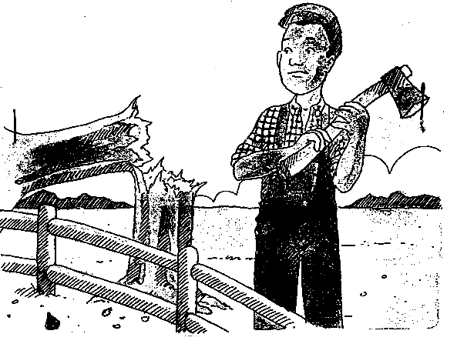

1.5 O moetapele wa baithuti sekolong. Ngolla mosuehlooho memorantamo moo le etsang kopo ya ho rekelwa khomputara. Fana ka mabaka ho tshehetsa kopo eo.

  - O molaodi wa lebenkele la difenitjhara. E se e le kgwedi tse tharo e mong wa bareki a sa lefe, hoo le seng le batla ho mo isa ho ba molao. Mo romelle telegrama ho mo hopotsa ka tefo eo. Sebedisa sebopeho se latelang sa telegrama.

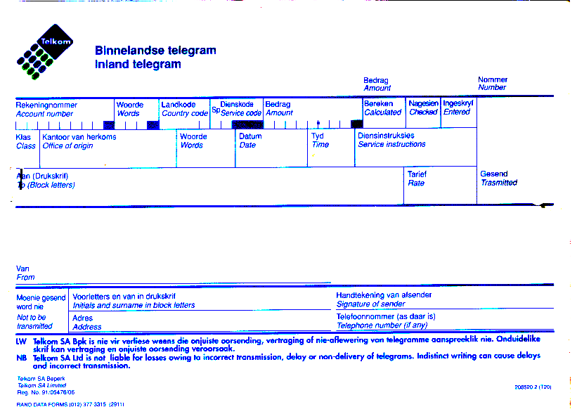  20+20 =  KAROLO B  POTSO 2  Badisisa ditaba tse latelang hore o tle o tsebe ho araba dipotso tse di hlahlamang.  Joseph o pheta taba tsa bophelo ba hae, ka moo dintho di neng di mo tsamaela hantle ka teng dilemong tse pedi tse fetileng. O bonahala a amohetse maemo a ditaba ao a leng ho ona ka sena sebaka. Ho ya ka maikemisetso le ditakatso tsa hae o ne a tlamehile ebe o Tekinikone, o ithutela ho ba Moejineere ho tsa motlakase. Ho jwang kajeno!  Afrika Borwa ke e nngwe ya naha tse lekileng ka matla ho lwantsha bohloko ba AIDS. Ba entse ka hohle 5 hore batho ba be le tsebo ka sewa sena. Ntle ho ba tsa bophelo bo botle, re fumana mafapha a mang a mmuso a thusang setjhaba ho lwantsha lefu lena. Re lehlohonolo hobane dikhohlopo, re di phaka mahala ditlinking le dikolong. Ya ka reng yena ha a tsebe letho ka lefu lena, o tla be a etseletsa mmuso. Tsohle di pepeneng, di iphumanelwa di tonositse. Ha o bula thelebishene, o teana le bo Soul City, Vicious Circle, Bohloko ba ka, Bophelo.  Joseph o se a felletse betheng jwalo ka lesea. O se o utlwa ka lentswe hore ke yena. O buela tlaase. O atisa ho bososela a nto qoqa ka tsa bophelo ba hae, ka moo a neng a itshwere hantle ka teng empa o ne a sa tsebe metsamao ya kgarebe ya hae. Le yena a senya ka ntho e le nngwe feela, a hloka ho itlhokomela. Re tseba ka moo re tshwanetseng ho itshireletsa lefung lena le sehlooho, leo le iphetotseng kgodumodumo, le kwenyang setjhaba ka sehloho. Na ebe ho na le seo o batlang ho se tseba ka kokwanahloko ena ya HIV? O ke ke be wa lefa le haele sente.  Botsa! | [40]  5  10  15
- Maetsi a latelang a fetohile hobane ho hoketswe dihlongwanthao tse itseng tse tswang ho letso la katoloso ya maetsi. Fana ka lebitso la katoloso ho tswa ho leetsi ka leng.  Mohlala: ratana > leetsani  - tsamaela  - bonahala  - tlamehile  - lwantsha  4x2 =  - Qolla masupi a mararo seratswaneng se ka hodimo  - Qotsa polelo e ho lekgathe lefitile.  - Hlahisa mabitso a mane a hlahang dihlopheng tse fapaneng tsa mabitso,  o be o fane ka nomoro ya sehlopha ka seng ho tswa serapaneng se ho  potso 2. 4x2 =  - Temaneng ya bobedi qotsa polelo e bolelang hore re di fumane mahala  kapa ha bonolo.  - Bopa dipolelo ka makopanyi a a latelang.  - Hore  - Hobane  - Empa  - le  - Ho sebedisitswe sekapuo sefe polelong eng?  “Joseph o se a felletse betheng jwalo ka lesea.”  - Bolela hore mantswe a latelang a sebedisitswe jwalo ka ditho dife tsa puo.  - Hohle (polelo 5)  - Dikolong (polelo 8)  - Yena (polelo 11)  - bo botle (polelo 6)  4x2 =  - Ngola malatodi a mantswe ana:  - Bobe (polelo 6)  - Kwala (polelo 9)  - Madimabe (polelo 7)  - Hodimo (polelo 11)  - Bophelong (polelo 14) | (8)  (3)  (2)  (8)  (1)  (5)  (1)  (8)  (5)

- Lokisa diphoso dipolelong tse latelang:  - Joseph o irutile ho ba Moejineeri  - Tsohle di pepeneneng, re ifumanela tsona di tonositse  - Joseph o ne a sa ihlokomele  - Re tseba ka moo re tshwanetseng ho isireletsa lefung lena.  4x2 =  - Fana ka lentswe la Sesotho le bolelang AIDS.  PALO HOHLE | (8)  (1)  [50]  [90]

