GAUTENG DEPARTMENT OF EDUCATION
SENIOR CERTIFICATE EXAMINATION

PLUMBING AND SHEET METALWORK SG

TIME: 3 hours

MARKS: 200

INSTRUCTIONS:

- Answer ALL the questions.

- Please detach pages 5 to 8 and place it alongside the relevant question for ease of reference.

- Question 2.1 should be answered on the diagram sheet on page 8.

- Question 8 and all the other sketches have to be done in the answer book.

QUESTION 1

1.1 Name SIX areas in the water supply chain that need specific attention in order to prevent cholera.  - Name FIVE organisms that can pollute water.  - Name THREE types of filters that are suitable for water purification.  - List the factors that cause pollution in a swimming pool.  - What is the purpose of backwashing and how is it done?  - Why is water aerated? | (6)  (5)  (3)  (5)  (4)  (2)  [25]

QUESTION 2

Seweraging  Answer this question on the diagram sheet on page 8.  2.1 The diagram on page 8 shows a partial plan of a house with outbuildings where the sanitary wall fitments are indicated by numbers. Design an efficient, suitable sewerage system that conforms to all regulations.  2.2 On completion of the lay-out of a sewerage system, you are requested to inspect the job. Name FIVE important aspects of the construction to which you will pay attention. | (15)  (10)  [25]

QUESTION 3

- How would you implement industrial housekeeping in your plumbing workshop?  - What safety precaution would you take when using each of the following apparatus?  3.2.1 Treadle guillotine  3.2.2 Oxyacetylene welding machine  - How would you solve the problem of a leaking tap?  - What safety measures would you prescribe to prevent the possible transmitting of Aids in the workshop?  - Name THREE causes of accidents in the workshop. | (4)  (3)  (5)  (4)  (6)  (3)  [25]

QUESTION 4

Tools, working techniques and methods  Figures A – L on pages 5 and 6 show a number of working techniques and methods used. Study the sketches carefully and answer the following questions.  4.1 Write the letters A – L below each other and name the technique or method used in each case.  4.2 Write the numbers 1 – 13 below each other and name the tools or equipment indicated by the arrow. | (12)  (13)  [25]

QUESTION 5

5.1 Explain how the intervals are regulated between each flushing of an automatic cistern.  - Where and for what purpose would you use slop hoppers?  - Show by means of a labelled cross-sectional drawing the design and layout you would use to instal a slab urinal.  - List SIX steps that can be taken to prevent cholera. | (2)  (5)  (12)  (6)  [25]

QUESTION 6

6.1 Name THREE principles of heating that you regard as important and give an example of how each is applied in a central heating system.  6.2 Design and draw a labelled diagrammatic sketch of a central heating system for a three-storey building. Make use of three radiators on each floor and arrange the pipes according to the two-pipe dropping system. Indicate the flow of water by means of arrows.  6.3 According to which TWO methods are the pipes of a central heating system arranged? | (9)  (14)  (2)  [25]

QUESTION 7

Ventilation and central air-conditioning  7.1 Name, in sequence, SIX important stages in the treatment of the air in a large air-conditioning system. Give a short description of each stage.  7.2 Name the type of ventilation system you would recommend in each of the following instances:  - A school classroom  - The kitchen in a hostel  - A large theatre  7.3 Name THREE aids which could assist the natural ventilation of a building.  7.4 What are the major advantages of natural ventilation over mechanical ventilation? | (12)  (6)  (6)  (1)  [25]

QUESTION 8

Pattern development  - Name the method you would apply to develop the following patterns:  8.1.1 An oblique cone  8.1.2 A square-to-round transition piece  - Figure 8 on page 7 shows two views of a square-to-square transitional piece tapered from 56 mm to 38 mm. Copy the given views full size and develop the pattern.  NOTE: The position of the groove joint is indicated by point E-E.  TOTAL: | (4)  (21)  [25]  200

A. B.
1

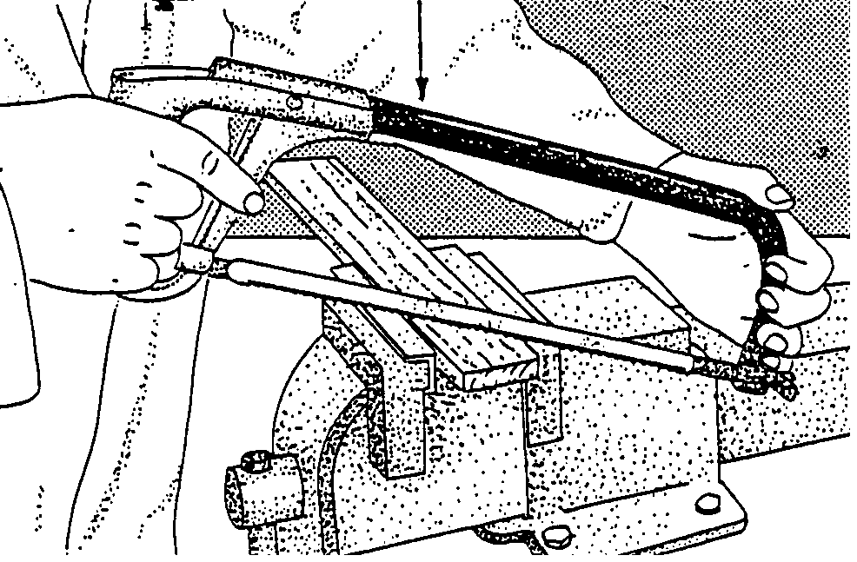
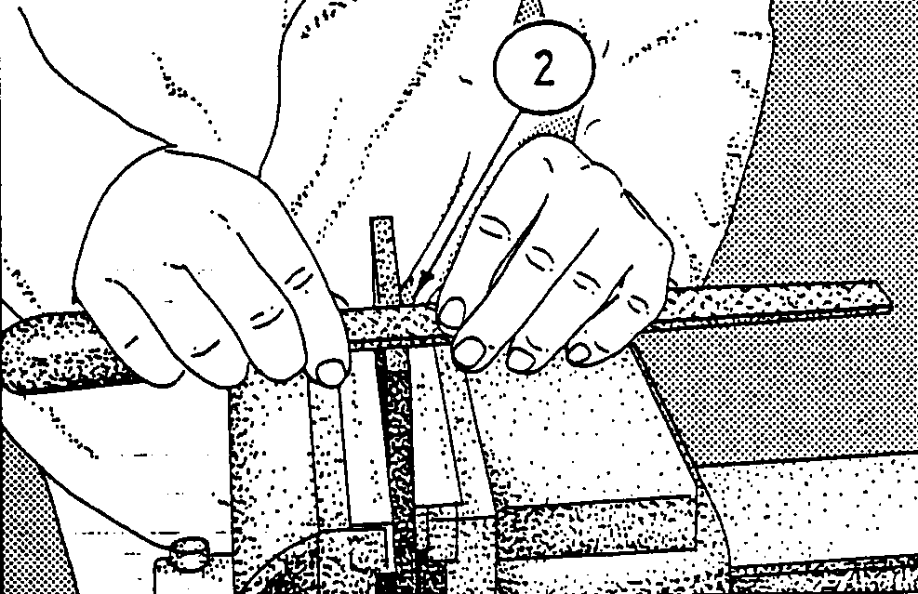

C. D.
4
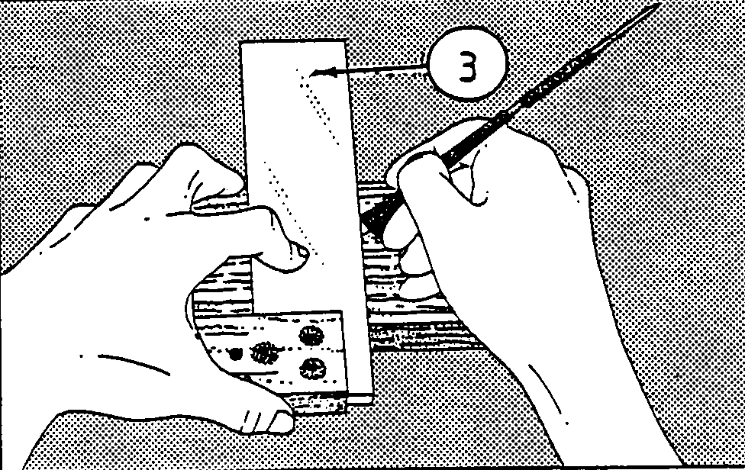
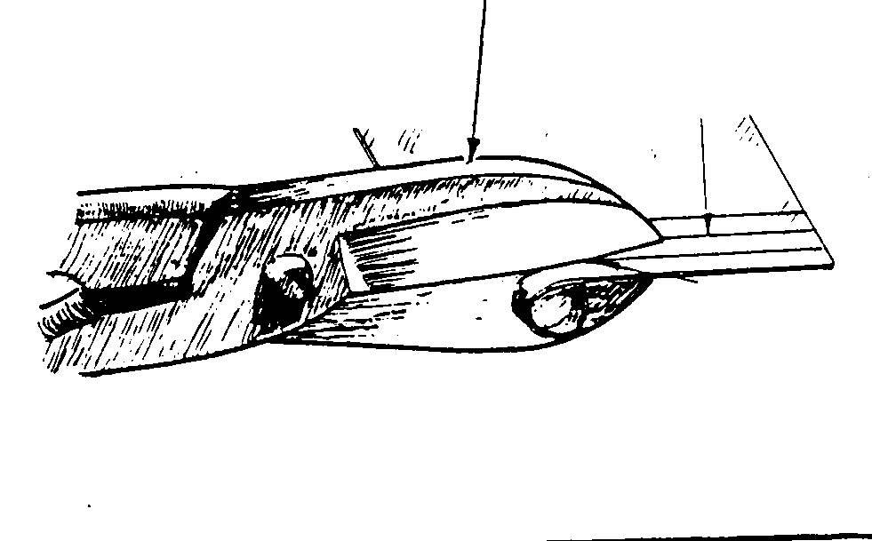

E. F.
5
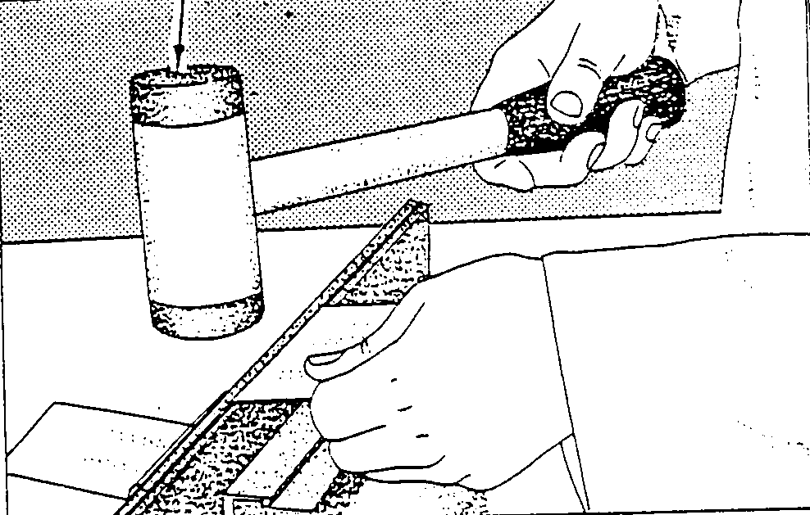
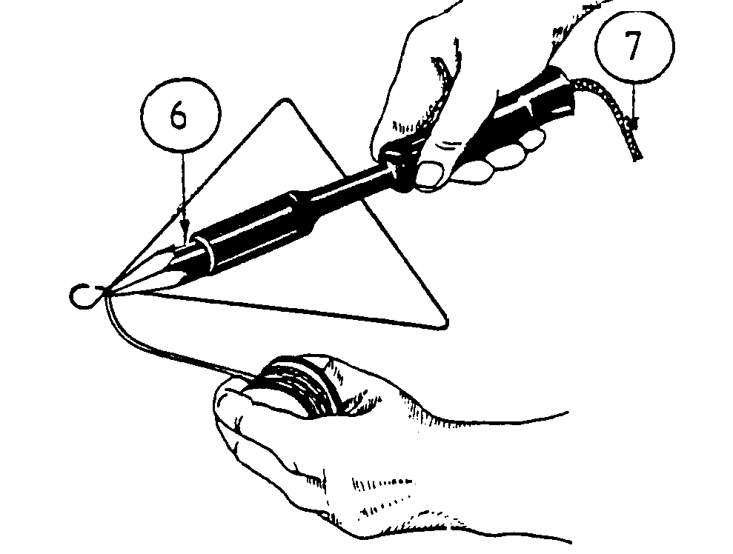

G. H.

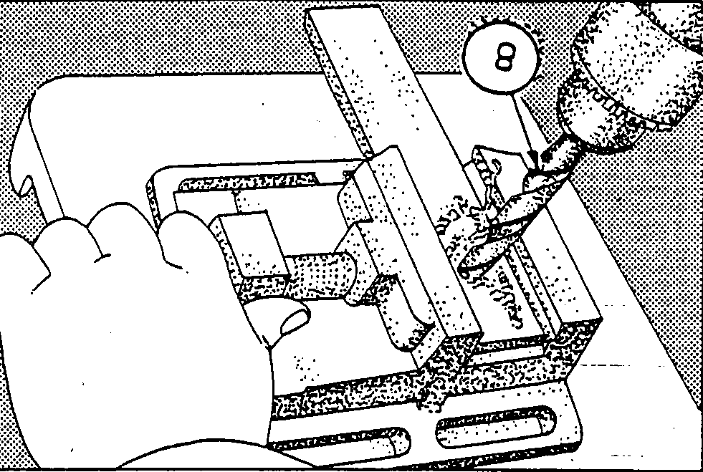
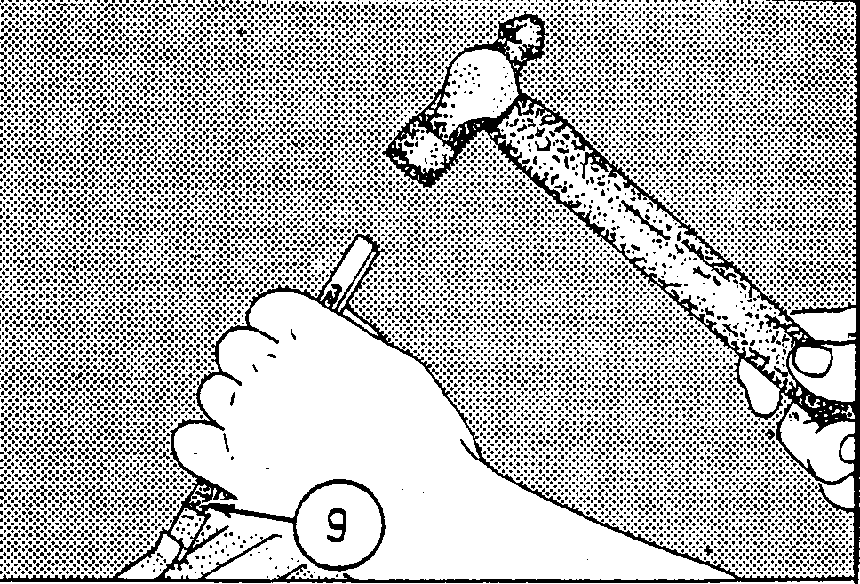

I. J.
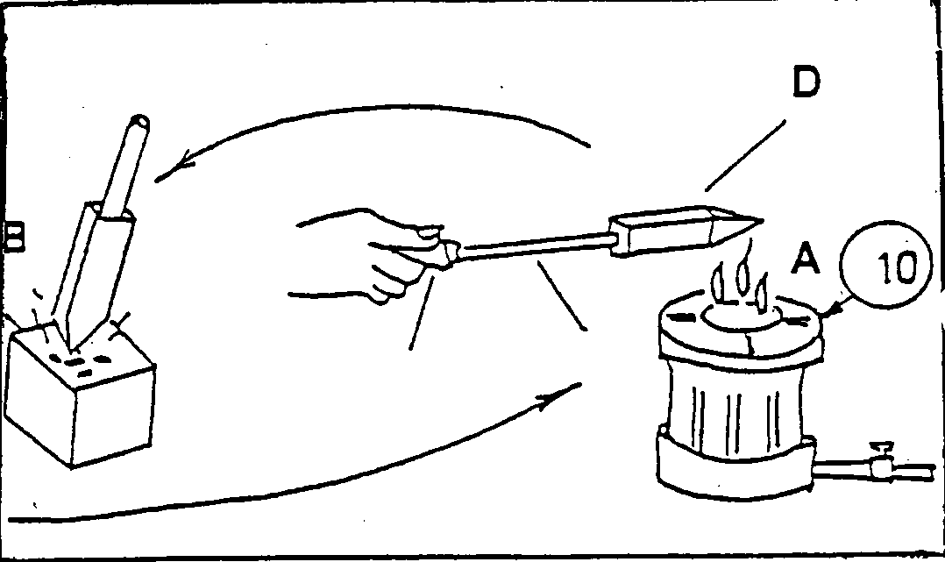
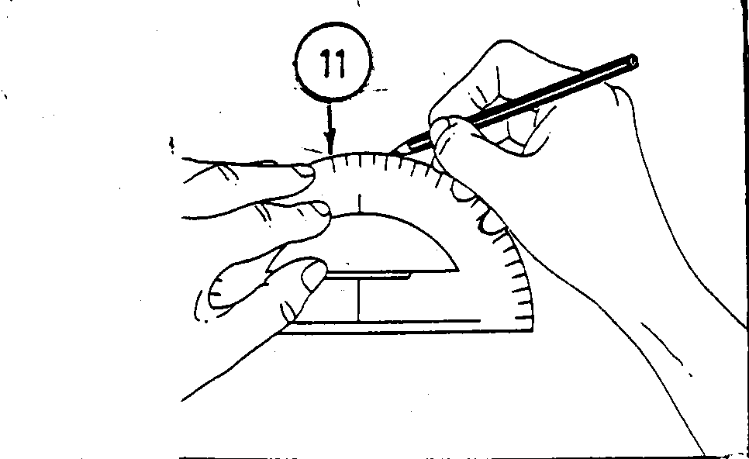

K. L.

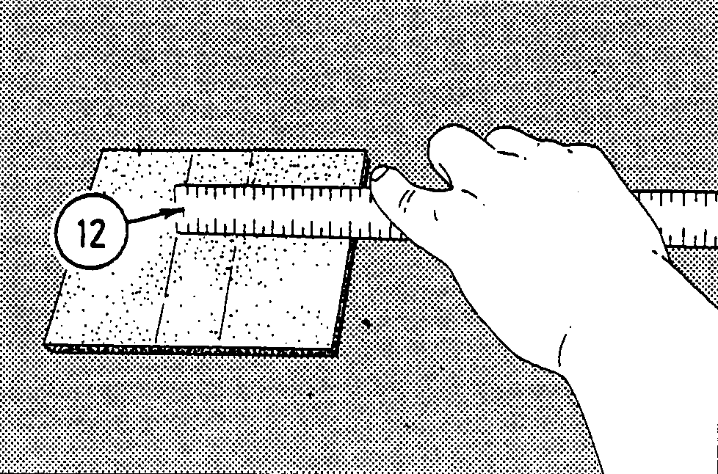
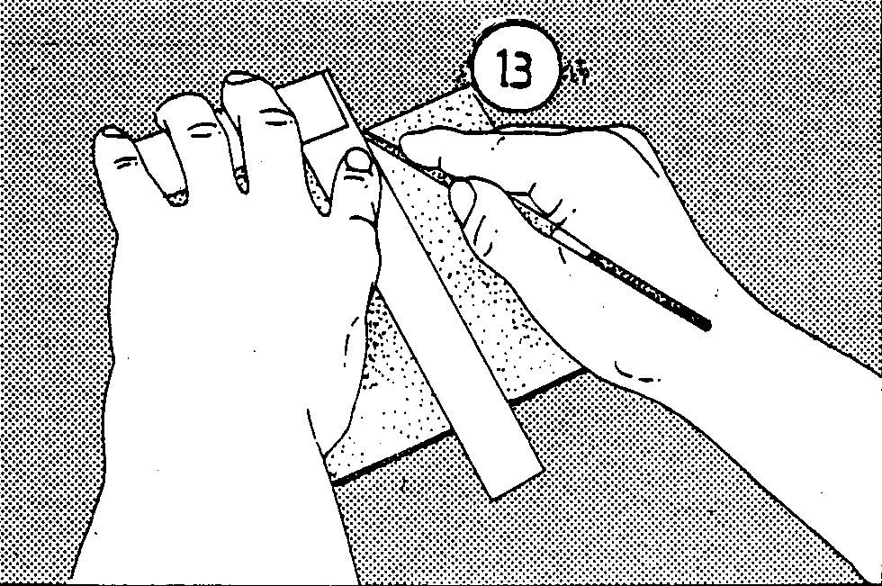

Figure 8

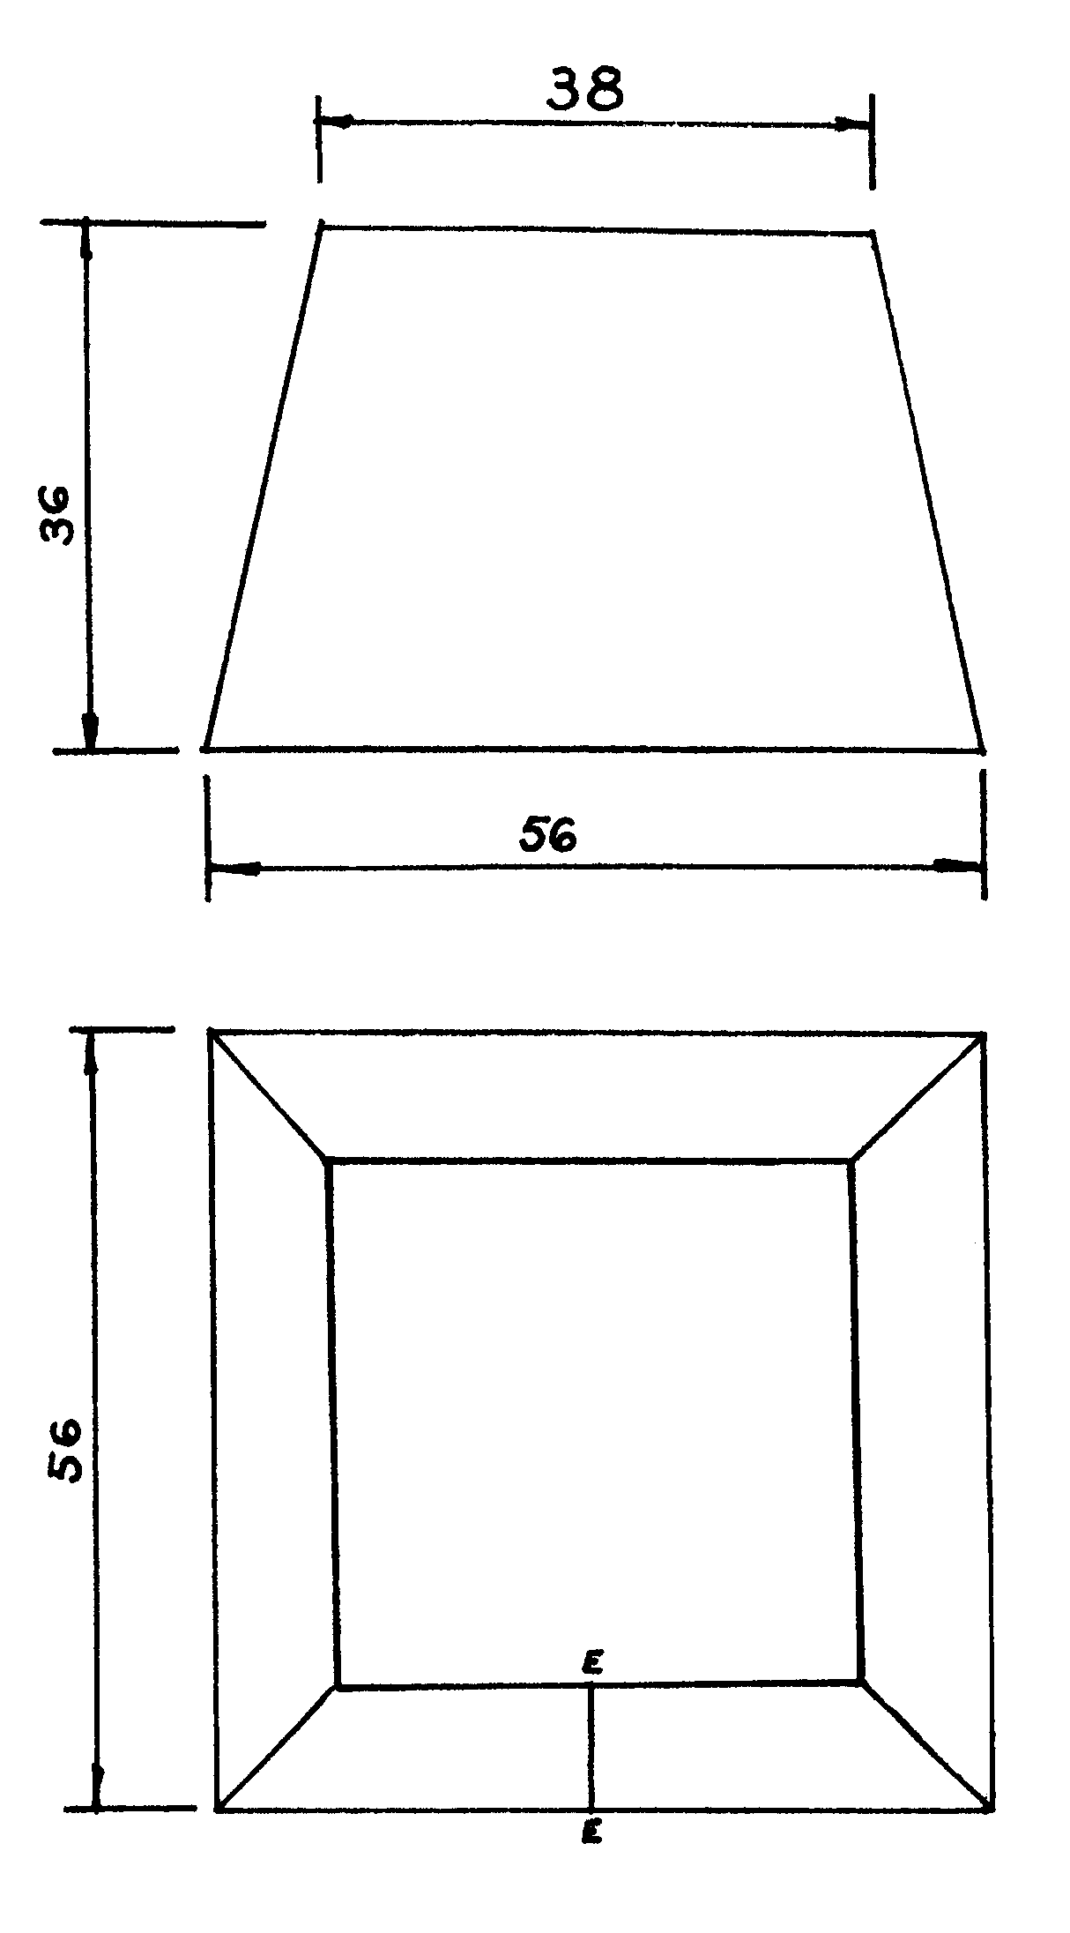

DIAGRAM SHEET

CANDIDATE’S EXAMINATION NUMBER

- Answer Question 2.1 on this diagram sheet.
- Once you have completed Question 2.1, please detach this page and place it at the back of your answer book.

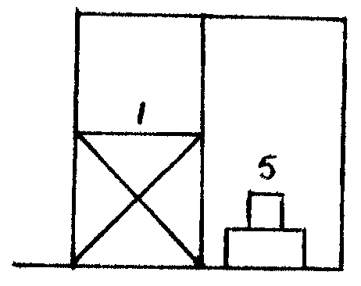 | Stort | 1 | Shower
 | Wastrog | 2 | Washing trough
 | Opwasbak | 3 | Sink
 | Bad | 4 | Bath
 | Spoelkloset | 5 | Water closet
 | Handewasbak | 6 | Hand wash basin

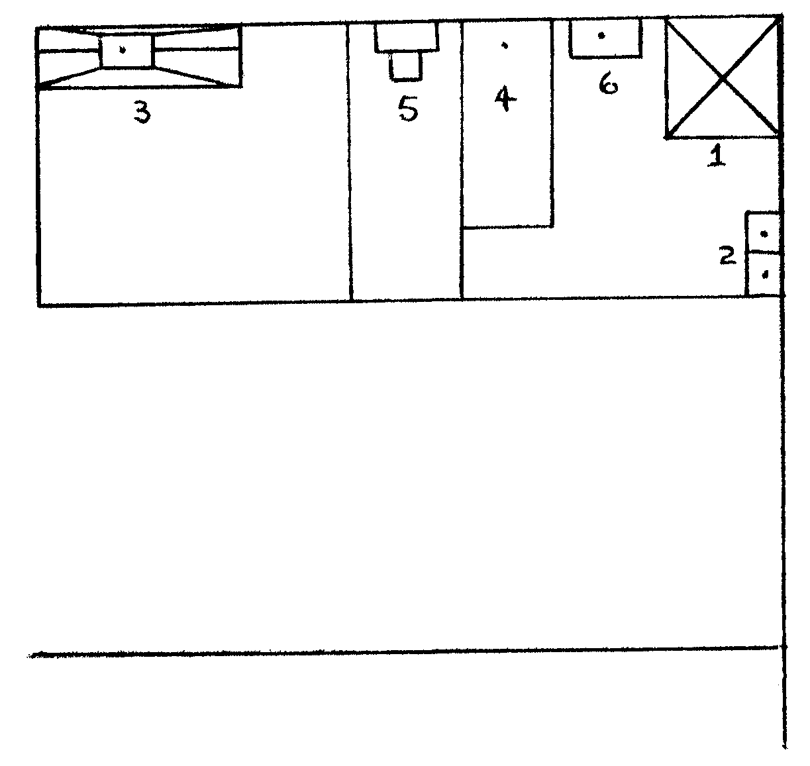

Municipal Main Sewage

