GAUTENG DEPARTMENT OF EDUCATION
SENIOR CERTIFICATE EXAMINATION

PLUMBING AND SHEETMETALWORK SG

TIME: 3 hours

MARKS: 200

INSTRUCTIONS:

- Answer ALL the questions.

- Ensure that all sketches are neat and in good proportion.

- Answer Question 2.1 on the diagram sheet on page 6. Place the diagram sheet at the back of your answer book when you have finished. Write your examination number on the diagram sheet.

- Do Question 8 and ALL the sketches in your answer book.

QUESTION 1
WATER PURIFICATION

1.1 Name FIVE tests which can be conducted to determine that water is safe for domestic use. | (5)

1.2 A person working in a water purification system injured himself and his blood entered the system. Assume that the person was infected with the aids virus. What are the risks of somebody else contracting aids by drinking water from this system? State TWO reasons for your answer. | (3)

1.3 Name THREE methods used in the purification of swimming pool water. | (3)

1.4 Name THREE ways of softening water. | (3)

1.5 What is the aim of coagulation and flocculation? | (6)

1.6 Name FIVE stages in public water purification. | (5)  [25]

QUESTION 2
DRAINAGE

Answer Question 2.1 on the diagram sheet on page 6. Detach this page and place it at the back of your answer book when you have finished.

2.1 The diagram shows the part plan of a dwelling and outbuildings under one roof. The sanitary fitments are indicated by means of numbers and the municipal connection is also shown on the plan.

2.1.1 Use the diagram sheet and design a suitable and efficient drainage system that complies with the regulations. | (9)

- Show the following details:  - ONE 100mm vent pipe  - FOUR gullies  - Adequate access openings for cleaning purposes  - Standard abbreviations for FOUR of the sanitary fitments  - Standard abbreviations for FOUR drainage details | (1)  (4)  (3)  (2)  (2)

2.2 Name FOUR precautionary measures to be observed when a drain passes underneath a building. | (4)  [25]

QUESTION 3
GENERAL

3.1 Draw a simple, labelled, longitudinal sectional sketch of a septic tank for a dwelling. | (10)

- Explain how a septic tank works. | (5)

3.3 Explain why it is advisable to install a grease trap instead of a gully in the kitchen of a hostel. | (4)

3.4 Name THREE instances where vacuum tanks are used. | (6)  [25]

QUESTION 4
LIFTING OF SEWERAGE

4.1 In the case of the stereophagus sewerage pump, a collecting sump and float- controlled switch are used. Draw a neat, labelled sketch of the float control unit. | (9)

4.2 Name FIVE advantages that the sewerage diverter has over the stereophagus sewerage pump. | (10)

4.3 Draw a labelled, cross-sectional sketch of a subsoil drain. | (6)  [25]
QUESTION 5
SANITARY FITMENT

5.1 Where and for what purpose are slophoppers used? | (4)

5.2 Where are slab urinals usually installed? | (4)

5.3 Explain how the intervals are regulated between flushings of an automatic cistern. | (4)

5.4 Name the major advantage that a flush valve has over a cistern. Motivate your answer. | (6)

5.5 Name TWO materials used in the manufacturing of slab urinals. | (2)

5.6 What is meant by a corbel type sanitary fitment? | (5)  [25]

QUESTION 6
CENTRAL HEATING

6.1 Name THREE principles of heating and provide an example of how each is applied in a central heating system. | (9)

6.2 Explain what is meant by central heating. | (6)

6.3 Name the TWO methods according to which pipes of a central heating system are arranged. | (2)

- Explain the function of each of the following components of a central heating system:  6.4.1 Return pipes  - Bleeding valve  - Booster pump  - Expansion tank | (2)  (2)  (2)  (2)  [25]

QUESTION 7
VENTILATION AND CENTRAL AIR-CONDITIONING

7.1 Name and describe the THREE laws on which natural ventilation is based. | (12)

7.2 Name TWO sources of carbon dioxide. | (3)

7.3 Name and describe TWO mechanical ventilation systems. | (10)  [25]

QUESTION 8
PATTERN DEVELOPMENT

The following diagram shows a front elevation and side elevation of a sheet metal pipe joint. Draw the given elevations and develop the curved surface of the branch pipe B. | [25]

45mm
15mm
B
A
35mm
80mm
40mm
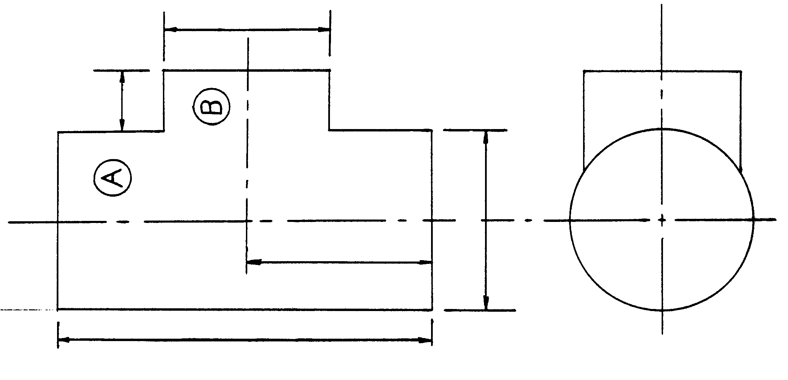

TOTAL: | 200

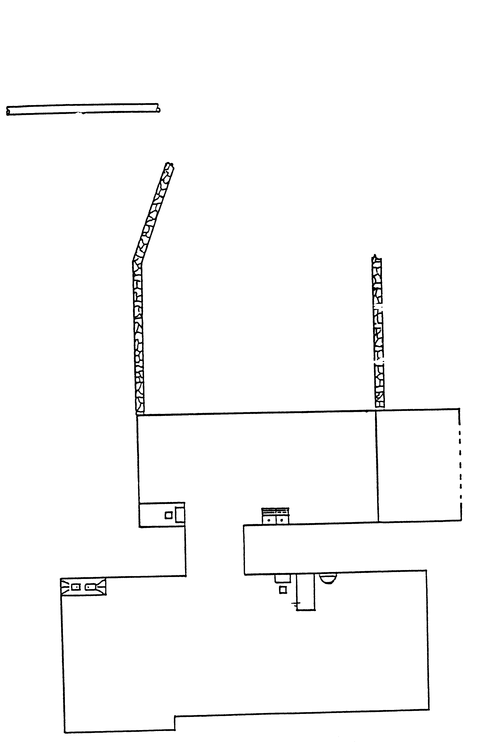
SINK
WASH TROUGH
BATH
LAVATORY BASIN
WATER CLOSET
1
2
3
4
5
Sewer connection/

Hoofrioolaansluiting

Terrace/

Terras

Terrace/

Terras

D4
5
2
1
3
5
4

OPWASBAK
WASTROG
BAD
HANDEWASBAK
SPOELKLOSET
DIAGRAM SHEET – QUESTION 2.1/DIAGRAMVEL – VRAAG 2.1

