GAUTENG DEPARTMENT OF EDUCATION
SENIOR CERTIFICATE EXAMINATION

PLUMBING AND SHEET METALWORK SG

TIME: 3 hours

MARKS: 200

INSTRUCTIONS:

- Answer ALL the questions.

- All sketches must be neat and in good proportion.

QUESTION 1
WATER PURIFICATION

1.1 Name THREE advantages that a mechanical pressure filter has over a sand filter. | (3)

1.2 Name TWO disadvantages of mechanical pressure filters. | (2)

1.3 Name and describe the purpose of each filter layer in the pressure filter. | (6)

1.4 What is the purpose of chlorinating filtered water? | (2)

1.5 Can the Aids virus spread through the water purification system? State FOUR reasons for your answer. | (4)

1.6 Draw a single line sketch of the water supply chain (storage dam to the consumer). The drawing must be in sequence and include the following stages: underground reservoir, filter, sedimentation, coagulation, chlorinating, storage dam, reservoir. | (8)  [25]

QUESTION 2
DRAINAGE

2.1 When a drainage inspector is requested to test a drain, he also has to pay attention to various other important aspects of the construction. Name FIVE of these aspects. | (10)

2.2 Name THREE requirements for vent pipes. | (6)

2.3 Name THREE materials used in the manufacturing of drain pipes. | (3)

- What do each of the following standard abbreviations mean?  2.4.1 CE  - IE  - CI  - WC  - ID  - HB | (6)  [25]

QUESTION 3
SEWERAGE WATER DISPOSAL

3.1 Name TWO methods of transfering sewerage water from a basement to a higher positioned main sewer. | (2)

- Draw a sectional diagram of a septic tank connected to a French drain. The following must be shown in your sketch:  manhole covers, brick walls, in- and outlets of the tank, dividing wall, floor, inspection eyes on pipe, water level, inlet at the French drain, placing of rocks and filling up to ground level. | (15)

3.3 Name FOUR instances where a vacuum tank should be used instead of a septic tank. | (4)

3.4 Why is it not advisable to cover a French drain with a steel plate before filling it up with soil? | (4)  [25]

QUESTION 4
LIFTING OF SEWERAGE

4.1 Name FOUR advantages of the sewerage diverter over the Stereophagus- sewerage pump. | (8)

4.2 Name TWO instances where the lifting of sewerage will be necessary. | (3)

4.3 Draw and label a vertical cross-section of a subsoil drain. | (8)

4.4 Explain the function of subsoil drainage. | (6)  [25]

QUESTION 5
SANITARY FITMENTS

5.1 Name FOUR types of materials which are used in the manufacturing of sanitary fitments. | (4)

5.2 Show by means of a labelled cross sectional drawing, the design and layout you would use to install a slab urinal. | (11)

5.3 What is meant by a corbel type sanitary fitment? | (2)

5.4 State TWO advantages and TWO disadvantages of a flush valve in contrast with a cistern. | (8)  [25]

QUESTION 6
CENTRAL HEATING

6.1 Name THREE principles of heating and provide an example of how each is applied in a central heating system. | (9)

6.2 Draw a labelled, diagrammatic sketch of a central heating system for a three- storeyed building. There are three radiators situated above one another on each floor, and the pipes are arranged according to the two-pipe dropping system. Indicate the flow of water by means of arrows. | (14)

6.3 According to which TWO methods can pipes of a central heating system be arranged? | (2)  [25]

QUESTION 7
VENTILATION

7.1 Name the THREE most important gases in the atmosphere. | (3)

7.2 Name ONE advantage and THREE disadvantages of natural ventilation. | (4)

7.3 Draw a single line sketch of a supermarket store equipped with the combined mechanical up draught and airconditioning unit. Indicate the following: airconditioning unit, fan, fresh air vents, air inlets, outlets, suction fan, outlet duct, roof and office. Also indicate the air flow with arrows. | (10)

- Name the type of ventilation system you will recommend for the following:  7.4.1 Large theatre with stage, like a civic theatre  - An ordinary large house  - Large kitchen | (1)  (1)  (1)

7.5 What are the functions of the following stages of airconditioning in a mechanical ventilation system?  - Humidifying chamber  - Cooling unit  - Mixing room | (1)  (1)  (1)

7.6 What is the maximum percentage of carbon dioxide that the municipal health regulations allow in public buildings? | (1)

7.7 What percentage of carbon dioxide will be fatal for humans? | (1)  [25]

QUESTION 8
PATTERN DEVELOPMENT

8.1 Name the method you would apply to develop the following patterns:

- An oblique cone  - A square-to-round transitional piece | (4)

8.2 Figure 1 on page 6 shows two views of a square-to-square transitional piece tapered from 56 mm to 38 mm. Copy the given views full size and develop the pattern. | (21)

NOTE: The position of the groove joint is indicated by point E–E. | [25]

TOTAL: | 200

36
56
38
56

E

E
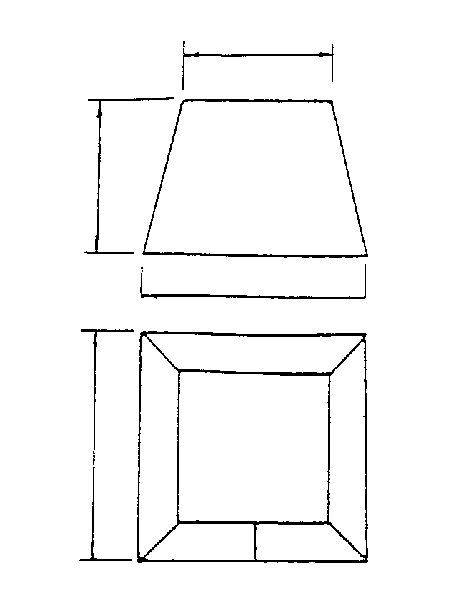
Figure 1/Figuur 1

