GAUTENG DEPARTMENT OF EDUCATION
SENIOR CERTIFICATE EXAMINATION

PHYSIOLOGY SG

TIME: 3 hours

MARKS: 300

INSTRUCTIONS:

- The question paper consists of TWO sections:
  - SECTION A: Total 100.
  - SECTION B: Total 200.
    - All questions are COMPULSORY.
    - Answer Question 1 (multiple-choice) on the answer sheet on the inside cover of your answer book.
    - Number ALL the questions correctly according to the question numbers.
    - Write neatly and legibly.

SECTION A

QUESTION 1

MULTIPLE-CHOICE QUESTIONS

Each of the following questions is supplied with four possible answers (A – D) of which only one possibility is correct. Indicate the correct answer by making a cross (X) over the appropriate letter next to the corresponding question number on the answer sheet on the inside cover of your answer book.

EXAMPLE: Saliva is secreted in the

- mouth.
- oesophagus.
- stomach.
- duodenum.

ANSWER: | A | B | C | D

1.1 In which of the following structures are you least apt to find urine?

- uterus
- urethra
- ureter
- bladder

1.2 Pressure filtration is associated with the

- glomerulus.
- distal convoluted tubule.
- loop of Henlé.
- collecting duct.

1.3 Which of these is mismatched?

- Cerebrum – consciousness
- Thalamus – motor and sensory centres
- Hypothalamus – internal environmental regulator
- Cerebellum – motor coordination

1.4 Which one of these would you not mention if you have to describe the path of sound vibrations?

- Auditory canal
- Tympanic membrane
- Cochlea
- Semicircular canals

1.5 Which one of the following structures and functions do not fit?

- Frontal lobe – motor area
- Temporal lobe – hearing, tasting and smelling
- Occipital lobe – sight
- Parietal lobe – controls voluntary movement

1.6 Which term does not belong with the others?

- Cerebrum
- Cerebral cortex
- Cerebral hemispheres
- Cerebellum

1.7 The two cerebral hemispheres are connected via the

- vermis.
- corpus callosum.
- medulla oblongata.
- cerebrospinal fluid.

1.8 The connection between two neurons is known as a

- gap.
- dendrite.
- synapse.
- terminal branch.

1.9 One function of the medulla oblongata is to

- control vital reflexes such as the heart rate.
- co-ordinate voluntary muscle movement.
- maintain body temperature.
- regulate sleep patterns.

1.10 The Eustachian tube connects the

- middle ear to the inner ear.
- middle ear to the pharynx.
- inner ear to the brain.
- external ear to the middle ear.

1.11 The correct sequence for the ear ossicles:

- Malleus – incus – stapes
- Incus – stapes – malleus
- Malleus – stapes – incus
- Stapes – malleus – incus

1.12 The maintenance of a relatively constant internal environment for normal cell functioning, is known as

- metabolism.
- osmoregulation.
- excretion.
- homeostasis.

Questions 1.13 to 1.16 are based on the following diagram:

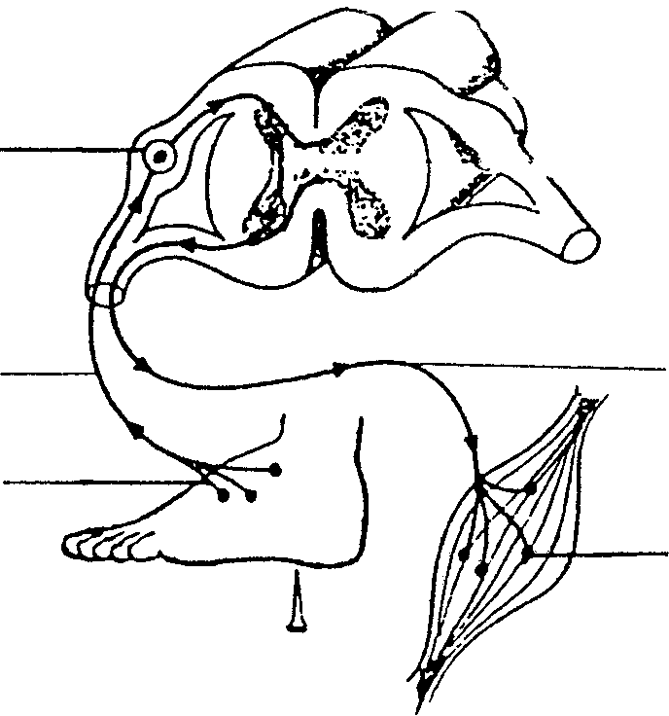

3

2
4

1
5

nail

1.13 Which numbered structure changes a stimulus into an impulse?

- 1
- 3
- 4
- 6

1.14 The cell body indicated by number 3 is situated in the

- dorsal root ganglion.
- ventral horn.
- ventral root.
- dorsal horn.

1.15 The structure numbered as 4 is known as the

- sensory neuron.
- connector neuron.
- motor neuron.
- terminal knob.

1.16 The receptor in part 1 is known as

- Meissner’s corpuscle.
- Pacinian corpuscle.
- the end-bulb of Krause.
- free nerve endings.

1.17 Which statement regarding adrenaline is correct? Adrenaline

- increases the heart rate.
- converts glucose to glycogen.
- decreases oxygen content in the blood.
- causes the muscles of the bladder to contract.

1.18 The blood leaving the kidney contains ______ than the blood entering the kidney.

- more water
- less carbon dioxide
- more oxygen
- less urea

1.19 Which one of the following is part of the circulatory system?

- Bowman’s capsule
- Glomerulus
- Loop of Henlé
- Convoluted tubes

1.20 If glucose is present in urine, it can be indicative of

- Addison’s disease.
- goitre.
- Grave’s disease.
- diabetes mellitus.

1.21 The pH of urine is usually

- strongly acidic.
- strongly alkaline.
- slightly acidic.
- slightly alkaline.

1.22 Which of the following means of birth control is the most effective in preventing HIV/AIDS?

- Oral contraceptive (The Pill)
- Condom
- Intra-uterine device
- Diaphragm

1.23 The Graafian follicle matures into the

- corpus luteum.
- corpus callosum.
- umbilical cord.
- placenta.

1.24 The menstrual cycle is a ______ day cycle.

- 14
- 21
- 28
- 18

1.25 Hormones are secreted by the

- endocrine system.
- circulatory system.
- excretion system.
- respiration system.

1.26 Which structure is present after ovulation?

- Primary follicle
- Secondary follicle
- Graafian follicle
- Corpus luteum

1.27 A person who lacks ADH

- has a low blood volume and blood pressure.
- will have sugar in his urine.
- will have protein in his urine.
- None of the above.

1.28 Urine is conducted from the kidney to the bladder via the

- urethra.
- ureter.
- uterus.
- vas deferens.

1.29 Kidney stones manifest because of

- an over-active parathyroid.
- low levels of calcium in the blood.
- under-active parathyroid.
- high blood pressure.

1.30 Goitre is the result of

- undersecretion (hyposecretion) of aldosterone.
- undersecretion (hyposecretion) of ADH.
- lack of iron.
- lack of iodine.

1.31 Oxytocin is produced in the

- hypophysis.
- ovaries.
- hypothalamus.
- thyroid.

1.32 The pancreas secretes ______ to lower the blood sugar.

- adrenalin
- glucagon
- insulin
- pancreatic juices

1.33 Which one of the following is mismatched?

- TSH – thyroid
- Islets of Langerhans – insulin
- Ovaries – oestrogen
- Neurohypophysis – FSH

1.34 Which endocrine gland is also known as the ‘master gland’?

- Pituitary gland / hypophysis
- Thyroid
- Adrenal medulla
- Pancreas

1.35 Sterilization in the male is also known as

- a vasectomy.
- hormonal treatment.
- a temporary solution.
- an ineffective birth-control method.

1.36 It is not a function of oestrogen.

- Triggers ovulation.
- Inhibits the production of FSH.
- Prepares the breasts for lactation.
- Repairs the endometrium after menstruation.

1.37 The duration of pregnancy is usually

- 3 months.
- 9 months.
- 6 months.
- 12 months.

1.38 A mature spermatozoa usually contains ______ chromosomes.

A. 23
B. 22
C. 46
D. 44

1.39 The correct travel sequence of the ova after ovulation is:

- fallopian tube, uterus, cervix, vagina.
- vagina, cervix, uterus, fallopian tube.
- uterus, vagina, cervix, fallopian tube.
- cervix, vagina, fallopian tube, uterus.

1.40 The hormone responsible for the development of the placenta.

- FSH  - TSH  - LH  - Progesterone 40x2 = | [80]

QUESTION 2

The accompanying diagrams illustrate certain human sense organs or parts thereof. Study the following diagrams and use them to answer questions 2.1 – 2.5.

In each instance, write down the letter from the diagram and supply the correct label.

2.1 Which structure in the skin is sensitive to pain? | (2)

2.2 In which structure would a sound vibration be converted into a nerve impulse? | (2)

2.3 Which structure prevents the reflection of sound waves in the inner ear? | (2)

2.4 Which structure plays a role in maintaining balance in the body? | (2)

2.5 Where are taste receptors sensitive to salty food found? | (2)  [10]

QUESTION 3

Each of the following statements is FALSE but can be corrected by changing the underlined word. Write down only the correct word next to the corresponding question number in your answer book.

3.1 The urethra leaves the kidney and enters the bladder.

3.2 In the glomerulus the afferent arteriole is narrower than the efferent arteriole.

3.3 Aldosterone regulates the amount of water that is reabsorbed in the kidney.

3.4 The end bulb of Krause is sensitive to heat.

3.5 Most heat loss from the body occurs through evaporation.

3.6 The fissure of Sylvius separates the frontal and parietal lobes.

3.7 The cochlea is situated in the external ear.

3.8 The iris is the opening in the eye that appears black.

3.9 Insulin increases the blood sugar levels.

3.10 Thyroxin is also known as the ‘fight or flight’ hormone. | [10]

TOTAL FOR SECTION A: | [100]

SECTION B

Answer ALL the questions in this section.

QUESTION 4

4.1 Study the two diagrams below and answer the questions that follow.

Hot sun
Cold wind
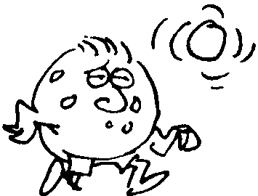
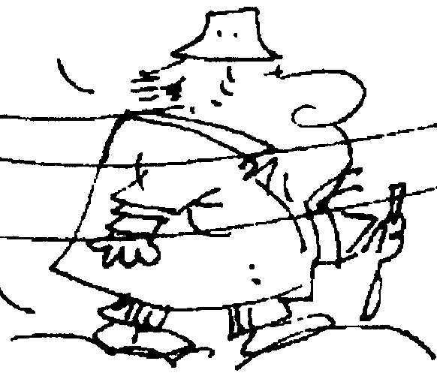

A
B

4.1.1 Name the FIVE physical processes through which heat is lost from the body. | (5)

4.1.2 Describe the changes that occur in the body of person B in an effort to conserve body heat. | (8)

4.1.3 What will happen to person A if he is to remain in these conditions for an extended period? | (2)

4.1.4 Describe the changes that will occur in the skin of person A if he were to spend a number of days in this kind of environment. | (4)

4.2 Give SIX functions of the skin. | (6)

4.3 | Receptors or sense organs provide information about our external environment. They are classified according to the type of stimulus they receive.

4.3.1 Name the different kind of receptors and state where each will be found in the body. | (12)

4.3.2 Study the diagram below of a multipolar neuron and write down the letters (A – L) in your answer book and supply the correct names for the structures. | (13)

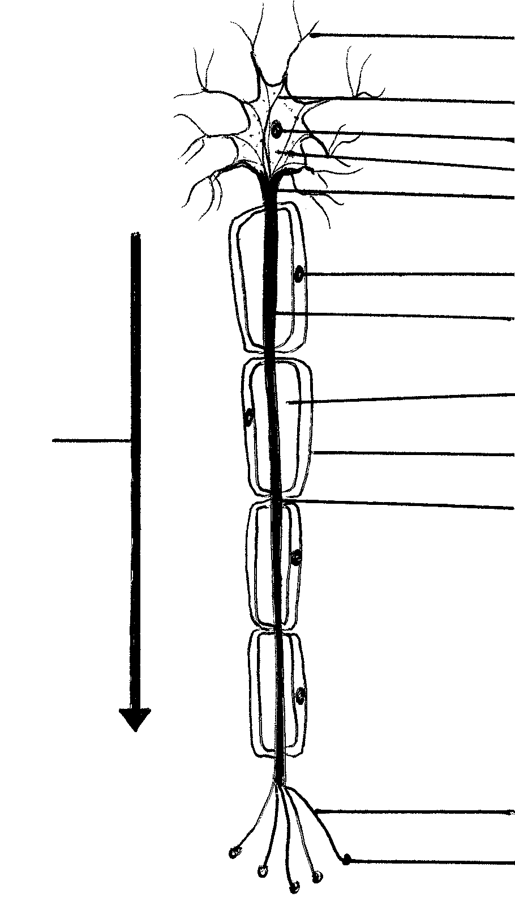
A
B
C
D
E
F
G
H
I
J
K
L
M

[50]

QUESTION 5

5.1 Study the diagram and answer the questions that follow.

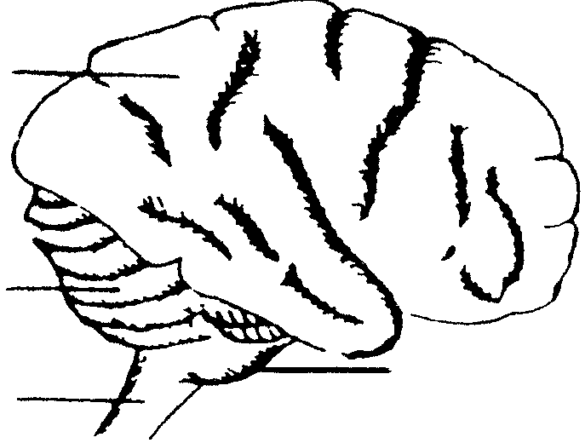
1
2
4
3

5.1.1 Name the FOUR structures of the central nervous system indicated by 1 to 4. | (4)

5.1.2 Tabulate three differences between structures numbered 1 and 2. | (6)

5.1.3 Name SIX structures that protect the brain against injury. | (6)

5.2 Give a simple definition of a reflex action. | (3)

5.3 Name THREE reflexes associated with the brain. | (3)

5.4 Name FOUR acquired or conditioned reflexes. | (4)

5.5 This is a diagrammatic presentation of the Malpighian body. Answer the related questions.
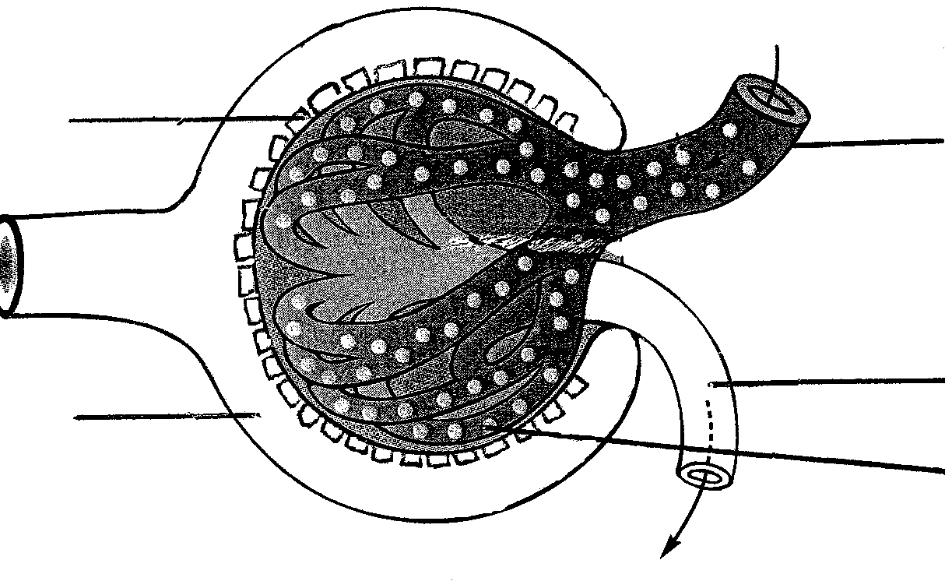
4
5
1
2
3

5.5.1 Label structures 1 to 5. | (5)

5.5.2 Discuss FIVE adaptations of this structure that facilitates ultrafiltration. | (5)

5.6 Choose from Table 5.1 those substances that:

5.6.1 are excreted in urine.  5.6.2 are reabsorbed in the kidneys.  5.6.3 are not part of the filtrate in the Bowman capsule.  5.6.4 are controlled by ADH.  5.6.5 contain waste nitrogen. | (6)  (3)  (2)  (1)  (2)

 | Table 5.1: List of substances that are controlled by the excretion system
 | water, urea, glucose, inorganic salts, blood corpuscles, plasma proteins, creatinine, amino acids, hormones, ammonia, foreign substances, e.g. preservatives | [50]

QUESTION 6

6.1 Study the diagrams below and answer the questions that follow.

 | 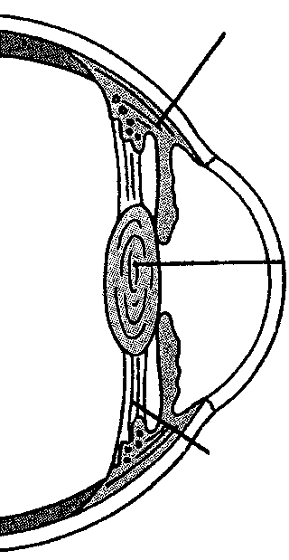  suspensory ligament  ciliary muscle  lens | 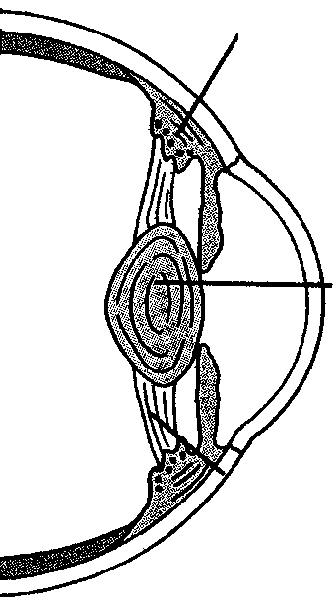  suspensory ligament  ciliary muscle  lens
 | Figure A: Focusing on a distant object | Figure B: Focusing on a near object

6.1.1 Diagram A indicates the eye focusing on a distant object. Describe the changes that occur from A to B, when the eye focuses on near objects. | (6)

6.1.2 Light has to travel from an object through different structures of the eye before it registers in the brain. List all of these structures in the correct sequence. | (8)

6.2 In which way is the eye protected against injury? | (5)

6.3 List the protective functions of lachrymal fluid (tears). | (5)

6.4 Give a brief description of the pupil of the eye and state how it functions. | (3)

6.5 List FOUR common eye defects and give a short explanation for each. | (8)

6.6 Answer the following questions regarding the next statement:

Hormones have a regulatory function in the human body.

6.6.1 Give FIVE characteristics / properties of hormones. | (5)

6.6.2 Abnormal secretion of hormones can lead to certain diseases. In each of the following cases, write down the name of the hormone causing this disease and state whether it is due to a hyper- or hyposecretion of the hormone mentioned.

(a) Dwarfism  (b) Cretinism  (c) Grave’s disease | (6)

6.6.3 Describe the development of a goitre. | (4)  [50]

QUESTION 7

7.1 The next diagram illustrates the male reproductive system.
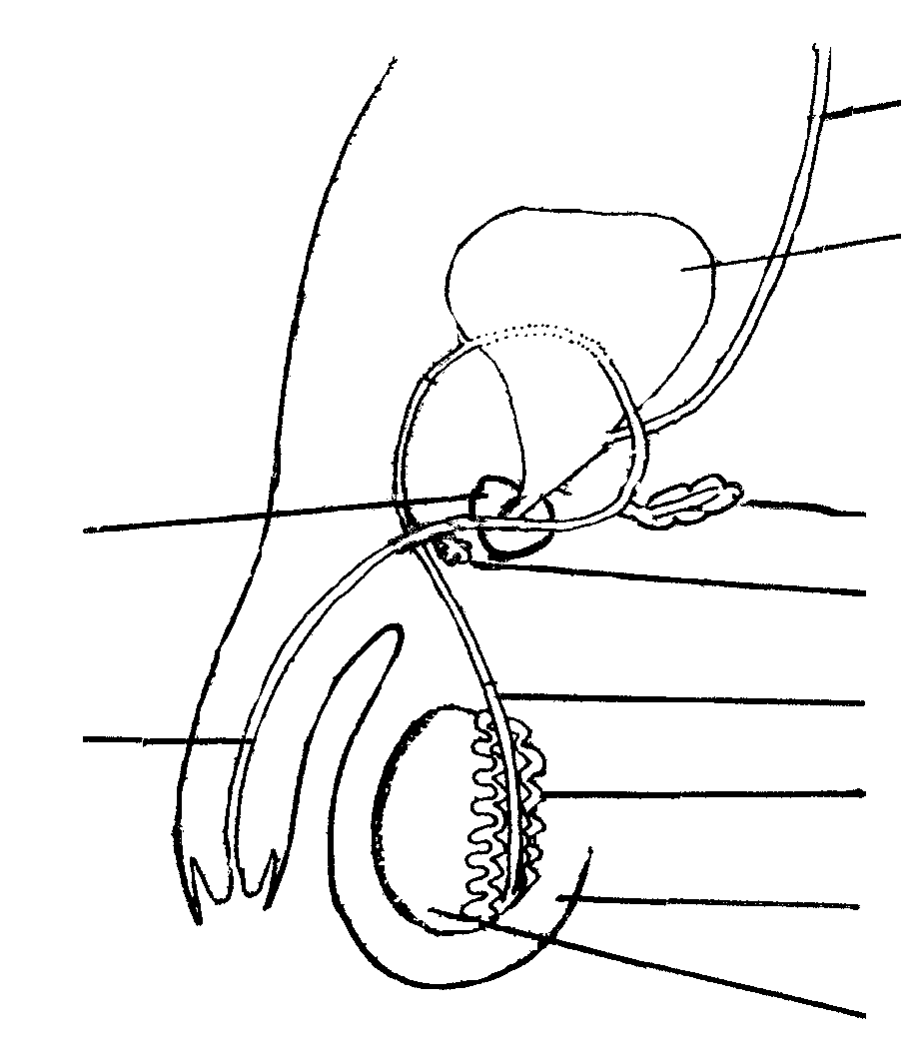
A
B
C
D
E
F
G
H
I
J

7.1.1 Label A to J. | (10)

7.1.2 In each of the following instances, write down only the letter (A – J) of the structure involved from the preceding diagram, next to the corresponding number:

(a) Spermatozoa matures here.
(b) It produces testosterone.
(c) It houses and protects the testes.
(d) Secretion from this gland activates the sperm.
(e) This is a communal canal for the transportation of semen and urine.
(f) Urine is stored here before excretion.
(g) This gland secretes most of the seminal fluid.
(h) Secretions from this gland lubricate the end of the penis during sexual intercourse.
(i) The end of this canal dilates to form the ampulla. | (9)

7.2 The proper usage of a condom can protect women against THREE dangers. What are these dangers? | (3)

7.3 List the secondary sexual characteristics in

(a) boys and  (b) girls. | (5)  (5)

7.4 The developing fetus is enveloped in amniotic fluid. What purpose does this fluid serve? | (5)

7.5 What does parental care entail? | (5)

7.6 Complete the following table by redrawing it in your answer book and filling in the necessary answers. | (8)

 | Female hormones | Functions
 | FSH | 1
 | 2 | Causes ovulation
 | Progesterone | 3  4  5
 | 6 | Repairs the endometrium after menstruation  7  8 | [50]

TOTAL SECTION FOR B: | [200]

TOTAL: | 300

