GAUTENG DEPARTMENT OF EDUCATION
SENIOR CERTIFICATE EXAMINATION

PHYSIOLOGY SG

TIME: 3 hours

MARKS: 300

INSTRUCTIONS:

- The question paper consists of TWO sections.
- Section A: Total: 100 Answer ALL questions
- Section B: Total: 200 Answer all FOUR questions.

- Answer Question 1A (multiple-choice) on the answer sheet on the inside cover of the answer book.

- Number all your answers correctly according to the question number.

SECTION A

QUESTION 1.1

MULTIPLE-CHOICE QUESTIONS

Choose the correct answer from the four possibilities (A – D) provided and draw a cross (X) over the corresponding letter on the answer sheet on the inside cover of the answer book.

EXAMPLE: Saliva is secreted in the

- mouth.
- oesophagus.
- stomach.
- duodenum.

ANSWER: | A | B | C | D

Questions 1.1.1 – 1.1.4 are based on the following diagram.

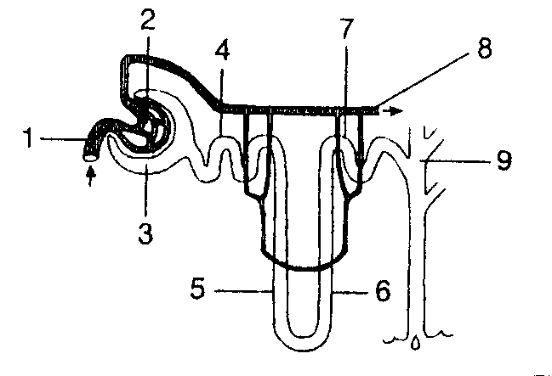

    - The diagram depicts

- a villus.
B. an alveolus.
- a section of the human skin.
- a nephron.

    - Water that filters from the blood, passes through the membranes between structures

- 2 and 3.
- 3 and 4.
- 5 and 6.
- 7 and 8.

    - At which numbered structure of this diagram would urine be found?

- 1
- 3
- 8
- 9

    - Re-absorption of most glucose and amino acids takes place mainly when the filtrate passes through the structure numbered

- 2.
- 4.
- 6.
- 8.

Questions 1.1.5 and 1.1.6 relate to the following diagram.
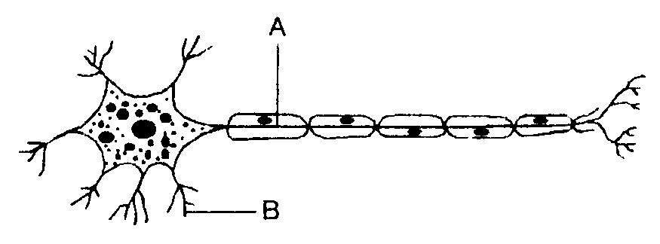
    - Structure A depicts a

- cytoplasm.
- dendrite.
- ganglion.
- axon.

    - The function of B is to

- transmit and discharge impulses.
- transmit impulses to the cell body.
- transmit impulses in two directions.
- stimulate muscle and glands to function.

Questions 1.1.7 to 1.1.10 are based on the following diagram.
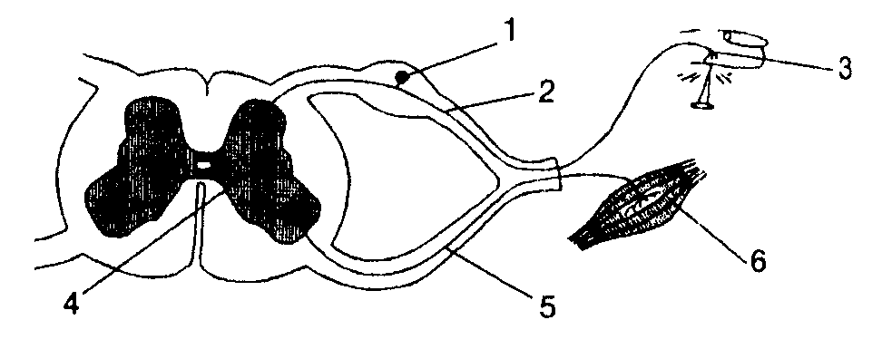
1.1.7 Structure number 3 depicts a

- receptor.
- spinal nerve.
- motor nerve-fibre.
- effector.

    - Structure number 6 is a

- receptor.
- spinal nerve.
- motor nerve fibre.
- effector.

    - This structure is the centre for reflex actions.

- 1.
- 2.
- 4.
- 5.

    - Structure number 2 refers to the

- receptor organ.
- axon of the sensory neuron.
- axon of the motor neuron.
- dendrite of the afferent neuron.

10 x 2 = | (20)

QUESTION 1.2

1.2 In each of the following statements one word has been used incorrectly. Identify the incorrect word and write it down in your answer book next to the corresponding question number, with the correct term next to it.

Example: Fertilisation occurs in males.
Answer: males = females

1.2.1 Menstruation refers to the process where a ripe ovum is released.  1.2.2 The tympanum is the tough membrane which covers the kidney.  1.2.3 Seafood is rich in sodium which is essential for the synthesis of thyroxin.  1.2.4 The iris is the protective layer covering of the eyeball.  1.2.5 The occipital lobe receives impulses along the auditory nerve where hearing is interpreted.  1.2.6 The rods, which are found in the retina, react to colour stimuli and cause a clear image.  1.2.7 Undersecretion (hypose cretion) of thyroxin in children causes diabetes.  1.2.8 The taste buds have cells that are photoreceptors.  1.2.9 The eye defect presbyopia is the result of the surface of the cornea being irregular.  - Progesterone stimulates ovulation during the menstrual cycle. 10 x 2 = | (20)

1.3 Copy the table below in your answer book. Complete the following table on the human eye by, under A, adding the numbers of the diagram below the table next to the appropriate label and, under B, making a tick () if the statement under B is TRUE or a cross (X) if the statement is FALSE in respect of each part.

Part of Eye |  | A | B = Refracts light rays
1.3.1 | Vitreous humor
1.3.2 | Retina
1.3.3 | Cornea
1.3.4 | Iris
1.3.5 | Blind spot
1.3.6 | Pupil
1.3.7 | Sclera
1.3.8 | Lens
1.3.9 | Conjunctiva
1.3.10 | Choroid

10x2 = | (20)

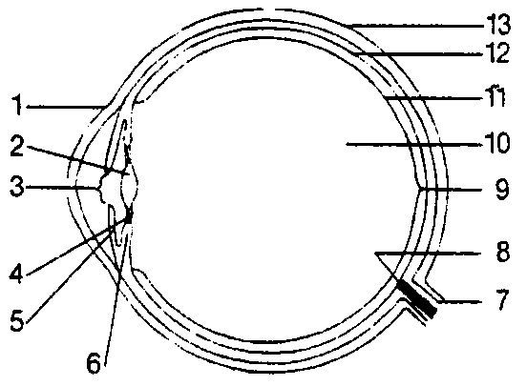

1.4 Study the diagram of the human tongue and answer the questions that follow.

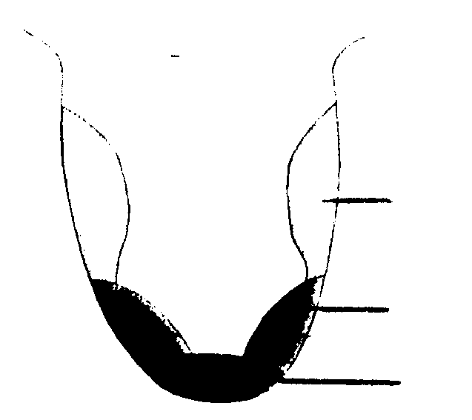  2  3  4  1.4.1 What type of structure has a sensory function on  the tongue?  1.4.2 Identify the FOUR taste sensation areas on the tongue.  1.4.3 Name TWO functions of the taste buds.  1.4.4 What type of taste buds are found in each of the four regions on the tongue? | (2)  (8)  (2)  (8)  (20)

1.5 Match the function in Column B with the term in Column A. Write down the question number and next to it, the correct letter, e.g. 1.5.11 M.
1

Column A |  | Column B
1.5.1 | Synapse | A. | Mechanical stimulus
1.5.2 | Neuroglia | B. | Smelling
1.5.3 | Pressure | C. | Absorbs shock
1.5.4 | Dura mater | D. | One way for impulses
1.5.5 | Cerebrospinal fluid | E. | Spinal reflex
1.5.6 | Frontal lobe | F. | Connective tissue between nerves
1.5.7 | Temporal lobe | G. | Lines the bony cranium
1.5.8 | Hypothalamus | H. | Thirst
1.5.9 | Cerebellum | I. | Autonomic nervous system
1.5.10 | Heart beat | J. | Empty bladder
 |  | K. | Voluntary movements start here
 |  | L. | Balance and equilibrium are controlled here

10x2 =  TOTAL FOR SECTION A: | (20)  [100]

SECTION B

QUESTION 2

2.1 Study the diagram below and answer the questions that follow.
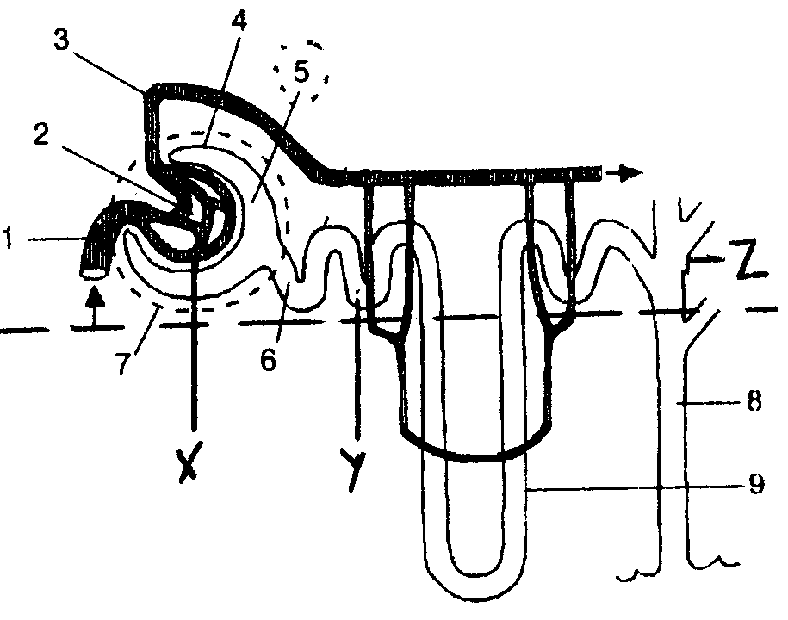

2.1.1 What is the name of this structural unit?  2.1.2 Where is this unit found?  2.1.3 Identify the part  (i) beneath the dotted line.  (ii) above the dotted line.  2.1.4 Name the processes that occur at X, Y and Z.  2.1.5 Name TWO waste substances that move through no. 4.  2.1.6 Why does number 3 have a smaller diameter than number 1?  2.1.7 Identify the structures numbered 1 to 9.  2.1.8 Name FOUR functions of the kidneys.  2.1.9 Make a neatly labelled drawing of a cross-section of a macroscopic kidney. | (1)  (1)  (2)  (3)  (2)  (2)  (9)  (4)  (10)  (34)

2.2 Study the diagram of the human skin and answer the questions that follow.

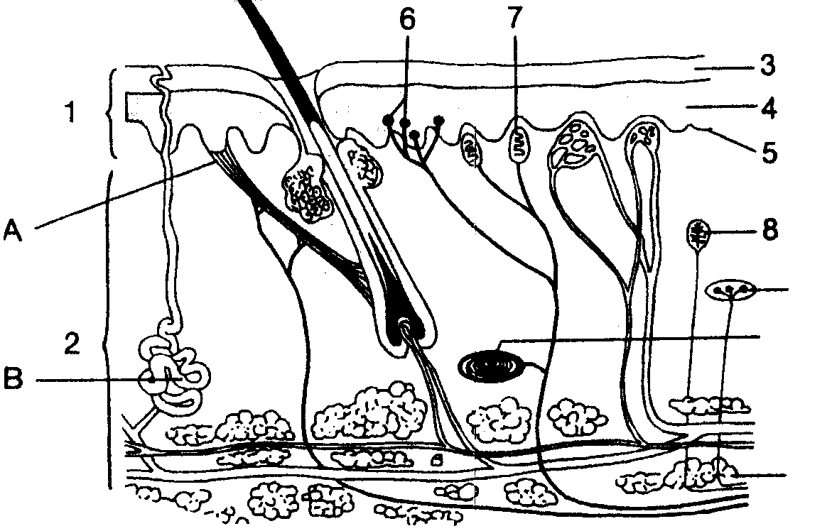
9
10

2.2.1 Identify the parts labelled 1 to 10.  2.2.2 Name the function of nos 7 and 8.  2.2.3 If the temperature drops, how will A and B react? | (10)  (2)  (4)  (16)  [50]

QUESTION 3

3.1 Study the diagram of the pancreas and answer the questions that follow.
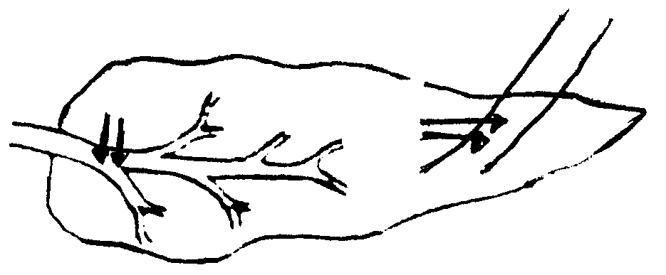
Y
X
Blood vessels

3.1.1 X and Y illustrate TWO types of glands. Identify each and explain the difference between them.  - TWO hormones are secreted at Y. Name them.  - Name the hormone that stimulates X to secretion.  - Name THREE hormones involved in digestion in the duodenum.  - What role will the pancreas play if there is too much sugar in the blood? | (4)  (2)  (1)  (3)  (5)  (15)

3.2 Study the following diagrams of the human eye and answer the questions that follow.
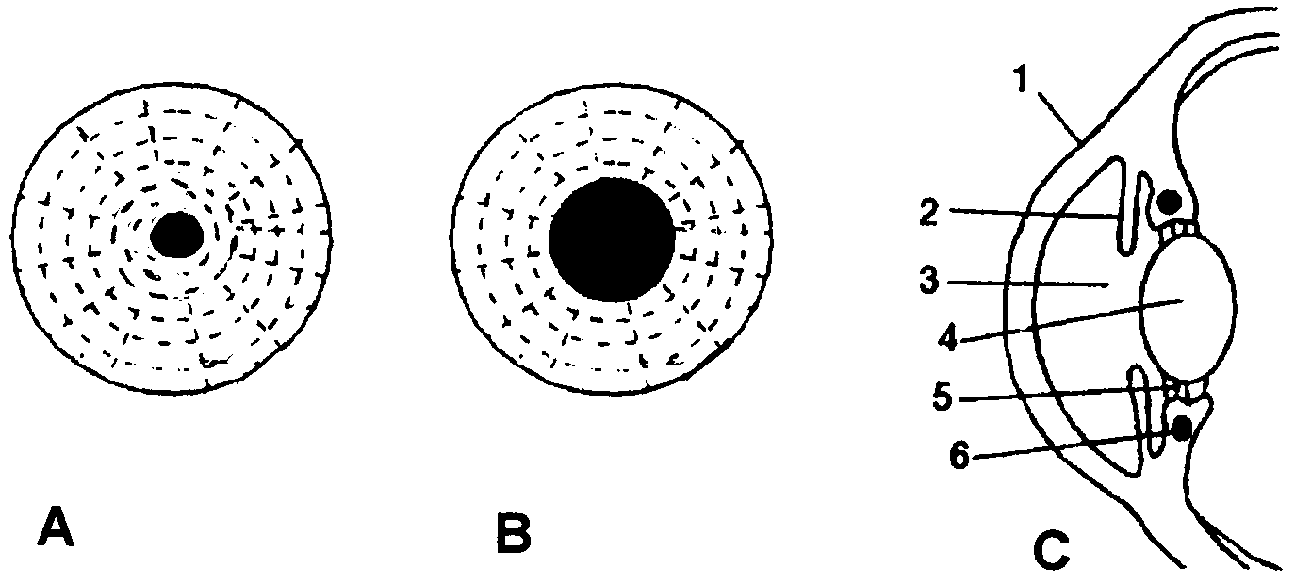

3.2.1 Identify the structures numbered 1 to 6 in diagram C.  3.2.2 Which diagram shows the state of the eye in dim light (A or B)?  3.2.3 What is this process called of controlling the amount of light?  3.2.4 Explain the changes which occur in the eye in dim light. | (6)  (2)  (1)  (6)  (15)

3.3 Study the diagram of the ear and answer the questions that follow.

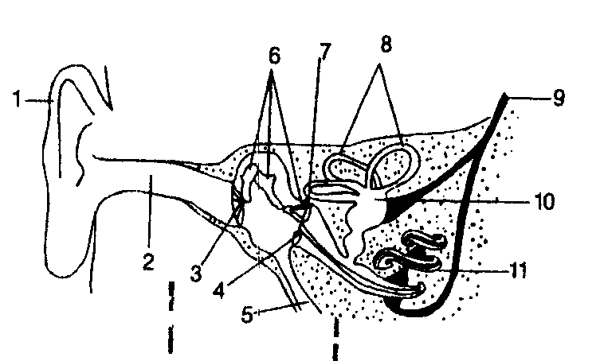
A B C

- Name the THREE regions marked A to C.  - State what each of these regions is filled with.  - What are the functions of no. 1 and 2?  - In what region is the cochlea found?  - Use the list of words below to complete the sentences below. Write only the numbers (1 – 7) down in your answer book with the correct word next to the appropriate number.  hair cells auditory nerve tectorial membrane  temporal lobe basilar membrane organ of Corti  cerebrum | (3)  (3)  (2)  (1)

The membranous cochlea contains the receptor for sound vibrations, namely the 1. which is found on the 2. and consists of 3. which are covered by the 4. and joined to the neuron of the 5. which carries nerve impulses to the 6. of the 7. | (7)

- Name TWO functions of the ear and indicate which part of the ear is concerned with each function respectively. | (4)  (20)  [50]

QUESTION 4

Study the diagrams which illustrate the brain (X) and the endocrine glands (Y) in the human body.

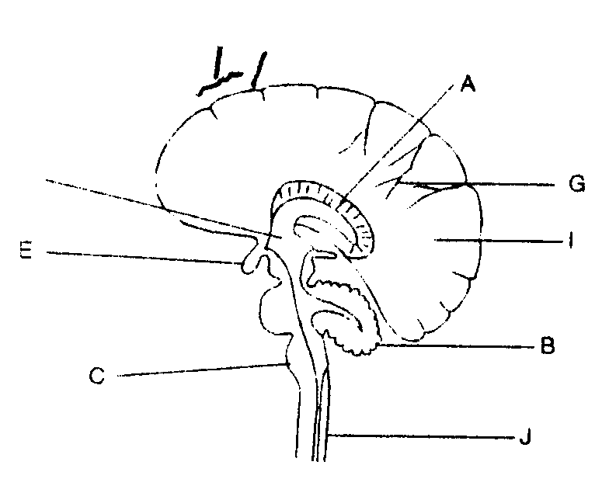
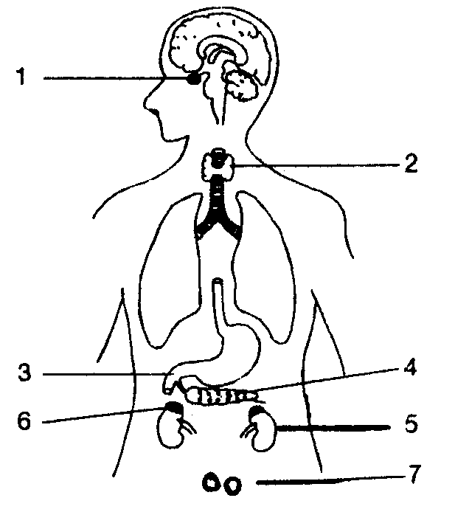
4

5

6

7
A
1

2

3

D
B

C

D

E
H

G

F

X Y

- Identify the parts (A – H) in diagram X.  4.1.1 Supply diagram X with a suitable heading.  4.2 Give the number of the structure which is responsible for the following functions:  4.2.1 Heat regulation  4.2.2 Voluntary movements  4.2.3 Involuntary movements  4.2.4 Balance co-ordination  4.2.5 Enlarge cerebral cortex surface  4.3 Tabulate TWO differences between gray and white matter in the cerebrum.  4.4 Name SIX ways in which the brain is protected.  4.5 Why is G called the master gland?  4.6 Name the hormones secreted by G, and the effect they have on some of the  structures 2 to 7 in Diagram Y.  4.7 Negative feedback occurs between 1 and 4. Draw a flow diagram to indicate the interaction.  4.8 Name TWO grooves that divide C (fig. X) into lobes. | (8)  (1)  (5)  (4)  (6)  (2)  (12)  (8)  (4)  [50]

QUESTION 5

- Give a schematic representation of spermatogenesis in a man.  5.2 Study the diagrams below representing the human reproductive system and answer the questions that follow. | (15)

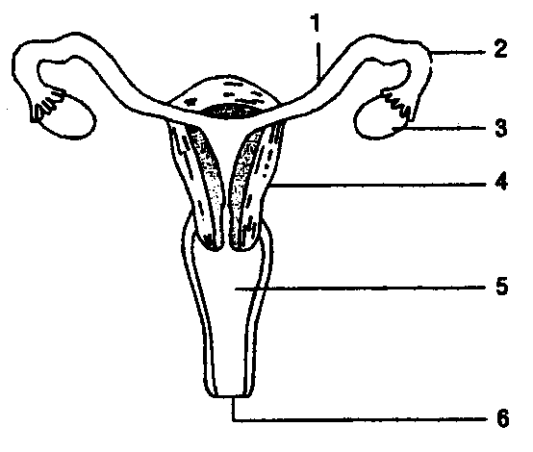
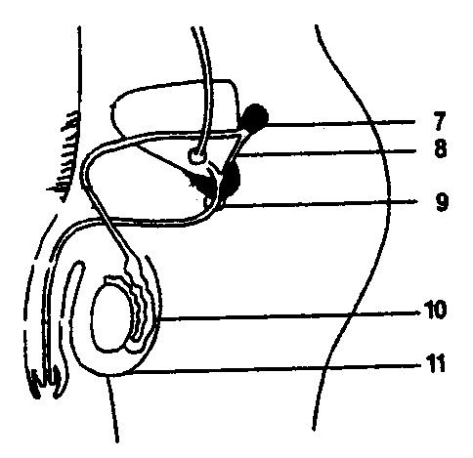

- Identify the structures numbered 1, 3, 4, 7, 8, 9 and 11.  - Which structures perform the following functions? Write down only the number.  (a) Produce egg cells.  (b) Fertilisation occurs in this organ.  (c) Is stimulated by oxytocin.  (d) Embryo develops in this structure. | (7)  (4)

5.3 Name FOUR functions of the placenta.  5.4 The table below indicates the percentage of HIV-positive individuals in certain areas. Study the data and answer the questions that follow. | (8)

% HIV-positive individuals in certain areas
 | 1998 | 1999 | 2000
Area A | 7,6 | 10,4 | 14,2
Area B | 12,1 | 18,3 | 19,8
Area C | 18,2 | 19,9 | 26,9
Area D | 4,5 | 6,0 | 8,1

- What does the abbreviation HIV stand for?  - Name THREE ways in which someone can contract this disease.  - How can individuals protect themselves from contracting this disease?  - What % of individuals were HIV-positive in Area C in 1999?  - What area had the (a) highest and (b) lowest percentage of HIV-positive individuals in the year 2000?  - Why do people refer to HIV as a killer disease?  TOTAL FOR SECTION B:  TOTAL: | (2)  (3)  (3)  (2)  (4)  (2)  (50)  [200]  300

