GAUTENG DEPARTMENT OF EDUCATION
SENIOR CERTIFICATE EXAMINATION

PHYSIOLOGY HG

TIME: 3 hours

MARKS: 300

INSTRUCTIONS:

- The question paper consists of THREE sections: Section A : Total 90
Section B : Total 160
Section C : Total 50
300

- Answer ALL the questions in Sections A and B.
- You have a choice in Section C: Answer either Question 6 or Question 7. For Question 7 you will need graph paper.

- Answer Question 1.1 (multiple-choice questions) on the answer sheet on the inside cover of the answer book.

- Number ALL the questions correctly.

- Graph paper is attached at the end of your paper. Complete and attach it at the front of your answer book.

SECTION A
COMPULSORY

QUESTION 1.1
MULTIPLE-CHOICE QUESTIONS

Four possibilities are given as answers to each of the following questions. Indicate the correct answer by marking the appropriate letter with a cross (X) on the answer sheet on the inside cover of your answer book.

EXAMPLE: Saliva is secreted in the

- mouth.
- oesophagus.
- stomach.
- duodenum.

ANSWER: | A | B | C | D

    - The arbor vitae is found in the

- cerebellum.
- cerebrum.
- medulla oblongata.
- hypothalamus.

    - The junction where one impulse is carried over from one neuron to another is called the

- axon.
- dendrite.
- synapse.
- ganglion.

    - Which control centre in the body is activated when an athlete is dehydrated and thirsty?

- Hypothalamus
- Cerebellum
- Thyroid
- Medulla oblongata

    - Menstruation begins in response to

- an increase in circulating levels of LH.
- a decrease in circulating progesterone levels.
- rupture of the ovarian follicle.
- secretion of FSH by the pituitary.

    - In-vitro fertilisation takes place in

- the vagina.
- a surrogate mother.
- a laboratory test tube.
- the uterus.

    - Which structure is present after ovulation?

- Primary follicle
- Secondary follicle
- Graafian follicle
- Corpus luteum

    - Which hormone has the same effect on the body as stimulation by the sympathetic nervous system?

- Cortisone
- Thyroxin
- Parathormone
- Adrenaline (Epinephrine)

    - Tubular secretions occur at the

- glomerulus.
- proximal convoluted tubule.
- loop of Henlé.
- distal convoluted tubule.

    - The middle ear is filled with

- perilymph.
- endolymph.
- tissue fluid.
- air.

    - Which one of the following is not associated with the excretion system?

- Uterus
- Urethra
- Ureter
- Malpighian bodies

    - Which system is involved during stress?

- Parasympathetic
- Sympathetic
- Somatic
- Both A and B are correct.

    - Acromegaly might be due to a tumor of the

- thyroid.
- anterior pituitary.
- pancreas.
- adrenal cortex.

    - The ______ gland exercises control over the metabolic rate of all cells in the human body.

- hypophysis
- thyroid
- pancreas
- adrenal

    - Which of the following are incorrectly paired?

- Crista – utriculus
- Macula – sacculus
- Organ of Corti – cochlea
- Ossicles – middle ear

1.1.15 Which method of birth control also gives 100% assurance of protection from sexually transmitted diseases?

- Birth control pill
- Condom and spermicide
- Diaphragm and spermicide
- None of the above

    - The Eustachian tube opens into the

- inner ear.
- outer ear.
- pharynx.
- pelvis.

    - Which substance is present in the glomerular filtrate but not in the urine of a healthy person?

- Urea
- Creatinine
- Glucose
- Water

    - The process that takes place in the Malpighian body is known as

- osmosis.
- ultra-filtration.
- secretion.
- re-absorption.

    - A person suffering from insulin shock should

- be given some sugar.
- sit with the head down.
- be given insulin.
- not eat fatty foods.

    - Podocytes are located in this part of the nephron:

- Glomerulus
- Bowman capsule
- Loop of Henlé
- Proximal convoluted tubule

    - The organ responsible for the deamination of amino acids:

- Lungs
- Colon
- Liver
- Kidneys

    - These cells secrete testosterone:

- Cells of Leydig
- Cells of Cowper
- Cells of Schwann
- Cells of the Malpighian layer

    - Which one of the following does not form part of the uterus?

- Fundus
- Vulva
- Cervix
- Corpus

    - Which one of the following cannot pass through the placental barrier?

- Blood corpuscles
- Glucose
- Antibodies
- Amino acids

    - The umbilical vein carries

A. waste products to the placenta.
B. oxygen and food substances to the foetus.
C. oxygen and food substances to the placenta.
D. oxygen and waste products to the foetus.

    - Myopia is caused because of the

- lens being too flat.
- lens being too convex.
- eyeball being too short.
- image being focused behind the retina.

1.1.27 In the ear, sound vibrations are transformed into nerve impulses by the

- Reissner’s membrane.
- organ of Corti.
- cochlear nerve.
- tectorial membrane.

    - Which one of the following is not connected to the middle ear?

- Tympanic membrane
- Oval window
- Round window
- Tectorial membrane

    - Which TWO of the following are sex hormones produced by the ovary?

  - Testosterone
  - Androgens
  - Oestrogen
  - Progesterone

    - (i) and (ii)
    - (ii) and (iii)
    - (iii) and (iv)
    - (i) and (iv)

1.2.30 What will the result be if the right and left vas deferens of a man are cut?  A. He will be unable to pass urine.  B. He will be sterile.  C. He will be unable to ejaculate.  D. Spermatogenesis will no longer take place. 30 x 2 = | (60)

QUESTION 1.2

Select the letter from the diagrams below which could best be associated with the statement below. In each case, write down the number of the statement and next to it, the selected letter from the diagram, example 1.2.11 T.

1.2.1. Structure sensitive to pain  1.2.2. Glands that secrete sebum  1.2.3. Layer that produces Vitamin D  1.2.4. Fatty tissue accumulates in this section  1.2.5. A touch corpuscle  1.2.6. Sleep and waking patterns are controlled here  1.2.7. This structure connects the two cerebral hemispheres  1.2.8. Nerve fibres to and from the higher centres cross over in this area  1.2.9. Injury to this structure will result in jerky movements  1.2.10. This structure is known for its hormonal secretions 10 x 2 = | (20)

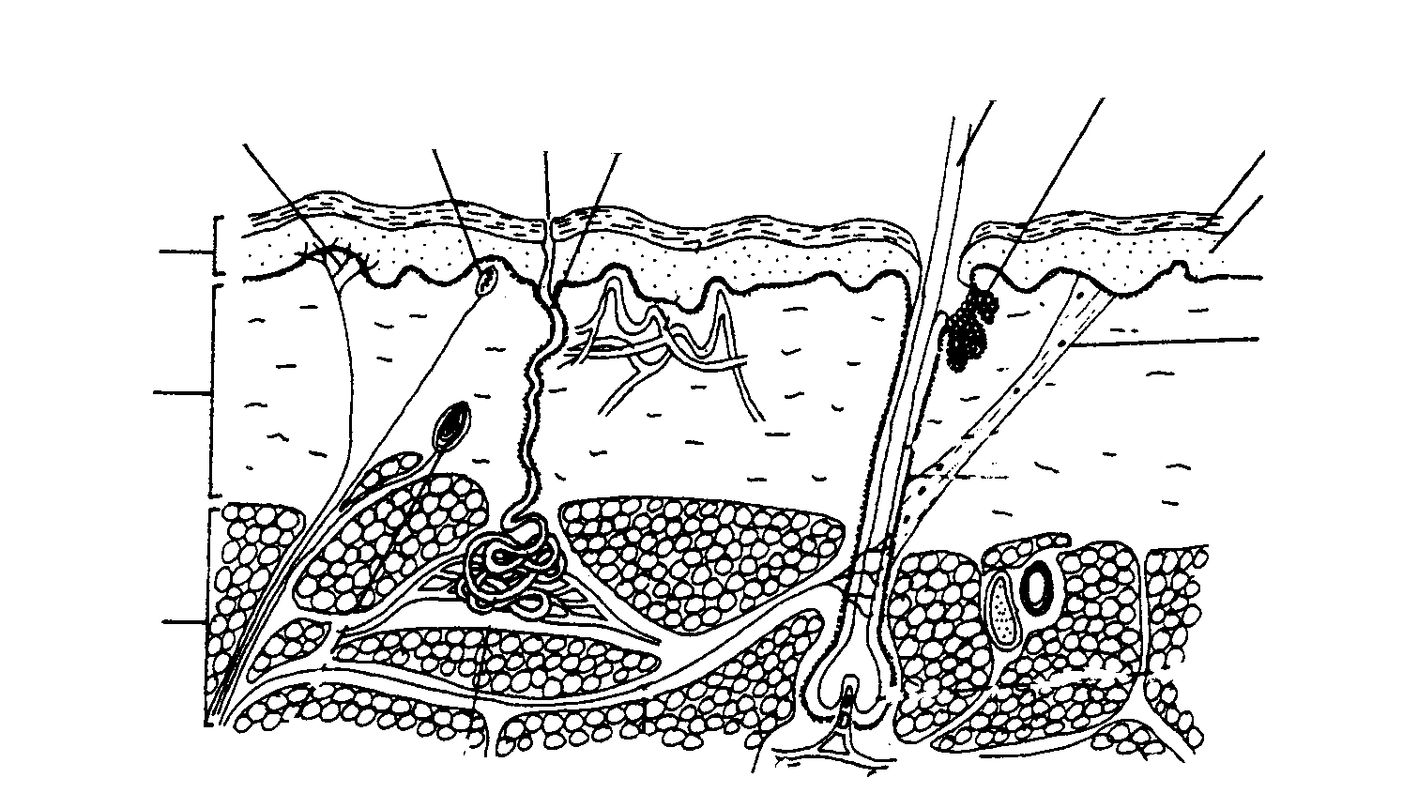
A B C D E
I

J

K
F
G

H
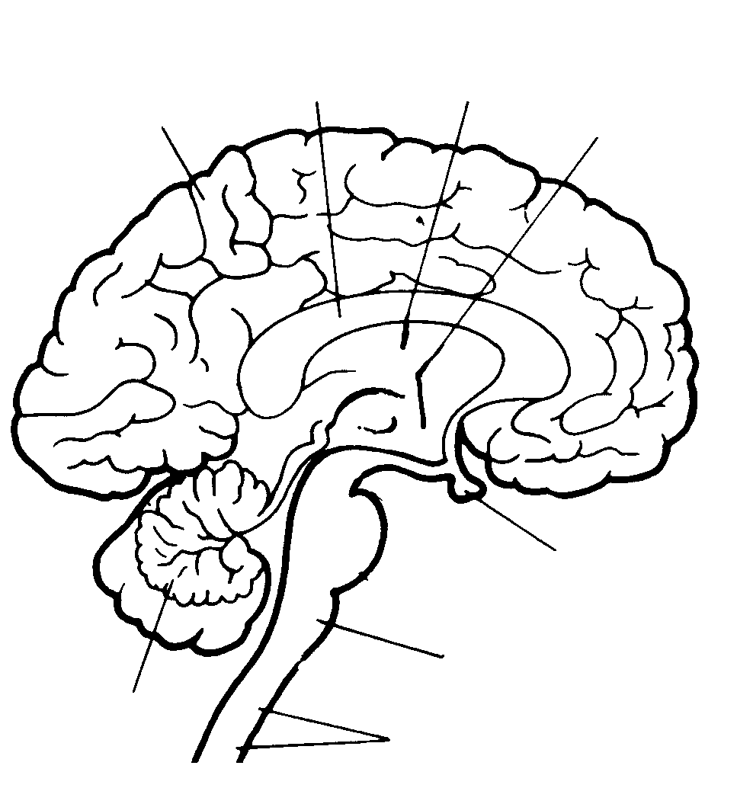
L M N O

P
S
Q
R

QUESTION 1.3

Supply the correct physiological term for each of the following:  1.3.1. The fissure that separates the frontal lobe and the parietal lobes  1.3.2. Skin receptors stimulated by light touch  1.3.3. The hormone responsible for milk production after birth  1.3.4. The surface upon which the stapes exert pressure in the ear  1.3.5. The liquid which fills the anterior cavity of the eye  1.3.6. This gland secretes tears  1.3.7. The part of the adrenal gland which secretes adrenaline (epinephrine)  1.3.8. The narrow strip of tissue joining the two hemispheres of the cerebellum  1.3.9. A common neurotransmitter  1.3.10. The protein found in the horny layer of the skin | (10)

TOTAL FOR SECTION A: | [90]

SECTION B
COMPULSORY

QUESTION 2

2.1 The skin consists of three different layers. List all the structures of the dermis found on the back of the hand and give a function of each.  2.2 The following graph (Fig. 2.2) shows the results of some experiments performed to investigate the functions of the liver and kidneys. | (16)

CONCENTRATION OF UREA IN BLOOD (MG / ℓ)
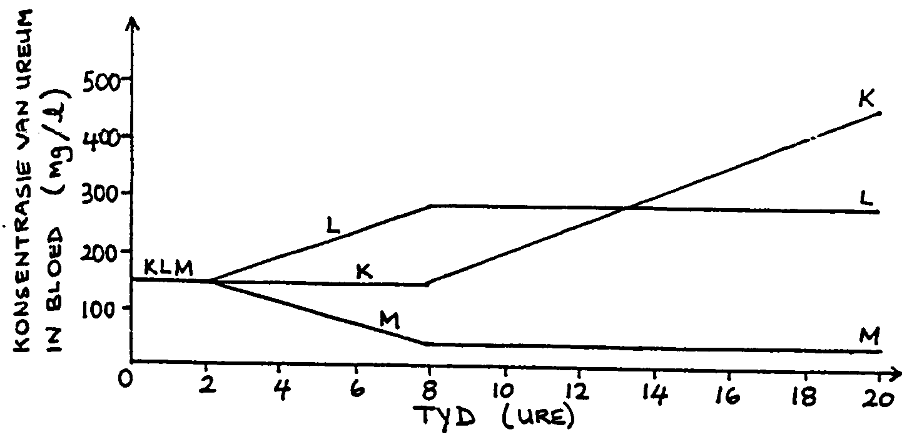

TIME (HOURS)

Fig. 2.2: Results of experiments to investigate the functions of the liver and kidneys where:

- For graph K the kidney was removed after 8 hours.
- For graph L the kidney was removed after 2 hours and then the liver was removed after 8 hours.
- For graph M the liver was removed after 2 hours and then the kidneys were removed after 8 hours.

- What effect did the removal of the kidneys have on the concentration of urea in the blood?  2.2.2 Give a detailed explanation of the effect you have described in 2.2.1.  2.2.3 Describe how the graphs L and M confirm your explanation in 2.2.2. | (2)  (12)  (4)

2.3 The following substances are not normally found in urine. If found in urine, an underlying health problem may be indicated. Give a simple explanation for each one of the following:  - Blood  - Glucose  - Kidney stones | (6)  [40]

QUESTION 3

3.1 Study the given passage below and answer the questions that follow.

NATURAL/INBORN REFLEX ACTIONS

From birth, we are able to perform these reflex actions. They may be associated with the brain, e.g. breathing and pupil mechanism, or they may be associated with the spinal cord, e.g. the knee-jerk reflex or the withdrawal reflexes (withdrawing your hand or foot from a painful stimulus). These reflexes serve mainly to protect the body from harmful stimuli.

- Give a simple definition for reflex action.  - List TWO other reflex actions that could be associated with the brain, not mentioned in the passage above.  - Explain why a vertebral disc in the back which has shifted or collapsed causes so much pain? Give TWO possible reasons.  - What are the advantages of acquired reflex actions?  - Describe the path that an impulse must follow to bring about a reflex action.  3.2 Discuss the factors that can affect reflex time. | (3)  (2)  (4)  (3)  (12)  (16)  [40]

QUESTION 4

- Name the structures that protect the brain against injury.  - Which vital reflex actions does the medulla oblongata control?  - Tabulate the differences between white and gray matter. | (6)  (5)  (6)

4.4 Study the following flow chart and answer the questions below:

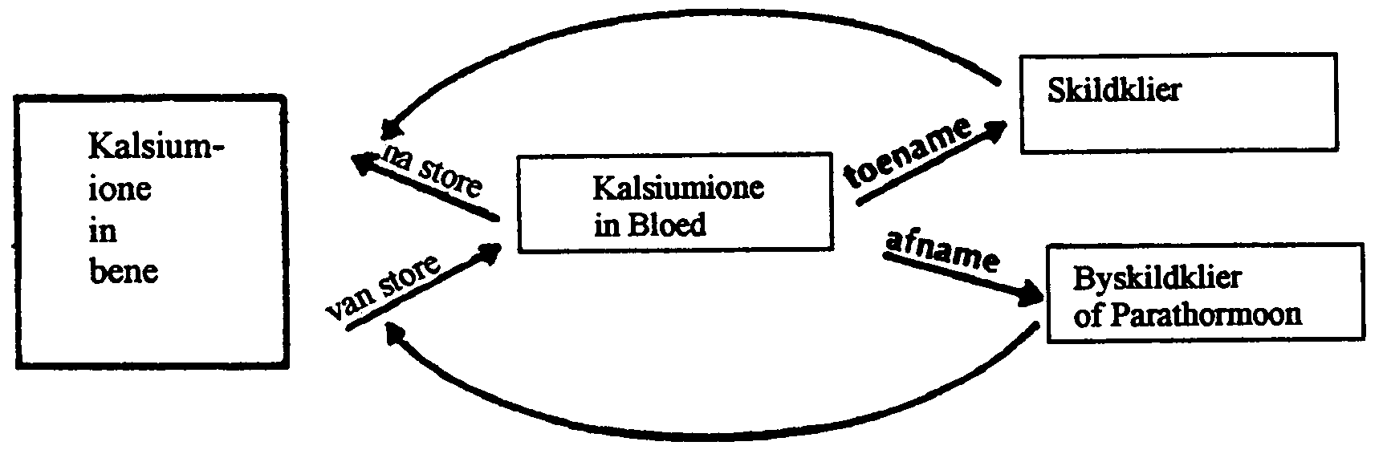

4.4.1 Which hormone causes the release of calcium from the bones into the blood? | (2)

- Describe TWO other ways in which this same hormone can cause an increase in blood calcium.  - Name FOUR characteristics of a deficiency of the above-mentioned hormone.  - What effect will an increase in blood calcium have on the body? | (4)  (4)  (5)

4.5 Name all the structures in the inner ear that are responsible for maintaining equilibrium of the body. Describe how they function. | (8)  [40]

QUESTION 5

- Identify and discuss the FOUR phases of gametogenesis.  - The proper usage of a condom can protect women against THREE dangers. What are these dangers?  5.3 What are the functions of the placenta? | (8)  (3)  (10)

5.4 Read the article below and answer the questions which follow.

EAR-BLASTING CONCERTS CAUSE DEAFNESS, STUDY REVEALS

London: Scientists have confirmed what parents have known for years: that ear-blasting rock concerts and long nights at discos can turn you deaf. New research suggests that thousands of young people could develop serious hearing problems much sooner that their predecessors, where deafness usually developed after the age of 60. It also suggests that noise from leisure pursuits have replaced workplace noise as the biggest risk to hearing in people. Yet there are no legal limits on the sound levels permissible at clubs or concerts – even if they would be illegal in a factory. A study of 1 364 people aged between 14 and 40 in the city of Nancy, France, found that of those who went to rock concerts once a month, 44% showed symptoms of temporary hearing loss. This included ringing in the ears, tinnitus and deadened hearing. The research conducted by a French hearing specialist, also showed that almost two thirds of those who went to concerts more than twice a month had such symptoms.

Independent News Service.

- In the article the reporter has used a medical term as well as a description of the same medical term as if they were two separate conditions. Name the term together with its description by referring to the article.  5.4.2 If people attended rock concerts more than twice a month, what proportion of those attending showed symptoms of hearing loss? Refer to the article. | (4)  (2)

5.4.3 Give ONE possible reason for the occurrence of temporary deafness after exposing your ears to loud noise. Use your own understanding of the physiology of hearing to derive your answer.  - According to the article, what constitutes the biggest environmental risk to hearing?  - Which nerve conducts impulses from the inner ear to the brain?  - You may have noticed that sometimes, when speaking to an elderly person, the person had asked you to repeat what you have said. You then raise your voice, and the elderly person says: “Don’t shout – I’m not deaf!” Suggest a possible reason for this common form of deafness found in the elderly, in which only high pitched sounds are lost while the rest of their hearing remains intact. | (2)  (2)  (1)  (2)

5.5 Seminal fluid refers to the liquid portion of semen. Name the glands responsible for these secretions and state ONE function of each. | (6)  [40]

SECTION C

Answer only ONE question from this section. Choose either Question 6 (essay type) or Question 7 (data response). If you answer both questions only the first one will be marked.

QUESTION 6

“The study of the development of the fertilised egg through to the eighth week in utero is referred to as embryology. By the end of the embryonic period, the rudiments of all the principal adult organs are present, and the placenta is functioning.”  Describe the events that take place from the time the zygote has formed to the start of the foetal stage of development.  OR | [50]

QUESTION 7

The volume of urine and its salt content was determined in an experiment.

The experiment was conducted on a 35-year-old male with healthy kidneys. He was required to drink one litre of pure water and then to abstain from taking in any liquid for the next four hours. His rate of urine production, both before drinking the water and for the next four hours after drinking the water, was carefully measured by collecting his urine at 30 minutes intervals. The quantity of sodium chloride per 100 ml of urine was also measured every half an hour. The results of the investigation are shown in the table below.

Table: Volume of urine and the salt content thereof.

Time when urine collected | Urine produced ml | NcCl content  mg/100 ml
30 mins before drinking | 55 | 230
At time of drinking | 45 | 287
30 mins after drinking | 375 | 38
60 mins after drinking | 470 | 27
90 mins after drinking | 180 | 75
120 mins after drinking | 50 | 264
150 mins after drinking | 73 | 182
180 mins after drinking | 55 | 228
210 mins after drinking | 20 | 635
240 mins after drinking | 32 | 401

Study the table above and answer the following questions:  - Draw a suitable graph to demonstrate the effect that drinking 1 litre of water has on urine production. (Use the graph paper supplied at the back of the exam question paper.)  - How long did it take after drinking the water for the urine output to reach a maximum?  - How long did it take for the extra water to be removed from the body?  - (a) Would you expect the urine produced at maximum flow to be hypertonic, isotonic or hypotonic?  (b) Give a reason for your answer to 7.4(a).  7.5 Discuss in detail the hormone which is responsible for the reabsorption of water in the kidney. | (6)  (1)  (2)  (1)  (2)  (10)

- The two human kidneys produce about 125 ml of glomerular filtrate per minute.  (a) How much glomerular filtrate would be produced in the first 30 mins after drinking the water?  (b) Calculate the percentage of this filtrate reabsorbed into the blood.  7.7 (a) Draw a suitable graph to show the concentration of sodium chloride in the urine. (Use the graph paper supplied at the back of the question paper.)  (b) What conclusion can be drawn from this graph?  7.8 Describe the control of sodium ions by the kidney.  TOTAL FOR SECTION C:  TOTAL: | (3)  (5)  (6)  (2)  (12)  [50]  [50]  300

QUESTION 7.1 / VRAAG 7.1

CANDIDATE’S NUMBER / KANDIDAAT SE NOMMER:

INSTRUCTIONS / INSTRUKSIES:

Complete this graph paper and place in front of your answer book.
Voltooi hierdie grafiekpapier en plaas dit voor in jou antwoordboek.

QUESTION 7.7 / VRAAG 7.7

CANDIDATE’S NUMBER / KANDIDAAT SE NOMMER:

INSTRUCTIONS / INSTRUKSIES:

Complete this graph paper and place in front of your answer book.
Voltooi hierdie grafiekpapier en plaas dit voor in jou antwoordboek.

