GAUTENG DEPARTMENT OF EDUCATION
SENIOR CERTIFICATE EXAMINATION

PHYSIOLOGY SG

TIME : 3 hours

MARKS : 300

INSTRUCTIONS:

- Answer ALL the questions.
- Question 1.1 must be answered on the answer sheet on the inside cover of your answer book.
- Examination paper consists of 15 pages

SECTION A

QUESTION 1.1

1.1 Choose the correct answer from the four possible answers provided (A – D) for questions 1.1.1 – 1.1.30. Draw a cross (X) over the corresponding letter on the answer sheet on the inside cover of your answer book. The numbering in your answer book is 1.1 – 1.30.

EXAMPLE: Saliva is secreted in the
- mouth.
- oesophagus.
- stomach.
- duodenum.

ANSWER: | A | B | C | D

    - The liver excretes
- bile and urea.
- urea and water.
- urea and carbon dioxide.
- creatine and urea.

    - The plasticity of the muscles of the bladder causes
- the triangular shape of the bladder.
- the folds in the mucous membrane.
- the increase of the volume of the bladder.
- the internal sphincter to open.

    - The part of the kidney where bloodvessels and nerves enter, is called the
- calyces.
- pelvis.
- ureter.
- hilum.

Answer 1.1.4 – 1.1.6 with reference to the following diagram:
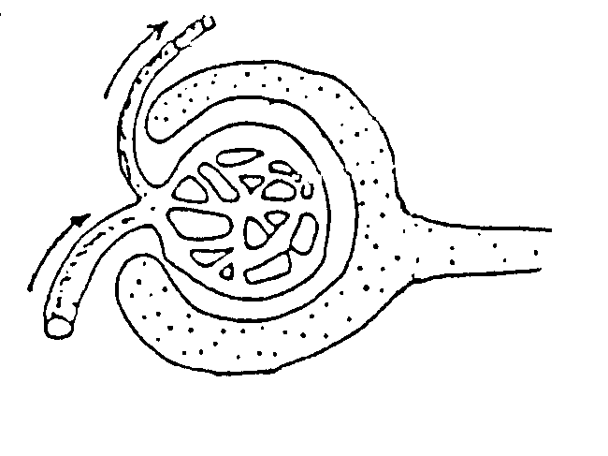

1

2

3

4

5

    - Number 3 is called the
- nephron.
- capsule of Bowman.
- glomerulus.
- Malpighian body.

    - Podocytes form the lining of
- 2.
- 3.
- 4.
- 3 and 2.

    - The high bloodpressure in 3 is due to
- the length of 4.
- the small diameter of 1.
- the cup shape of 2.
- the thin walls of the capillaries.

    - These arteries run between the medulla and cortex of the kidney:
- Interlobar arteries
- Arcuate arteries
- Interlobular arteries
- Renal artery

    - The ducts of Bellini are responsible for the formation of the
- loop of Henle.
- calyces.
- ureter.
- pyramids.

    - Urea is formed from the
- breakdown of nucleic acids.
- deamination of ammonia.
- deamination of amino acids.
- breakdown of fats.

Questions 1.1.10 and 1.1.11 are based on the following diagram:

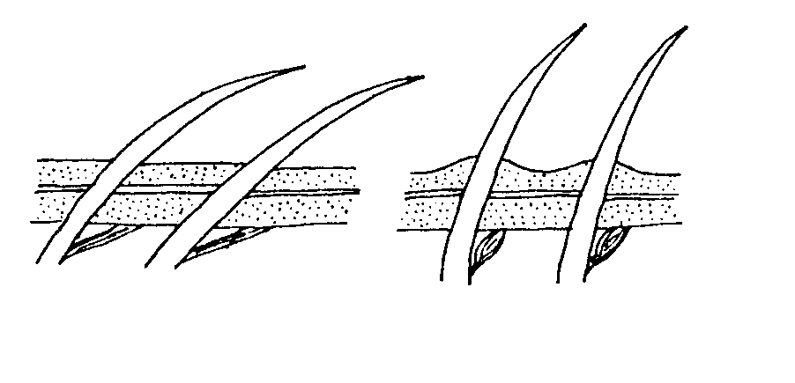
A
B
erector muscle
relaxed
erector muscle
contracted

    - Hairs on the skin will be as in diagram A when
- it is hot.
- you are frightened.
- it is cold.
- you do not sweat.

    - The action of the muscles in diagram B is due to
- parasympathetic nerve stimulation.
- sympathetic nerve stimulation.
- voluntary muscle action.
- stimulation by the olfactory nerve.

    - The auditory canal of the ear secretes a waxy substance called
- endimf.
- cerumen.
- cerebro-spinal fluid.
- sebum.

    - When you are lying on a cold floor, your body is losing heat through
- convection.
- radiation.
- excretion.
- conduction.

1.1.14 This neuron is called a
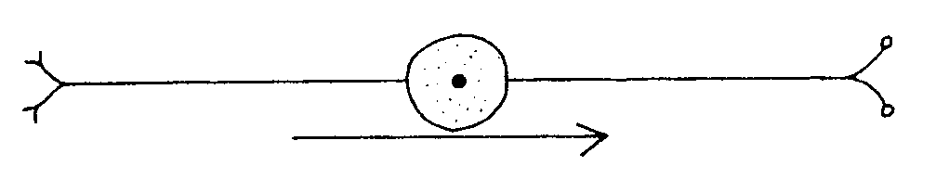

- multipolar neuron.
- unipolar neuron.
- bipolar neuron.
- motor neuron.

    - The neuron in 1.1.14 usually occurs in the
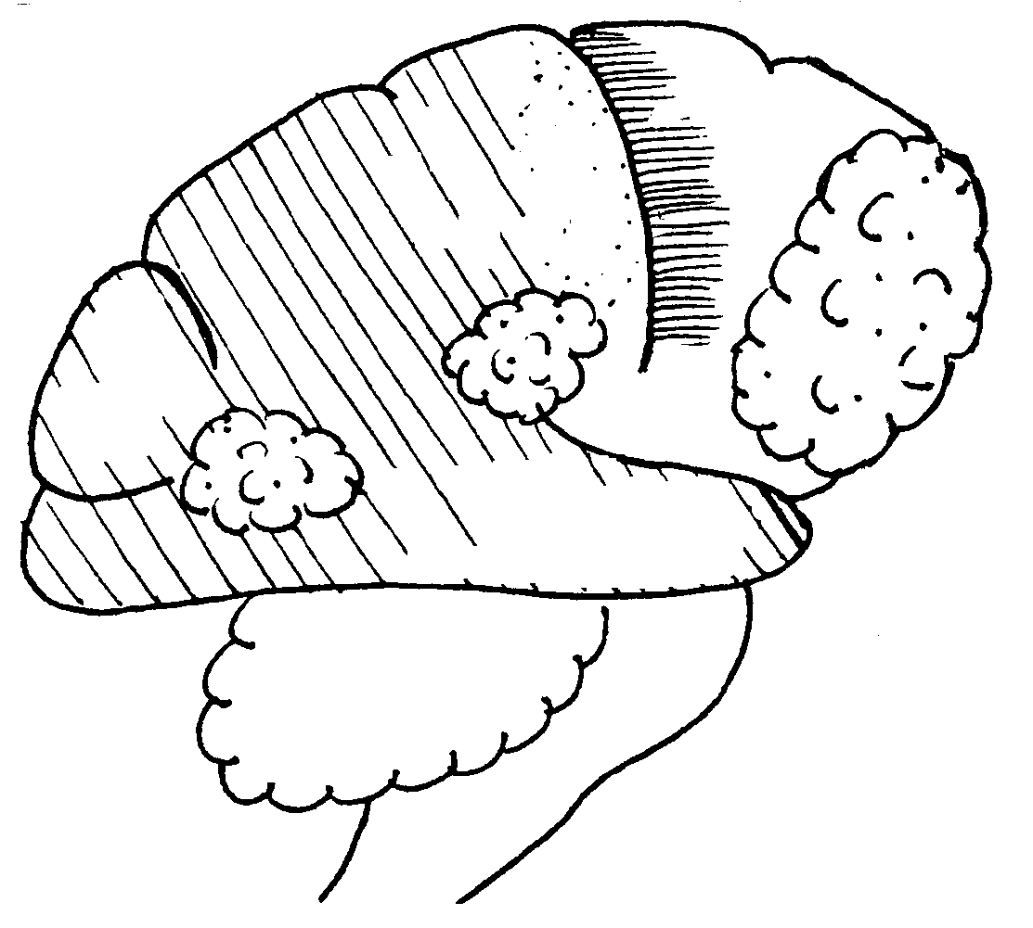
- spine.
- brain.
- retina and nose.
- cerebellum.

1.1.16 The main function of synapses is to
- slow down impulses.
- allow impulses to travel in one direction only.
- accelerate impulses.
- inhibit impulses.

Questions 1.1.17 – 1.1.20 are based on the following diagram below.

3
Frontal
lobe
2
Parietal
lobe
1
Occipital
lobe
4
Temporal lobe
5

1.1.17 The sensations of the skin are interpreted by
- 2.
- 4.
- 3.
- 5.

    - Smell is interpreted by
- 2.
- 1.
- 3.
- 4

    - The vermis is found in
- 2.
- 5.
- 6.
- 1

    - The control of balance and equilibrium of the body is maintained by
- 2.
- 5.
- 6.
- 1.

1.1.21 When a doctor shines a torch in the patient’s eye, the reaction of the eye will be as in:

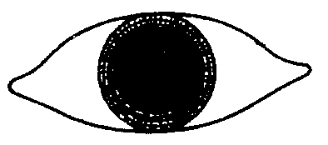

A
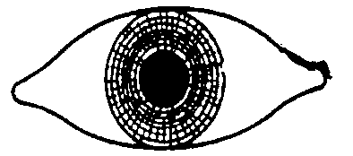

B
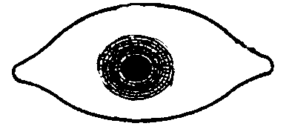

C
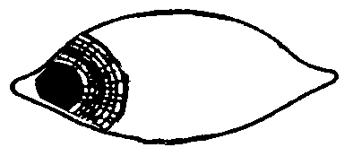
D

    - Stereoscopic vision is the result of the
- crossover of optic nerves in the optic chiasma.
- interpretation of sight in the occipital lobe.
- visual fields of the two eyes overlapping.
- colour of the iris.

Questions 1.1.23 and 1.1.24 are based on the diagram of the tongue below:
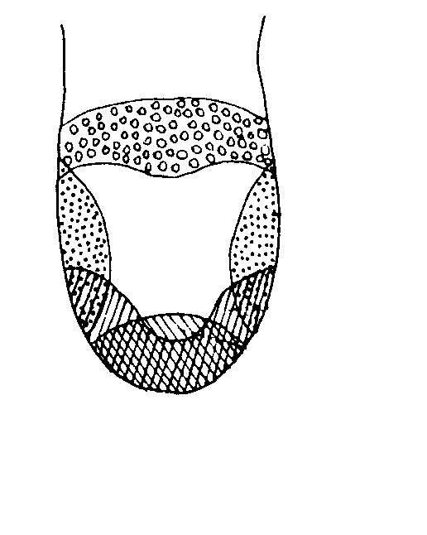
1

2

3

4
The areas of taste on the tongue

    - A sweet taste is perceived by area
- 1.
- 2.
- 3.
- 4

    - The papillae that are found in area 1:
- Circumvallate papillae
- Fungiforme papillae
- Filiforme papillae
- B and C

    - The following are thermoreceptors:
- Corpuscles of Pacini and Meissner
- Endbulbs of Krause and Ruffini
- Rods and cones
- Maculae and corpuscles of Pacini

    - The ________ form(s) part of the inner ear.
- eustachian tube
- ossicles
- tympanic membrane
- utriculus and sacculus

    - The part of the ear where the sound vibrations are changed to nerve impulses:
- Ossicles
- Maculae
- Organ of Corti
- Christae

1.1.28 Hormones that can be stored:
1. ADH
- Oxytocin
- Insulin
- Thyroxin

- 1,2 and 3
- 1, 3 and 4
- 1, 2 and 4
- 2, 3 and 4

1.1.29 This hormone stimulates milk production.
- Prolactin
- Oxytocin
- Lactogen
- Relaxin

- Hormones that are produced in the hypothalamus:  - Prolactin and growth hormone  - ADH and oxytocin  - Thyroxin and FSH  - FSH and LH 30 x 2 = | (60)

1.2 Give the physiological term for each of the following descriptions. Write this in your answer book next to the question number.

    - The part of the ear that prevents sound reflection
    - The hole in the scull where the hypophysis is situated
    - The hormone secreted by the cells of Leydig
    - Diabetes mellitus is caused by a high level of _______
    - Goitre is the result of a lack of this in the diet
    - A lack of this hormone in adults will cause myxodema
    - The hormone released by the adrenal medulla
    - The hormone starting puberty in boys
    - The part of the pancreas where alfa and beta cells occur
    - The structure formed after ovulation
    - The watery medium around the embryo
    - The gland that is referred to as the old man’s gland
    - The link between mother and baby
    - The process where milk is released
    - The shedding of the endometrium if fertilisation does not occur
1x15= | (15)

1.3 Write down the letter of the term from Column B that matches each description in Column A, alongside the question number in your answer book.

COLUMN A |  | COLUMN B
1.3.1  1.3.2  1.3.3  1.3.4  1.3.5  1.3.6  1.3.7  1.3.8  1.3.9  1.3.10 | It secretes progesterone  Secreted by the adrenal cortex  Too much cortisone  Hyperthyroidism  Spermatozoa mature here  Hold ovaries in position  Ciliated outgrowths of infundibulum  Formation of sperms or ova  Expulsion of sperms by the penis  The form of the fertilised ovum that embeds in the endometrium | - Graves disease  - Fimbriae  - Adrenaline  - Ejaculation  - Cushing’s syndrome  - Morula  - Placenta  - Blastocist  - Gametogenesis  - Epididymus  - Erection  - Aldosterone  - Seminal vesicle  - Round ligament

10 x 2 = (20)

1.4
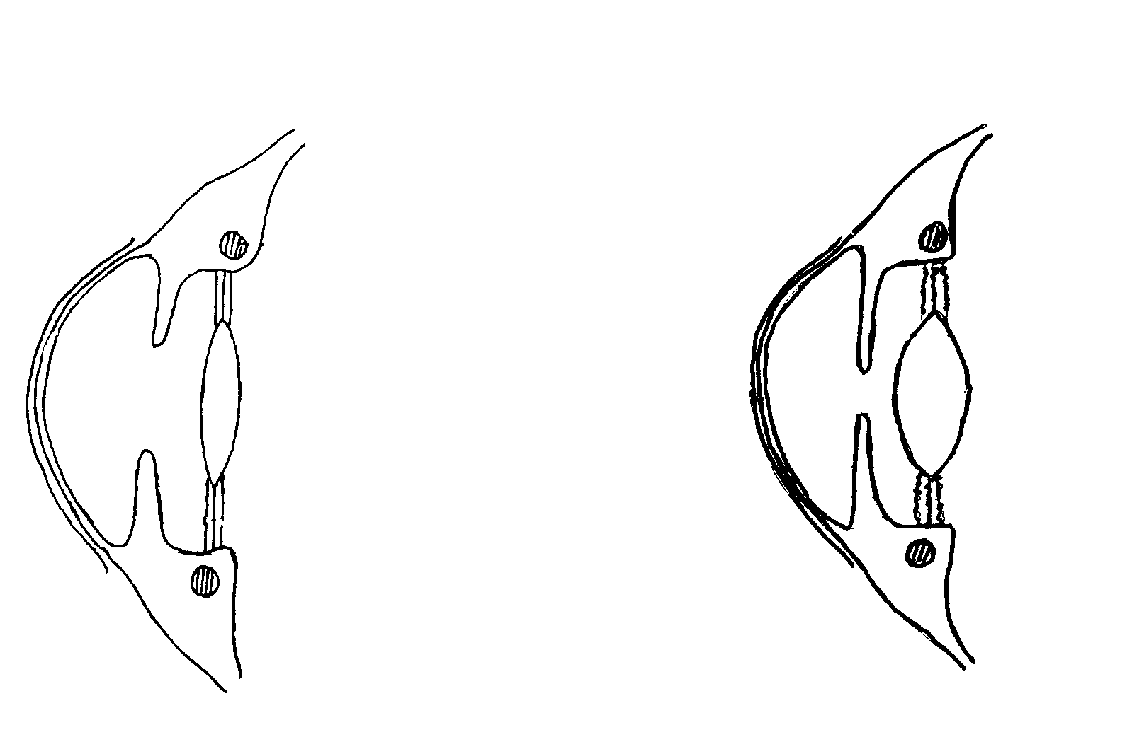

NORMAL EYE

A

B
C

D

EYE ACCOMMODATING

A

B

C

D

4.1 The eye on the right is accommodating to an object. Is the object near or far?  4.2 Write down the action of each of parts A – D for this accommodation.  TOTAL FOR SECTION A: | (1)  (4)  [100]

SECTION B

Answer ALL the questions in this section.

QUESTION 2

2.1 Study the diagram of the skin and answer the questions that follow.

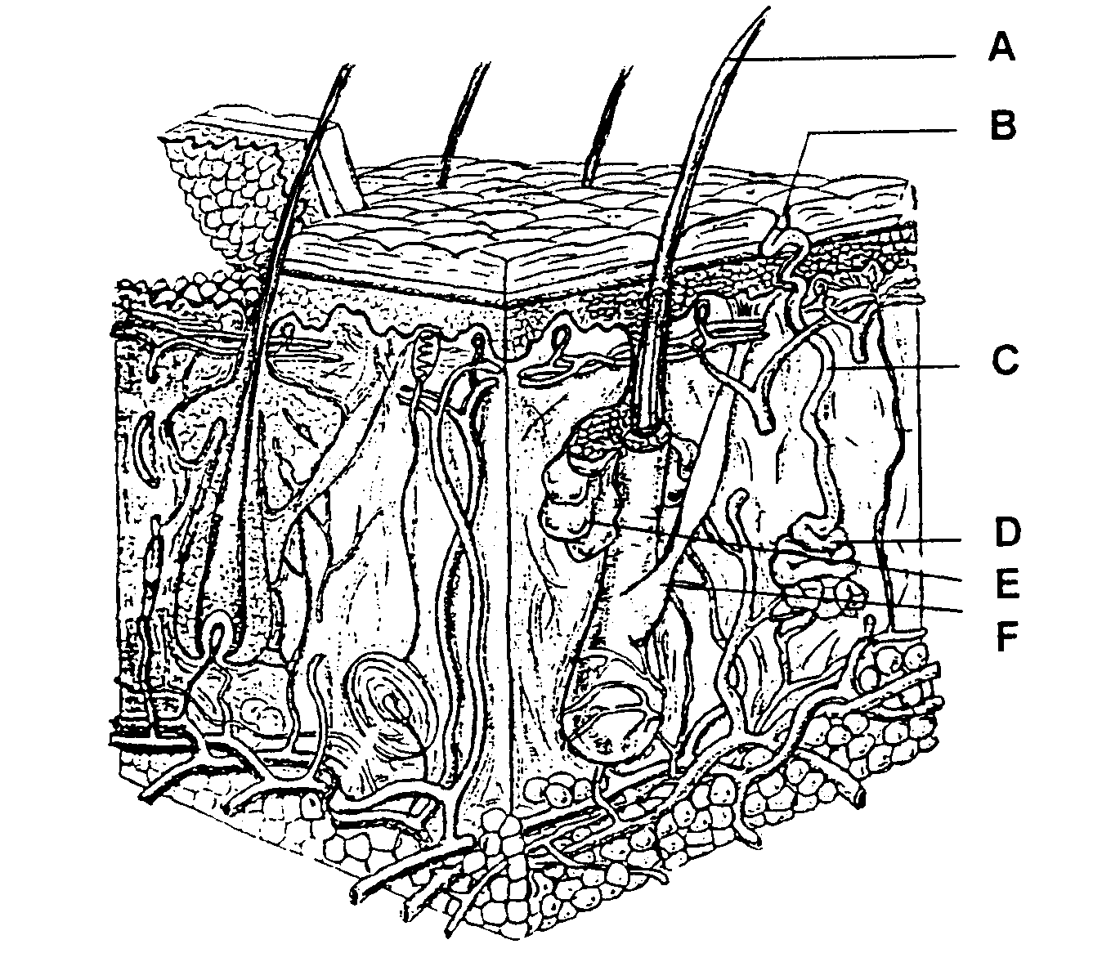
1
2

- Name the parts labelled A – F.  - What do we call the secretion of E and what is the function thereof?  - Describe the actions of the arterioles, D and F in extreme cold to control heat loss.  - Which special cells in layer 1 protect the body against the ultraviolet rays of the sun? | (6)  (2)  (8)  (1)

- The kidney  - Write down, one below the other, all parts of the nefron and next to each part its main function.  - Which substances in the blood will not enter the Bowman capsule?  - Which substances that filtered into the Bowman capsule, will be fully reabsorbed?  - Which endocrine glands are responsible for hormones to help the nefron in its function? Name the glands, the hormones and functions. | (8)  (2)  (2)  (6)

2.3 Name THREE other organs of excretion (not kidneys or skin) and their products of excretion.  - How does the body excrete sulphur?  - The main function of the kidneys is excretion. Name FIVE homeostatic functions which are hereby being fulfilled.  - Name TWO protective functions of the cornified layer of the skin. | (6)  (2)  (5)  (2)  [50]

QUESTION 3

3.1 Spinal Nerves

- How many pairs of spinal nerves are there in humans?  - Supply the names and numbers of all the spinal nerves.  - What do we call the last 10 pairs of spinal nerves?  - Why are the spinal nerves also called mixed nerves?  - Name TWO types of outgrowths found in multipolar neurons.  Indicate the differences between them in column form. | (1)  (10)  (1)  (2)  (2)  (8)

3.2 Protection of the Brain

- Name the membranes and the fluid that protect the brain.  - Name the THREE places where the fluid indicated in 3.2.1, is found. | (4)  (3)

3.3 The hypothalamus is a very important part of the brain. Explain this statement by describing its functions. | (8)

3.4 Study the diagram below of a cross section through the ear.
A
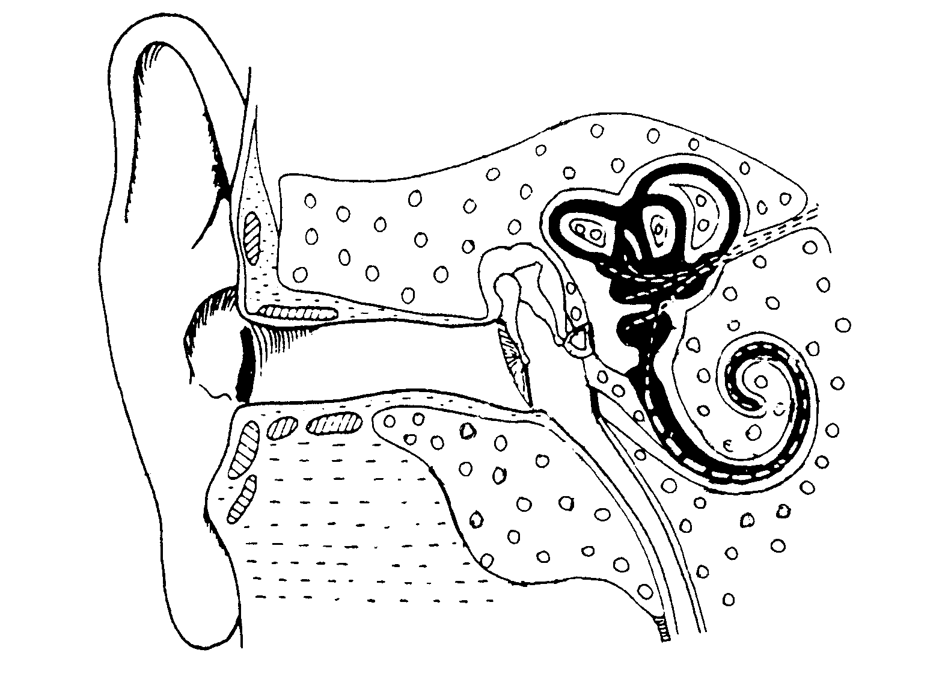
B
C
D
E
F

Name the functions of:  - A  - B  - C  - D  - E  - F | (2)  (2)  (2)  (1)  (2)  (2)  [50]

QUESTION 4

4.1 Study the diagram below and answer the questions that follow.
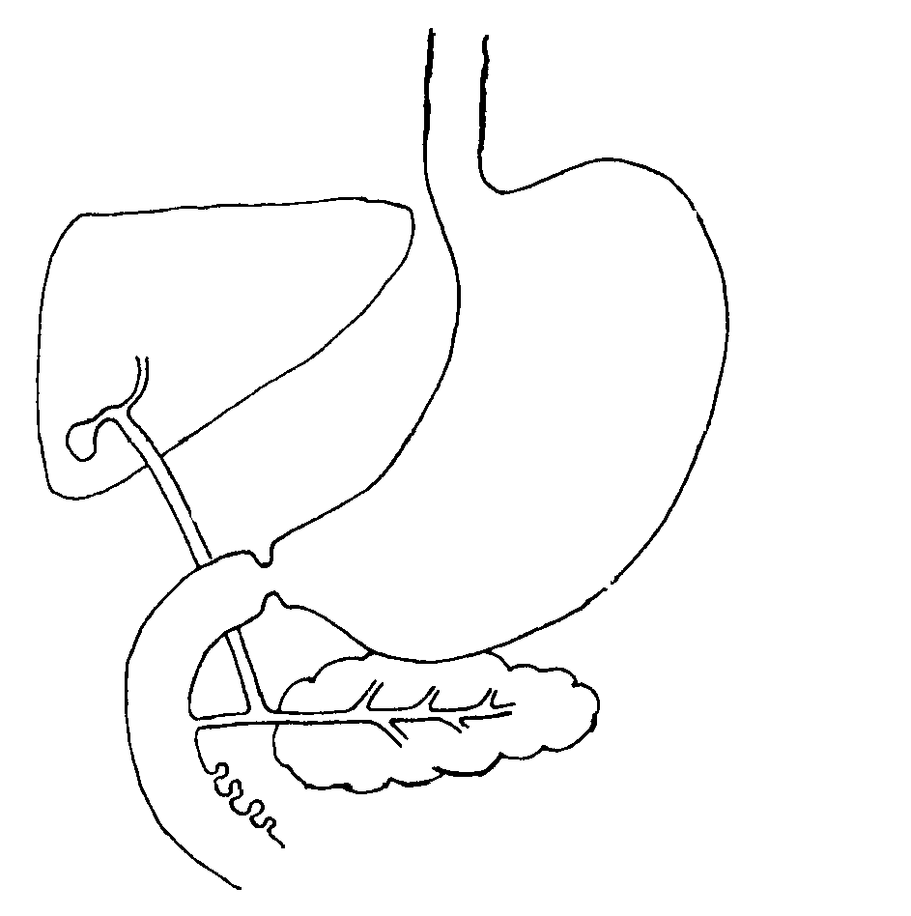
A

B

C

D

E

F

4.1.1 Name the parts labelled A – F.  - Number E is an endocrine as well as an exocrine gland. Explain.  - How is number D stimulated to secrete its content?  - What will the result be if the endocrine section of number E degenerates? | (6)  (6)  (4)  (4)

4.2 The following diagram represents the position of the thyroid to the trachea.

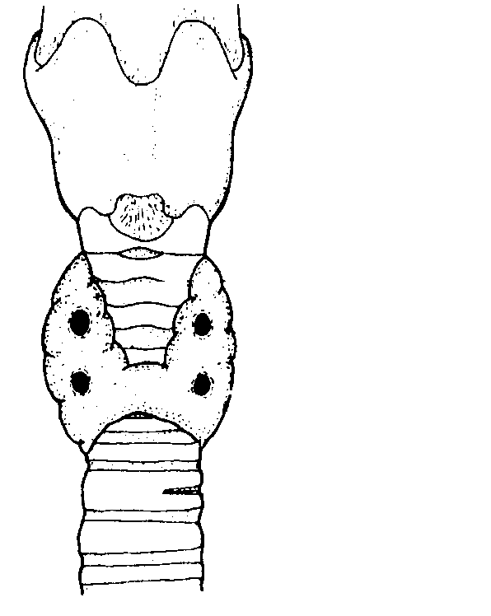
larynx

B

thyroid
trachea

4.2.1 Which hormone is secreted by the thyroid?  4.2.2 What are the functions of this hormone?  4.2.3 What is the condition in a child called when there is an under secretion of the above hormone? Name the characteristics as well.  - Which endocrine gland is represented by the FOUR dots marked B and what is the hormone called?  - The metabolism of which element in the body is affected by this hormone?  - What is the result of an overactive gland B? | (1)  (4)  (3)  (2)  (1)  (4)

4.3 Redraw the following table to compare the nervous and chemical co-ordination under the following headings.

 |  | Nervous | Chemical
 | - Nature of message  - Method of transmission  - Destination of message  4.3.4 Response rate to a message |  |  | (2)  (2)  (2)  (2)

4.4 The negative feedback mechanism  - Define this mechanism.  - Give an example of such a mechanism in the body. | (3)  (2)

4.5 Which disease will occur when there is  - an oversecretion of growth hormone in adults?  - an undersecretion of growth hormone in babies? | (1)  (1)  [50]

QUESTION 5

5.1 The following is a diagram of spermatogenesis in men.

growth phase
reduction phase
maturing phase
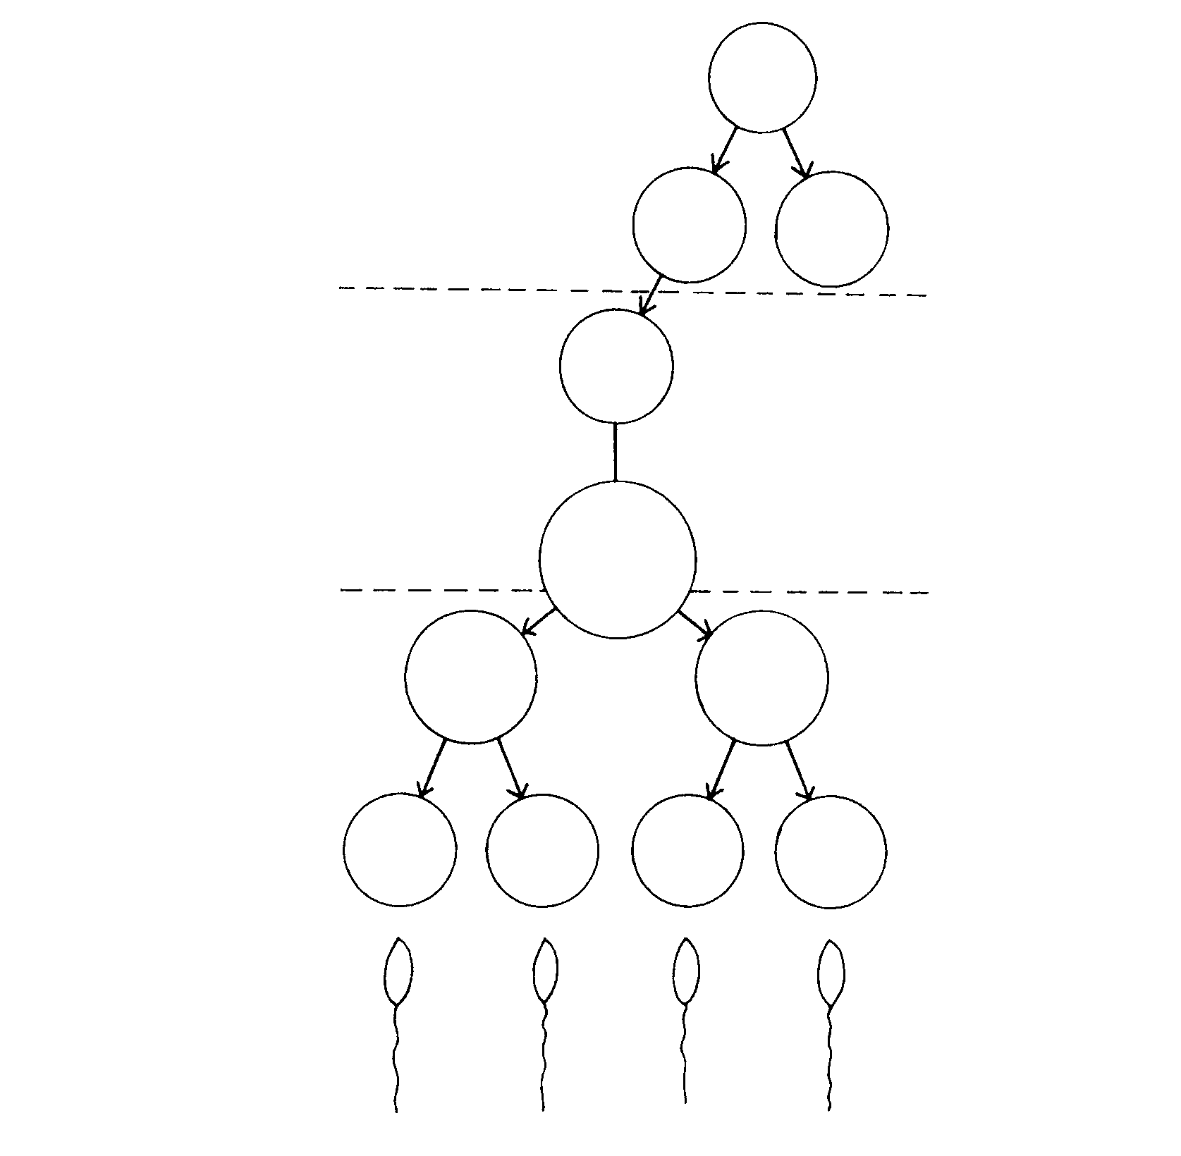
phase 1
phase 2
phase 3
phase 4
2n
2n 2n
2n
2n
n
n
n n n n
n n n n
germ cell

spermatogonia

primary
spermatocyte

secondary
spermatocyte

spermatids

mature
spermatozoa

- Where exactly does this process take place?  - What is the function of mitosis in phase 1?  - What kind of division does the primary spermatocyte undergo to form the secondary spermatocyte?  - What is the result of this type of division?  - Why is the division mentioned in 5.1.3 and 5.1.4 essential?  - Where do the spermatozoa mature? | (2)  (1)  (1)  (1)  (3)  (1)

- Redraw the diagram of spermatogenesis in your answer book.  5.2.1 Add to it the chromosomes (gonosomes) to show that the man determines the sex of children when ova are fertilised.  - What do we call the product of a sperm fusing with an ovum?  - Give the function of each part of a mature sperm. | (6)  (1)  (10)

5.3 Study the diagram below of the female reproductive system.
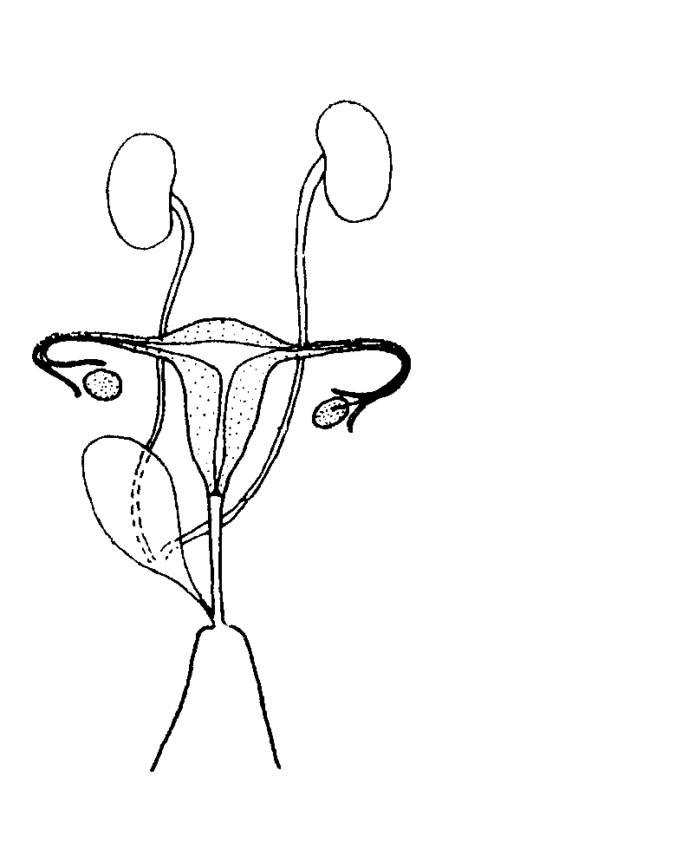
A

B
C
D

E

F

G

H

I

J

- Name the parts numbered A – J.  - Which hormones secreted by E have an influence on F?  5.3.3 Name the TWO membranes which surround the embryo and the function of each. | (10)  (2)  (5)

5.4 The eye develops from the ectoderm layer of the embrionic plate.  - What will happen if the eyeball develops into a long spheric form? Discuss in full and give a possible remedy.  - What do we call the phenomenon when cones have no sensitivity?  - Name the pigment that we find in cones and rods.  - In which part of the eye do we find only cones? | (3)  (1)  (2)  (1)  [50]

TOTAL FOR SECTION B:  TOTAL: | [200]  300

