GAUTENG DEPARTMENT OF EDUCATION
SENIOR CERTIFICATE EXAMINATION

PHYSIOLOGY SG

TIME : 3 hours

MARKS : 300

INSTRUCTIONS:

- This paper consists of 14 pages.
- Answer ALL the questions.
- Question 1.1 must be answered on the answer sheet on the inside cover of your answer book.

SECTION A

QUESTION 1

  - Choose the correct answer from the four possible answers (A–D) provided. Draw a cross (X) over the corresponding letter on the answer sheet on the inside cover of your answer book. The numbering in your answer book is
1.1 – 1.30.

EXAMPLE: Saliva is secreted in the

A

B

C

D
- mouth.
- oesophagus.
- stomach.
- duodenum.

ANSWER:

1.1.1 ______ is excreted by the colon.
- Faeces
- Urine
- CO₂
- Enzymes

    - The bladder can stretch a lot because of
- a big pelvic region.
- the large abdominal cavity.
- the plasticity of bladder muscles.
- the urethers entering the bladder on top.

    - ______ are special cells on the inside of Bowman’s capsule.
- Calyxes
- Podocytes
- Myelin cells
- Nissl cells

    - The part of the nefron that is impermeable to water:
- Bowman’s capsule
- Ascending limb of Henle
- Proximal convoluted tubule
- Descending limb of Henle

    - These substances are not found in the glomerular filtrate:
- Blood corpuscles
- Glucose
- Urea
- Plasma proteins

A. 1, 2 and 4
B. 2 and 3
C. 3 only
D. 1 and 4

    - This hormone plays an important role in the conservation of water by the kidneys:
- ATP
- ADH
- Aldosterone
- Adrenaline

    - Urea is produced by the
- liver.
- kidneys.
- muscles.
- gallbladder.

    - This organ controls the pH of body fluids:
- Skin
- Bladder
- Testes
- Kidneys

    - ______ are sensitive to warmth from the environment.
- Corpuscles of Pacini
- Corpuscles of Krause
- Corpuscles of Meissner
- Corpuscles of Ruffini

    - This part of the brain is sensitive to blood temperature:
- Thalamus
- Medulla Oblongata
- Hypothalamus
- Temporal lobe

    - Neurons that are not found in the spinal column:
- Multipolar neurons
- Bipolar neurons
- Unipolar neurons
- None of the above-mentioned

    - These structures increase the speed that impulses travel along a neuron:
- Nodes of Ranvier
- Nissl granules
- Synapses
- Schwann cells

    - ______ are structures which secrete cerebrospinal fluid.
- Choroid plexus
- Choroid layer
- Arachnoid villi
- Aqueduct of Sylvius

    - The bridge between the two cerebral hemispheres:
- Arbor vitae
- Vermis
- Corpus callosum
- Aqueduct of Sylvius

    - This part of the cerebrum regulates appetite:
- Hypothalamus
- Mid-brain
- Pons Varolii
- Thalamus

    - An injury to the occipital lobe of the cerebum will influence
- speech.
- hearing.
- memory.
- sight.

    - The following actions are all non-vital reflex actions:
- Salivation
- Breathing
- Hiccuping
- Coughing

A. 1, 2 and 3
B. 1, 3 and 4
C. 2, 3 and 4
D. 2 and 4

    - Which cranial nerve is responsible for smell?
- Nervus vagus
- Nervus olfactorius
- Nervus opticus
- Nervus cochlearis

Questions 1.1.19 to 1.1.21 relate to the following diagram of the eye.

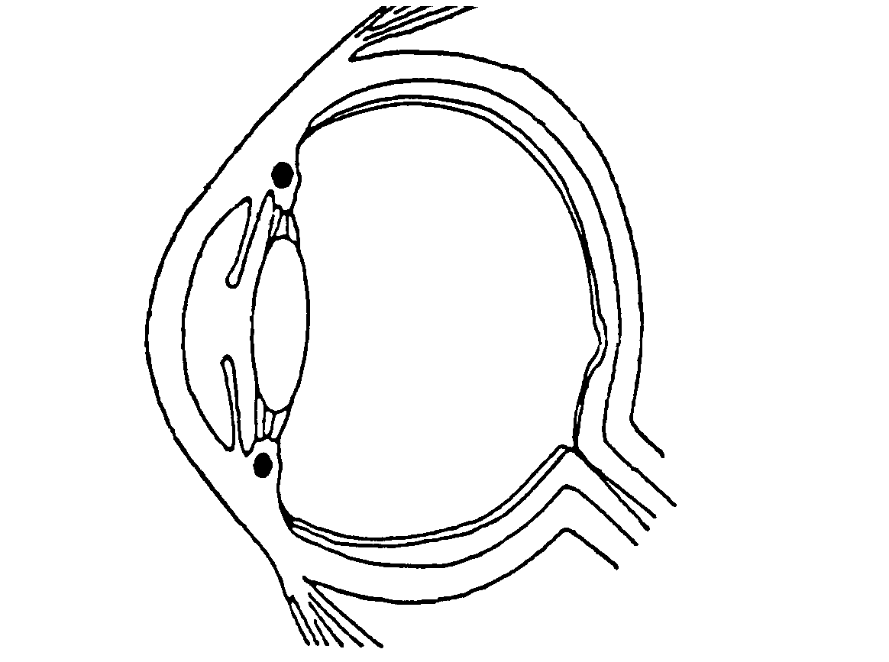
1

2

3

4

5

6
7

8

9

10

11

12

    - Number 9 is called the
- macula lutea.
- blind spot.
- cornea.
- choroid.

    - Number 6 is covered on the front by the sensitive
- conjunctiva.
- retina.
- choroid.
- sclera.

    - The following structures are responsible for refracting light rays:
- 3, 4 and 6
- Only 4
- 4 and 6
- 3, 4 and 12

    - Colour blindness is known as
- stereoscopic vision.
- astigmatism.
- presbyopia.
- acromatosis.

    - This structure equalises pressure on both sides of the tympanic membrane:
- External auditory tube
- Eustachian tube
- Cochlear tube
- Round window

    - Papillae at the back of the tongue:
- Circumvallate papillae
- Filiforme papillae
- Fungiforme papillae
- Otoliths

    - ______ promotes skeletal and muscular growth.
- STH
- FSH
- ACTH
- LH

    - The hormone which stimulates contraction of the uterus during childbirth as well as the flow of milk after childbirth is known as
- prolactin.
- folicle stimulating hormone.
- oxytocin.
- oestrogen.

    - Oversecretion of thyroxin leads to
- cretinism.
- myxoedema.
- goitre.
- Graves disease.

    - This gland regulates the calcium concentration in the blood:
- Thyroid
- Parathyroid
- Hypophysis
- Adrenals

    - Both the following structures secrete progesterone:
- Corpus luteum and ovum
- Corpus luteum and placenta
- Graafian follicle and corpus luteum
- Testes and ovaria

- These cells secrete testosterone:  - Cells of Sertoli  - Cowper cells  - Meiboom cells  - Cells of Leydig  30 x 2 = | (60)

1.2 Write down the letter of the term in Column B, that best matches each description in Column A, opposite the question number in your answer book.

Column A | Column B
- Transfer spermatozoa to vagina  - Skin sac that covers testes  - Spermatozoa will mature here  - The secretion of this gland activates sperm  - The secretion of this gland gives nourishment to sperm  - The mass of cells formed from the zygote  - The form of the zygote that embeds in the endometrium  - The outer layer of embryonic membranes  - The release of milk  - The release of an ovum | - Epididymis  - Yolk sac  - Cowpers gland  - Scrotum  - Lactation  - Morula  - Chorion  - Ovulation  - Penis  - Menstruation  - Prostate gland  - Blastocyst  - Seminal vesicles
10 x 2 = (20)

- Give the physiological term for each of the following descriptions.  1.3.1 The structure responsible for nutrition of the embryo  - The hormone that triggers the release of the ovum  - The gonosomes in males  - The watery fluid which surrounds the embryo  - The cell division during spermatogenesis which causes reduction  - The structure of the sperm that contains enzymes  - The duct between the epididymus and ejaculatory duct  - This disease is caused by a lack of insulin  - This organ produces bile  - The syndrome which is caused by an oversecretion of cortisone | (10)

1.4 Indicate why the following statements are FALSE. Give a reason for your  answer in each case.  - The organ of Corti converts chemical stimuli into nerve impulses.  - The cones in the eye contain rhodopsin for colour vision.  - The neuro hypophysis is linked to the hypothalamus by means of blood vessels.  - The ossicles pass vibrations from the tympanic membrane to the round window.  - Glands of Meiboom secrete tears to destroy germs in the eyes.  5 x 2 = | (10)

TOTAL FOR SECTION A: | [100]

SECTION B

QUESTION 2

Answer ALL the questions in this section.

2.1 Define the term excretion. | (5)

2.2 Study the diagram of a longitudinal section of the human kidney and answer the questions that follow.

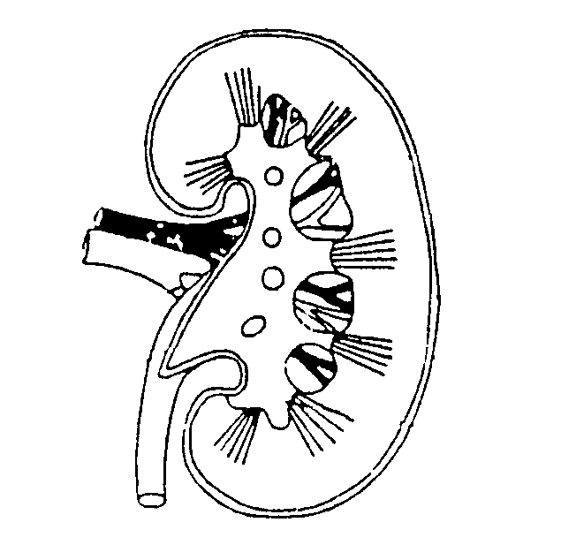
1

2

3

4

5

6
7
8
9

10

11

Identify the parts numbered 1 – 10.  - Name the functions of numbers 7, 8 and 11.  - Name the organic and inorganic substances that occur in 11.  - Which substances will under normal circumstances not appear in 11? | (10)  (3)  (6)  (2)

2.3 Study the following structure.

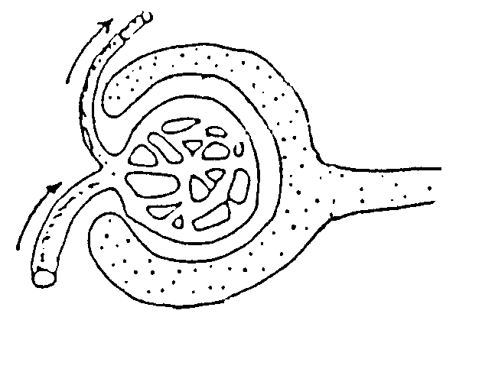
1

2

3
4
5

Name this structure.  - Which process takes place between 2 and 3?  - Give reasons for the difference between 1 and 5.  - Name number 2. | (1)  (1)  (2)  (1)

2.4 Study the diagram of a sweat gland and answer the questions.

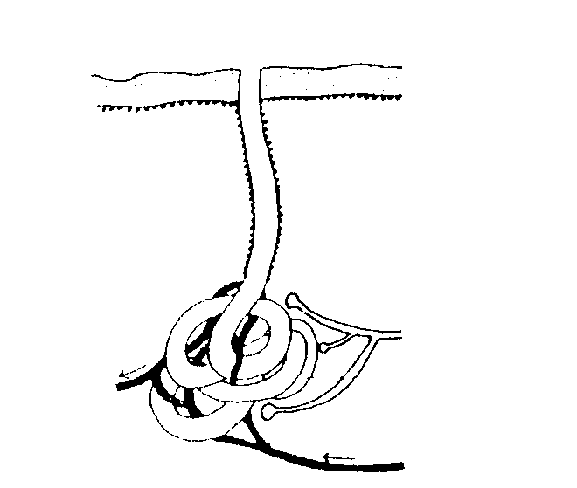
6

7
1

2

3

4

5

Give labels for the parts numbered 1 – 7.  - Name the physical processes through which heat is lost by the skin.  - Name and discuss THREE ways in which the skin reacts to conserve body heat. | (7)  (4)  (8)  [50]

QUESTION 3

3.1 Study the diagram showing the different parts in the human body and answer the following questions.

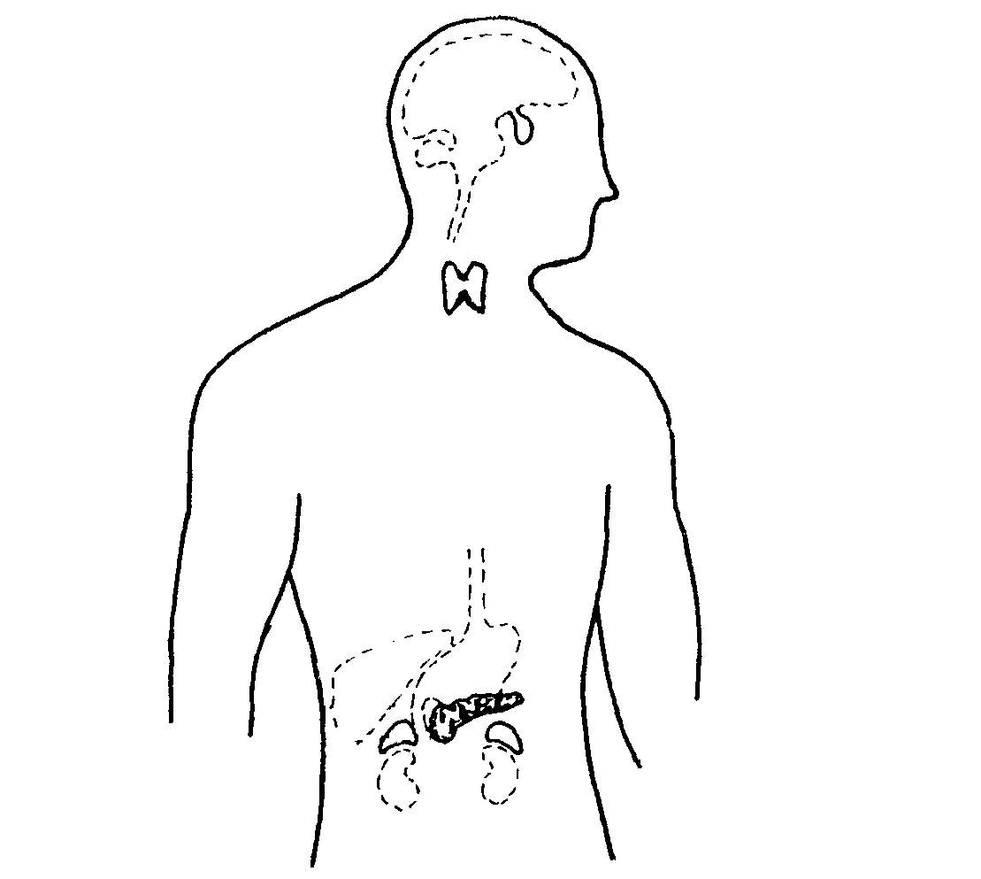
1

2
3

4
5

Name all the endocrine glands shown in the above diagram.  - List THREE characteristics of hormones.  - Name THREE hormones secreted by 4 and give the major functions of each.  - What will the result be, if number 2 is under secreting in children?  - Number 3 is not only an endocrine gland. Explain.  - Mention all the endocrine tissue of 3 as well as the hormones and functions thereof.  - Name a hormone, if any, secreted by number 5. | (4)  (3)  (6)  (5)  (3)  (7)  (1)

3.2 Study the diagram of the female reproductive system and answer the questions which follow.

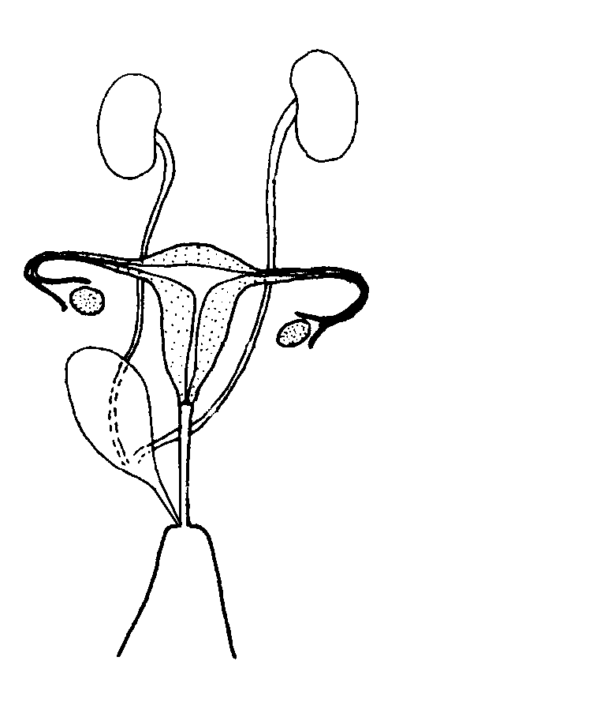
1

2

3

4

5

6

Give labels for the parts numbered 1 – 6.  - Give the numbers and names of the structures where  (a) the formation of ova takes place.  - fertilisation takes place.  - the embryo will develop until birth.  3.2.3 Name the TWO hormones secreted by number 3.  3.2.4 Name the secondary sexual characteristics that is the result of one of these hormones mentioned in 3.2.3 and which is secreted during puberty. | (6)  (1)  (1)  (1)  (2)  (6)

3.3 What is the process called by which ova develop?  3.4 What is a zygote? | (1)  (2)  [50]

QUESTION 4

4.1 Study the diagram of the cross-section of the cochlea.

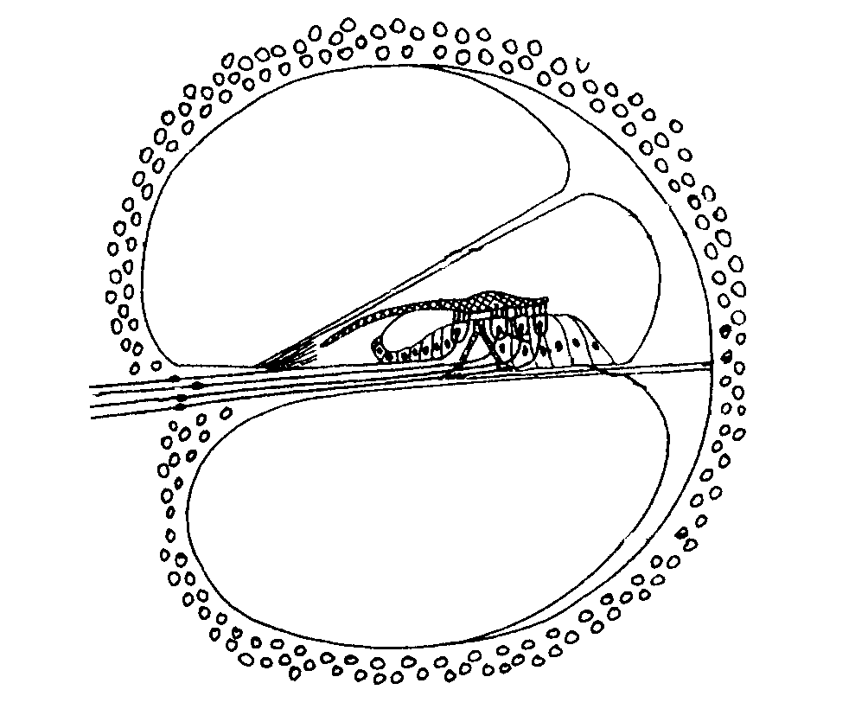
4

5
6

7
8
1

2

3

Name the parts numbered 1 – 8.  - Name the fluids found in numbers 1 and 4.  - The fluid in number 8 appears to be the same as the fluid in 1. Give a reason for this.  - Which part is connected to the round window?  - Name the function of the round window. | (8)  (2)  (2)  (1)  (2)

4.2 Answer the following questions based on the eye.  - How does the iris react in the dark?  - How will the eyes accommodate when you are reading a book? Discuss briefly.  - What is the result, cause, problem and remedy for someone that suffers from myopia? | (4)  (5)  (6)

4.3 Where are the following receptors situated and what type of stimuli is received by them?  - Chemoreceptors  - Mechanoreceptors  - Photoreceptors  - Thermoreceptors  - Proprioceptors 5 x 2 = | (10)

4.4 Name the most important glands in the skin and the secretion of each. | (8)

4.5 Where and how is sulphur excreted from the body? | (2)  [50]

QUESTION 5

5.1 Study the diagram of a neuron and answer the questions that follow.

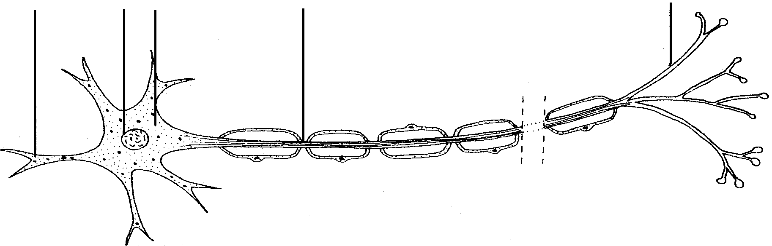
1
2
3
4
5

Name the parts numbered 1 – 5.  - What is the function of the part numbered 1?  - Which type of neuron is represented by this diagram? Give a reason for your answer.  - What is the function of this type of neuron in the body?  - Which small cell organelle is only found in the part numbered 3?  - How is number 4 protected? | (5)  (1)  (2)  (2)  (1)  (2)

5.2 Reflexes  - What is the difference between a reflex arc and a reflex action?  - What is the function of the white matter in the spinal cord? | (4)  (2)

5.3 The Autonomic Nervous System  - Name the TWO parts into which the above system is divided.  - The two systems have THREE structural differences. Name them.  - Name the neurotransmitters of each system.  - The two systems function antagonistically. Explain this term with the aid of an example. | (2)  (6)  (2)  (3)

5.4 Study the diagram of the brain.

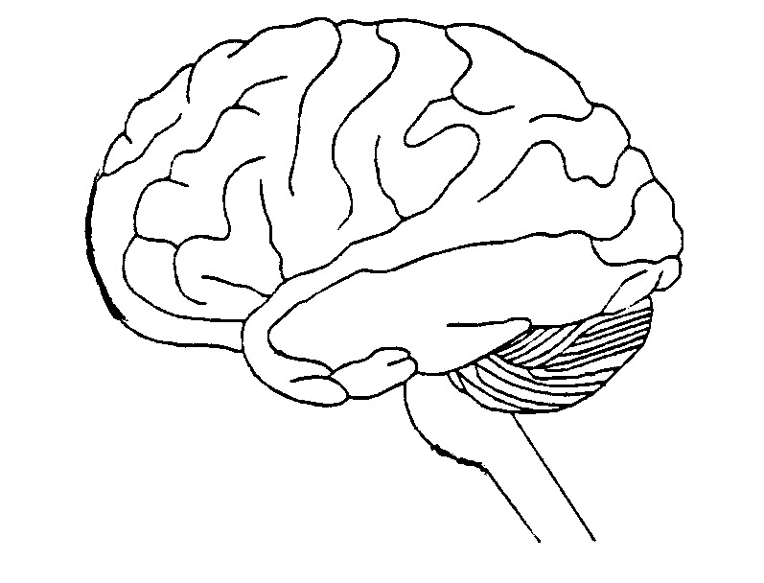
1
2
3
4
5

What is the reason for the gyri and sulci on the brain?  - Name the TWO large fissures of the brain.  - What are the functions of number 5?  - Which vital reflex centres are situated in number 3?  - Which problems will a person experience with injury to number 2?  - Name FOUR structures that protect the brain. | (2)  (2)  (4)  (4)  (2)  (4)  [50]

TOTAL FOR SECTION B:  TOTAL: | [200]  300

