GAUTENG DEPARTMENT OF EDUCATION
SENIOR CERTIFICATE EXAMINATION

PHYSIOLOGY HG

TIME: 3 hours

MARKS: 300

INSTRUCTIONS:

- The question paper consists of THREE sections: Sections A – C.

►Answer ALL questions in Sections A and B.
►You have a choice in Section C: answer either Question 6 or Question 7.

- Answer Question 1 (multiple choice questions) on the answer sheet on the inside cover of the answer book.

- NOTE: The answer sheet is numbered 1.1 to 1.30 for Question 1 Section A.

SECTION A

QUESTION 1.1

1.1 Indicate the correct answer to each of the following statements by marking the appropriate letter with a cross (X) on the inside cover of your answer book.

EXAMPLE: Saliva is secreted in the

- mouth.
- oesophagus.
- stomach.
- duodenum.

ANSWER:

A | B | C | D

    - The system which is responsible for growth, reproduction and general metabolism is the

- endocrine system.
- skeletal system.
- excretory system.
- duodenum.

    - The _______ joins the two cerebral hemispheres.

- corpus luteum
- ventricle
- vermis
- corpus callosum

    - Which of the following is the most suitable definition of excretion? It is the removal of

- metabolic waste products.
- digested food substances.
- cellular metabolic waste products.
- chemical waste products.

1.1.4 Which of the following substances will not be found in the filtrate of the glomerulus?

- Glucose
- Fibrinogen
- Amino acids
- Urea

    - The consciousness of balance originates in the

- cerebrum.
- semicircular canals.
- sacculus.
- cerebellum.

    - The concentration of ______ is higher in the hepatic vein than in any other blood vessel.

- carbon dioxide
- urea
- oxygen
- glucose

Questions 1.1.7 to 1.1.9 refer to the following drawing:

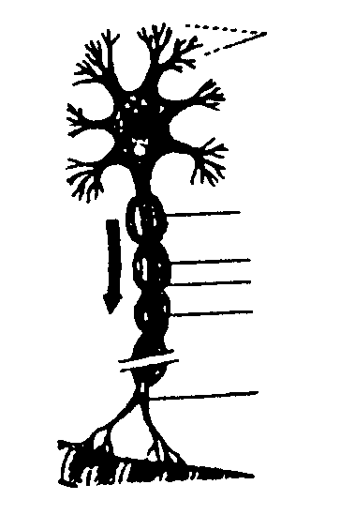
7
3
4
2
1
7
6
5

1.1.7 The above neuron is ________ neuron.

- a motor
- a sensory
- a connector
- an afferent

1.1.8 An impulse enters the neuron at

- 1.
- 2.
- 1 and 2.
- 6.

1.1.9 The grey matter of the brain is formed when many of ______ are grouped together.

- 5
- 2
- 7
- 4

    - With which of the following fluids is the internal ear filled?

- Serumen
- Perilymph
- Perilymph and endolymph
- Endolymph

    - The _________ does not participate in the accommodation process.

- suspensory ligaments
- retina
- lens
- ciliary muscle

    - The ______ is richly supplied with blood vessels.

- choroid
- retina
- sclera
- fovea

    - The ______ is both an exocrine and endocrine gland.

- pituitary
- pancreas
- thyroid
- adrenal

    - Which of the following plays a role in orientation of the body?

- Semicircular canals
- Organ of Corti
- Utriculus
- Sacculus

- (i) + (ii)
- (i), (iii) + (iv)
- (ii) + (iii)
- (ii), (iii) + (iv)

    - The pituitary gland does not control the functioning of the

- pancreas.
- thyroid.
- adrenal glands.
- ovaries.

    - The immediate products of spermatogenesis in the male are called the

- spermatids.
- spermatozoa.
- primary spermatocytes.
- secondary spermatocytes.

1.1.17 An egg that is fertilised by a sperm containing an X chromosome normally develops into

- a male.
- a female.
- either a male or female.
- a dwarf.

1.1.18 If an ovum is not fertilised after ovulation, the remains of the Graafian follicle

- migrate to the uterus and degenerate.
- develop into a corpus luteum.
- are digested and absorbed in the ovary.
- are used to nourish other developing follicles.

1.1.19 Which of the following statements is TRUE?

- The umbilical cord arteries carry blood rich in nutrients to the foetus.
- The umbilical cord arteries carry blood loaded with waste materials to the placenta.
- The umbilical vein carries blood rich in nutrients to the foetus.
- The umbilical vein carries oxygenated blood to the foetus.

1.1.20 In which one of the following pairs are the terms not directly related to each other?

- Corpus callosum and cerebrum
- Middle ear and balance
- Proprioceptors and muscles
- ADH and osmoregulation

1.1.21 The hormone _____ has the same effect on the body as stimulation by the sympathetic nervous system.

- cortisone
- thyroxin
- parathormone
- adrenaline

1.1.22 Otoliths are

- constituents of the olfactory cells in the nose.
- concerned with hearing.
- bones in the middle ear.
- co-responsible for the equilibrium of the body.

    - Which one of the following has no reference to the sensation of taste?

- Circumvallate papillae
- Chemoreceptors
- Olfactory cells
- Proprioceptors

    - Which one of the following is not a function of the skin?

- Formation of vitamin D
- Secretion of sebum
- Formation of vitamin A
- Excretion of sweat

    - Which TWO of the following are hormones which influence sexual development in the female?

- Testosterone
- Luteinising hormone (LH)
- Estrogen
- Insulin
- Secretin
- Progesterone

- (i) + (ii)
- (ii) + (iii)
- (i) + (iv)
- (iii) + (iv)

    - These structures are part of the ventrical system of the brain:

- Foramen magnum
- Foramen of Monro
- Aqueduct of Sylvius
- Fissure of Sylvius
- Cerebrospinal fluid

- (i), (iii) + (v)
- only (v)
- (ii), (iii) + (v)
- (ii) + (iv)

    - The following is the brain area responsible for interpretation of visual stimuli:

- Medulla oblongata
- Occipital lobe
- Pons
- Mid-brain

    - _______ is part of the protection of the brain.

- Duramater
- Filum terminale
- Piamater
- Cerebrospinal fluid

- (i), (iii) + (iv)
- only (i)
- (i), (ii), (iii) + (iv)
- only (iv)

1.1.29 The cranial nerve(s) below is/are concerned with hearing and maintaining of balance.

- N. vagus
- N. olfaktorius
- N. vestibulocochlearis
- N. facialis

- Only (iii)
- (i) + (iii)
- Only (iv)
- (ii) + (iv)

- These structures are common in the autonomic nervous system:  - Proprioceptors  - Ganglia  - Otoliths  - Glands of Meiboom | 30x2=[60]

QUESTION 1.2

State the physiological term for each of the following.

1.2.1 The tube between the kidneys and bladder.

1.2.2 The hormone responsible for the reabsorption of water.

1.2.3 The outer layer of the skin.

1.2.4 The secretion of wax glands.

1.2.5 The type of neuron that is sensory or afferent.

1.2.6 The structures of a neuron that carry impulses towards the cell body.

1.2.7 A transmitter substance that conducts the impulse through the synapse.

1.2.8 The structure that secretes cerebrospinal fluid.

1.2.9 The opening in the cranium through which the spinal cord passes.

1.2.10 The gland in the eye that prevents dessication.

1.2.11 The receptor-cells containing photopsin.

1.2.12 The condition of the eye whereby vertical and horizontal lines are not seen with the same clarity.

1.2.13 The fluid in the scala media.

1.2.14 The junction between the scala vestibuli and scala tympani.

1.2.15 The result of hypersecretion of growth hormone in children. | 15x2=[30]

TOTAL FOR SECTION A: | [90]

SECTION B

Answer ALL the questions in this section.

QUESTION 2

2.1 Describe the structure of the renal tubule and mention all adaptations regarding its function of reabsorption. | (13)

2.2 Glomerular filtration

2.2.1 Which THREE factors make ultrafiltration possible? | (3)

2.2.2 Mention which substances will filter out of the glomerulus and which will stay behind. | (8)

2.3 Name the FIVE functions of the kidneys. | (5)

2.4 When it is very cold, the skin has various ways of controlling the loss of heat.  Discuss this statement. | (11)  [40]

QUESTION 3

3.1 The brain is divided by different fissures into different areas.

3.1.1 Name the different fissures. | (3)

3.1.2 Name the different lobes the cerebrum is divided into as well as the functions of each lobe. | (12)

3.1.3 What is the function of the association areas of the cerebrum? | (5)

3.2 Name the functions of the cerebellum to show the importance of this part of the brain. | (6)

3.3 The Autonomic nervous system.

3.3.1 Name the structures of the body that are regulated by this system. | (3)

3.3.2 Which TWO parts is this system divided into? | (2)

3.3.3 What are the main antagonistic functions of these two sections? | (2)

3.3.4 Indicate how these two sections affect the following organs:

- Bloodvessels of the skin  - The heart  - The iris | (4)  (2)  (1)  [40]

QUESTION 4

4.1 We must be aware of everything that is happening in our external environment.

4.1.1 Name the different receptors that make the above possible as well as the type of stimulation the receptors react to. | (8)

4.1.2 What is a proprioceptor? | (4)

4.2 Name the photoreceptors of the eyes and the pigment present in each. | (4)

4.3 Write notes on the structure and functions of the blind spot. | (4)

4.4 What is the cause of night blindness? | (2)

4.5 The middle ear has various structures that play a major role in proper hearing. Name all these structures and their functions. | (15)

4.6 Name the THREE types of papillae found on the tongue. | (3)  [40]

QUESTION 5

5.1 The blood sugar level must always be in homeostasis.

5.1.1 Define the term homeostasis. | (4)

5.1.2 What is the normal level of bloodsugar? | (1)

5.1.3 How will the body react to a low blood glucose level? | (8)

5.1.4 What is the result of degeneration of beta cells in the pancreas? | (2)

5.2 Puberty

5.2.1 Which hormone is secreted by the hypophysis of boys to start puberty? | (1)

5.2.2 Which hormone in boys causes the secondary sexual changes? | (1)

5.2.3 Name FIVE of these secondary sexual changes in boys. | (5)

5.3 Name all the hormones secreted by the adrenals. | (3)

5.4 Discuss the results of an undersecretion of thyroxin in adults. | (7)

5.5 Read the following about AIDS.

HOW AIDS WORKS

Your body is looked after by the immune system which is made up of White Blood Cells (WBCs).
These White Blood Cells help fight disease germs in your body.
Diseases make you sick but WBCs fight them off and make you well.
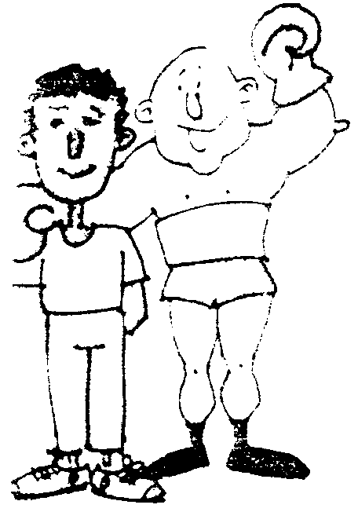
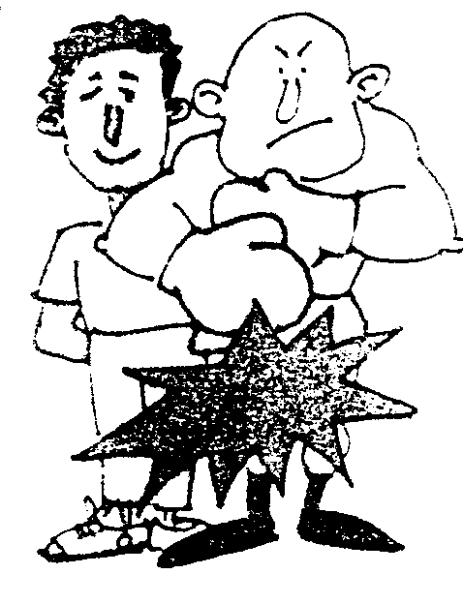
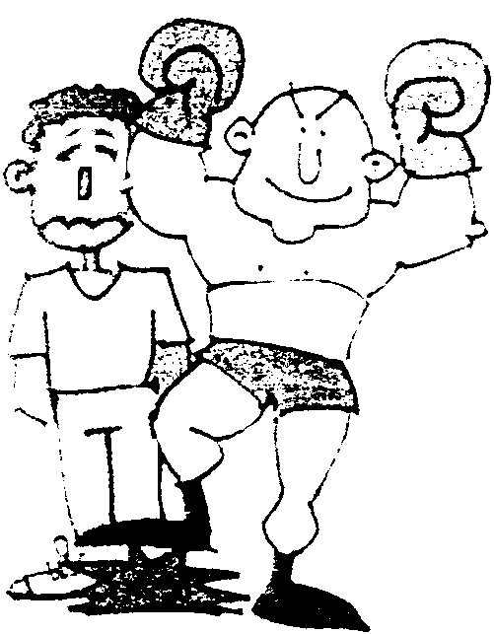

The Human
Immunodeficiency Virus
(HIV) is a very fierce germ that attacks the WBCs themselves.
After a struggle, sometimes lasting years, HIV kills most of your WBCs leaving your body open to invading germs.
These germs cause diseases which attack and kill the body: Acquired Immuno-Deficiency Syndrome. AIDS.
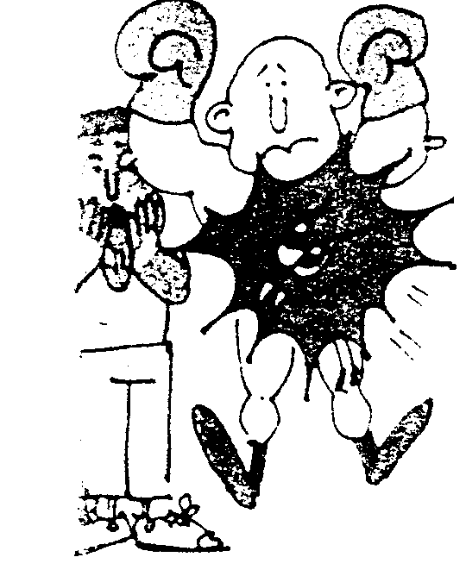
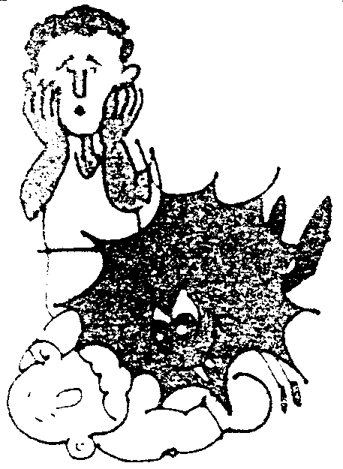
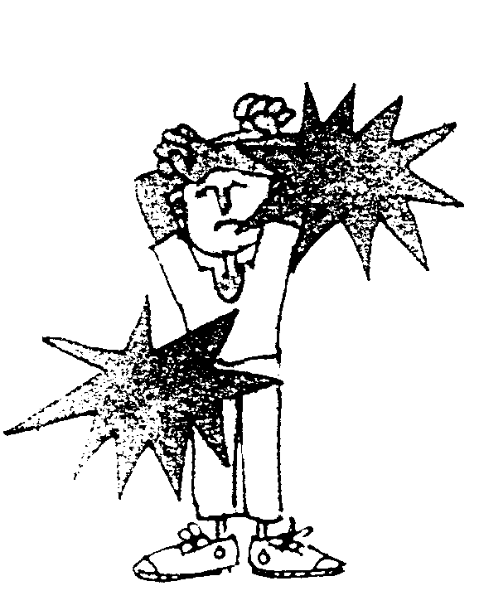

You CANNOT get
AIDS from
- A toilet seat
- Mosquitos, moths or bedbugs
- Doorknobs or rails
- Sharing cups, mugs, forks and spoons
- Swimming pools
- Working alongside or being close to someone with AIDS
- Blood donations
- Tears, saliva
- Open or French kisses
- Second-hand clothes

You CAN get AIDS
from
- Having unprotected sex with an infected person
- Sharing a needle for intravenous drugs (i.e. injecting yourself with drugs).
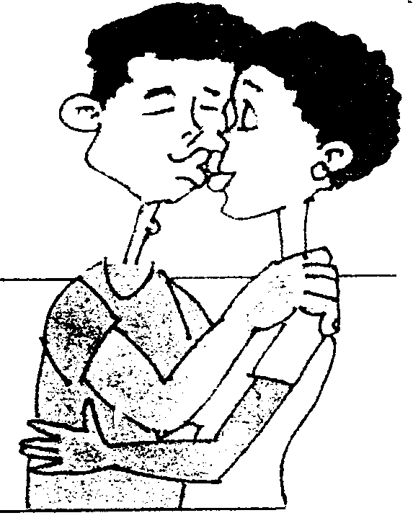

IT IS NOT POSSIBLE TO GET AIDS IN ANY OTHER WAY THAN THROUGH SEXUAL FLUIDS, BLOOD, OR FROM AN INFECTED MOTHER TO HER UNBORN BABY.

KISSING IS

SAFE

5.5.1 Which cells in the body form part of a person’s immune system? | (1)

5.5.2 How does AIDS affect the human body? | (2)

5.5.3 What is the result of AIDS infection? | (1)

5.5.4 Does AIDS kill a person? | (2)

5.5.5 Name TWO ways in which a person can be infected with AIDS. | (2)  [40]

TOTAL FOR SECTION B: | [160]

SECTION C

Answer only ONE of the following questions.

QUESTION 6

6.1 Study the following diagram on menstruation and answer the questions that follow.

2
3
5
4
1
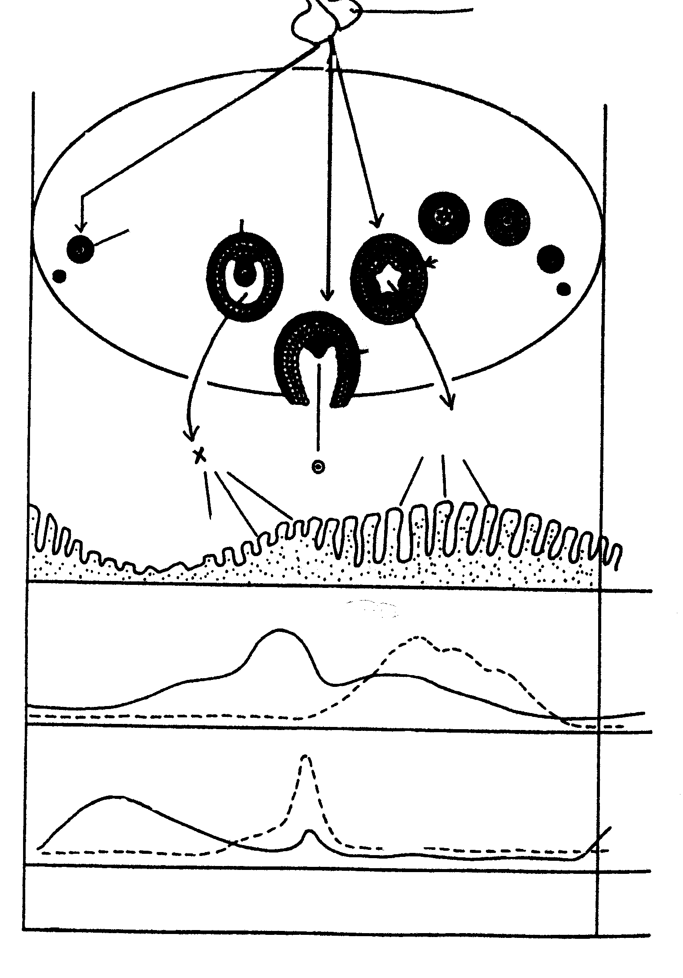

FSH

LH

Y

X
ovary
ovary
lining of the uterus
ovarian hormones
adenohypophysis hormones

FSH

LH
days
0
14
28

6.1.1 Which structure is numbered 3? | (1)

6.1.2 Which hormone (X) does number 3 secrete? | (1)

6.1.3 Which process is shown at number 4? | (1)

6.1.4 What is the structure at number 5 called? | (1)

6.1.5 Which hormone (Y) does number 5 secrete? | (1)

6.1.6 What is the name of the structure numbered 1? | (1)

6.2 Give the functions of hormone (Y) and its influence on the uterus. | (10)

6.3 Discuss the functions of the placenta. | (8)

6.4 How is the embryo protected? Discuss in detail. | (14)

6.5 If fertilisation does not take place, what are the functions of oestrogen? | (5)

6.6 Discuss sex determination. | (7)  [50]

OR

QUESTION 7

- The structure of the male reproductive organs is well suited to ensure maximum possibility for fertilisation.  Discuss the structure of the male reproductive organs according to this statement. | (40)

7.2 Name the FIVE parts of the female reproductive system and give the functions of each. | (10)

TOTAL FOR SECTION C: | [50]

TOTAL: | 300

