
NATIONAL
SENIOR CERTIFICATE

GRADE 12

PHYSICAL SCIENCES: PHYSICS (P1)

EXEMPLAR 2008

MARKS: 150

TIME: 3 hours

This question paper consists of 15 pages, a 3-page data sheet, an answer sheet and graph paper.

INSTRUCTIONS AND INFORMATION

1.  2.  3.  4.  5.  6.  7.  8.  9. | Write your name and/or examination number (and centre number if applicable) in the appropriate spaces on the ANSWER SHEET, ANSWER BOOK and GRAPH PAPER.  Answer ALL the questions.  Answer SECTION A on the attached ANSWER SHEET.  Answer SECTION B in the ANSWER BOOK. Answer QUESTION 10.1 on the attached GRAPH PAPER.  Non-programmable calculators may be used.  Appropriate mathematical instruments may be used.  Number the answers correctly according to the numbering system used in this question paper.  Data sheets are attached for your use.  Give brief motivations, discussions, et cetera where required.

SECTION A

Answer this section on the attached ANSWER SHEET.

QUESTION 1: ONE-WORD ITEMS

Give ONE word/term for EACH of the following descriptions. Write only the word/term next to the question number (1.1 – 1.5) on the attached ANSWER SHEET.

1.1  1.2  1.3  1.4  1.5 | Change in momentum  Energy that an object has because of its motion  The ability of a wave to spread out after it has passed through a small aperture  The electric potential energy of a point charge situated at a point divided by the charge itself  The minimum energy needed to eject electrons from a metal using light |  | (1)  (1)  (1)  (1)  (1)  [5]

QUESTION 2: MATCHING ITEMS

Choose an item from COLUMN B that matches a description in COLUMN A. Write only the letter (A – J) next to the question number (2.1 – 2.5) on the attached ANSWER SHEET.

COLUMN A |  | COLUMN B
2.1  2.2  2.3  2.4  2.5 | The energy that an object has due to its height above a reference point  Any two colours which, when added together, give white light  The force per unit charge  Waves propagated as magnetic and electric fields that oscillate  perpendicularly to each other  The emission of electrons from a metal surface using light of an appropriate frequency | A  B  C  D  E  F  G  H  I  J | radio waves  primary colours  photo-electric effect  kinetic energy  sound waves  gravitational potential energy  thermionic effect  potential difference  complementary colours  electric field |  | [5]

QUESTION 3: TRUE/FALSE ITEMS

Indicate whether the following statements are TRUE or FALSE. Choose the answer and write 'true' or 'false' next to the question number (3.1 – 3.5) on the attached ANSWER SHEET. Correct the statement if it is FALSE.

3.1  3.2  3.3  3.4  3.5 | No work is done by the earth's gravitational force on a satellite which is moving at a constant speed and constant altitude around the earth.  When catching a ball, a cricketer pulls his hands back to reduce the change in momentum of the ball.  When monochromatic light passes through glass its frequency changes.  A filament bulb is an ohmic conductor because it emits heat energy.  The photo-electric effect is proof that light has a wave nature. |  | (2)  (2)  (2)  (2)  (2)  [10]

QUESTION 4: MULTIPLE-CHOICE QUESTIONS

Four possible options are provided as answers to the following questions. Each question has only ONE correct answer. Choose the answer and make a cross (X) in the block (A – D) next to the question number (4.1 – 4.5) on the attached ANSWER SHEET.

4.1 | A girl sits in a train travelling east at 100 km•h⁻¹. An aeroplane, travelling west at 300 km•h⁻¹, passes overhead.
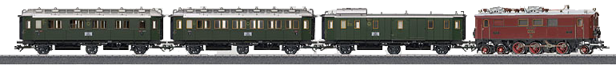
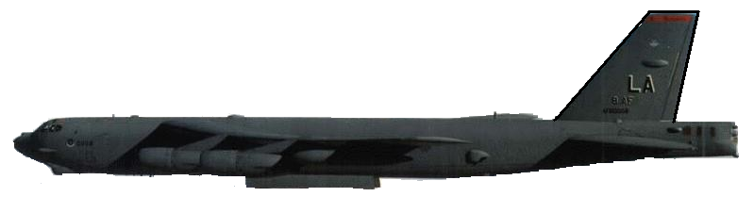
100 km•h⁻¹, east
300 km•h⁻¹, west

Which ONE of the following is the description of how the aeroplane is moving relative to the girl in the train?

 |  | Magnitude of velocity of aeroplane (km•h⁻¹) | Direction of velocity of aeroplane
 | A | 400 | west |  |  | (3)
 | B | 200 | east |  |  | (3)
 | C | 200 | west |  |  | (3)
 | D | 400 | east |  |  | (3)

4.2 | An object moving at a constant velocity v has a kinetic energy E. The velocity is changed to 2v. Which ONE of the following is the correct kinetic energy at this velocity?

 | A  B  C  D | ¼E  ½E  2E  4E |  | (3)

4.3 | Cut glass is used to make ornaments. In light, it shows all the colours of the rainbow. Which ONE of the following is NOT an explanation for this observation?

 | A  B  C  D | White light consists of a spectrum of colours.  Each colour in white light is refracted by different amounts in glass.  Cut glass has its own characteristic colours.  White light splits into colours of different frequencies as it passes through glass. |  | (3)

4.4 | Two identical metal spheres on insulated stands carry charges of Q and q respectively, as indicated in the diagram. When they are at a distance r from each other, they experience a force F.
Q
r
q
Initial position
Q
½ r
q
Final position

The two charges are now moved closer to each other so that the final distance between them is half the original distance, as illustrated. Which ONE of the following correctly describes the new magnitude of the force that the charges experience?

 | A  B  C  D | ¼F  ½F  2F  4F |  | (3)

4.5 | A variable resistor, an ammeter, a battery of emf 12 V and voltmeters V₁ and V₂ are connected as shown in the diagram below.  A  R  V₁  V₂  When the switch is open, the readings on voltmeters V₁ and V₂ respectively are …

 |  |  | (3)  [15]
   | Reading on V₁ | Reading on V₂
  A | 12 V | 0 V
  B | 12 V | 12 V
  C | 0 V | 0 V
  D | 0 V | 12 V

 | TOTAL SECTION A: |  | 35

SECTION B

INSTRUCTIONS AND INFORMATION

1.  2.  3. | Answer SECTION B in the ANSWER BOOK.  The formulae and substitutions must be shown in ALL calculations.  Round off your answers to TWO decimal places.

QUESTION 5

A hot-air balloon is rising vertically at constant velocity. When the balloon is at a height of 88 m above the ground, a stone is released from it. The displacement-time graph below represents the motion of the stone from the moment it is released from the balloon until it strikes the ground. Ignore the effect of air resistance.

1 2 3 4 5 6
0
20
40
60
80
100
•
•
•
•
•
Time (s)
Displacement (m)

88

Use information from the graph to answer the following questions:

5.1 | Calculate the velocity of the hot-air balloon at the instant the stone is released. |  | (6)

5.2 | Draw a sketch graph of velocity versus time for the motion of the stone from the moment it is released from the balloon until it strikes the ground. Indicate the respective values of the intercepts on your velocity-time graph. |  | (3)  [9]

QUESTION 6

Collisions happen on the roads in our country daily. In one of these collisions, a car of mass 1 600 kg, travelling at a speed of 30 m·s⁻¹ to the left, collides head-on with a minibus of mass 3 000 kg, travelling at 20 m·s⁻¹ to the right. The two vehicles move together as a unit in a straight line after the collision.



20 m·s⁻¹
30 m·s⁻¹
1 600 kg
3 000 kg

6.1  6.2 | Calculate the velocity of the two vehicles after the collision.  Do the necessary calculations to show that the collision was inelastic. |  | (6)  (6)

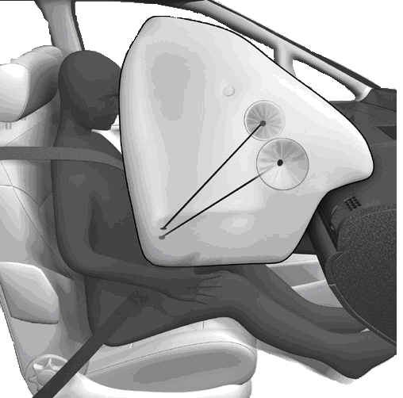  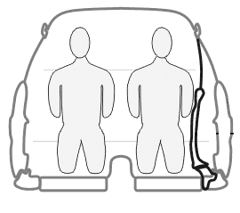  6.3  Safety first!  Both in one package!  Before impact  After impact  Crumple zone  Airbag | The billboard below advertises a car from a certain manufacturer.

 | Use your knowledge of momentum and impulse to justify how the safety features mentioned in the advertisement contribute to the safety of passengers. |  | (3)  [15]

QUESTION 7

A person skis down a 20 m long snow slope which makes an angle of 25° with the horizontal.

The total mass of the skier and skis is 50 kg. There is a constant frictional force of 60 N opposing the skier's motion. The speed of the skier as he/she descends from the top of the slope is 2,5 m·s⁻¹.
v_{i} = 2,5 m·s⁻¹
25º
20 m

7.1 | Calculate the magnitude of the net force parallel to the slope experienced by the person. |  | (5)

7.2 | Calculate the maximum speed of the skier at the bottom of the 20 m slope. |  | (6)  [11]

QUESTION 8

During an experiment to determine the speed of sound, learners are given a siren that sounds a single note of frequency 426 Hz. They attach it to a remote controlled car and move it at constant speed past a stationary tape recorder which is mounted in the middle of a runway. Ignore the effects of friction. The tape recorder records the sound of the siren.

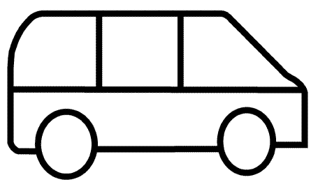
Tape recorder
Emitted sound
 Tape Recorder
Microphone
The learners make the following observation:
The pitch of the sound from the siren as it moved towards the tape recorder was higher than the pitch as the siren moved away from the recorder.

8.1 | Name the effect which explains this observation. |  | (2)

In one of the trials the speed of the remote controlled car was noted as 31 km·h⁻¹. Two notes from the siren were recorded: one with a frequency of 437 Hz and the other note with a frequency lower than 426 Hz.

8.2 | Convert 31 km·h⁻¹ to m·s⁻¹. |  | (2)

8.3 | Determine the speed of sound in air. |  | (5)

8.4 | Give a reason why the observed frequencies are respectively higher and lower than the frequency of the source (426 Hz). |  | (2)  [11]

QUESTION 9

Red light from two stationary narrow slits, S₁ and S₂, reaches a large white screen PON, indicated in the diagram below.

P
O
N
M
S_{1}
S_{2}
S
CR
E
E
N




A dark band is observed at point P on the screen. The brightest band is observed at point O on the screen. Bands are arranged such that the band at point N on the screen is dark.

9.1 | State Huygens' principle in words. |  | (2)

9.2 | Write down the type of interference that occurs at point O. Write down only DESTRUCTIVE or CONSTRUCTIVE. Briefly explain your answer. |  | (3)

9.3 | Describe the change in brightness, if any, of the light bands formed on the screen as you walk closer to the screen from point M to point O. Briefly explain your answer. |  | (3)

The red light is now replaced with a green light.

9.4 | How will the new pattern differ from the previous one? |  | (2)  [10]

QUESTION 10

A learner sets up a circuit as illustrated in the circuit diagram below to investigate the change in electric current over time while a capacitor is being charged. Initially there is no charge on the capacitor.
A
●
●
S
V

After closing the switch, the learner takes the ammeter readings every 20 seconds. The table below shows the results obtained during the investigation.

I ($μ$A) | 90 | 66 | 46 | 30 | 20 | 14 | 9 | 6
t (s) | 0 | 20 | 40 | 60 | 80 | 100 | 120 | 140

10.1 | Draw a graph of electric current (on the dependent, y-axis) versus time (on the independent, x-axis) on the attached GRAPH PAPER. Draw the axes and choose an appropriate scale. Plot the points and then draw the best fitting line. Supply a suitable heading for your graph. [HINT: The graph is not a straight-line.] |  | (5)

10.2 | Use the graph in QUESTION 10.1 to determine the reading on the ammeter after 30 s. |  | (1)

10.3 | Consider the change in the ammeter reading and change in the potential difference to explain the shape of the graph. |  | (2)

A capacitor is rated 9 V, 50 μF.

10.4 | Calculate the charge on the fully charged capacitor. |  | (3)

10.5 | Capacitors are seen as batteries of the future. State ONE advantage that capacitors have over batteries such as torch batteries. |  | (2)

10.6 | Appliances such as TVs contain large capacitors. Give a reason why such capacitors are discharged before servicing the appliances. |  | (2)  [15]

QUESTION 11

A group of learners are requested to investigate the relationship between electric current and potential difference. Before conducting the investigation they have to plan and design a suitable experiment.

The learners approach you to assist them with the planning and design of the investigation. Make use of the layout below to help them with the planning and design of the investigation.

11.1 | Planning

 | 11.1.1  11.1.2  11.1.3 | What is the investigative question for this investigation?  Write down a possible hypothesis for this investigation.  Write down ONE variable that the learners must control during this investigation. |  | (2)  (2)  (1)

11.2 | Design

 | 11.2.1  11.2.2  11.2.3 | List ALL the apparatus that the learners will need for this investigation.  Draw a circuit diagram that they can use to assemble the apparatus.  Describe, in not more than four lines, how the learners must use this apparatus to take the required measurements. |  | (3)  (3)  (3)  [14]

QUESTION 12

The simplified sketch below shows the principle of operation of the alternating current (AC) generator.
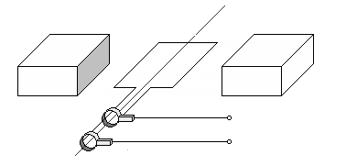
N
S
A
B
X
Y
Q
P

12.1 | Name the parts labelled A and B respectively. |  | (2)

12.2  12.3  12.4  12.5 | In which direction does segment PQ of the coil have to be rotated in order to cause the current direction as shown in the diagram? Write down only clockwise or anticlockwise.  Write down TWO changes that can be brought about to improve the output of the generator.  What changes must be made to the AC generator to make it function as a direct-current (DC) motor?  The induced emf versus time graph for an AC generator is shown below.  0 |  | (1)  (2)  (2)
t (s)
E (V)
12.6 | Sketch a graph to show how the above waveform changes, if at all, after changing this generator into a DC generator.  State TWO advantages of using AC over DC for the long-distance transmission of electrical power. |  | (2)  (2)  [11]

QUESTION 13

The sine waveform shown below represents the variation of current (I) with time (t) for a generator used by a man to light his home. The current alternates between a maximum and a minimum.
I (A)
I_{RMS}
0
I_{average}
t (s)

I₀

In the diagram, I₀ = the peak current
I_{RMS} = root mean square current
I_{average} = average value of the current

13.1 | Write down an expression for the instantaneous current in terms of the frequency of the source and the time. |  | (2)

13.2 | Write down a formula which represents the relationship between the maximum peak current (I₀) and the root mean square current (I_{RMS}). |  | (2)

13.3 | The frequency of the AC generated by Eskom is 50 Hz. A substation supplies 240 V (RMS) to a house. Calculate the peak voltage at a wall socket. |  | (3)

13.4 | Explain why it is of greater value to use RMS current than the average current. |  | (2)  [9]

QUESTION 14

A laser is a device that controls the way that energised atoms release photons. 'Laser' is an acronym for light amplification by stimulated emission of radiation, which describes how a laser works.

The diagram below shows how stimulated emission occurs:

incident photon from external source
photon
photon
high energy
low energy
electron

Lasers are used in dental drills, compact disk players (CD players), high-speed metal cutting machines, measuring systems, printers and for delicate surgery.

14.1  14.2  14.3  14.4 | Describe the process that leads to the emission of the two photons as shown in the diagram.  Write down TWO properties that distinguish a laser beam from an ordinary light beam.  Why is a beam from a torch light to illuminate an area preferable to that from a laser when you go on a camping trip?  Write down TWO advantages of using lasers for eye operations. |  | (4)  (2)  (2)  (2)  [10]

 | TOTAL SECTION B:  GRAND TOTAL: |  | 115  150

NATIONAL SENIOR CERTIFICATE

NASIONALE SENIOR SERTIFIKAAT

DATA FOR PHYSICAL SCIENCES P1 GRADE 12

GEGEWENS VIR FISIESE WETENSKAPPE V1 GRAAD 12

TABLE 1: PHYSICAL CONSTANTS/TABEL 1: FISIESE KONSTANTES

NAME/NAAM | SYMBOL/SIMBOOL | VALUE/WAARDE
Acceleration due to gravity  Swaartekragversnelling | g | 9,8 m·s⁻²
Speed of light in a vacuum  Spoed van lig in 'n vakuum | c | 3,0 x 10⁸ m·s⁻¹
Planck's constant  Planck se konstante | h | 6,63 x 10⁻³⁴ J·s
Gravitational constant  Swaartekragkonstante | G | 6,67 x 10⁻¹¹ N·m²·kg⁻²
Coulomb's constant  Coulomb se konstante | k | 9,0 x 10⁹ N·m²·C⁻²
Charge on electron  Lading op elektron | e⁻ | -1,6 x 10⁻¹⁹ C
Electron mass  Elektronmassa | m_{e} | 9,11 x 10⁻³¹ kg
Permittivity of free space  Permittiwiteit van vry ruimte | $$ε_{0}$$ | 8,85 x 10⁻¹² F·m⁻¹
Permeability of free space  Permeabiliteit van vry ruimte | $$μ_{0}$$ | 4$π$ x 10⁻⁷ T·m·A⁻¹

TABLE 2: FORMULAE/TABEL 2: FORMULES

MOTION/BEWEGING

$$v_{f}=v_{i}+a Δt$$ | $Δx=v_{i}Δt+\frac{1}{2}{aΔt}^{2}$ or $Δy=v_{i}Δt+\frac{1}{2}{aΔt}^{2}$
$v_{f^{2}}=v_{i^{2}}+2aΔx$ or $v_{f^{2}}=v_{i^{2}}+2aΔy$ | $Δx=\left(\frac{v_{f} + v_{i}}{2}\right) Δt$ or $Δy=\left(\frac{v_{f} + v_{i}}{2}\right) Δt$

FORCE/KRAG

$$F_{\text{net}} =\text{ma}$$ | $$p =\text{mv}$$
$$FΔt= Δp = {\text{mv}}_{f }− {\text{mv}}_{i}$$ | $$F_{g}=\text{mg}$$

WORK, ENERGY AND POWER/ARBEID, ENERGIE EN DRYWING

$$W = FΔx$$ | U$=$$E_{P} = \text{mgh}$
$$K = E_{k}= \frac{1}{2} {\text{mv}}^{2}$$ | $$W=ΔK={ΔE}_{k}=E_{\text{kf}}−E_{\text{ki}}$$
$$P = \frac{W}{Δt}$$

WAVES, SOUND AND LIGHT/GOLWE, KLANK EN LIG

$v=f λ$ or/of | $T = \frac{1}{f}$ or/of $T = \frac{1}{ν}$
$$f_{L} = \frac{v ± v_{L}}{v ± v_{s} }f_{s}$$ | $E = \text{hf}$or/of $E = hν$ or/of $E =h\frac{c}{λ}$
$$λ = \frac{h}{m v}$$ | sin$θ=\frac{mλ}{a}$
$\text{hf} = W_{0 } +\frac{1}{2}{\text{mv}}^{2} = {\text{hf}}_{0} + \frac{1}{2}{\text{mv}}^{2}$

MATTER AND MATERIALS/MATERIE EN MATERIALE

$$F=kΔx$$ | Stress/Spanning $=\frac{F}{A}$
Strain/Vervorming $=\frac{Δx}{ℓ}$

ELECTRICITY AND MAGNETISM/ELEKTRISITEIT EN MAGNETISME

$I_{\text{rms}}=\frac{I_{\text{max}}}{\sqrt{2}}$ / $I_{\text{wgk}}=\frac{I_{\text{maks}}}{\sqrt{2}}$  $V_{\text{rms}}=\frac{V_{\text{max}}}{\sqrt{2}}$ / $V_{\text{wgk}}=\frac{V_{\text{maks}}}{\sqrt{2}}$ | $$ε = − N\frac{ΔΦ}{Δt}$$
$Φ$= BA | P_{average} = V_{rms}I_{rms} / P_{gemiddeld} = V_{wgk}I_{wgk}  P_{average} = $\frac{V_{\text{rms}}^{2}}{R}$ / P_{gemiddeld} = $\frac{V_{\text{wgk}}^{2}}{R}$  P_{average} = I²_{rms}R / P_{gemiddeld} = I²_{wgk}R

ELECTROSTATICS/ELEKTROSTATIKA

$$F = \frac{{\text{kQ}}_{1}Q_{2}}{r^{2}}$$ | $$E= \frac{\text{kQ}}{r^{2}}$$
$$E= \frac{V}{d}$$ | $$U = \frac{{\text{kQ}}_{1}Q_{2}}{r}$$
$$E= \frac{F}{q}$$ | $$Q=\text{It}$$
C = $\frac{Q}{V}$ | C = $\frac{ε_{0}A}{d}$

ELECTRIC CIRCUITS/ELEKTRIESE STROOMBANE

$$R = \frac{V}{I}$$ | $$\frac{1}{R_{p}} = \frac{1}{R_{1}} + \frac{1}{R_{2}} + \text{.}\text{.}\text{.}$$
$$R_{s}=R_{1}+R_{2}+ \text{.}\text{.}\text{.}$$ | emf/emk($ε$) = I(R + r)

NAME/EXAMINATION NUMBER:

ANSWER SHEET/ANTWOORDBLAD

QUESTION 1/VRAAG 1

1.1 |  | (1)
1.2 |  | (1)
1.3 |  | (1)
1.4 |  | (1)
1.5 |  | (1)  [5]

QUESTION 2/VRAAG 2

2.1 |  | (1)
2.2 |  | (1)
2.3 |  | (1)
2.4 |  | (1)
2.5 |  | (1)  [5]

QUESTION 3/VRAAG 3

3.1  3.2  3.3  3.4  3.5 |  |  | (2)  (2)  (2)  (2)  (2)  [10]

QUESTION 4/VRAAG 4

4.1 | A |  | B | C | D
4.2 | A |  | B | C | D
4.3 | A |  | B | C | D
4.4 | A |  | B | C | D
4.5 | A |  | B | C | D
 |  | (5 x 3) [15]

 | TOTAL SECTION A/TOTAAL AFDELING A: |  | 35

NAME/EXAMINATION NUMBER:

QUESTION 10

10.1

(5)

