GAUTENG DEPARTMENT OF EDUCATION

SENIOR CERTIFICATE EXAMINATION

PHYSICAL SCIENCE SG
(Second Paper: Chemistry)

TIME: 2 hours

MARKS: 150
REQUIREMENTS:

An approved (non programmable scientific) pocket calculator. Candidates should supply their own calculator.

INSTRUCTIONS:

- Write your examination number and centre number in the spaces provided on the cover of the examination script.
- Answer ALL questions.
- Answer Question 1 on the answer sheet in the inside cover of your answer book.
Make a cross (X) over the letter A, B, C or D on the answer sheet to show which
answer you choose.
- A data sheet is provided at the end of this question paper. The data sheet contains a periodic table, equations and constants. Some of the information given may be useful in answering this question paper.
- Rough work may be done in the examination script. Mark rough work as such.
- Number your answers clearly.

QUESTION 1
A B C D
MULTIPLE CHOICE QUESTIONS

Study each item and the suggested answers indicated by the letters A, B, C and D. When you have decided which answer is correct, make a cross over the appropriate letter to indicate your answer. No marks will be awarded where more than one cross appears in any one answer.

EXAMPLE:

Pure ice melts at

- 4°C
- 0°C
- 0°K
- -4°C

ANSWER:

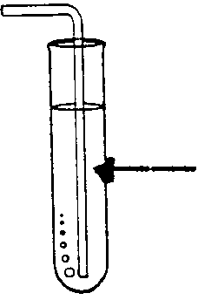
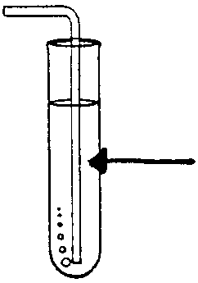
  - If a mixture of zinc granules and dilute hydrochloric acid is placed in ice-cold water, the rate of reaction will
NH₃(g)
NH₃(g)
Bromothymol blue in water
Litmus in water
Test tube A
Test tube B
2A₂(g) + 3B₂(g)  2A₂B₃(g) ∆H = 1 000 kJ/mol

- decrease.
- increase.
- become zero.
- remain the same.

  - Consider the following reaction:

What can be done to promote the reverse reaction?
- Reduce the volume of the reaction mixture.
- Raise the temperature of the reaction mixture.
- Decrease the concentration of B₂(g).
- Add a catalyst to the reaction mixture.

  - In test tube A ammonia gas (NH₃(g) ) is bubbled through a solution of litmus in water. In test tube B ammonia gas is bubbled through a solution of bromothymol blue in water:

Which set of results better shows the colours of the two solutions after gas bubbling?

 | Test tube A | Test tube B
A | Blue | Yellow
B | Blue | Blue
C | Red | Yellow
D | Yellow | Red

1.4 Substance X dissolves in substance Y. X and Y are probably:
- NaCℓ and CCℓ₄
- CCℓ₄ and Water
- I₂ and ether
- KBr and Xylene

1.5 Which solution X and which solid Y are used to prepare hydrogen sulphide gas (H₂S):

 | Solution X | Solid Y
A | H₂O | S
B | H₂SO₄ | S
C | Fe²⁺ | FeS
D | HCℓ | FeS

You are provided with a solution of an unknown salt of potassium. Barium chloride solution and hydrochloric acid is added to the solution. An insoluble white precipitate forms. The salt can therefore be identified as
- potassium sulphite.
- potassium chloride.
- potassium nitrate.
- potassium sulphate.

  - When concentrated hydrochloric acid is added to a saturated solution of table salt (NaCℓ), a precipitate forms. This illustrates
- ionisation.
- ion exchange.
- the common ion effect.
- an acid-base reaction.

  - In which one of the following pairs will a spontaneous reaction occur?
Hint: use the Redox table on page 11.
- Mg²⁺ (aq) + Cr(s)
- Zn (s) + Ni²⁺ (aq)
- Pb (s) + Aℓ³⁺ (aq)
- Ag(s) + Cu²⁺ (aq)

  - When an atom becomes a negative ion,
- it loses electrons and is oxidised.
- it gains electrons and is reduced.
- it loses protons and is oxidised.
- it gains protons and is reduced.

  - Organic compounds with the same molecular formula, but with different structural formulae are called isomers. Which one of the following is not an isomer of C₅H₁₂?

A. CH₃ – CH₂ – CH₂ – CH₂ – CH₃

- CH₃

CH₃ – CH – CH₂ – CH₃

C. CH₃ – CH = CH – CH₂ – CH₃

D. CH₃

CH₂

CH₃ – CH –CH₃

The general formula for alkenes is:
- C_{n}H_{2n}
- C_{n}H_{2n-2}
- C_{n}H_{2n+2}
- C_{2n}H_{2n+2}

Dissolving KCℓ is an endothermic reaction. A saturated solution of potassium chloride is prepared in water at 20°C. The solution is heated to 50°C. This will result in
- precipitation of KCℓ crystals.
- the solution remaining saturated.
- a heterogeneous solution being formed.
- the solution becoming unsaturated

  - When sodium nitrate is heated, one of the products is:
- NaNO₂
- NO
- NO₂
- Na₂O

  - Chlorine gas is bubbled through a solution of potassium bromide. It goes brown. The brown colour is due to the production of
- Chlorine.
- Bromide ions.
- Chloride ions.
- Bromine.

In the reaction
HF(aq) + OH–(aq)  F–(aq) + H₂O

the following is the conjugate acid- base pair

- HF(aq) and F–(aq)
- HF(aq) and OH–(aq)
- F–(aq) and H₂O
- OH–(aq) and F–(aq)
15x3=[45]

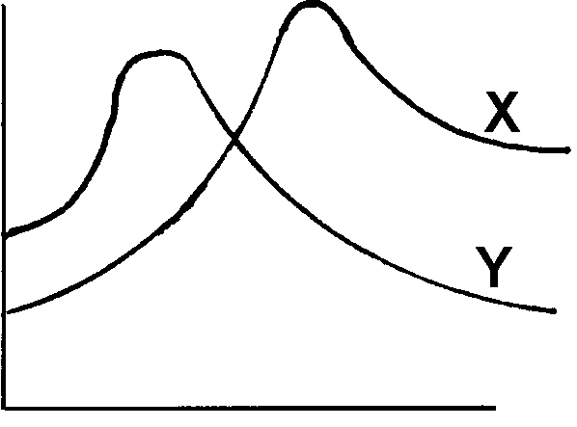  QUESTION 2  E_{P}  t (s)  The above energy diagram shows two reactions X and Y on the same axis.  - Which of the two reactions has a positive heat of reaction?  - Which of the two reactions has the greatest activation energy?  - If reaction Y is reversible, is the reverse reaction exo- or endothermic?  - 2.4.1 How will the reaction rate of X be affected by heating?  2.4.2 How will the reaction rate of Y be affected by heating? | (2)  (2)  (2)  (2)  [8]

QUESTION 3  X(g) + Y(g)  XY(g) ∆H<0  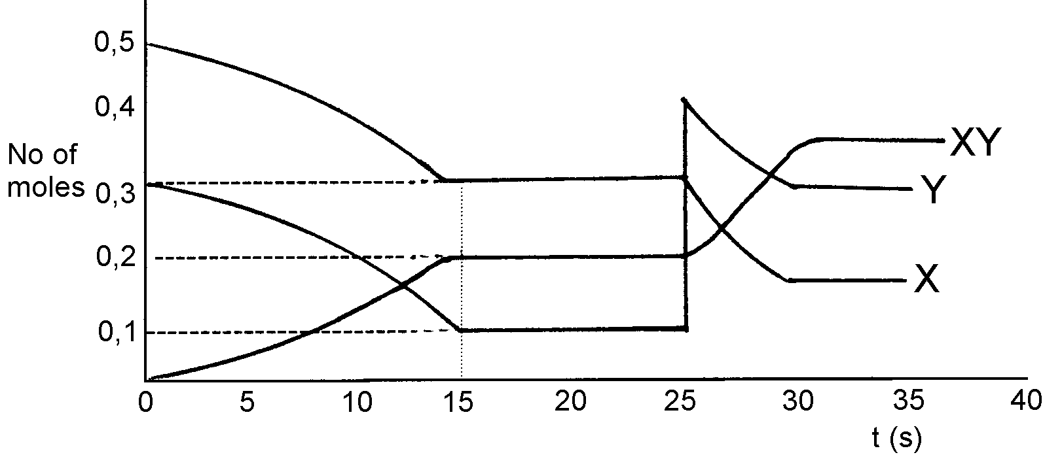  0,5 mol of X(g) and 0,3 mol of Y(g) are placed in a 2dm³ reaction vessel. X and Y react and reach equilibrium.  The graph shows the number of moles of X, Y and XY against time.  - At time t = 2s, is the forward or reverse reaction occurring faster?  - At what time does the system first reach equilibrium? Give a reason for your answer. | (1)  (2)

- Write down the law of mass action (the Kc expression) for this reaction.  - What is the concentration of X, Y and XY at t = 20s?  - Use the values found in Question 3.4 to calculate the equilibrium constant.  - What caused the change at t = 25s?  - Draw the corresponding sketch graph of rate of reaction vs. time for t = 0 to t = 40s for this reaction. Clearly indicate on your graph which is the forward reaction and which is the reverse reaction. | (1)  (4)  (2)  (2)  (4)  [16]

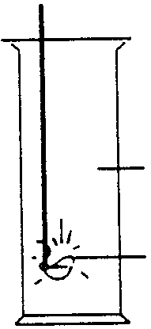  QUESTION 4  SO₂  Mg  - A piece of burning magnesium is lowered into a gas jar containing sulphur dioxide as illustrated below:  - A yellow product is obtained on the side of the gas jar. NAME the product. |  | (1)
- Give a balanced equation for the reaction that takes place.  - From the balanced equation NAME:  - the oxidising agent (oxidant) and  - the compound that is oxidised. | (3)  (4)

Sulphuric acid has many chemical properties. In each of the following reactions, state the property that sulphuric acid displays.  - Concentrated sulphuric acid reacts with copper sulphate crystals to form a white powder.  - Concentrated sulphuric acid reacts with copper turnings. | (2)  (2)  [12]

QUESTION 5  nitrogen dioxide, chlorine, hydrogen chloride, sodium chloride, lead(II)sulphate, ammonia and lead(II)nitrite.  - Consider the following list of compounds:  From this list choose  - a compound that is formed when lead nitrate is heated.  - a reactant in the preparation of hydrogen chloride.  - a gas which produces two acids when bubbled through water.  - a green gas that acts as a bleaching agent. | (2)  (2)  (2)  (2)  [8]

QUESTION 6  - In the electrochemical cell: Zn(s) ⏐ Zn²⁺ (aq)⏐⏐Cu²⁺ (aq)⏐ Cu(s)  - Which substance is the cathode?  - What does the double line represent if the apparatus is set up practically?  - Write down the equation for the net cell reaction.  - H₂S(g) is bubbled into the copper half-cell. A precipitate is formed.  - What colour is the precipitate?  - Write down the chemical equation for the formation of this precipitate.  - Name the instrument you would use to measure the ability of this cell to do work.  - Which metal electrode undergoes a decrease in mass while the cell is producing electricity? | (2)  (2)  (3)  (2)  (3)  (2)  (2)  [16]

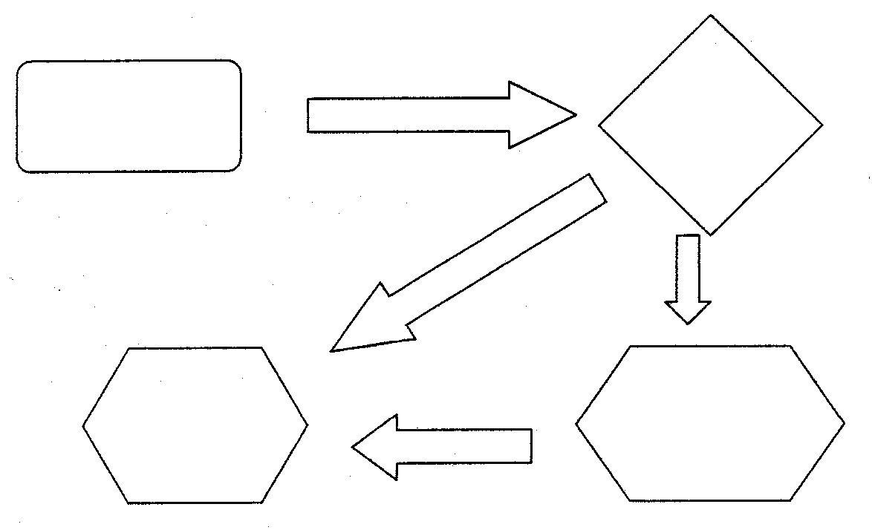  QUESTION 7  N₂  Process 1  Ammonia  Nitric acid  Fertiliser  The diagram represents a flow chart of processes for the preparation of ammonia, nitric acid and fertiliser.  - Write down a balanced equation for the industrial preparation of ammonia. Indicate the different phases of the reactants.  - How will the yield of the ammonia be influenced if the pressure in process 1 is increased while the temperature is kept constant? Explain your answer with the aid of le Chatelier’s Principle.  - Name process 1.  - What use can be made of the product which is formed when NH₃ reacts with nitric acid? | (4)  (4)  (2)  (2)  [12]

QUESTION 8  Concentrated hydrochloric acid reacts with manganese(IV)oxide to produce chlorine gas. With the aid of the Redox table on page 11, supply the following:  - The balanced reduction half-reaction.  - The balanced oxidation half-reaction.  - The balanced redox reaction (in ion form omitting the spectator ions).  - Make a labelled sketch to show how the chlorine gas could be collected efficiently.  - Give a reason for this method of collecting chlorine gas. | (2)  (2)  (2)  (3)  (2)  [11]

QUESTION 9  20 cm³ of an H₂SO₄ solution is titrated against 25 cm³ of a 0,1 mol.dm⁻³ NaOH solution. The endpoint is reached when the bromothymol blue in the flask turns a pale green colour.  - Write down the balanced reaction equation.  - At the end point, will the solution in the flask be acid, neutral or alkaline?  - Calculate the concentration of the H₂SO₄ solution in the burette from the readings given. | (3)  (2)  (5)  [10]

QUESTION 10  - Write down the structural formula for trichloromethane (chloroform).  - Name the following compound:  CH₃ – CH₂ – CH₂ – OH  - 10.3.1 Give the structural formula of a saturated hydrocarbon which has four carbon atoms per molecule and a branched chain.  - Give the name of a saturated hydrocarbon which has four carbon atoms per molecule and a branched chain.  - Give the expanded structural formula of the functional group of the carboxylic acids.  - Give TWO important uses of the halo-alkanes.  TOTAL: | (2)  (2)  (2)  (2)  (2)  (2)  [12]  150

