GAUTENG DEPARTMENT OF EDUCATION
SENIOR CERTIFICATE EXAMINATION

PHYSICAL SCIENCE HG
(Second Paper: Chemistry)

TIME: 2 hours

MARKS: 200

REQUIREMENTS:

- An approved (non-programmable, scientific) pocket calculator. Candidates should provide their own calculators.

INSTRUCTIONS:

- Answer ALL questions.

- Answer Question 1 on the answer sheet on the inside cover of the answer book. Make a cross (X) over the letter A, B, C or D on the answer sheet to show which answer you choose for each question.

- A data sheet is provided at the end of this question paper. The data sheet contains a periodic table, equations and constants. Some of the information given may be useful in answering this question paper.

- Rough work may be done in the answer book, but should be clearly marked as rough work.

- Number your answers clearly.

- Begin each question on a new page.

QUESTION 1

MULTIPLE CHOICE QUESTIONS

Study each question and the suggested answers indicated by the letters A, B, C and D carefully. When you have decided which answer is correct, make a cross (X) over the appropriate letter on the answer sheet to indicate your answer. No marks will be awarded where more than one cross appear in any one answer.

Example: Pure ice melts at:

- -4ºC
- 0ºC
- 0K
- 4ºC

ANSWER: | A | B | C | D

Questions 1.1 – 1.4 deals with ammonia.

Your chemistry teacher wishes to do the fountain experiment in class, for revision.

1.1 Which reagents would he need to prepare ammonia in a FACTORY? (Industrial preparation)  - Ammonium chloride and slaked lime (Ca(OH)₂)  - Ammonium chloride and quick lime (CaO)  - Nitrogen and hydrogen  - Copper metal turnings and nitric acid | (3)

- He decides rather to use a laboratory method of preparation, with a base and an ammonium salt:  The balanced equation for the reaction is:  Ca(OH)₂(s) + 2 NH₄Cℓ(s) → 2NH₃(g) + CaCℓ₂(s) + 2H₂O(ℓ)  The correct molar ratio in which the reagents (NH₄Cℓ : Ca(OH)₂) react, is:  - 1:1  - 2:1  - 1:2  - 2:3 | (3)

- Which method would be best to collect the formed ammonia?  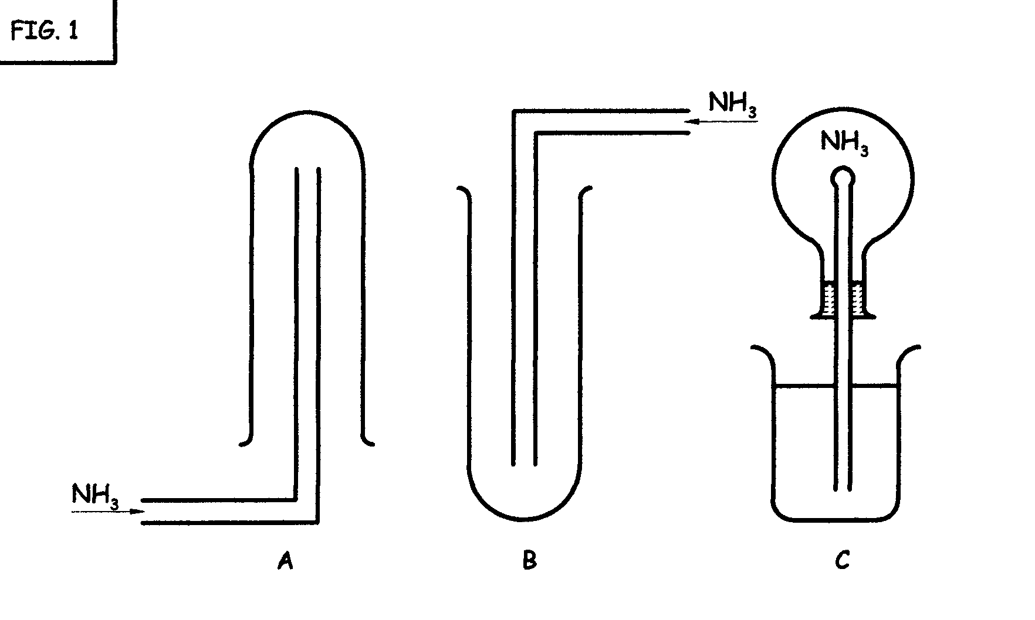 | (3)

- Your teacher prepares the ammonia and collects it in a flask. He performs the fountain experiment with phenolphthalein as indicator. The solution forms a pink fountain in the flask.  Which property of ammonia did he not wish to illustrate?  - The fact that ammonia is a base  - The fact that ammonia is able to change colour with an indicator in the presence of hydroxide ions  - The very high pressure gradient that forms and forces the solution into the flask.  - The very high solubility of ammonia in water | (3)

- Which one of the following substances would have the highest viscosity due to hydrogen bonding as intermolecular forces?  - Butan- 1- ol.  - Butan- 2- ol.  - Butan-1,2 -diol.  - Butan- 1, 2, 3- triol. | (3)

1.6 Ezekhiel Sepeng wants to prepare a “slowmag” vitamin supplement. He dissolves 0,1 moles of magnesium chloride (MgCℓ₂) and 0,1 moles of magnesium phosphate (Mg₃(PO₄)₂) in some distilled water. He dilutes the solution to exactly  1dm³ (1 000 cm³).  What is the magnesium cation [Mg²⁺] concentration?  - 0,1 mol.dm⁻³  - 0,2 mol.dm⁻³  - 0,3 mol.dm⁻³  - 0,4 mol.dm⁻³ | (3)

1.7 Michael is decalcifying an electric kettle. He uses a dilute solution of hydrochloric acid.  The balanced equation of the decalcification is:  CaCO₃(s) + 2HCℓ(aq) → CaCℓ₂(aq) + CO₂(g) + H₂O  To increase the rate of the reaction, Michael should  - use more acid of the same concentration.  - use another bottle of acid with a higher concentration.  - increase the pressure.  - replace the kettle’s lid. | (3)

1.8 An equilibrium mixture of CO₂(g), H₂(g), CO(g) and H₂O(g) in a 1 dm³ container at 700ºC contains 1,00 mole CO(g), 1,00 mole of H₂O(g) and equal amounts of CO₂(g) and H₂(g).  The value of K_{c} = 8,13 and the balanced equation for producing hydrogen in the Bosch process is:  H₂O(g) + CO(g) ⇌ CO₂(g) + H₂(g)  The number of moles of hydrogen present at equilibrium is:  - 0,50 moles.  - 1,00 moles.  - 2,85 moles.  - 4,07 moles. | (3)

- Which properties must be constant if a reaction has reached equilibruim?  I temperature  II colour  III concentration  - I only  - III only’  - I and III only  - I, II and III. | (3)

1.10 Consider the reaction of hydrogen gas with iodine gas to form hydrogen iodide gas, being at equilibrium.  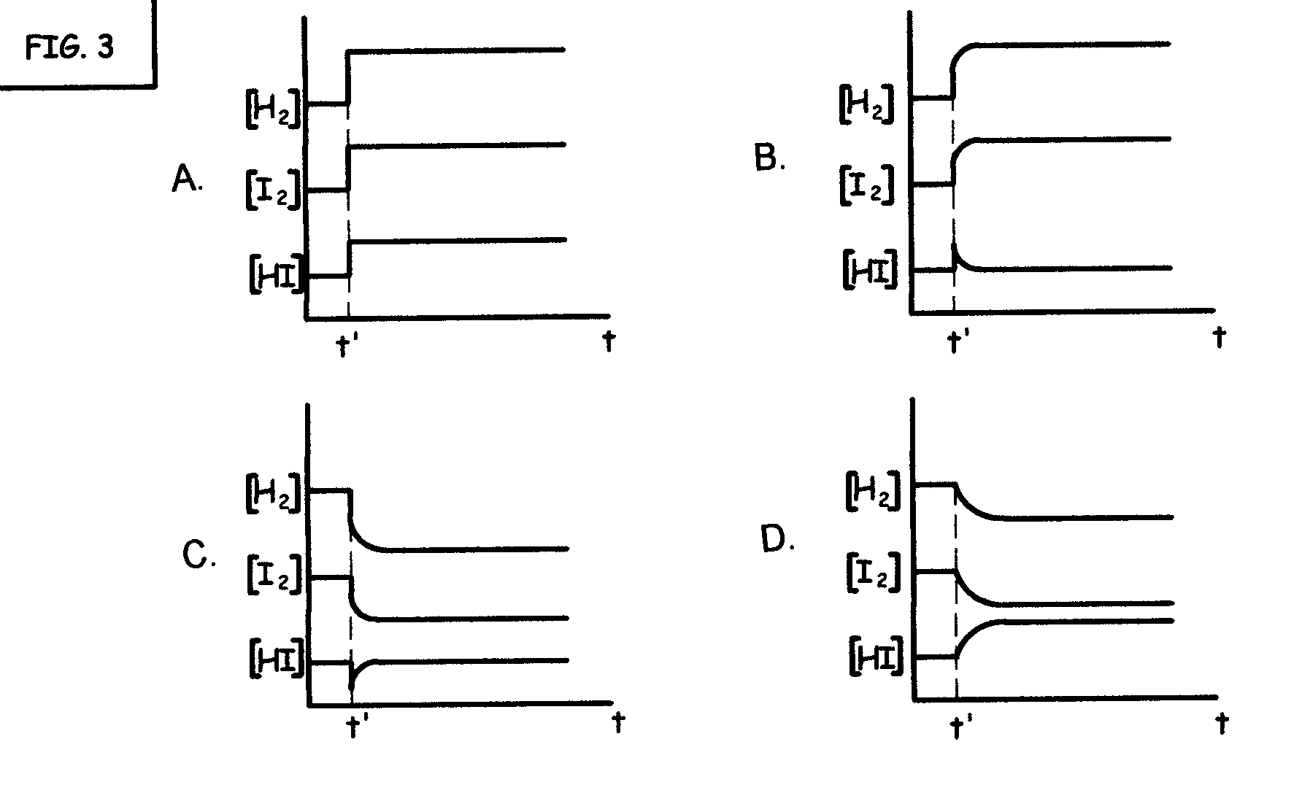  H₂(g) + І₂(g) ⇋ 2HІ(g)  The pressure is then increased at time t' in the container at a constant temperature of 400ºC.  The graph that best represents the change in concentration of the three gases as a result of the compression is: | (3)

Questions 1.11 and 1.12 concerns the following two organic substances:
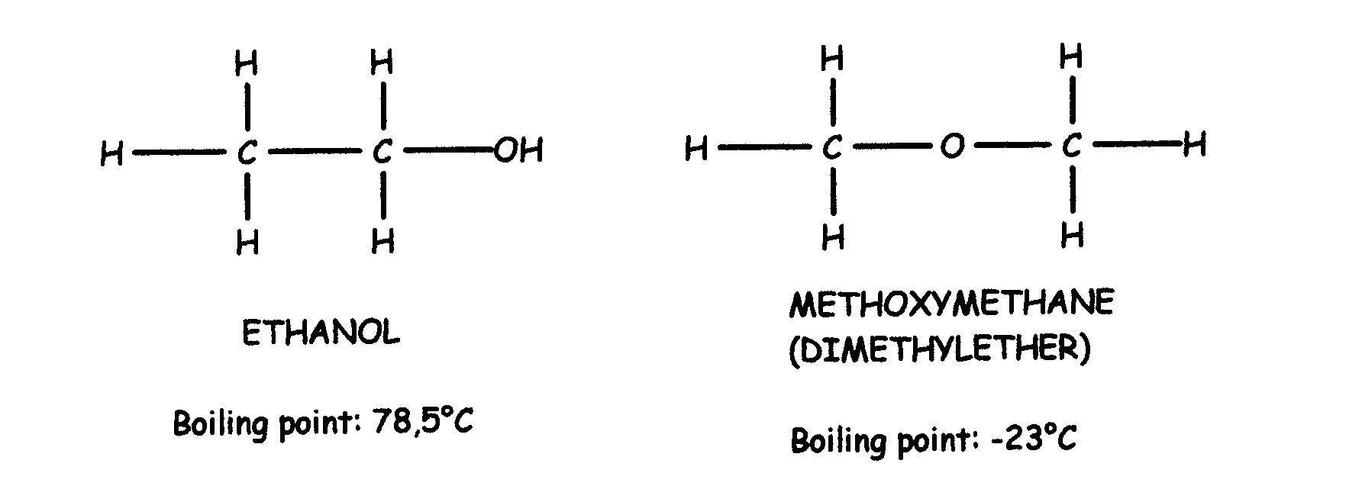

1.11 These two compounds are:  A. allotropes  - isotopes  - isomers  D. isobars | (3)

- If ethanol and methoxymethane are at the same temperture,  I ethanol has stronger intermolecular forces than methoxytmethane.  II the average kinetic energy of the molecules of both substances is the same.  III the vapour pressures of both substances is the same.  Which of the above are true?  - Only I.  - Only III.  - I and II.  - I, II and III. | (3)

- Before starting an acid-base titration experiment, Jenny rinses the apparatus. Which rinsing method would cause inaccurate results?  - The Erlenmeyer (conical) flask is rinsed with the base that will be pipetted into it.  - The burette is rinsed with the acid it is to be filled with.  - The pipette is rinsed with the base it is to be used for.  - The volumetric (measuring) flask, which is used to make up the standard solution of the base, is rinsed with distilled water. | (3)

1.14 The pH of a an aqueous solution of sodium carbonate is 9. How would the dissociation constant (K_{w}) and the hydroxide ion concentration ([OH– ]) be influenced, if distilled water is added to the solution? | (3)

 | K_{w} | [OH– ]
A | Increase | Decreases
B | Decreases | Increases
C | Decreases | Decreases
D | Unchanged | Decreases

1.15 Which one of the following redox reactions will not occur spontaneously?  (Hint: use the table of standard reduction potentials to help you.)  - Magnesium ribbon in a copper(ΙΙ)nitrate solution  - Iron nail in a copper(ΙΙ)sulphate solution  - Copper metal turnings in a cobalt(ΙΙ)chloride solution  - Copper metal turnings in a silver(I)nitrate solution | (3)

- What is the numeric value of the EMF of a standard “Nicad” battery? The nicad battery is an electrochemical cell, with nickel and cadmium as the two electrodes.  (Hint: use the table of standard reduction potentials to help you.)  - –0,15 V  - 0,03 V  - 0,15 V  - 0,65 V | (3)

  - The organic chemistry experiment to illustrate addition to unsaturated compounds is conducted by adding bromine water to cyclohexene. The reaction is as follows:
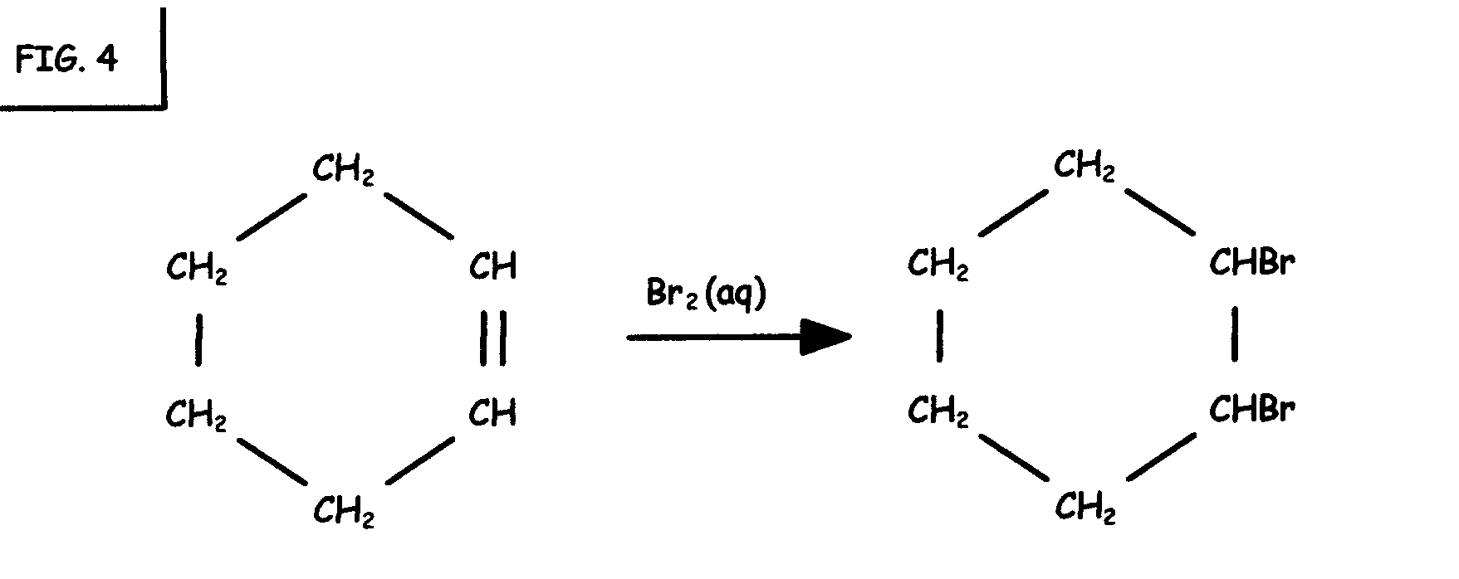

Which of the following processes occurred?  - 1. Hydrogenation 3. Halogenation  2. Addition 4. Hydrolysis  - 1 and 2 C. 3 and 4  - 2 and 3 D. 2, 3 and 4 | (3)

- In an esterification reaction to prepare ethyl propanoate, which substances are used as reagents?  - Propanoic acid and ethanol  - Ethanoic acid and propan-1 -ol  - Ethanoic acid and propan-2 -ol  - Ethanol and propane | (3)

  - Deionised water, mercury and aqueous detergent solution are placed on a Teflon (plastic) surface.
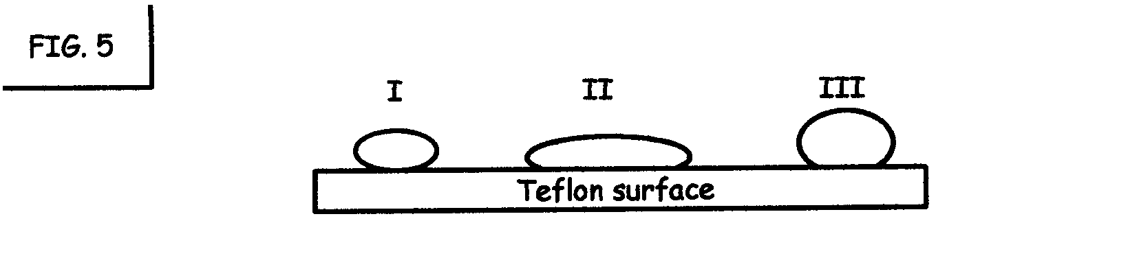

The expected appearance of the liquids would be one of the following:

 | I | II | III
A | mercury | water | detergent
B | mercury | detergent | water
C | detergent | mercury | water
C | water | detergent | mercury
(3)

- The forces that keep bromine molecules together in liquid bromine are  - covalent bonding.  - Coulomb forces.  - hydrogen bonding.  - Van der Waals forces. | (3)  20x3=[60]

QUESTION 2  You have a part time job at a tannery, where leather is being treated with several different compounds of sulphur.  You are to assist the chief chemist in the analytical laboratory.  Firstly you have to prepare hydrogen sulphide gas (H₂S).  - Write down a balanced equation for the laboratory preparation of H₂S(g).  - You must prove the gas produced is hydrogen sulphide gas:  2.2.1 Write down the name of a solution which is commonly used to test for hydrogen sulphide gas.  2.2.2 Write down your observation when hydrogen sulphide gas is bubbled through the solution in Question 2.2.1.  You also have to prepare sulphur dioxide gas for another test in the laboratory.  - Give the balanced equation for the preparation of sulphur dioxide in the laboratory, using a salt and an acid as reagents.  The smell of the sulphur dioxide irritates your nose, but to make sure it is sulphur dioxide, you bubble it through an acidified potassium dichromate solution. | (3)  (2)  (2)  (4)

- What is your observation?  - Write down the reduction half reaction from the table of standard reduction potentials.  - Write down the oxidation half reaction from the table of standard reduction potentials.  - Use the two half reactions to write down the balanced, net ionic equation. | (2)  (2)  (2)  (4)

- If sulphuric acid was used to acidify the solution, add the spectator ions and write down the balanced molecular equation for the reaction.  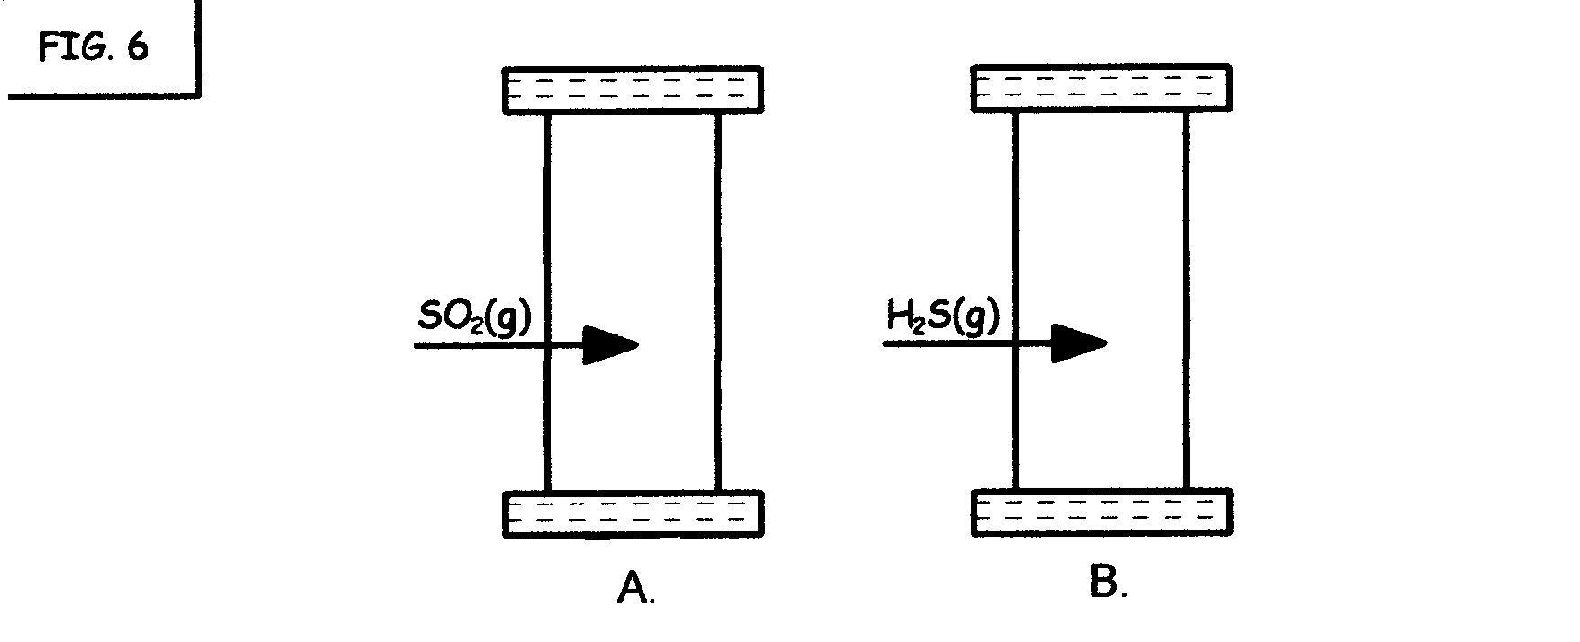  Now you have two gas jars, one filled with sulphur dioxide gas and the other with hydrogen sulphide gas. | (3)

- You want to mix the two gases to ensure a rapid reaction by inverting the one jar on top of the other. Which one (A or B) should be on top, and why?  - Write down what you observe when the two gases mix.  - Write down the balanced molecular equation for the reaction that takes place in the two cylinders. Use the table of standard reduction potentials, if necessary, to balance the equation. Show the phases of the reactants and products. | (3)  (4)  (4)  [35]

QUESTION 3

If dilute nitric acid is added to copper metal turnings in a test tube, a colourless gas is formed.

3.1 Write down the name of the gas that is formed. | (2)

3.2 At the open end of the cylinder a brown gas is formed. Write down the name of the gas that is formed.  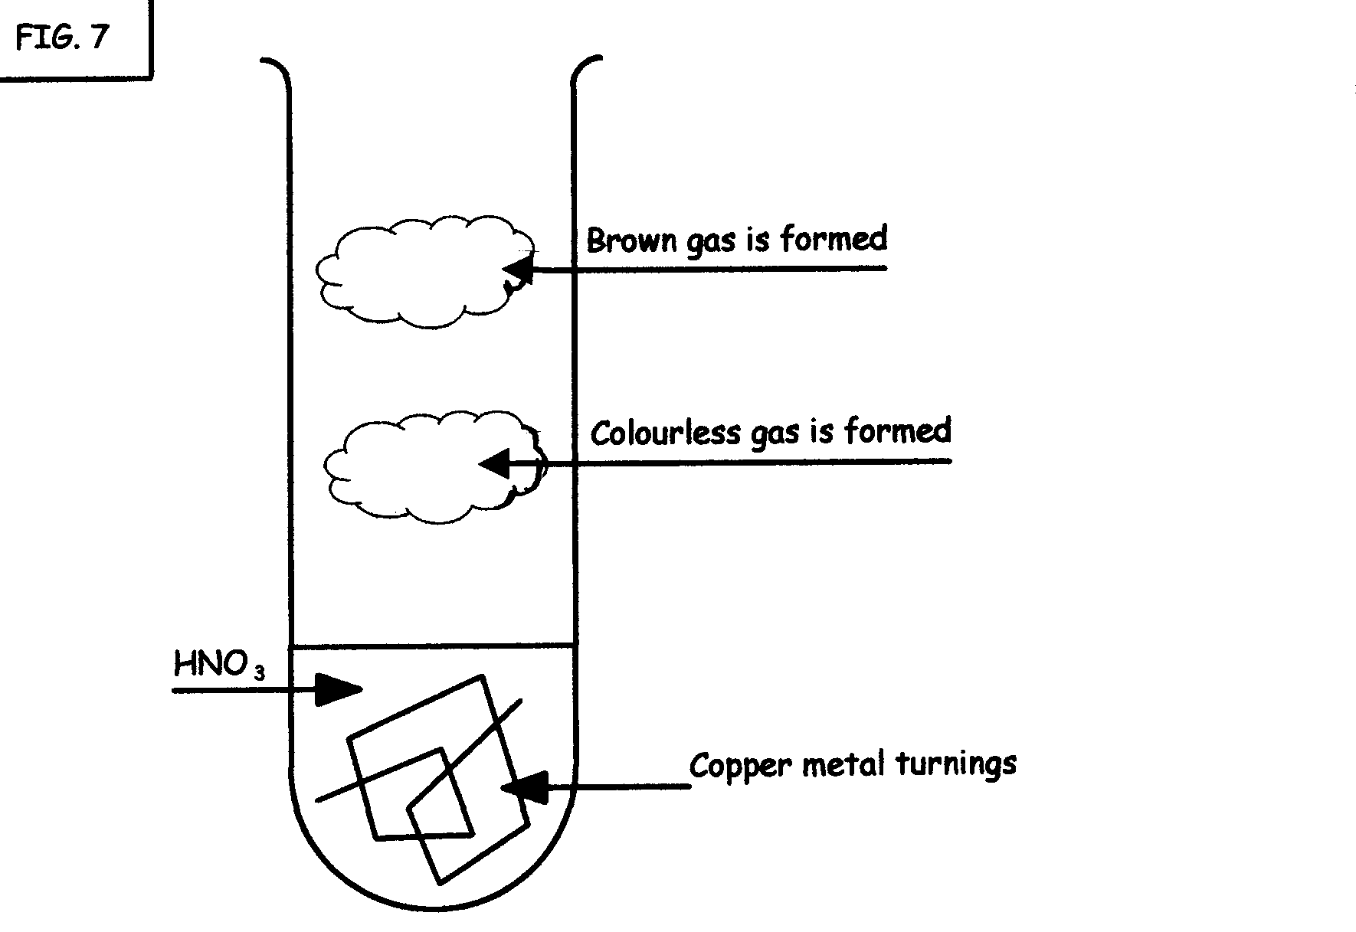 | (2)

- A small clear glass bottle of concentrated nitric acid was left on the windowsill in the laboratory. The acid turned yellow.  3.3.1 Explain, using an equation, what has happened to the nitric acid.  3.3.2 What precaution could be taken to ensure that the nitric acid is not contaminated in the future? | (4)  (2)  [10]

QUESTION 4
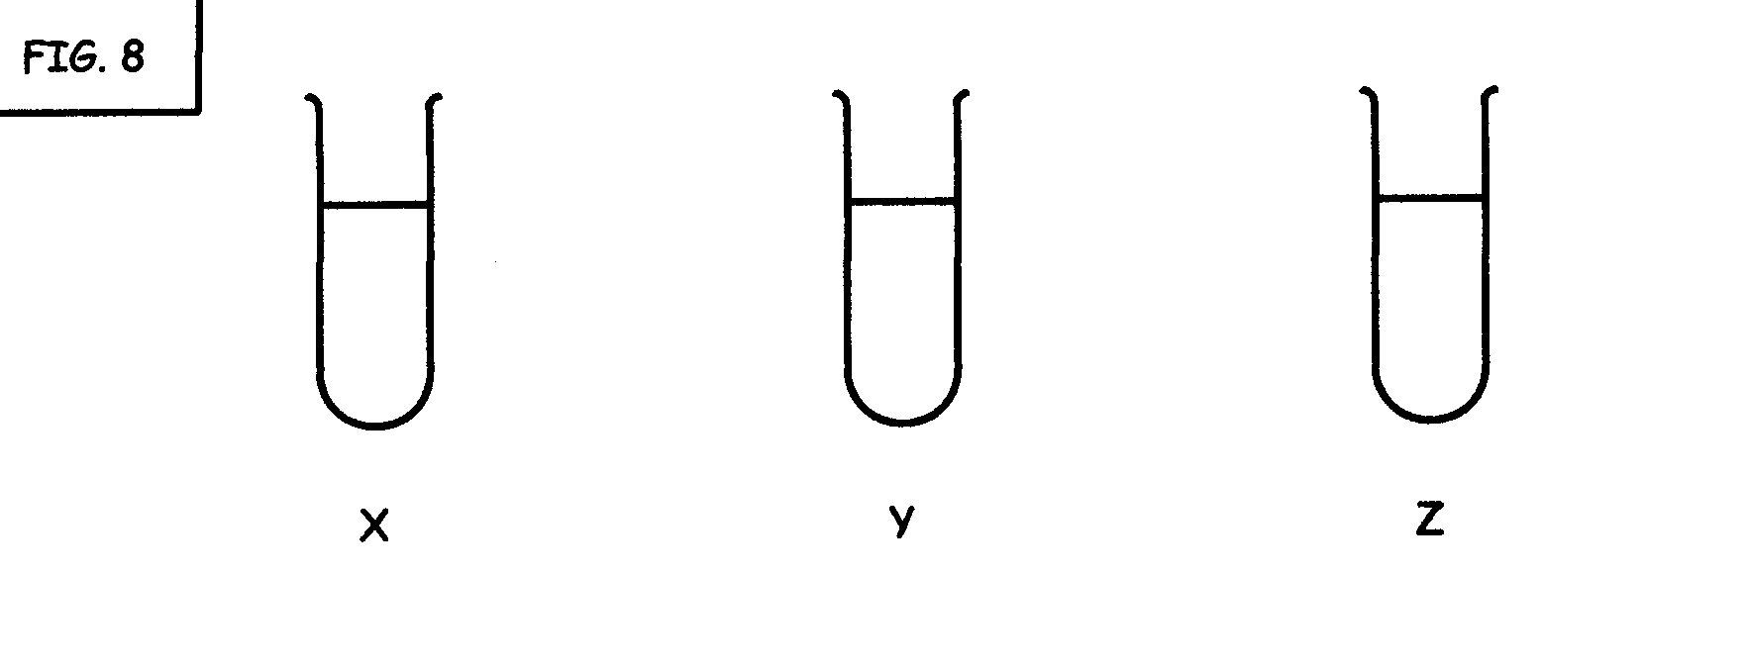

You have completed an inorganic chemistry practical on halogens, but forgot to label the test tubes. Now you have to identify them.

There are three unknown salt solutions. They could be sodium chloride(NaCℓ), sodium bromide (NaBr) and sodium iodide (NaΙ).

It’s better to label the three solutions X, Y and Z.

You have the following chemicals in the laboratory:

- silver nitrate
- chlorine water
- carbon tetrachloride

- You add silver nitrate to all the solutions.  - X forms a yellow precipitate, Y forms a yellowish-cream precipitate, while Z forms a white precipitate.  - You add chlorine water to the test tubes. X turns brownish and forms a white precipitate at the bottom of the test tube. Y turns yellowish and forms a white precipitate at the bottom of the test tube. Z does not show a reaction with the chlorine water at all, but its colour changes from white to a grayish purple after a lapse of time.  - You add carbon tetrachloride to all the test tubes. The solution at the bottom of test tube X turns purple; the solution at the bottom of test tube Y turns yellowish-brown, while the solution at the bottom of test tube Z stays clear.  Identify the three salts. Write down the symbol, then the formula of the original solution in each of test tubes X, Y and Z. | [9]

QUESTION 5

The decomposition of hydrogen peroxide can be accelerated by the catalyst manganese dioxide. The peroxide rapidly decomposes to oxygen and water. The water is given off as steam, because of the high heat of reaction.

MnO₂(s)
2H₂O₂(aq) O₂(g) + 2H₂O(g)

5.1 What is the function of MnO₂? (Refer to the activation energy.) | (2)

  - A graph is drawn for the mass loss in peroxide againt time for the decomposition.
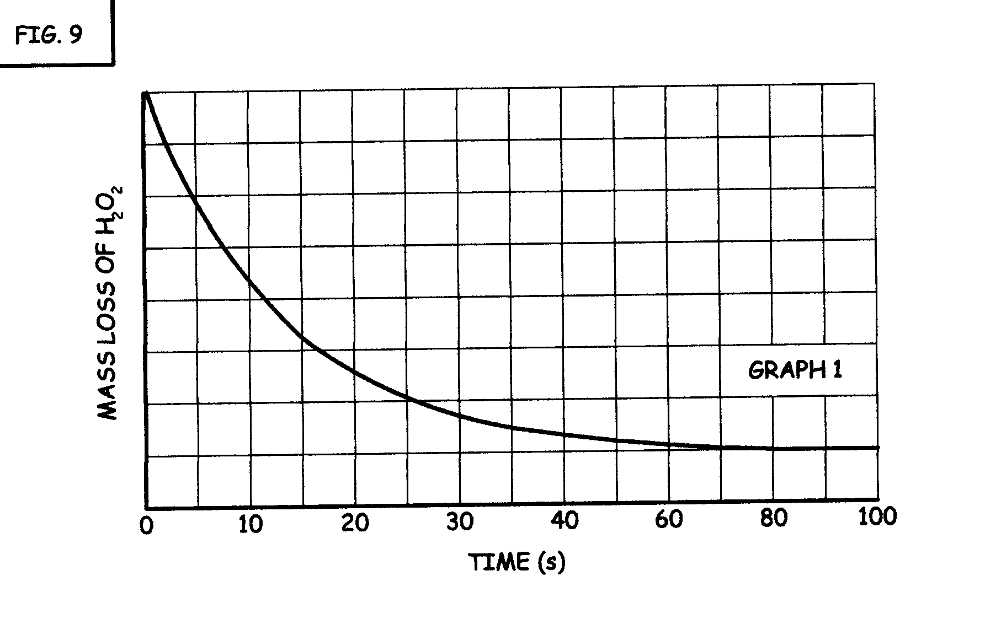

5.2.1 What does the horizontal section of the graph indicate during the last  20 seconds of the reaction?  - Redraw the graph in your answer book, as well as graph 1. Draw another graph of the mass loss on the same axes if MnO₂(s) was omitted from the reactor vessel. Label it as graph 2.  5.2.3 On the same axes, draw a graph of the mass loss against time if the peroxide solution was heated, prior to the adding of manganese dioxide. Label it as graph 3. | (2)  (3)  (3)  [10]

Sssscccchhh…!

QUESTION 6  - Ntombi listens to a radio advertisement. It’s about a fizzy drink.. “When you open the can… it goes…ssssccchhhh….!”  Given the following equilibrium: CO₂(aq) ⇄ CO₂(g)  Explain why it goes ssssccchhhh… when the can is opened, by using Le Chatelier’s principle and the solubility of carbon dioxide in water. | (4)

  - In the second step of the Contact process, sulphur dioxide reacts with oxygen to give sulphur trioxide.

2 SO₂(g) + O₂(g) ⇌ 2 SO₃(g)

- Initially 10 moles of sulphur dioxide and 4 moles of oxygen were put in the container.
- The volume of the container is 2 dm³.
- The equilibrium concentration of oxygen is 0,25 mol.dm⁻³.

Complete the following table. Redraw the table in your answer book and do the calculations in the table. | (12)

 | SO₂ | O₂ | SO₃
Mole ratio
Number of moles initially | 10 | 4 | 0
Number of moles used |  |  | 0
Number of moles at equilibrium
Equilibrium concentration |  | 0,25 mol.dm⁻³

- By using the information in the table, calculate the equilibrium constant for the reaction. | (5)  [21]

QUESTION 7
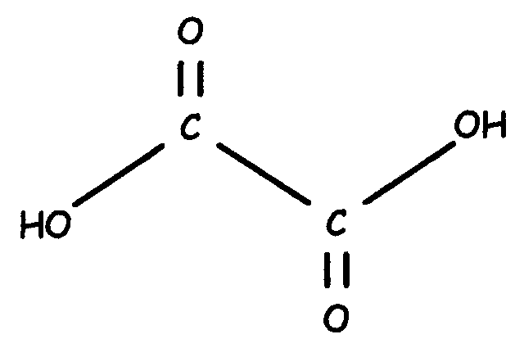

- Oxalic acid is an organic acid. The formula is (COOH)₂. The structural formula for oxalic acid is:

- Oxalic acid is thus a diprotic acid.

- It has a K_{a1} of 5,9 x 10⁻² at 25ºC.

- Write down the first step of ionization of oxalic acid in water. (Use the structural formula of the acid.) | (2)

- Show the conjugate acid/base pairs in Question 7.1, and name them, clearly indicating which are acids and which are bases.  - A dilute oxalic acid solution is titrated by a standardized 0,15 mol.dm⁻³ sodium hydroxide solution. | (4)

7.3 Write down a balanced, molecular equation for the complete neutralization reaction. | (4)

7.4 Given the table of a few indicators, choose a suitable indicator for the reaction. | (2)

Indicator | Range | Colour (acidic) | Colour (basic)
Crystal violet | 0,8 – 1,2 | yellow | blue
Eriochrome black T | 5,6 – 5,9 | red | blue
Bromthymol blue | 6,8 – 7,2 | yellow | blue
o-cresolphtalein | 8,5 – 8,9 | colourless | red

- If 30 cm³ of the oxalic acid is neutralized by 49 cm³ of the base, calculate the concentration of the oxalic acid solution. | (6)  [18]

QUESTION 8
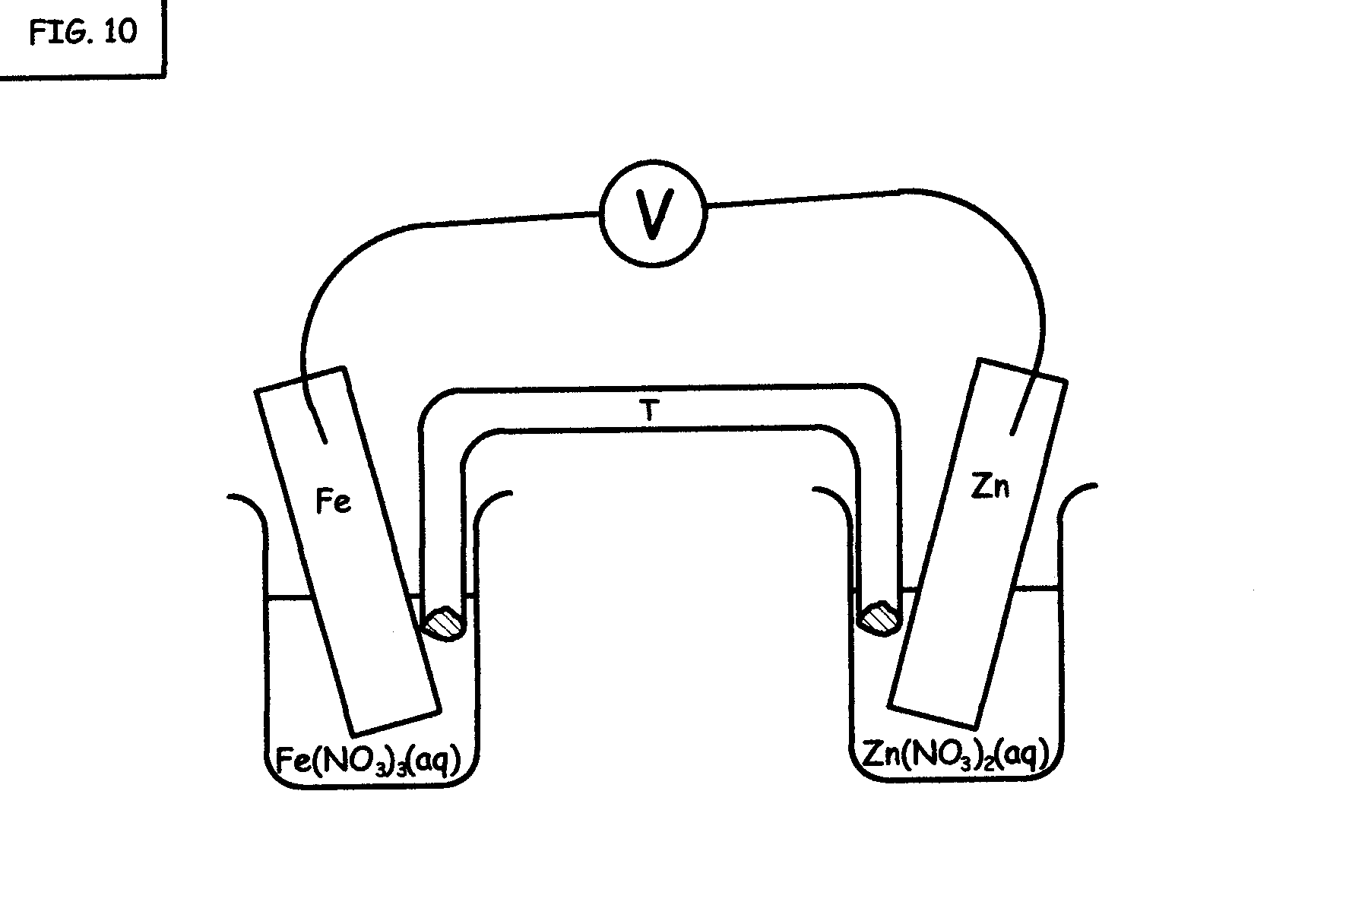

A standard zinc/iron electrochemical cell is set up as shown below:

- Write down the appropriate iron half reaction. It is given that the EMF of the cell is 0,72 V. Show how you arrived at your answer.  - Which electrode is the cathode?  - Write down the half reaction that occurs at the anode.  - Write down the balanced, net ionic equation of the cell. | (5)  (2)  (2)  (4)

As an industrial application, zinc is used to protect the iron hulls of big ocean liners. The iron is galvanized (covered by a layer of Zinc) and the iron is protected from oxidizing. It is called cathodic protection.
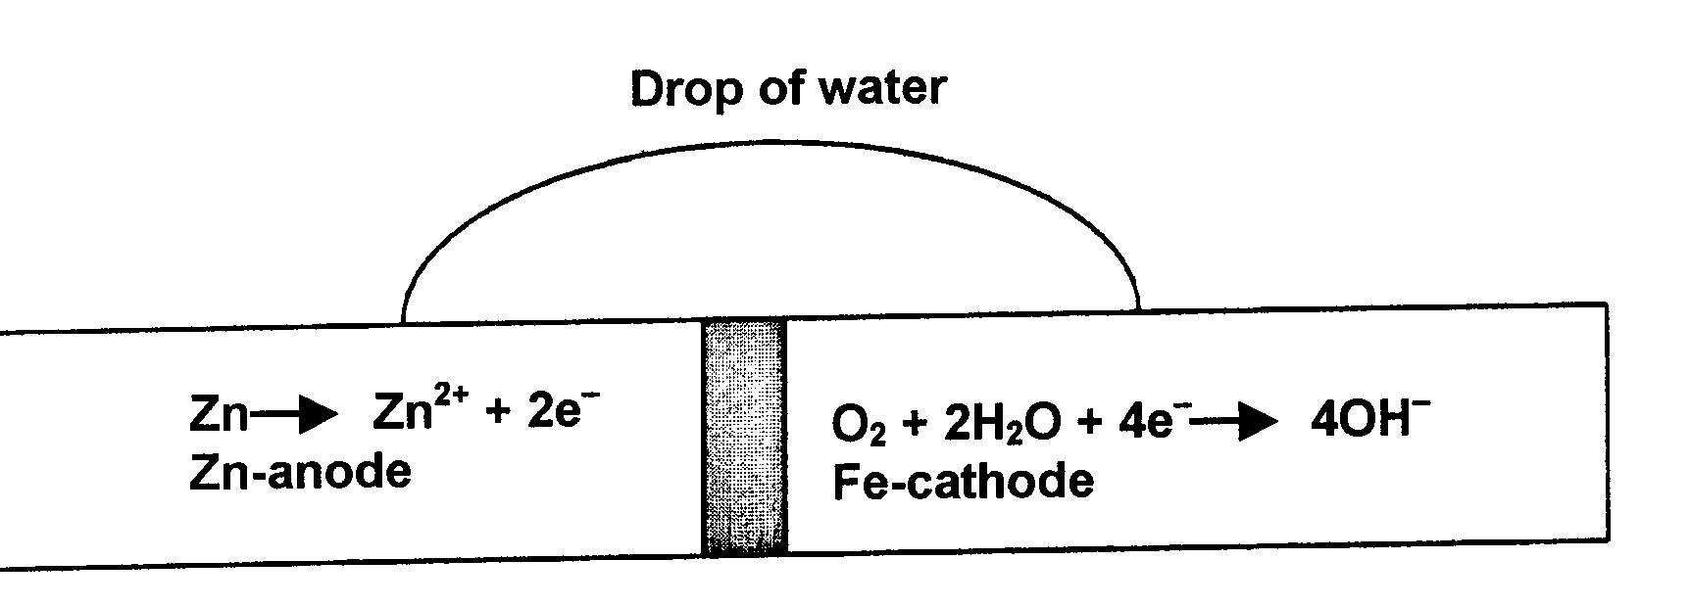

The zinc anode is called a “sacrificial” anode. Another reason for using a zinc coating, is that, when the zinc is corroded, Zn(OH)₂(s) is formed, which is even more insoluble than the Fe(OH)₂(s) that forms, so the insoluble hydroxide film, further slows corrosion.

- Write down the oxidation half reaction that takes place on the surface of a big, galvanized ocean liner. (Use the above diagram for the half reaction.)  - Write down the reduction half reaction that takes place on the surface of a big, galvanized ocean liner. (Use the above diagram for the half reaction.)  - Write down the balanced, net molecular equation. | (1)  (1)  (4)  [19]

QUESTION 9

CH₂ CH₂

Study the following organic compounds:

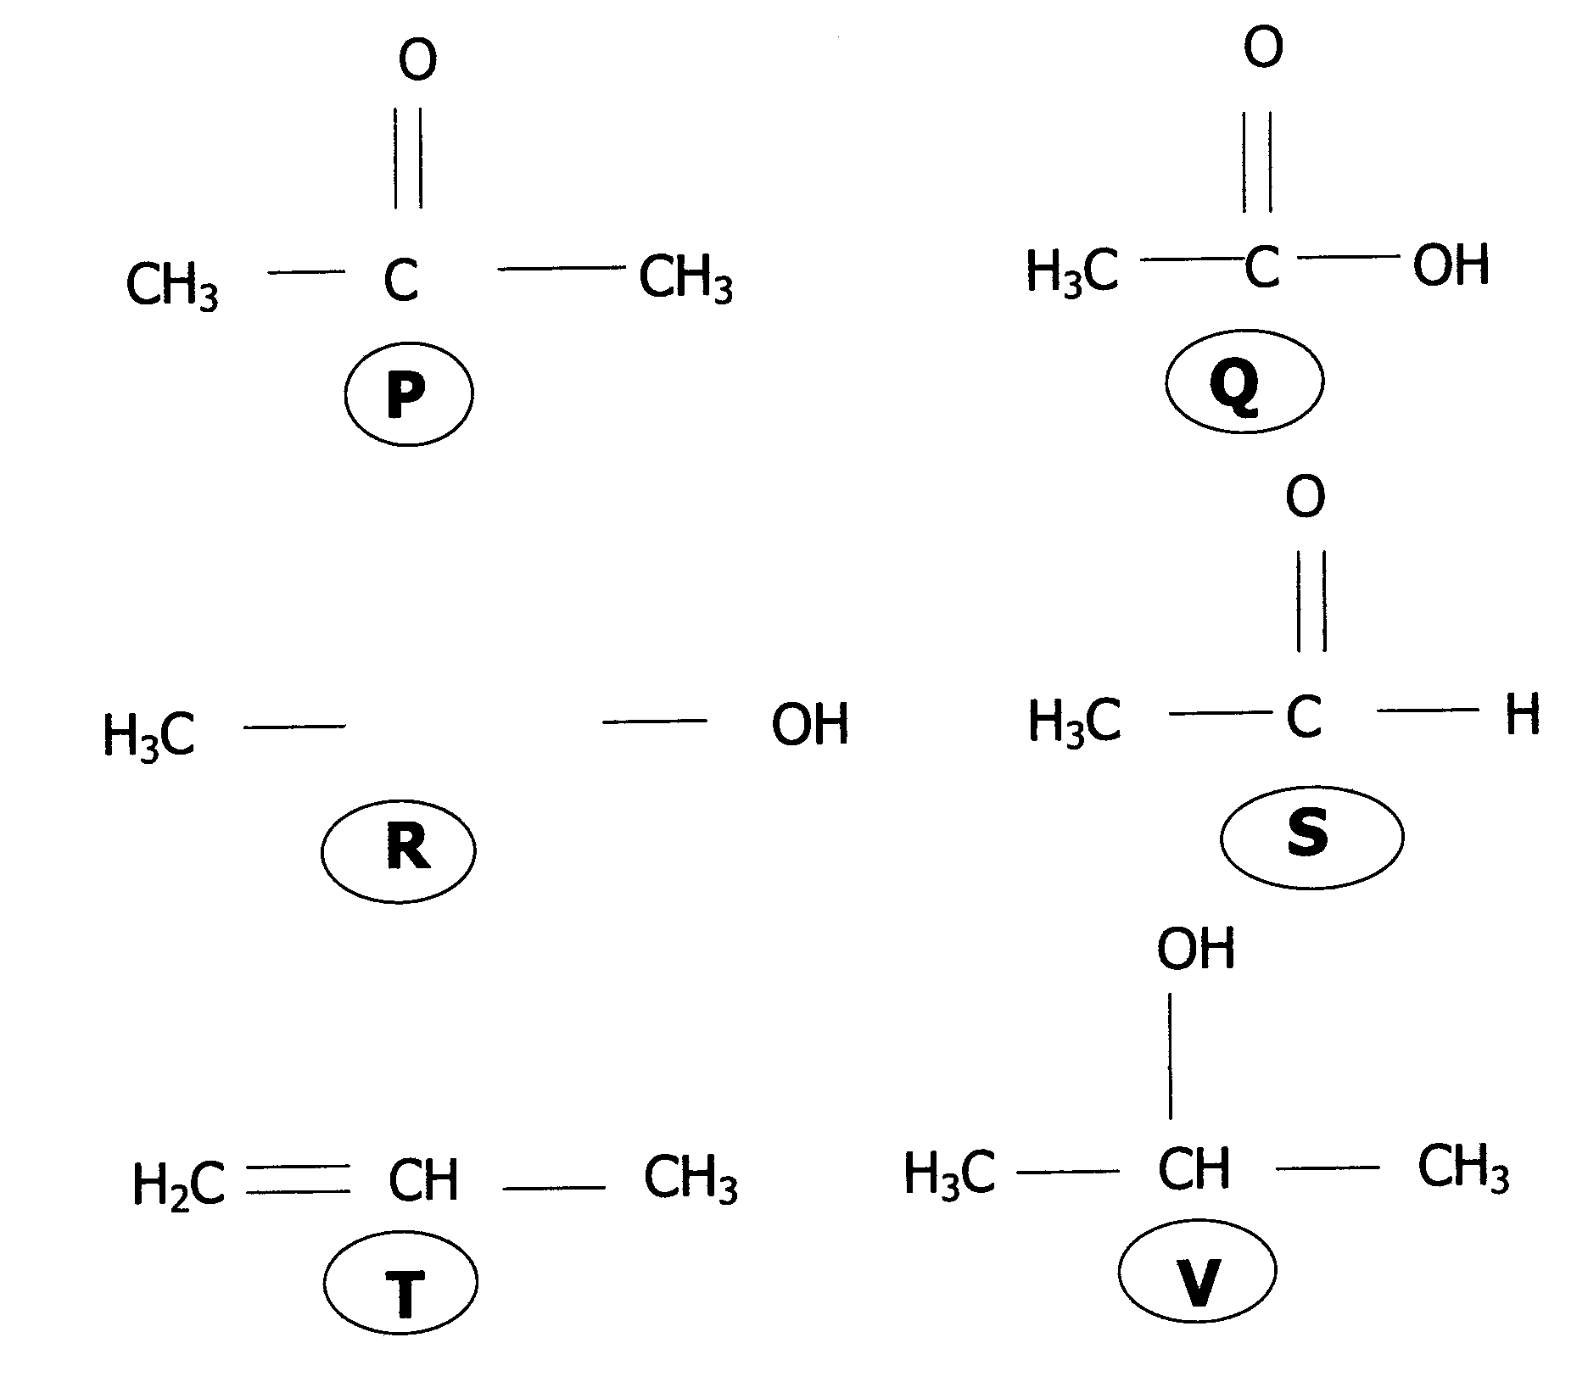

Answer the following questions. When referring to the list of compounds, just write down the corresponding letter.  - Name TWO isomers.  - Give the structural formulae of the two products when Q and R are heated together on a water bath, with a few drops of concentrated sulphuric acid added before the two substances are heated.  - Which one of the compounds is a ketone?  - Which one of the compounds is an aldehyde?  - Compound T is bubbled through an “iodine (І₂)-solution.” Give the IUPAC- name and the structural formula of the product of this addition reaction.  - Which one of the compounds is called acetone, and is used as a nail polish remover? | (4)  (4)  (2)  (2)  (4)  (2)  [18]
TOTAL: | 200

