GAUTENG DEPARTMENT OF EDUCATION
SENIOR CERTIFICATE EXAMINATION

NEEDLEWORK AND CLOTHING SG

TIME: 3 hours

MARKS: 200

INSTRUCTIONS:

- All questions are COMPULSORY.

- Number your answers in exactly the same way as the questions are numbered.

- Answer Question 1 on the answer sheet on the inside cover of your answer book.

- Answer all other questions in your answer book.

- Read all instructions carefully before answering the questions.

SECTION A

QUESTION 1
MULTIPLE-CHOICE QUESTIONS

Indicate the correct answer clearly by making a cross (X) over the corresponding letter on the answer sheet on the inside cover of your answer book. Where more than one cross appears in any answer, NO marks will be allocated for that question.

EXAMPLE: The basic element of design is:

- Texture
- Colour
- Form
- Line

ANSWER:

A | B | C | D

1.1 A motor-bike rider wears a crash helmet for the sake of

- self-esteem.  - protection.  - approval.  - self respect. | (1)

1.2 The collar, which is cut in one with the front bodice of the garment, is a

- roll collar.  - Mandarin collar.  - shawl collar.  - reverse collar. | (1)

1.3 Which finishing process will result in a textile fabric being softer and warmer?

- Glazing  - Laminating  - Singeing  - Napping | (1)

1.4 Good taste is the ability to

- be fashionably dressed.  - adapt fashions and styles to one’s specific needs.  - choose styles which are comfortable to wear.  - buy the correct type of fabric for the style. | (1)

1.5 A shaped facing should be cut with the grain parallel to the

- weft threads.  - warp threads.  - true bias.  - grain of the garment piece. | (1)

1.6 The specific characteristics that distinguish one person from another refer to

- conformity.  - personality.  - uniformity.  - self-confidence. | (1)

1.7 Shadow work is a dainty type of embroidery which is worked on the

- wrong side of the fabric with single backstitch.  - right side of the fabric with double backstitch.  - wrong side of the fabric with satin stitch.  - right side of the fabric with chain stitch. | (1)

1.8 In appliqué embroidery the design is transferred onto the garment or article by using ___________ on the outline of the design.

- herringbone stitch  - running stitch  - tailor’s tacking stitch  - slip stitch | (1)

1.9 The intensity (depth) of a colour is the

- brightness or dullness of the colour.  - lightness or darkness of the colour.  - brightness or darkness of the colour.  - shade and lightness of the colour. | (1)

1.10 Which colour combination represents the primary colours?

- Yellow, red, green  - Yellow, blue, green  - Green, blue, orange  - Yellow, red, blue | (1)

1.11 The use of a seam roll in tailoring is important because it

- simplifies the easing away of fullness at sleeve-head seam.  - simplifies pressing curved seams in narrow areas.  - prevents the pressing through of seams onto the right side of the garment.  - prevents bulkiness in a curved seam. | (1)

1.12 Emphasis in a design

- is achieved by regular repetition of similar features of a design.  - is the size of one part of a design in relation to another.  - creates pleasing relations of the various parts of an outfit to each other.  - causes the eye to move first to the most interesting part, then to the other parts. | (1)

1.13 The method of seam finish used in this diagram is

- turned and zigzagged edge.  - machine-overedged.  - turned and stitched.  - stitched and pinked. | 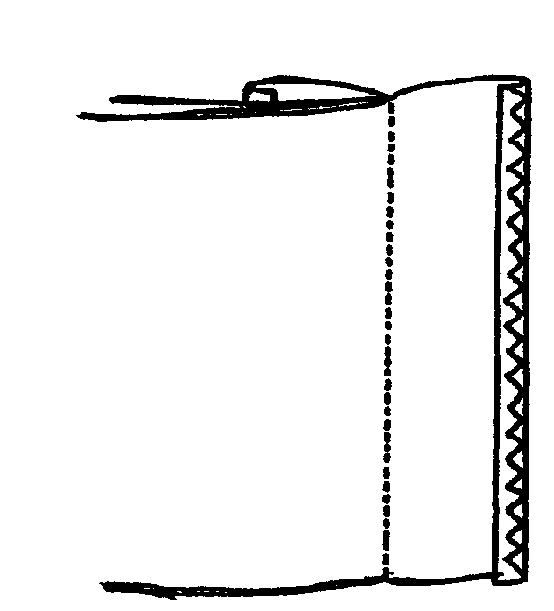  V.K.  W.S. |  | (1)
1.14 Which ONE of the following is a functional finish?

- Flame-retardency  - Glazing  - Printing  - Flocking | (1)

1.15 A French seam is suitable to be used on _________ fabrics.

- loosely woven  - thick bulky  - transparent  - closely woven | (1)

1.16 An advantageous property when choosing embroidery fabric for a tray cloth is

- dimensional stability.  - moth proofing.  - stretchability.  - elasticity. | (1)

1.17 When compared to woven fabrics, knits usually have greater

- resistance to pilling.  - resiliency.  - stiffness.  - dimensional stability.  1.18 The illustration shows the _______ weave.  - plain  - basket  - twill  - gauze | 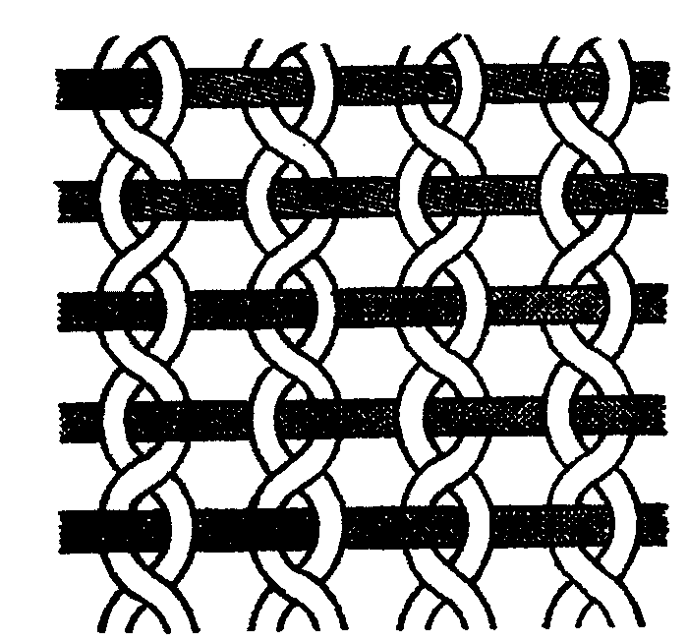 | (1)  (1)

1.19 The knitting method which does not unravel easily and is ladder proof, is

- weft-knit.  - warp-knit.  - double jersey knit.  - single jersey knit. | (1)

1.20 How wide are seam allowances on commercial patterns normally?

- 10 mm  - 15 mm  - 20 mm  - 25 mm | (1)  [20]

QUESTION 2

2.1 Match each sketch in Column A with a type of pleat in Column B. Write the question numbers (2.1.1–2.1.4) below one another in your answer book and then the correct letter (A–E) next to the appropriate question number.

 | COLUMN A |  | COLUMN B
 | SKETCHES OF PLEATS |  | NAME OF PLEAT TYPE
 | 2.1.1  2.1.2  2.1.3  2.1.4 | 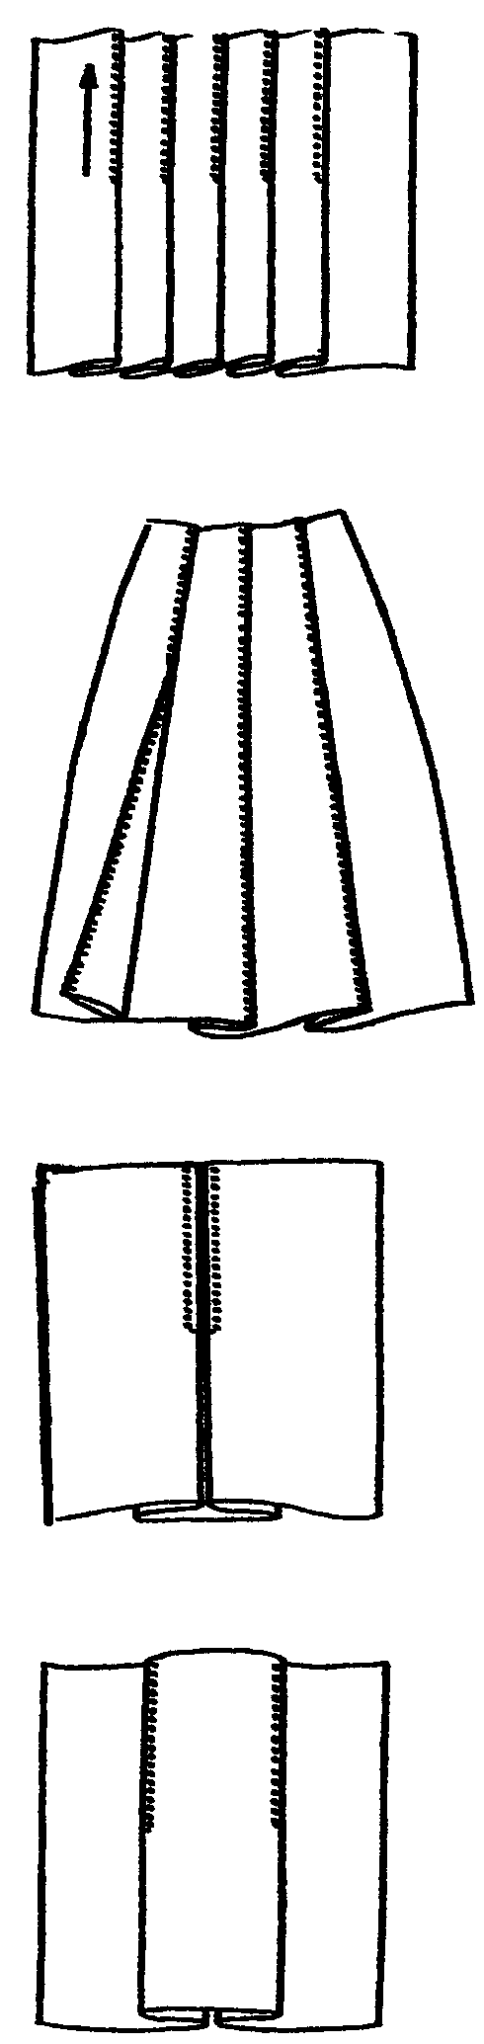  RK  RS  RK  RS  RK  RS  RK  RS | A. Inverted pleat  B. Box pleat  C. Knife pleat  D. Edge-stitched pleat  E. Unpressed pleat | (4)
2.2 Match each sketch in Column A with a specific characteristic/property in Column B. Write only the question numbers (2.2.1–2.2.4) below one another in your answer book and then the correct letter (A–G) next to the appropriate question number.

 | COLUMN A |  | COLUMN B
 | SKETCHES OF PLEATS |  | SPECIFIC CHARACTERISTICS (PROPERTIES)
 | 2.2.1  2.2.2  2.2.3  2.2.4 | RK  RS  RK  RS  RK  RS  RK  RS | A. Flat pleats all facing in the same direction.  B. This forms a box pleat on the wrong side.  C. Formed when two pleats are folded away from each other on the right side.  D. Pleats with an edge stitching.  E. Tacking is removed from the completed garment and the pleats are left.  F. Easing in fullness.  G. A decorative type of pleat. | (4)
2.3 Select from Column B the applicable description of each sleeve type in Column A. Write only the question numbers (2.3.1–2.3.7) below one another in your answer book and then the correct letter (A–H) next to the appropriate question number.

COLUMN A |  | COLUMN B
SLEEVE TYPE |  | DESCRIPTION
2.3.1  2.3.2  2.3.3  2.3.4  2.3.5  2.3.6  2.3.7 | Bishop sleeve  Cap sleeve  Dolman sleeve  Magyar sleeve  Raglan sleeve  Plain short sleeve  Puff sleeve | A.  B.  C.  D.  E.  F.  G.  H. | The armhole seam ends at the neckline.  A plain two-piece sleeve.  A long, full sleeve with no fullness at the armhole but gathered into a cuff at the wrist.  A sleeve which is wide at the top and set into a low-cut armhole.  The sleeve which is cut in one with the bodice.  This is a short type of Magyar sleeve formed by lengthening the shoulder line of the garment.  Full sleeve head gathered into the armhole.  No fullness is visible at the armhole seam. | (7)

2.4 Indicate whether the following statements are TRUE or FALSE. Write only the question numbers (2.4.1–2.4.10) below one another in your answer book and then the correct letter (T or F) next to the appropriate question number.

2.4.1 Silk is the only natural fibre obtained in a filament form.

2.4.2 Wool fibre absorbs moisture, therefore it creates static electricity.

2.4.3 All synthetic fibres are sensitive to heat and should not be ironed with a hot iron.

2.4.4 Embroidery must be pressed on the right side of the article.

2.4.5 The term bulk refers to the shine or brightness of a fibre caused by the reflection of light.

2.4.6 A fabric made from nylon filament fibres looks like woollen fabric.

2.4.7 Acrylic fabrics drape well.

2.4.8 Cotton is an example of staple fibre.

2.4.9 Terylene turns yellow when exposed to sunlight for a long time.

2.4.10 Acrylic fibres can be ironed with a cool iron. | (10)

2.5 Correct the FALSE statements in Question 2.4. Write only the question numbers of the FIVE false statements in your answer book (choose from 2.4.1–2.4.10) and then the correct answer next to the relevant number. | (5)  [30]

TOTAL FOR SECTION A: | [50]

SECTION B
TEXTILES

QUESTION 3

3.1 Redraw the table below in your answer book and answer the questions that follow.

CHARACTERISTIC | 3.1.1  GOOD or BAD | 3.1.2  IMPORTANCE TO THE USER
Durability
Shrink-resistance
Resistance to moths and mildew

3.1.1 Indicate whether the characteristics (properties) in the table are good or bad for acrylic fabrics. | (3)

3.1.2 Explain the importance of the characteristics (properties) when caring for acrylic fabrics. | (3)

3.2 Nylon

3.2.1 Mention THREE reasons why nylon clothing is a good choice for travelling to Cape Town. | (3)

3.2.2 Name ONE disadvantage of using nylon for children’s nightwear. | (1)

3.3 Cotton

3.3.1 What does the term mercerisation mean on the label of a cotton article? Mention treatment and one property. | (2)

3.3.2 Name the process indicating that cotton has been pre-shrunk. | (1)

3.3.3 Explain why cotton fabrics have a beetling finish applied to it. | (2)

3.4 Give THREE reasons why orlon fabrics are particularly suitable for industrial curtains. | (3)

3.5 Terylene washes well. Give THREE reasons or motivations for this statement. | (3)

3.6 Functional finishes of fabrics.

3.6.1 Mention TWO reasons for the use of functional finishes on fabrics. | (2)

3.6.2 Name ONE finish which performs both a functional and decorative purpose. | (1)

3.7 Name ONE effect of the finish mentioned in Question 3.6.2 on fabrics. | (1)

TOTAL FOR SECTION B: | [25]

SECTION C
CLOTHING

QUESTION 4

4.1 Mention THREE psychological needs that influence a person’s choice of clothing. | (3)

4.2 Analyse the sketch alongside and answer the following questions:  4.2.1 Identify TWO ways in which rhythm has been used.  4.2.2 Identify the area that is emphasized on the dress.  4.2.3 Which method was used to reduce fullness in this outfit?  4.3 Wardrobe planning  4.3.1 Jane wants to improve her present wardrobe. Mention FOUR steps she should consider when planning her wardrobe.  4.3.2 Explain the difference between a basic wardrobe and a functional wardrobe. | (2)  (1)  (1)  (4)  (4) | 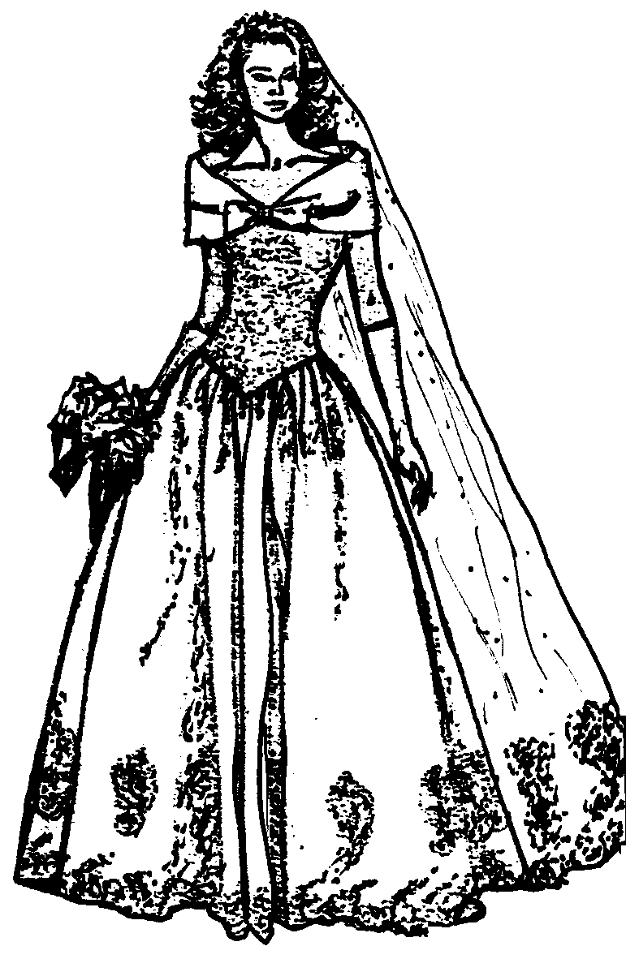

4.4 Name FOUR of the basic design elements which are present in all designs. | (4)

4.5 Name the terms used to describe the following:

4.5.1 A colour darker than a standard/normal colour  4.5.2 A colour lighter than a standard/normal colour | (1)  (1)

4.6 Classify the colours below as either WARM, COOL or NEUTRAL. | (4)

Orange, White, Blue-green, Brown

[25]

QUESTION 5

5.1 Study the sketch of a jacket and answer the following questions:

5.1.1 Before buying the jacket, how would you evaluate it with regard to the following?  (a) Lining  (b) Interfacing  5.1.2 Name FOUR areas where interfacing should be used on this jacket.  5.1.3 Identify the type of balance used in this outfit.  5.1.4 What is the effect of this type of balance mentioned in Question 5.1.3 on a figure?  5.1.5 Identify the type of  (a) collar.  (b) sleeve. | (2)  (2)  (4)  (1)  (2)  (2) | 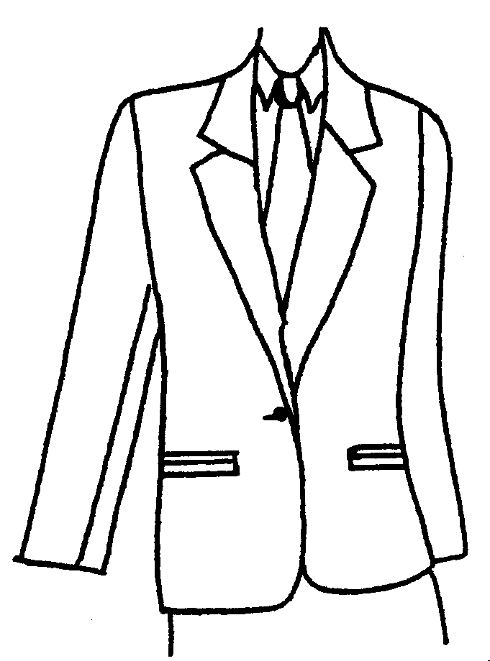

5.2 When choosing clothes, the following play a very important role.

Values, Attitudes, Desires

Which of the above will play a role in the choice of clothes in each of the following cases? Write only the question numbers (5.2.1 – 5.2.3) below one another and then the correct word according to your opinion next to the appropriate number.

5.2.1 Susan is not very interested in clothes or in dressing fashionably. | (1)

5.2.2 Shareen, a religious girl, always wears clothing that is suited to her Muslim religion. | (1)

5.2.3 Thabiso longs to have a ballroom (Cinderella) dress for the Matric Farewell. | (1)

5.3 Explain the following statement:  “Clothing plays an important role in the formation of a teenager’s self-concept.” | (3)

5.4 Explain how a short and slim teenage girl can use clothing to improve this figure irregularity. Refer to styles and colours. | (3)

5.5 Explain the following symbols on a care label. | (3)

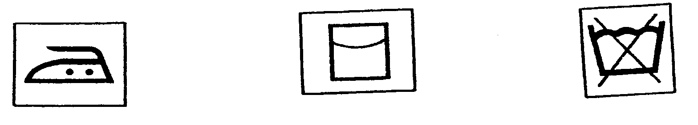
5.5.15.5.2 5.5.3

[25]

QUESTION 6

6.1 Redraw the table below in your answer book and answer the questions that follow.

THREE CHARACTERISTICS | EXPLANATION OF EACH
6.1.1 | 6.1.2

6.1.1 Name THREE characteristics of fashion.  6.1.2 Explain the meaning of each characteristic. | (3)  (3)

6.2 Explain the difference between fashion leaders and fashion followers. | (4)

6.3 Study the following statement carefully and answer the following questions:

“A style remains a style whether it is currently fashionable or not.”

6.3.1 Define the term style.  6.3.2 Name TWO examples of clothing, for example a pair of blue denim jeans, which are referred to as a classic style. | (2)  (2)

6.4 List THREE factors that contribute to the final price of an outfit. | (3)

6.5 To be dressed according to the latest fashion is no guarantee of “good taste”. Justify this statement with THREE sound arguments. | (3)

6.6 Name TWO types of mass media used for the advertising of clothing. | (2)

6.7 Study the following diagrams depicting a person who is short, stout and plump and answer the following questions:

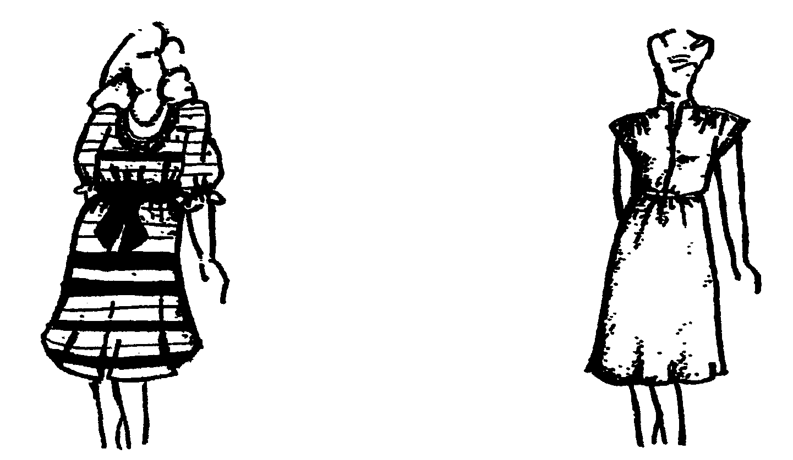

A
B

6.7.1 Indicate which garment will improve the irregularity in the above- mentioned figure.  6.7.2 Identify TWO other ways to improve this figure irregularity. | (1)  (2)  [25]

TOTAL FOR SECTION C: | [75]

SECTION D
CLOTHING CONSTRUCTION AND EMBROIDERY

QUESTION 7

7.1 Study the sketch and answer the following questions:

7.1.1 The sleeve as sketched has been eased into the armhole. Explain the term easing.  7.1.2 Name TWO places where easing is generally used in clothing construction.  7.1.3 Which pattern markings are important when a sleeve is put into an armhole?  7.1.4 What are the differences between the front and back of a sleeve head pattern? | (2)  (2)  (3)  (2) | 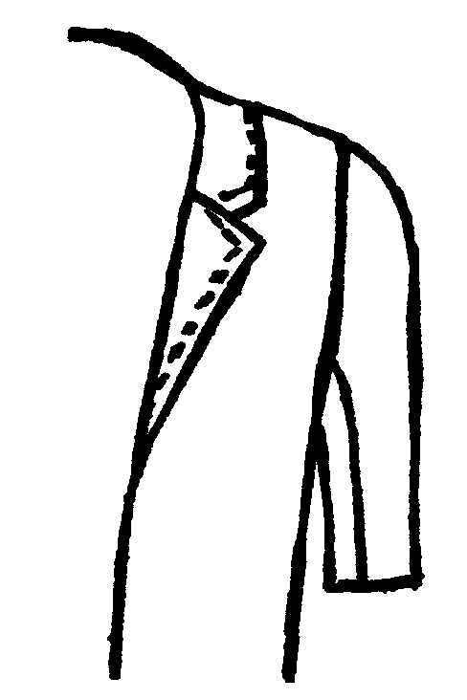

7.2 Study the diagrams of the outfits and answer the following questions:

7.2.1 Identify the type of  (a) collar.  (b) sleeve.  (c) method by which the zip is inserted.  7.2.2 Name TWO factors that should be considered when choosing a fabric for the lining of the outfit.  7.2.3 Identify the method used to reduce fullness in the skirt. | (1)  (1)  (1)  (2)  (1) | 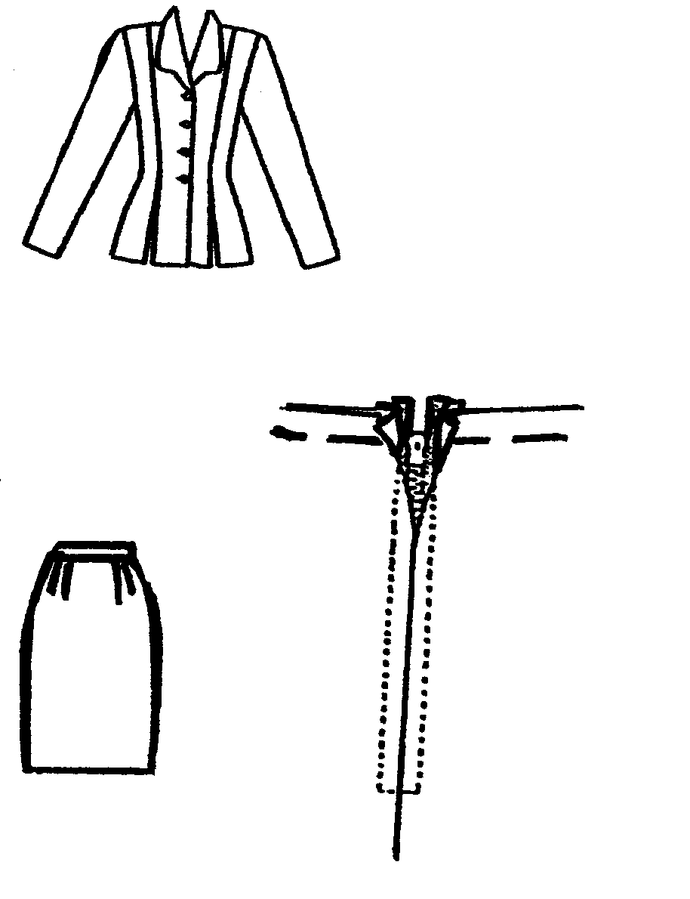  7.2.1  7.2.2  7.2.3  FRONT

7.3 Hems:

7.3.1 Which TWO factors determine the width and finishing of a hem? | (2)

7.3.2 Study the sketch and answer the following questions:  (a) Which type of hem is illustrated in this sketch?  (b) What type of fabric is suitable for finishing this hem?  (c) What type of stitch is used to sew the hem? | (1)  (1)  (1) | 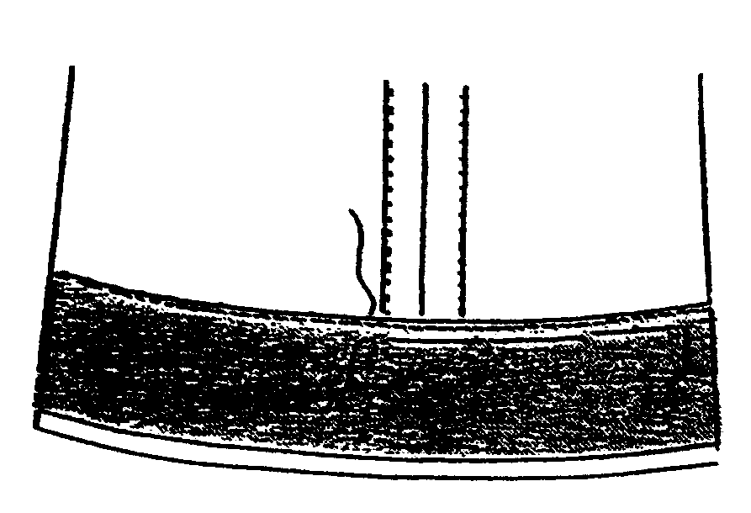  V.K.  W.S.

7.4 Tucks:

7.4.1 What are tucks?  7.4.2 Explain TWO uses of tucks.  7.4.3 Name TWO areas where tucks can be used on garments. | (1)  (2)  (2)  [25]

QUESTION 8

8.1 Study the sketch below and answer the following questions:

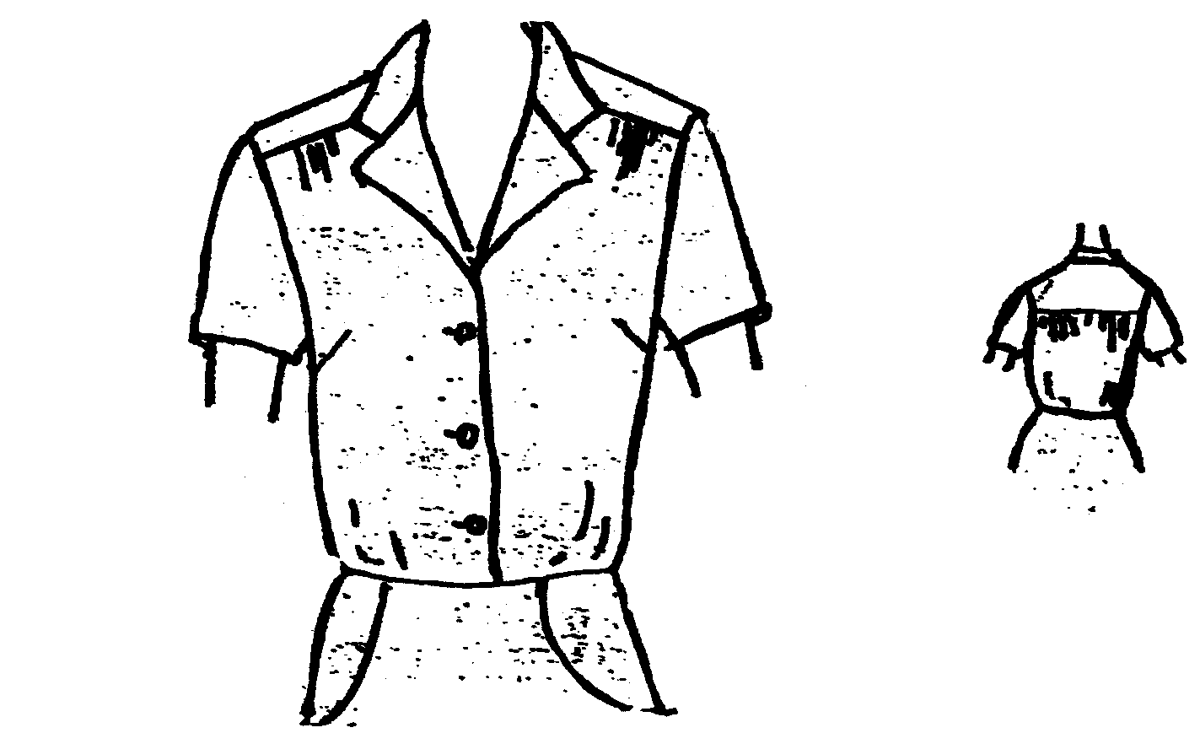
FRONT

BACK

8.1.1 Name TWO methods used in this blouse to reduce fullness. | (2)

8.1.2 Identify the type of yoke used. | (1)

8.1.3 Name THREE methods that can be used to neatly finish the sleeve edges of the blouse. | (3)

8.1.4 Identify the type of pockets on the skirt. | (1)

8.2 The following sketch illustrates how a button should be attached to a thick wool fabric.
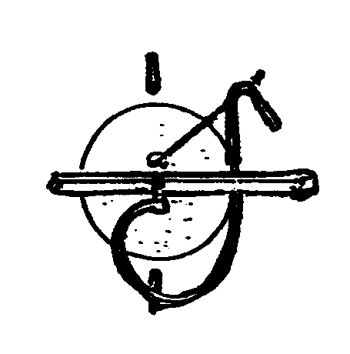
8.2.1 Explain why the stitches are worked over a matchstick.  8.2.2 Name TWO stitches that can be used to neaten the bar on the wrong side. | (1)  (2) | R.K.  R.S.

8.3 Name TWO important functions of embroidery frames? | (2)

8.4 Briefly explain THREE hints on the choice of colour schemes for an embroidery article. | (3)

8.5 Redraw the table below in your answer book and answer the following questions:

8.5.1 NAME OF STITCH | 8.5.2 PLACES WHERE USED
A
B
C

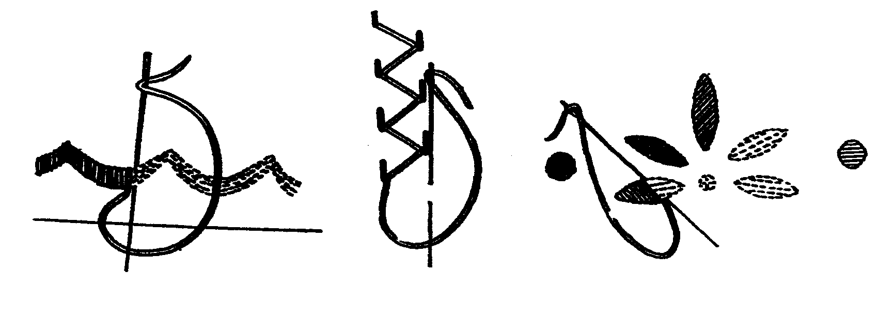

R.K.
R.S.

A
B
C

8.5.1 Identify the embroidery stitches illustrated above. | (3)

8.5.2 Name TWO places where each of the THREE stitches can be used on embroidery articles. | (6)

8.6 Give ONE reason why an embroidered article should be pressed on the wrong side. | (1)
 | [25]

TOTAL FOR SECTION D: | [50]

TOTAL: | 200

