GAUTENG DEPARTMENT OF EDUCATION
SENIOR CERTIFICATE EXAMINATION

NEEDLEWORK AND CLOTHING SG

TIME : 3 hours

MARKS : 200

INSTRUCTIONS:

- All the questions are COMPULSORY.

- Number your answers in exactly the same way as the questions are numbered.

- Write clearly.

- Answer Question 1.1 on the answer sheet on the inside cover of your answer book. Use the numbers as on the answer sheet, e.g. 1.1 (1.1.1).

- Answer all the other questions in your answer book.

SECTION A

QUESTION 1

Read the instructions for each question carefully before answering the question.

1.1 Indicate the correct answer clearly by making a cross (X) next to each question number over the corresponding letter on the answer sheet on the inside cover of your answer book.

EXAMPLE: The basic element of design is:
- Texture
- Colour
- Form
- Line

ANSWER: | A | B | C | D

- __________ is an example of a regenerated fibre.  - Flax  - Rayon  - Acrylic  - Polyester | (1)

- The fibre with the lowest moisture absorption is  - wool.  - rayon.  - cotton.  - courtelle. | (1)

- One of the following is a vegetable fibre.  - Wool  - Cotton  - Acrylic  - Silk | (1)

- When wearing a fur coat to the local cinema, one wears it for  - fashion.  - conformity.  - confidence.  - prestige. | (1)

- The retail shop which caters for exclusive styles for a specific market, is called a  - boutique.  - chain store.  - discount store.  - department store. | (1)

- The design (art) principle represented when a hat is in good relationship to the size of the face, is called  - balance.  - harmony.  - emphasis.  - proportion. | (2)

- A teenager wears a bottle green pair of jeans with a red T-shirt. What colour scheme (harmony) does this represent?  - Related  - Analogous  - Monochromatic  - Complementary | (2)

- The hip measurement for a Miss Petite figure type is taken _____ cm from the natural waistline.  - 12 – 17  - 18 – 23  - 24 – 25  - 26 – 31 | (2)

- Which one of the following colours is a secondary colour?  - Red  - Black  - Yellow  - Green | (1)

- The most suitable method of transferring pattern markings onto velvet fabric would be  - tailor’s chalk.  - tailor’s tacking.  - dressmaker’s pencil.  - dressmaker’s carbon paper. | (1)

- __________ are used to dispose of fullness at one end and to give fullness at the other end.  - Gathers  - Pleats  - Tucks  - Darts | (1)

- __________ is a self-finished seam.  - A French seam  - An overlaid seam  - An open single seam  - A closed single seam | (1)

- The stitch illustrated is called __________ stitch.  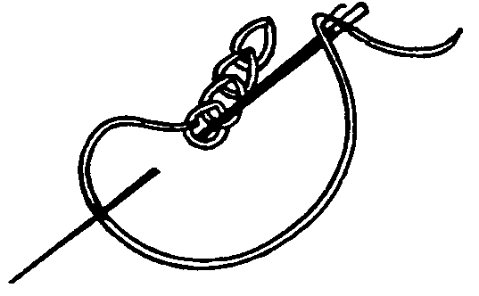  - back  - chain  - stem  - whip | (1)

- Holbein stitch is used in __________ embroidery.  - Assisi  - canvas  - cross-stitch  - Florentine | (1)  [17]

1.2 Match the clothing item in Column A with the most desired textile property in Column B. Write the question numbers (1.2.1 – 1.2.5) below each other in your answer book and then the correct letter (A – G) next to the appropriate number.

COLUMN A | COLUMN B | (5)
CLOTHING ITEM | TEXTILE PROPERTY | (5)
- Fireman’s clothing  - Rugby socks  - Tennis dress  - Baby’s nappy  - Winter coat | - Stretch and recovery  - Poor abrasion resistance  - Poor conductor of heat  - Non-flammable  - Dimensionally stable  - Good absorbency  - Poor electrical conductivity | (5)

1.3 Match each sketch in Column A with the design principle represented in Column B. Write the question numbers (1.3.1 – 1.3.3) below each other in your answer book and then the correct letter (A – E) next to the appropriate number.

COLUMN A | COLUMN B | (6)
SKETCH | DESIGN PRINCIPLE | (6)
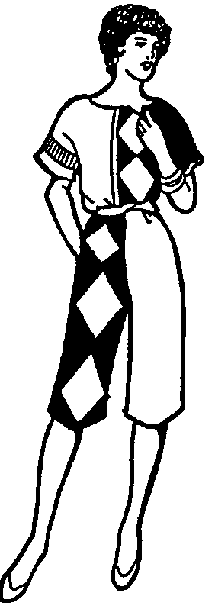  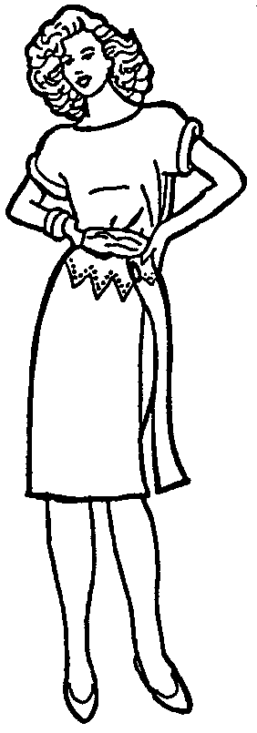  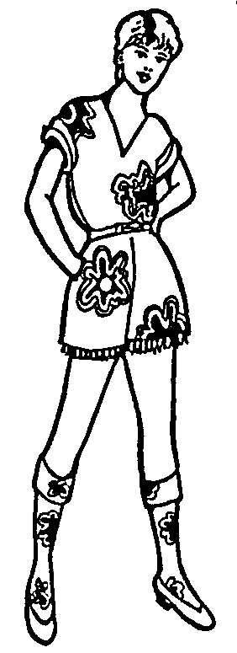  1.3.1  1.3.2  1.3.3 | - Rhythm  - Harmony  - Proportion  - Emphasis  - Formal balance | (6)

1.4 Match each zipper type in Column A with the appropriate garment in
Column B. Write the question numbers (1.4.1 – 1.4.4) below each other in your answer book and then the correct letter (A – D) next to the appropriate number.

COLUMN A | COLUMN B | (4)
ZIPPER TYPES | GARMENTS | (4)
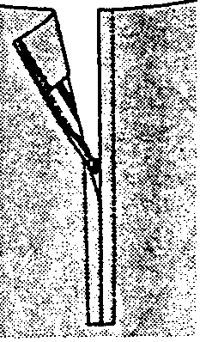  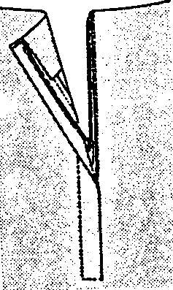  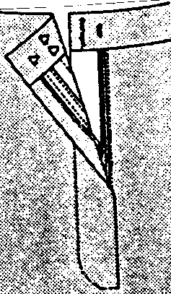  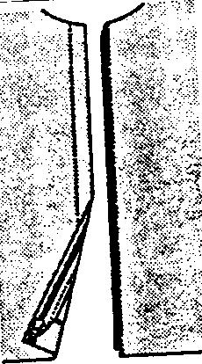  1.4.1  1.4.2  1.4.3  1.4.4 | - Trousers  - Wind breaker  - Skirt with a side opening  - Skirt with a centre back opening | (4)

  - Viscose (rayon) is not the ideal fibre to use for the manufacturing of tea
towels (dishcloths).

Select from the list below THREE reasons to substantiate the above statement. In your answer book, write the question number (1.5) and the THREE correct letters (A – F) of your choice below each other.

REASONS TO SUBSTANTIATE THE STATEMENT
A.  B.  C.  D.  E.  F. | Poor dimensional stability  Weak when wet  Good wrinkle resistance  Good absorbency  Resistant to bleaches  Poor abrasion resistance | (3)

1.6 Select from the list below THREE properties that shower curtaining should possess. In your answer book, write the question number (1.6) and the THREE correct letters (A – E) of your choice below each other.

PROPERTIES OF SHOWER CURTAINING |  | (3)
A.  B.  C.  D.  E. | Good strength  Mildew resistant  Good absorbency  Water resistant/waterproof  Resilient | (3)

1.7 Select from the list below THREE correct care symbols for a pair of black linen trousers. In your answer book, write the question number (1.7) and the THREE correct letters (A – F) of your choice below each other.

CARE SYMBOLS FOR BLACK LINEN TROUSERS |  |  |  | (3)
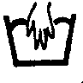  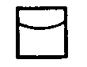  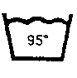  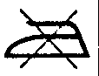  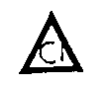  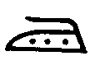  A.  B.  C. |  | D.  E.  F. |  | (3)

  - Draw the table below in your answer book. Write ONLY the correct letters
(A – D) in the correct column after you have studied the question below this table.

DECORATIVE FINISHES | FUNCTIONAL FINISHES

Classify the fabric finishes in the list below as decorative or functional finishes.

FABRIC FINISHES |  | (4)
A.  B.  C.  D | Calandering  Moiré  Glazing  Mercerising | (4)

1.9 Indicate whether the following statements are TRUE or FALSE. Write the numbers (1.9.1 – 1.9.5) below each other in your answer book and next to each number TRUE or FALSE.

STATEMENTS |  | (5)
1.9.1  1.9.2  1.9.3  1.9.4  1.9.5 | A tall stout figure should avoid wearing light, bright colours.  For the best results, use a large variety of colours in a smart outfit for an older woman.  A sewing gauge is used for measuring the width of hems.  Run-and-fell seams can be used for princess seams.  Tucks are narrow folds evenly stitched on the right side of a garment. | (5)

TOTAL FOR SECTION A: | [50]

SECTION B

TEXTILES

QUESTION 2

2.1 Redraw the table below in your answer book and fill it in by providing the definitions and examples asked for in the question that follows below this table.

TERM | DEFINITION | ONE EXAMPLE OF A FIBRE
Felting
Thermoplasticity

Define the terms below and name ONE example of a fibre that is representative of each term.  - Felting  - Thermoplasticity | (2)  (2)

2.2 Name THREE properties that will influence the durability of a fibre. | (3)

2.3 The extract below is from the back of a commercial pattern envelope. Answer Questions 2.3.1 – 2.3.3 referring to the suggested fabrics in the extract.

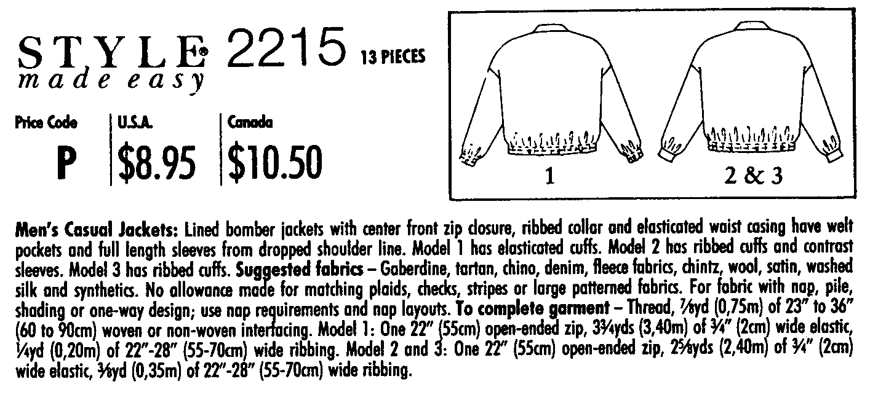

- Name TWO natural fibre groups represented in the list of suggested fabrics.  - Give ONE example from the suggested fabrics for EACH of the following weave structures. | (2)  (3)
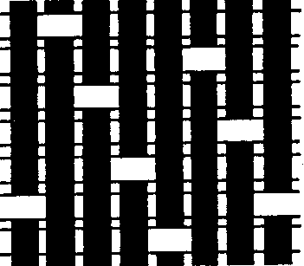
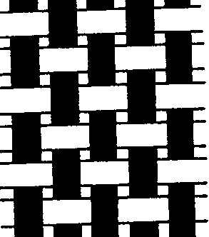
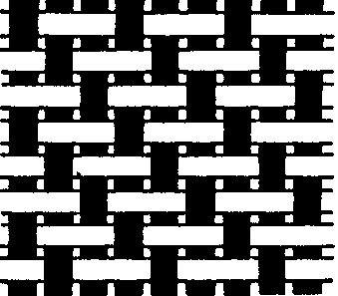
A

B
C

- Chintz fabric  (a) Name the fibre used to manufacture chintz fabric.  (b) Explain how the glazing process is applied to chintz fabric.  (c) Mention TWO additional finishes that may be applied to the chintz fabric to improve the maintenance or care of the fabric. | (1)  (2)  (2)

2.4 Differentiate between waterproof and water-repellent finishes.  2.5 Explain why a woollen jacket is ideal for the winter months.  2.6 Which ONE of the garments in the sketch below will dry the fastest? Only write the ONE letter (A – E) of your choice. Motivate your answer. | (2)  (3)  (3)

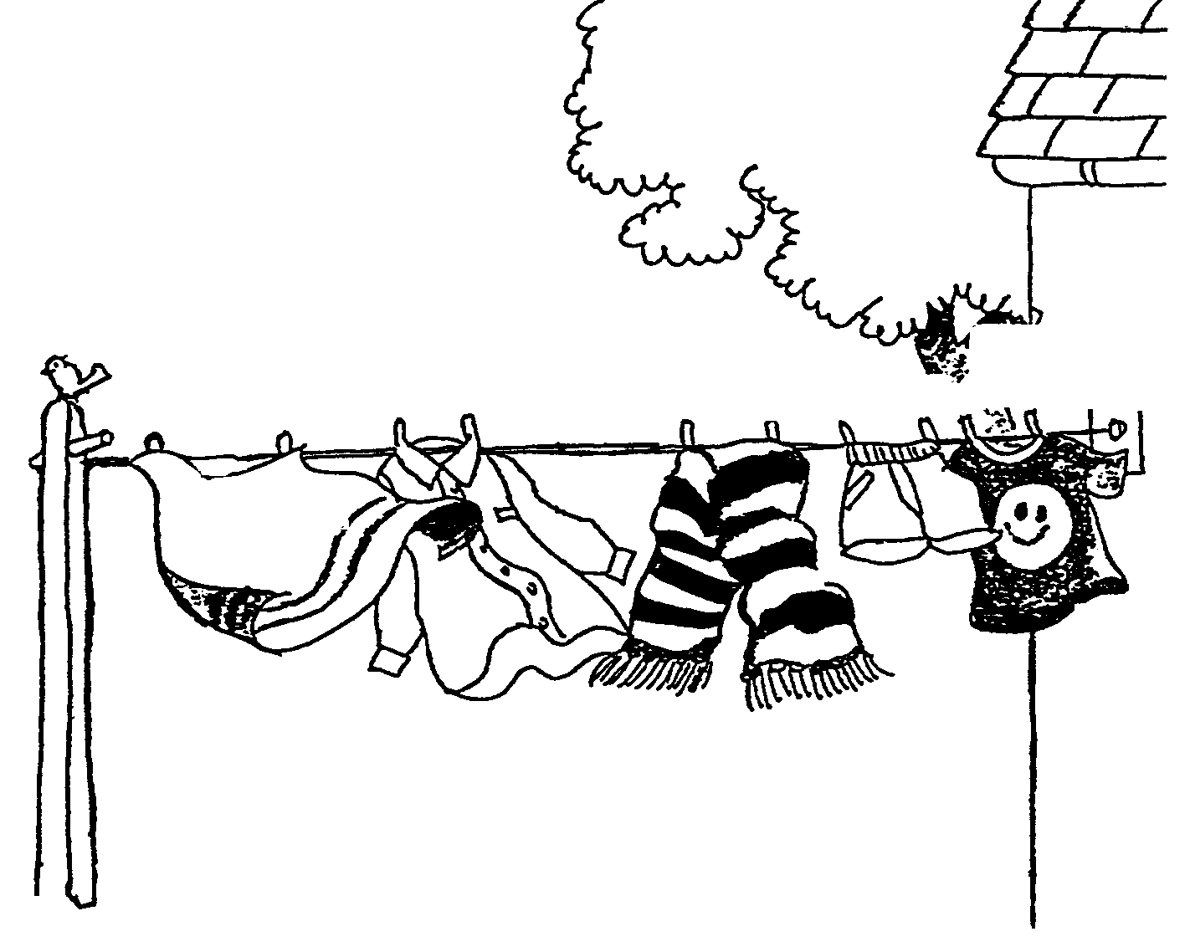  COTTON VISCOSE WOOL NYLON  COTTON  BLEND  A  B  C  D  E | [25]

QUESTION 3

3.1 Off-grain is a term often associated with woven fabrics (especially when laying out a pattern). Describe how fabrics become off-grain after the weaving process. | (2)

- Flame-retardant finishes are applied to workers’ overalls in the mining industry.  3.2.1 What is the function of flame-retardant finishes?  - Name a trade name used for flame-retardant finishes.  - Name the type of fibre that these overalls are made of. Motivate your answer. | (2)  (1)  (2)

3.3 Vilene is a non-woven fabric used as interfacing when constructing collars. Explain how Vilene is manufactured. | (2)

3.4 Arrange the following fibres according to their resiliency, from the most resilient to the least resilient. | (3)

cotton; wool; nylon

- Some types of swimwear are made from knitted Lycra fabrics.  3.5.1 Explain why fabrics for swimwear should be knitted.  - Suggest the type of fibre used to manufacture Lycra.  - Explain why this fibre is used to manufacture swimwear. (Give THREE reasons). | (2)  (1)  (3)

3.6 Spencers (vests with long sleeves) can either be made from dacron or cotton fibres. Name ONE advantage and ONE disadvantage of each of these fibres. | (4)

Redraw the table below and answer the question by filling in the table.

SPENCER | ONE ADVANTAGE | ONE DISADVANTAGE
Dacron
Cotton

3.7 What is the function of mercerising finishes? | (3)  [25]

TOTAL FOR SECTION B: | [50]

SECTION C

CLOTHING

QUESTION 4

4.1 Explain the terms individuality and conformity. Give ONE example of recognition for each. Table your answer by redrawing the table below in your answer book.

TERM | EXPLANATION | ONE EXAMPLE OF RECOGNITION
Individuality | (1) | (1)
Conformity | (1) | (1) | (4)

- Briefly explain how the following social factors influence fashion changes:  4.2.1 The level of education  - More leisure time  - The changing role of women | (2)  (2)  (2)

4.3 Explain the statement: “A bargain is a bargain only if you need the article.” | (2)

4.4 The trend of platform shoes follows the same curve as any other fashion, as illustrated below. Explain the varying costs of these shoes with relation to the THREE main areas of the fashion cycle. | (3)
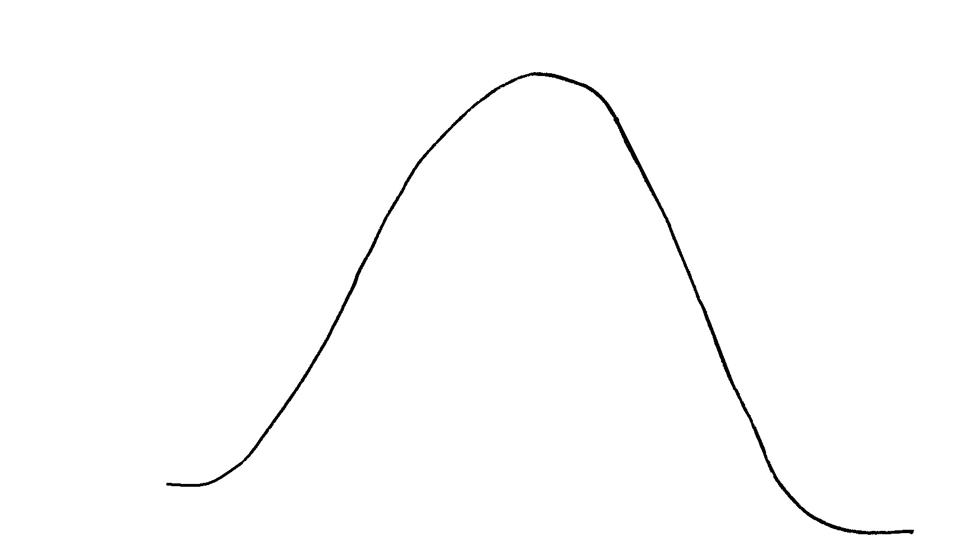
PEAK
INTRODUCTORY PERIOD
Fashion Cycle

DECLINE PERIOD

- Study the sketch and answer the following  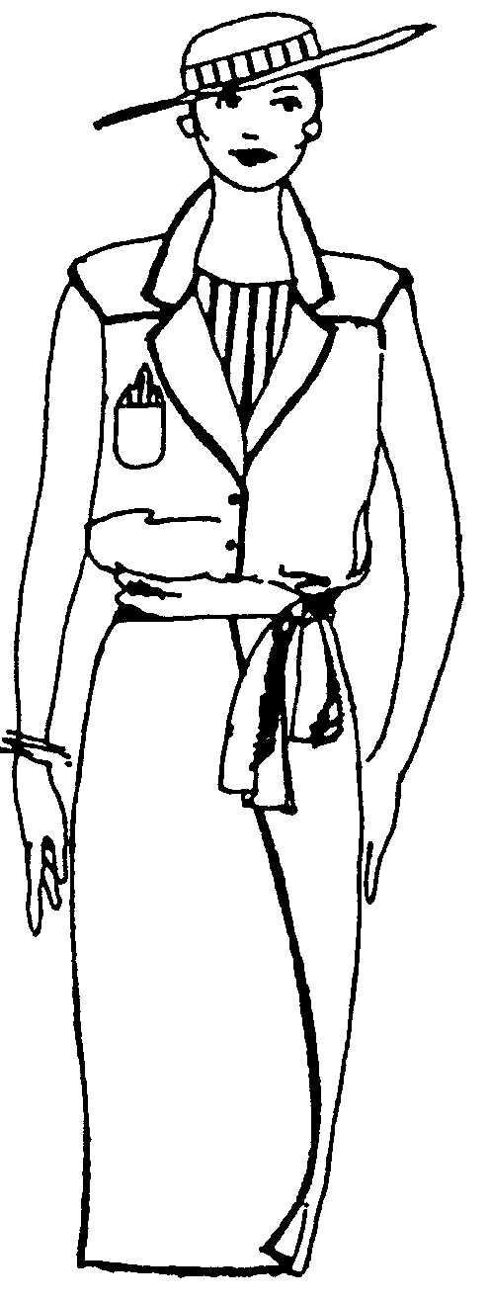  questions.  4.5.1 Identify FOUR ways in which line has been  used in various directions in this dress.  Give examples of each.  - Explain how informal balance was achieved  in the bodice of this dress.  - Explain how rhythm has been achieved in  this outfit.  - Name the type of personality that would  wear this outfit. | (4)  (2)  (2)  (2)  [25]

QUESTION 5

5.1 Provide examples of any THREE warm colours for each of the following colour schemes (harmonies).

Redraw the table below in your answer book and fill it in.

COLOUR SCHEME (HARMONY) | EXAMPLE
Monochromatic | 3
Analogous | 3 | (6)

5.2 Certain factors should be considered when a pattern is laid out on fabric with unusual designs and textures. List FOUR points that one should consider when laying out the pattern pieces on this type of fabric. | (4)

- Study the sketch and answer the following questions:  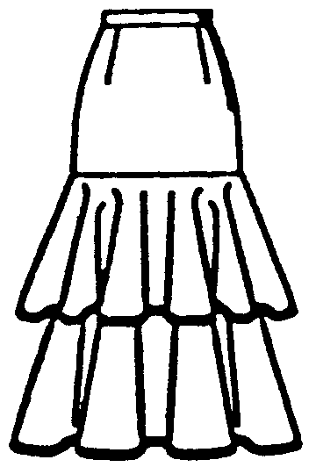  5.3.1 Identify the type of line emphasised in the  skirt and explain what effect if will have  on the tall and slender figure.  - What design (art) principle is represented  by the frills in the skirt? Also mention TWO  ways in which it was achieved. | (3)  (3)

5.3.3 Select from the examples below the fabric you would use to make the skirt. Motivate your answer. | (2)

Thick denim; Cotton-polyester

- If you were to buy the skirt, how would you evaluate each of the following construction techniques?  (a) Seams  (b) Hem | (2)  (2)

5.4 Provide THREE reasons why accessories are worn. | (3)  [25]

TOTAL FOR SECTION C: | [50]

SECTION D

CONSTRUCTION

QUESTION 6

6.1 Redraw columns A, C and D in your answer book and then complete the table below by filling in the missing information.

A | B | C | D
 | TYPE OF SEAM | NAME OF SEAM | ONE EXAMPLE OF WHERE SEAM MAY BE USED
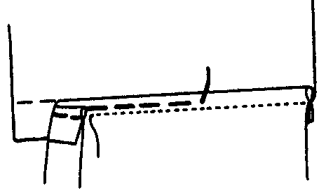
6.1.1
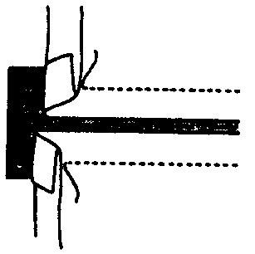
6.1.2
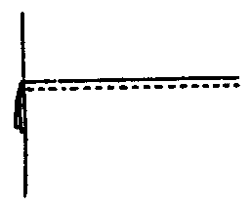
(6)
6.1.3

6.2 Name TWO factors which influence the purchasing of buttons for an outfit. | (2)

6.3 List THREE characteristics (properties) of a good tape measure. | (3)

  - Types of collars

6.4.1 Identify the following types of collars.
B
C
D
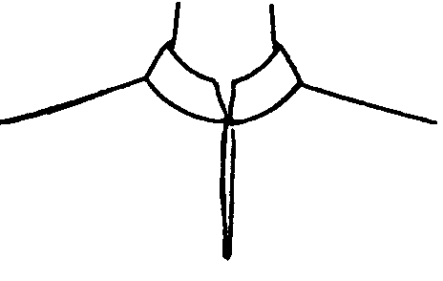  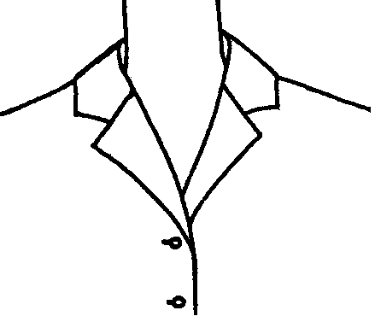  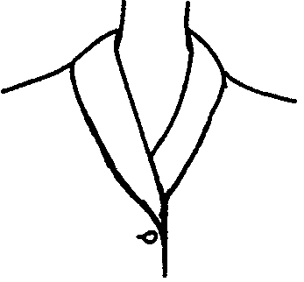  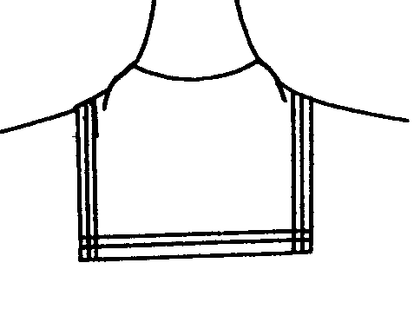  A | (4)

6.4.2 Which of the above collars will be most flattering on a person with a long, thin neck? | (1)

- Study the sketch and answer the following questions:  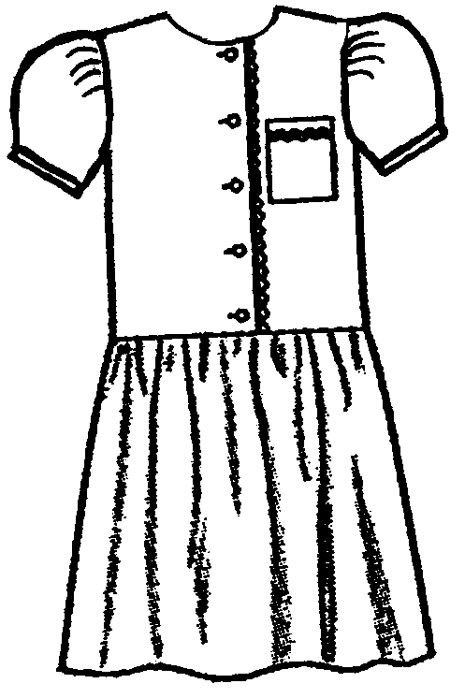  COTTON-POLYESTER PLAY DRESS  6.5.1 Suggest TWO methods of neatening the  neck line edge.  - Explain in which direction the opening on this  girl’s dress should close.  - Identify the type of disposal of fullness and  state where it has been used in this dress.  - How wide should the skirt be in relation to  the bodice, to obtain sufficient fullness?  - Explain why hems on toddler’s dresses  should be wider. | (2)  (1)  (3)  (2)  (1)  [25]

QUESTION 7

7.1 Study the following sketch of embroidery work and answer the questions below.
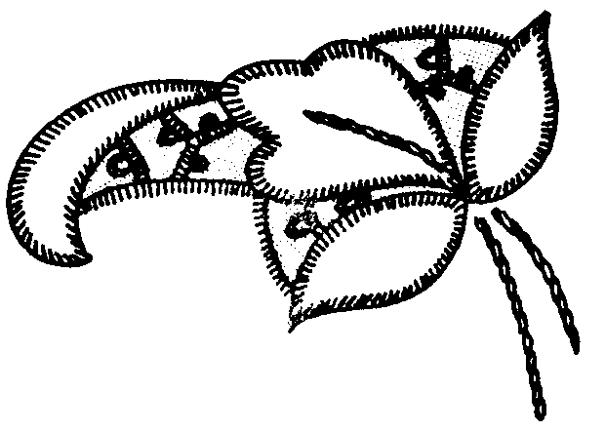

- Identify the type of embroidery work illustrated.  - Name THREE embroidery stitches which may be used for this type of embroidery.  - If the article is made from a cotton- polyester blend, what type of embroidery thread would you choose? | (1)  (3)  (1)
- Name THREE hints to ensure that embroidery thread will stay neat and strong while it is being used.  - Compare the type of needles used for tapestry and shadow work embroidery. | (3)  (4)

7.2 Compare how the hem finishes on the skirts below will differ.
A
B
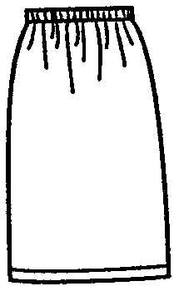  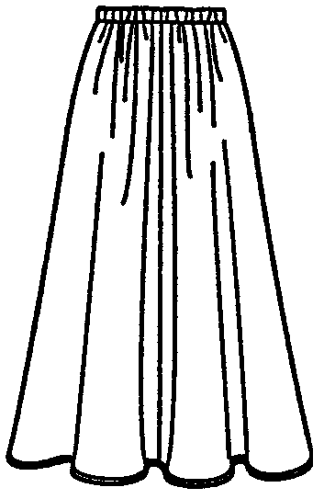  Woollen fabric Cotton-polyester fabric | (4)

7.3 Explain how you would treat darts when made on a thick woollen winter coat.  - Explain how you are going to solve the problem if your school skirt/dress becomes too short in your final school year. | (3)  (2)

  - Identify and explain the reasons for the techniques illustrated in the sketches below.

(i)  (ii)  (ii)  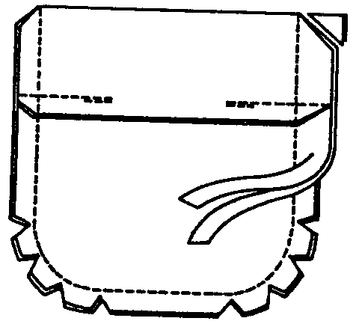  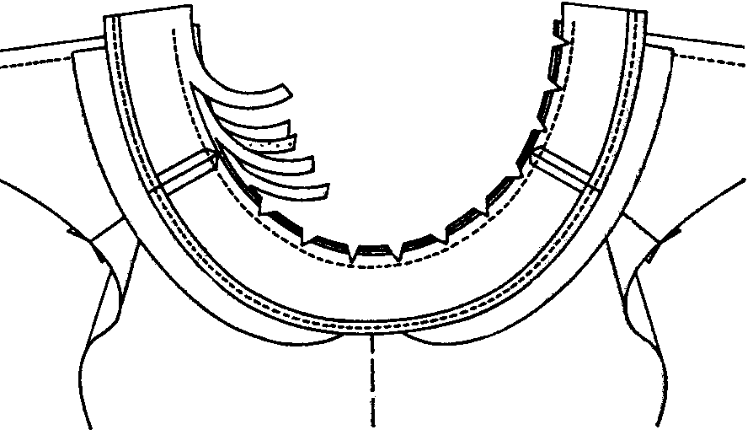  A  B  (i) | (4)  [25]

TOTAL FOR SECTION D:  TOTAL: | [50]  200

