GAUTENG DEPARTMENT OF EDUCATION

SENIOR CERTIFICATE EXAMINATION

MUSIC HG
(Second Paper: History of Music and Form)

TIME: 2 hours

MARKS: 100
INSTRUCTIONS:

- Answer all questions in the Answer Book provided.

- Answers must be clearly numbered.

- Write the answers clearly and in ink.

- Question 1 is COMPULSORY.

- Answer any TWO of Questions 2, 3, and 4.

QUESTION 1

COMPULSORY

  - Study the following incomplete diagrammatic sketch of the exposition of a fugue with four voices. Identify the spaces (A), (B), (C), (D), (E), (F), (G) and (H).

 | SOPRANO | Subject | (A) | C  O
 | ALTO |  | Answer | D  E | (C)
 | TENOR |  |  | T  T | (D) | (F)
 | BASS |  |  | A |  | (G)
 | KEY | E^{b} Major | (B) |  | (E) | (H)
 |  |  |  |  |  |  |  | (8)

  - Match the information in Column A with the correct term in Column B, for example 1.2.11 K. Answer any SEVEN questions.

 | COLUMN A | COLUMN B |  | (7)
1.2.1  1.2.2  1.2.3  1.2.4  1.2.5  1.2.6  1.2.7  1.2.8  1.2.9  1.2.10 | Art Song  Dominant Preparation  Answer  Absolute music  Divertimenti  Nationalism  Second subject  Poetry, Literature and Art  Variation  Scarlatti Sonata | A.  B.  C.  D.  E.  F.  G.  H.  I.  J. | Folk tunes  Modified repetition of theme  Contrasting key  Sonata Form  Classical Period  Programme music  Fugue  Binary Form  Strophic Form  Chamber music | (7)

  - Indicate the form of the Prelude to Carmen by Bizet by using bar numbers
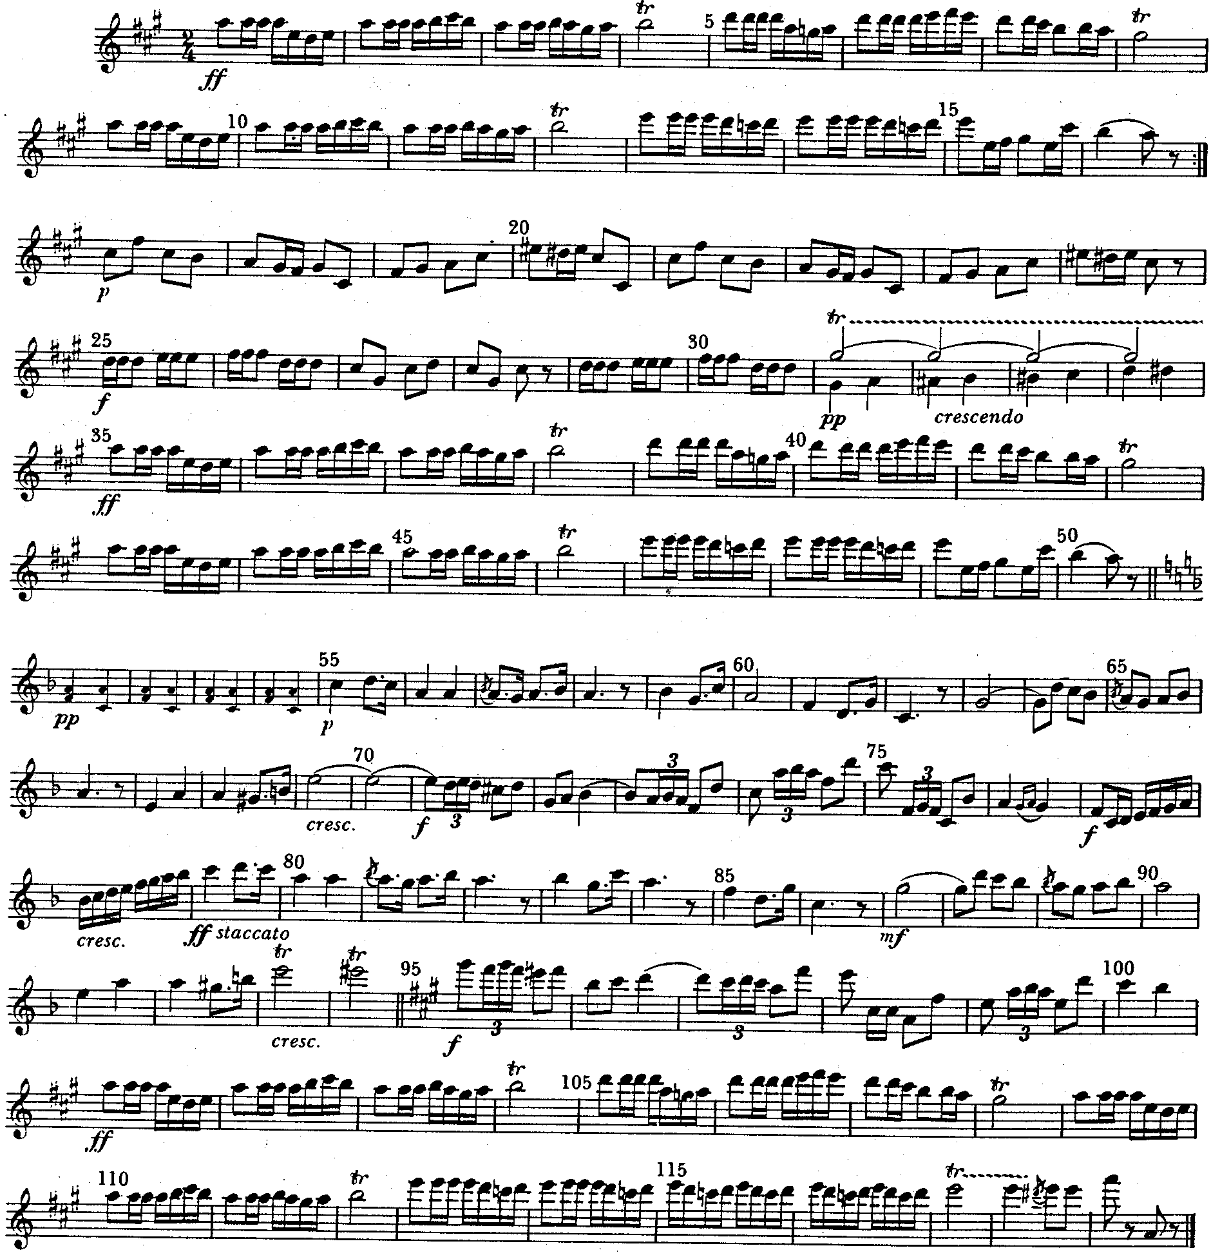
e.g. A: Bars 1 – 12.

(5)
[20]

Answer any TWO of Questions 2, 3 and 4.

QUESTION 2
OPERA

- The pinnacle of 18th century opera was attained by Mozart. Discuss Mozart’s style of operatic writing.  - Wagner has often been referred to as “the most innovative composer of the nineteenth century opera”. Discuss this statement with reference to any TWO of the following:  - Endless melody  - Harmony  - Orchestration | (12)  2x4=(8)

2.3 The following sentences each contain TWO errors. Rewrite each sentence making it factually correct.

- In the preface to his opera, Orfeo ed Euridice, Gluck stated a number of operatic reforms. One of the reforms was that the drama must be subordinate to the music.  - Verdi’s opera, The Marriage of Figaro, is written in Singspiel style and is based on the libretto of Lorenzo da Ponte.  - Wagner’s Der Ring des Nibelungen comprises five music dramas of which Der Walküre is the first music drama.  - Act II of Verdi’s Rigoletto contains the court jester’s aria La donna e mobile and the famous quartet.  - Donizetti often interrupted arias with ensembles, his melodies were ornate and he used dialogue and choirs to heighten climaxes. | 5x2=(10)

2.4 German Romantic Opera was established in Der Freischütz by C.M. von Weber. What are the origins of the stories of this type of opera? | (5)

2.5 Name the composers of the following operas:  - La Fille di Regimente  - Falstaff  - Euryanthe  - Die Feen  - Iphigenie en Tauride | (5)
 | [40]

QUESTION 3

SYMPHONY

3.1 Name THREE aspects which the Symphonic Poem and the Concert Overture have in common. | (3)

- Study the following theme and answer the questions that follow:  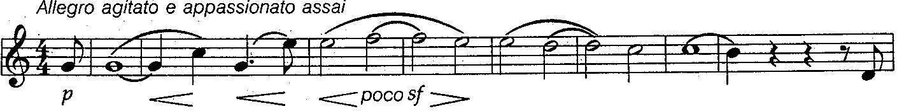  - Name the composition from which the theme comes.  - Which style period does the theme represent?  - Give THREE reasons for your answer in Question 3.2.2. which are applicable to this work.  - How is unity achieved in this work? Discuss by referring to instrumentation.  - Which TWO instruments are used to evoke a feeling of loneliness in the third movement? | (1)  (1)  (3)  (6)  (2)

- Compare the symphonies of Beethoven and Haydn under the following headings:  3.3.1 Third movement  AND  3.3.2 Finale | (8)

  - Study the following theme and answer the questions that follow:
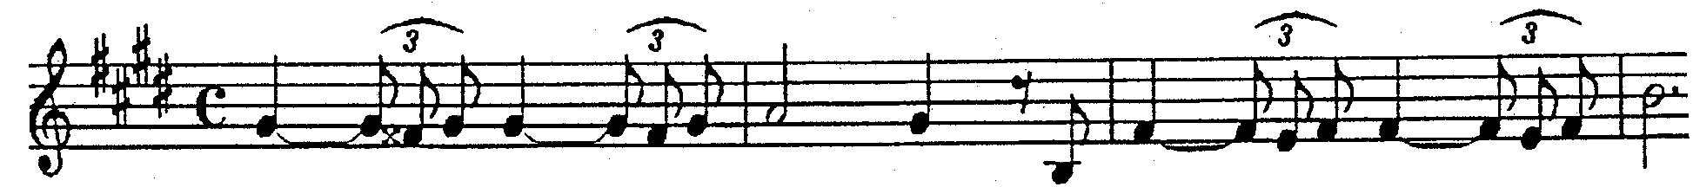

- How is unity mainly achieved in this work?  - Name FOUR other ways in which unity is achieved. | (1)  (4)

  - Study the following theme and answer the questions that follow:
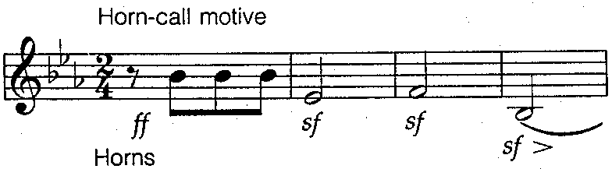

3.5.1 Discuss the contribution of the composer of the above theme with regards to:  (a) Orchestration  OR  - Sonata form | (5)

  - Study the following theme and answer the questions which follow:
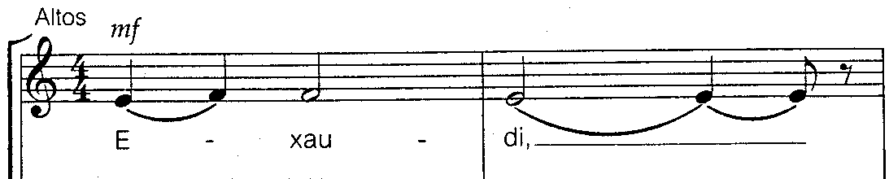

- On which mode is the above theme based?  - Which period in the above composer’s life does this work represent?  - Give FOUR reasons that prove that Bach has a strong influence on this style of composition. | (1)  (1)  (4)  [40]

QUESTION 4
CHAMBER MUSIC

- Name FOUR aspects which distinguish chamber music from symphonic music.  - Name TWO of Haydn’s contributions to the development of the string quartet. | (4)  (2)

- The following statements refer to the string quartets of Beethoven. Each statement has ONE error. Rewrite the statements so that they are factually correct.  - The String Quartet Op. 18 no. 1 is in A major.  - The String Quartet Op. 113 has 6 movements which are connected in subtle ways.  - The second movement of the String Quartet Op. 18 no. 1 is a fast, passionate movement which was inspired by Shakespeare’s Romeo and Juliet.  - The first movement of the String Quartet Op. 18 no. 1 starts with a slow, emotional introduction which is followed by an Allegro con brio section in Sonata Form. | (4)

- “Bartok used a synthesis of folk music and new and old elements of Western Art Music. In this way he developed new compositional styles.” Discuss | (10)
  - Study the following transformed theme and answer the question that follows:
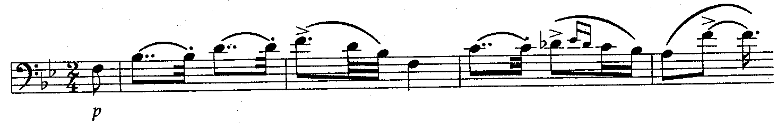

- Name the instruments in their order of appearance on the score,which are used in this work. | (5)

  - Study the following theme and answer the questions that follow:
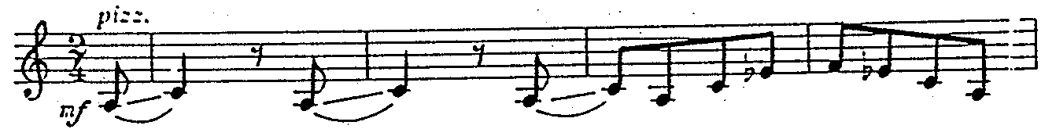

- Give the full title of the work which is represented by the given theme.  - Name the composer of this work.  - What is the form of the movement which the above theme represents?  - Discuss tone colour as utilized in this movement.  - On which mode is the theme based?  - Write a short paragraph on Bartok’s night music. | (1)  (1)  (1)  (4)  (1)  (3)

- Name the composer of the following works:  4.7.1 Russian Quartets  - Grosse Fugue  - Basle concerto for Chamber Orchestra  - Death and the Maiden | (4)  [40]

TOTAL: | 100

