GAUTENG DEPARTMENT OF EDUCATION

SENIOR CERTIFICATE EXAMINATION

MUSIC HG
(First Paper: Harmony and Composition)

TIME: 3 hours

MARKS: 100
INSTRUCTIONS TO THE INVIGILATOR:

- Each candidate must be supplied with 3 sheets of music manuscript paper.

- Each candidate must have access to a piano for the full duration of the examination.

- No candidate may, however, disturb another candidate nor share the use of a piano at any particular time.

INSTRUCTIONS TO THE CANDIDATE:

- This question paper is also the answer book.

- Enter your examination number in the space provided.

- Ensure that your notation is neat and unambiguous.

- Answer Question 1 OR Question 2 AND ALL other questions.

Answer Question 1 OR Question 2.  QUESTION 1  Set ONE of the following poems to music. Choose a suitable voice, key and metre. Neatly write the text below the melodic line. | [20]

THE WHEEL OF FORTUNE  Round goes life’s wheel with ceaseless spin,  Some fellows up, and others under;  And those who lose and those who win,  And those who’re right and those who blunder–  Succeed each other, day by day,  Till all, in time are swept away!  There’s many a slip  Twixt the ‘stuff ’ and the scrip.  [A. Brodrick] | OR | WONDERLIK  Dit is vir my so wonderlik  Hoe, uit die stille nag,  Die sterretjies gebore word  Sommerso uit die dag.  Ek dink daar’s bokant kindertjies  Wat sterre aan kan steek, –  Dit is vir my so wonderlik  So lag-lag deur die nag.  [J.R.L. van Bruggen]

Voice _____________________

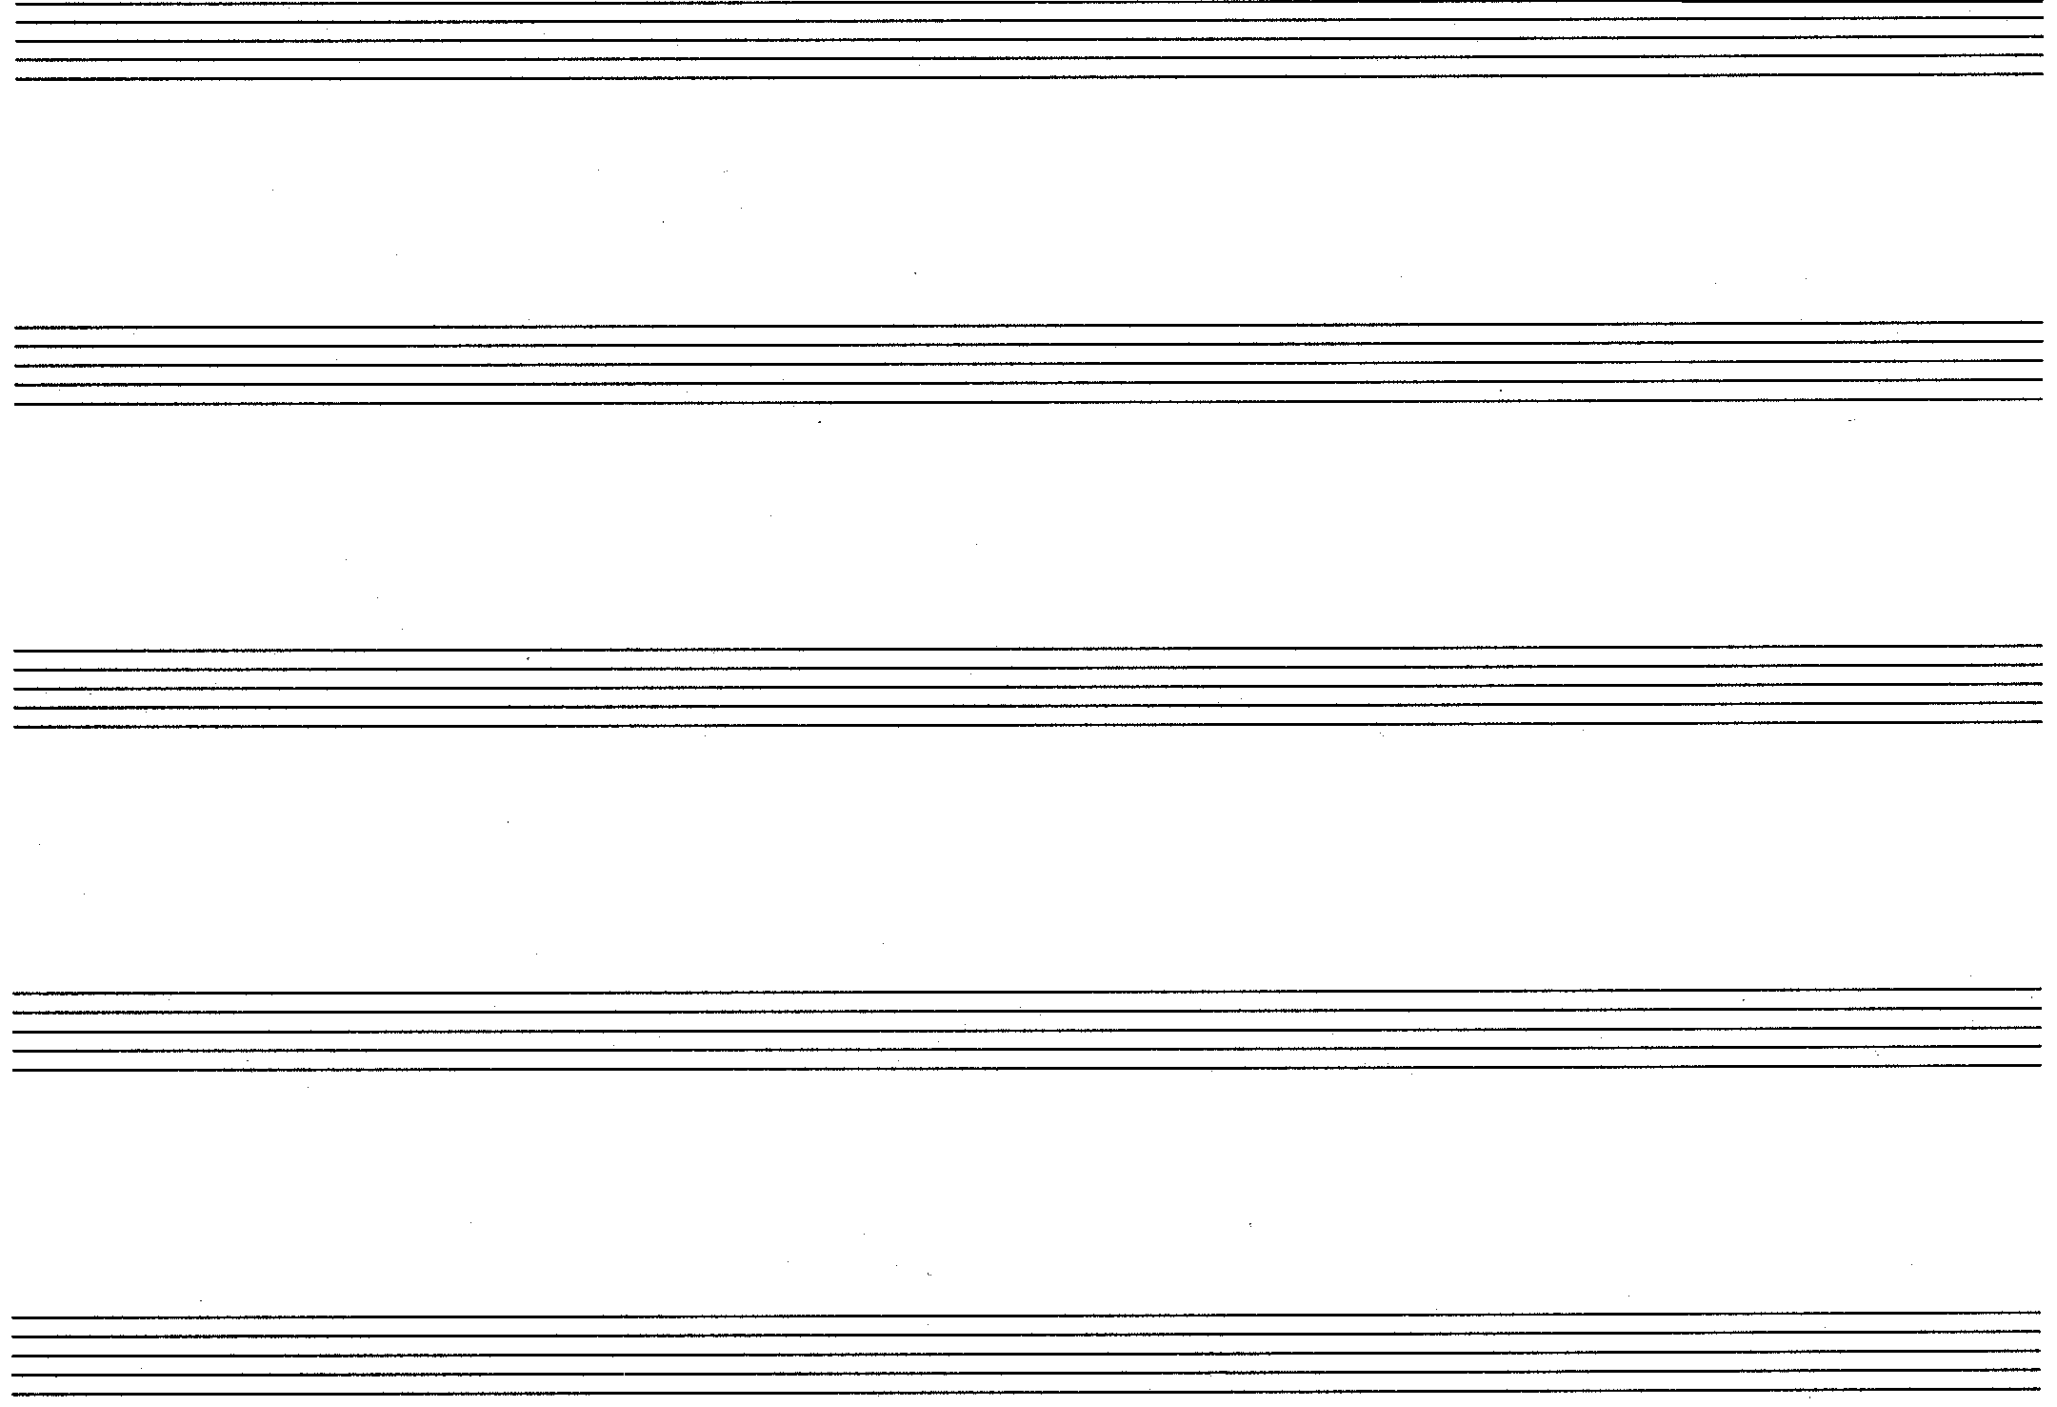

OR

QUESTION 2  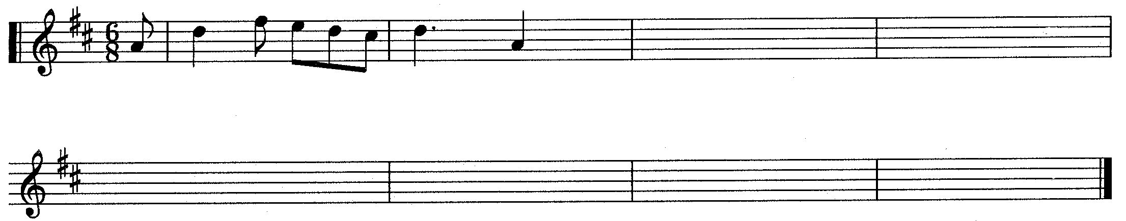  2.1 Add TWO sequences to the following two-bar melodic fragment. Ensure that you create a coherent musical phrase of 8 bars by ending with a suitable cadence. | [20]  (5)

- Extend the given opening to a symmetrical melody consisting of 12 bars in ternary form. Modulate to a related key and end in the original key. Indicate for which voice or instrument the melody is intended.  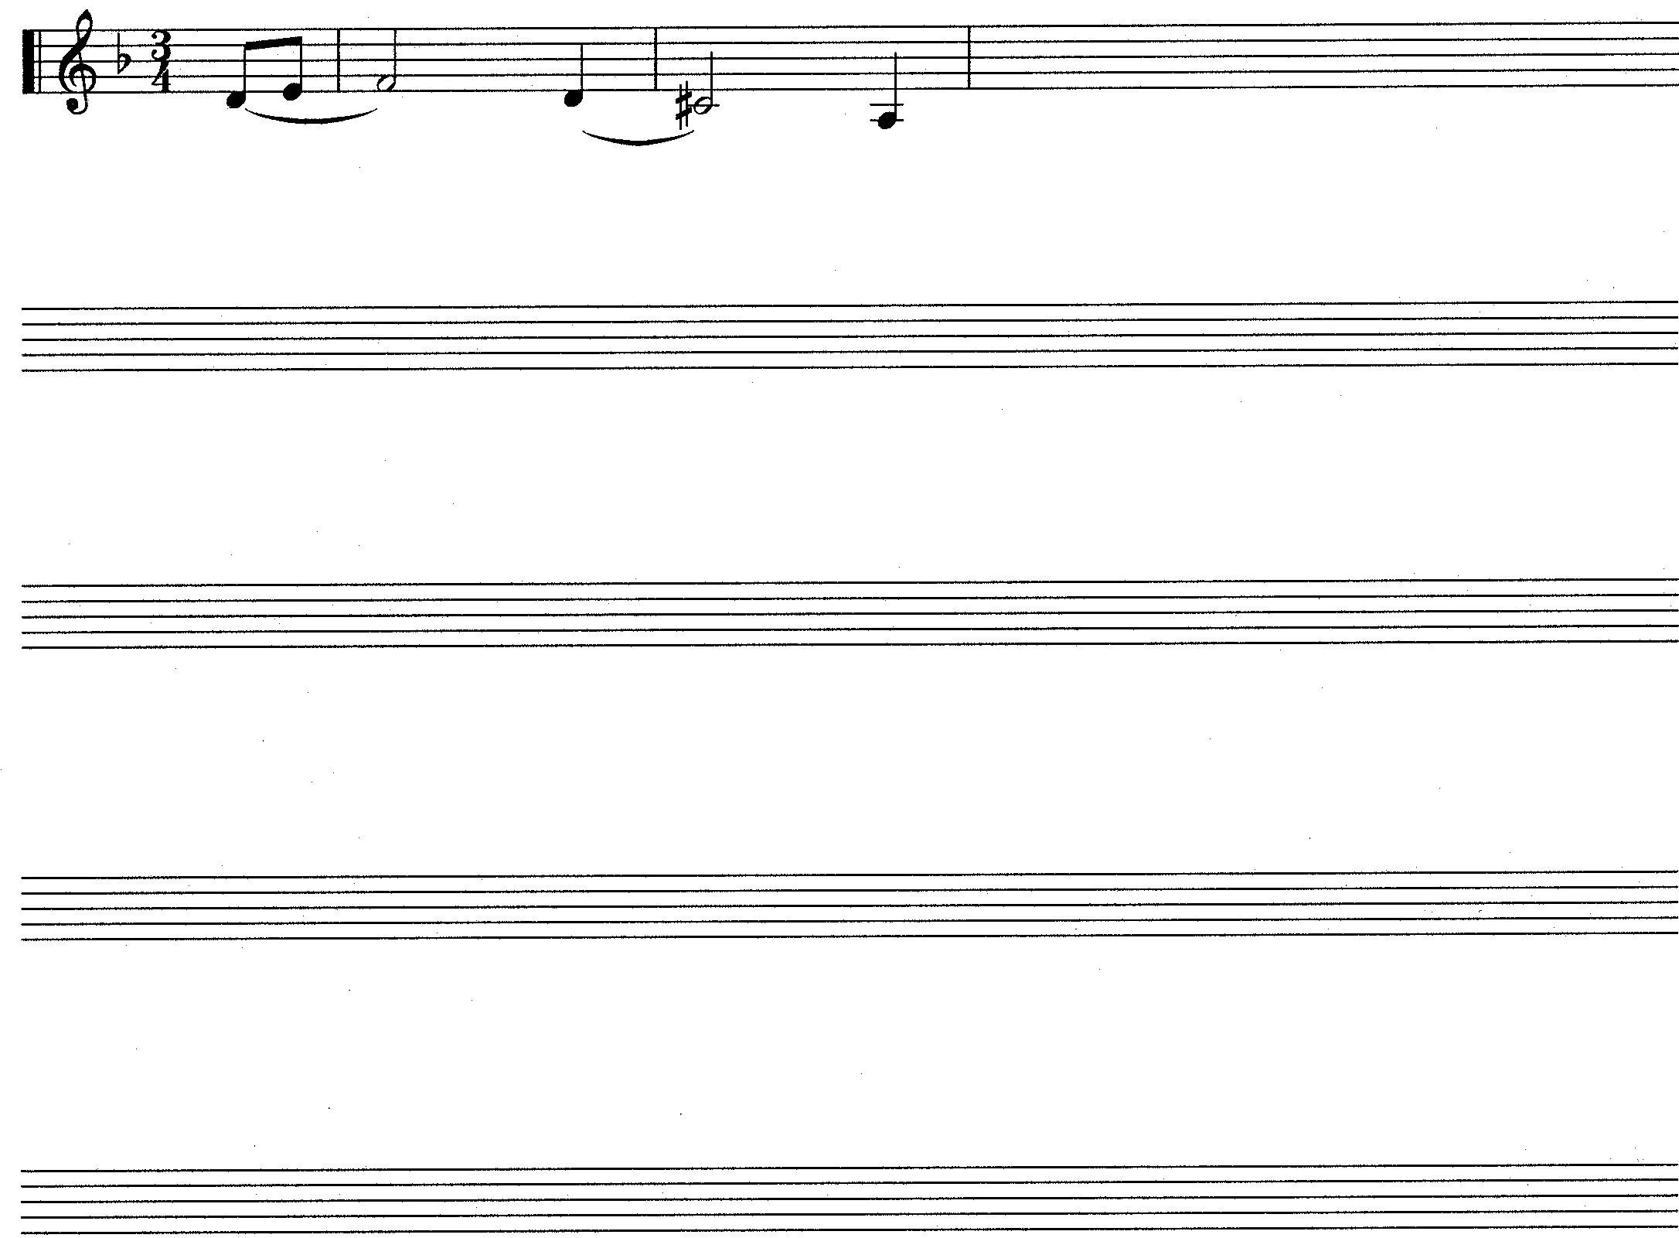  Voice / Instrument __________________ | (15)

QUESTION 3  1  (a)  (b)  (c)  (h)  (g)  (f)  (d)  (e)  5  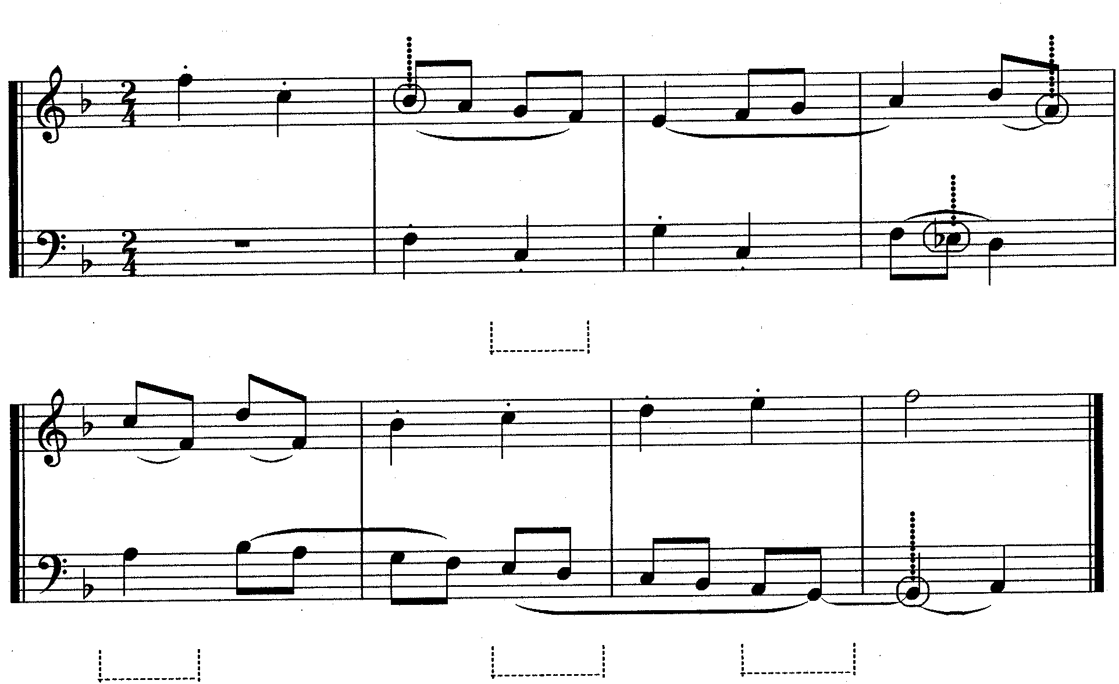  - Study the extract of a two-part counterpoint and answer the questions that follow:  - Provide harmonic analysis at (a) – (d). Indicate the key, chord and inversion in each case.  - What contrapuntal technique is used in bars 1 – 2? ___________________  - Name the non-harmonic notes or harmonic notes at (e) – (h).  (e) _____________________ (f) _____________________  (g) _____________________ (h) _____________________ |  | [25]  (4)  (2)  (4)
Complete the following passage in two-part counterpoint by adding the missing part. Continue in the style suggested by the given material.  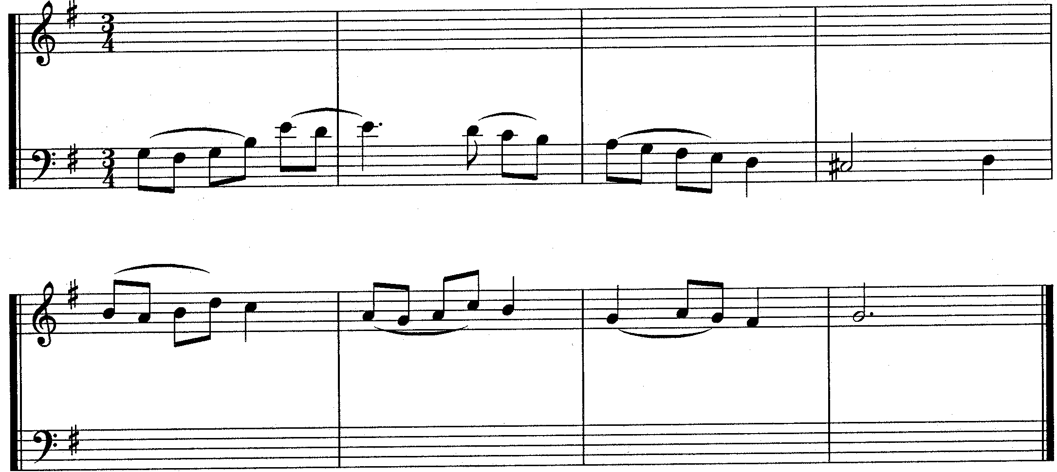 | (15)

QUESTION 4  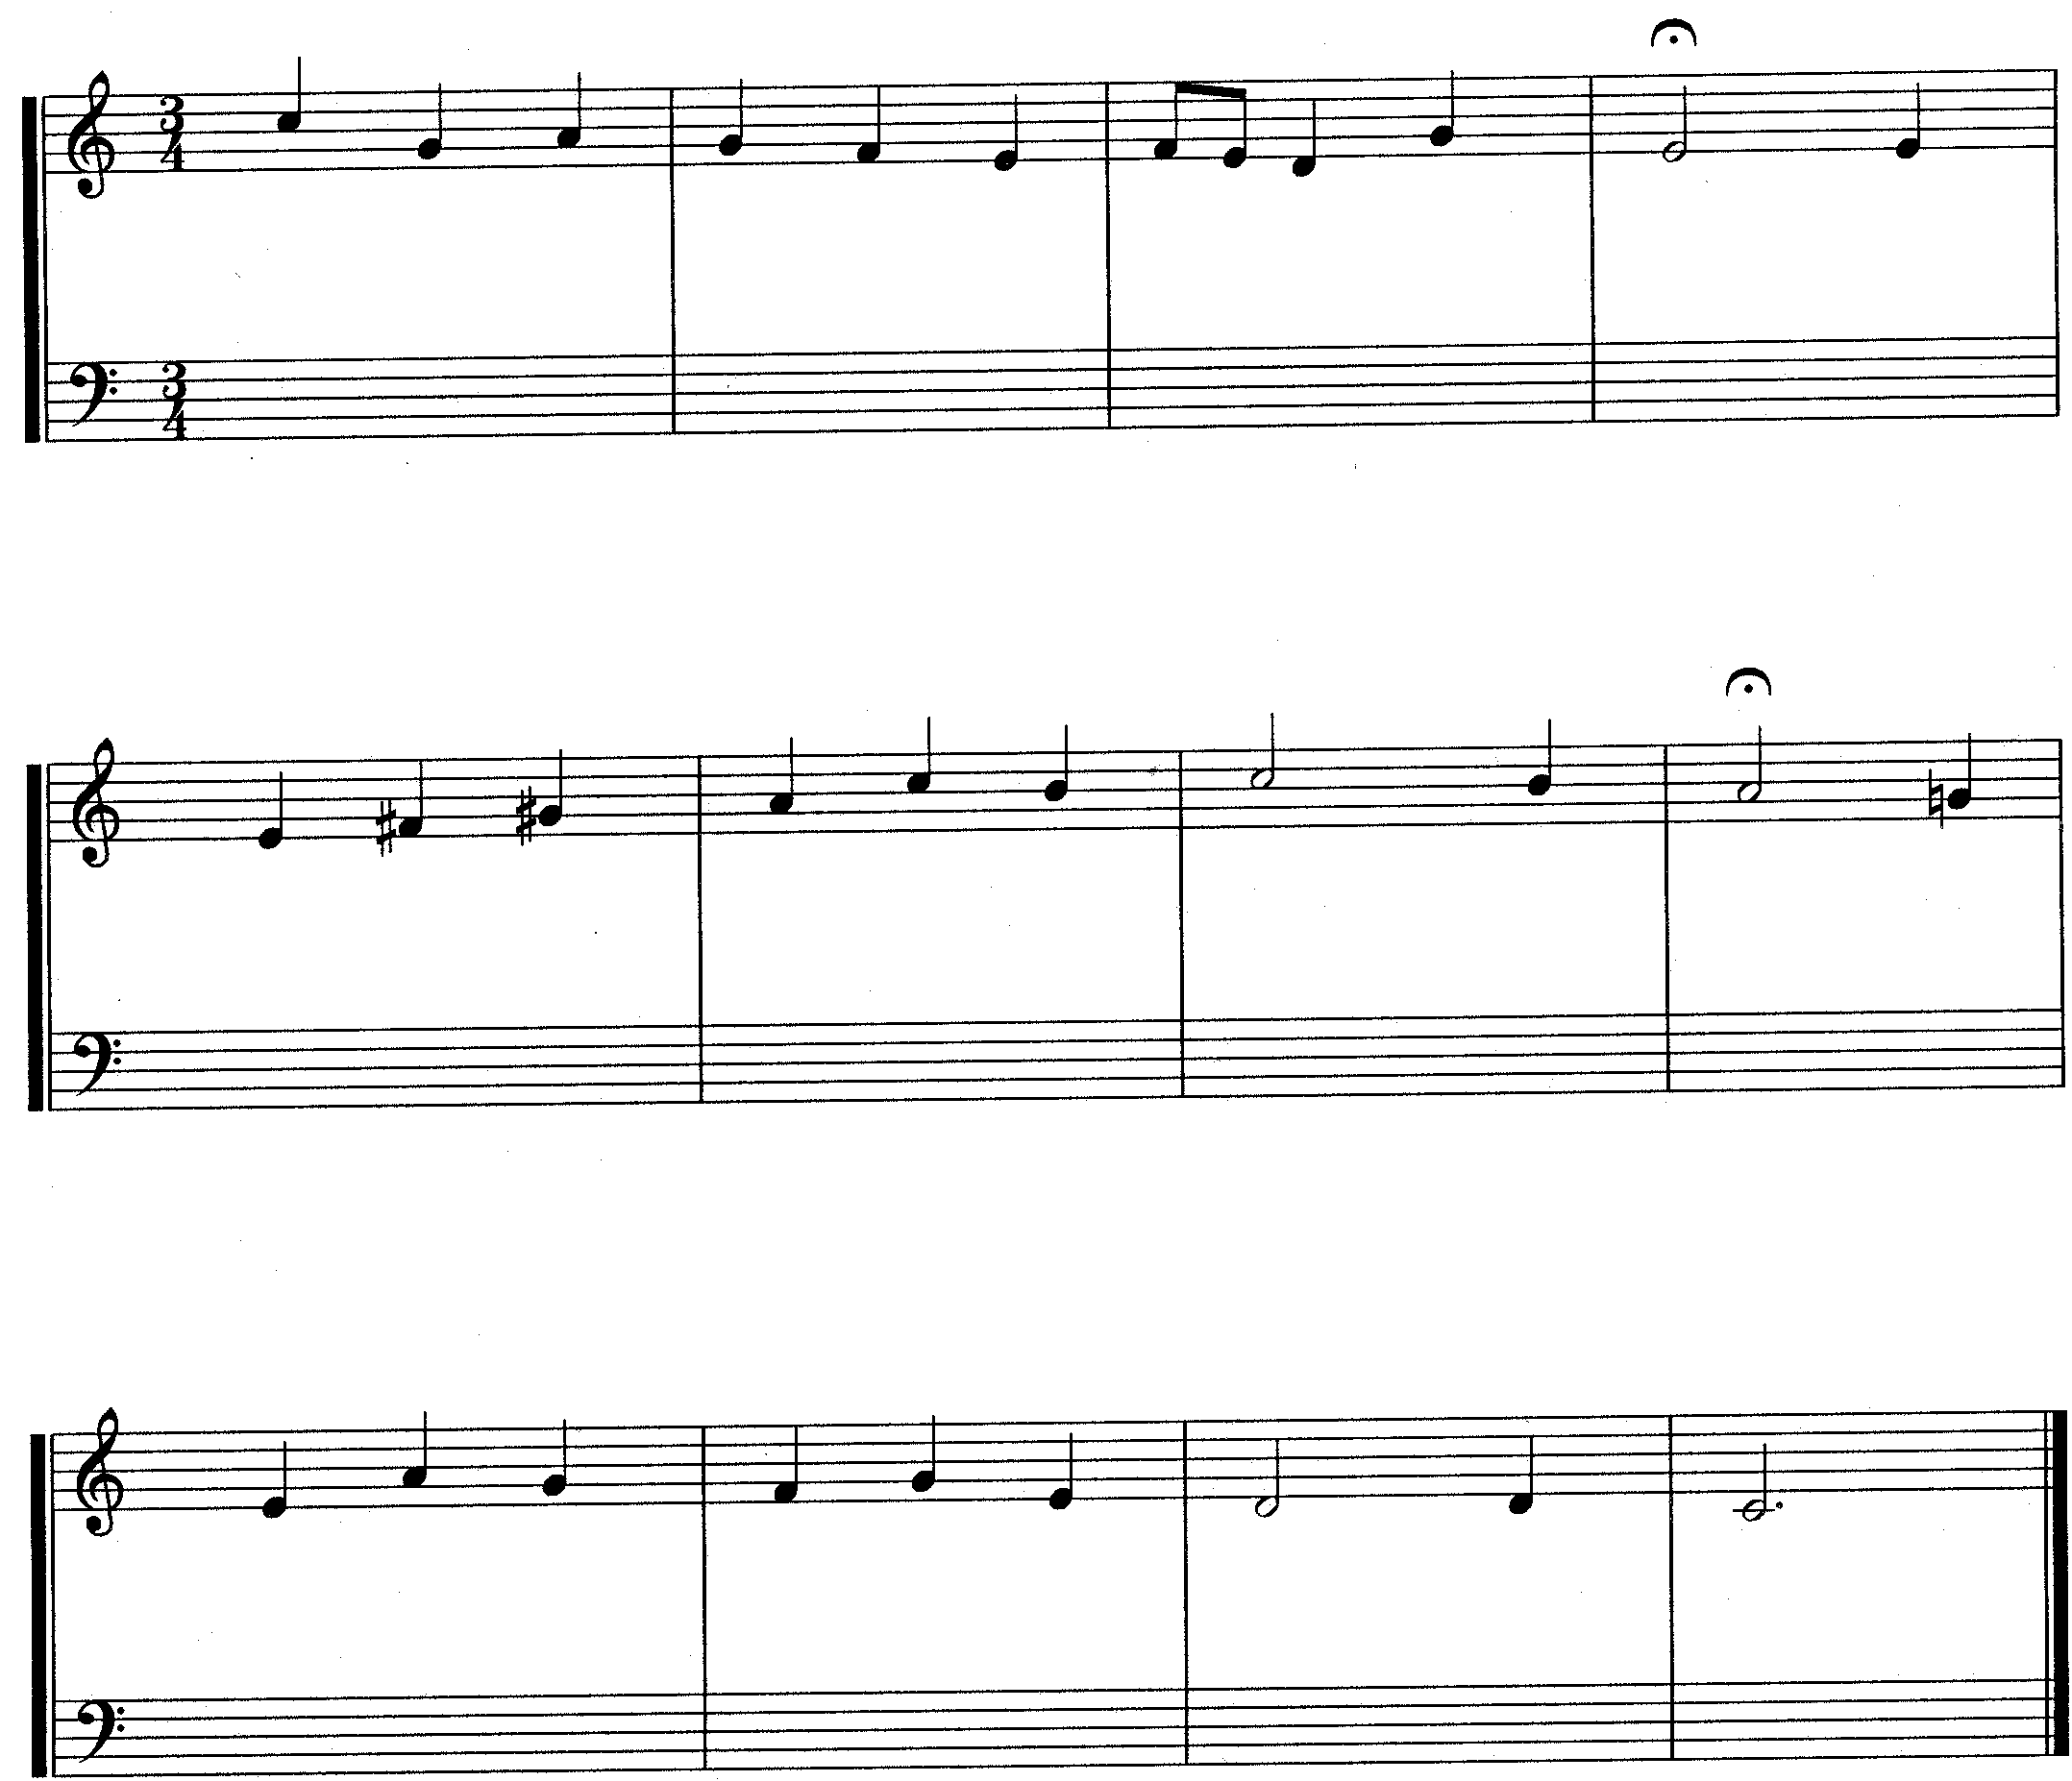  Harmonize the given soprano part for mixed choir (SATB). Use harmonic devices with which you are familiar. | [20]

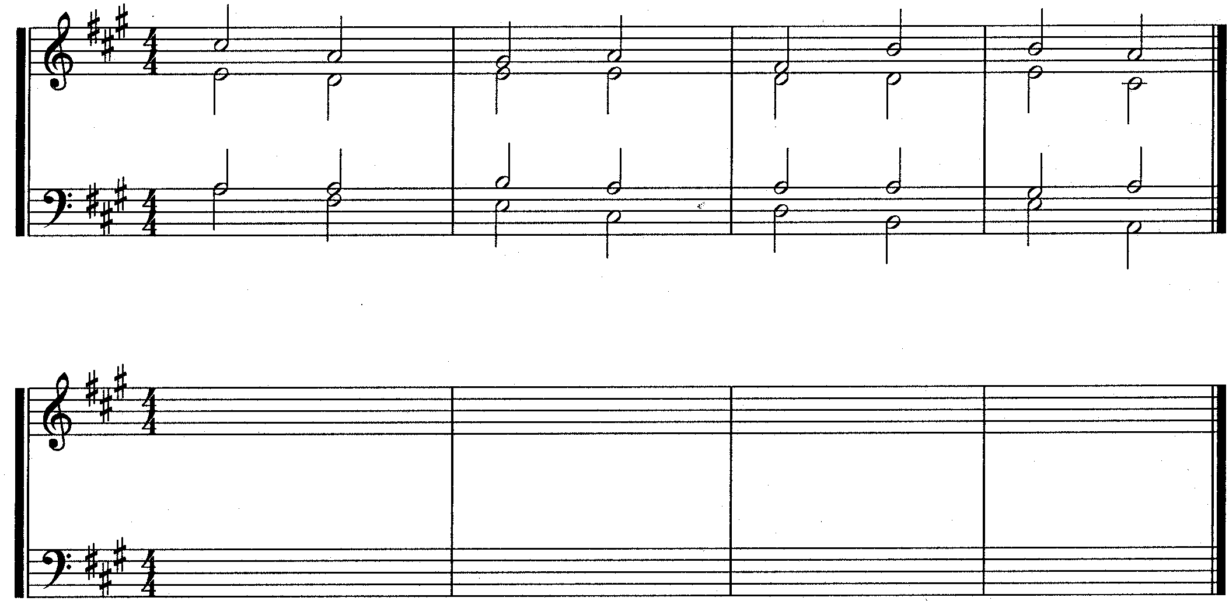  QUESTION 5  Fragment  Answer  Re-write the given harmonic fragment and insert the following harmonic features at suitable places. Label the answers clearly e.g. (a), (b), etc.  (a) An echappeè (escape note)  - Two suspensions  - An anticipation  - An accented passing note  - An upper auxiliary note  - A secondary dominant  - An interrupted cadence at the end | [10]  (1)  (2)  (1)  (1)  (1)  (2)  (2)

QUESTION 6  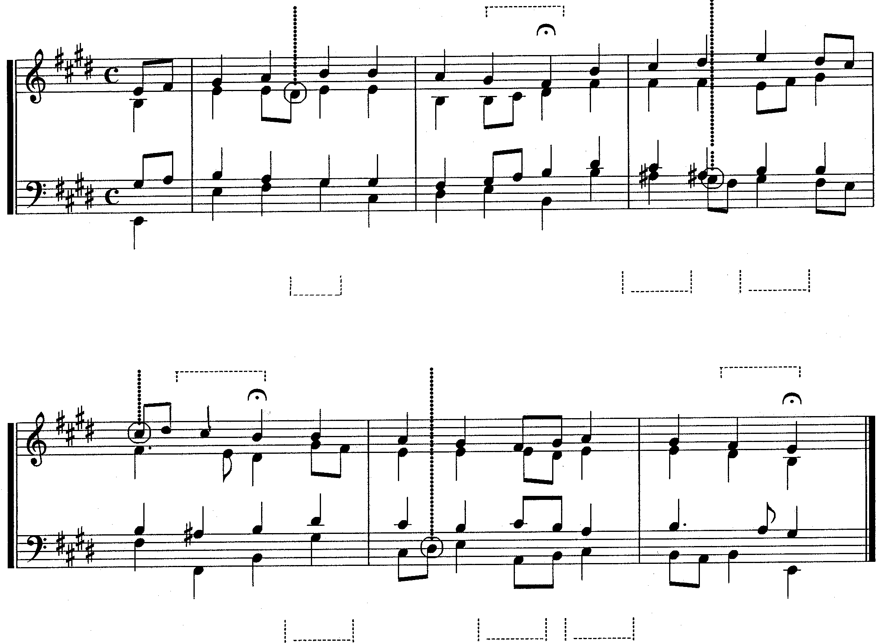  (j)  (k)  (g)  (b)  (a)  (c)  (m)  (l)  (h)  (i)  (e)  (f)  (d)  Study the given excerpt from a chorale and carry out the following instructions:  - Figure the harmonies (a) – (f). Indicate the key, chord and inversion for each.  - Name the cadences (g) – (i). Indicate the key and chord progression for each.  - Name the circled notes as non-harmonic notes or harmonic notes at (j) – (m).  Cadence (g) ________________________________  Cadence (h) ______________________________ Cadence (i) | [25]  (12)  (9)  (4)

Non-harmonic notes: | (j) | __________________________________________
 | (k) | __________________________________________
 | (l) | __________________________________________
 | (m) | __________________________________________
TOTAL: |  |  | 100

