GAUTENG DEPARTMENT OF EDUCATION
SENIOR CERTIFICATE EXAMINATION

MUSIC SG
(Second Paper)

TIME : 2 hours

MARKS : 75

INSTRUCTIONS:

Read the following instructions carefully before answering any questions.

- Answer ALL the questions in the answer book provided.
- Ensure that your answers are numbered clearly and correctly.
- Write your answers clearly and in ink.
- Question 1 is COMPULSORY.
- Answer any TWO questions from Question 2, 3 and 4.

QUESTION 1
COMPULSORY

- Name FIVE important aspects with regard to any three of the following subjects:  1.1.1 Gluck’s aims with regard to the reformation of the Italian style  - Der Ring des Nibelungen  - Sonata form in the Classical period  - Haydn and the symphony  - The chamber music of Béla Bartók  - The elements of timbre in the Classical period | (15)

1.2 Identify any FOUR of the following themes with regard to the

- genre.
- work in which the theme appears.
- style period which is represented (e.g. Classical).

1.2.1
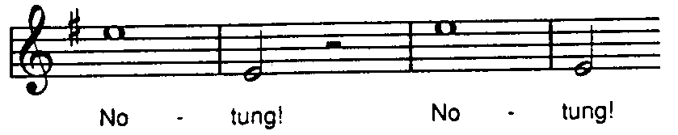

1.2.2
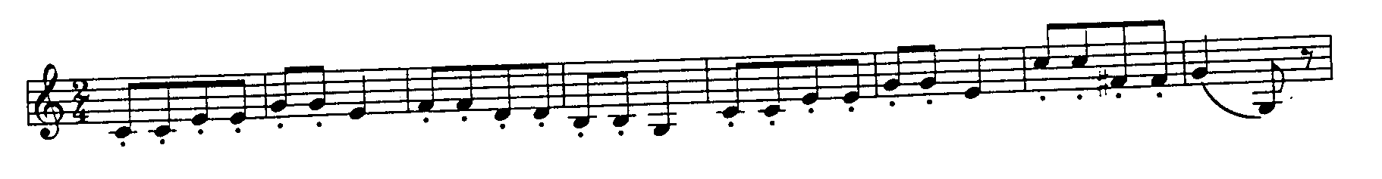

1.2.3
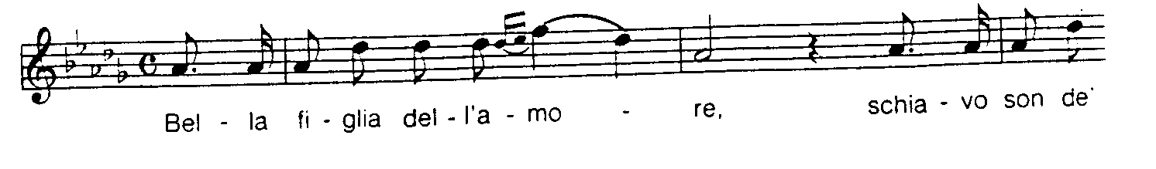

1.2.4
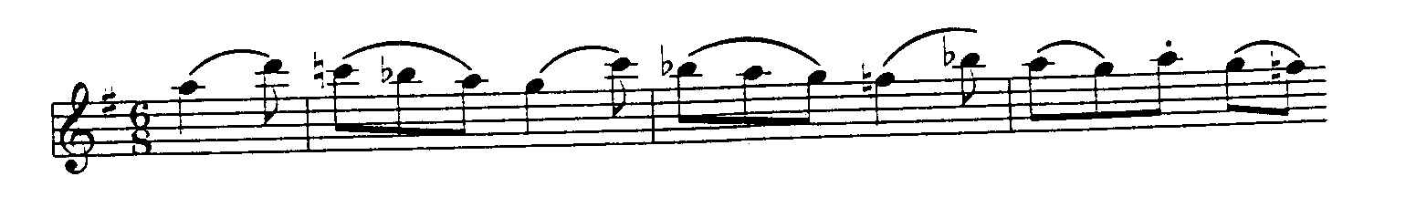

1.2.5
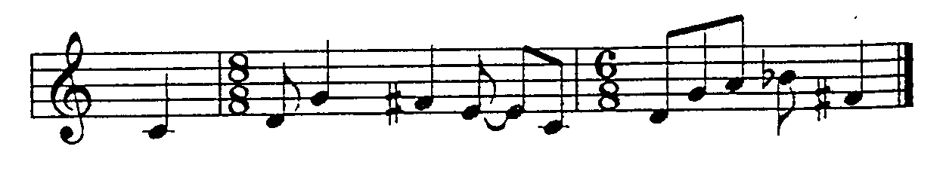

1.2.6
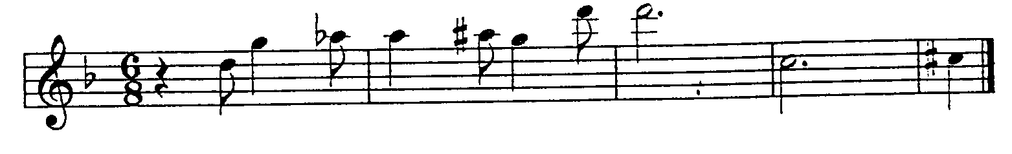

1.2.7
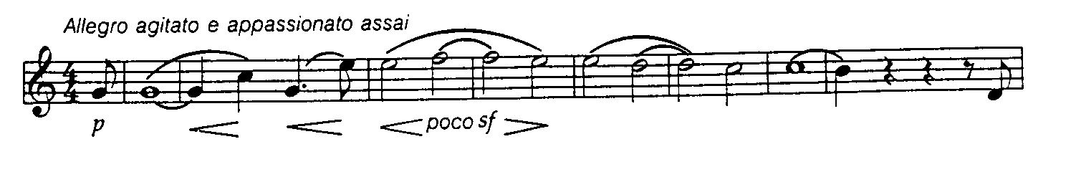

1.2.8  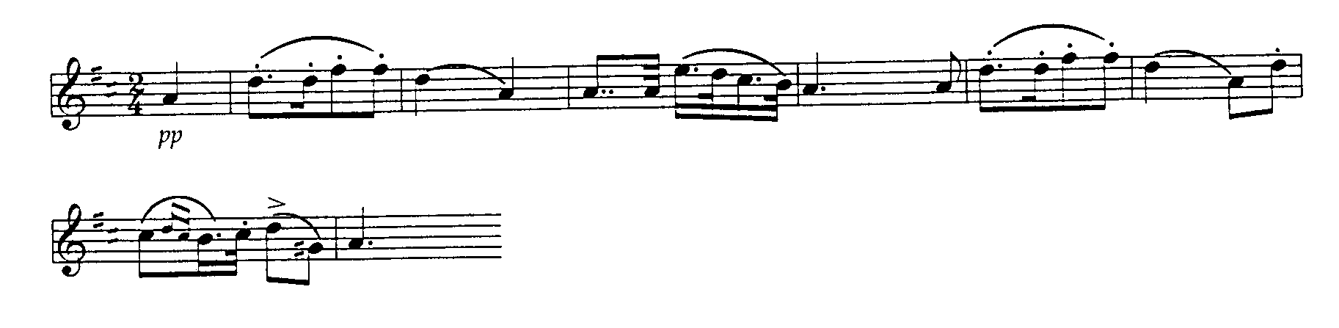 | (12)

1.3 Match any EIGHT works from Column A with a composer from Column B by writing a letter next to the corresponding question number. Composers may be repeated or omitted.

COLUMN A |  | COLUMN B | (8)
1.3.1  1.3.2  1.3.3  1.3.4  1.3.5  1.3.6  1.3.7  1.3.8  1.3.9  1.3.10  1.3.11  1.3.12  1.3.13 | Dumbarton Oaks Concerto  Symphony of Psalms  String quartet in F major Op. 18, No. 1  Falstaff  Piano quintet in A major  Parsifal  Symphonie Fantastique  Don Giovanni  Grande Messe des Morts  Don Pasquale  Les Préludes  Lucrezia Borgia  Arabella | - Stravinsky  - Beethoven  - Schubert  - Berlioz  - Liszt  - Strauss  - Donizetti  - Mozart  - Wagner  - Verdi | (8)

[35]

Answer any TWO questions from Questions 2,3 and 4.

QUESTION 2
OPERA

2.1 Are the following statements TRUE or FALSE? Indicate your answer by writing TRUE or FALSE in your answer book.

- Pietro Metastasio was a composer of the Florentine school.  - Euridice of Jacopo Peri is the earliest opera that has been preserved.  - Mozart’s comic operas contain both humorous and serious characters.  - Der Freischütz by Weber does not have any spoken dialogue.  - Wagner’s only comic opera was Parsifal. | (5)

2.2 Discuss Wagner’s operas with reference to:  - Philosophical theories of art  - Orchestra  - Leitmotif  - Harmony and tonality  - Gesamtkunstwerk | (15)  [20]

QUESTION 3
THE SYMPHONY AND SYMPHONIC POEM

3.1 Answer these questions by writing A, B, C or D in your answer book opposite the number of the question:

3.1.1 The third movement of Haydn’s Simphony No. 94 in G major is in

- sonata form.
- minuet and trio.
- rondo form.
- binary form.

3.1.2 The Pastoral Symphony by Beethoven contains the following elements:

- neoclassicism
- program music
- thematic transformation
- early classical elements

3.1.3 Idée fixe occurs in

- Les Preludes.
- the Symphony of Psalms.
- the Surprise Symphony.
- the Symphonie Fantastique.

3.1.4 The Faust Symphony is a

- five-movement program symphony.
- classical symphony.
- symphonic poem by Liszt.
- symphony by Beethoven.

3.1.5 Beethoven uses a choir and four soloists in his

- Symphony no. 5.  - Symphony no. 9.  - Fate Symphony.  - Pastoral Symphony. | (5)

Stravinsky’s composition styles and techniques changed considerably from c. 1910 to c. 1960 – perhaps more so than that of any other composer’s styles.  Describe Stravinsky’s creative period known as back to Bach in a letter to a friend who is a music lover. | (15)  [20]

QUESTION 4
CHAMBER MUSIC

4.1 Write the missing words in your answer book.

- The earliest string quartets of Haydn and his contemporaries were called __________ (music for entertainment).  - The subtitle of Haydn’s String Quartet in C major, Op. 76. no. 3 is __________.  - Franz Schubert wrote a number of chamber music works that are based on themes from __________ his art.  - Bartók’s compositional technique is very dependent on the development of __________.  - Beethoven’s Grosse Fuge for string quartet is a gigantic __________. | (5)

4.2 Write an article for the music centre’s newsletter in which Beethoven’s string quartets are discussed. | (15)  [20]

TOTAL: | 75

