GAUTENG DEPARTMENT OF EDUCATION

SENIOR CERTIFICATE EXAMINATION

MUSIC SG
(First Paper: Harmony and Composition)

TIME: 3 hours

MARKS: 75

REQUIREMENTS

- Each candidate must be supplied with THREE sheets of music manuscript paper.

- Pianos must be available to the candidates for the full duration of the examination.

- No candidate may, however, disturb another candidate, nor share the use of a piano at any particular time.

INSTRUCTIONS

- This examination paper also serves as an answer book.

- Write your examination number clearly on this answer book.

- Ensure that your notation is clear and unambiguous.

- Answer either Question 1 OR Question 2, then answer ALL the other questions.

Answer either Question 1 OR Question 2.

QUESTION 1

Set ONE of the following poems to music. Choose a suitable voice type, key and metre. Clearly write the text below the melodic line.

Herinnering

As kind het’k eens die maan se ronde skyf
langsaam sien uitswel bo die silwer vlei
om saggies soos ŉ seepbel weg te dryf
en tussen yl popliere in te gly.

(Elizabeth Eybers)

OR

The Witch’s Garden

In the witch’s garden
The gate is open wide.
Come inside, come inside
See my lovely poison ivy.

(Lilian Moore)

Voice Type: _____________________________________

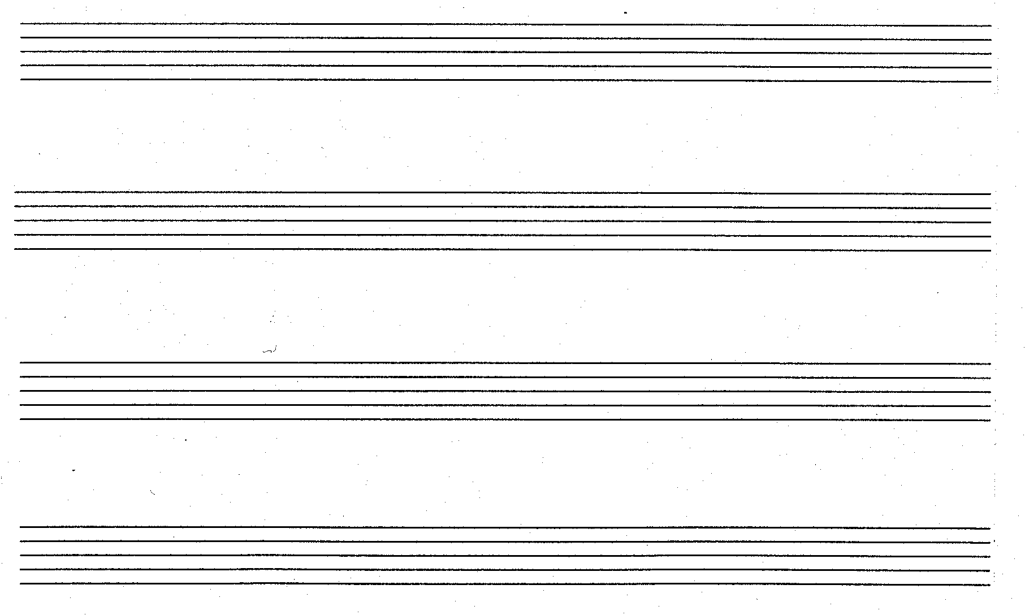

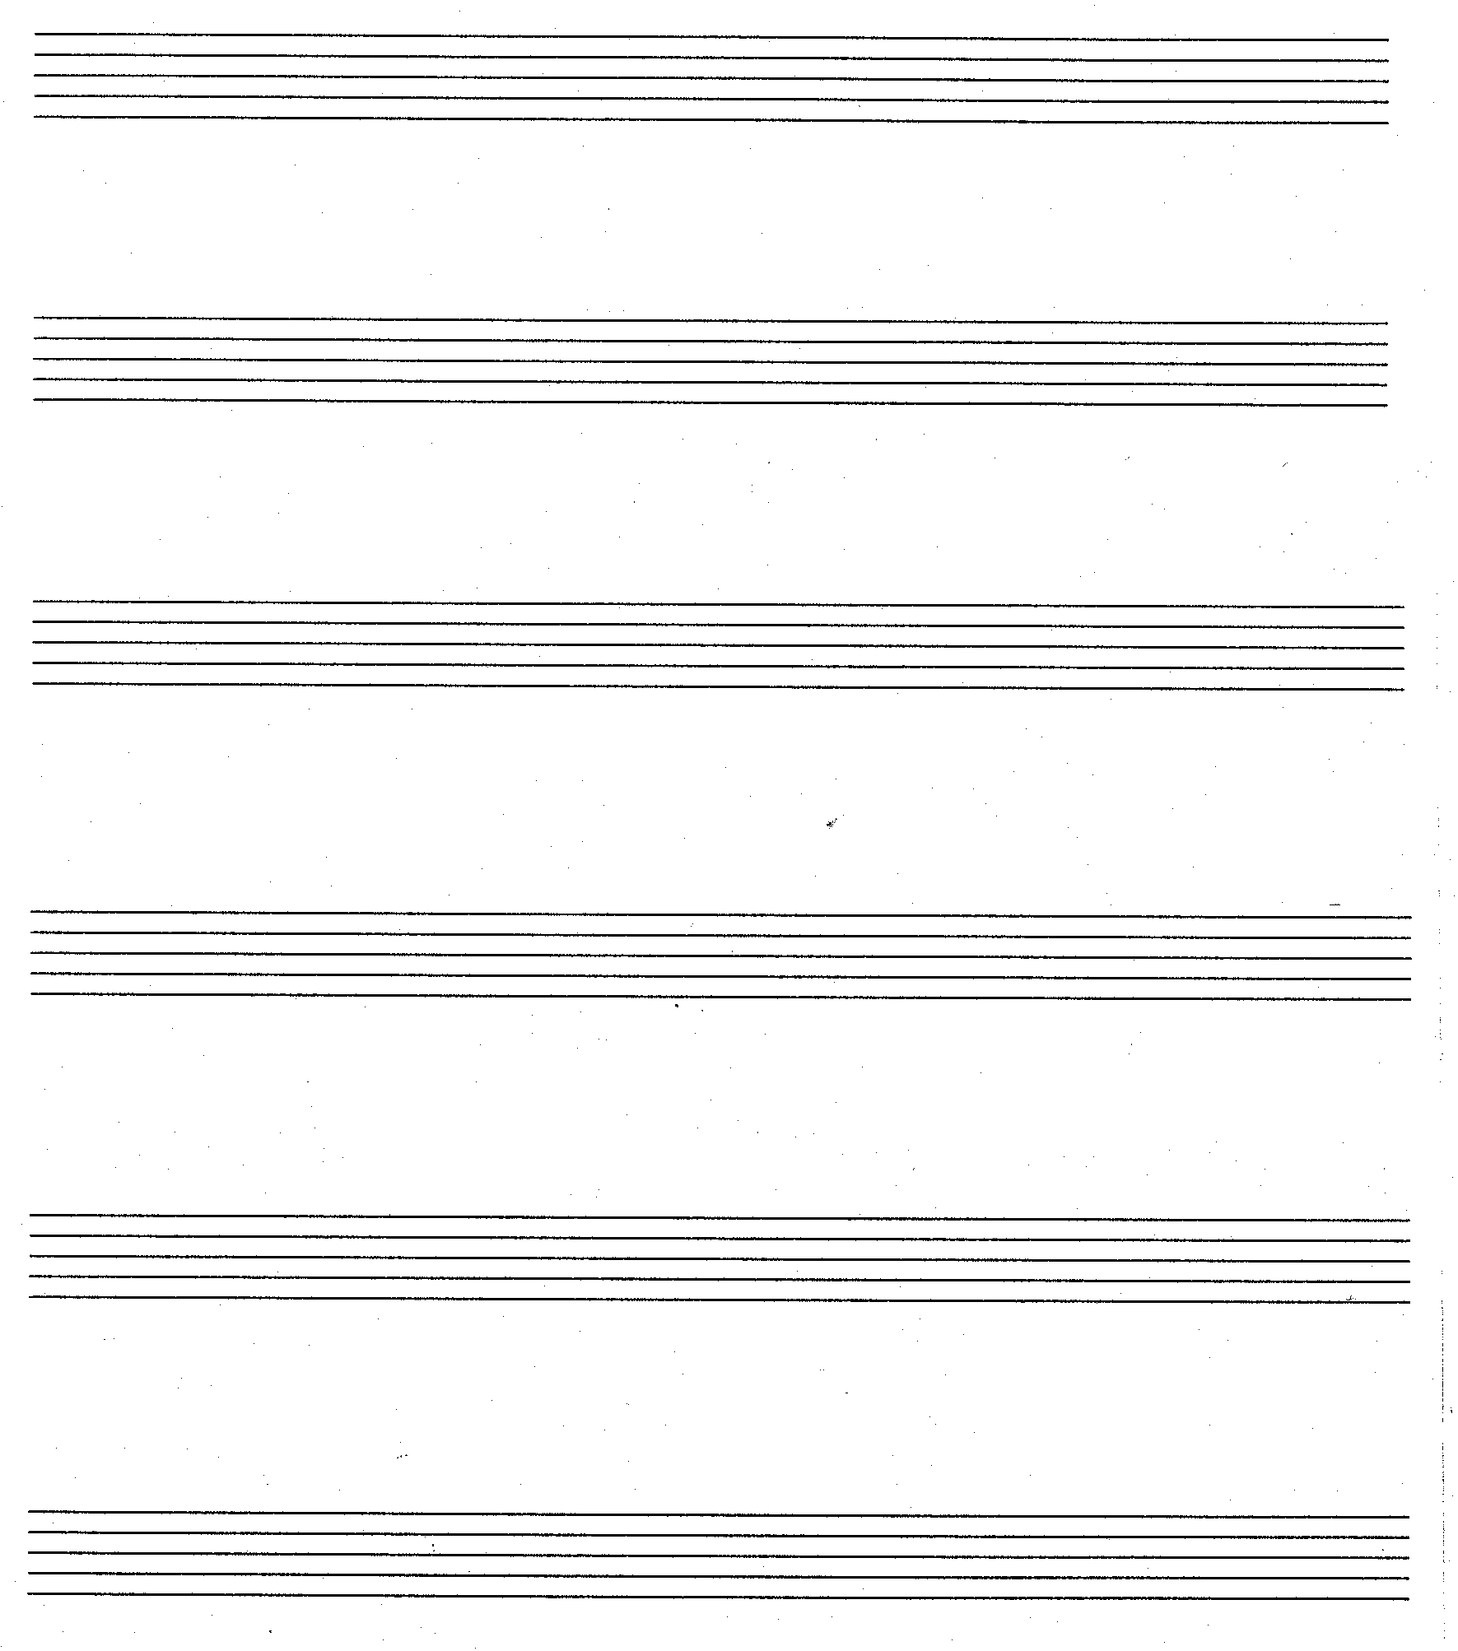 | [15]

OR

QUESTION 2

Extend the given opening to a symmetrical eight bar melody. Indicate for which voice type or instrument the melody is intended. Indicate the tempo above bar 1 and insert indications of interpretation.

Voice type or instrument ________________________________________

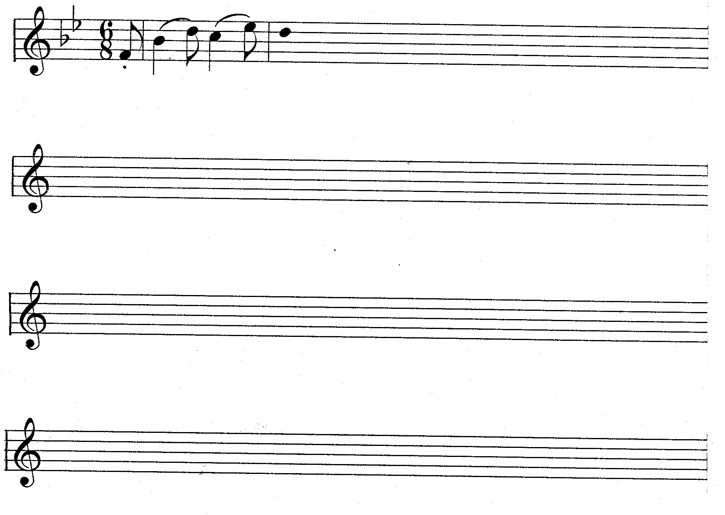 | [15]

Answer ALL the questions that follow.

QUESTION 3

3.1 Complete the two-part passage in polyphonic style according to the instructions.
*
- Use suitable motives to complete the five sections indicated by the .  - Harmony notes as well as non-harmonic notes may be used. | (5)

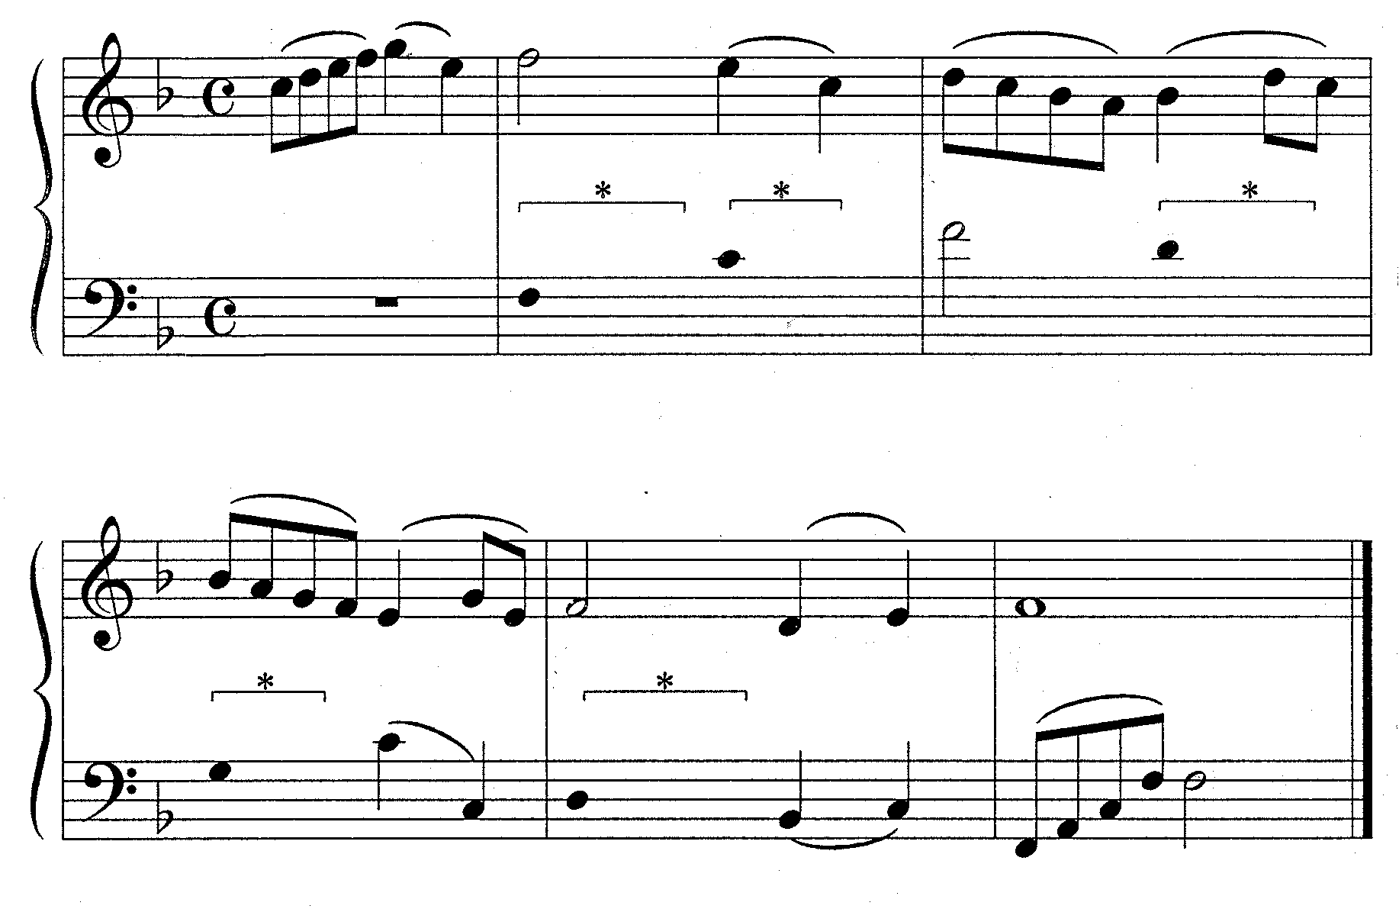

3.2 Complete the following passage in two-part contrapuntal style by adding the missing part. Retain the style characteristics of the given material. | (15)

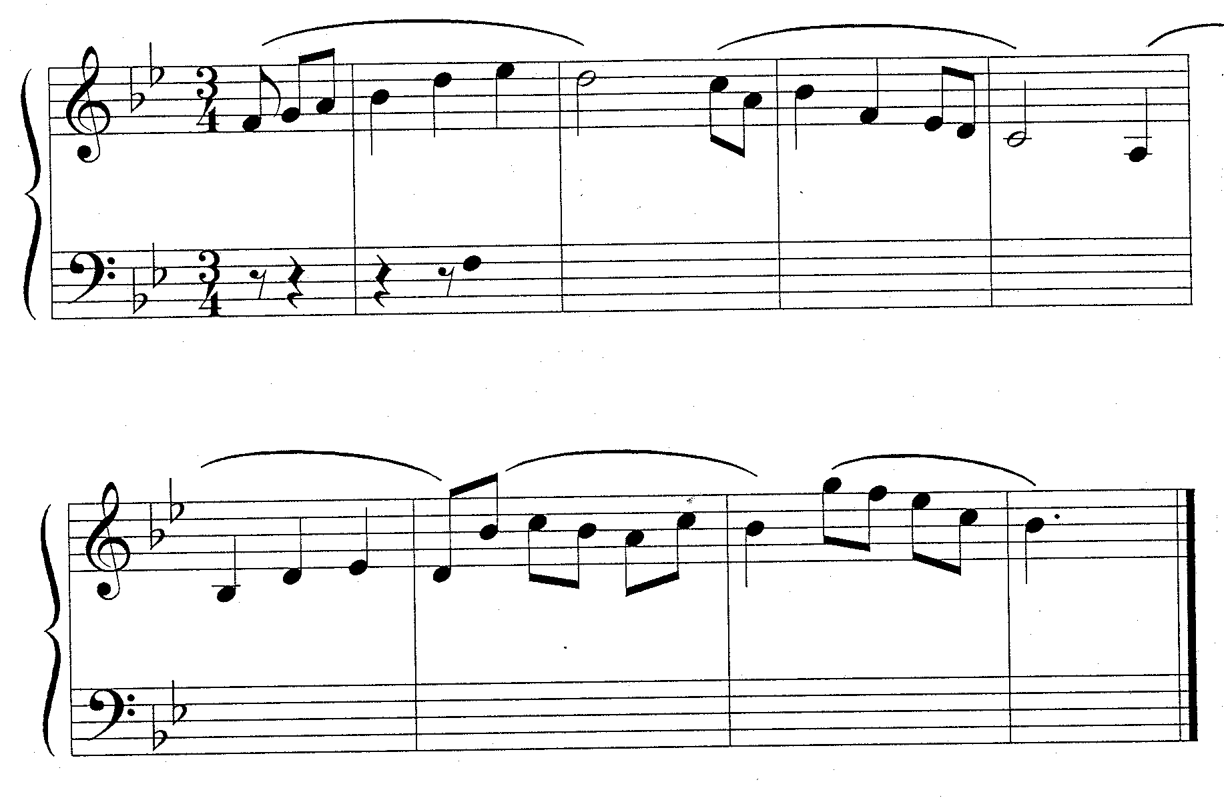 | [20]

QUESTION 4

Harmonise the soprano part for mixed choir (SATB).

- A slur over two or three notes of the soprano part indicates that only one chord should be used for these notes.

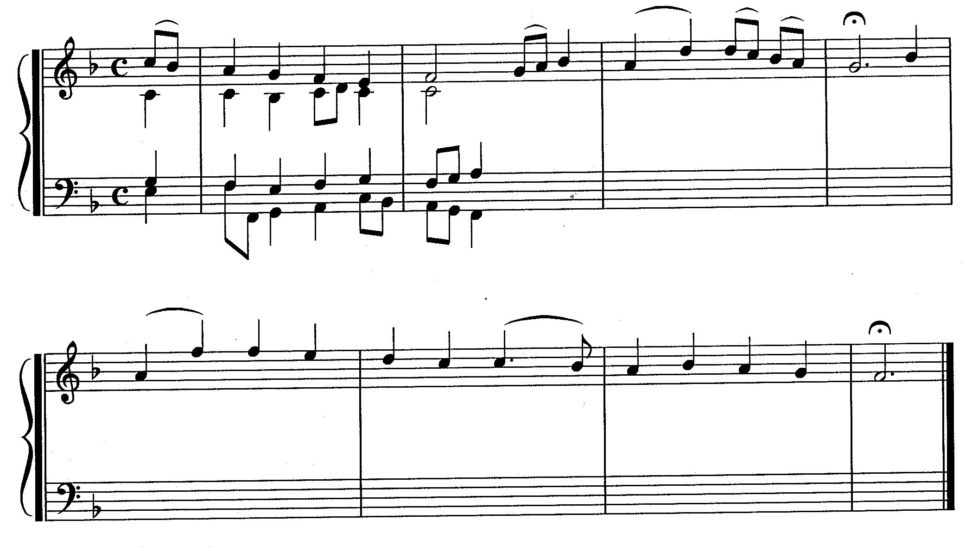 | [20]

QUESTION 5

Write the following chords in four-part harmony:

- Bar 1³: the dominant seventh in first inversion.  - Bar 2¹ˉ²: a chord in second inversion (six-four chord) with an accented passing note in the soprano.  - Bar 2⁴: add the seventh to the dominant triad. | (2)  (2)  (1)
*
*
*
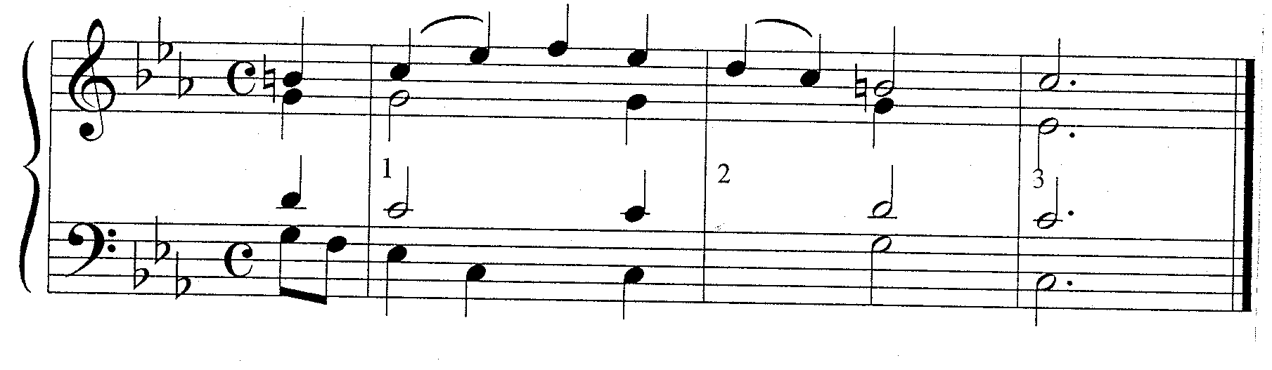 | [5]

QUESTION 6

Study the following extract from a chorale and answer the questions that follow.

- Name the keys and figure the chords at (a) (b) and (c). E.g. F:Vb or V6.  (d)  - Identify the cadences at (d), (e) and (f). Specify the key, chord progression and cadence type. E.g. F: IV – I, plagal cadence.  - Name the non-harmonic notes (g) (h) and (i).  (g)_________________________________  (h)_________________________________  (i)__________________________________ | (6)  (6)  (3)

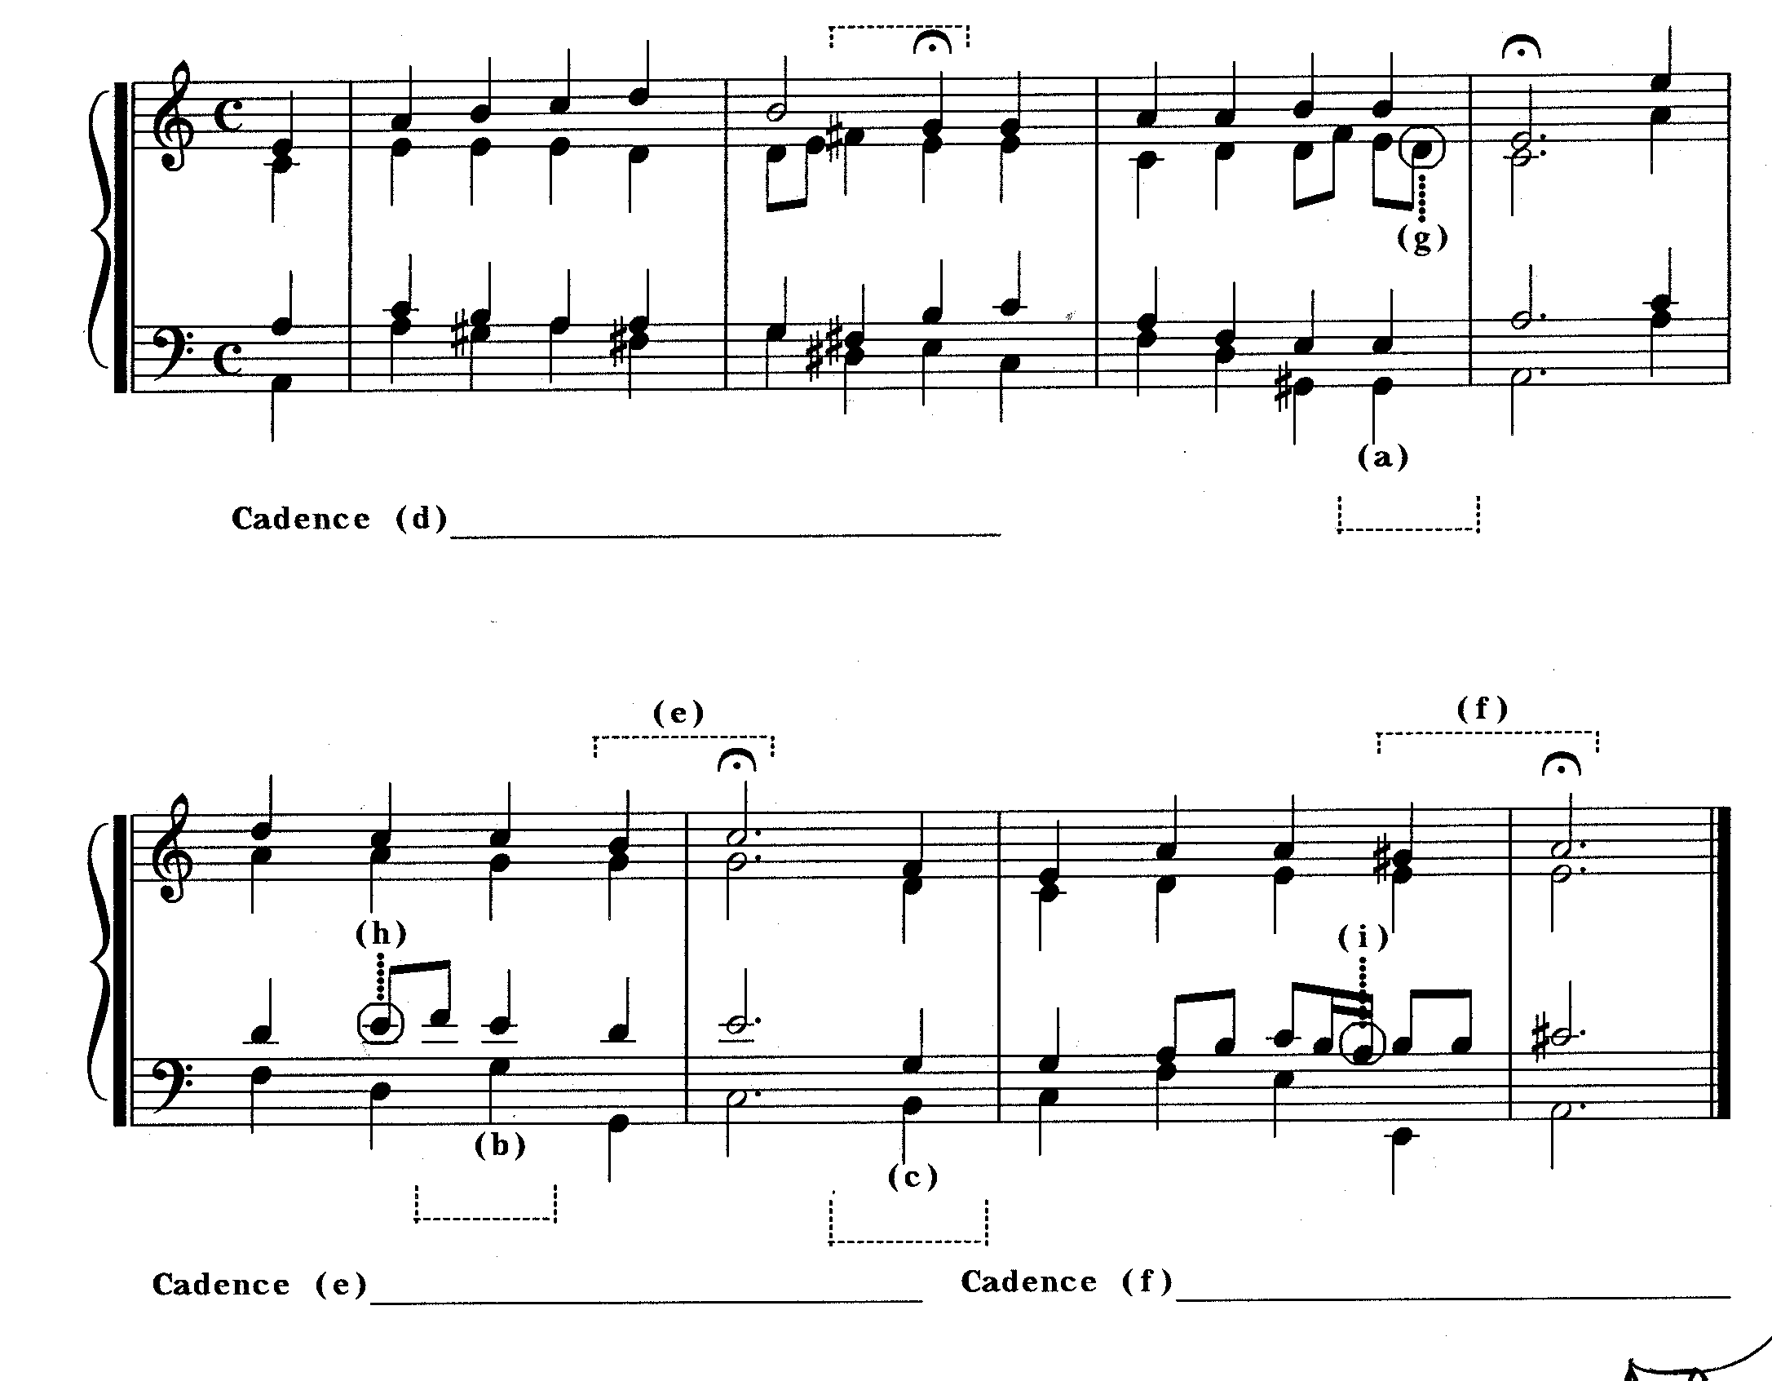  Cadence  Cadence  Cadence  TOTAL: | (15)  75

