GAUTENG DEPARTMENT OF EDUCATION

SENIOR CERTIFICATE EXAMINATION

MUSIC SG
(First Paper: Harmony and Composition)

TIME: 3 hours

Marks: 75

REQUIREMENTS:

- Each candidate must be supplied with THREE sheets of music manuscript paper.

- Pianos must be available to the candidates for the full duration of the examination. No candidate may, however, disturb another candidate, nor share the use of a piano at any particular time.

INSTRUCTIONS:

- This examination question book also serves as an answer book.

- Write your examination number clearly on this answer book.

- Ensure that your notation is clear and unambiguous.

- Answer EITHER Question 1 OR Question 2, then answer ALL the other questions.

Answer either Question 1 OR Question 2.

QUESTION 1

Set ONE of the following poems to music. Choose a suitable voice type, key and metre. Clearly write the text below the melodic line.

Die Vlinder

Vang vir jou ’n vlinder en hou hom saggies vas,
droom die mooiste drome wat by ’n vlinder pas.
Droom van blommevelde wat in die sonlig staan,
en los dan weer jou vlinder om daarheen terug te gaan.

(Alba Bouwer)

OR

Ballad

Oh my love is like a red, red rose
That’s newly sprung in June;
Oh my love is like the melody
That’s sweetly played in tune.

(Robert Burns)

Voice :____________________________

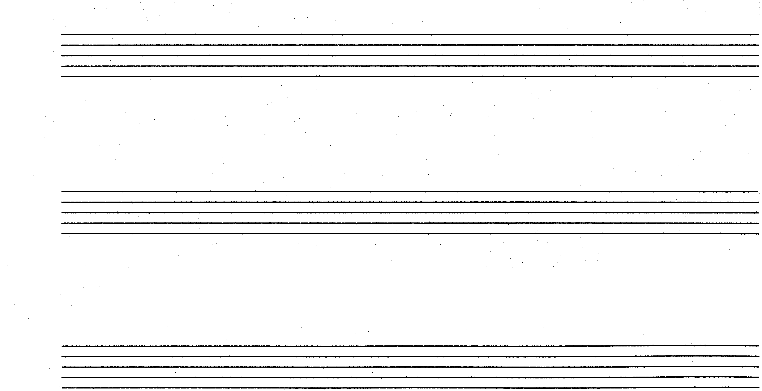

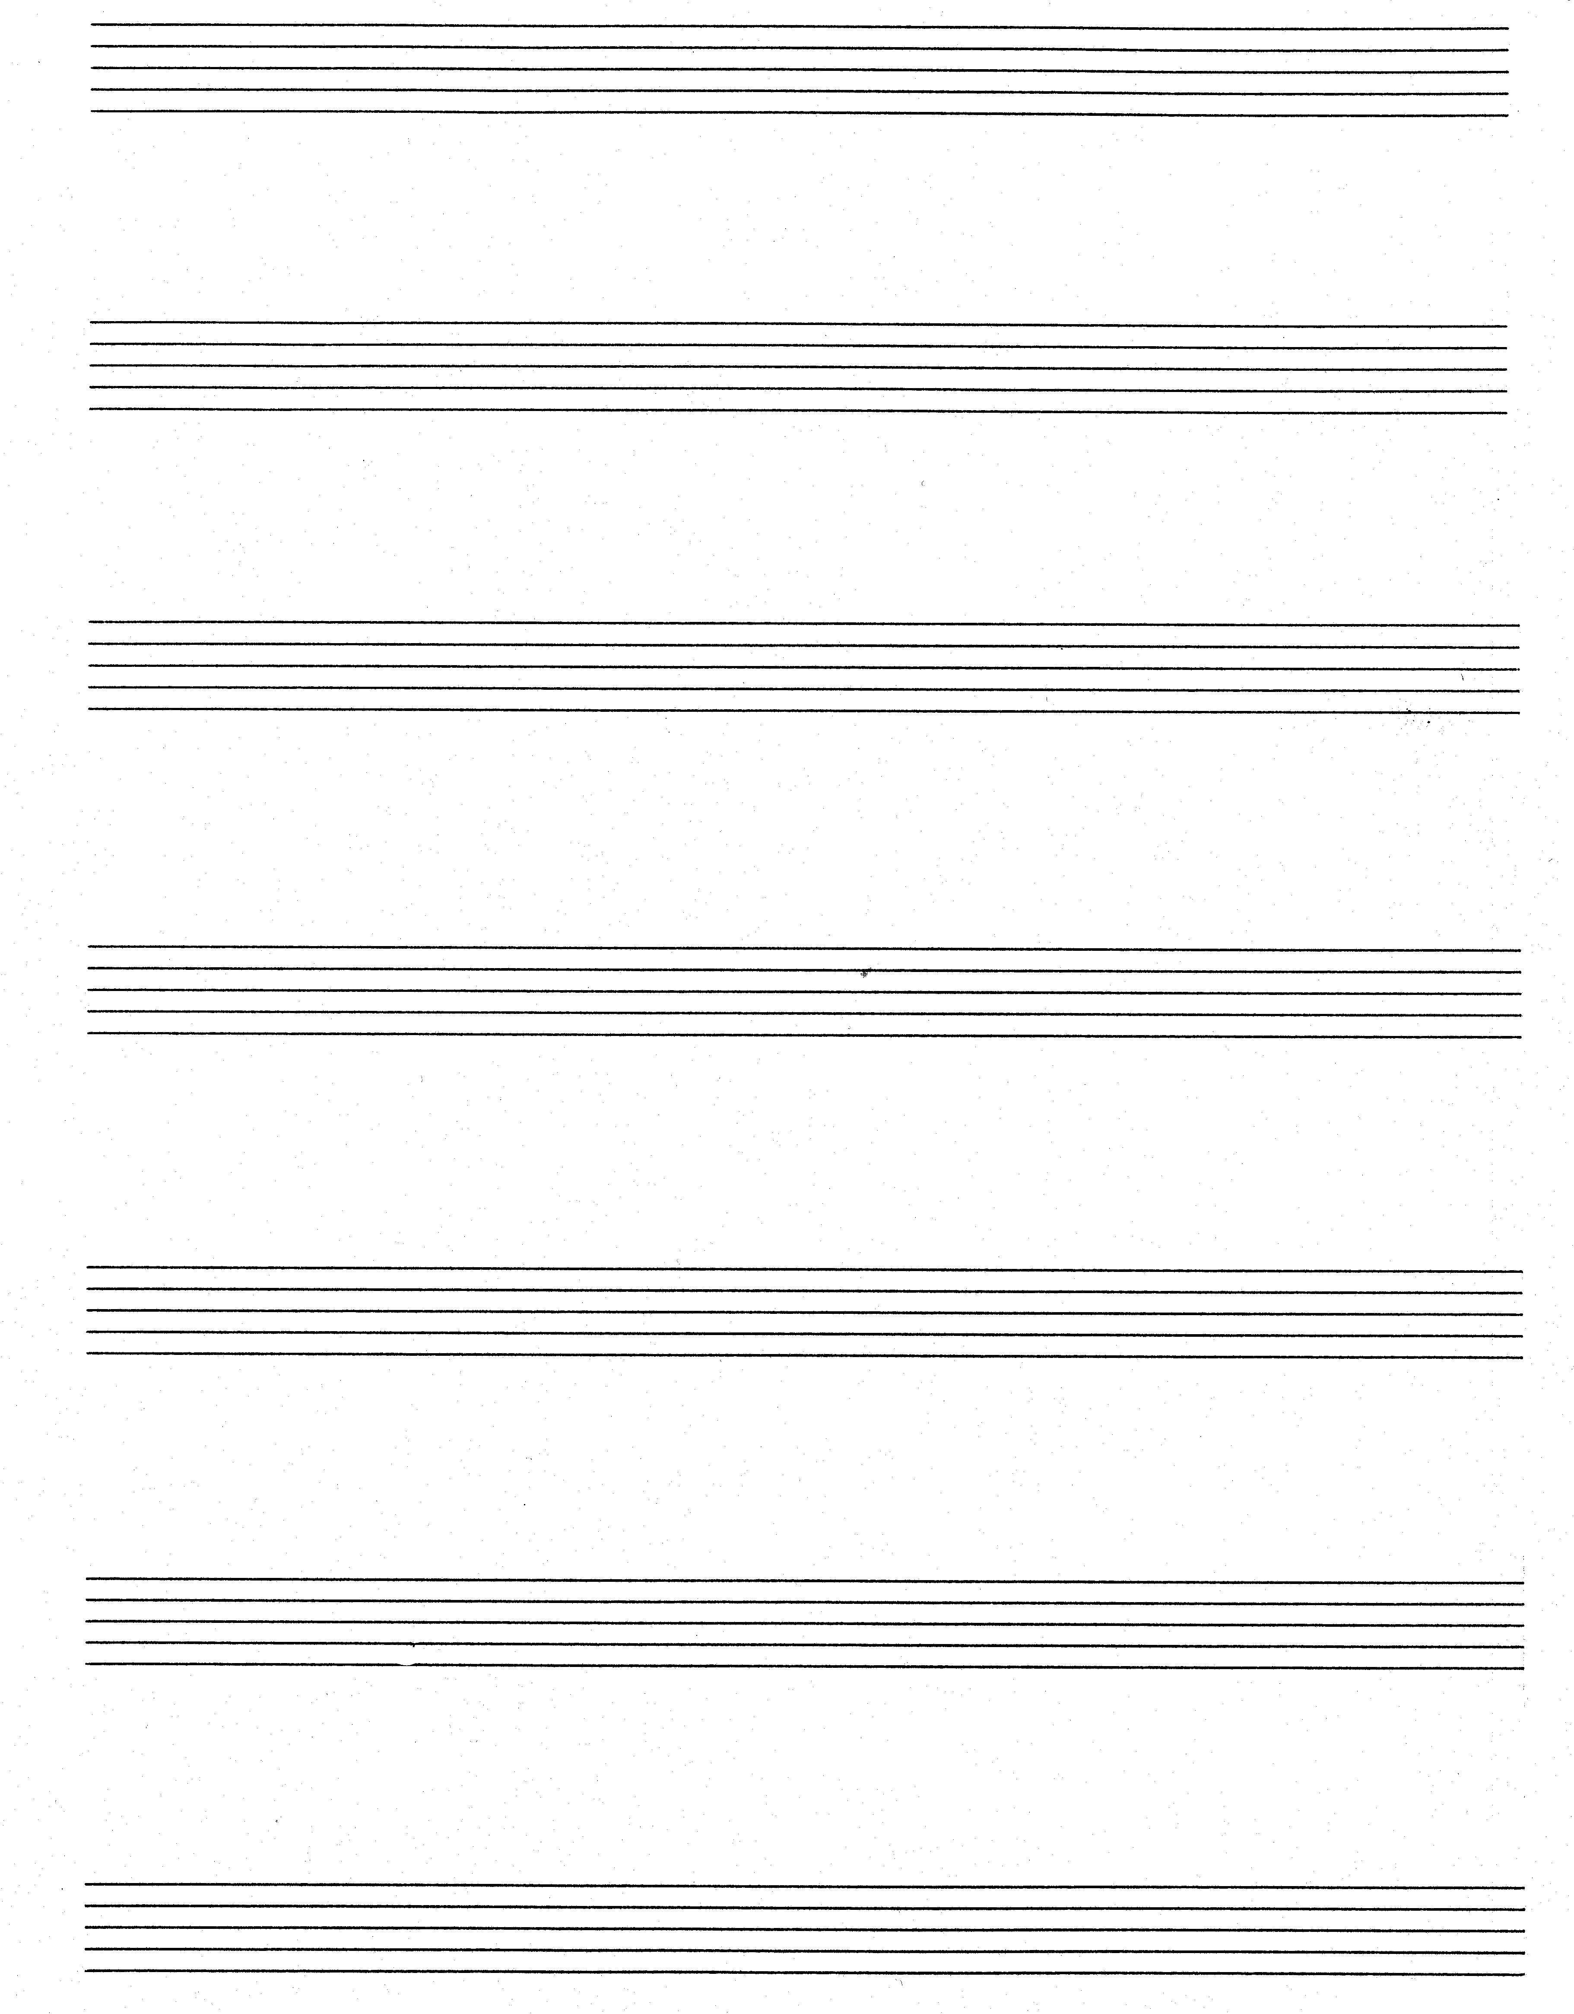

OR  QUESTION 2  Extend the given opening to a symmetrical eight bar melody. Indicate for which voice type or instrument the melody is intended. Indicate the tempo above bar 1 and insert indications of interpretation.  Voice type or instrument :_____________  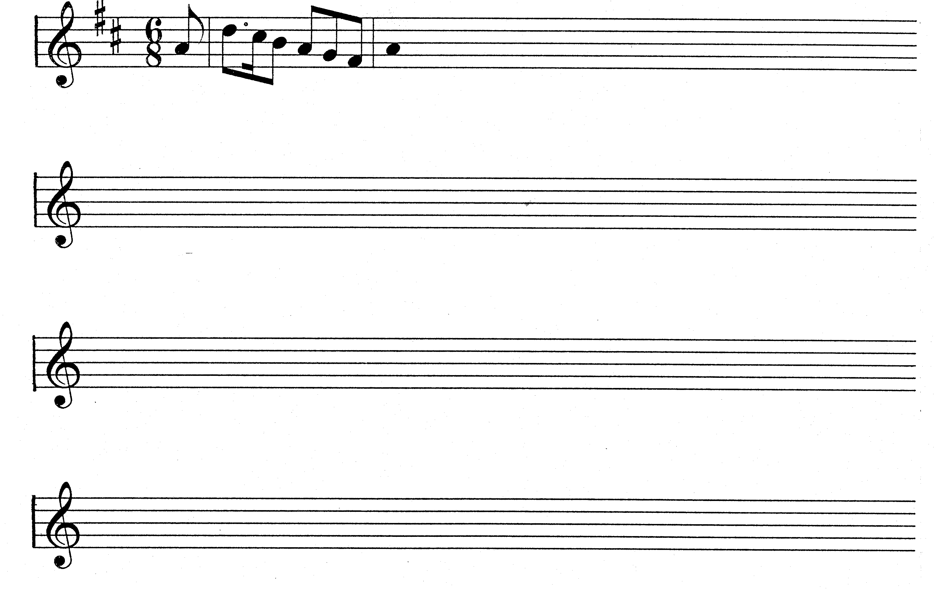 | [15]

Answer ALL the questions that follow.  *  QUESTION 3  - Complete the two-part passage in polyphonic style according to the instructions:  - Use a rest for the duration of the first bar.  - Use suitable motives to complete the four sections indicated by the . .  - Harmony notes as well as non-harmonic notes may be used.  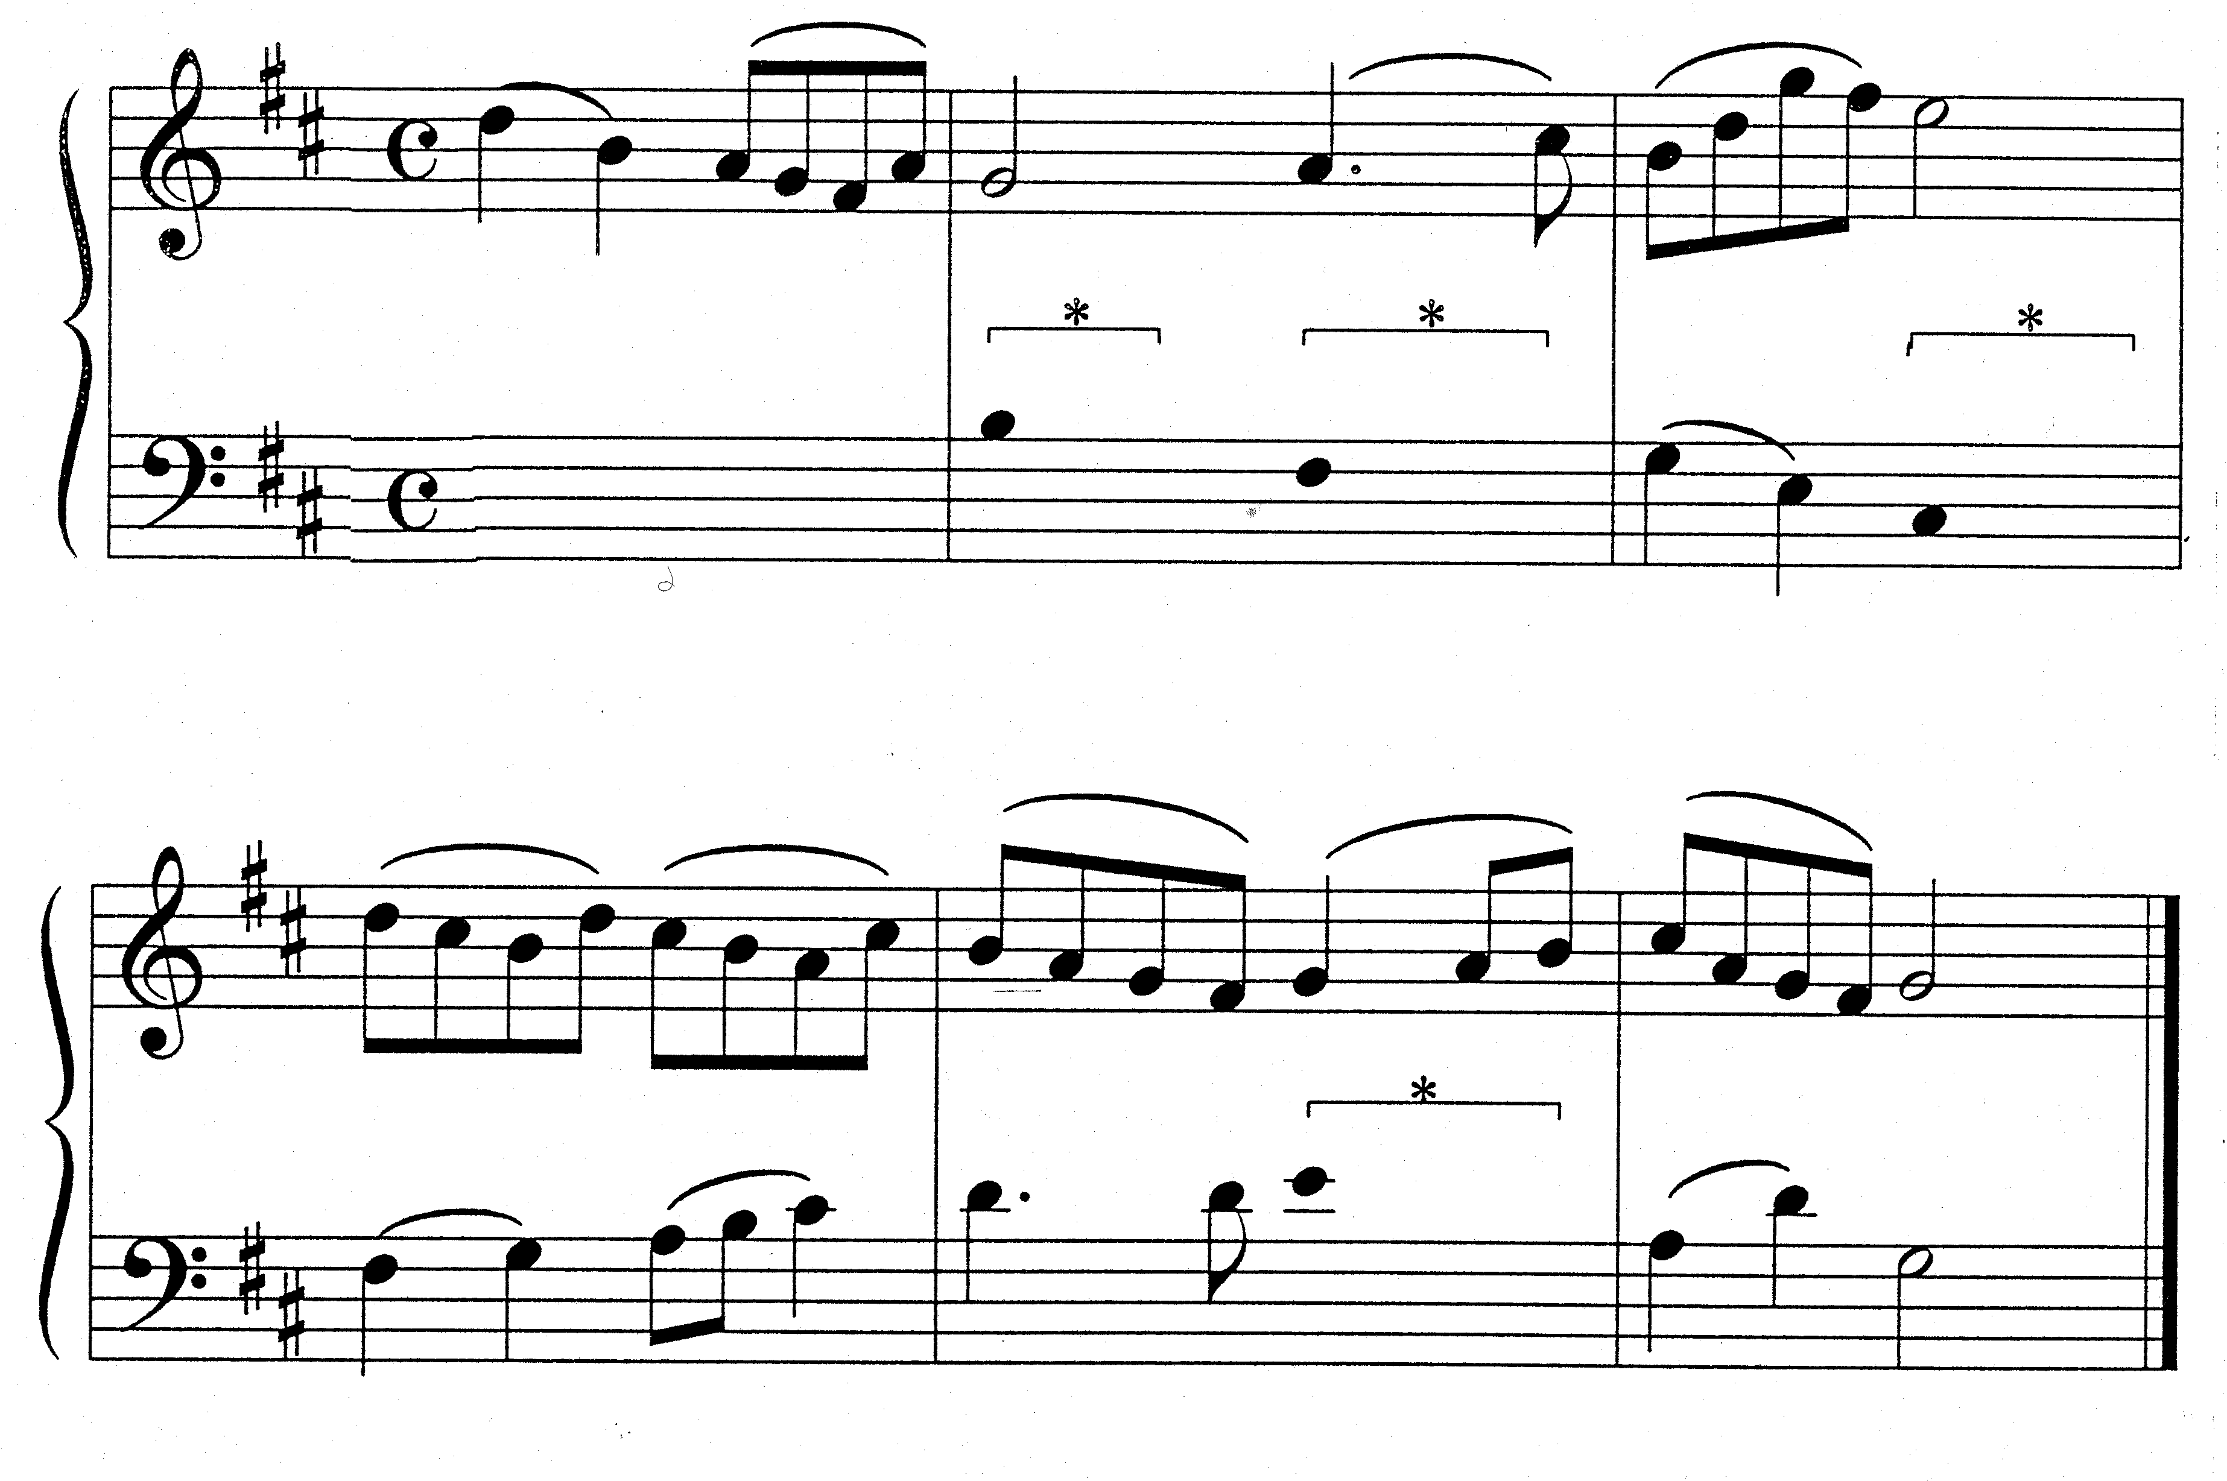 | (5)

- Complete the following passage in two-part contrapuntal style by adding the missing part. Retain the style characteristics of the given material.  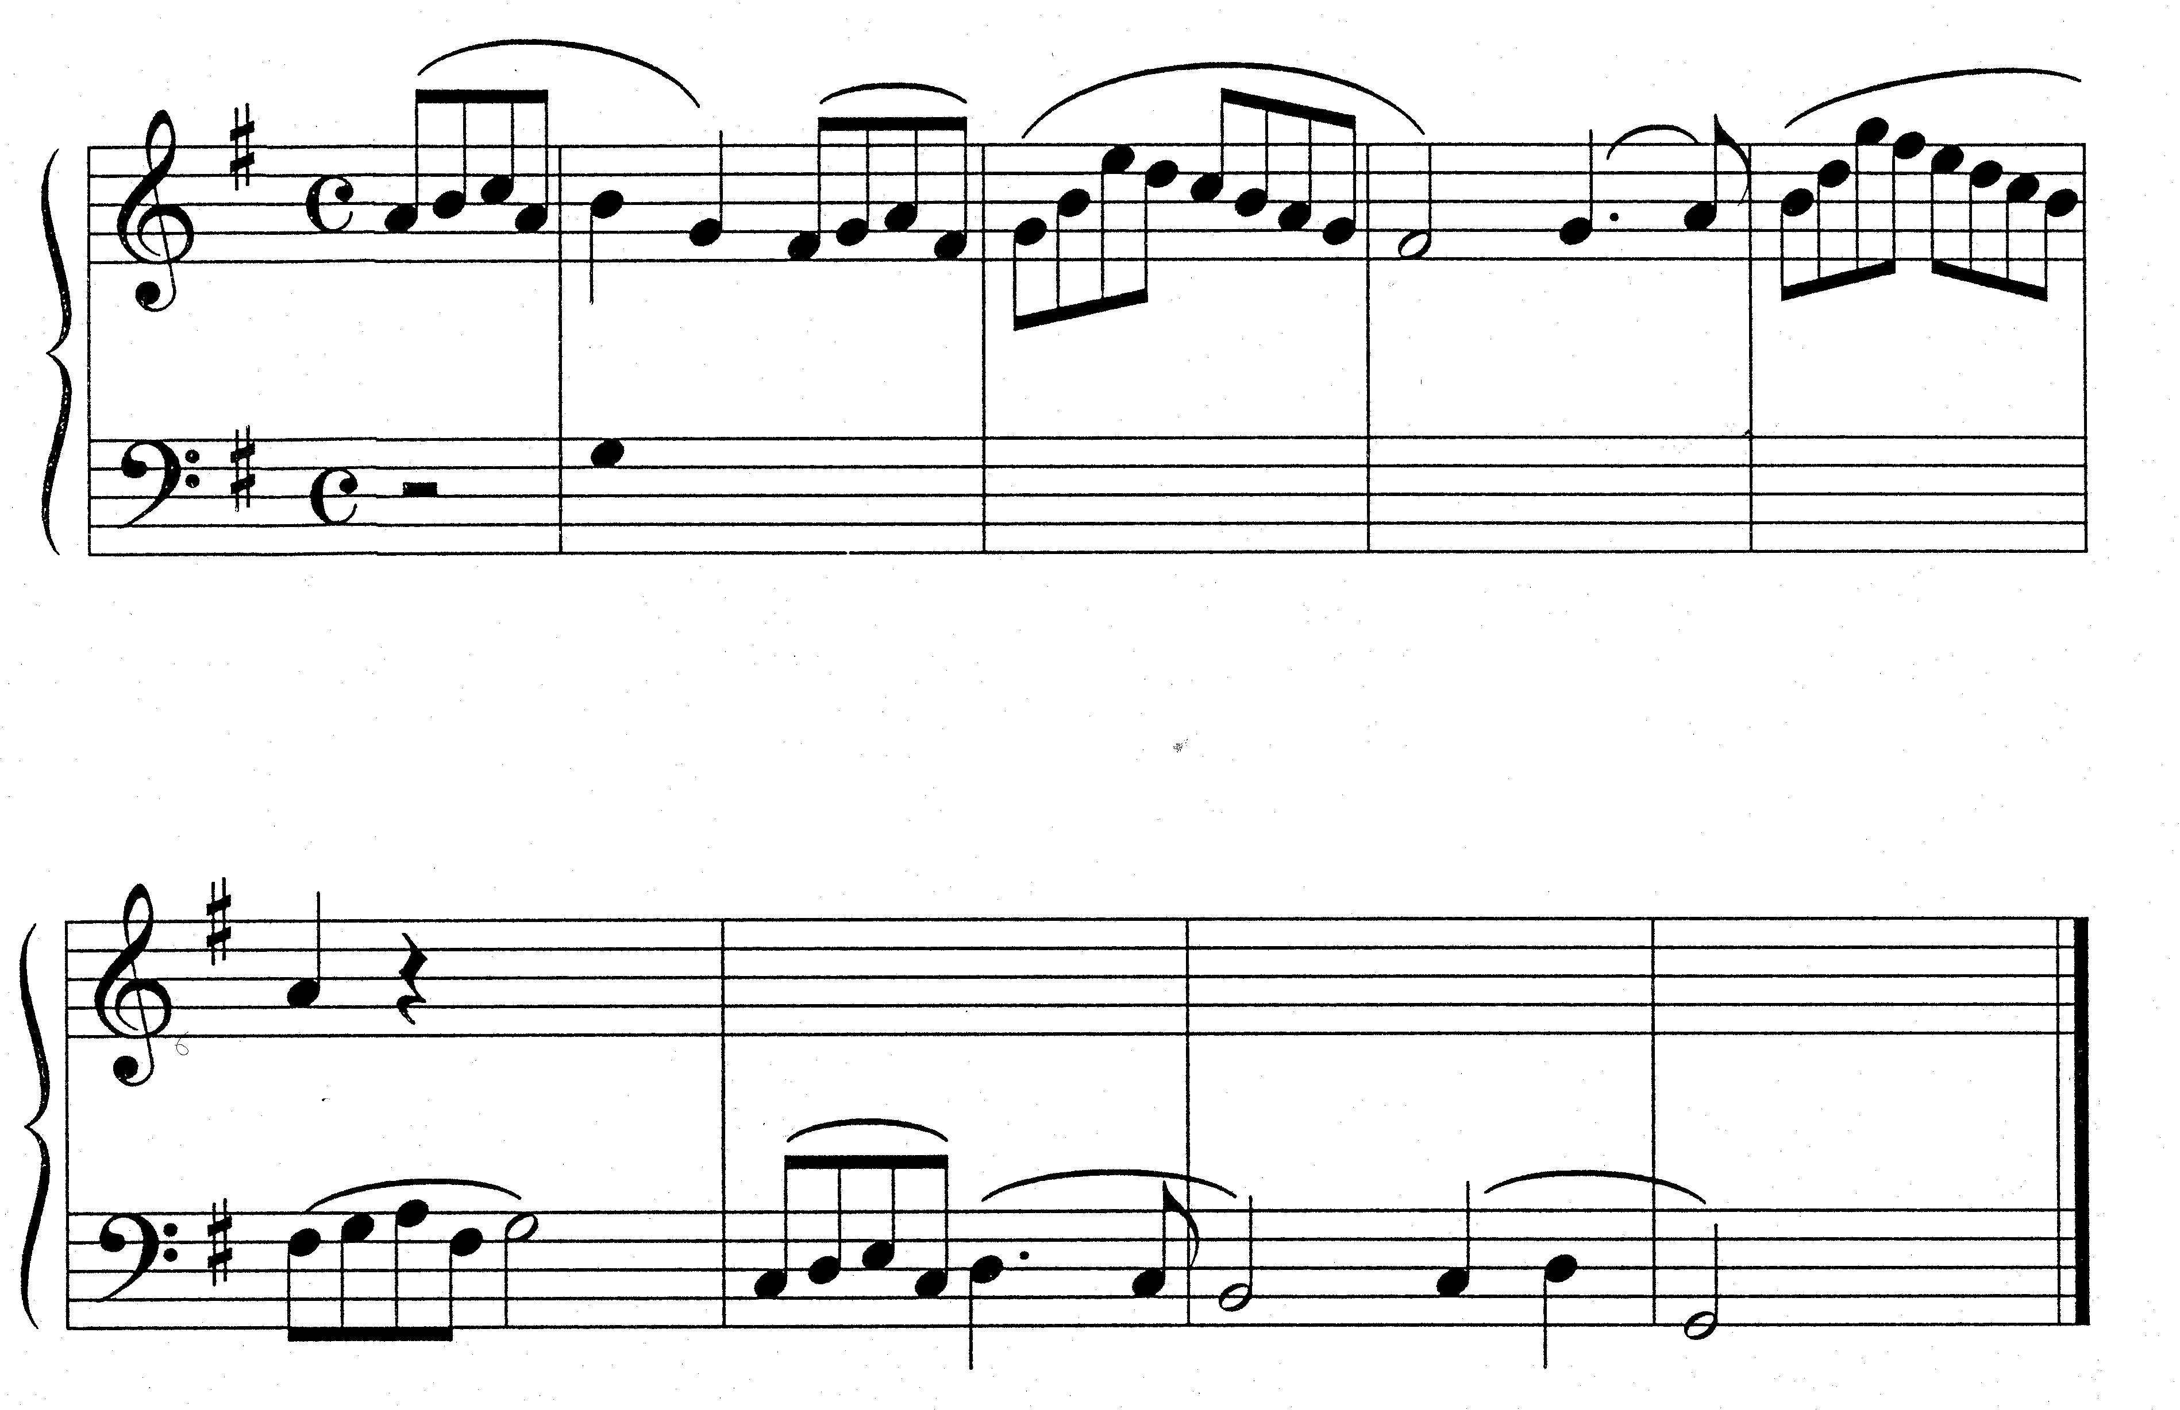 | (15)  [20]

QUESTION 4  Harmonise the soprano part for mixed choir (satb).  - A slur over two or three notes of the soprano part indicates that only one chord should be used for these notes.  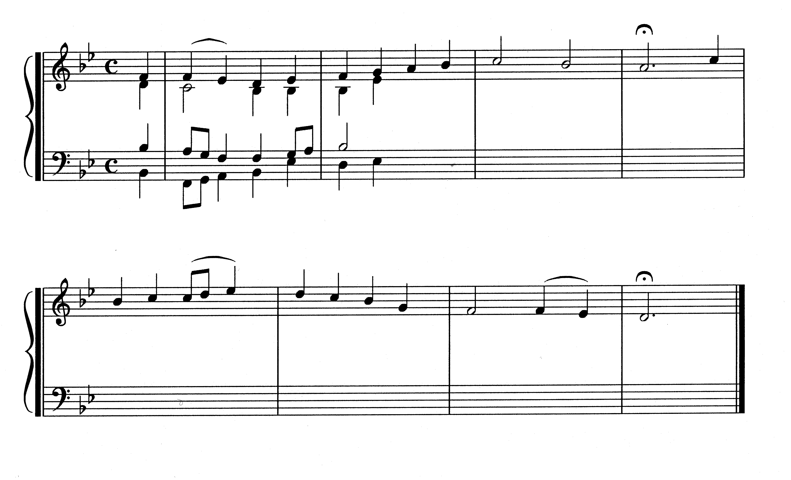 | [20]

QUESTION 5  Write the following chords in four-part harmony:  - Bar 1³: the dominant seventh in third inversion.  - Bar 2³: a chord which will create a plagal cadence with the last chord.  - Bar 3¹: add an accidental to this chord to create a Tierce de Picardie.  ∗ ∗ ∗  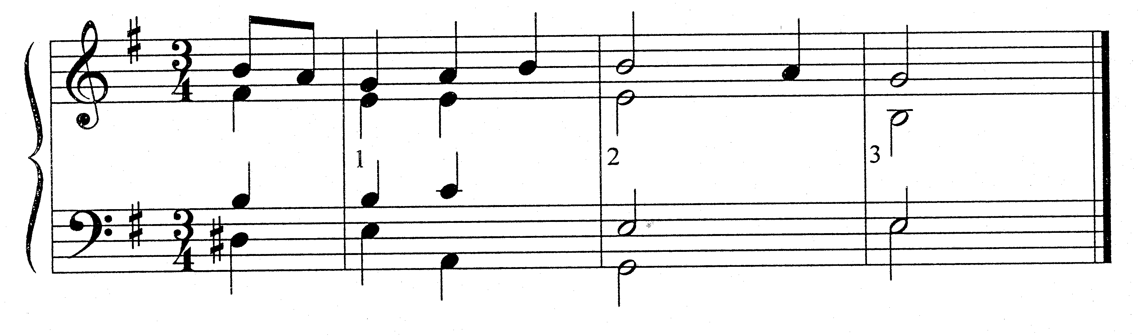 | (2)  (2)  (1)  [5]

QUESTION 6  (d)  Cadence  Cadence  Cadence  Study the following extract from a chorale and answer the questions that follow.  - Name the keys and figure the chords at (a), (b) and (c). E.g. F: Vb or V6.  - Identify the cadences at (d), (e) and (f). Specify the key, chord progression and cadence type. E.g.F: IV – I, plagal cadence.  - Name the non-harmonic notes (g), (h) and (i).  (g) _______________________________  (h) _______________________________  (i) _______________________________  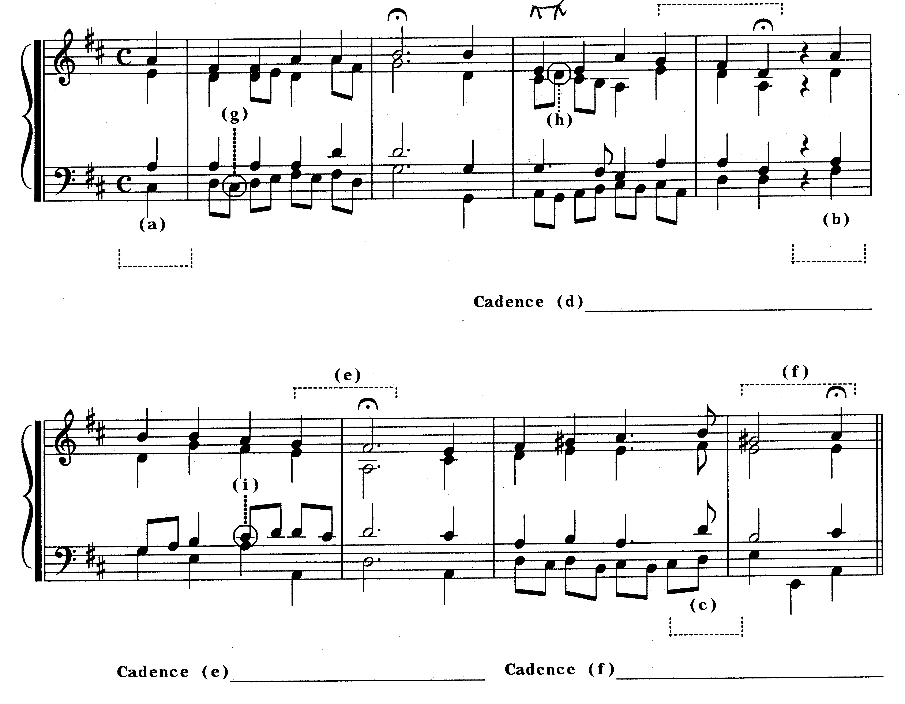  TOTAL: | (6)  (6)  (3)  [15]  75

