GAUTENG DEPARTMENT OF EDUCATION

SENIOR CERTIFICATE EXAMINATION

MUSIC HG
(Second Paper: History of Music
and Form)

TIME: 2 hours

Marks: 100

INSTRUCTIONS :

- Answer ALL the questions in the answer book which is provided.
- Answers must be clearly numbered.
- Write clearly and in ink.
- Question 1 is COMPULSORY.
- Answer any TWO of Questions 2, 3 and 4.

QUESTION 1  COMPULSORY  1.1 Explain how, and why, traditional form structures of the baroque and classical periods were adapted as a result of new trends in romantic and twentieth century music.  1.2 Choose any FIVE statements from Column A and match them with the corresponding terms in Column B. | (10)

COLUMN A |  | COLUMN B
1.2.1 | Structure of chords | A. | Metre
1.2.2 | Key | B. | Harmony
1.2.3 | Subdivision of music into bars | C. | Tone duration
1.2.4 | Length of sound | D. | Codetta
1.2.5 | Use of composition techniques from the past | E. | Variation
1.2.6 | The introduction to an opera | F. | Coda
1.2.7 | Harmonic or rhythmic change of a theme | G | Overture
1.2.8 | The highest male voice | H. | Neo Classicism
1.2.9 | Closing section of a work in sonata form | I. | Tonality
1.2.10 | Closing section of the exposition of a work in sonata form | J. | Tenor
(5)

1.3 The following sentences each contain one or more inaccurate fact/s. Rewrite the sentences so that the facts are correct.  - In sonata-rondo form (old rondo form) the first theme (first subject) appears once in the recapitulation.  - The main sections of a sonata cycle are the exposition, development and recapitulation.  - In compositions from the classical period pedal notes (pedal points) are usually on the sub-dominant of a key.  - Composers never use new material in the development section of sonata form.  Answer any TWO of Questions 2, 3 and 4.  QUESTION 2  OPERA  - You are responsible for writing the programme notes for operas. Write notes on ONE of the following so that an uninformed audience will have a clear understanding of the nature and content of the opera.  2.1.1 Don Giovanni  OR  2.1.2 Rigoletto  2.2 Choose any THREE of the following themes (2.2.1 – 2.2.4) and in each case, name the composition and the composer.  2.2.1  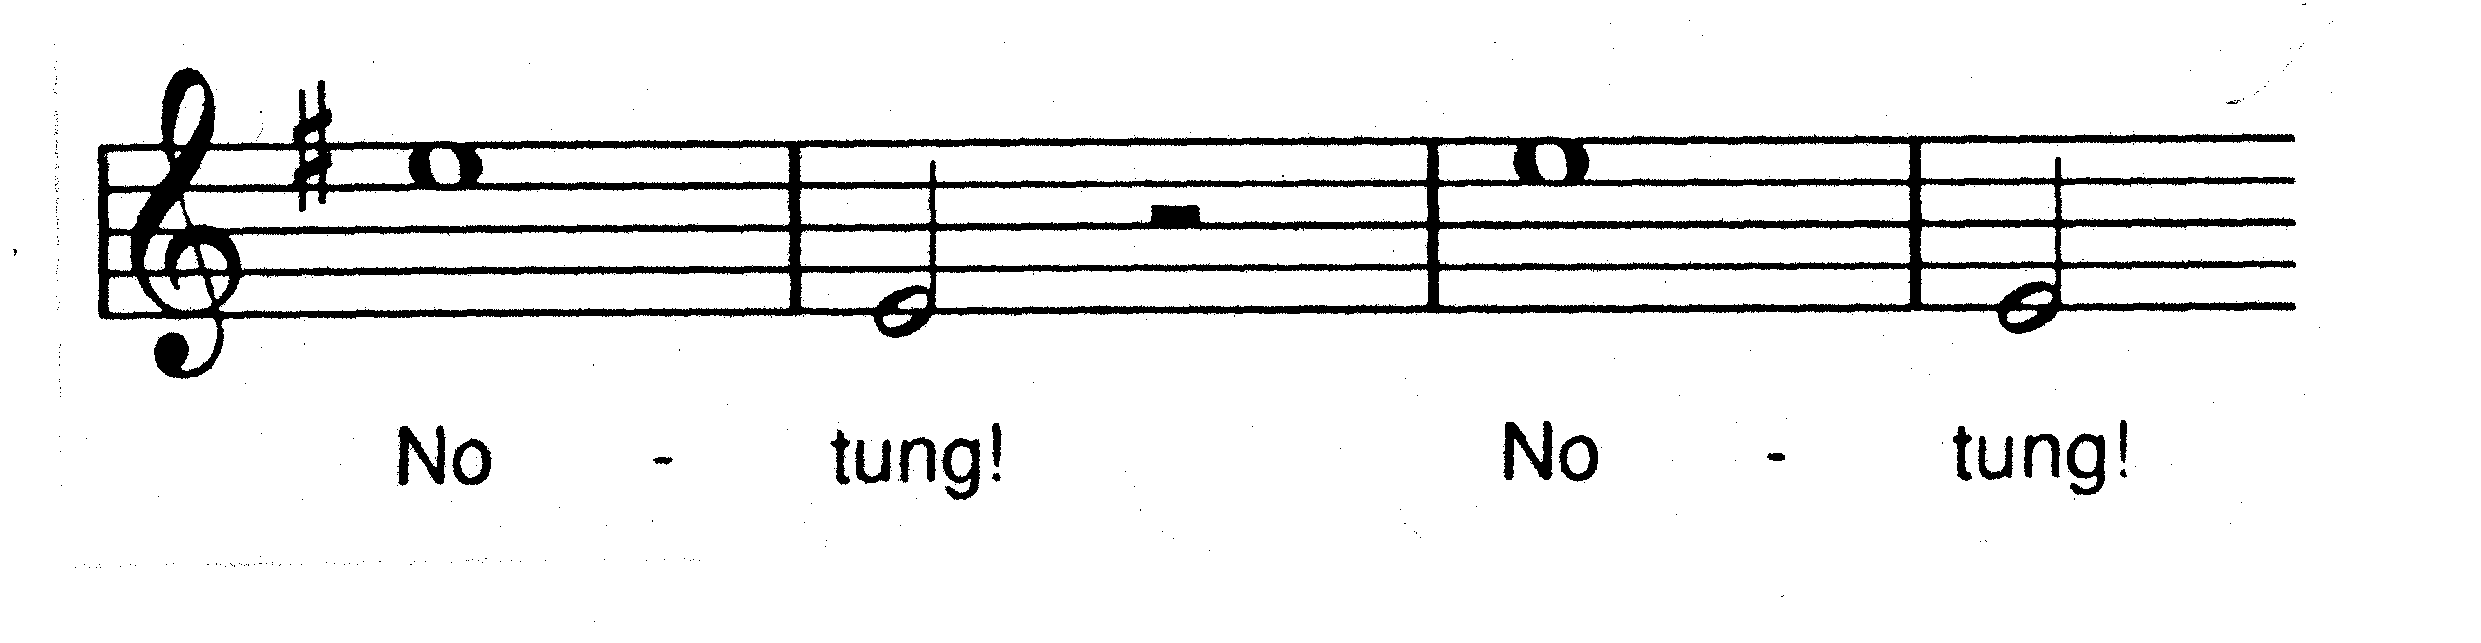  2.2.2  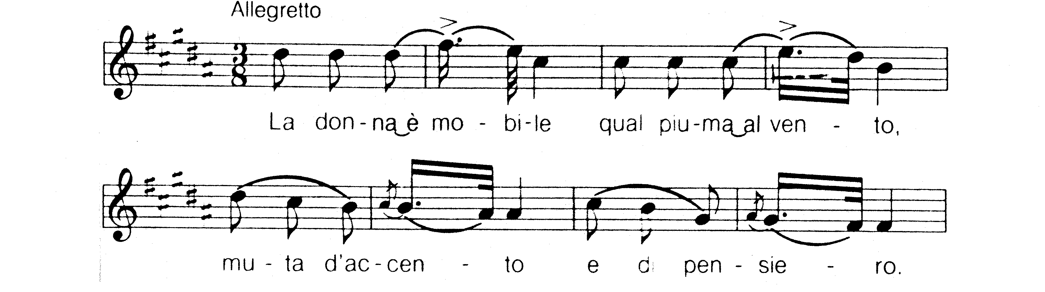 | (5)  [20]  (10)

2.2.3  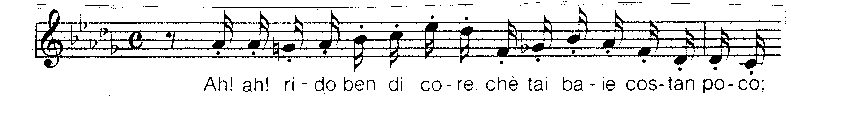  2.2.4  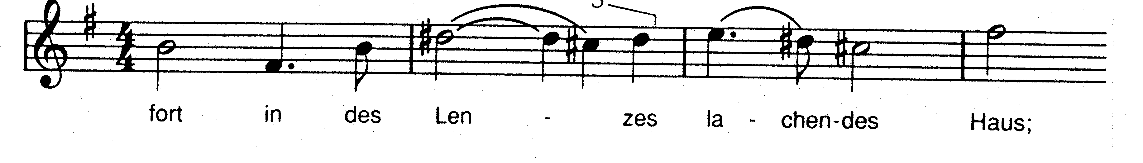  3x2=  2.3 Wagner is regarded as one of the most innovative and creative composers of nineteenth century opera. Discuss this statement by referring to THREE of the following:  - Leading motive  - Music drama  - Harmony  - Orchestration  3x4=  2.4 Briefly name the sources from which C.M. von Weber established the German romantic opera in Der Freischütz.  2.5 Write a short letter to a friend telling him/her of your visit to a theatre during the first rehearsal of an opera. Write about the different people involved in such a large scale production, as well as about their tasks. | (6)  (12)  (4)  (8)  [40]

QUESTION 3  SYMPHONY  3.1 Who was the founder of the Mannheim School and what was the school’s contribution to the development of the classical symphony?  - Study the music excerpt below and answer the questions which follow.  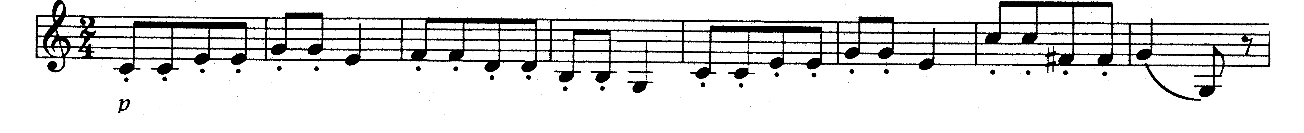  3.2.1 Name the composition from which the excerpt comes.  3.2.2 Who is the composer of the work?  3.2.3 Name TWO stylistic features of the period from which the excerpt comes. These characteristics must be clearly present in the given example.  3.3 Write an essay on Haydn’s contribution to the development of the symphony. | (5)  (1)  (1)  (2)  (10)

3.4 Beethoven was a transitional figure between the classical and romantic periods. Explain this statement by using his Symphony no.5 (1808) as an example which anticipates the innovations in the works of the romantic period.  3.5 Berlioz is known for his innovative use of orchestral sound. Name FOUR ways in which he achieves this.  3.6 Theme A below is the basic motive on which Les Preludes by Liszt is based.  Theme A  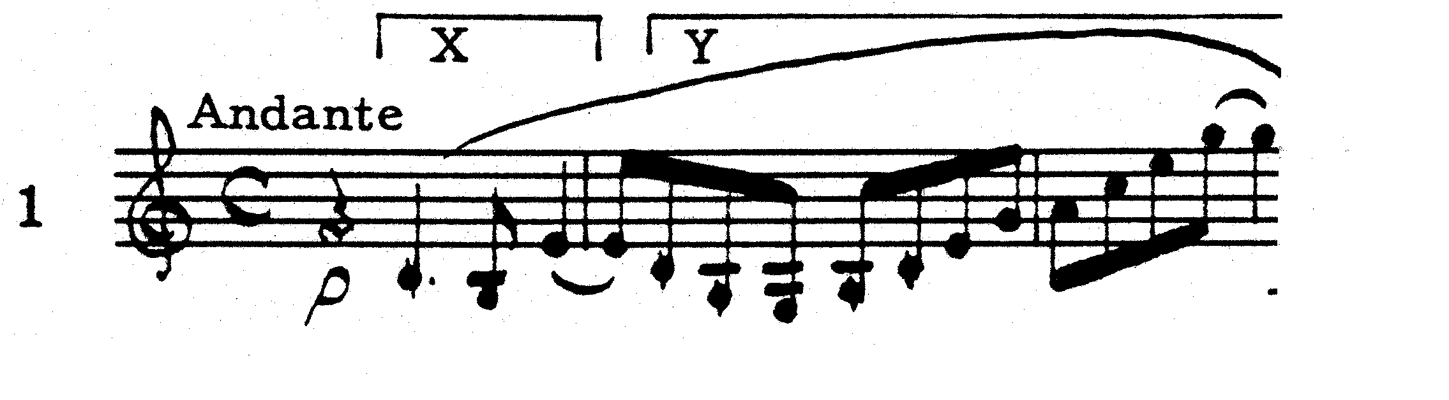  3.6.1 Name the composition technique which Liszt uses to change Themes B, C and D below.  Theme B  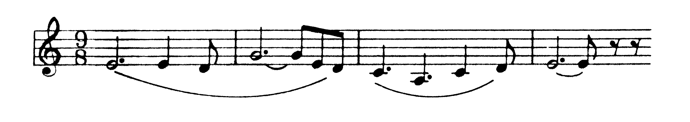  Theme C  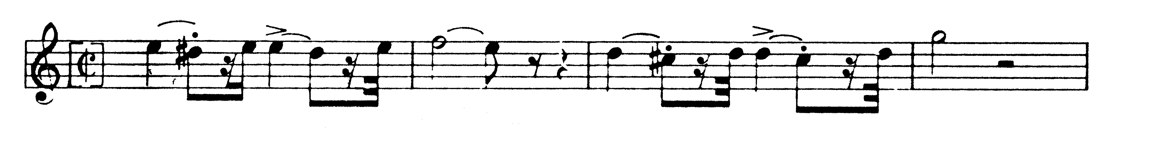  Theme D  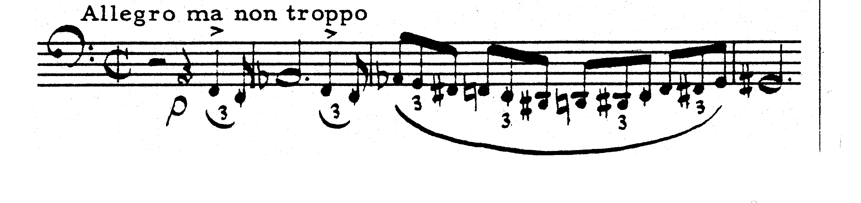  - What causes Theme B to sound like a love theme?  3.6.3 Which technique does Liszt use to make Theme C sound urgent and energetic?  3.6.4 Theme D represents a stormy section in the work. How does Liszt obtain this character? | (7)  (4)  (1)  (1)  (1)  (1)

3.7 Stravinski’s Symphony of Psalms (1930) is an outstanding example of  neo-classic music. Write brief notes in which you specifically refer to neo- classical elements in this composition.  3.8 Why is the rondo form so well suited to Richard Strauss’ work Till Eulenspiegel’s lustige Streiche? | (4)  (2)  [40]

QUESTION 4  Allegro con brio  CHAMBER MUSIC  - Write an article for your local newspaper explaining the specific features and origins of chamber music as well as its present relevance.  - Study the theme below and answer the questions which follow.  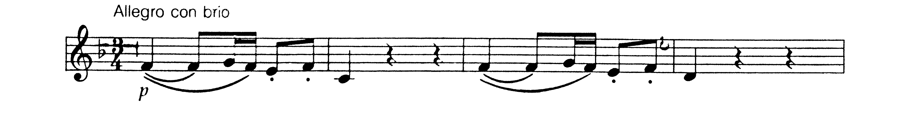  - Name the work from which the theme comes.  - Name the composer of the work.  - Discuss the development which takes place in his later chamber music compositions.  - Schubert is a famous composer of art songs. To what extent does his love for the art song influence his chamber music?  - Choose the correct answer for each of the following statements. Write only the correct letter (choose from A – C) next to the corresponding question number  (4.4.1 – 4.4.2).  4.4.1 The Octet for Wind Instruments was composed by  - Bartók.  - Stravinsky.  - Beethoven.  - The following instruments are used in a string quintet:  - 2 violins, 2 violas, 1 cello  - 3 violins, 1 viola, 1 cello  - 1 piano, 2 violins, 1 viola, 1 cello  4.5 Bartók developed an individualistic compositional style which was accepted as standard practice by many other twentieth century composers. Motivate this statement. | (12)  (1)  (1)  (8)  (2)  (2)  (12)

4.6 Chamber music is usually associated with the classical period. Why is it that so many works in this genre were also composed during the first half of the twentieth century?  TOTAL: | (2)  [40]  100

