GAUTENG DEPARTMENT OF EDUCATION

SENIOR CERTIFICATE EXAMINATION

MUSIC HG
(Second Paper: History of Music and Form)

TIME: 2 hours

Marks: 100

INSTRUCTIONS :

- Answer all questions in the answer book which is provided.

- Answers must be clearly numbered.

- Write clearly and in ink.

- Question 1 is COMPULSORY.

- Answer any TWO of Questions 2, 3 and 4.

QUESTION 1  COMPULSORY  1.1 The music teacher at your school is ill. She asks you to explain the importance of rhythm in twentieth century music to the grade 9 class.  1.1.1 Explain the topic as simply as possible.  1.1.2 Name the title AND the composer of ONE twentieth century composition of which you can play a recording to the class to enable them to experience the rhythm. | (8)  (1)

1.2 Match the information in Column A with the correct information in Column B
(eg. 1.2.3 = F.)

Answer any FIVE questions.

COLUMN A |  | COLUMN B
1.2.1 | Pedal point or pedal note | A. | Sonata cycle
1.2.2 | Sonata-rondo form | B. | Codetta
1.2.3 | Episode | C. | Wind technique
1.2.4 | Development section | D. | Opera text
1.2.5 | Orchestral work with three or four movements | E. | New rondo form
1.2.6 | Linking passage which joins entries of the dux and comes in the exposition of a fugue | F. | Old rondo form
1.2.7 | Col legno | G | Sonata form
1.2.8 | Libretto | H. | String technique
1.2.9 | Flatterzünge | I. | Dominant
1.2.10 | ABACA | J. | Contrasting section
(5)
1.3 Briefly explain the difference between harmony and tonality.  1.4 Name the composer of any FOUR of the following works:  1.4.1 Dumbarton Oaks Concerto  - Fidelio  - London Symphonies  - Mazeppa  - Octet for Wind Instruments  1.4.6 La Traviata | (2)  (4)  [20]

Answer any TWO of Questions 2, 3 and 4.  QUESTION 2  OPERA  2.1 Explain why Gluck deemed it necessary to reform the Italian baroque opera. Also name THREE reforms which he proposed in the introduction to his opera Alceste. | (5)

2.2 You invite a friend, who has never attended the production of an opera, to an opera by Mozart. Explain to him why Mozart is regarded as a master of opera composition.  2.3 Briefly discuss the elements in Lohengrin which point to techniques which Wagner uses in his later music dramas.  2.4 In Music: An Appreciation by Kamien, the author states that Wagner regarded the theatre as a temple where the audience must be overwhelmed by music and drama. Discuss this attitude of Wagner in an essay of approximately one page.  2.5 Explain THREE of the following concepts applicable to opera:  - Prelude  - Overture  - Act  - Recitative 2x3= | (7)  (6)  (12)  (6)

2.6 Identify the opera and the composer represented by each of the themes below.  2.6.3  2.6.4  2.6.1  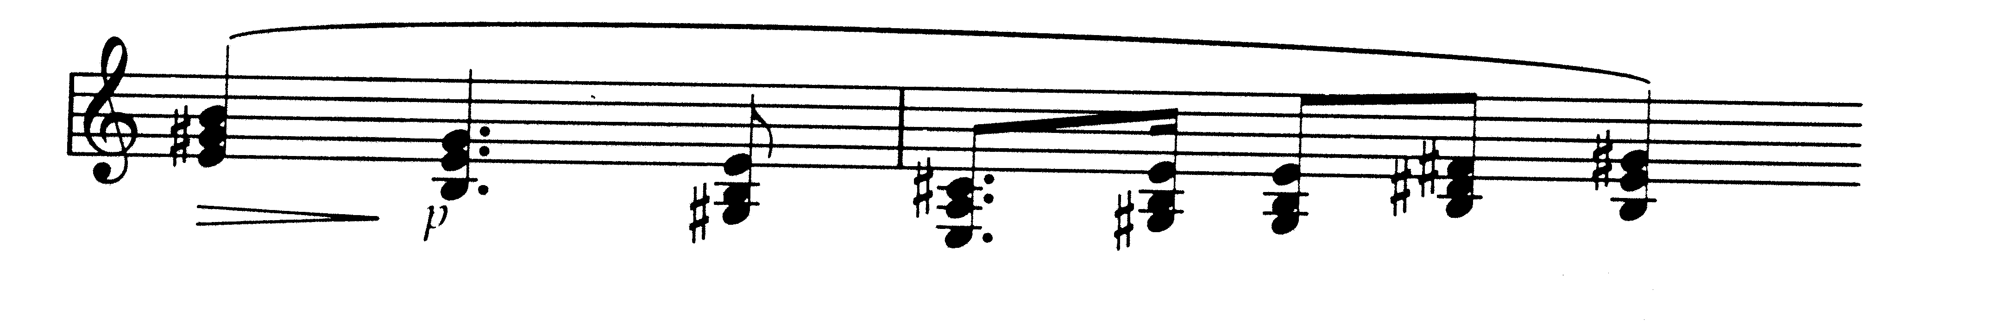  2.6.2  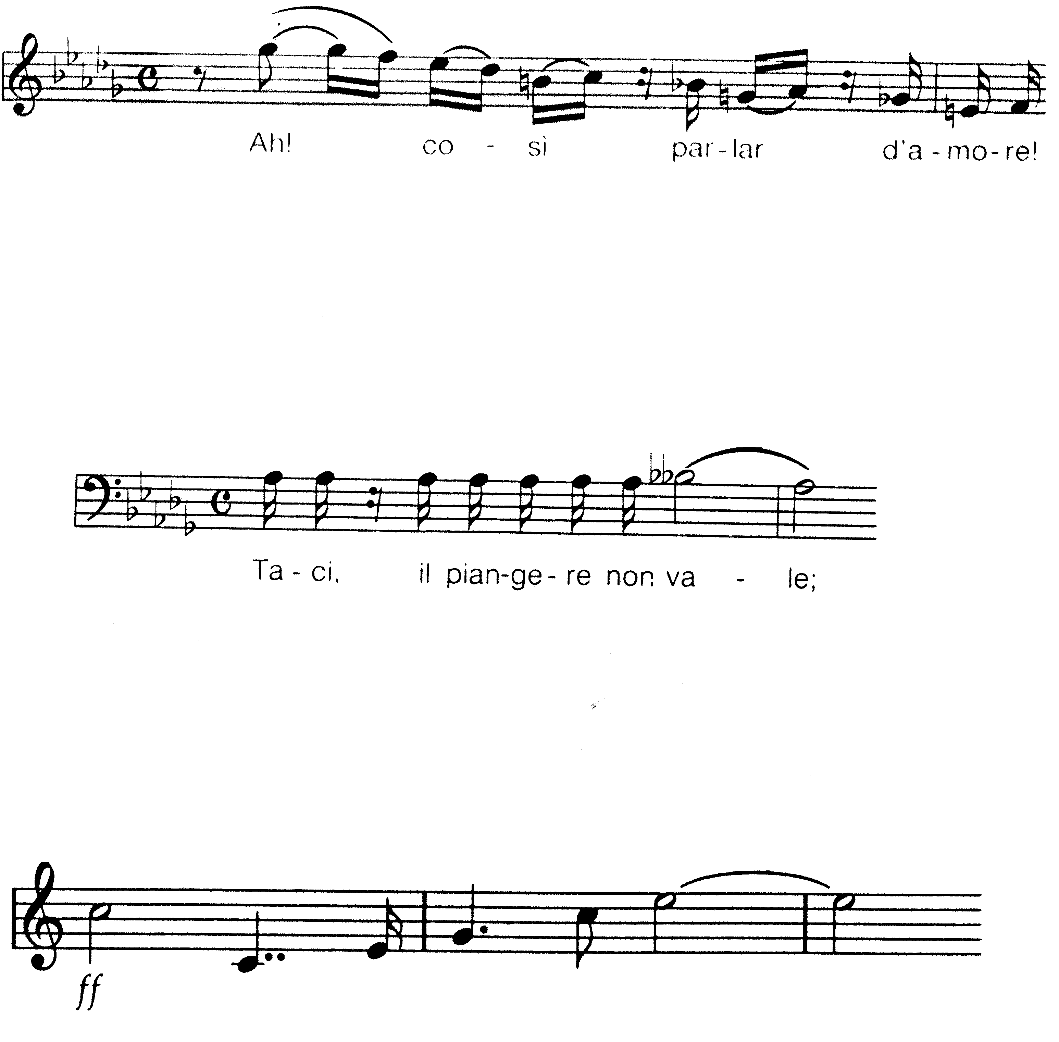 | (4)  [40]

QUESTION 3  SYMPHONY  3.1 Study the theme below and answer the questions which follow.  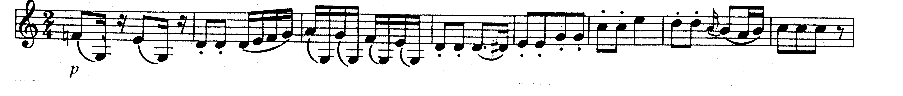  - Name the composition from which the theme comes.  - Name the composer.  - From which movement of the work does the theme come?  - What is the main key of the composition in 12.1?  - Name TWO sources which influenced the composer of this symphony.  3.2 Write a concise essay on Beethoven and the symphony.  3.3 Which techniques did romantic composers use to obtain unity in extended symphonic works?  3.4 Why is the Symphonie Fantastique by Berlioz regarded as an excellent example of the symphony in the romantic style period?  3.5 What is the difference between a programme symphony and a symphonic poem?  3.6 Write a paragraph on the form of Les Preludes by Liszt.  3.7 Between 1920 and 1950 the slogan of a group of composers was “Back to Bach”. Explain why the movement originated and what their aims were. | (1)  (1)  (1)  (1)  (2)  (12)  (3)  (9)  (2)  (4)  (4)  [40]

QUESTION 4  CHAMBER MUSIC  4.1 Briefly explain why the use of the basso continuo in chamber music was discontinued  4.2 Study the music excerpt below and answer the questions which follow. | (2)

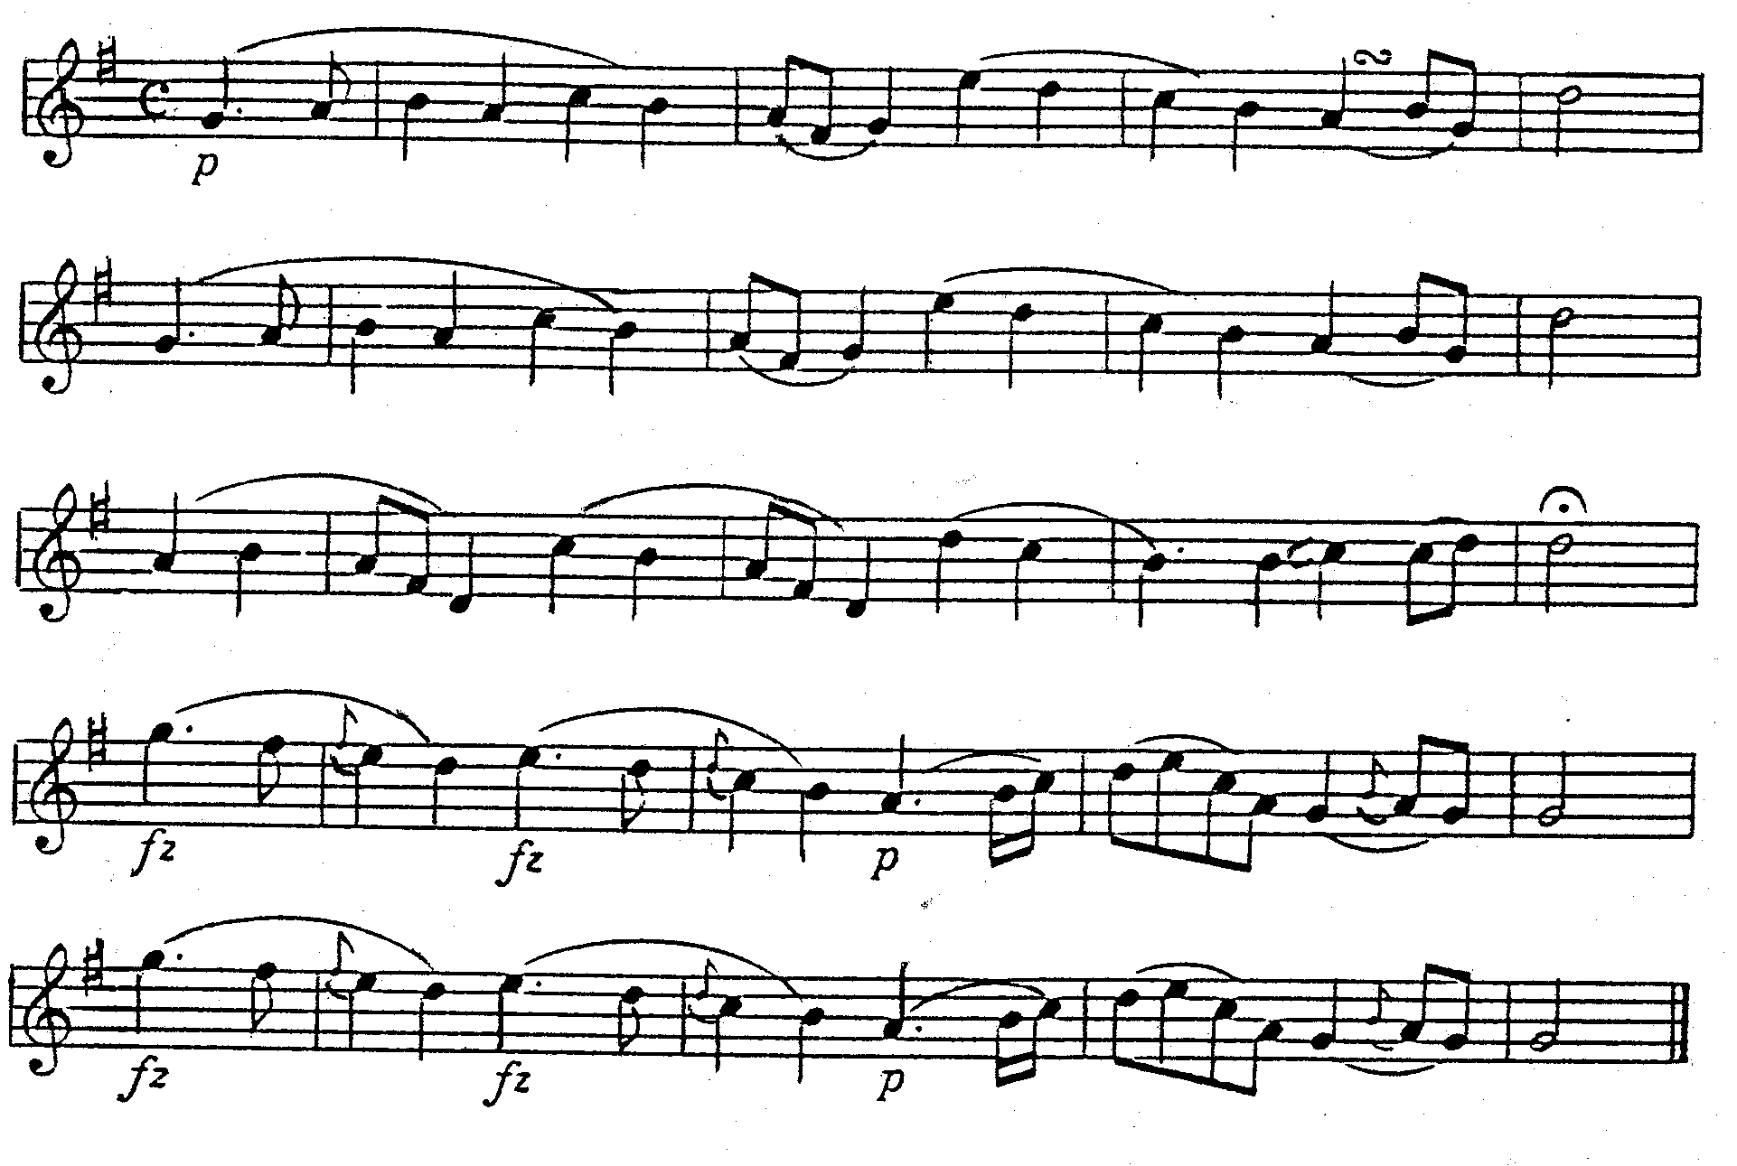  - Comment on the phrase structure.  - On which country’s anthem is the excerpt based?  - Compare the first two phrases with the last two.  4.3 The sentences below each contain one or more incorrect fact/s. Rewrite the sentences so that the facts are correct.  - Beethoven’s 6 String Quartets opus 18 are composed in the style of Mozart and they are easy to perform by amateurs.  - One of the striking characteristics of Beethoven’s last string quartets is the use of the basso continuo from the Baroque.  - Opus 133 is a majestic fugue for string trio. | (2)  (1)  (5)  (4)

4.4 How does Schubert’s Piano Quintet in A major (Die Forelle) differ from a traditional piano quintet of the classical period?  4.5 Why do you think that Bartók’s Music for Strings, Percussion and Celesta is regarded as an excellent example of twentieth century chamber music? | (9)  (12)

4.6 The incomplete table below illustrates Bartók’s placing of the instruments on the stage in his Music for Strings, Percussion and Celesta. Draw the table below in your answer book and provide the missing information by writing it at A, B and C.

Cello l | Double bass l | Double bass ll | Cello ll
Viola l | A | Bass drum | Viola ll
Violin ll | Side drums | Cymbals | Violin IV
Violin l | Celesta | Xylophone | Violin lll
(3) | B | C
(3) | Conductor

4.7 Name the composer of TWO of the following:  - Duo Concertante for Violin and Piano (1932)  - Octet in F major (1824) for string quartet, double bass, clarinet, horn and bassoon  - Rasumovsky Quartets  - Russian Quartets  TOTAL | (2)  [40]  100

