GAUTENG DEPARTMENT OF EDUCATION

SENIOR CERTIFICATE EXAMINATION

MUSIC HG
(First paper: Harmony and Composition)

TIME: 3 hours

MARKS: 100
INSTRUCTIONS TO THE INVIGILATOR:

- Each candidate must be supplied with 3 sheets of music manuscript paper.

- Each candidate must have access to a piano for the full duration of the examination.

- No candidate may, however, disturb another candidate, nor share the use of a piano at any particular time.

INSTRUCTIONS TO THE CANDIDATE:

- This question paper is also the answer sheet.

- Remember to write your examination number on the answer sheet.

- Ensure that your notation is neat and clear.

- Answer Question 1 OR Question 2 and ALL the other questions.

Answer Question 1 OR Question 2.  QUESTION 1  Set ONE of the following poems to music. Choose a suitable voice, key and metre. Write the text neatly below the melodic line. | [20]

The actress  I look in the mirror  And what do I see?  A famous actress  Yes! That’s ME  One day I’m going  Into a show  But first  Guess what?  I have to grow!  M Pincus | OR | Die Vlinder  Vang vir jou ’n vlinder  En hou hom saggies vas,  Droom die mooiste drome  Wat by ’n vlinder pas:  Droom van blommevelde  Wat in die sonlig staan,  En los dan weer jou vlinder  Om daarheen terug te gaan.  A Bouwer

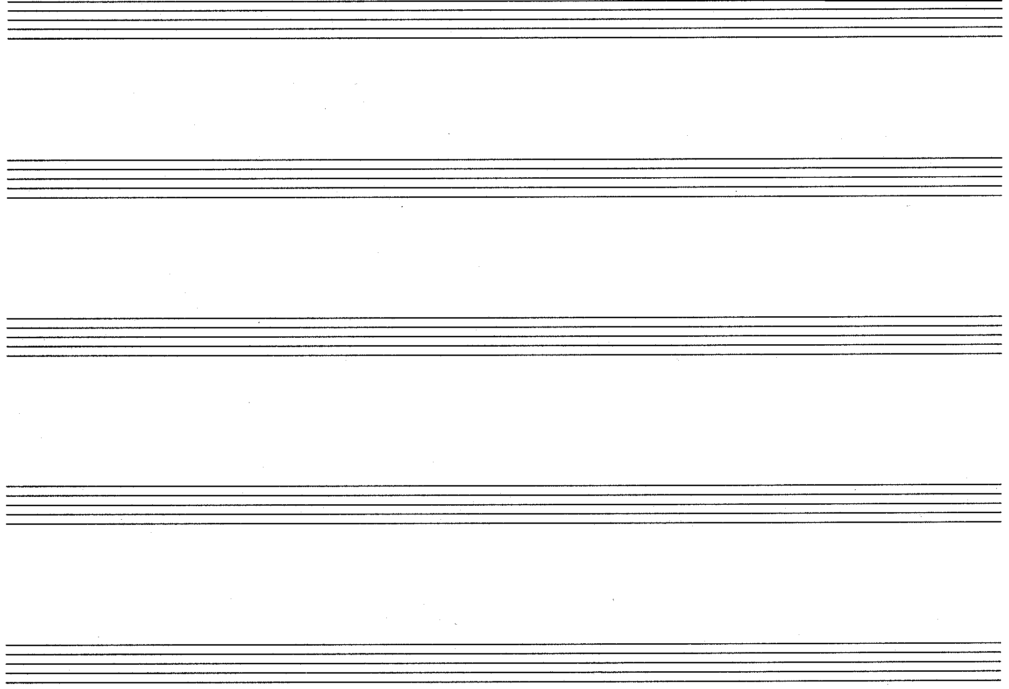

OR

QUESTION 2  mf  - Study the undermentioned extract from a melody and clearly label the following aspects in the score where required.  - Circle an example of melodic repetition.  - Block an example of a sequence.  - Identify the type of cadence. Figure the harmonic implication and state the key.  __________________________________________________________ | [20]  (1)  (2)  (2)

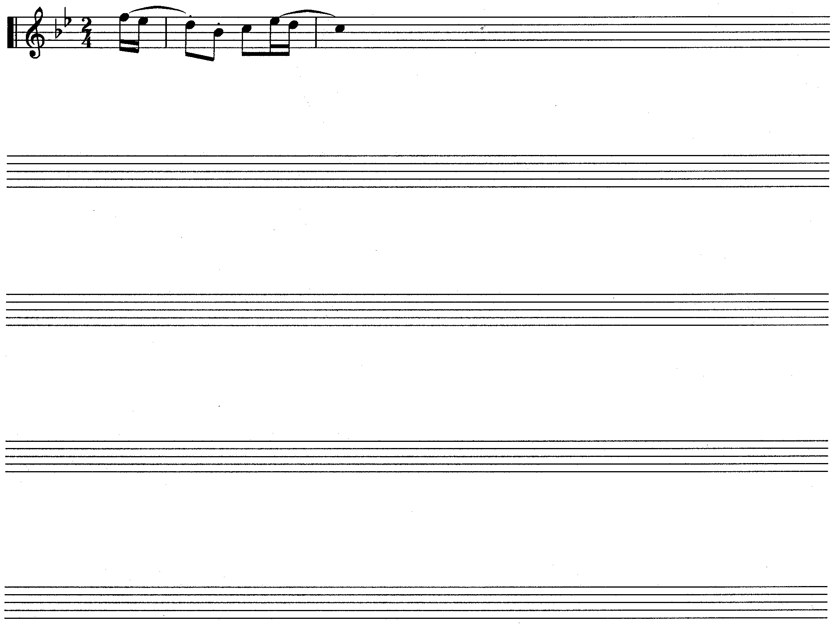  - Extend the given opening to a symmetrical melody consisting of 12 bars in ternary form. Modulate to a related key and end in the original key. Indicate for which voice or instrument the melody is intended.  Vivo | (15)  [20]

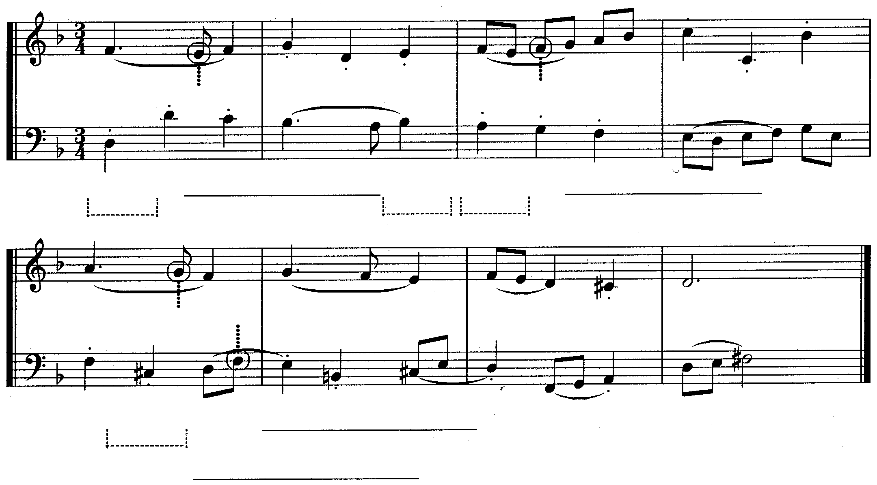  QUESTION 3  1  (e)  (f)  (f)  (c)  (b)  (e)  (a)  5  (g)  (h)  (h)  (g)  (d)  - Study the extract below and answer the questions that follow.  - Provide harmonic analysis at (a) – (d). Indicate the key, chord and inversion in each case.  - What compositional technique is used in bar 8? ___________________  _______________________________________  - Name (e) – (h) as non-harmonic notes or harmonic notes. | [25]  (4)  (2)  (4)

Complete the following passage in two-part counterpoint by adding the missing part. Continue in the style suggested by the given material.  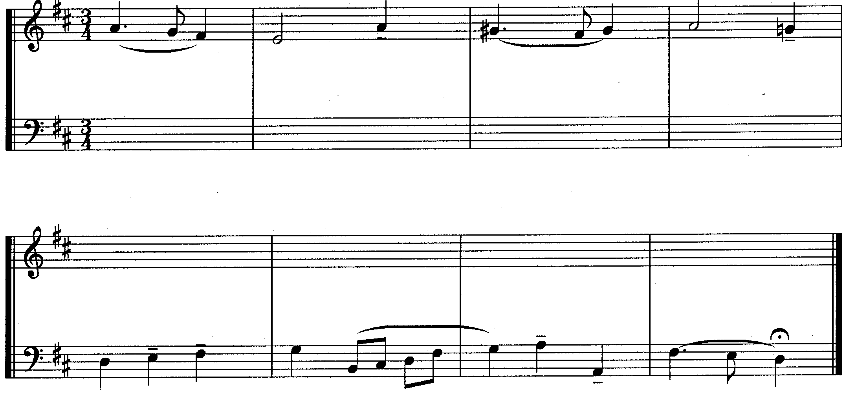 | (15)

QUESTION 4  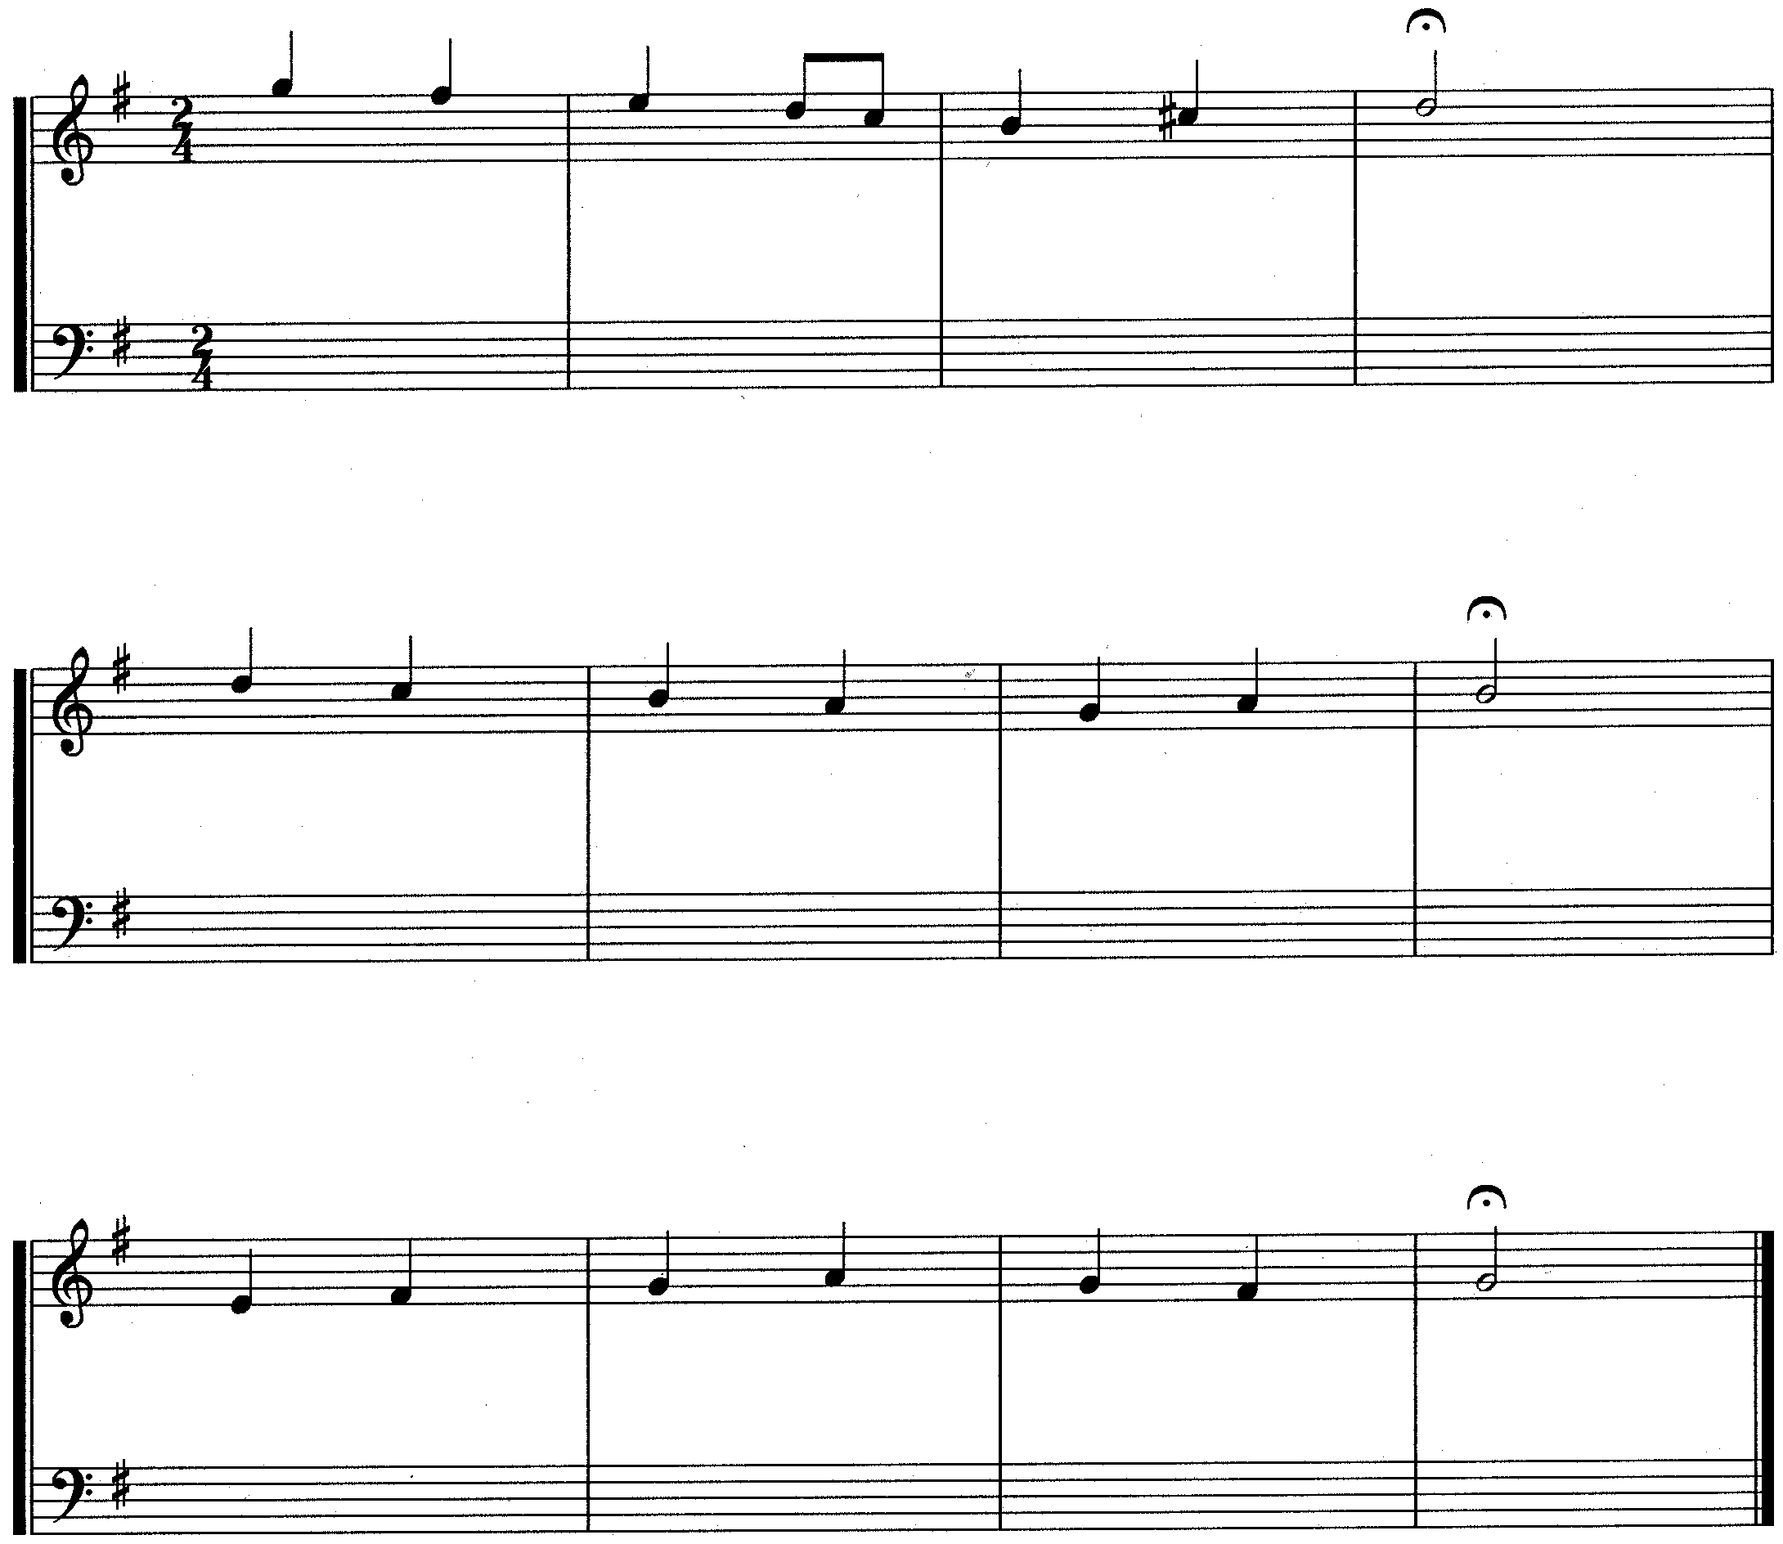  Harmonise the given soprano part for mixed choir (SATB) and use harmonic devices with which you are familiar. | [20]

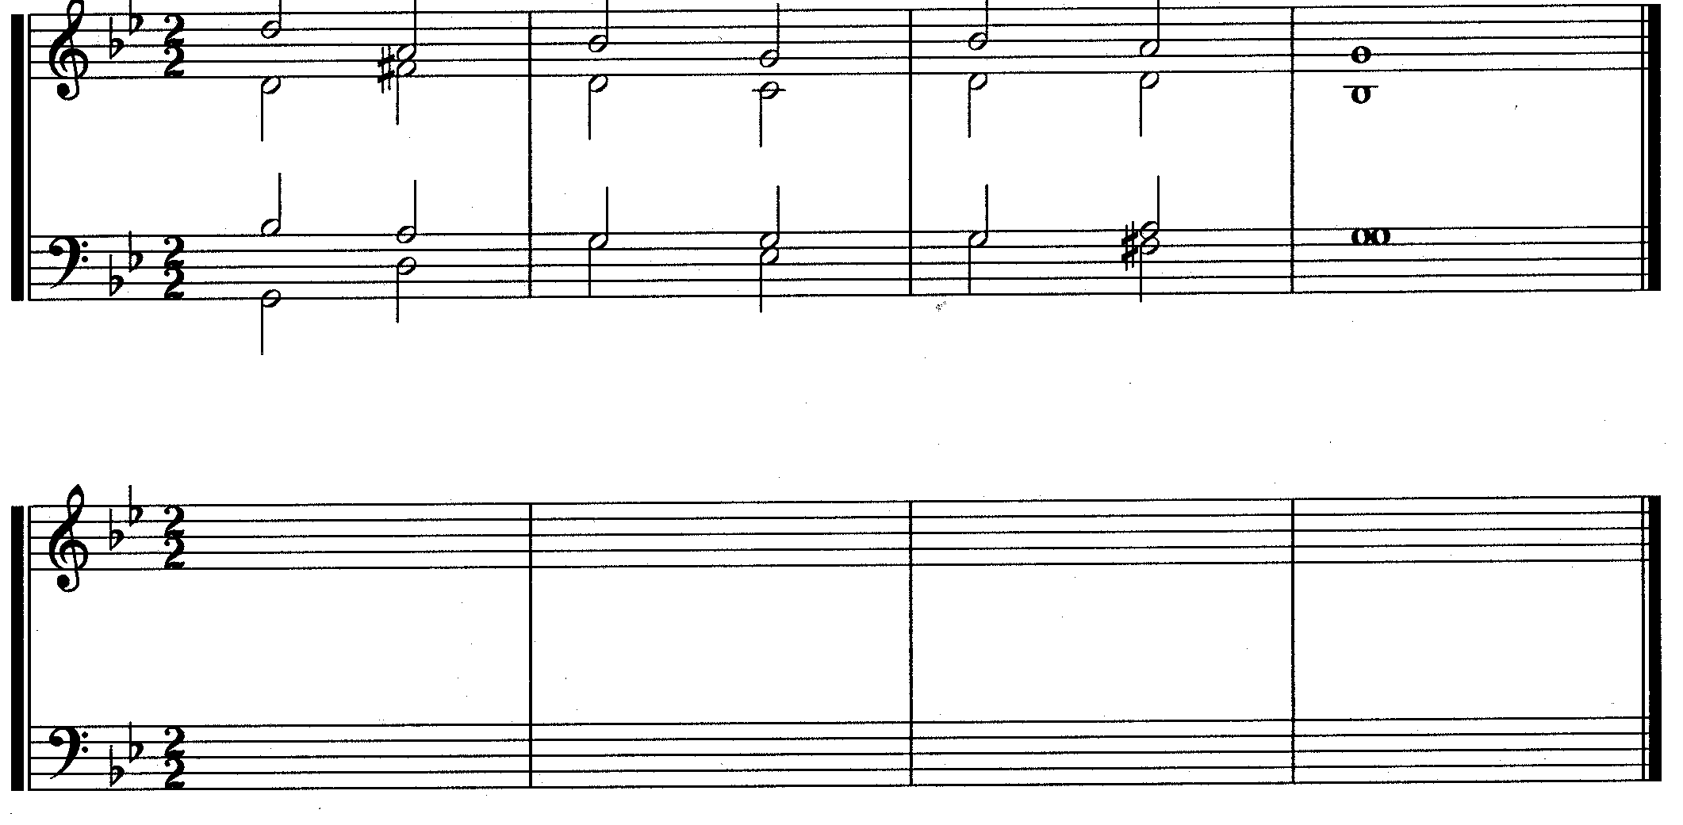  QUESTION 5  Fragment  Answer  Rewrite the given harmonic fragment and insert the undermentioned harmonic features at suitable places:  - Two passing notes  - Two suspensions  - A chromatic lower auxilliary note (neighbouring note)  - A suitable chord in second inversion, correctly resolved  - A Tierce di Picardi | [10]  (2)  (2)  (2)  (3)  (1)

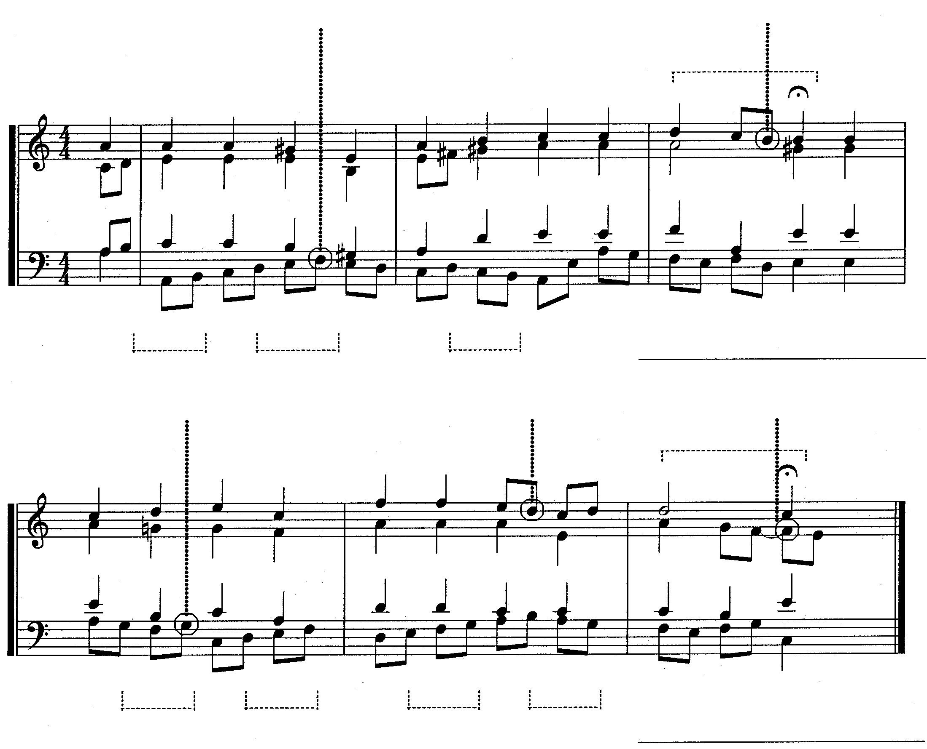  QUESTION 6  (j)  (k)  (h)  (h)  (c)  (b)  (a)  (l)  (m)  (n)  (i)  Cadence  (g)  (f)  (e)  (d)  Cadence  (i)  (i)  Study the given excerpt from a chorale and carry out the following instructions:  - Figure the harmonies (a) – (g). Indicate the key, chord and inversion for each.  - Name the cadences (h) and (i). Indicate the key and chord progression for each.  - Name (j) – (n) as non- harmonic notes or harmonic notes. | [25]  (14)  (6)  (5)

Non-harmonic notes: | (j)
 | (k)
 | (l)
 | (m)
 | (n)

TOTAL: | 100

