GAUTENG DEPARTMENT OF EDUCATION
SENIOR CERTIFICATE EXAMINATION

MOTOR MECHANICS SG

TIME: 3 hours

MARKS: 200

REQUIREMENTS:

- Calculator and drawing instruments

INSTRUCTIONS:

- This examination paper consists of SECTION A and SECTION B.

- Section A is COMPULSORY.
- Answer any FIVE questions from Section B.

- Answer QUESTION 1 (1.1 – 1.15: Multiple-choice Questions) on the answer sheet on the inside cover of your answer book. All the other questions should be answered in your answer book.
- A formulae sheet is included on page 9.
- Sketches should be large, neat and well-proportioned. Please label all parts.

SECTION A

QUESTION 1
MULTIPLE-CHOICE QUESTIONS

1.1 It is advisable to keep the ________ when lifting heavy objects.

- legs apart and use the arms  - back straight and use the legs  - legs straight and use the back | (2)

1.2 The international colour code for a 220 Volt, three-core cable is

- earth red, live blue, neutral green and yellow.  - earth green, live red, neutral black.  - earth green and yellow, live brown, neutral blue. | (2)

1.3 Fuel should be stored in one of the following places:

- The store  - A fireproof room  - The mechanical workshop | (2)

1.4 When connecting a battery, the first step would be to connect the

- live conductor.  - negative conductor.  - earth conductor. | (2)

1.5 Petrol used in internal combustion engines consists of hydrogen and

- nitrogen.  - carbon.  - oxygen. | (2)

1.6 Which one of the following refers to the calibrating of the injector pump?

- The beginning of injection  - The end of injection  - The quantity of fuel injected | (2)

1.7 What would a foam-type fire extinguisher be used for generally?

- Solid matter  - Electrical fires  - Flammable liquids | (2)

1.8 Never work under a vehicle when the engine is running because

- the engine might overheat.  - carbon monoxide is a heavy gas.  - it is not very comfortable. | (2)

1.9 The __________ is not classified as a positive displacement blower.

- centrifugal-type blower  - vane-type blower  - roots-type blower | (2)

1.10 The firing order for a six-cylinder in-line engine is:

- 1, 4, 2, 5, 3, 6  - 1, 4, 3, 6, 2, 5  - 1, 5, 3, 6, 2, 4 | (2)

1.11 Torsional vibrations by the crankshaft could be caused by

- static unbalance.  - dynamic unbalance.  - effect of the torque resulting from power strokes. | (2)

1.12 The diode in an electrical circuit allows current to

- flow in both directions.  - flow in one direction.  - stop flowing in the circuit. | (2)

1.13 The voltmeter is connected in

- series.  - parallel.  - None of the above. | (2)

1.14 The two-speed final drive is engaged in high speed when the engaging gear is

- locked.  - free. | (2)

1.15 In the compression ignition injection, pump injection ceases when the helix of the pump plunger

- uncovers the spill port.  - closes the spill port.  - closes the inlet port. | (2)  2x15=[30]

QUESTION 2

2.1 What effect would a leaking cylinder head gasket have on an internal combustion engine? | (2)

2.2 Why does a bi-metal strip deflect when heated? | (4)

2.3 Name the THREE connecting terminals of the transistor. | (6)

2.4 A motorcar engine develops a torque of 560 Newton metres at 3 000 revolutions per minute. Calculate the brake power of the engine. | (4)

2.5 Define effective pump stroke. | (4)

2.6 What is the purpose of the steering box in the motor vehicle? | (2)

2.7 Define the catalytic cracking process. | (6)

2.8 State TWO alternative firing orders for four-cylinder engines. | (4)

2.9 State TWO advantages of epicyclic gear trains. | (4)

2.10 The sketch in Figure 1 shows a linkage-type power steering with the front wheels in a straight-ahead position. Draw this sketch in your answer book showing the position of the various components when the front wheels are turned to the right. Label fully. | (20)

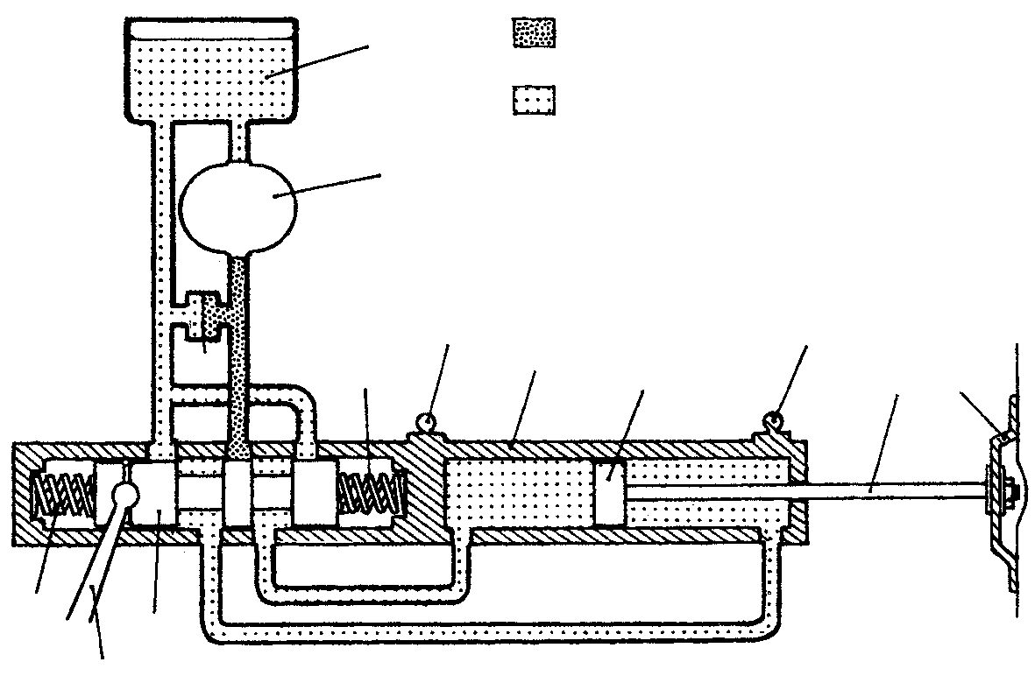
1
2
11
12
13
7
10
3
4
10
5
6
7
9
8

Figure 1

2.11 State TWO advantages of a power-steering steering box in comparison to the conventional steering box. | (4)

2.12 Read the following statements carefully and indicate whether they are TRUE or FALSE by writing down only TRUE or FALSE in your answer book next to the relevant question number.

- The electric motor used for windscreen wipers is known as an alternating motor.  - The indicated power could be used as a measure to determine the theoretical power developed by an engine.  - In the torque converter, torque increase could be provided automatically.  - The workshop is a place to work hard and play carefully.  - Fuel filters should remove any foreign solid matter from the fuel.  - Transistors are not sensitive to engine vibrations. | (1)  (1)  (1)  (1)  (1)  (1)

- Commencement of injection varies in the petrol injection system with the inverted helix.  - The number of gear ratios provided by the gearbox is doubled by the use of a two-speed final drive.  - Power unbalance is caused by the uneven spreading of the mass around the axis of rotation of the crankshaft.  - The power balance of a V-4 engine is good. | (1)  (1)  (1)  (1)  [70]

TOTAL FOR SECTION A: | [100]

SECTION B

Answer any FIVE questions from this section.

QUESTION 3

3.1 Draw a diagrammatic layout of a transistor ignition system equipped with contact points. | (10)

3.2 Draw a neat sketch of a transistor symbol. | (4)

3.3 State THREE advantages of the transistor ignition system in comparison with the conventional system. | (6)  [20]

QUESTION 4

4.1 By means of simple sketches illustrate the following fuel injection pump components:

4.1.1 Delivery valve  4.1.2 Pump element showing the plunger on maximum fuel delivery | (8)  (4)

4.2 What component should be removed from the fuel injection pump to be able to set spill timing? | (2)

4.3 Name TWO types of compression ignition fuel injection pumps. | (4)

4.4 At what stage during the effective pump stroke does ignition take place in a C.I. engine? | (2)  [20]

QUESTION 5

5.1 The following data refers to a two-cylinder two-stroke engine which was tested with a Prony brake:

Mean effective pressure : 900 kPa
Length of stroke : 86 mm
Cylinder bore : 84 mm
Revolutions per minute : 2 000
Brake arm length : 400 mm
Spring balance reading : 25 kg

Assume 1 kg = 9,8 N

Calculate:

- Indicator power  - Brake power  - Mechanical efficiency | (6)  (4)  (2)

5.2 Draw a typical cylinder pressure diagram for a four-stroke petrol engine having a compression ratio of 9:1. | (8)  [20]

QUESTION 6

6.1 Illustrate the following wheel alignment angles by means of simple sketches:

- Positive camber  - Negative castor  - King pin inclination | (4)  (4)  (4)

6.2 Name TWO factors that could affect toe out on turns. | (4)

6.3 Name TWO advantages of negative castor. | (4)  [20]

QUESTION 7

7.1 Draw a neat sectional sketch of a torque converter. | (12)

7.2 State the TWO basic differences in construction between a fluid coupling and a torque converter. | (4)

7.3 State TWO advantages of a torque converter. | (4)  [20]

QUESTION 8

Study the sketch of the multibarrel carburettor below and answer the questions that follow.

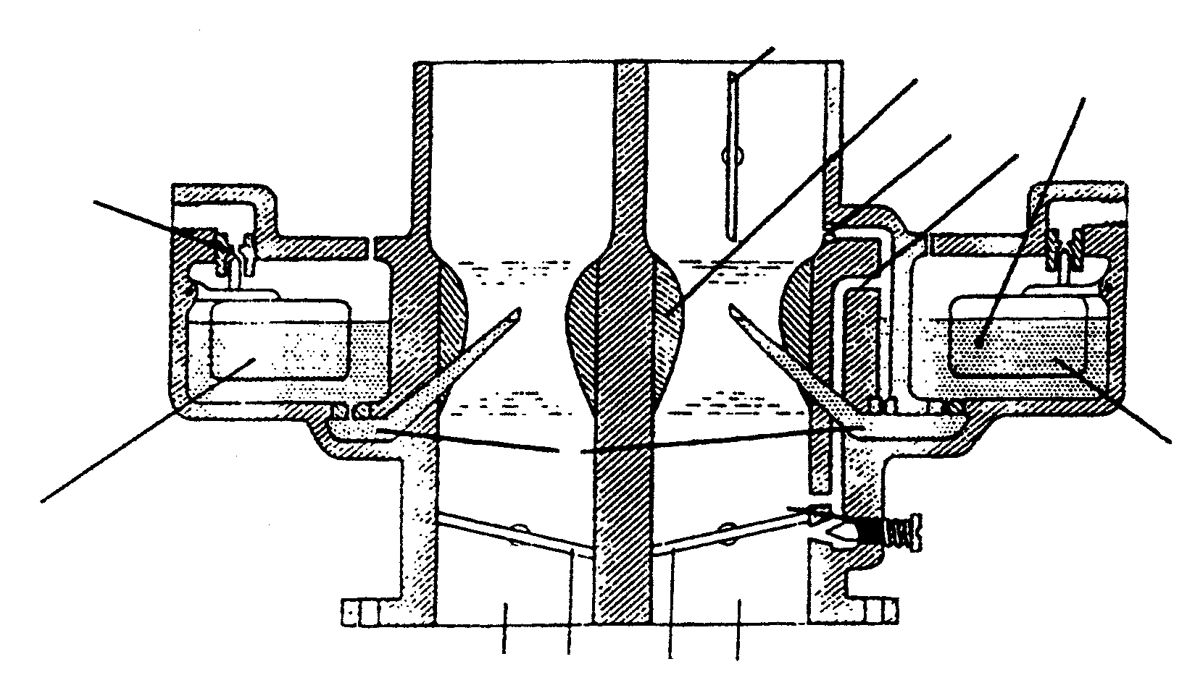
3
1
10
A
B
9
9
C
2
5
7
6
4
8

Figure 2

8.1 Name the components marked 1–10. | (10)

8.2 Name the carburettor circuits indicated by A, B and C. | (6)

8.3 Name TWO types of constant vacuum carburettors. | (2)

8.4 What component is responsible for the jet size in the constant vacuum carburettor? | (2)  [20]

TOTAL FOR SECTION B: | [100]

TOTAL: | 200

FORMULAE SHEET

- F = m x a

- Work = F x distance

- T = F x R

- Power = $\frac{F\text{ x distance}}{\text{time}}$

- Power = $\frac{M\text{.}E\text{.}P\text{.}\text{ x }π{\text{ x D}}^{2}\text{ x stroke length x r/s x number of cylinders}}{4\text{ x 2}}$

- Power = $\frac{M\text{.}E\text{.}P\text{ x }π{\text{ x D}}^{2}\text{ x stroke length x r/s x number of cylinders}}{4}$

- IP = PLANn

- Brake power = F x 2 $π$ R x N

- Brake power = 2 $π$ NT

Mechanical efficiency = $\frac{B\text{.}P\text{.}}{I\text{.}P\text{.}}$ x $\frac{\text{100}}{1}$

C.R. = $\frac{\text{SV }+\text{ CV}}{\text{CV}}$

Area = $\frac{π{\text{ D}}^{2}}{4}$

Stroke volume = $\frac{π{\text{ D}}^{2}L}{4}$

